# Lithium-ion batteries for the E-Rapid

## Introduction

Considering the goal to develop the E-transporter and enhance its range capabilities, converting from gel batteries to lithium-ion batteries became a necessary step. The advantages of lithium-ion batteries, including higher energy density, longer lifespan, and significantly reduced weight, make them an ideal choice for this application. By switching to lithium-ion batteries, the E-rapid will not only be able to cover greater distances on a single charge but will also benefit from improved efficiency and performance due to the substantial weight savings. This transition is crucial for meeting the demands of modern transportation and ensuring the competitiveness and reliability of the E-rapid in the market.

## Battery sample.

Li-ion batteries factory in Bekaa offers customized lithium batteries, phone number +961 71 526 130. They offered a ready product for similar vehicles, a Lithium-ion battery of voltage 60 V and 70 Ah of 31 cm x 16.5 cm x 17.5 cm. type?? Price?? Discharge current?? BMS??

Fig.1 shows the Lithium battery pack that may be assembled to the E-rapid.

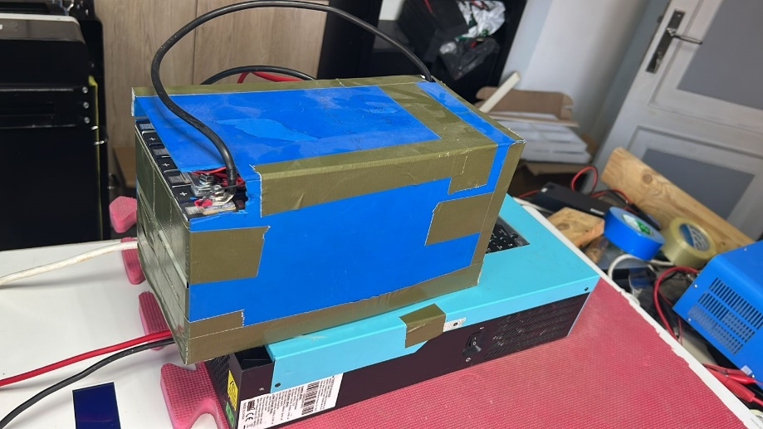

**Fig. 1.** Li-ion battery

After spacing up the old batteries, there will plenty of free space even after assembling this lithium battery. The remaining space will be invested in the solar system. The wiring and inverter will be packed in the rear part of the space shown in Figure 2.

Fig.2 shows the free spaces in the E-rapid trunk after disassembling the old gel batteries.

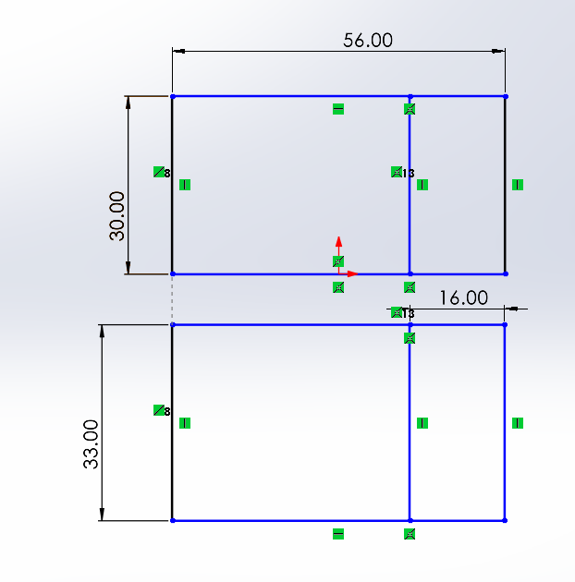

front

Rear

Free

space

Free

space

occupied

occupied

**Fig. 2.** 2D sketch for E-rapid trunk

## BMS

Lithium batteries acquire battery management system (BMS) to feature safety, performance, efficiency and longevity.

## Conclusion

For the safety, performance, and longevity of your E-rapid using lithium-ion batteries, incorporating a BMS is not just advisable but essential. Skipping this critical component can lead to serious safety hazards, reduced efficiency, and a significantly shortened battery lifespan. It is worth investing in a proper BMS to ensure the reliability and success of your E-transporter project.