**E-Rapid Report**

Completing the journey of development and enhancement of the E-rapid to reach an innovative product.

**1. Introduction:**

The E-Rapid is an Electric Vehicle that is meant to transport goods within cities. This E-rapid is a rear-wheel-drive vehicle that is fully electric, it is powered by an advanced solar system that assists the vehicle to charge.

## 1.1. Brief Timeline recap of the development of E-transporter:

* Assembly of E-tuktuk
* Designing and manufacturing of solar panel system
* Installing new front suspension with two wheels

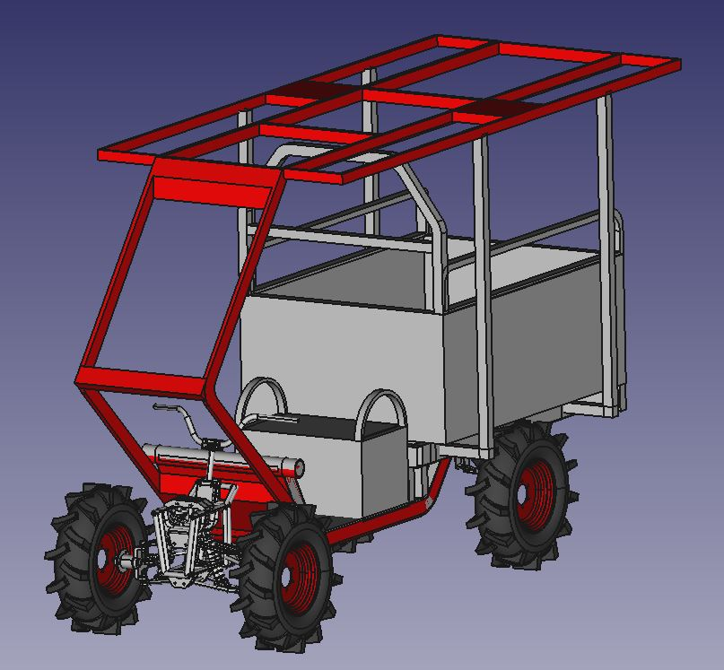

**Fig. 1.** E-transporter final design [1]

## 1.2. Current specs of the E-transporter

* Batteries a series of five 12V Gel batteries sums a 60V cell of 45.2 Ah.
* Electric motor a brushless DC motor (BLDC) of rated voltage 60V, power 1000W and 3000 rpm.
* Controller offers reversing, 3 speed shift, over temperature protection.
* Solar system consists of 5 solar panels of 100W with an inverter that is directly connected the charge the batteries when possible.

## 2. Recommendations for the final E-rapid product:

* Improve front suspension weldments.
* Replace the oil wheels (smoother threads)
* Install Li-ion batteries and increase their capacity
* Improve solar system installation (wires and inverter)

## 2.1. Improvements descriptions:

1. **Front suspension** that was added to the vehicle to maintain 2 wheels, has loose connections and weldments. To increase its quality and performance, advanced FEM simulations should be drawn out to check its viability, it may need some optimizations in its design.
2. Current **wheels** are the agricultural use, for asphalt use smoother thread wheels to decrease loses.
3. Wires and the inverter of the **solar system** can be packed in a better and safer way.
4. Installing **Li-ion batteries** is a just winning step since the vehicle will be lighter and has batter range.

Mass rough estimation of Li-ion batteries according to its energy density:

Assumption if the lithium batteries will have the same specs the current gel battery of 60 V and 45.2 Ah.

Lithium-ion batteries energy density is between 200-300 Wh/kg [2]. The energy of the battery is its voltage by capacity that implies 2700 Wh. The mass of the battery is its energy over materials energy density, the minimum energy density will be used of 200 Wh/kg. The rough estimated mass is 15 kg, for sure that an error margin depends on the material used.

$Mass=\frac{Energy Density}{Energy​}=\frac{200Whkg}{2700Wh}​=15kg$ (1)

According to this mass gain we can increase the capacity/range.

**3. conclusion**

Optimizing the current E-transporter to reach the ideal stage of performance and quality takes our product to the market-ready status. This includes the enhancements of the key variables like range, battery efficiency, drivetrain performance and overall satisfaction. By doing so, we can confidently introduce to the market our E-Rapid

**References**

**1.** NLAS ANNUAL REPORT 2023

**2.** Energy, T. S. (2023, July 14). Lithium ion batteries: energy density?