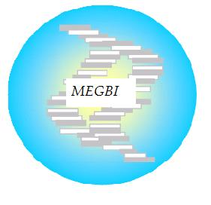
MEGBI - Middle East Genetics and Biotechnology Institute
مركز أبحاث للجينات والتقنية البيولوجية
http://aecenar.com/index.php/institutes/megbi

MEGBI-APP (Antibiotitic Pilot Plant) Report 2022
Penicillin Pilot Plant Production, Ampicillin Production & Quantification of Penicillin and Ampicillin

Author:
Hind Abd El Hamid

Last Update: 11.04.2022 11:02

Table of Contents

I- Overview 1
1- Whole study of Pilot plant penicillin production: 1
i. Penicillin Production (totally about 29 days) 1
ii. List of materials we need for this trial: 4
2- Bacterial strains those will be used in our trials and their Characteristics: 5
3- Testing the activity of the presented Ampicillin as an active antibiotic: 5
4- How the standard antibiotic solution can be produced(6): 6
5- Bioreactor and penicillin production pilot plant: 7
i. Introduction: 7
II- Materials and Methods: 13
1- Experiment 1: Ethyl acetate preparation: 13
2- Experiment 2: Penicillin production 14
III- Results: 16
1- Experiment 1: Ethyl acetate preparation: 16
IV- References: 17

I- Overview

Whole study of Pilot plant penicillin production:

Penicillin Production (totally about 29 days)

In the first, we put a half of bread in a fermentation conditions until will be able to see many fermented regions.
All used lab glassware are sterilized by adding some ml of water, covering with metallic paper and bowling until the water are totally evaporates (Or in the oven)
Microbial essays (culture and inoculation) are performed in a sterile area near a flame

Preparation of agarose gel(1days)
- We try to melt six tryptone tubes by using a heated water (bain marie)
- We weigh 3g of glucose powder
- In an Erlenmeyer flask we mix the melted tryptone, the glucose and 60 ml of distilled water
- We keep heat until we get a homogeneous mixture
- We fill the mixture in six petri dishes
- We heat them in a pressure cooker after boiling for 15 min
- We let them cool down and we wait about 30 min until the gel are totally solidified
- We put them in the fridge until the time of microbial cultivation

Microbial culture (7 days)
- We cultivate the six petri dishes with the strains of penicillium
- We incubated them at room temperature for 7 days

Preparation of liquid medium(7 days)
- We weigh 400g of glucose powder, 400 g of lactose, 200g of peptone, 20g of MgCl₂, 20g of KCl, and 100g of KH₂PO₄ than we add them in the first container of the bioreactor
- We add 20 L of distilled water
- We heat them with mixing for 15min
- We let them cool down
- We inoculate them by the petri dishes already prepared (we need about 200 colony)
- We incubate them at room temperature for 7days with shaking

Filtration and the adding of ethyl acetate(7 days)
- After 7 days of incubation in liquid medium we filter the inoculated liquid medium by using of filter paper to the second container of the bioreactor containing 86g of charcoal and 100g of KH₂PO₄ and we leave them for 20 min
- We decant the liquid from the charcoal to the third container than we add ethyl acetate (proportion 50/50)
- (we may obtain about 12 L of bread penicillim filtrate so we need about 12 L of ethyl acetate)
- We incubate them at 4ºC some days (about 7 days).

Purification(7 days)
- Here the penicillin was dissolved in ethyl acetate
- The centrifugation method was applied to eliminate the pellet containing cells debris and all other contaminant (4000x for 15 min)
- The supernatant is moved to a forth other container (We may obtain about 12L of supernatant)
- We add about 1000g of sodium bicarbonate for the supernatant to obtain the penicillium in salt form.
- We cool them at 4ºC for about 7 days
- Then we remove the liquid and we dry the crystal

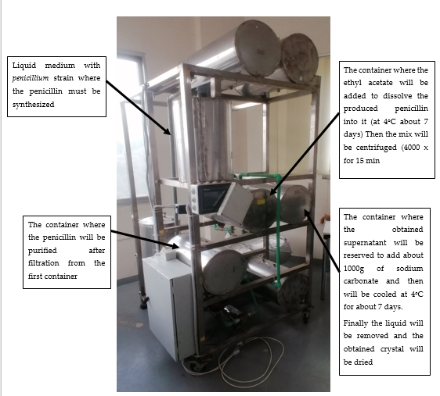
Figure 1: MEGBI- Bioreactor

List of materials we need for this trial:

- 6 tubes of tryptone
- 40 g + 3 g glucose powder
- 20 L + 60 ml distilled water
- 400 g lactose
- 200g peptone
- 20 g MgCl₂
- 20 g KCL
- 100g + 100g KH₂PO₄
- 12 L ethyl acetate
- 86g Charcoal
- 1000g sodium bicarbonate

2- Bacterial strains those will be used in our trials and their Characteristics:

- Staph. Aureus:
S. aureus can grow at a temperature range between 15° to 45°C and at NaCl concentrations up to 15%. However, extended exposures above 42°C or below 10°C are not recommended(1).

- Streptococcus pyogene:
S. pyogenes is a facultative anaerobe and is grown at 37°C in either ambient air or in 5–10% CO₂(2)
This bacterium can be cultivated on standard I- nutrient agar (3).

- Esherichia coli:
Escherichia coli (E. coli) is a stick asporulated Gram negative bacteria. It is an aerobic or facultative anaerobic species. It is grown at a temperature range between 35ºC and 37 °C, but it can support until 44,5 °C. For this reason it is called thermo-tolerant coliform (4). The naturally occurring (wild-type) strain of E. coli doesn't require any growth factors. If given the appropriate elements and an energy source, E. coli can synthesize all 20 amino acids, all vitamins, all nucleotides, and all fatty acids that it uses during growth and metabolism(5).

3- Testing the activity of the presented Ampicillin as an active antibiotic:

In light of testing the activity of our presented ampicillin, first we add 0.015g of ampicillin in 100 ml NaCl 0.9%. Then we prepare two petri dish filled with tryptone yeast extract agar, the first to cultivate E.coli without Ampicillin and the second to cultivate E.coli with Ampicillin(about 300µlof ampicillin), Then We incubate them for 24 Hours at 37ºC. Then we have getting these results showing below:
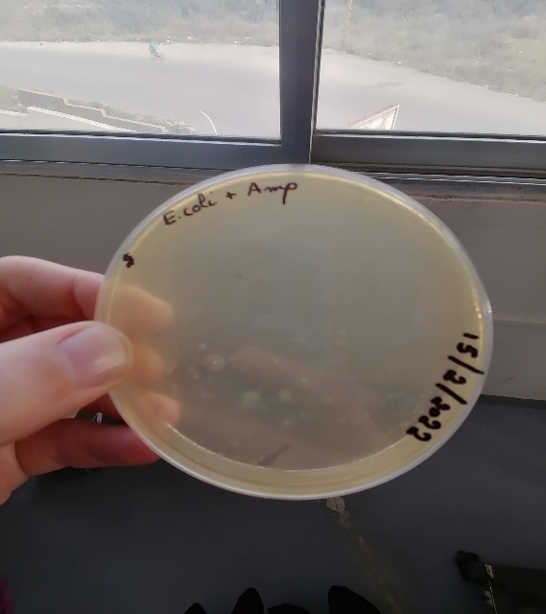
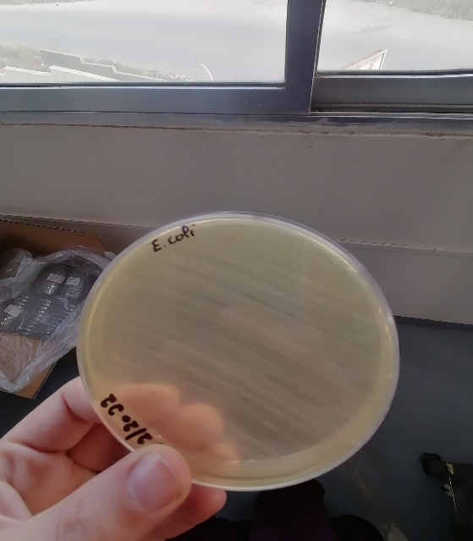

Interpretation: The used ampicillin inhibit E.coli to grow on the media culture which is non the case for the other petri dish without ampicillin. These results show that this ampicillin can will be used to quantify our pretended produced ampicillin as a reference antibiotic.

4- How the standard antibiotic solution can be produced(6):
Ampicillin:
- diluted in distilled water
- Standard stock solution(0.1mg/ml)
- Storage with refrigeration (1 week)
- Final concentration to drawing the standard curve (0.64 , 0.80 , 1 , 1.25 , 1.56) (µg/ml)( will be prepared on the same day of the essay)
Penicillin G:
- Diluted in NaCl 0.9%
- Standard stock solution (1000 units/ml)
- Storage with refrigeration (4 days)
- Final concentration to drawing the standard curve (0.64 , 0.80 , 1 , 1.25 , 1.56) (µg/ml)( will be prepared on the same day of the essay)

5- Bioreactor and penicillin production pilot plant:

Introduction:

Penicillin was discovered by Alexander Fleming. Different penicillins are produced by different strains of Penicillium.
Sodium penicillin G (MW = 356.4 KDa, Activity: 1,670 U/mg) is administered parenterally, as it is degraded in acid conditions. Penicillin is active against Gram positive bacteria by inhibition of cell wall synthesis.
Different species of the genus Penicillium produce different forms of penicillin. The strain used by Fleming was P. notatum. Later on, different strains were used, such as P. chrysogenum, which is the most widely used strain in industry.
The original medium contained the following compounds: lactose, 3–4%; corn steep liquor, 4% (as a nitrogen source); CaCO3, 1%; KH2PO4, 0.4%; antifoam, 0.25%. Improved media resulting in higher penicillin yields have been developed. A typical composition of such media is: glucose or molasses, 10%; corn steep liquor solids, 4–5%; phenylacetic acid (continuous feed), 0.5–0.8% total; vegetable oil-antifoam, 0.5% total. Penicillin G requires about 0.47g sodium phenylacetate per gram of produced penicillin.
The production fermenters need a mechanical agitation between (100-300 rpm) and the temperature is controlled around 25-28ºC (optimum26ºC)(7).

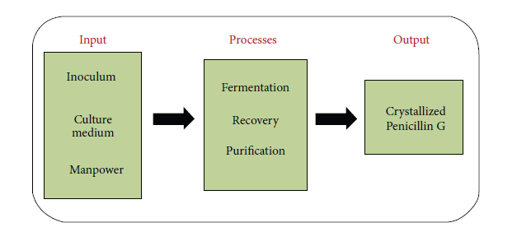
Figure 1:Schematic representation of producing crystallized Penicillin G(8).

The original process for the recovery of penicillin from fermentation broth was based on adsorption on activated carbon. After washing with water, the activated carbon was eluted with 80% acetone. The penicillin was concentrated by evaporation under vacuum at 20 to 30°C. The remaining aqueous solution was cooled to 2°C, acidified to pH = 2–3, and the penicillin extracted with amyl acetate. Penicillin was crystallized from amyl acetate with excess mineral salts at pH of 7 under vacuum. This process is uneconomical because of the high cost of activated carbon.
The current recovery process includes filtration, extraction, adsorption, crystallization,
and drying(7).

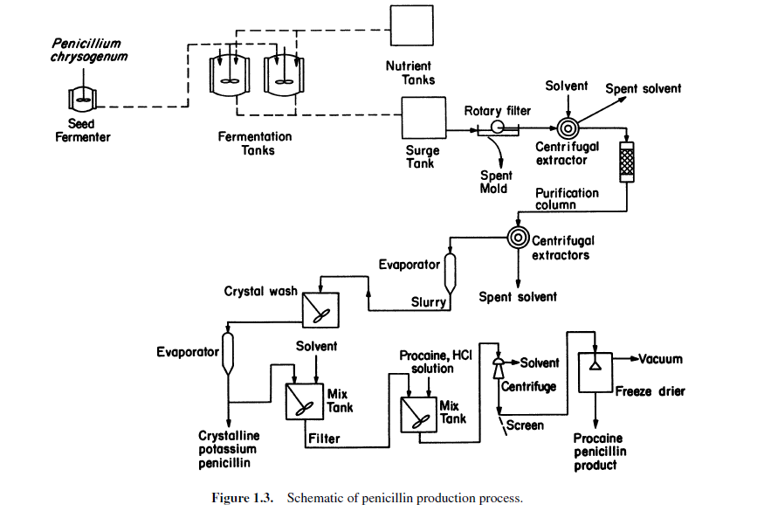
Figure 2: Schematic of penicillin production process(7).
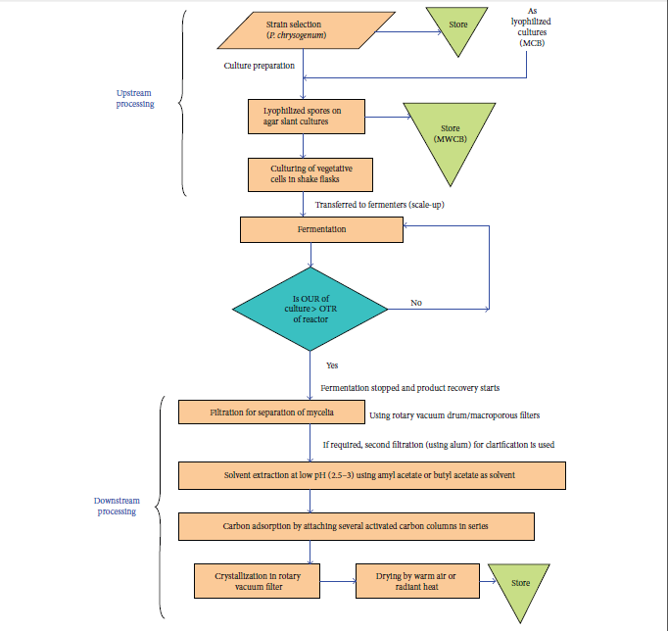
Figure 3:Schematic representation for large-scale production of Penicillin G (reproduced and redrawn from elsewhere). Steps are self-explanatory. For a detailed account, see the source. “OUR”: oxygen uptake rate, “OTR”: oxygen transfer rate, “MCB”: master cell bank, and “MWCB”: manufacturer’s working cell bank(8).
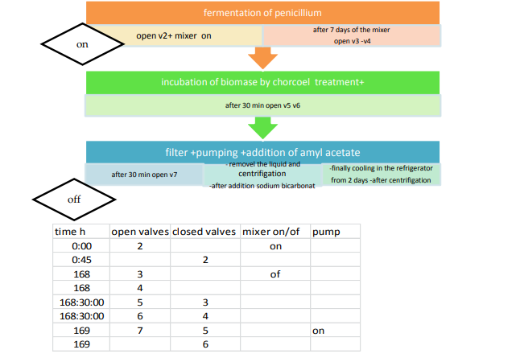
Figure 4:Program (Flow Diagram) for Automatic Synthesis of penicillin in machine(9)

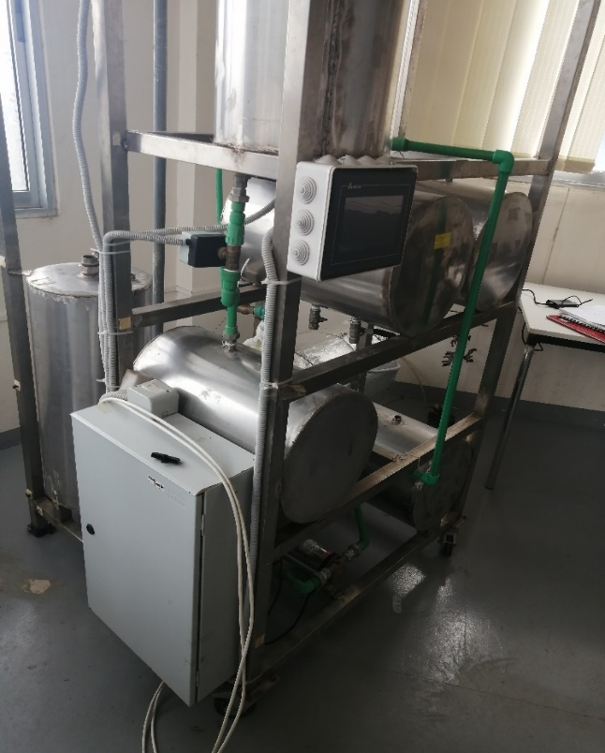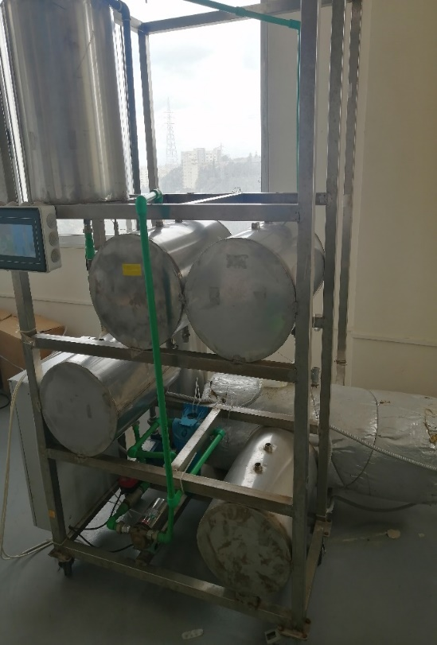

Sodium bicarbonate
The penicillin-rich filtrate is cooled to 2–4ºC to avoid chemical or enzymatic
degradation of the penicillin
Production Fermenter

Charcoal

Ethyl acetate
Nutrient tank
Pump
Pump
Filter
The current Bioreactor
As it should be Bioreactor
Production Fermenter
(25–28°C (26°optimum))

Ethyl acetate (2ºC)

Nutrient tank
Pump
Pump
Filter
Disk centrifuge (or charcoal treatment)
Basket Centrifuge- Extremely using in the removal of solids in this case Penicillin salt
To avoid degradation of penicillin during solvent extraction at low pH, temperature is kept around 2–4°C and filtration time is kept very short (1–2 min).
The crystals may be washed and pre-dried with anhydrous butyl alcohol to remove some impurities. Large horizontal belt filters are used for collection and drying of the crystals. Usually warm air or radiant heat is used for drying.
ألمشاكل التي من المتوقع أن تصادفنا:

-The produced penicillin is not a penicillin G because of the absent of The precursor: sodium phenyl acetate
-The obtained penicillin is with a bad purity or bad stability because of the used solvent (butyl acetate is better of ethyl acetate)
- The charcoal is not enough to purify the produced penicillin

II- Materials and Methods:

Experiment 1: Ethyl acetate preparation:

- 100 ml ethanol with 100 ml spirit of vinegar (concentrated vinegar) are added in a round flask
- Then 20 ml of concentrated H₂SO₄ is added (added slowly)
- The flask is connected to a water cooled reflux condenser
- The mixture is heated under reflux for 30 min on round flask heater
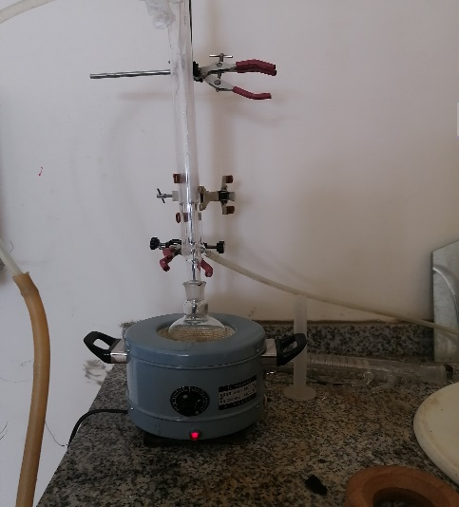

- After 30 min the flask is cooled
Now a separation is carried out to purify the produced ethyl acetate of any excess acid
- In a separating funnel containing the produced ethyl acetate we add 10g of anhydrous sodium carbonate diluted in 50 ml distilled water.
- Shacking- Degassing- waiting 2 minutes- separation (we keep the organic phase into the funnel)
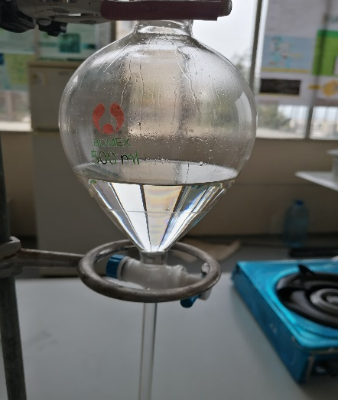
- Then we add 10g of anhydrous calcium chloride diluted in 50 ml distilled water.
- Shacking- Degassing- waiting 2 minutes- separation (we keep the organic phase into the funnel)
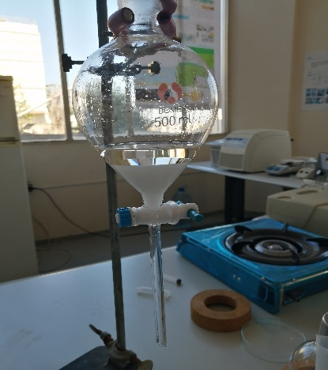

- Finally, we carry out to a final distillation of the obtained organic phase for about 10 min to obtain the purified ethyl acetate
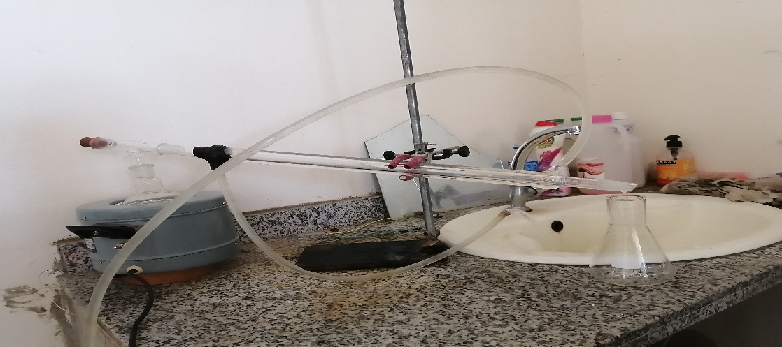

- To ensure the purity of ethyl acetate and the absence of acid we test a little of our product on sodium bicarbonate, there must be no effervescence.
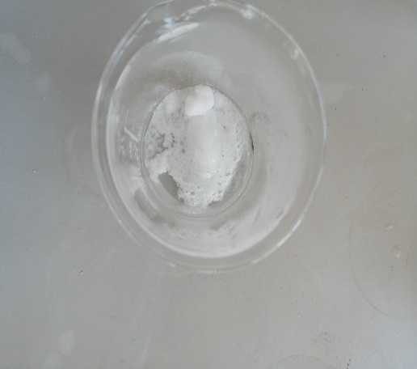

Experiment 2: Penicillin production

- The same steps already mentioned in a last report are followed(10).
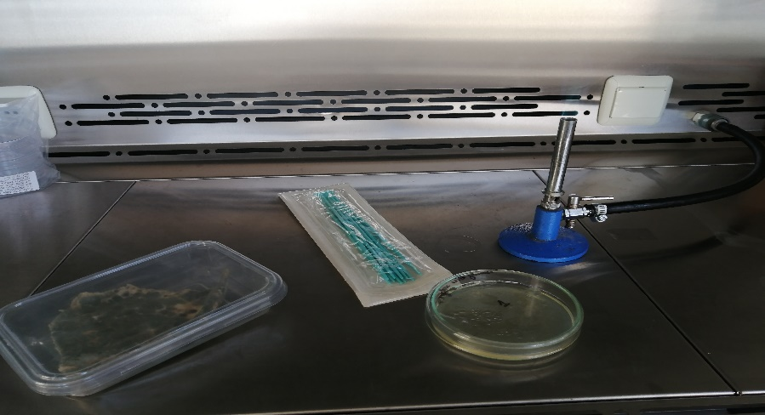

III- Results:

Experiment 1: Ethyl acetate preparation:

We had obtain about 80 ml of purified ethyl acetate

IV- References:

1. Missiakas DM, Schneewind O. Growth and Laboratory Maintenance of Staphylococcus aureus. Curr Protoc Microbiol. 2013 Feb;CHAPTER 9:Unit-9C.1.
2. Gera K, McIver KS. Laboratory Growth and Maintenance of Streptococcus pyogenes (The Group A Streptococcus, GAS). Curr Protoc Microbiol. 2013 Oct 2;30:9D.2.1-9D.2.13.
3. Standard I- nutrient agar [Internet]. Merck Millipore; Available from: https://www.merckmillipore.com/INTERSHOP/web/WFS/Merck-LU-Site/fr_FR/-/EUR/ShowDocument-Pronet?id=18327#:~:text=Typical%20Composition%20(g%2Flitre),1.0%3B%20agar%2Dagar%2012.0.
4. Recherche et dénombrement d’ Escherichia coli thermotolérants dans les échantillons solides ou semi-solides :.pdf [Internet]. [cited 2022 Feb 18]. Available from: https://www.ceaeq.gouv.qc.ca/methodes/pdf/MA705EcBCIG1.pdf
5. Growth Requirements of E. coli and Auxotrophs - Video & Lesson Transcript [Internet]. Study.com. [cited 2022 Feb 18]. Available from: https://study.com/academy/lesson/growth-requirements-of-e-coli-and-auxotrophs.html
6. CFR-1998-title21-vol5-part436.pdf [Internet]. [cited 2022 Feb 21]. Available from: https://www.govinfo.gov/content/pkg/CFR-1998-title21-vol5/pdf/CFR-1998-title21-vol5-part436.pdf
7. L. Shuler M, Kargi F. Bioprocess Engineering Basic Concepts Second Edition [Internet]. Second edition. United States: Prentice Hall PTR Upper Saddle River, NJ 07458 www.phptr.com; 2002. 576 p. Available from: https://www.academia.edu/44843690/Bioprocess_Engineering_Basic_Concepts_Second_Edition?pop_sutd=false
8. Nandi A, Pan S, Potumarthi R, Danquah MK, Sarethy IP. A Proposal for Six Sigma Integration for Large-Scale Production of Penicillin G and Subsequent Conversion to 6-APA. Journal of Analytical Methods in Chemistry. 2014;2014:1–10.
9. Fatima Antar, Mariam Mourad, Asia Mourad, Samer Youssef, Samar Youssef, Samir Mourad. MEGBI Antibiotics Production Pilot Plant (MEGBI-APP) - 6 th Project Report (Apr 2018 - Feb 2019) - [Internet]. 2018. Available from: http://aecenar.com/index.php/downloads/send/6-megbi-institute/463-megbi-app-report-6-2018-pdf
10. MEGBI-APP (Antibiotics Production Pilot Plant) Final Report (Period 2016 - 2020). 2016.

