Penicillin Production
Introduction:
Penicillin was discovered by Alexander Fleming. Different penicillins are produced by different strains of Penicillium.
Sodium penicillin G (MW = 356.4 KDa, Activity: 1,670 U/mg) is administered parenterally, as it is degraded in acid conditions. Penicillin is active against Gram positive bacteria by inhibition of cell wall synthesis.
Different species of the genus Penicillium produce different forms of penicillin. The strain used by Fleming was P. notatum. Later on, different strains were used, such as P. chrysogenum, which is the most widely used strain in industry.
The original medium contained the following compounds: lactose, 3–4%; corn steep liquor, 4% (as a nitrogen source); CaCO3, 1%; KH2PO4, 0.4%; antifoam, 0.25%. Improved media resulting in higher penicillin yields have been developed. A typical composition of such media is: glucose or molasses, 10%; corn steep liquor solids, 4–5%; phenylacetic acid (continuous feed), 0.5–0.8% total; vegetable oil-antifoam, 0.5% total. Penicillin G requires about 0.47g sodium phenylacetate per gram of produced penicillin.
The production fermenters need a mechanical agitation between (100-300 rpm) and the temperature is controlled around 25-28ºC (optimum26ºC)(1).

The original process for the recovery of penicillin from fermentation broth was based on adsorption on activated carbon. After washing with water, the activated carbon was eluted with 80% acetone. The penicillin was concentrated by evaporation under vacuum at 20 to 30°C. The remaining aqueous solution was cooled to 2°C, acidified to pH = 2–3, and the penicillin extracted with amyl acetate. Penicillin was crystallized from amyl acetate with excess mineral salts at pH of 7 under vacuum. This process is uneconomical because of the high cost of activated carbon.
The current recovery process includes filtration, extraction, adsorption, crystallization,
and drying(1).

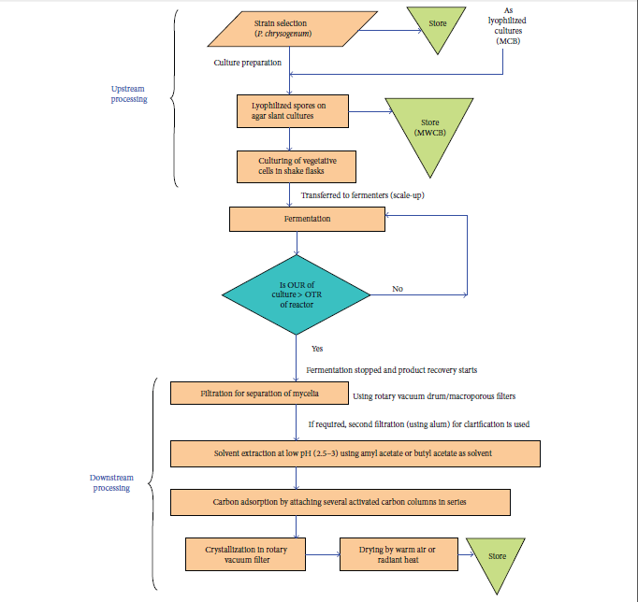
Figure 1:Schematic representation for large-scale production of Penicillin G (reproduced and redrawn from elsewhere). Steps are self-explanatory. For a detailed account, see the source. “OUR”: oxygen uptake rate, “OTR”: oxygen transfer rate, “MCB”: master cell bank, and “MWCB”: manufacturer’s working cell bank(2).

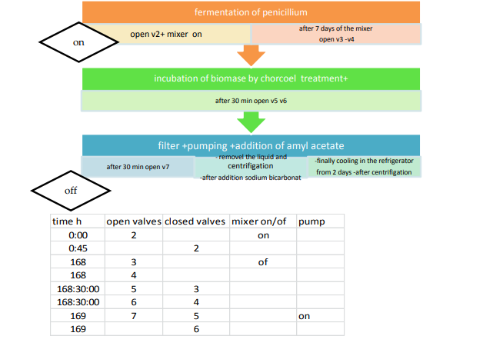
Figure 2:Program (Flow Diagram) for Automatic Synthesis of penicillin in machine(3)
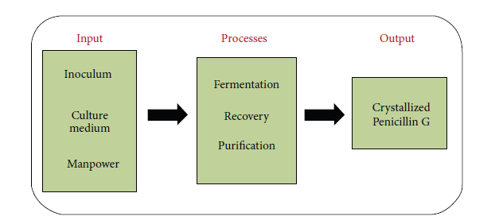
Figure 3:Schematic representation of producing crystallized Penicillin G(2).

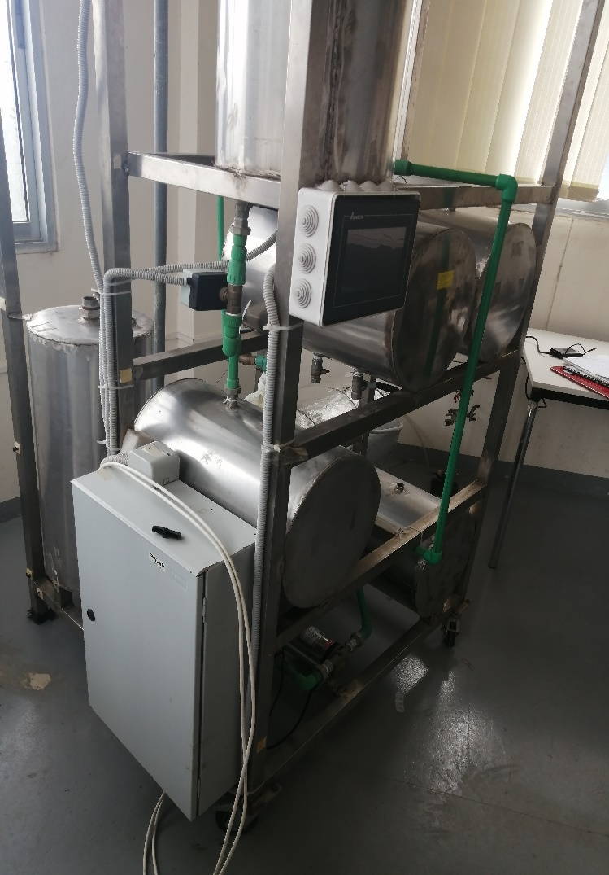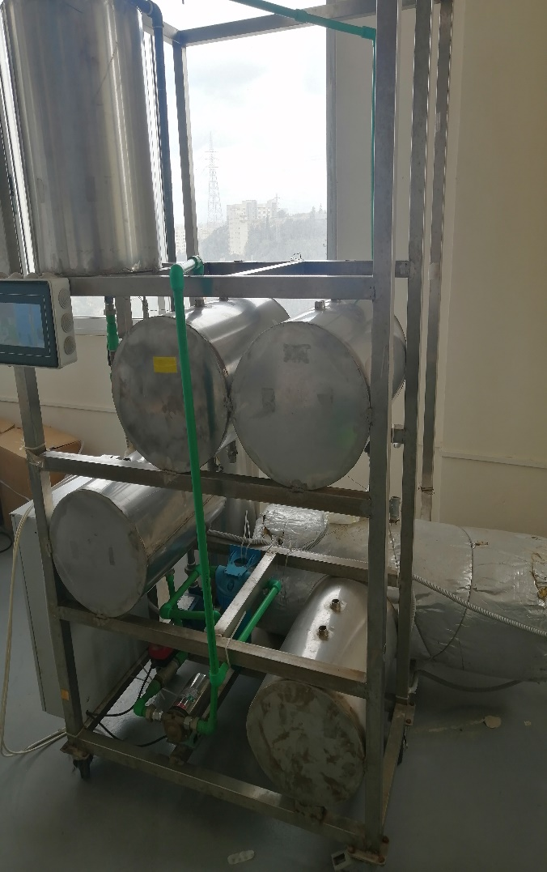

As it should be Bioreactor
The current Bioreactor
Production Fermenter

Charcoal

Ethyl acetate
Nutrient tank
Pump
Pump
Filter
Production Fermenter

Ethyl acetate
Nutrient tank
Pump
Pump
Filter

Disk centrifuge

The penicillin-rich filtrate is cooled to 2–4ºC to avoid chemical or enzymatic
degradation of the penicillin

To avoid degradation of penicillin during solvent extraction at low pH, temperature is kept around 2–4°C and filtration time is kept very short (1–2 min).

Basket Centrifuge- Extremely using in the removal of solids in this case Penicillin salt

Sodium bicarbonate

