- Bacterial strains those will be used in our trials and their Characteristics:

- Staph. Aureus:
S. aureus can grow at a temperature range between 15° to 45°C and at NaCl concentrations up to 15%. However, extended exposures above 42°C or below 10°C are not recommended(1).

- Streptococcus pyogene:
S. pyogenes is a facultative anaerobe and is grown at 37°C in either ambient air or in 5–10% CO₂(2)
This bacterium can be cultivated on standard I- nutrient agar (3).

- Esherichia coli:
Escherichia coli (E. coli) is a stick asporulated Gram negative bacteria. It is an aerobic or facultative anaerobic species. It is grown at a temperature range between 35ºC and 37 °C, but it can support until 44,5 °C. For this reason it is called thermotolerant coliforme(4). The naturally occurring (wild-type) strain of E. coli doesn't require any growth factors. If given the appropriate elements and an energy source, E. coli can synthesize all 20 amino acids, all vitamins, all nucleotides, and all fatty acids that it uses during growth and metabolism(5).

- Testing the activity of the presented Ampicillin as an active antibiotic:
In light of testing the activity of our presented ampicillin, first we add 0.015g of ampicillin in 100 ml NaCl 0.9%. Then we prepare two petri dish filled with tryptone yeast extract agar, the first to cultivate E.coli without Ampicillin and the second to cultivate E.coli with Ampicillin(about 300µlof ampicillin), Then We incubate them for 24 Hours at 37ºC. Then we have getting these results showing below:
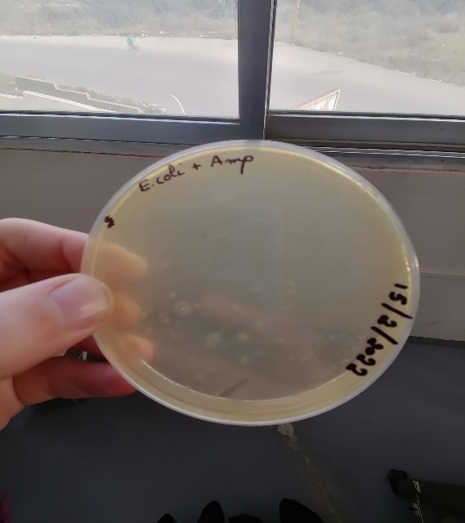
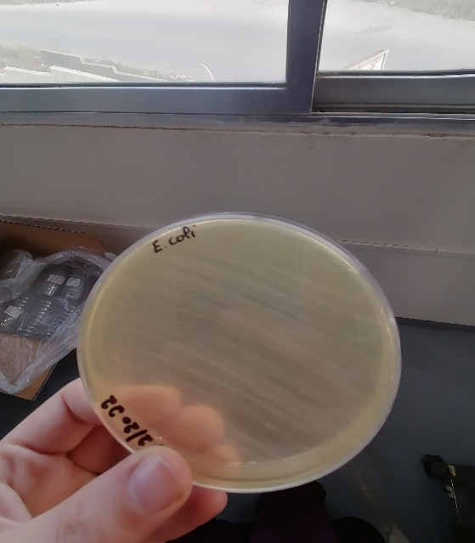

Interpretation: The used ampicillin inhibit E.coli to grow on the media culture which is non the case for the other petri dish without ampicillin. These results show that this ampicillin can will be used to quantify our pretended produced ampicillin as a reference antibiotic.
- How the standard antibiotic solution can be produced(6):
Ampicillin:
- diluted in distilled water
- Standard stock solution(0.1mg/ml)
- Storage with refrigeration (1 week)
- Final concentration to drawing the standard curve (0.64 , 0.80 , 1 , 1.25 , 1.56) (µg/ml)( will be prepared on the same day of the essay)
Penicillin G:
- Diluted in NaCl 0.9%
- Standard stock solution (1000 units/ml)
- Storage with refrigeration (4 days)
- Final concentration to drawing the standard curve (0.64 , 0.80 , 1 , 1.25 , 1.56) (µg/ml)( will be prepared on the same day of the essay)
References:
1. Missiakas DM, Schneewind O. Growth and Laboratory Maintenance of Staphylococcus aureus. Curr Protoc Microbiol. 2013 Feb;CHAPTER 9:Unit-9C.1.
2. Gera K, McIver KS. Laboratory Growth and Maintenance of Streptococcus pyogenes (The Group A Streptococcus, GAS). Curr Protoc Microbiol. 2013 Oct 2;30:9D.2.1-9D.2.13.
3. Standard I- nutrient agar [Internet]. Merck Millipore; Available from: https://www.merckmillipore.com/INTERSHOP/web/WFS/Merck-LU-Site/fr_FR/-/EUR/ShowDocument-Pronet?id=18327#:~:text=Typical%20Composition%20(g%2Flitre),1.0%3B%20agar%2Dagar%2012.0.
4. Recherche et dénombrement d’ Escherichia coli thermotolérants dans les échantillons solides ou semi-solides :.pdf [Internet]. [cited 2022 Feb 18]. Available from: https://www.ceaeq.gouv.qc.ca/methodes/pdf/MA705EcBCIG1.pdf
5. Growth Requirements of E. coli and Auxotrophs - Video & Lesson Transcript [Internet]. Study.com. [cited 2022 Feb 18]. Available from: https://study.com/academy/lesson/growth-requirements-of-e-coli-and-auxotrophs.html
6. CFR-1998-title21-vol5-part436.pdf [Internet]. [cited 2022 Feb 21]. Available from: https://www.govinfo.gov/content/pkg/CFR-1998-title21-vol5/pdf/CFR-1998-title21-vol5-part436.pdf

