|  |  |
| --- | --- |
|  | **MEGBI - Middle East Genetics and Biotechnology Institute**  **مركز أبحاث للجينات والتقنية البيولوجية**  <http://aecenar.com/index.php/institutes/megbi> |



**Penicillin and Ampicillin Production (Report 2021)**

* **Improvement of Lab Scale Penicillin Production**
* **Lab Scale Ampicillin Production (Penicillin -> Ampicillin)**
* **Improvement of Quality Assurance (Determination of penicillin and Determination of Ampicillin)**

Last update: Monday, November 15, 2021

Authors of Document:

Amin Etro, Fatima El Hamadi, Hind Abdulhamid, Ihab Wahbe

Editor: Samir Mourad

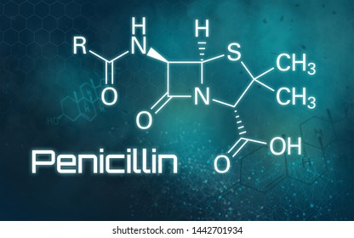

Contents

1 Basics 3

1.1 Penicillins 3

1.2 Ampicillin 3

1.2.1 Pharmacology 4

1.2.1.1 Pharmacokinetics 4

1.2.2 Side effects 5

1.2.3 Overdose 5

1.3 Perspectives: 5

2 Devices, Materials and Methods 7

2.1 Devices: 7

2.2 Penicillin Production 7

2.2.1 Preparation of agarose gel 7

2.2.2 Microbial culture 8

2.2.3 Preparation of liquid medium 8

2.2.4 Filtration and the adding of ethyl acetate 9

2.2.5 Purification 9

3 Results 11

3.1 Penicillin Production 11

3.2 Ampicillin Production: 11

# Basics

## Penicillins

Penicillins (P, PCN or PEN) are a group of antibiotics originally derived from Penicillium moulds (principally, P. chrysogenum, P. notatum and P. rubens). The discovery and manufacture of penicillins have changed the face of medicine. The several kinds of penicillin synthesized by various species of the mold *Penicillium* may be divided into two classes: the naturally occurring penicillins (those formed during the process of mold fermentation) and the semisynthetic penicillins (those in which the structure of a chemical substance—6-aminopenicillanic acid—found in all penicillins is altered in various ways). Because it is possible to change the characteristics of the antibiotic, different types of penicillin are produced for different therapeutic purposes.

## Ampicillin[1]

**Ampicillin** is an [antibiotic](https://en.wikipedia.org/wiki/Antibiotic) used to prevent and treat a number of [bacterial infections](https://en.wikipedia.org/wiki/Bacterial_infection), such as [respiratory tract infections](https://en.wikipedia.org/wiki/Respiratory_tract_infection), [urinary tract infections](https://en.wikipedia.org/wiki/Urinary_tract_infections), [meningitis](https://en.wikipedia.org/wiki/Meningitis), [salmonellosis](https://en.wikipedia.org/wiki/Salmonellosis), and [endocarditis](https://en.wikipedia.org/wiki/Endocarditis).[[3]](https://en.wikipedia.org/wiki/Ampicillin#cite_note-AHFS2015-3) It may also be used to prevent [group B streptococcal infection](https://en.wikipedia.org/wiki/Group_B_streptococcal_infection) in newborns.[[3]](https://en.wikipedia.org/wiki/Ampicillin#cite_note-AHFS2015-3) It is used by mouth, by [injection into a muscle](https://en.wikipedia.org/wiki/Intramuscular_injection), or intravenously.[[3]](https://en.wikipedia.org/wiki/Ampicillin#cite_note-AHFS2015-3) Common side effects include rash, nausea, and diarrhea.[[3]](https://en.wikipedia.org/wiki/Ampicillin#cite_note-AHFS2015-3) It should not be used in people who are [allergic to penicillin](https://en.wikipedia.org/wiki/Allergic_to_penicillin).[[3]](https://en.wikipedia.org/wiki/Ampicillin#cite_note-AHFS2015-3) Serious side effects may include [*Clostridium difficile* colitis](https://en.wikipedia.org/wiki/Clostridium_difficile_colitis) or [anaphylaxis](https://en.wikipedia.org/wiki/Anaphylaxis).[[3]](https://en.wikipedia.org/wiki/Ampicillin#cite_note-AHFS2015-3) While usable in those with [kidney problems](https://en.wikipedia.org/wiki/Kidney_problem), the dose may need to be decreased. Its use during  [pregnancy](https://en.wikipedia.org/wiki/Pregnancy) and [breast-feeding](https://en.wikipedia.org/wiki/Breastfeeding) appears to be generally safe. Ampicillin was discovered in 1958 and came into commercial use in 1961. It is on the [World Health Organization's List of Essential Medicines](https://en.wikipedia.org/wiki/WHO_Model_List_of_Essential_Medicines). The World Health Organization classifies ampicillin as critically important for human medicine. It is available as a [generic medication](https://en.wikipedia.org/wiki/Generic_medication).

|  |  |
| --- | --- |
|  |  |
| Ampicillin Structure | Penicillin G Structure |

### Pharmacology

**Mechanism of Action:**

Ampicillin is in the [penicillin](https://en.wikipedia.org/wiki/Penicillin) group of [beta-lactam antibiotics](https://en.wikipedia.org/wiki/%CE%92-Lactam_antibiotic) and is part of the [aminopenicillin](https://en.wikipedia.org/wiki/Aminopenicillin) family. It is roughly equivalent to [amoxicillin](https://en.wikipedia.org/wiki/Amoxicillin) in terms of activity. Ampicillin is able to penetrate Gram-positive and some Gram-negative bacteria. It differs from [penicillin G](https://en.wikipedia.org/wiki/Benzylpenicillin), or benzylpenicillin, only by the presence of an [amino](https://en.wikipedia.org/wiki/Amino) group. This amino group, present on both ampicillin and amoxicillin, helps these antibiotics pass through the pores of the outer membrane of Gram-negative bacteria, such as *E.coli*, [*Proteus mirabilis*](https://en.wikipedia.org/wiki/Proteus_mirabilis),  [*Salmonella enterica*](https://en.wikipedia.org/wiki/Salmonella_enterica), and [*Shigella*](https://en.wikipedia.org/wiki/Shigella).

Ampicillin acts as an irreversible inhibitor of the enzyme [transpeptidase](https://en.wikipedia.org/wiki/DD-transpeptidase), which is needed by bacteria to make the cell wall. It inhibits the third and final stage of bacterial cell wall synthesis in [binary fission](https://en.wikipedia.org/wiki/Binary_fission), which ultimately leads to cell [lysis](https://en.wikipedia.org/wiki/Lysis); therefore, ampicillin is usually bacteriolytic.

#### Pharmacokinetics

Ampicillin is well-absorbed from the [GI tract](https://en.wikipedia.org/wiki/GI_tract) (though food reduces its absorption), and reaches peak concentrations in one to two hours. The [bioavailability](https://en.wikipedia.org/wiki/Bioavailability) is around 62% for parenteral routes. Unlike other penicillins, which usually bind 60–90% to [plasma proteins](https://en.wikipedia.org/wiki/Plasma_proteins), ampicillin binds to only 15–20%.

Ampicillin is distributed through most tissues, though it is concentrated in the liver and kidneys. It can also be found in the [cerebrospinal fluid](https://en.wikipedia.org/wiki/Cerebrospinal_fluid) when the meninges become inflamed (such as, for example, meningitis).[[24]](https://en.wikipedia.org/wiki/Ampicillin#cite_note-eghianruwa-24) Some ampicillin is metabolized by hydrolyzing the beta-lactam ring to [penicilloic acid](https://en.wikipedia.org/wiki/Penicilloic_acid),[[3]](https://en.wikipedia.org/wiki/Ampicillin#cite_note-AHFS2015-3) though most of it is excreted unchanged.[[9]](https://en.wikipedia.org/wiki/Ampicillin#cite_note-dailymed-9) In the kidneys, it is filtered out mostly by [tubular secretion](https://en.wikipedia.org/wiki/Tubular_secretion); some also undergoes [glomerular filtration](https://en.wikipedia.org/wiki/Glomerular_filtration), and the rest is excreted in the [feces](https://en.wikipedia.org/wiki/Feces) and [bile](https://en.wikipedia.org/wiki/Bile).

[Hetacillin](https://en.wikipedia.org/wiki/Hetacillin) and [pivampicillin](https://en.wikipedia.org/wiki/Pivampicillin) are ampicillin [esters](https://en.wikipedia.org/wiki/Esters) that have been developed to increase bioavailability.

### Side effects

Ampicillin is comparatively less toxic than other antibiotics, and side effects are more likely in those who are sensitive to penicillins and those with a history of [asthma](https://en.wikipedia.org/wiki/Asthma) or [allergies](https://en.wikipedia.org/wiki/Allergies).[[9]](https://en.wikipedia.org/wiki/Ampicillin#cite_note-dailymed-9) In very rare cases, it causes severe side effects such as [angioedema](https://en.wikipedia.org/wiki/Angioedema), anaphylaxis, and [*C. difficile*](https://en.wikipedia.org/wiki/C._difficile) infection (that can range from mild [diarrhea](https://en.wikipedia.org/wiki/Diarrhea) to serious [pseudomembranous colitis](https://en.wikipedia.org/wiki/Pseudomembranous_colitis)).[[9]](https://en.wikipedia.org/wiki/Ampicillin#cite_note-dailymed-9) Some develop [black "furry" tongue](https://en.wikipedia.org/wiki/Black_hairy_tongue). Serious adverse effects also include [seizures](https://en.wikipedia.org/wiki/Seizure) and [serum sickness](https://en.wikipedia.org/wiki/Serum_sickness). The most common side effects, experienced by about 10% of users are diarrhea and rash. Less common side effects can be [nausea](https://en.wikipedia.org/wiki/Nausea), [vomiting](https://en.wikipedia.org/wiki/Vomiting), [itching](https://en.wikipedia.org/wiki/Itching), and blood [dyscrasias](https://en.wikipedia.org/wiki/Dyscrasia#Modern_use). The gastrointestinal effects, such as hairy tongue, nausea, vomiting, diarrhea, and colitis, are more common with the oral form of penicillin.[[9]](https://en.wikipedia.org/wiki/Ampicillin#cite_note-dailymed-9) Other conditions may develop up several weeks after treatment.[[3]](https://en.wikipedia.org/wiki/Ampicillin#cite_note-AHFS2015-3)

### Overdose

Ampicillin overdose can cause behavioral changes, [confusion](https://en.wikipedia.org/wiki/Confusion), blackouts, and convulsions, as well as neuromuscular hypersensitivity, [electrolyte imbalance](https://en.wikipedia.org/wiki/Electrolyte_imbalance), and [kidney failure](https://en.wikipedia.org/wiki/Kidney_failure).[[9]](https://en.wikipedia.org/wiki/Ampicillin#cite_note-dailymed-9)

## Perspectives:

For PhD preparation, we must choose an innovated topics. Here there are many topics that can be taken into account that are based on:

* Antibiotics combination and synergic effect
* Resistante bacteria (vector)
* The purety and the productivity of antibiotics
* Signal transduction pathways and anti-microbial activity into the bacteria
* Conversion derivatives and novel antimicrobial activities
* Vaccine
* Ampicillin and amoxicillin spectrum properties.
* Studying and Try to clone several antimicrobial peptides That can be produced by insect hemolymph such as Drosomycin by evaluating the deceded bacteria into them.(Insects doesn’t have an immune system but they produce several peptide such as defens system.

# Devices, Materials and Methods

## Devices:

To quantify the produced penicillin the most standard method was HPLC (high performance liquid chromatography). We can quantify them after a cooperation with chamber of commerce, industry and agriculture in Tripoli-North Lebanon.

## Penicillin Production

**In the first**, we put an orange and a half of bread in a fermentation conditions until will be able to see many fermented regions.

**All used lab glassware** are sterilized by adding some ml of water, covering with metallic paper and bowling until the water are totally evaporates

**Microbial essays (culture and inoculation)** are performed in a sterile area near a flame

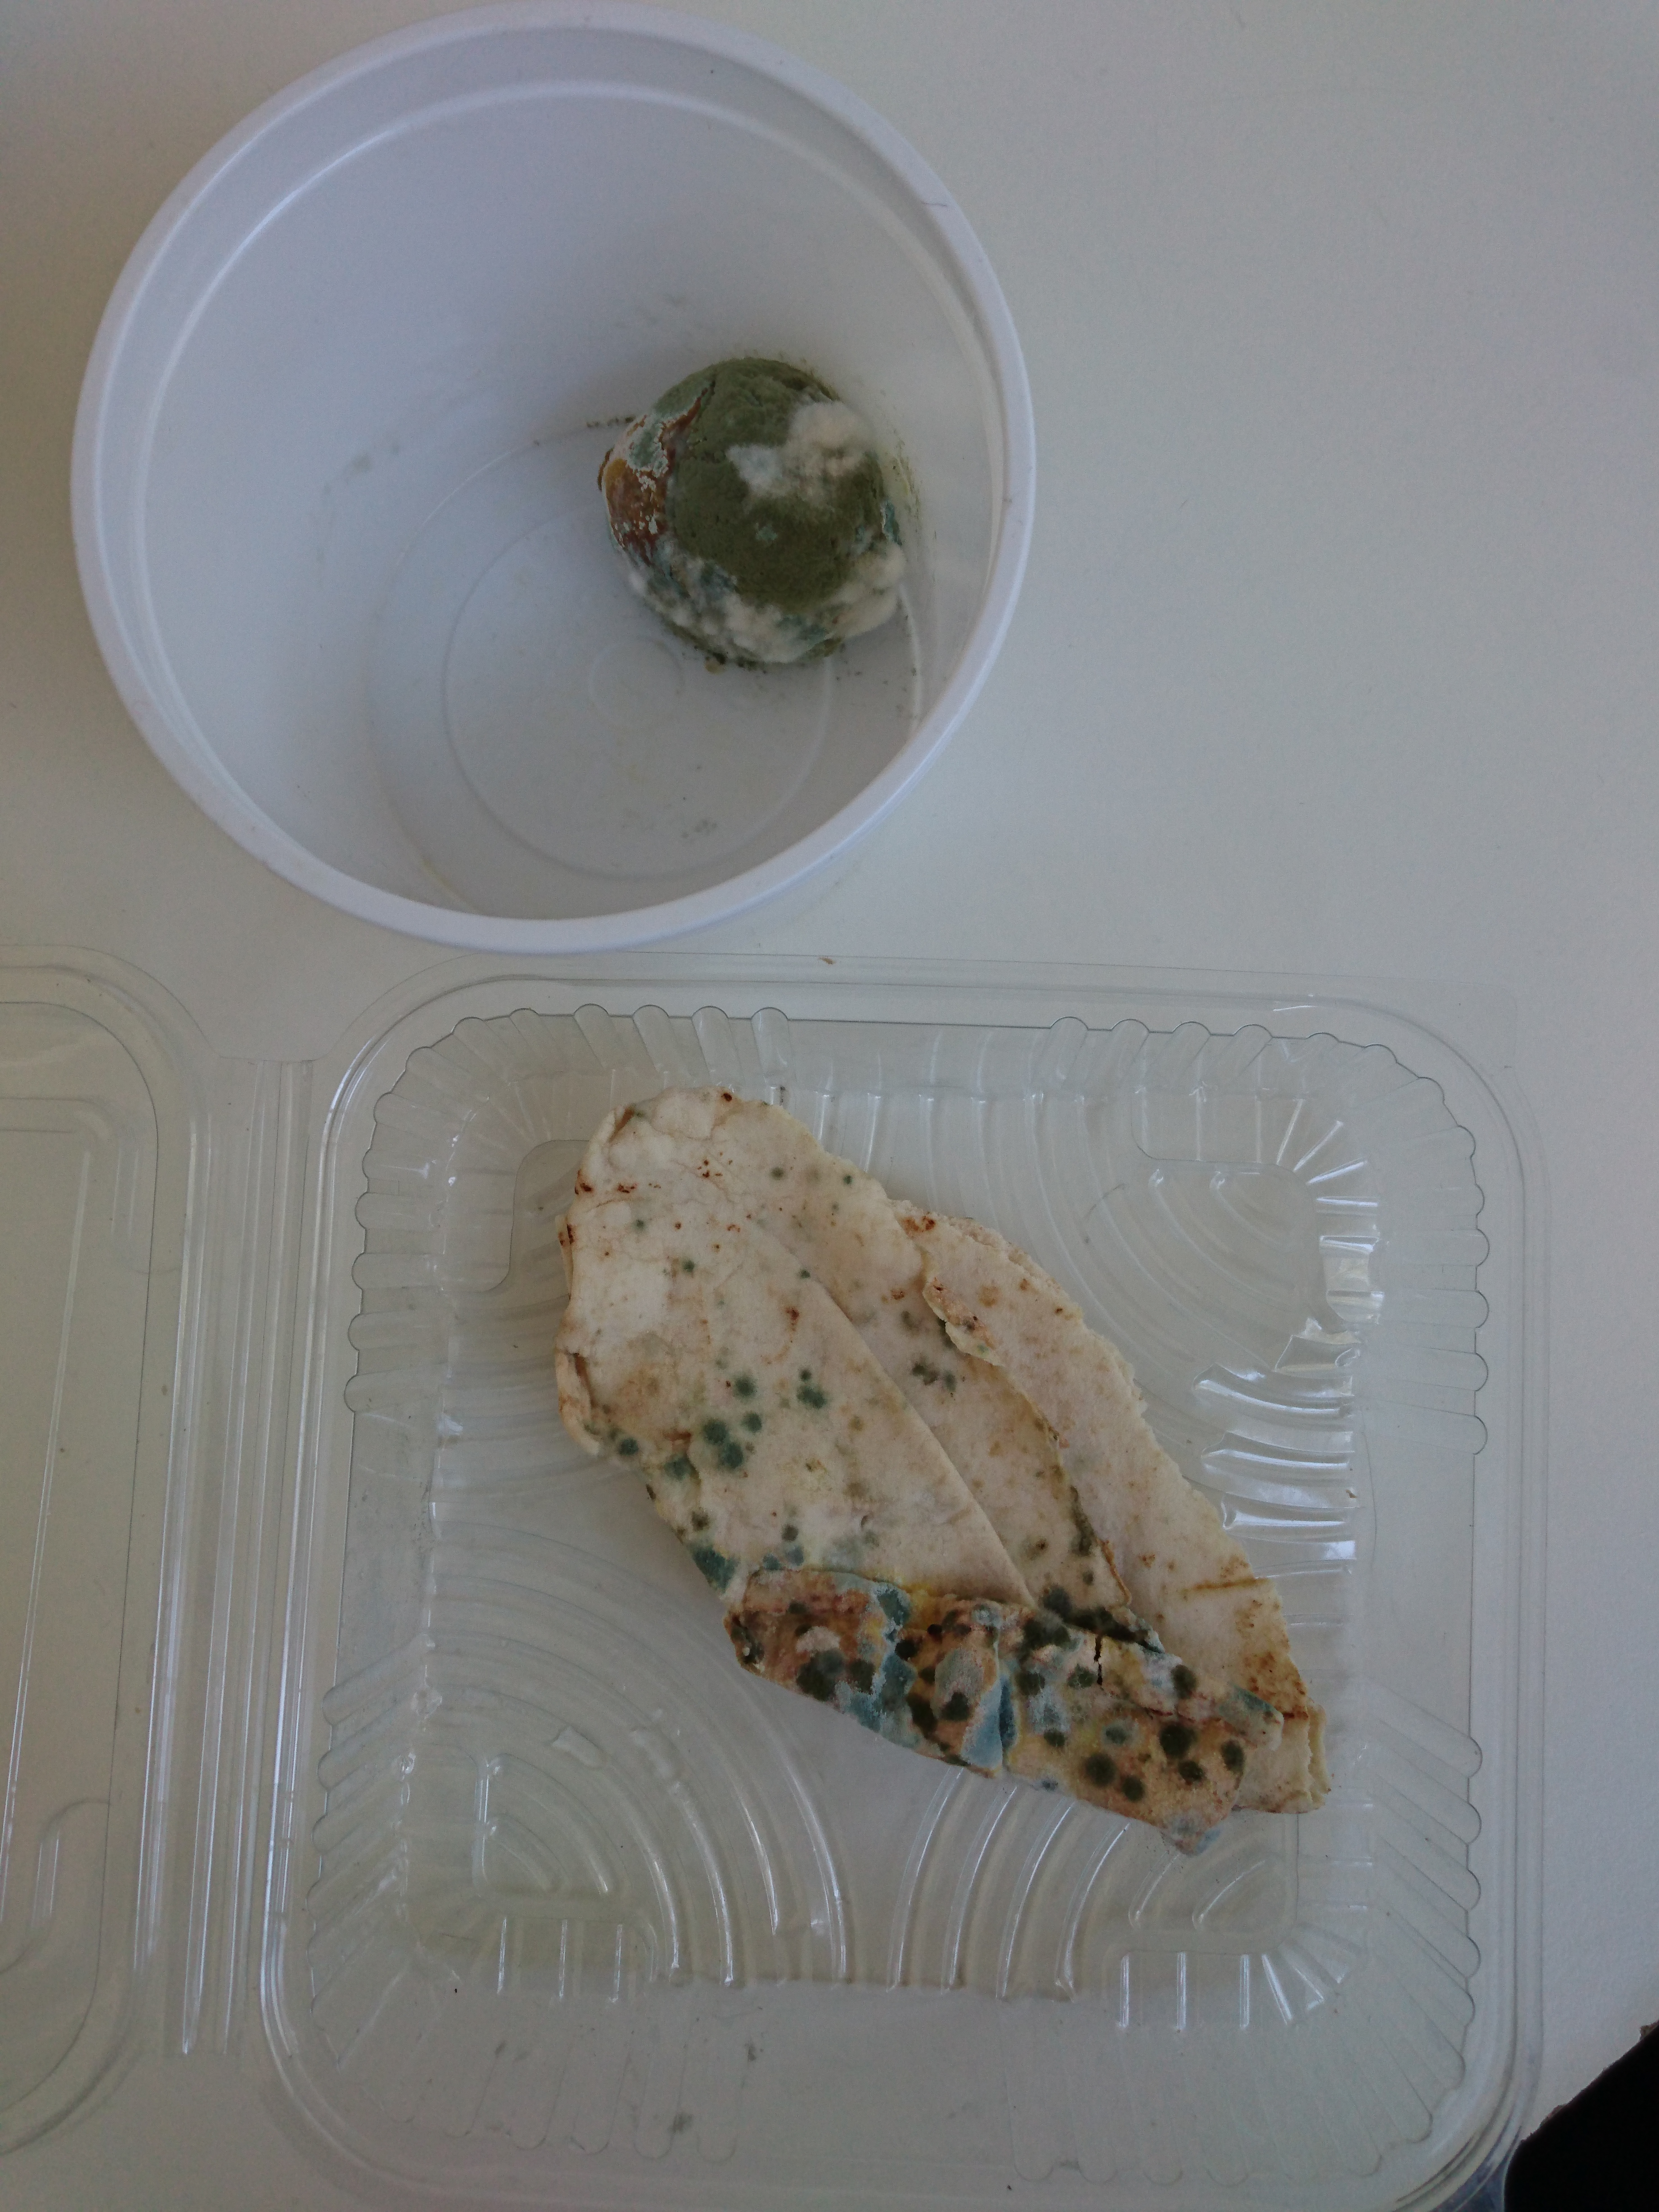

### Preparation of agarose gel

* We try to melt two tryptone tubes by using a heated water (bain marie)
* We weigh 1 g of glucose powder
* In an erlenmeyer flask we mix the melted tryptone, the glucose and 20 ml of distilled water
* We keep heating until we get an homogeneous mixture
* We fill the mixture in two petri dishes
* We heat them in a pressure cooker after boiling for 15 min
* We let them cool down and we wait about 30 min until the gel are totally solidified
* We put them in the fridge until the time of microbial cultivation

### Microbial culture

* We cultivate the two petri dishes differently with the two used strains of penicillium

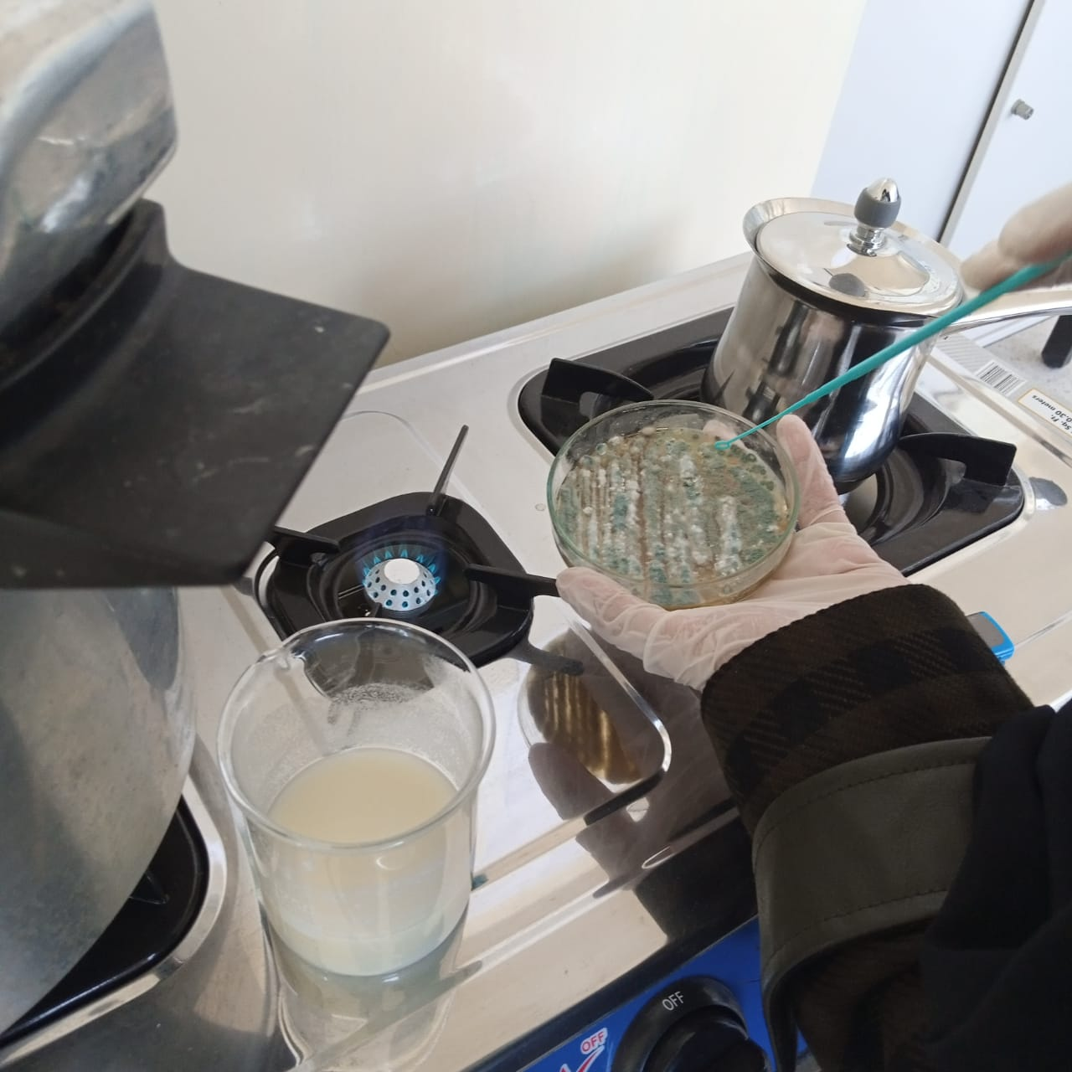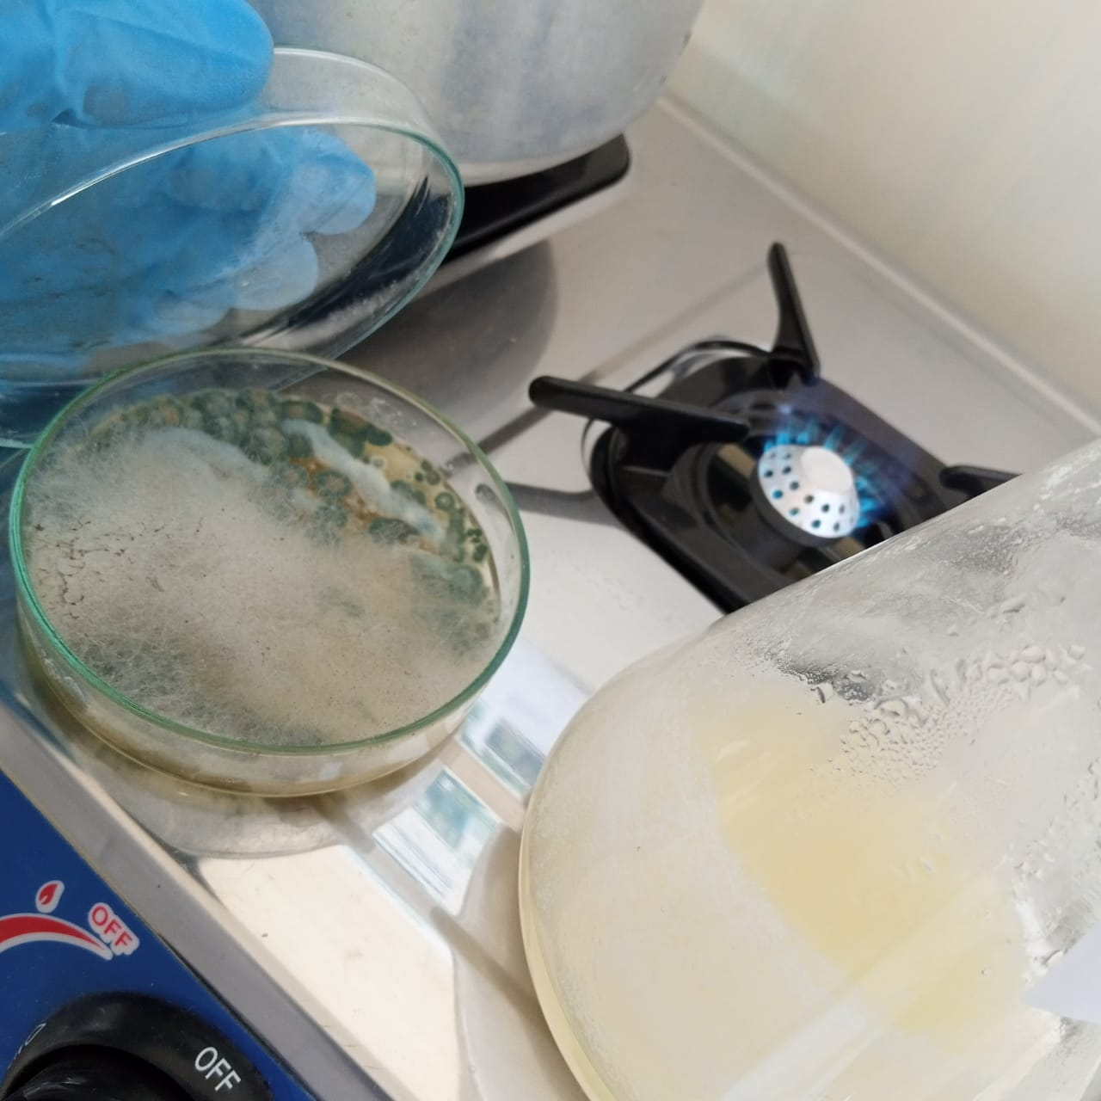

We incubatated them at room temperature for 7 days

### Preparation of liquid medium

* We weigh 4g of glucose powder, 4 g of lactose, 2g of peptone, 0.2g of MgCl2, 0.2g of KCl, and 1g of KH2PO4
* We add 200ml of distilled water
* We distribute the mixture in 2 erlenmeyer flasks (100 ml) with an equal proportion
* We heat them with mixing for 15min by using a magnetic hot plate stirrer
* We let them cool down for about 30 min
* We inoculate each of them with one of the two cultivated petri dishes already prepared (about two to three colony for each of them)
* We incubate them at room temperature for 7days (bread penicillium with shaking and the other lemon penicillium without shaking)

|  |  |
| --- | --- |
|  |  |

### Filtration and the adding of ethyl acetate

* After 7 days of incubation in liquid medium we filter the two inoculated liquid medium by using of filter paper
* Then in each of the obtaining filtrate we add 0.43g of charcoal and 0.5g of KH2PO4 and we leave them for 20 min
* We decant the liquid from the charcoal, then we add ethyl acetate(proportion 50/50)
* (we have used 60ml of lemon penicillim filtrate with 60 ml of ethyl acetate and 46 ml of bread penicillium filtrate with 46 ml of ethyl acetate)
* We incubate them in the fridge some days(about 7 days).

|  |  |
| --- | --- |
|  |  |

### Purification

1. Here the penicillin was dissolved in ethyl acetate
2. The centrifugation method was applied to eliminate the pellet containing cells debris and all other contaminant (4000x for 15 min)

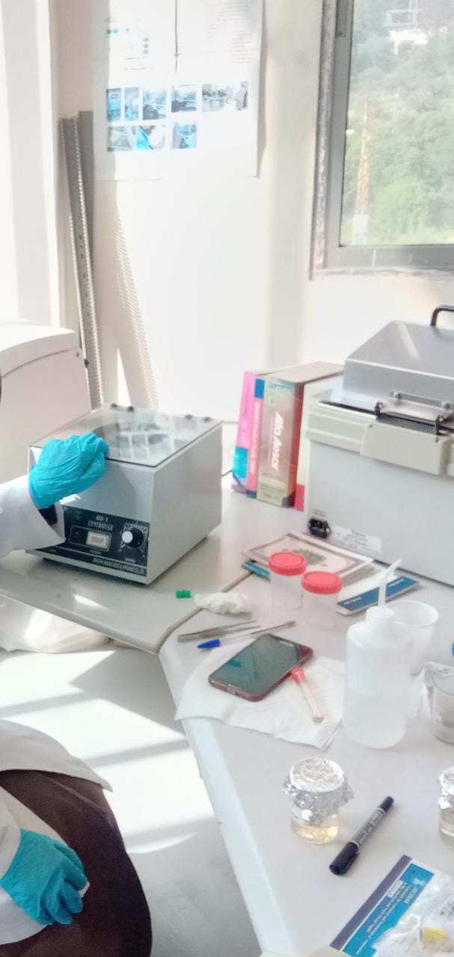

1. The supernatant is reserved (we got about 60 ml of supernatant for each species of penicillium)

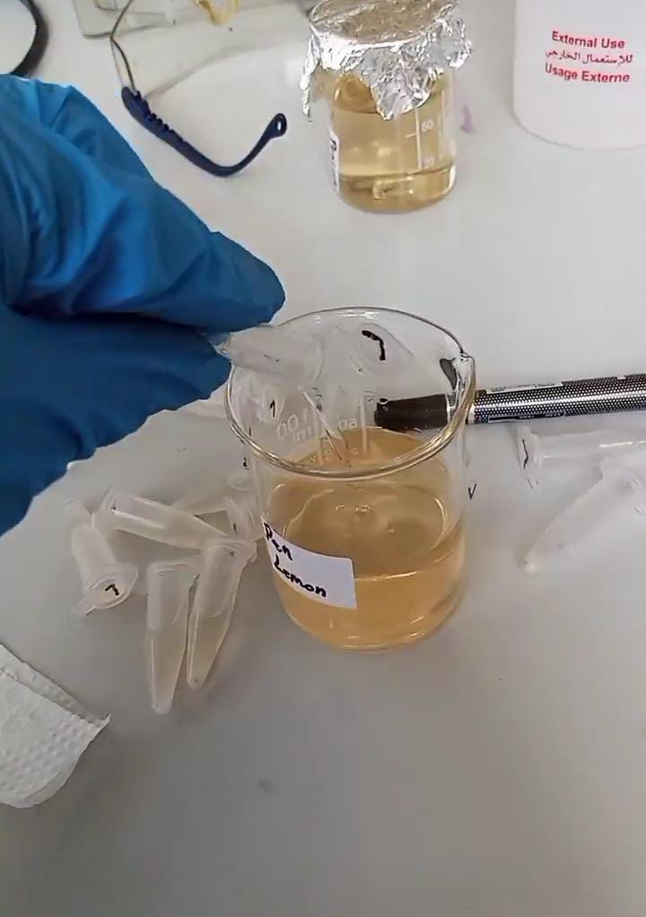

1. We add 5g of sodium bicarbonate for each supernatant to obtain the penicillium in salt form.

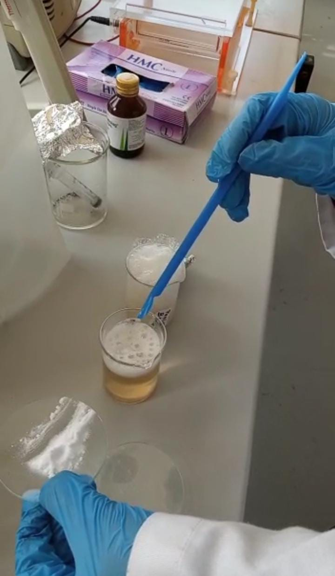

1. We left it in the fridge for a few days to precipitate the penicillium salt

# Results

## Penicillin Production

After cooling about 7 days we obtained penicillin crystals.

|  |  |
| --- | --- |
|  |  |

We poured the liquid throughly to remove it, then we kept the crystals in the fridge in order to dry them well.

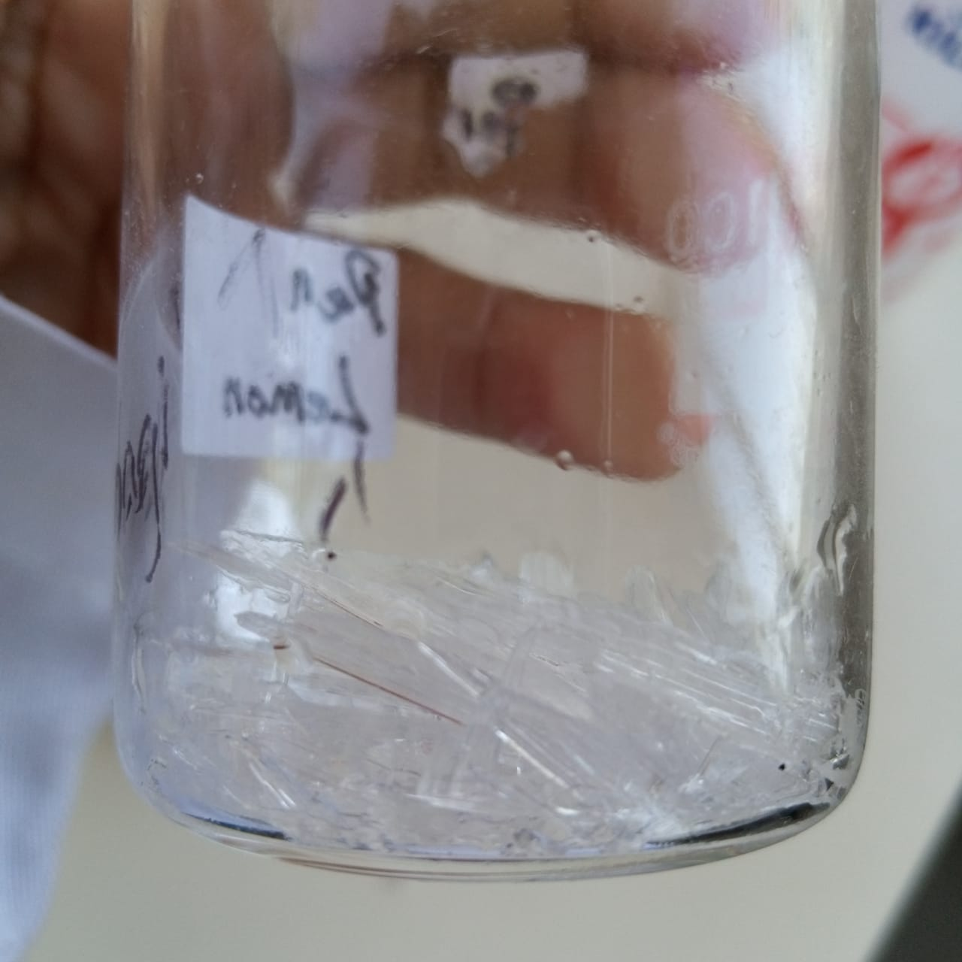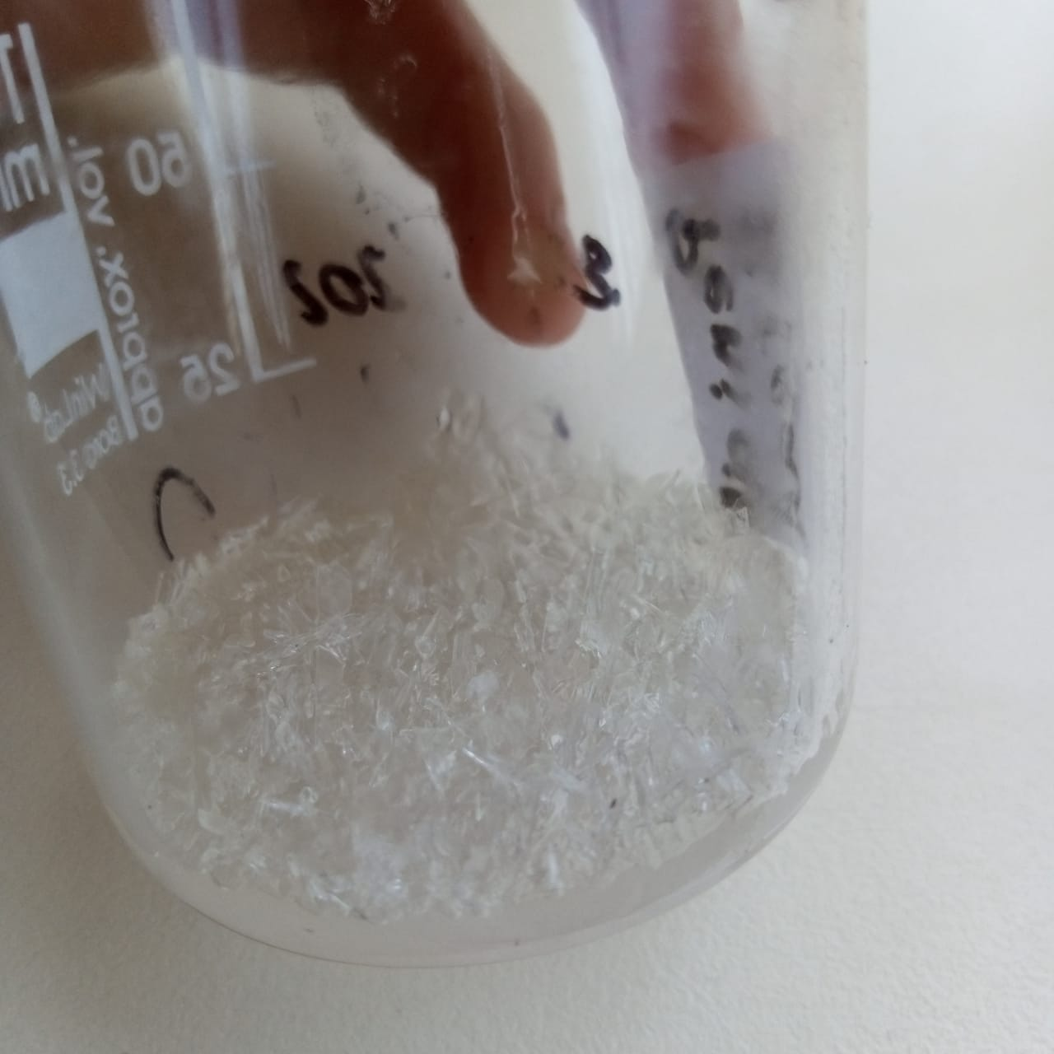

## Ampicillin Production:

…

1. From https://en.wikipedia.org/wiki/Ampicillin