AGU FACULTY of LIFE and NATURAL SCIENCES
DEPARTMENT of MOLECULAR BIOLOGY and GENETICS
SUMMER INTERNSHIP
FINAL REPORT
By
Ghenwa Younes
2114011069

Company Name: MEGBI Middle East Genetics and Biotechnology Institute
Internship Dates: 20/07/2023- 04/09/2023
Date of the Submission:
SUMMARY

During this internship, I undertook an extensive journey generally in Microbiology field and specifically in penicillin production and optimization. I have contributed in performing several techniques and procedures that takes a part in our research project such as petri dishes preparations, stocking bacteria, serial dilutions, quantifications, sensitivity test, culture and liquid media preparation. I was responsible for noting down the qualitative and quantitative results. In addition to that, I delved in performing some research works to solve certain errors and make changes in the protocol. I went through conducting numerous trials with the team members and laboratory technician in order to reach the optimum concentration for penicillin production. After each trial, we held meetings in the presence of other trainees for not only conclude a new result values but also hypothesize another proposals for a better results in the upcoming trials. Furthermore, we present the updates as a presentations in the presence of Dr. Sami Mourad, the manager, to receive his discernments and evaluations.

INTRODUCTION

Association for Economical and Technological Cooperation in the Euro-Asian Region (AECENAR) is an institute that not only encompasses scientific researches and applications but also encompasses researches in other sectors such as in physics, engineering, automotive, and environmental projects. Specifically Middle East Genetics and Biotechnology Institute (MEGBI) sector focus on various pharmaceutical researches such as vaccine production, antibiotic production, and aspirin production. Moreover, they involved in working with DNA, and tissue culture methods. They are committed to perform the needed studies and researches in order to obtain the correct protocol for the project. This laboratory aims to supports the volunteering and contribution of the trainees in their projects in order to maintain creativity and reach various proposal solutions.

PERFORMED ACTIVITIES

In the research laboratory where I did my internship in, worked on penicillin production and optimization and aspirin production at the current time. I decided to work on penicillin production because I have enough background information about penicillin from Microbiology course that I took last semester with Prof. Özkan Fidan. I was quite interested in implementing my theory knowledge into practical works. In addition to that I learned from the microbiology Lab section most of the techniques and procedures that were performed throughout the project in my internship such as serial dilutions, inoculum transformation, plating methods, and culture and liquid media preparation etc. Penicillium chrysogenum is a fungi strain that naturally grow in high humidity environments, and waste food. Moreover, in 1928, Alexander Fleming, discovered the first naturally grown penicillin from P.chrysogenum strain. For penicillin production, the strain undergo stress due to the lack of nutrients during the fermentation in the peroxisomes organelle. Therefore, it produce secondary metabolite. (Fierro et al., 2022) The report will be divided into fermentation, filtration, purification, and quantification which are the steps of penicillin production and optimization followed by their outcomes and reasons for performing the procedures.
Broth liquid medium preparation Starting the first trial with preparing the liquid broth medium for adaptation of the inoculum that was taken from the strain “Penicillium chrysogenum” the aim of this adaptation is that it will be adapted in the penicillin liquid medium for fermentation. The liquid broth medium composed of the following components:
Chemicals | Amount
Peptone | 0.5g
Tryptone | 0.1g
Glucose | 0.1g
Yeast extract | 0.1g
NaCL | 0.25
Distilledwater | 50ml
- After weighing all the components needed, it is transferred into the tube then the pH is adjusted to 7.
- The inoculum is transferred by a sterile loop to the prepared medium tube
- The tube is incubated for 4 days at room
Temperature

The table above showing the amount of grams each component is needed.
A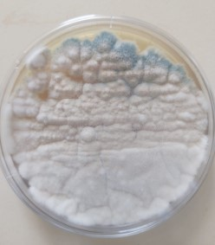 | B  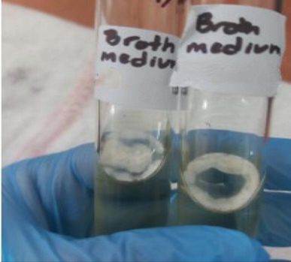
A: the stain of Pencillium chrysogenum. & B: inoculum in the broth medium

Fermentation preparation:
Constituents of Pencillin G production are the following components mixed with 100ml of distilled water.
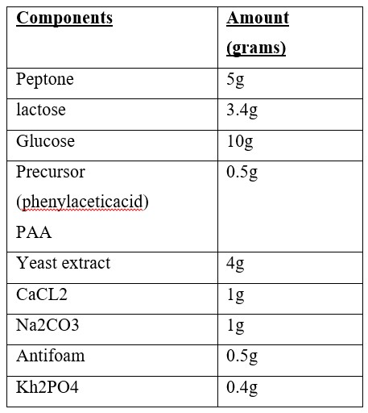
  - All the components was in Erlenmeyer flask
  - The pH was measured and adjusted to 7.
  - The medium was heated and mixed for 15 minutes
  - The medium was autoclaved for one hour and then cooled down for 30 minutes
  - The inoculum was added to the medium
  - Then, it was incubated under 28$℃$ for 10 days with shaking at 120 RPM

Filtration and purification step:
After 10 days of fermentation, the penicillin medium was filtrated by Buchner funnel to avoid any macro-organisms and precipitates. The solution in beaker is called as (filtrate). This filtration technique is new to me since I never saw or try it in AGU lab course sections. It was an advantageous procedure
  - After the filtration, the pH was adjusted to 1.5-202 by adding H2SO4 to avoid any reactions that could degrade the penicillin. (as shown in figure1A, 1B)
Note: acidic environment ionize the penicillin due to the positive charges that protect the penicillin from being recognized by the recognition sites of the enzymes that could degrade the penicillin (Aldeek et al., 2016)
  - (1V solvent/2V filtrate) of butyl acetate was added in a separatory funnel to separates the medium into organic and aqueous phases. The lower phase that is in the beaker is the aqueous phase (filtrate) and the upper phase is the organic phase that contain the penicillin (as shown in figure 1C)
  - 2% (weight/volume) of phosphate buffer was added to the organic phase in order to extract and attract the penicillin from the phase. Phosphate buffer is –ve charge while penicillin is +ve charge.
  - The pH is adjusted at 7 by adding NaOH to the organic phase (as shown in figure 1D)
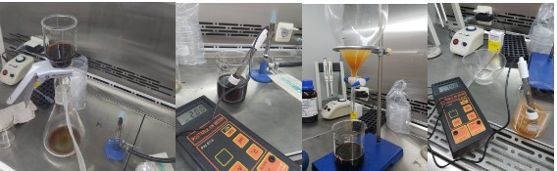
Figure 1A | Figure1B | Figure 1C | Figure 1D

  - After that, the pB was filtrated from organic phase and kept separated from the organic phase in a beaker.
  - At the meantime, the Mueller Hinton was prepared for performing sensitivity test. This procedure is familiar to me because in microbiology and general biology lab section the TAs already taught us how to prepare it. Therefore, I was responsible for preparing it.
  - 3.8 grams of Mueller Hinton were weighed by weighing balance and mixed with 150ml of distilled water in a flask. The flask was heated up until boiling then placed it in the autoclave for 1 hour.
  - Sensitivity test was conducted for (1) aqueous phase after the organic separation by butyl acetate (2) organic phase and (3)pB solution after the separation from organic phase. (as shown in figure 2A)
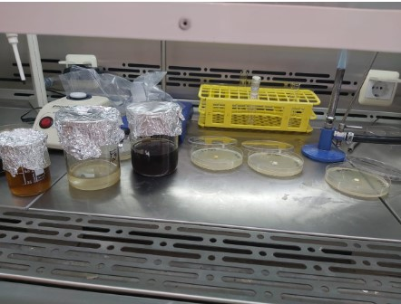
Figure 2A

  - The petri dishes were incubated for 24 hours at room temperature.
The results are as follows:
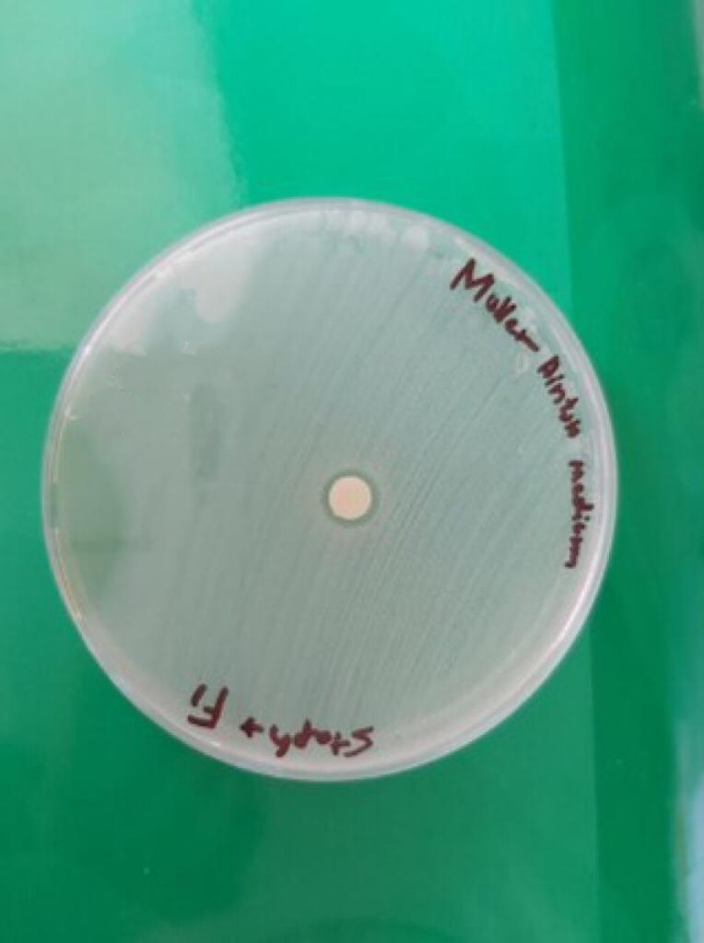 | 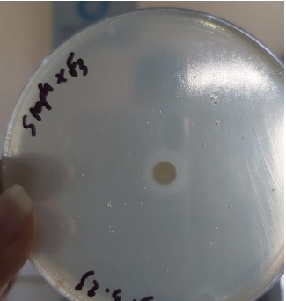
Aqueous phase inhibition zone | pB phase inhibition zone
  - The organic phase didn’t show any inhibition zone. We could propose that there is a problem during the separation step because the penicillin is not found in organic phase. However, we further continued with the quantification for both aqueous phase and pB solution.
  - (weight/volume) of NaHCO3 was added to the aqueous phase and pB phase solution for crystallization. And then was incubated for 7 days.
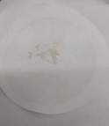 | 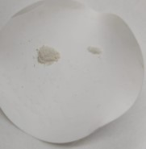
Penicillin G powder of aqueous solution | Penicillin G powder of pB solution

Quantification step
Quantification for aqueous solution
  - A control solution of known concentration was prepared from a commercial penicillin G sodium. The label says that 600mg into 1ml of phosphate buffer (1 Million UI). In our experiment, 1 grams of commercial penG solution was mixed with 1.6ml of phosphate buffer in order to prepare tube 0.
  - Serial dilution was conducted by having 10 tubes starting with tube zero (commercial) to perform 1/10 dilution factor and each tube have a different concentration: ${10}^{6}$ mol/L, ${10}^{5}$ mol/L, ${10}^{4}$mol/L, ${10}^{3}$ mol/L, ${10}^{2}$ mol/L, 30mol/L, 25 mol/L, 20 mol/L, 16 mol/L, until 10 mol/L. Note that this techniques is also familiar to me because we have learnt it in molecular biology lab section.
Conc.(UI) mg/ml | Tubes | Amount transferred from one tube to another tube
$${10}^{6}$$ | Zero | 1g of commercial penG in 1.6ml of pB
$${10}^{5}$$ | 1 | 1ml from tube zero in 9ml of NaCL
$${10}^{4}$$ | 2 | 1ml from tube 1 in 9ml of NaCL
$${10}^{3}$$ | 3 | 1ml from tube 2 in 9ml of NaCL
$${10}^{2}$$ | 4 | 1ml from tube 3 in 9ml of NaCL
30 | 5 | 3ml from tube 4 in 7ml NaCL
25 | 6 | 5ml from tube 5 in 1ml of NaCL
20 | 7 | 4ml from tube 6 in 1ml of NaCL
16 | 8 | 4ml from tube 7 in 1ml of NaCL
10 | 9 | 2.5ml from tube 8 in 1.5ml of NaCL
Table shows the values of serial dilution procedure.
  - 10 staphylococcus cultured petri dishes were prepared for disk diffusion tests.
  - After 24 hours of incubation, the result appeared. The diameters were noted down and the standard graph was drown (as shown in figure 3A)
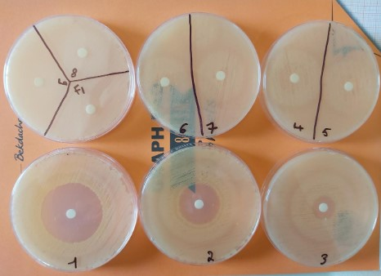

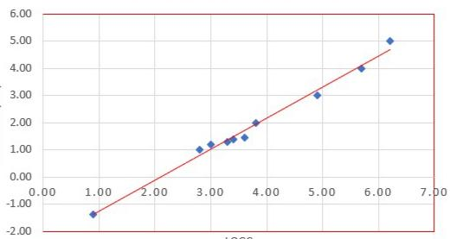
The standard graph showing the logC of aqueous phase penicillin (-1.356) as a function of diameter (0.9)
According to the graph, the diameter of our penicillin is 0.9 cm, the logC is -1.356. Therefore, the concentration is ${10}^{-1.356}$ = the concentration of our penicillin 0.04 mg/ml
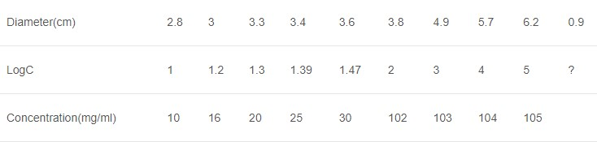
Table showing the result values in order to draw the graph (logC as a function of diameter)

Quantification for pB solution: the procedure is same as the quantification of aqueous solution.
The results are as follow:
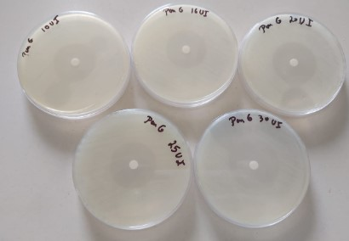
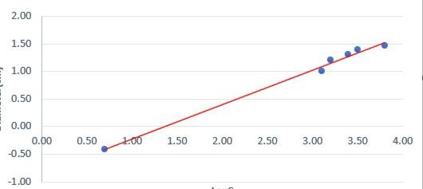
The standard graph showing the logC of aqueous phase penicillin (-0.44) as a function of diameter (0.9)
According to the graph, the diameter of our penicillin is 0.7 cm, the logC is -0.44. Therefore, the concentration is ${10}^{-0.44}$ = the concentration of our penicillin 0.39 ≈ 0.4 mg/ml.
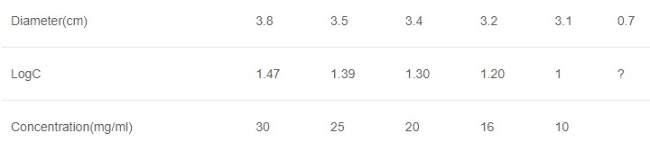
Table showing the result values in order to draw the graph (logC as a function of diameter)

2nd trial steps:
The second protocol slightly different from the previous one. In the fermentation step, the duration of the fermentation was 8 days instead of 10 days. Regarding the PAA, unlike the first trial, the amount of PAA was dissolved with water to be a solvent and poured gradually at a constant rate for 8 days. The filtration and separation steps are same. However, in this trial, we replaced the Mueller Hinton by agar medium. Therefore, the agar medium was prepared for performing sensitivity test and culturing staphylococcus. This procedure is familiar to me because in microbiology and general biology lab section the TAs already taught us how to prepare it. Therefore, I was responsible for preparing it.
  - 5.55 grams of agar was weighed in the weighing balance and mixed with 150ml of distilled water in a flask. The flask was heated up until boiling then placed it in the autoclave for 1 hour. (as shown in figure 3A, 3B, 3C)
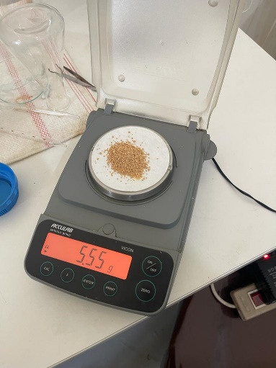 | 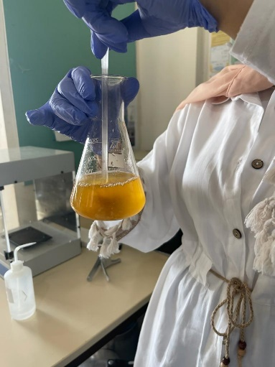 | 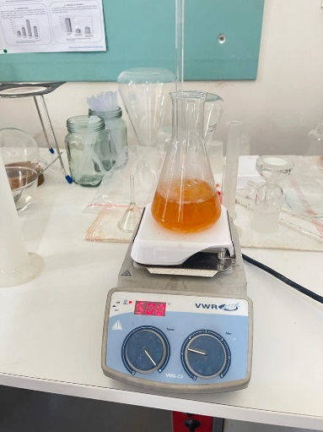
Figure 3A | Figure 3B | Figure 3C
  - The agar medium was poured into 3 petri dishes: (1) for culturing staphylococcus (2) for detecting the presence of penicillin in the aqueous phase and (3) is divided into two sides: for detecting the presence of penicillin in the organic phase and for the extracted phosphate buffer. This test is known as qualitative test. (as shown in figure 4A)
  - The staphylococcus cultured petri dish was incubated for 24 hours a room temperature
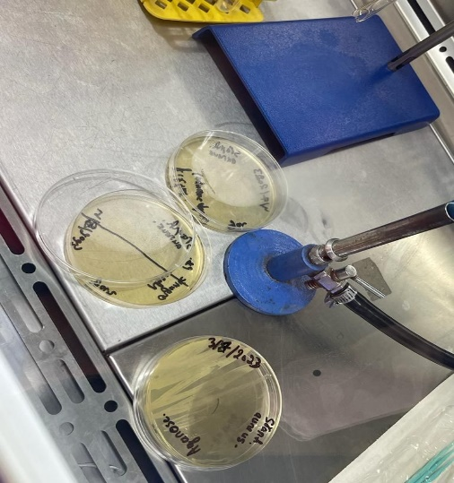
Figure 4A

  - Regarding the preparation of staphylococcus, the colony was taken from its petri dish and mixed in the Nacl. Then, its turbidity was compared with a control known as McFarland standard. This procedure is also familiar to me because I have background information about this technique from microbiology course. From the prepared tube, staphylococcus was transferred by swapping with a sterile swap to 2 petri dishes for culturing ( as shown in figure 5A, 5B, 5C)
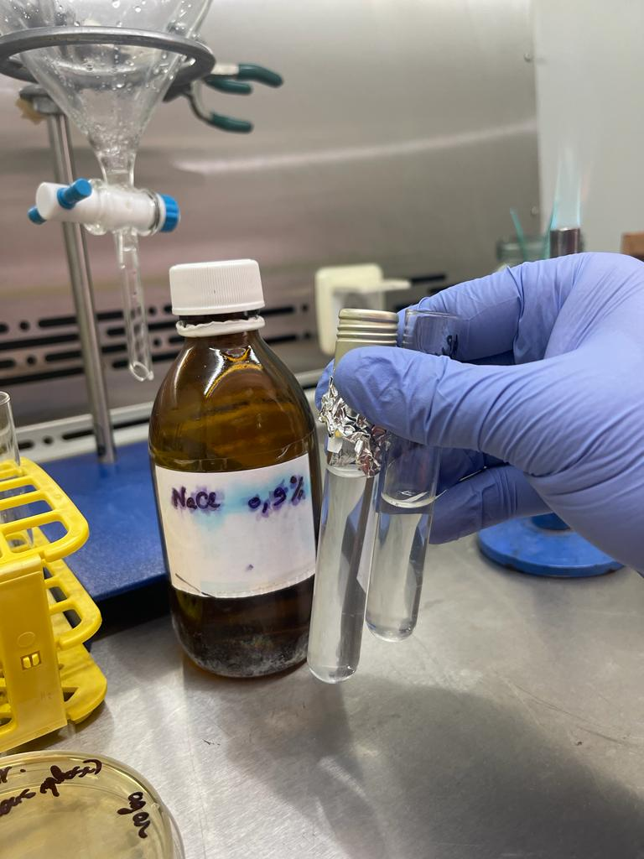 | 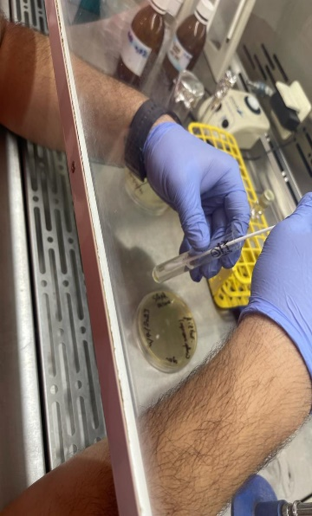 | 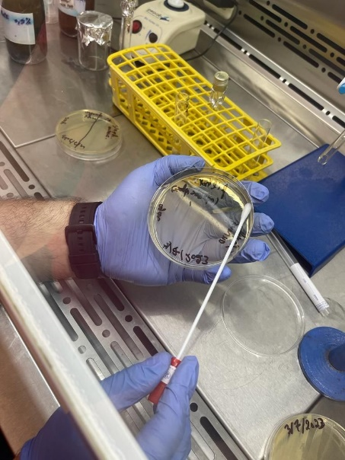
Figure 5A | Figure 5B | Figure 5C

  - 20µl of filtrate (aqueous phase), organic phase, and phosphate buffer (pB) were added to its disks in the petri dishes. (as shown in figure 6A) the petri dishes were incubated under 37$℃$ for 24 hours
  - The disk diffusion test was repeated only for organic and aqueous phases in one petri dish for accuracy according to the lab laboratory technician suggestions by using another type of disks (as shown in figure 6B) the petri dish was also incubated under 37$℃$ for 24 hours.
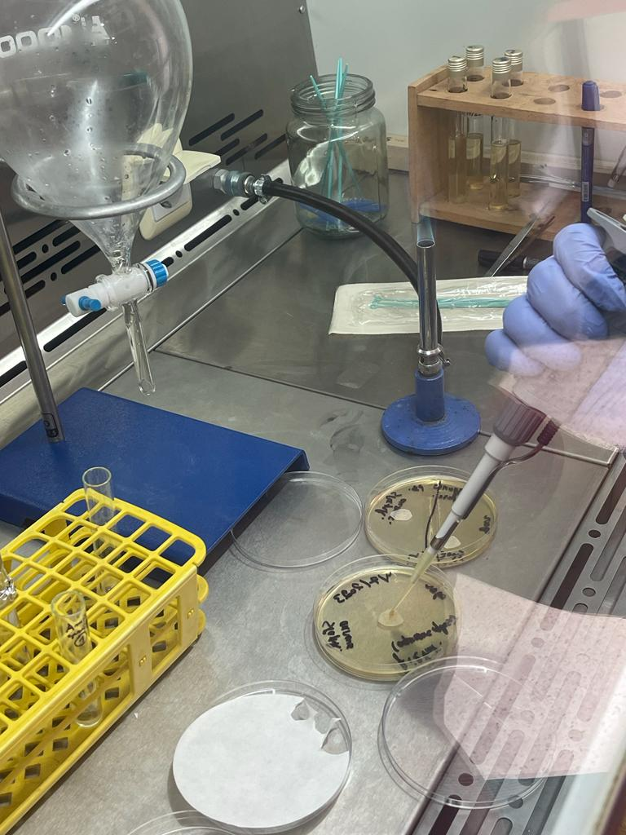 | 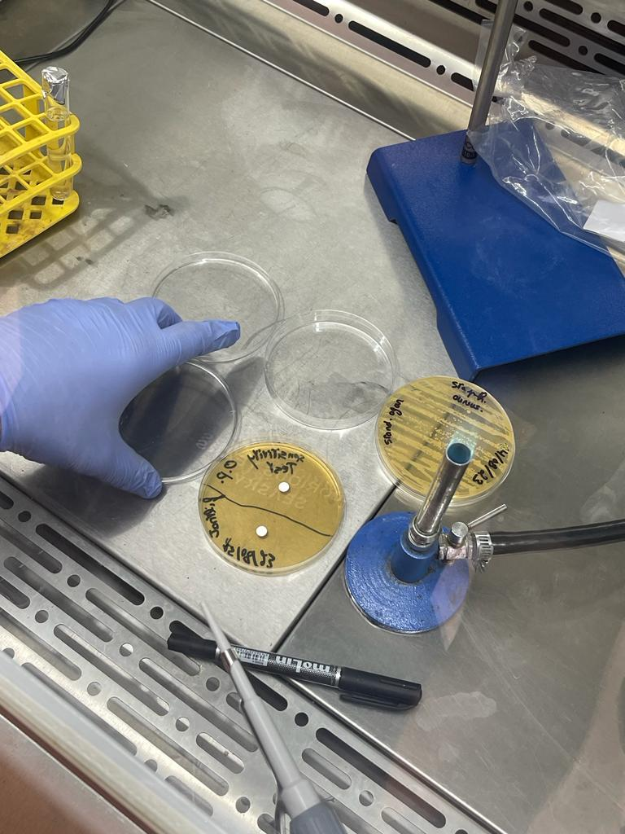
Figure 6A | Figure 6B
  - The 2nd trial’s result are positive. The first attempt’s result weren’t so clear and accurate. However, we could see that there is no inhibition zone for filtrate (aqueous phase) and phosphate buffer. On the other hand, there is inappropriate inhibition zone for organic phase-highlighted by red circle for clearance. (as shown in figure 7A, 7B) This made us sure that there is no penicillin in these phases. The second attempt is very accurate and clear zones with a diameter of 1cm around the organic phase which shows that penicillin is in organic phase. (as shown in figure 7C)
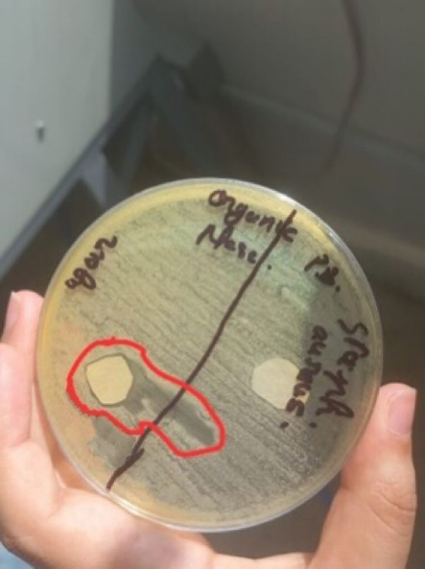 | 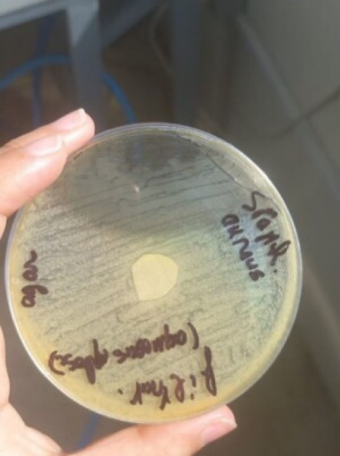
Figure 7A | Figure 7B | Figure 7C
Quantification step:
This step was quite similar to the first trial’s step. However we only performed quantification for organic phase. We only consider from concentration 30 mg/ml and so on because our aim is to compare its diameters with our penicillin diameter. Therefore, we can observe the concentration of our penicillin by drawing the standard graph
  - 6 staphylococcus cultured petri dishes were prepared for disk diffusion tests. Each petri dish is divided into two sides with different concentration. Each concentration is test twice for accuracy.
  - After 24 hours of incubation, the result appeared. The diameters were noted down and the standard graph was drown.
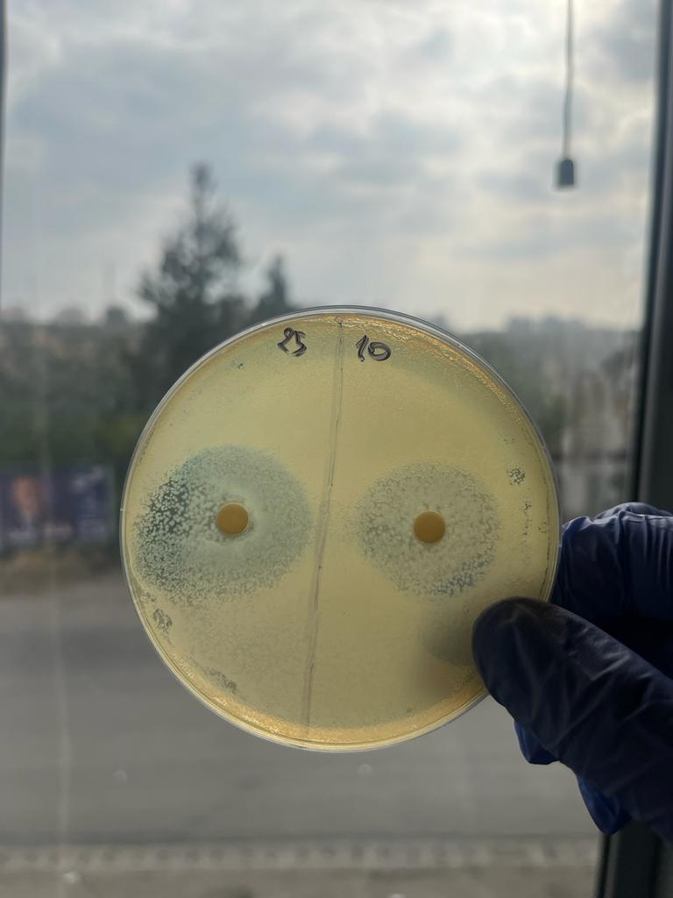 | 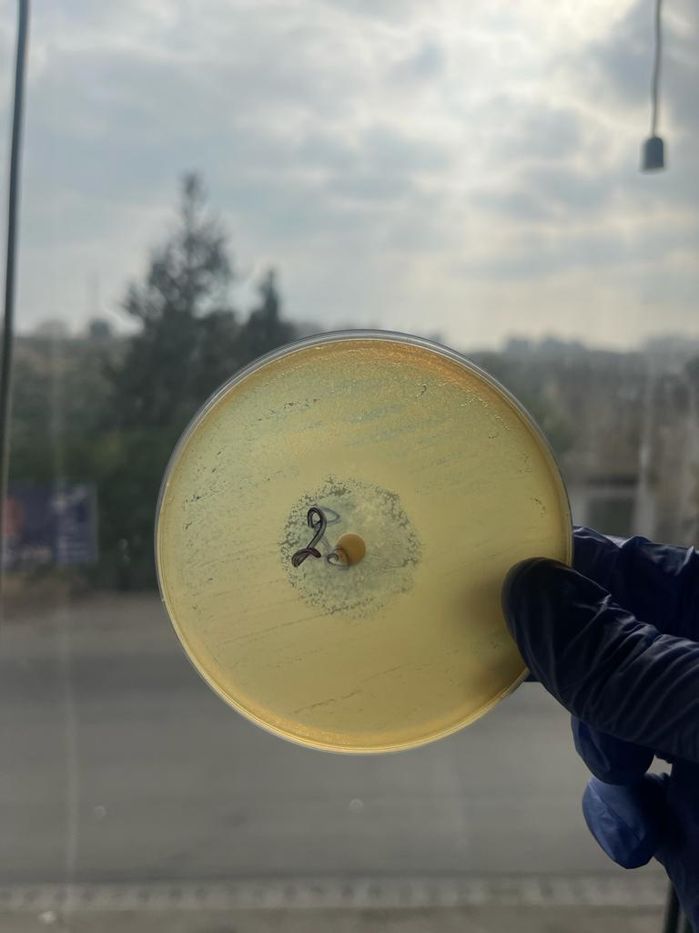 | 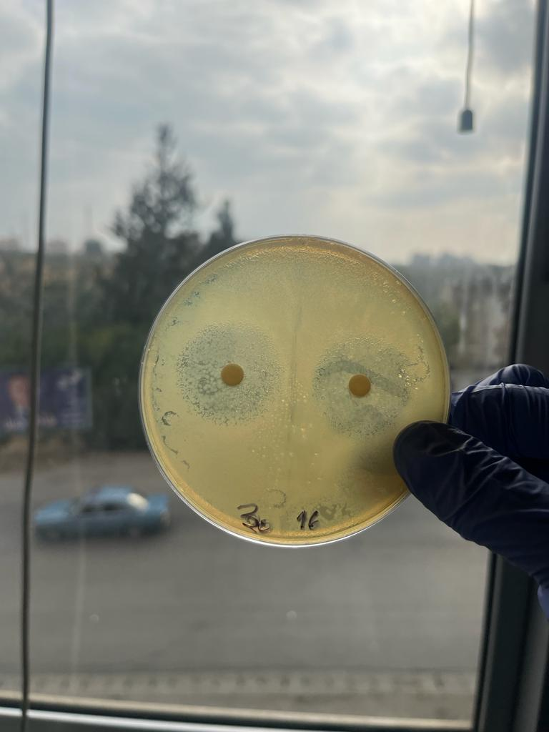
Conc. 25 & 10 mg/ml | Conc. 20 mg/ml | Conc. 30 & 16 mg/ml
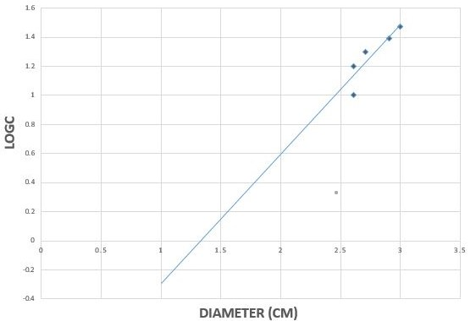
According to the graph, the diameter of our penicillin is 1 cm, the logC is -0.3. Therefore, the concentration is ${10}^{-0.3}$ = the concentration of our penicillin 0.5 mg/ml.
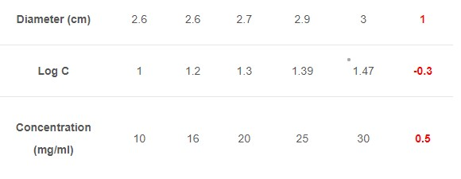
Table showing the result values in order to draw the graph (logC as a function of diameter)

3rd trial steps:
The third trial’s protocol is same as the previous trials but there is difference in the temperature and the Precursor (phenyl acetic acid) PAA. Unlike the previous trials, the temperature is controlled. As a matter of fact, the temperature of the first two days of fermentation was set at 30$℃$ then it was set at 25$℃$ for the rest of the fermentation. Moreover, unlike the first trial, the PAA was dissolved with 70% ethanol to make it soluble. In this trial, we didn’t separated the PAA from organic phase because we already observed that there is no penicillin in PAA based on the result of the first trial. In this trial, the cultured staphylococcus petri dishes that were used for sensitivity test for (1) filtrate –aqueous phase(as shown in figure 7A) and (2)pB + organic phases (as shown in figure 7B) weren’t properly grown as it shows precipitates and droplets of staphylococcus but not strains. Moreover, the filtrate shows a small inhibition zone around the disk while the organic phase do not show any inhibition zone.
The results of this trial is as follows:
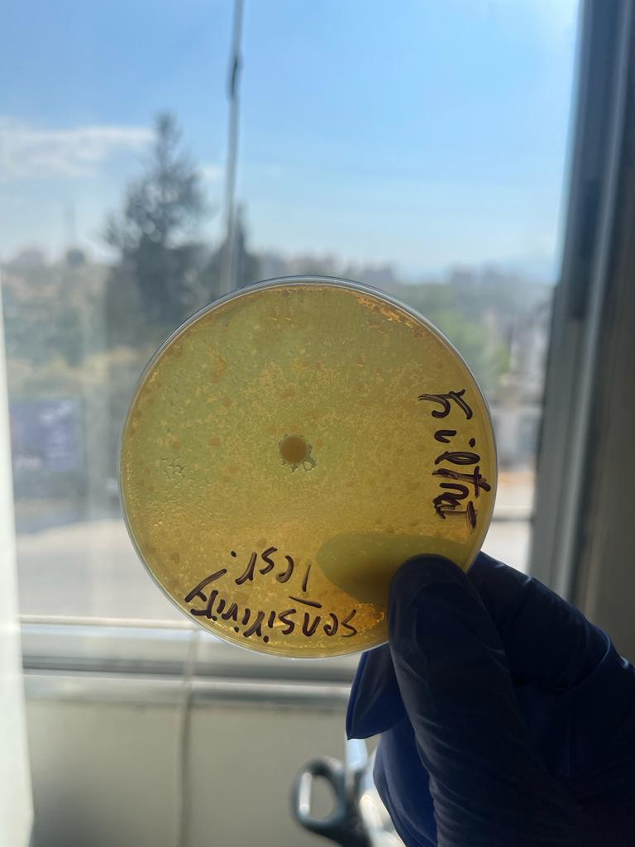 | 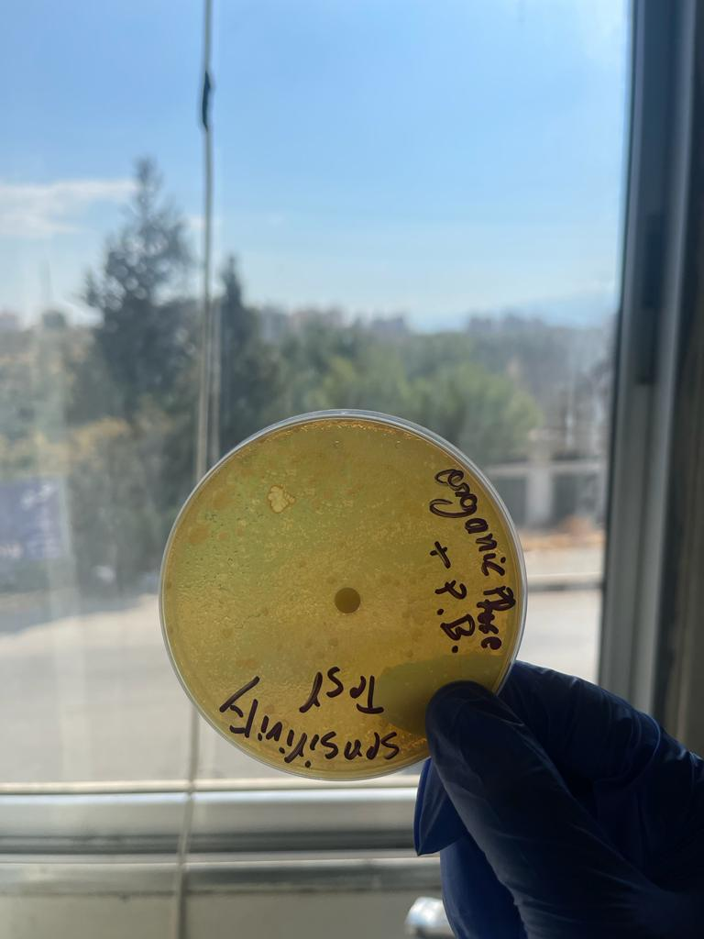
Figure 8A | Figure 8B

Based on this result, we proposed that there was a problem in the separation since it shows that there is penicillin in the aqueous phase but not organic phase which is unusual. Therefore, we decided on two hypothesis. First, trying to separate the PAA from the organic phase by Buchner funnel. Second, trying to repeat the separation process for the aqueous phase solution by the separatory funnel. Therefore, the separation of PAA from the organic phase completely failed because nothing went down the beaker. On the other hand, we also separated the aqueous phase by separatory funnel by adding 60ml of N-butyl acetate before the separation. (as shown in figure 9A) then we separated by separatory funnel. After the separation, we will have again organic phase and aqueous phase (filtrate) (as shown in figure 9B). After that, we performed the sensitivity test for both phases on two separated staphylococcus petri dishes (as shown in figure 9C)
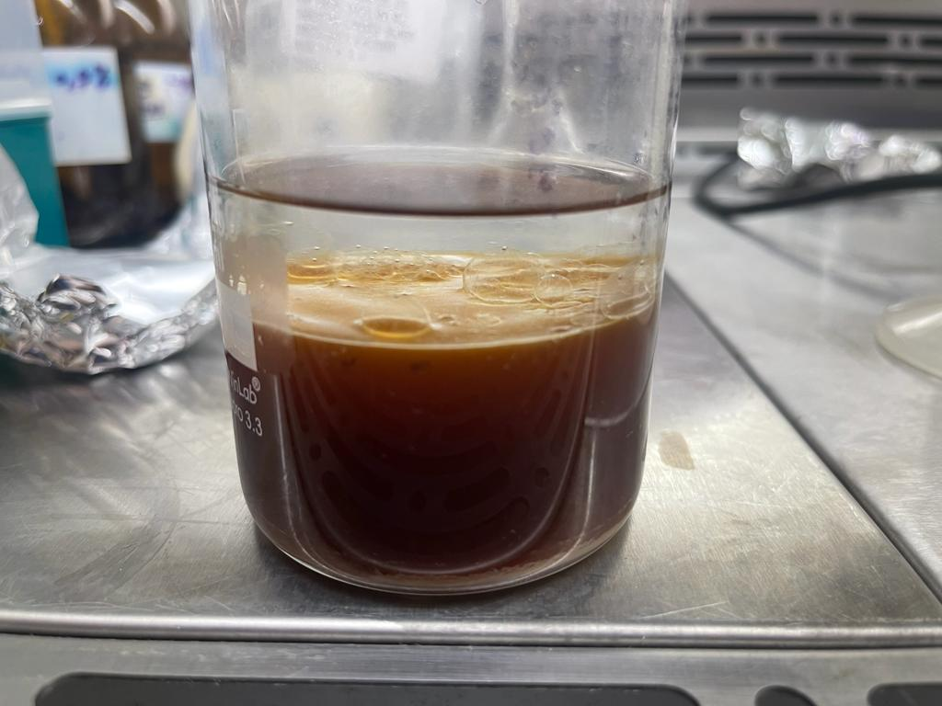 | 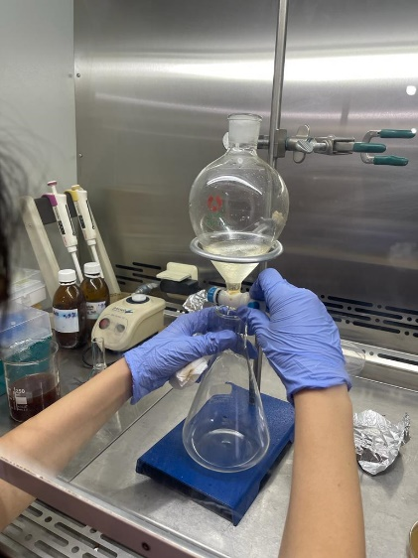 | 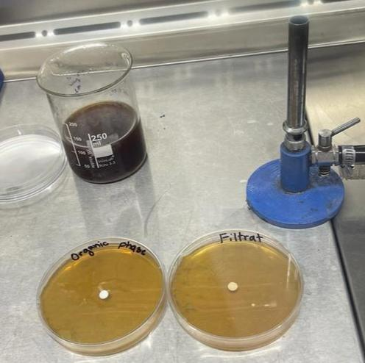
Figure 9A | Figure 9B | Figure 9C
After the incubation, the result were noted down. There was no inhibition zone neither around the organic phase disk nor around the aqueous phase.
After this negative result, we had meeting with the members and the manager and did some research works. We observed that glucose repress the biosynthesis of penicillin G production. According to my background information that I acknowledge in gene regulation course, the presence of glucose repress the transcription of the gene cluster of E.coli because it behave as inducible silencer which binds to the operator, controls the activation of transcription, and prevent the binding of the RNA polymerase to the promoter. Therefore, it prevent the gene transcription and operon is off. (Kolb et al., 1993). This process also appear to happen in Penicillium chrysogenum. (Fierro et al., 2022) The gene transcription of P.chrysogenum enhance the biosynthesis of penicillin G production. Based on the previous information and in order to stimulate the gene regulation, glucose should be replaced by lactose because the presence of lactose activate the allolactose (inducer) binding to the silencer protein and cause the binding of RNA polymerase to the promoter. Therefore, it enhance the gene transcription and operon is on. Furthermore, the gene cluster is transcript and the enzymes needed for the biosynthesis are translated. (Ariyo et al., 1997) In addition, these enzyme leads to the production of lactose which is degraded to glucose and galactose. As a result, during the fermentation the glucose that is produced makes stress on the penicillium chrysogenum to produce penicillin G.
After further researches, based on this article, (Fierro et al., 2022)we found out that the fermentation should be held in aerobic environment because the biosynthesis of penicillin G held in peroxisome organelle. The processes that occurs in peroxisome require oxygen.
CONCLUSIONS
I delved in not only practical works but also research works by preparing documentations for the institute website. I had contributed in sharing my hypothesis for proposal solutions and in discussing editing the protocol for the project. This enhance the analytical and critical thinking of me. In addition, the institute had gave me a complete responsibility in performing some techniques without the help of the technician which gave me the confidence and ethical awareness. Being the one who finds out the reasons for negative result such as finding out the glucose is the reason for repressing the biosynthesis of penicillin G production gave me the chance for taking initiative and showing enthusiasm for learning.

REFERENCES

- Fierro, F., Vaca, I., Castillo, N. I., García-Rico, R. O., & Chávez, R. (2022). Penicillium chrysogenum, a vintage model with a cutting-edge profile in biotechnology. Microorganisms, 10(3), 573.‏
- Aldeek, F., Canzani, D., Standland, M., Crosswhite, M. R., Hammack, W., Gerard, G., & Cook, J. M. (2016). Identification of penicillin G metabolites under various environmental conditions using UHPLC-MS/MS. Journal of agricultural and food chemistry, 64(31), 6100-6107.‏
- Kolb, A., Busby, S., Buc, H., Garges, S., & Adhya, S. (1993). Transcriptional regulation by cAMP and its receptor protein. Annual review of biochemistry, 62(1), 749-797.‏
- Ariyo, B. T., Bucke, C., & Keshaverz, T. (1997). Alginate oligosaccharides as enhancers of penicillin production in cultures of Penicillium chrysogenum. Biotechnology and bioengineering, 53(1), 17-20.‏

APPENDIX
