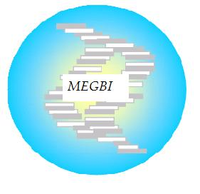
MEGBI - Middle East Genetics and Biotechnology Institute
مركز أبحاث للجينات والتقنية البيولوجية
http://aecenar.com/index.php/institutes/megbi

MEGBI-APP (Antibiotitic Pilot Plant) Report 2022
Penicillin Pilot Plant Production, Ampicillin Production & Quantification of Penicillin and Ampicillin

Author:
Hind Abd El Hamid

Last Update: 28.07.2022 12:07

Table of Contents

I- Overview 1
1- Whole study of Pilot plant penicillin production: 1
i. Penicillin Production (totally about 29 days) 1
ii. List of materials we need for this trial: 4
2- Bacterial strains those will be used in our trials and their Characteristics: 5
3- Testing the activity of the presented Ampicillin as an active antibiotic: 5
4- How the standard antibiotic solution can be produced(6): 6
5- Bioreactor and penicillin production pilot plant: 7
i. Introduction: 7
II- Materials and Methods: 13
1- Experiment 1: Ethyl acetate preparation: 13
2- Experiment 2: Penicillin production 14
III- Results: 16
1- Experiment 1: Ethyl acetate preparation: 16
IV- References: 17

I- Overview

Whole study of Pilot plant penicillin production:

Penicillin Production (totally about 29 days)

In the first, we put a half of bread in a fermentation conditions until will be able to see many fermented regions.
All used lab glassware are sterilized by adding some ml of water, covering with metallic paper and bowling until the water are totally evaporates (Or in the oven)
Microbial essays (culture and inoculation) are performed in a sterile area near a flame

Preparation of agarose gel(1days)
- We try to melt six tryptone tubes by using a heated water (bain marie)
- We weigh 3g of glucose powder
- In an Erlenmeyer flask we mix the melted tryptone, the glucose and 60 ml of distilled water
- We keep heat until we get a homogeneous mixture
- We fill the mixture in six petri dishes
- We heat them in a pressure cooker after boiling for 15 min
- We let them cool down and we wait about 30 min until the gel are totally solidified
- We put them in the fridge until the time of microbial cultivation

Microbial culture (4days)
- We cultivate the six petri dishes with the strains of penicillium
- We incubated them at room temperature for 7 days

Preparation of liquid medium(7-10days)
- We weigh 400g of glucose powder, 400 g of lactose, 200g of peptone, 20g of MgCl₂, 20g of KCl, and 100g of KH₂PO₄ than we add them in the first container of the bioreactor
- We add 20 L of distilled water
- We heat them with mixing for 15min
- We let them cool down
- We inoculate them by the petri dishes already prepared (we need about 200 colony)
- We incubate them at room temperature for 7days with shaking

Filtration and the adding of ethyl acetate(7 days)
- After 7 days of incubation in liquid medium we filter the inoculated liquid medium by using of filter paper to the second container of the bioreactor containing 86g of charcoal and 100g of KH₂PO₄ and we leave them for 20 min
- We decant the liquid from the charcoal to the third container than we add ethyl acetate (proportion 50/50)
- (we may obtain about 12 L of bread penicillim filtrate so we need about 12 L of ethyl acetate)
- We incubate them at 4ºC some days (about 7 days).

Purification(7 days)
- Here the penicillin was dissolved in ethyl acetate
- The centrifugation method was applied to eliminate the pellet containing cells debris and all other contaminant (4000x for 15 min)
- The supernatant is moved to a forth other container (We may obtain about 12L of supernatant)
- We add about 1000g of sodium bicarbonate for the supernatant to obtain the penicillium in salt form.
- We cool them at 4ºC for about 7 days
- Then we remove the liquid and we dry the crystal

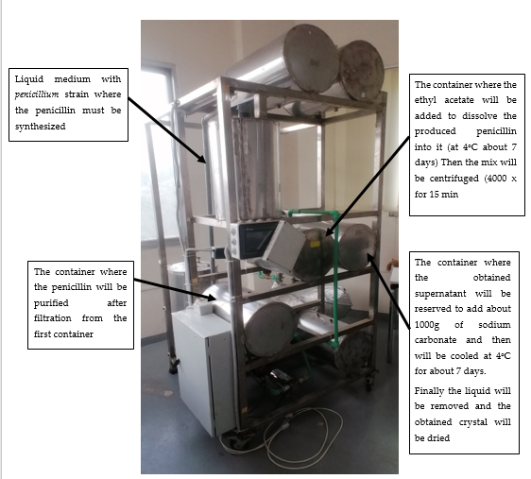
Figure 1: MEGBI- Bioreactor

List of materials we need for this trial:

- 6 tubes of tryptone
- 40 g + 3 g glucose powder
- 20 L + 60 ml distilled water
- 400 g lactose
- 200g peptone
- 20 g MgCl₂
- 20 g KCL
- 100g + 100g KH₂PO₄
- 12 L ethyl acetate
- 86g Charcoal
- 1000g sodium bicarbonate

2- Bacterial strains those will be used in our trials and their Characteristics:

- Staph. Aureus:
S. aureus can grow at a temperature range between 15° to 45°C and at NaCl concentrations up to 15%. However, extended exposures above 42°C or below 10°C are not recommended(1).

- Streptococcus pyogene:
S. pyogenes is a facultative anaerobe and is grown at 37°C in either ambient air or in 5–10% CO₂(2)
This bacterium can be cultivated on standard I- nutrient agar (3).

- Esherichia coli:
Escherichia coli (E. coli) is a stick asporulated Gram negative bacteria. It is an aerobic or facultative anaerobic species. It is grown at a temperature range between 35ºC and 37 °C, but it can support until 44,5 °C. For this reason it is called thermo-tolerant coliform (4). The naturally occurring (wild-type) strain of E. coli doesn't require any growth factors. If given the appropriate elements and an energy source, E. coli can synthesize all 20 amino acids, all vitamins, all nucleotides, and all fatty acids that it uses during growth and metabolism(5).

3- Testing the activity of the presented Ampicillin as an active antibiotic:

In light of testing the activity of our presented ampicillin, first we add 0.015g of ampicillin in 100 ml NaCl 0.9%. Then we prepare two petri dish filled with tryptone yeast extract agar, the first to cultivate E.coli without Ampicillin and the second to cultivate E.coli with Ampicillin(about 300µlof ampicillin), Then We incubate them for 24 Hours at 37ºC. Then we have getting these results showing below:
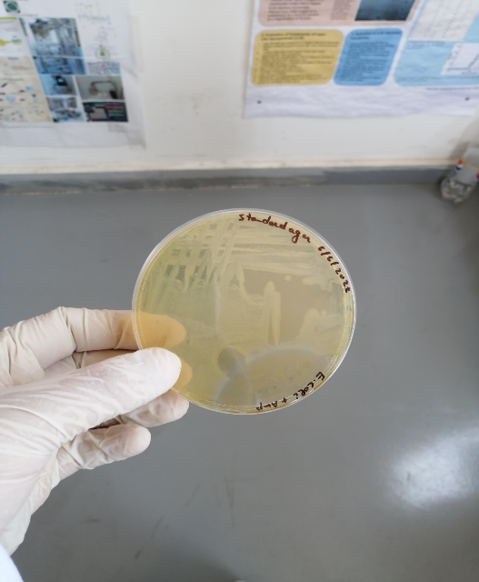
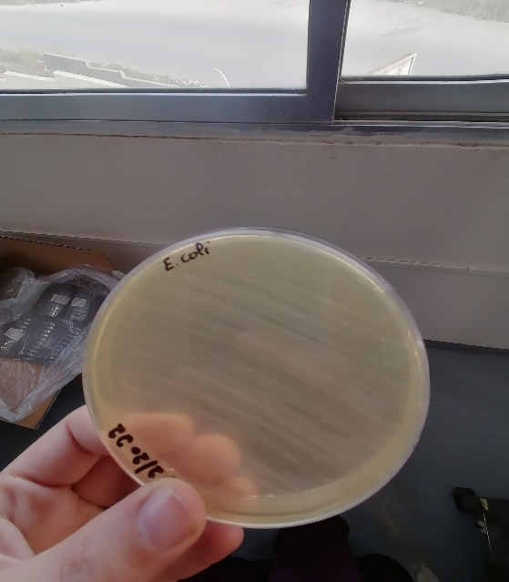
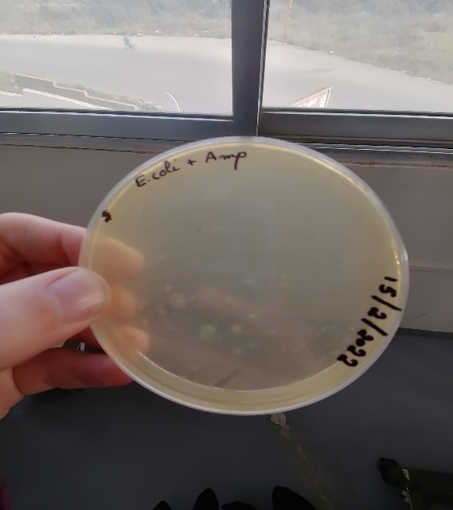

Interpretation: The used ampicillin doesn’t inhibit E.coli to grow up on the media culture . These results show that this ampicillin can‘t be used to quantify our pretended produced ampicillin as a reference antibiotic.

4- How the standard antibiotic solution can be produced(6):
Ampicillin:
- diluted in distilled water
- Standard stock solution(0.1mg/ml)
- Storage with refrigeration (1 week)
- Final concentration to drawing the standard curve (0.64 , 0.80 , 1 , 1.25 , 1.56) (µg/ml)( will be prepared on the same day of the essay)
Penicillin G:
- Diluted in NaCl 0.9%
- Standard stock solution (1000 units/ml)
- Storage with refrigeration (4 days)
- Final concentration to drawing the standard curve (0.64 , 0.80 , 1 , 1.25 , 1.56) (µg/ml)( will be prepared on the same day of the essay)

Penicillin is one of the few antibiotics that is still measured in terms of units rather than weight in milligrams or micrograms. One unit of penicillin represents the specific activity in 0.6 mcg of sodium penicillin. Thus 1 mg of penicillin sodium represents 1667 units of penicillin. In some references, an approximate conversion of 1000 units per mg is used(7).

5- Bioreactor and penicillin production pilot plant:

Introduction:

Penicillin was discovered by Alexander Fleming. Different penicillins are produced by different strains of Penicillium.
Sodium penicillin G (MW = 356.4 KDa, Activity: 1,670 U/mg) is administered parenterally, as it is degraded in acid conditions. Penicillin is active against Gram positive bacteria by inhibition of cell wall synthesis.
Different species of the genus Penicillium produce different forms of penicillin. The strain used by Fleming was P. notatum. Later on, different strains were used, such as P. chrysogenum, which is the most widely used strain in industry.
The original medium contained the following compounds: lactose, 3–4%; corn steep liquor, 4% (as a nitrogen source); CaCO3, 1%; KH2PO4, 0.4%; antifoam, 0.25%. Improved media resulting in higher penicillin yields have been developed. A typical composition of such media is: glucose or molasses, 10%; corn steep liquor solids, 4–5%; phenylacetic acid (continuous feed), 0.5–0.8% total; vegetable oil-antifoam, 0.5% total. Penicillin G requires about 0.47g sodium phenylacetate per gram of produced penicillin.
The production fermenters need a mechanical agitation between (100-300 rpm) and the temperature is controlled around 25-28ºC (optimum26ºC)(8).

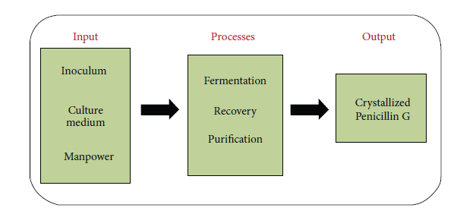
Figure 2:Schematic representation of producing crystallized Penicillin G(9).

The original process for the recovery of penicillin from fermentation broth was based on adsorption on activated carbon. After washing with water, the activated carbon was eluted with 80% acetone. The penicillin was concentrated by evaporation under vacuum at 20 to 30°C. The remaining aqueous solution was cooled to 2°C, acidified to pH = 2–3, and the penicillin extracted with amyl acetate. Penicillin was crystallized from amyl acetate with excess mineral salts at pH of 7 under vacuum. This process is uneconomical because of the high cost of activated carbon.
The current recovery process includes filtration, extraction, adsorption, crystallization,
and drying(8).

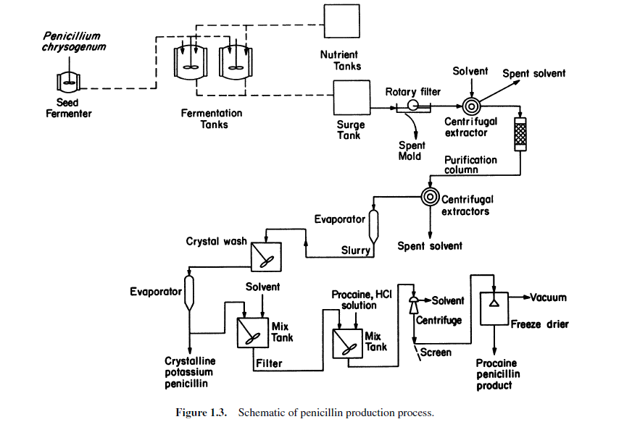
Figure 3: Schematic of penicillin production process(8).
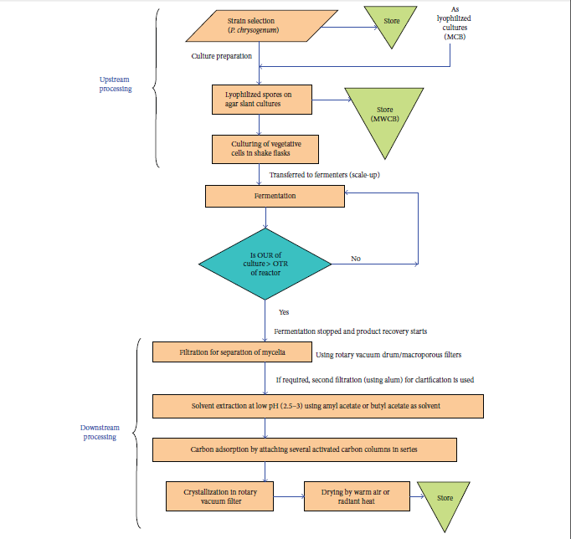
Figure 4:Schematic representation for large-scale production of Penicillin G (reproduced and redrawn from elsewhere). Steps are self-explanatory. For a detailed account, see the source. “OUR”: oxygen uptake rate, “OTR”: oxygen transfer rate, “MCB”: master cell bank, and “MWCB”: manufacturer’s working cell bank(9).
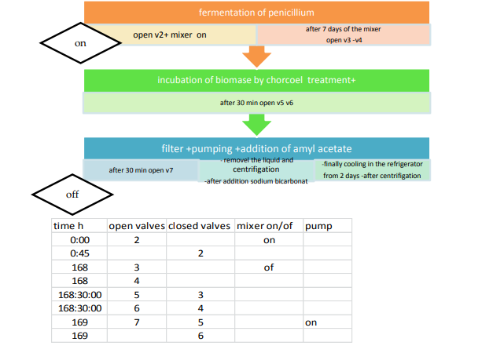
Figure 5:Program (Flow Diagram) for Automatic Synthesis of penicillin in machine(10)

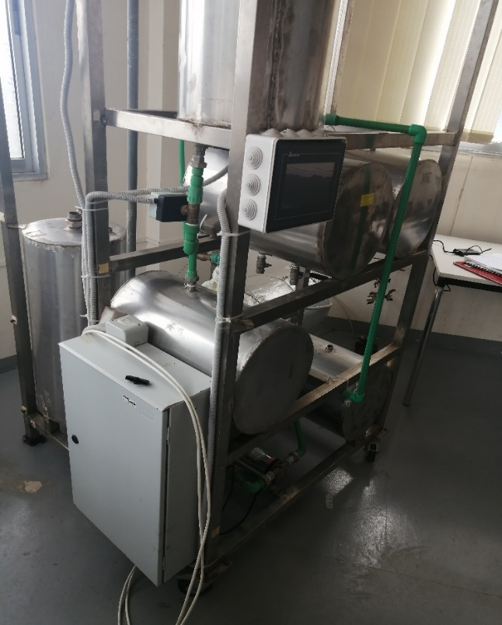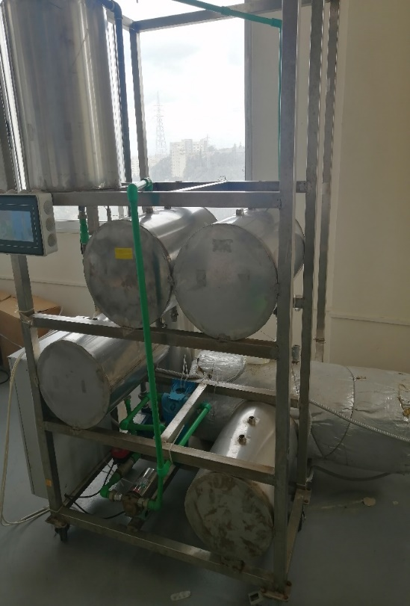

Sodium bicarbonate
The penicillin-rich filtrate is cooled to 2–4ºC to avoid chemical or enzymatic
degradation of the penicillin
Production Fermenter

Charcoal

Ethyl acetate
Nutrient tank
Pump
Pump
Filter
The current Bioreactor
As it should be Bioreactor
Production Fermenter
(25–28°C (26°optimum))

Ethyl acetate (2ºC)

Nutrient tank
Pump
Pump
Filter
Disk centrifuge (or charcoal treatment)
Basket Centrifuge- Extremely using in the removal of solids in this case Penicillin salt
To avoid degradation of penicillin during solvent extraction at low pH, temperature is kept around 2–4°C and filtration time is kept very short (1–2 min).
The crystals may be washed and pre-dried with anhydrous butyl alcohol to remove some impurities. Large horizontal belt filters are used for collection and drying of the crystals. Usually warm air or radiant heat is used for drying.
ألمشاكل التي من المتوقع أن تصادفنا:

-The produced penicillin is not a penicillin G because of the absent of The precursor: sodium phenyl acetate
-The obtained penicillin is with a bad purity or bad stability because of the used solvent (butyl acetate is better of ethyl acetate)
- The charcoal is not enough to purify the produced penicillin

II- Materials and Methods:

Experiment 1: Ethyl acetate preparation:

- 100 ml ethanol with 100 ml spirit of vinegar (concentrated vinegar) are added in a round flask
- Then 20 ml of concentrated H₂SO₄ is added (added slowly)
- The flask is connected to a water cooled reflux condenser
- The mixture is heated under reflux for 30 min on round flask heater
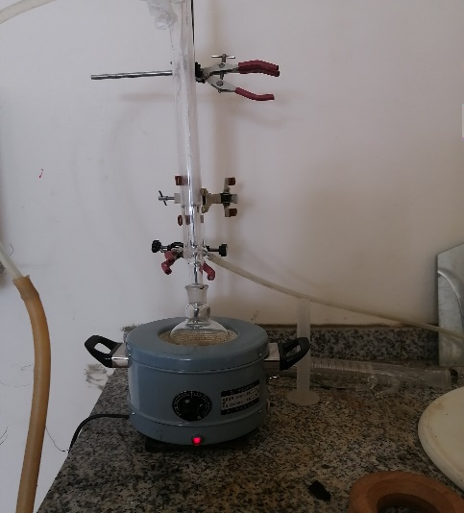

- After 30 min the flask is cooled
Now a separation is carried out to purify the produced ethyl acetate of any excess acid
- In a separating funnel containing the produced ethyl acetate we add 10g of anhydrous sodium carbonate diluted in 50 ml distilled water.
- Shacking- Degassing- waiting 2 minutes- separation (we keep the organic phase into the funnel)
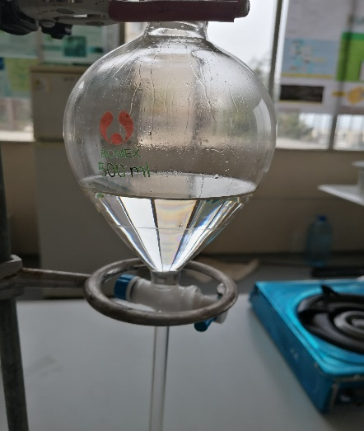
- Then we add 10g of anhydrous calcium chloride diluted in 50 ml distilled water.
- Shacking- Degassing- waiting 2 minutes- separation (we keep the organic phase into the funnel)
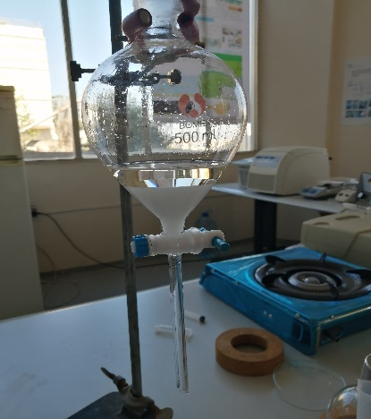

- Finally, we carry out to a final distillation of the obtained organic phase for about 10 min to obtain the purified ethyl acetate
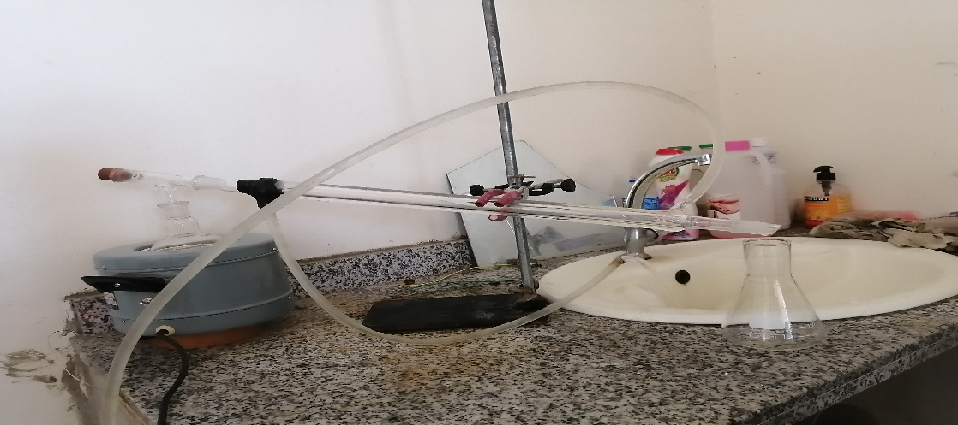

- To ensure the purity of ethyl acetate and the absence of acid we test a little of our product on sodium bicarbonate, there must be no effervescence.
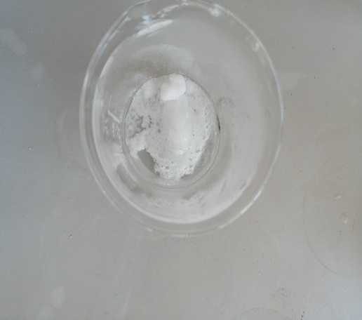

Experiment 2: Penicillin production

- The same steps already mentioned in a last report are followed(11).
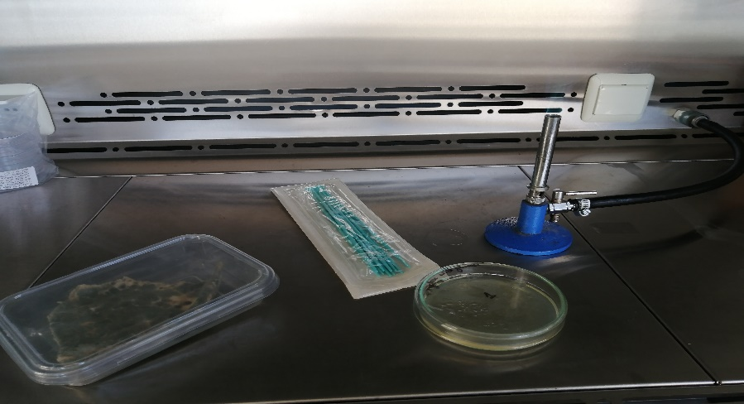

Penicillin purification:
To purify the produced penicillin we had pursued different three protocol.
The first (P1) without using charcoal (just: filtration-ethyl acetate-centrifugation- sodium bicarbonate)
The second by using charcoal and V/V from the ethyl acetate
The third by using charcoal and V[14:2] from the ethyl acetate( for each 14 ml of the filtrate use 2 ml of ethyl acetate)

Then we have tested the filtrate when we had obtain a lot of contaminant.
For this reason the protocol was retried with the autoclaving of the liquid medium before adding the penicillium colony. Then the quantification will be tried.

Experiment 3: Penicillin quantification

In this section we have realised two trial the first is with an industruel penicillin to know the efficacity of the proposed protocole then the quantification is applied to our produced penicillin.

The first trial of quantification:
Step 1:
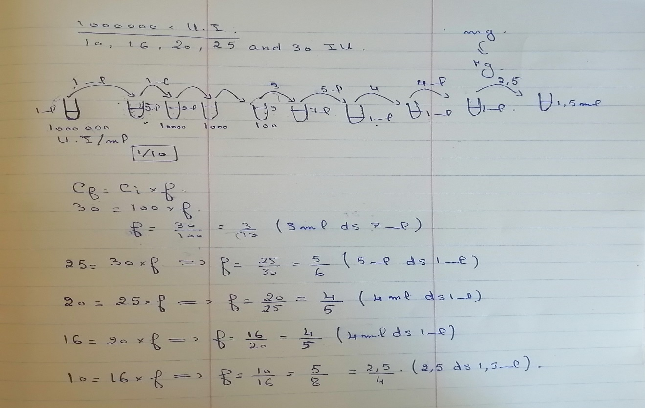
- First we dissolute the industrial penicillin (1000000 UI) in 1 ml NaCl 0.9%.
- We filtrate the obtained solution of penicillin to obtain a stock solution containing 1000000 UI/ml.
- From this stock solution we add 1 ml in 9 ml of physiological water (NaCl0.9%). Here the concentration is 100 000 UI/ml and the tube is called tube 2
- From the recent solution (tube 2) we add 1 ml in 9 ml of physiological water (NaCl0.9%). Here the concentration is 10 000 UI/ml and the tube is called tube 3.
- From the recent solution (tube 3) we add 1 ml in 9 ml of physiological water (NaCl0.9%). Here the concentration is 1 000 UI/ml and the tube is called tube 4.
- From the recent solution (tube 4) we add 1 ml in 9 ml of physiological water (NaCl0.9%). Here the concentration is 100 UI/ml and the tube is called tube 5.
- From the tube 5 we took 3 ml and we put them in 7 ml of physiological water (NaCl0.9%). Here the concentration is 30 UI/ml and the tube is called tube 6.
- From the tube 6 we took 5 ml and we put them in 1 ml of physiological water (NaCl0.9%). Here the concentration is 25 UI/ml and the tube is called tube 7.
- From the tube 7 we took 4 ml and we put them in 1 ml of physiological water (NaCl0.9%). Here the concentration is 20 UI/ml and the tube is called tube 8.
- From the tube 8 we took 4 ml and we put them in 1 ml of physiological water (NaCl0.9%). Here the concentration is 16 UI/ml and the tube is called tube 9.
- From the tube 9 we took 2.5 ml and we put them in 1.5 ml of physiological water (NaCl0.9%). Here the concentration is 16 UI/ml and the tube is called tube 9.
- Here we have obtained the standard concentration that we will need for drawing the standard curve of concentration.
!!!! The think that the physiological water will be sterile(autoclaved) is important.

Step 2 :

- First we prepared the bacterial inoculate (desired bacterial strain in sterile physiological water) to rich a bacterial concentration of 0.5 MF. In this step a standard 0.5 MF is used to know the bacterial concentration.
- Then we streaked them into a surface of Muller-Hinton agar by using a swab three times with a rotation of 60º each time to make sure that the entire medium is covered.
- Here the sterile disk was applied (4 disks per dish) and each of the obtained concentration was added to one of each disk (about 20µl)
- Finally, the plates were incubated at 37ºc for 24hours

The second trial of quantification: quantification of our produced penicillin:

The same steps of last quantification protocol are followed and the obtained penicillin is diluted in NaCl0.9%. (we have obtained about 0.1g of penicillin sodium powder ---> diluted in 5 ml NaCl 0.9%).

Experiment 4: Ampicillin Production(12).

Step for ampicillin production by using 1 pot two steps method (1P2S)

- In order to prepare penicillin G solution 40mM, we dissolve 0.143g of penicillin powder in 10ml PB (pH= 7, 0,1M).
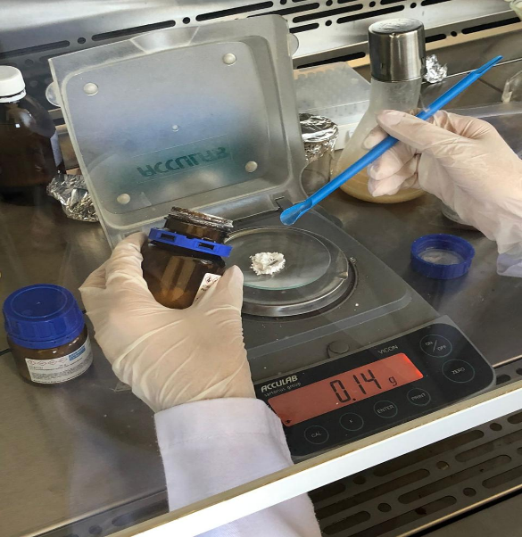

- We take 7.5ml of this solution and we place it in beaker 100ml.
- We put 0,8g iPGA ( or about 99,2 UpenG/gram of carrier).
- Stir (T˚= 22-25˚c / for 60min).

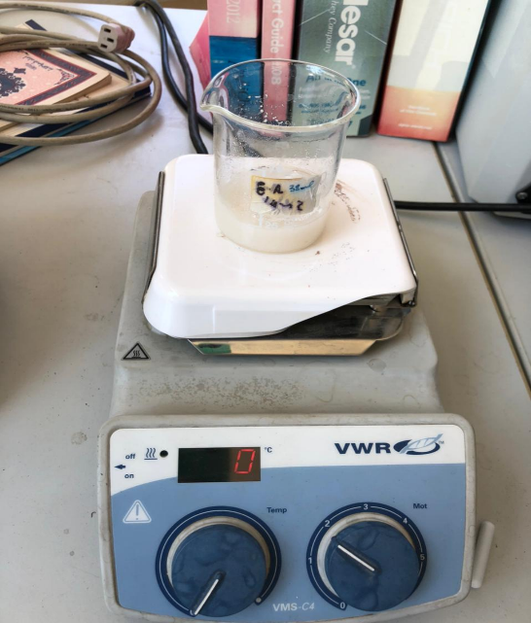

- Here we have 6-APA with PAA in the solution.
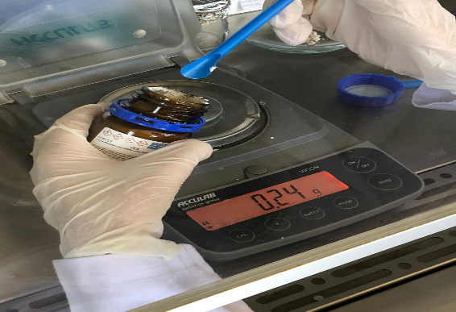
- After 60min we prepare a D-PGME solution (120mM) by dissolving 0,24g of powdered D-PGMEH in 10 ml PB (pH= 7, 0,1M).

- We take 7.5 ml of the preceded solution that will be added in the beaker where the reaction is happened.
- Then we add 0.24g of iPGA (or 30 UpenG/ gram of carrier).
- We adjust pH from 6.4 to 7 (with NaOH, 1M).
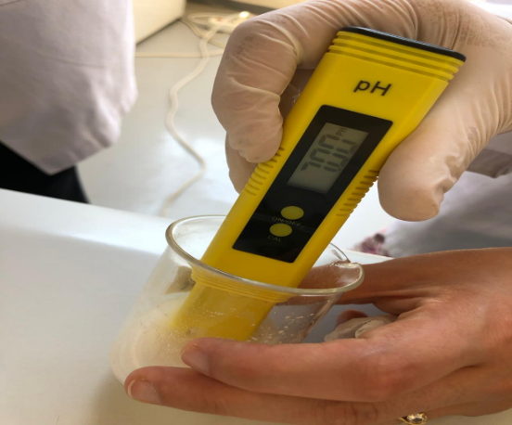

- We wait for about 1270min (22.5h) till the reaction will be achieved.
- The total time needed to produce ampicillin is 1350 min

Ampicillin purification and harvesting(13).

- After the reaction will be finished, H2SO4 is added in order to stop the enzymatic reaction.
- Then the solution is filtrated to discard the enzyme from the filtrate
- 1ml is took in Eppendorf to testing the effectiveness of our produced ampicillin against E.coli which is a sensitive strain against ampicillin
- Then a solvent is added to the residual solution (ethyl acetate)with ratio 14:2 (each 14ml of filtrate need 2ml of solvent) in order to make ampicillin soluble in ethyl acetate ----- Here we have obtained two phase
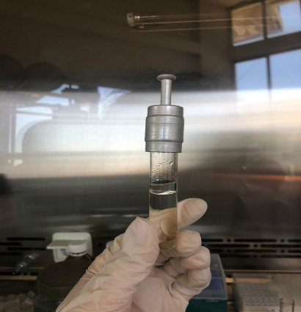
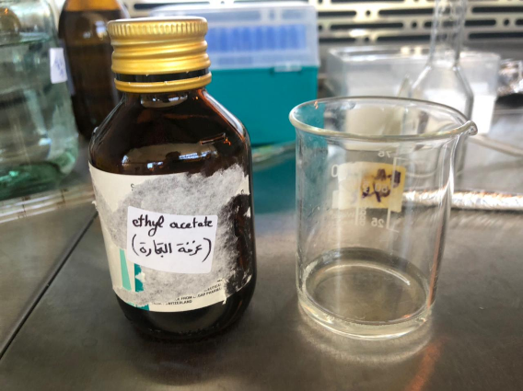

- We discard the aqueous phase and we conserve the organic phase in a tube
- Sodium bicarbonate is added with ratio 10:1.44 to the medium ( 1.44 g of sodium bicarbonate is added to 10ml) in order to obtain a solid phase.
- The last step is to filter and dry the residue to obtain ampicillin powder as ampicillin sodium. Her the produced ampicillin is ready to be tested and quantified.
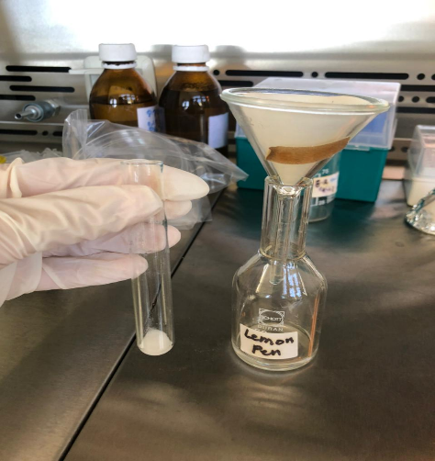

Ampicillin qualification:

- To qualify our produced ampicillin, the obtained filtrate took in a last step is adding to the surface of a standard agar plate
- After 2 or 3 minute we discard the surplus of the filtrate from the surface then a strain of E.coli sensitive to ampicillin is streaked to the surface of medium
- After 24 hours of incubation at 37ºC the result is mentioned below

Ampicillin quantification:
To quantify our produced ampicillin, first, we need a standard ampicillin solution that will be used as standard to draw a standard curve.

- Preparation of the disks:
- First we need to prepare ampicillin stock solution, for this reason we dissolve 1 g commercial ampicillin sodium in 5 ml PBS (PH=7/ 0.1M) to obtain a 200 mg/ml standard ampicillin solution
- we dilute the standard ampicillin 6 times (Concentrations: 20;15;12;10;8;5 mg/ml) to obtain different concentrations.
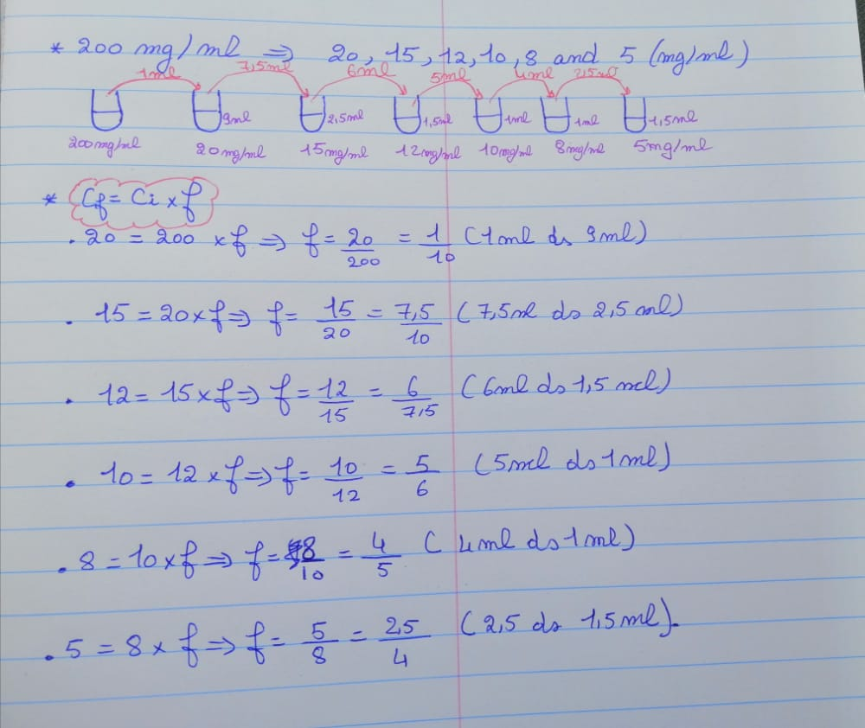

- Preparation of the inoculum:
- We took 3 to 5 colonies of the isolated colonies with a loop, and we added them in 2ml sterile saline (NaCl 0.9%)
- We Vortex the saline tube to create a smooth suspension.
- We adjust the turbidity of this suspension to a 0.5 McFarland standard
- by adding more organism if the suspension is too light or diluting with
- sterile saline if the suspension is too heavy.
- Use this suspension within 15 minutes of preparation.
- We inoculate the surface of Mueller Hinton agar plate by streaking the swab 3 times over the entire agar surface, we rotated the plate approximately 60֯ each time to ensure an even distribution of the inoculum.
- We allow the plate to sit at room temperature at least 3 to 5 minutes (but no more than 15 minutes) for the surface of the agar plate to dry before proceeding to the next step.

- We distribute 16 disks in plates. On each disk, we add 20 µl of each ampicillin concentration obtained before, in order to have three disks with known concentration and one disk with unknown concentration per plate when we shall add our obtained produced ampicillin.
- Once all disks are in place, we replaced the lid, inverted the plate and placed it at 37ºC for 18 to 24 hours.

Experiment 5: A second trial of ampicillin with maximization of its purification:

- The same steps for ampicillin production are followed with few differences in ampicillin purification when 2 trials are applicated; The first is by adding solvent in proportion 14:2 and the second by adding it in proportion V:V.
- Then, and after a liquid- liquid extraction and separation, we have obtained two separated organic phases. The first have a volume of 5.13ml and the second have a volume of 12ml.
- For the first volume we have added 0.73g of sodium bicarbonate and for the second we have added 1.728g.
- We let them in the fridge for 24 hours. Then we filter them and we let them dehydrate under the safety cabinet for about 6 hours or until we obtained a dehydrated powder.
- After that we proceed with the quantification by following the same steps mentioned before.
- We dilute the first powder that having weigh 1.6g with 14ml phosphate buffer, and the second that having weigh 0.38g with 4 ml phosphate buffer.
- We distribute them in Epeindorf tubes, then we proceed with the next steps of quantification

III- Results:

Experiment 1: Ethyl acetate preparation:

We had obtained about 80 ml of purified ethyl acetate.

Experiment 2: Penicillin production
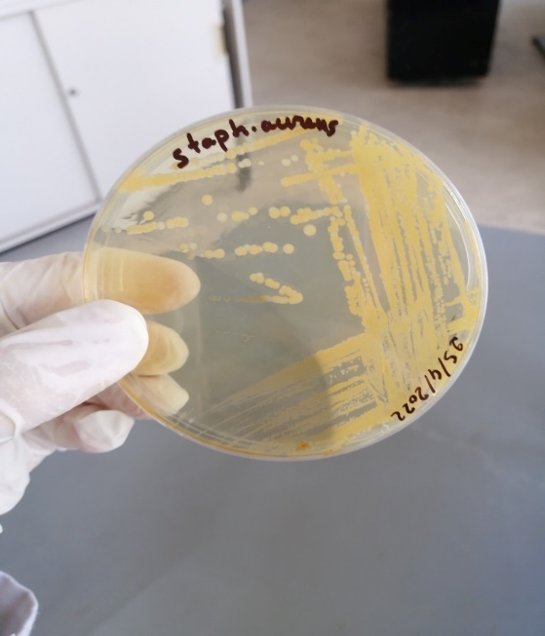
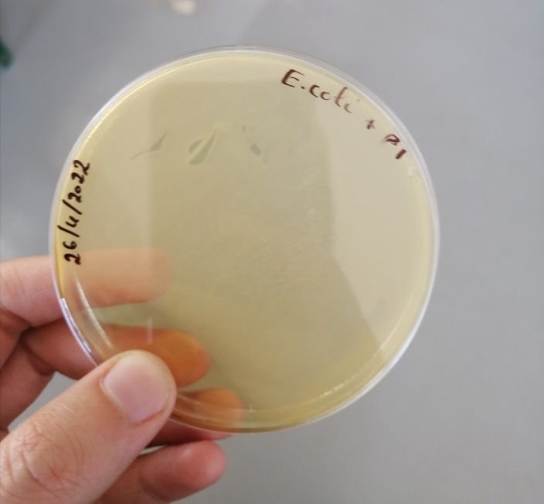
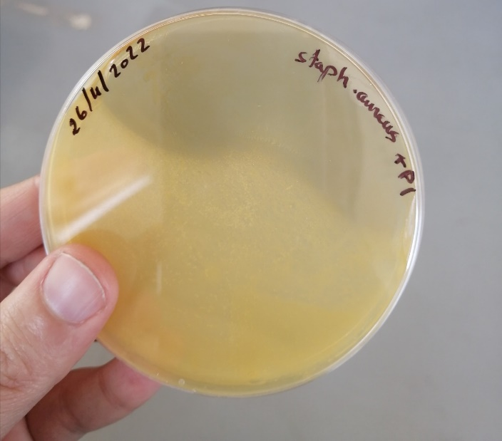

Experiment 3: Penicillin quantification

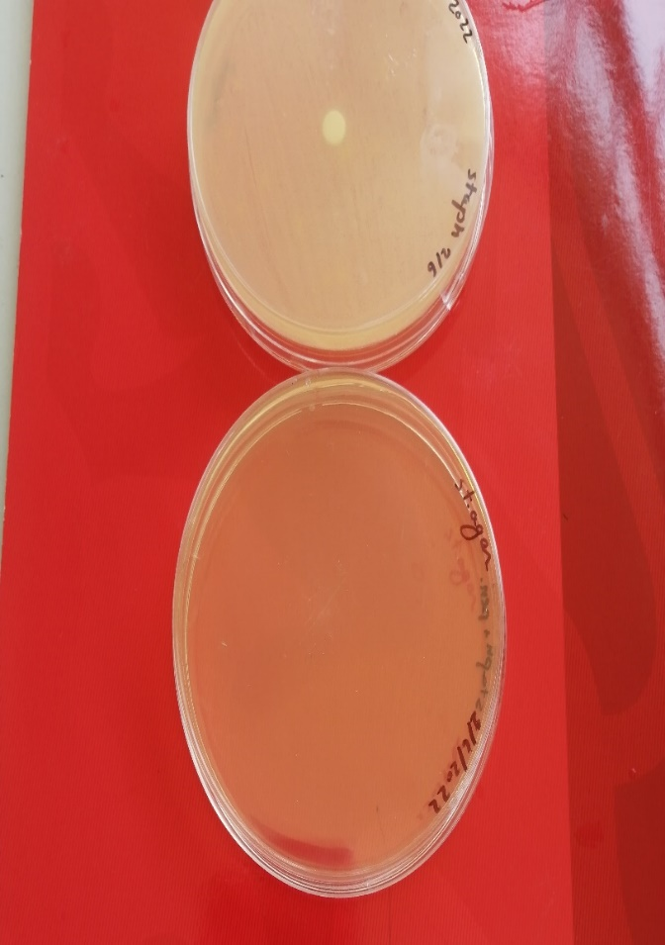
    - The first trial of quantification:
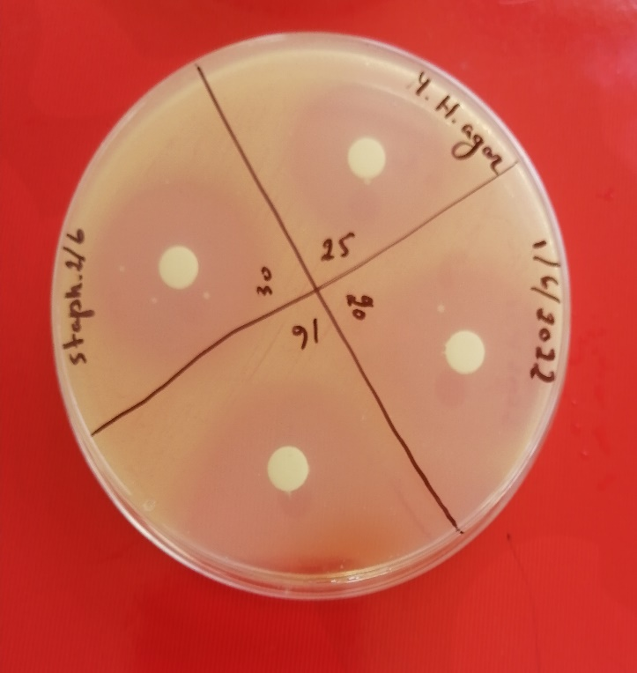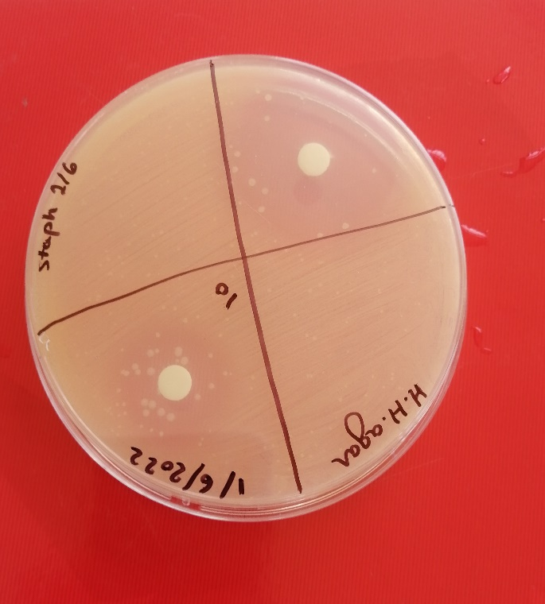

Concentration (UI) | 30 | 25 | 20 | 16 | 10 | ?
Log (concentration) | 1.48 | 1.4 | 1.3 | 1.2 | 1 | ?
Diameter (cm) | 2.6 | 2.5 | 2.35 | 2 | 1.9 | 3.5
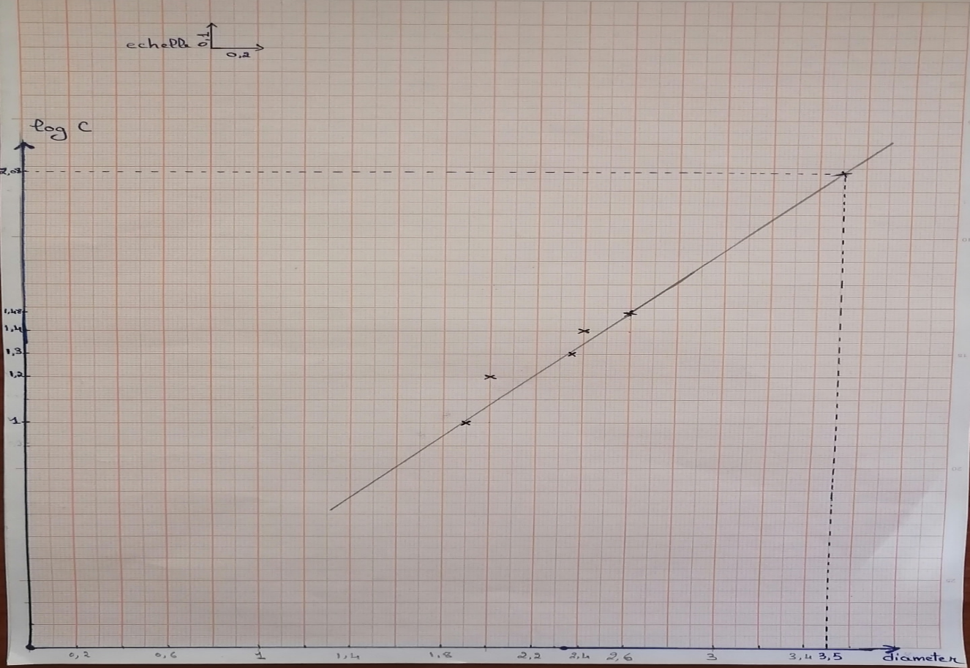

For Diameter= 3.5cm ;log C=2.08 ===> C~120 UI. This result show the effectiveness and the applicability of this methode to quantify the produced penicillin

The second trial of quantification: quantification of our produced penicillin:
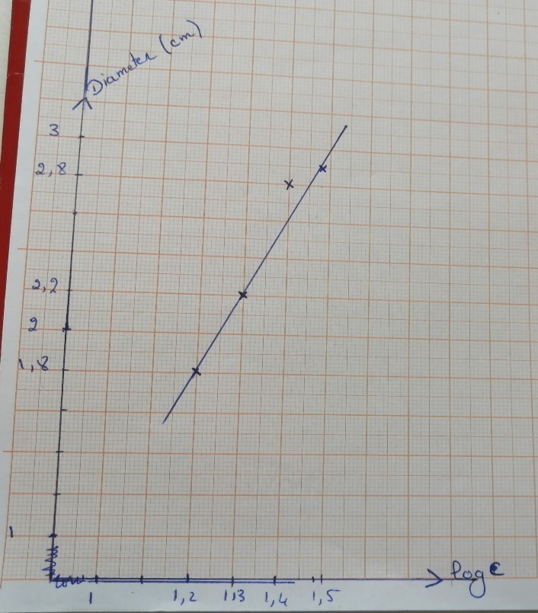
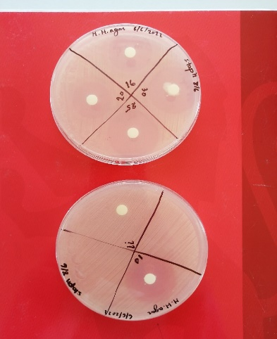
Figure 7: penicillin standard curve for last results
Figure 6: This result show that our produced penicillin has not any antibacterial activity. So it is important to find and try another protocol with sure results.

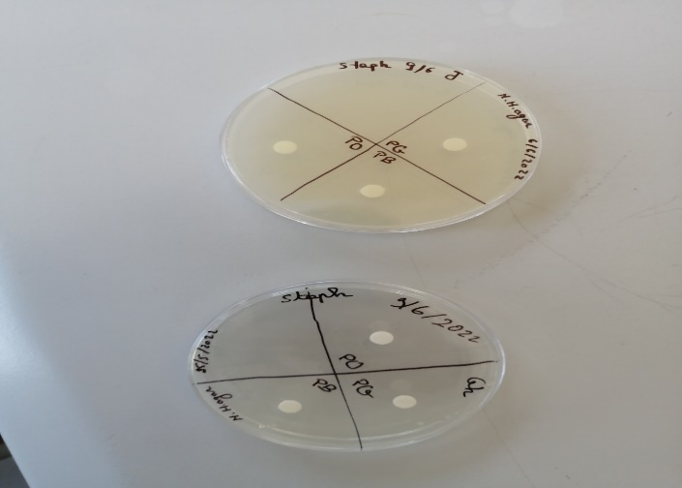
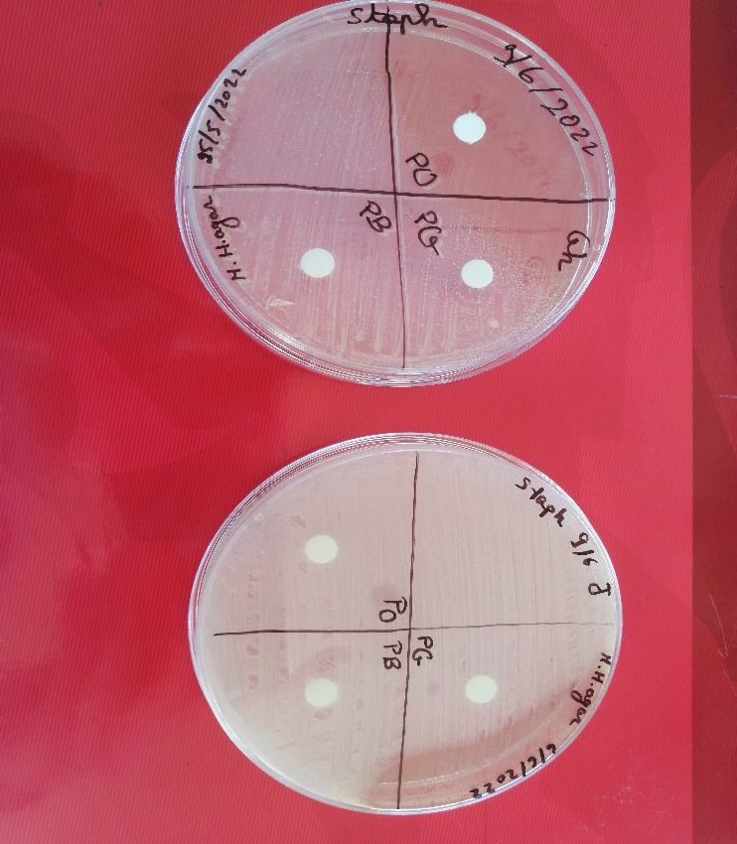
Figure 6: This pictures is a result of trial to say that this protocol is ineffective for all our last tried penicillin( 1: before incubation and 2: after incubation)
1
2

Experiment 4: Ampicillin production
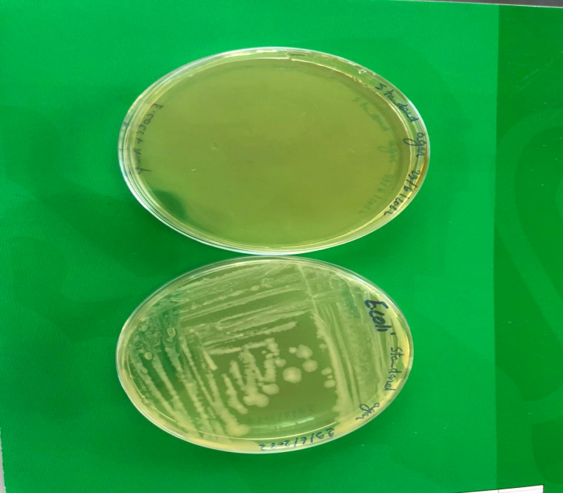
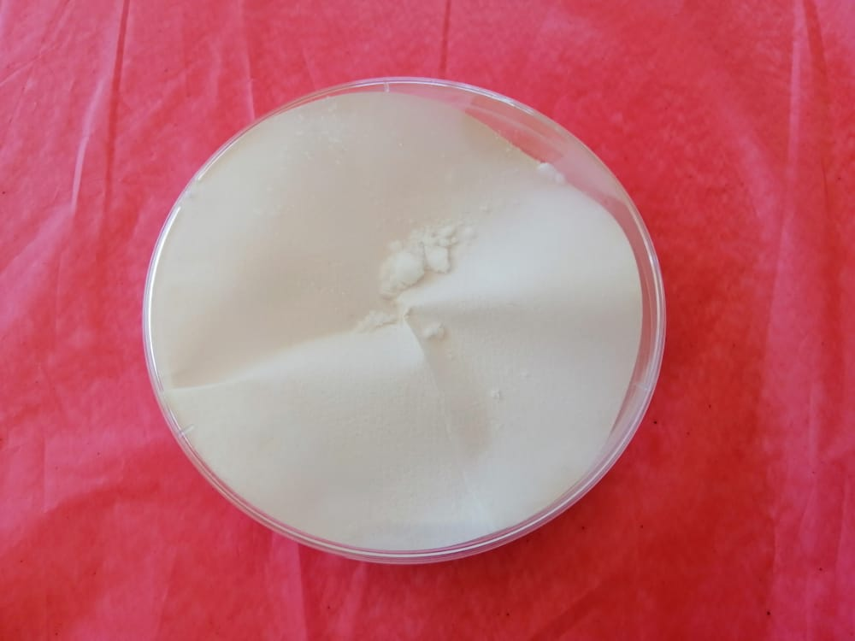
Figure 7: result of ampicillin qualification. Here the produced ampicillin show a total inhibition of E.coli growth
Figure 8: obtained powdered ampicillin

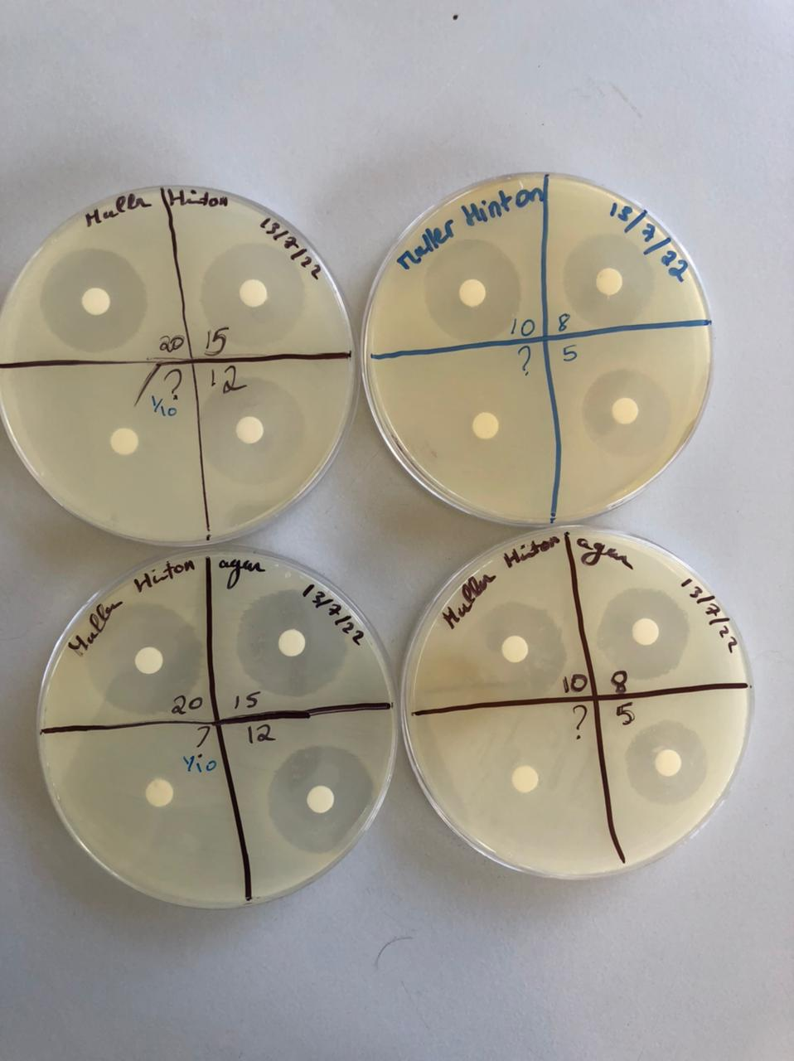
Figure 10:Ampicillin quantification results

Experiment 5: A second trial of ampicillin with maximization of its purification:

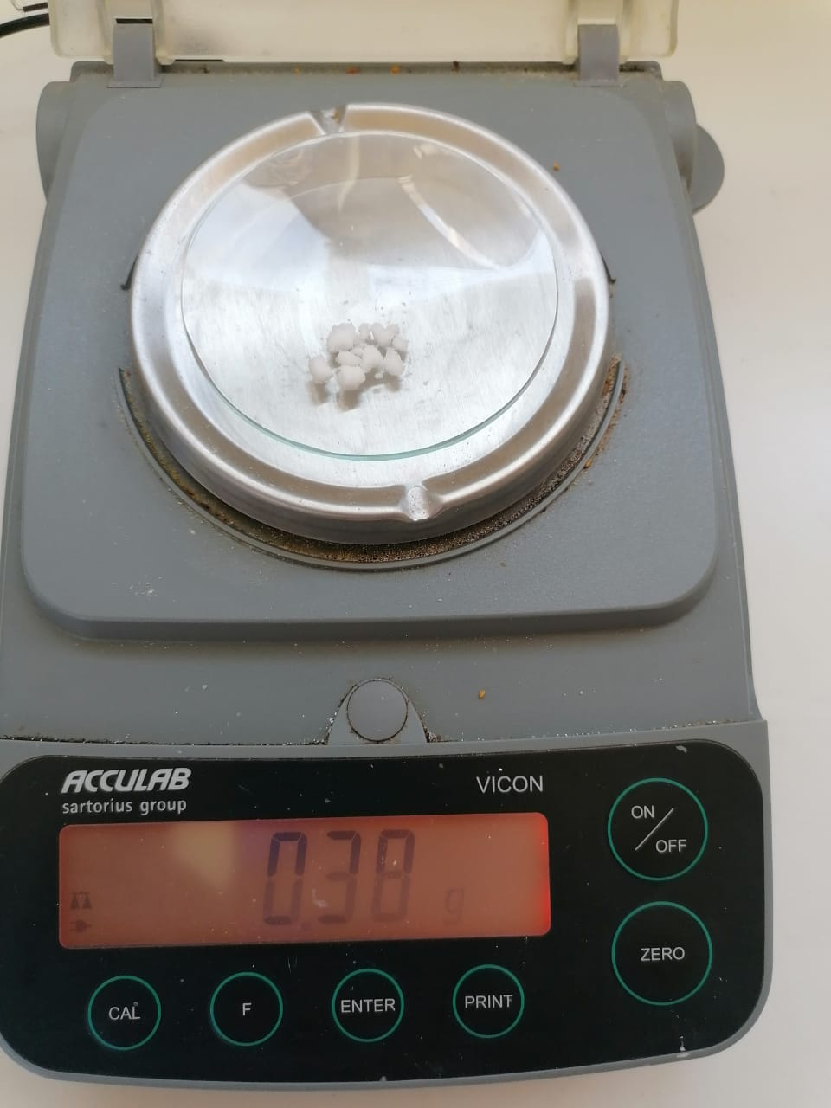
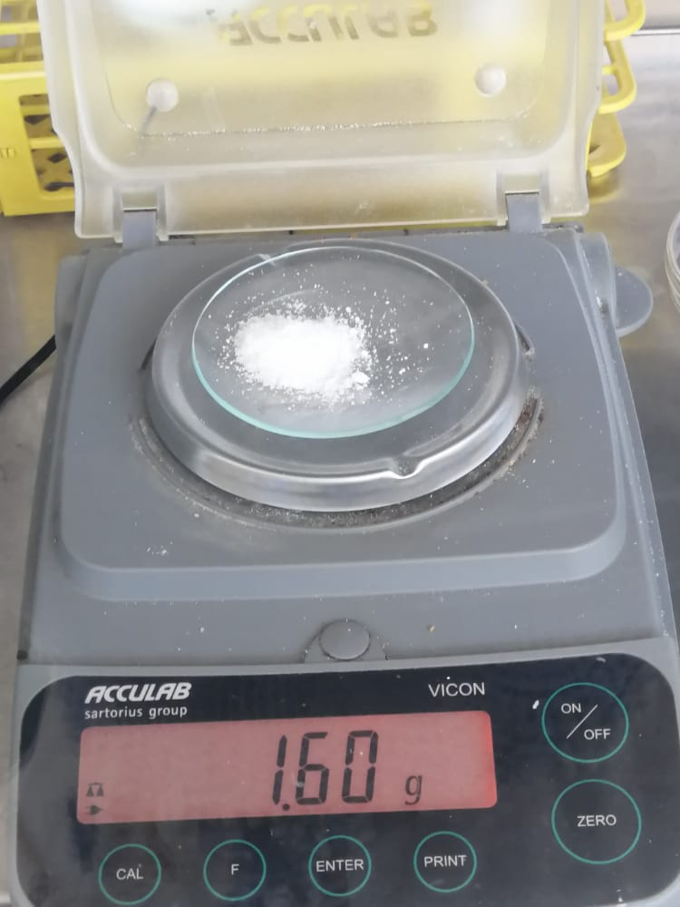
Figure 10: obtained ampicillin sodium after 14:2 purification
Figure 9:obtained ampicillin sodium after V:V purification

IV- References:

1. Missiakas DM, Schneewind O. Growth and Laboratory Maintenance of Staphylococcus aureus. Curr Protoc Microbiol. 2013 Feb;CHAPTER 9:Unit-9C.1.
2. Gera K, McIver KS. Laboratory Growth and Maintenance of Streptococcus pyogenes (The Group A Streptococcus, GAS). Curr Protoc Microbiol. 2013 Oct 2;30:9D.2.1-9D.2.13.
3. Standard I- nutrient agar [Internet]. Merck Millipore; Available from: https://www.merckmillipore.com/INTERSHOP/web/WFS/Merck-LU-Site/fr_FR/-/EUR/ShowDocument-Pronet?id=18327#:~:text=Typical%20Composition%20(g%2Flitre),1.0%3B%20agar%2Dagar%2012.0.
4. Recherche et dénombrement d’ Escherichia coli thermotolérants dans les échantillons solides ou semi-solides :.pdf [Internet]. [cited 2022 Feb 18]. Available from: https://www.ceaeq.gouv.qc.ca/methodes/pdf/MA705EcBCIG1.pdf
5. Growth Requirements of E. coli and Auxotrophs - Video & Lesson Transcript [Internet]. Study.com. [cited 2022 Feb 18]. Available from: https://study.com/academy/lesson/growth-requirements-of-e-coli-and-auxotrophs.html
6. CFR-1998-title21-vol5-part436.pdf [Internet]. [cited 2022 Feb 21]. Available from: https://www.govinfo.gov/content/pkg/CFR-1998-title21-vol5/pdf/CFR-1998-title21-vol5-part436.pdf
7. Why does Penicillin concentration is given in Units and not micro grams per mL ? [Internet]. ResearchGate. [cited 2021 Dec 24]. Available from: https://www.researchgate.net/post/Why_does_Penicillin_concentration_is_given_in_Units_and_not_micro_grams_per_mL
8. L. Shuler M, Kargi F. Bioprocess Engineering Basic Concepts Second Edition [Internet]. Second edition. United States: Prentice Hall PTR Upper Saddle River, NJ 07458 www.phptr.com; 2002. 576 p. Available from: https://www.academia.edu/44843690/Bioprocess_Engineering_Basic_Concepts_Second_Edition?pop_sutd=false
9. Nandi A, Pan S, Potumarthi R, Danquah MK, Sarethy IP. A Proposal for Six Sigma Integration for Large-Scale Production of Penicillin G and Subsequent Conversion to 6-APA. Journal of Analytical Methods in Chemistry. 2014;2014:1–10.
10. Fatima Antar, Mariam Mourad, Asia Mourad, Samer Youssef, Samar Youssef, Samir Mourad. MEGBI Antibiotics Production Pilot Plant (MEGBI-APP) - 6 th Project Report (Apr 2018 - Feb 2019) - [Internet]. 2018. Available from: http://aecenar.com/index.php/downloads/send/6-megbi-institute/463-megbi-app-report-6-2018-pdf
11. MEGBI-APP (Antibiotics Production Pilot Plant) Final Report (Period 2016 - 2020). 2016.
12. deaguero_andria_l_201112_phd.pdf [Internet]. [cited 2022 Jul 20]. Available from: https://smartech.gatech.edu/bitstream/handle/1853/42727/deaguero_andria_l_201112_phd.pdf
13. Evaluation of separation and purification processes in the antibiotic industry | SpringerLink [Internet]. [cited 2022 Jul 20]. Available from: https://link.springer.com/article/10.1007/BF02930830

