Introduction
Siting an union of municipality solid waste (UMSWI) incineration plant requires a comprehensive evaluation to identify the best available location(s) that can simultaneously meet the requirements of regulations and minimize economic, environmental, health, and social costs.

- Description of the area:

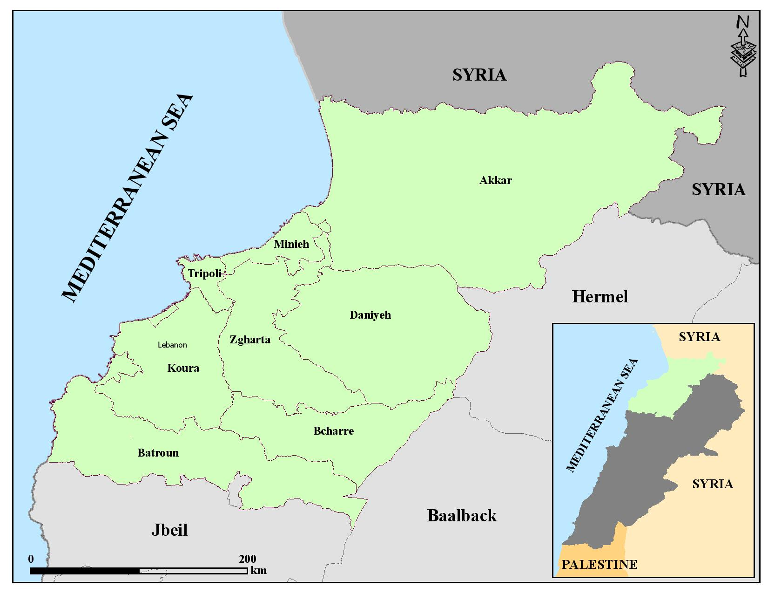

2- Unions of municipalities map:

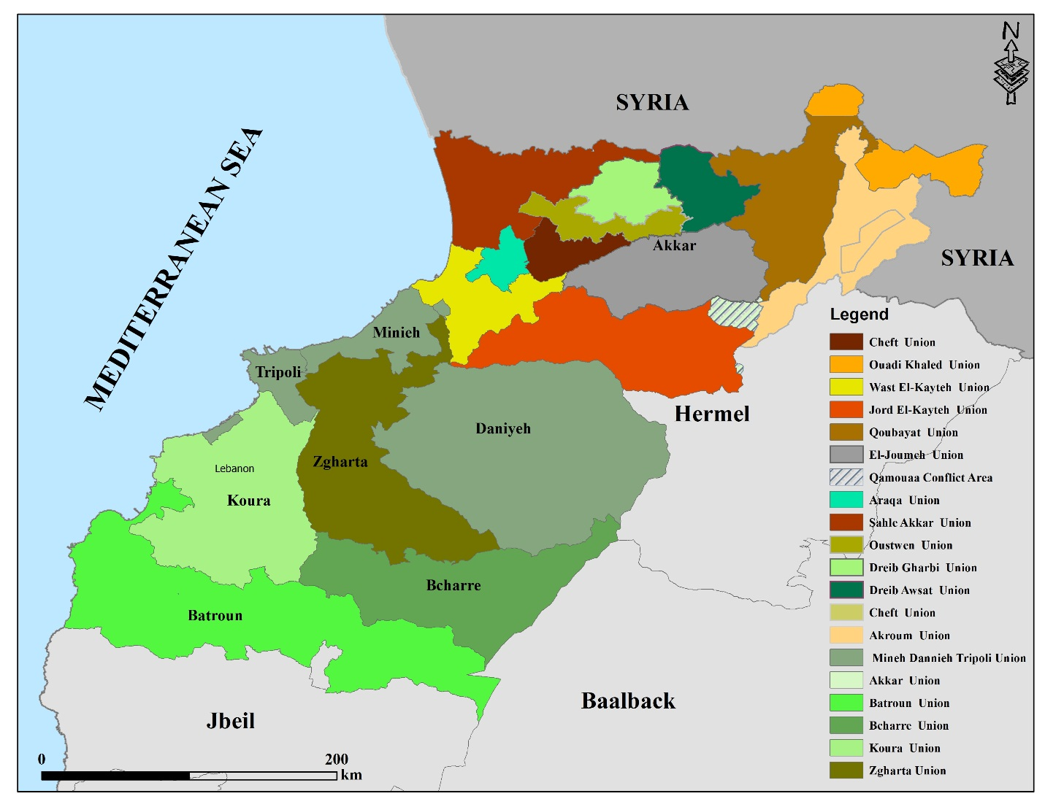

3- Caza of Akkar:

The Governorate of Akkar is located in the far north of Lebanon, with the Mediterranean Sea on its western border, Hermel to the East, Syria to the North, the Bared River and Minieh-Daninieh to the South.
The landscape of of Akkar is extremely diverse. There are 3 principal physiographic zones: the plain, the mid-elevation plateau and the mountains.
Akkar is the home of the Qammou’a forest, a unique environmental treasure, and to vast areas of oak and pine forests.
The plain is endowed with rich fertile soils and generous water resources. On the coast small scale fishing and vegetable production are a major source of income.

- UM Joumeh:

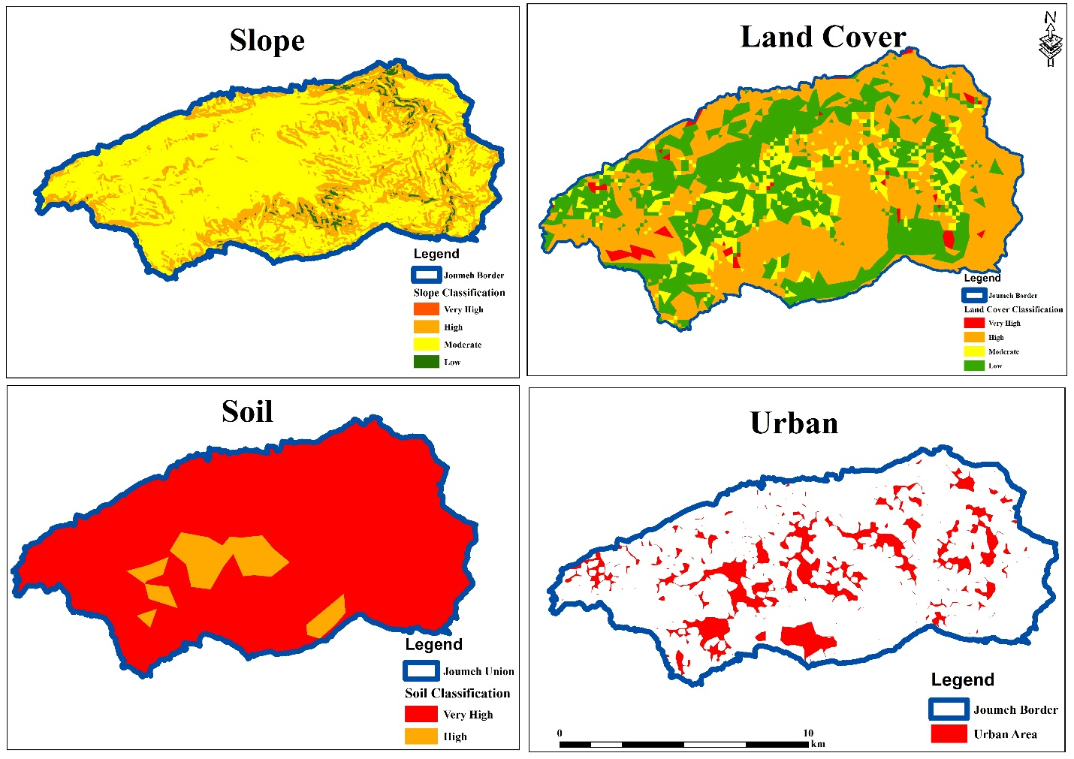

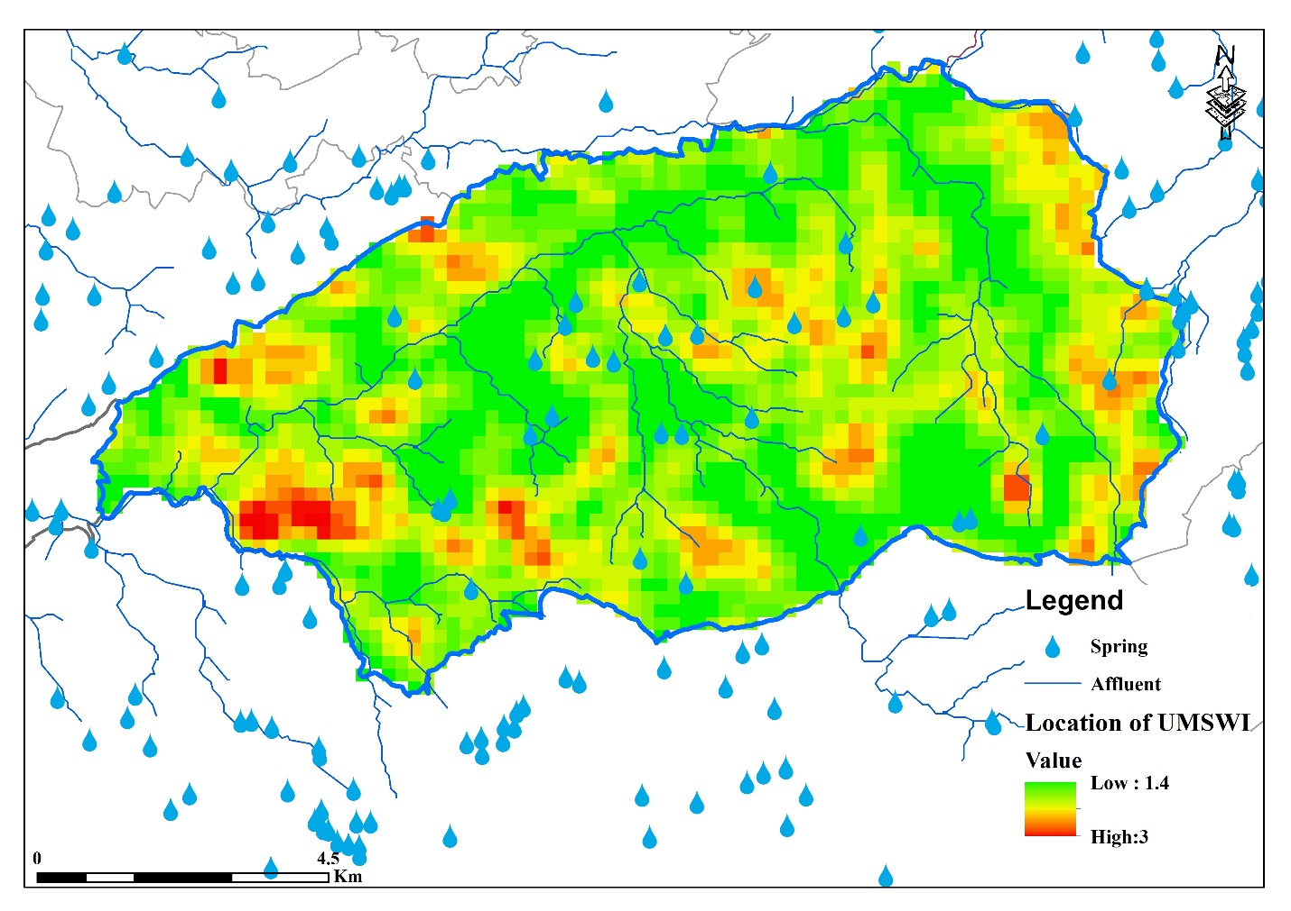

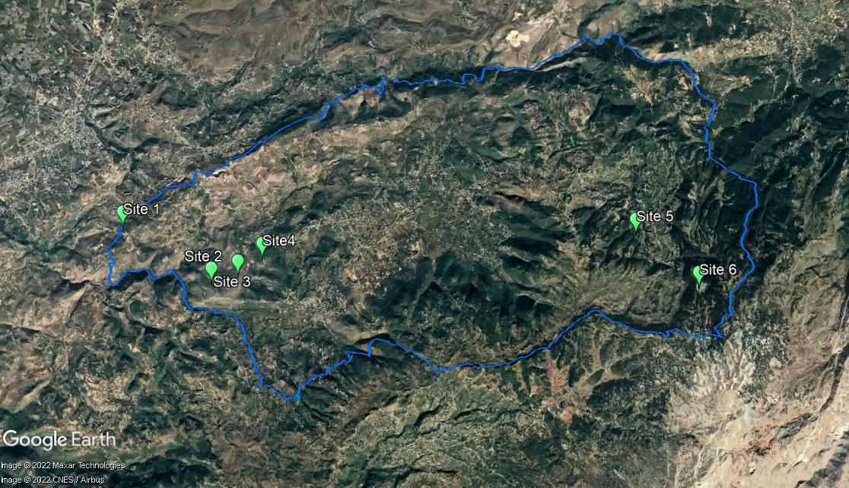

- UM Chefet:

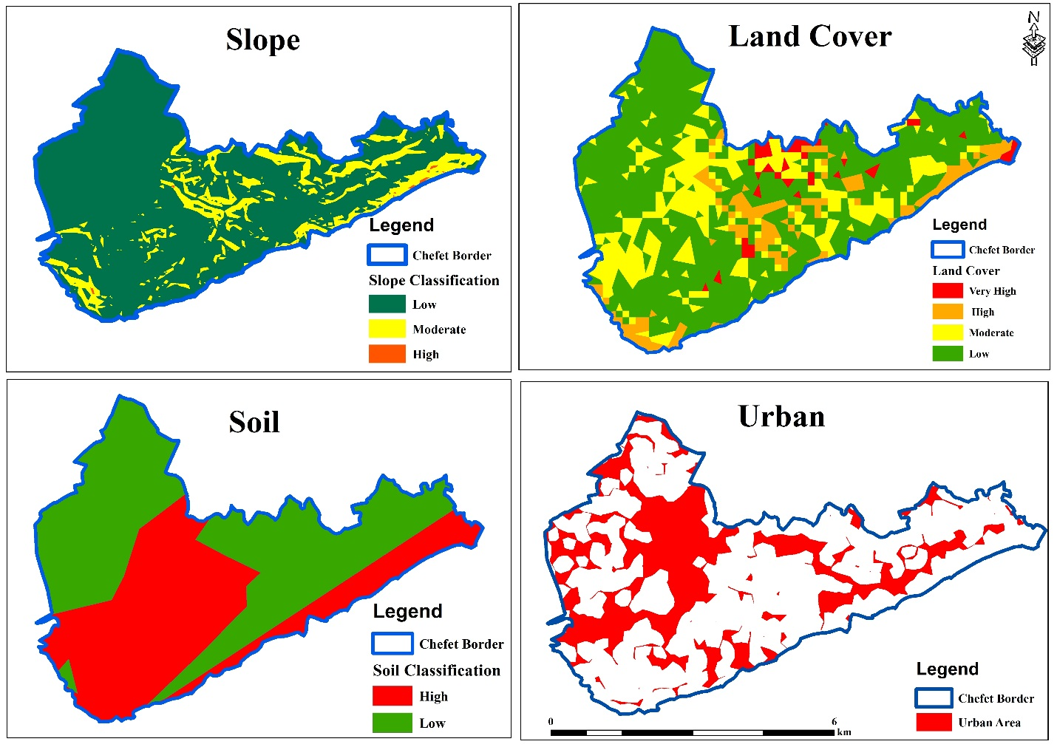

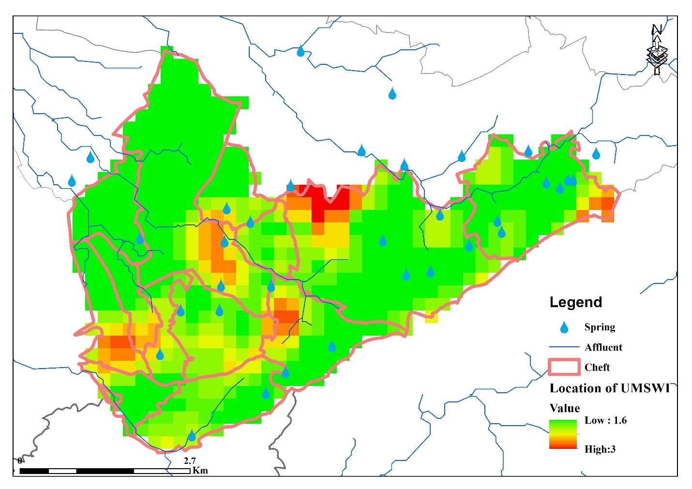

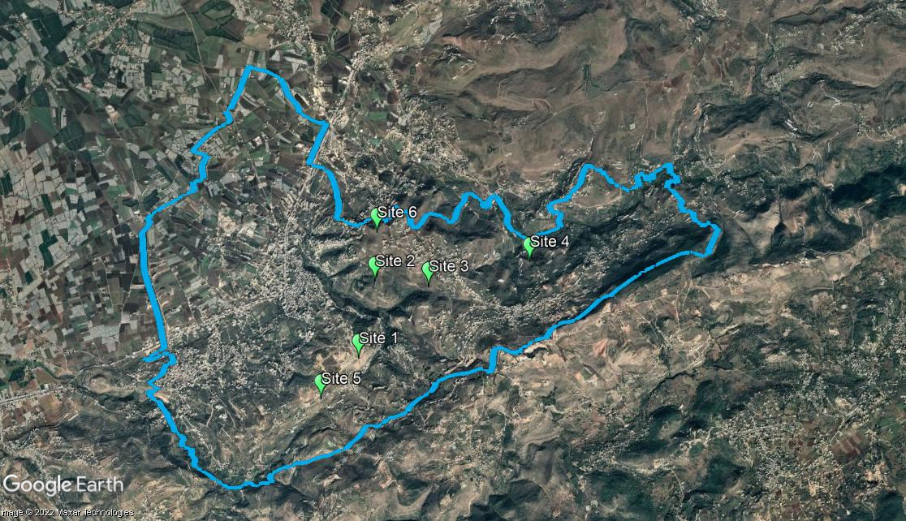

- UM Oustwan:

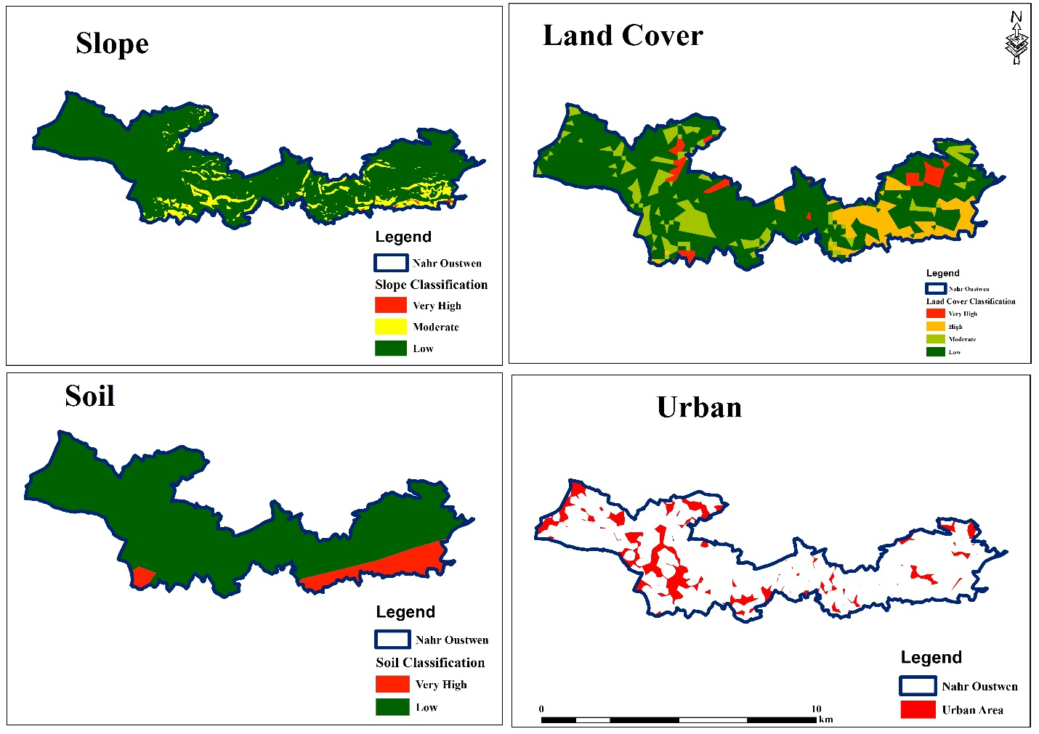

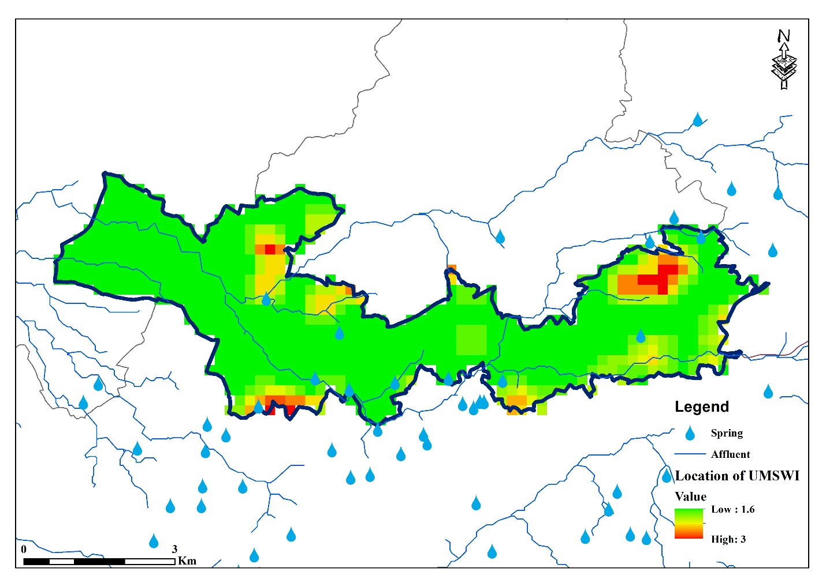

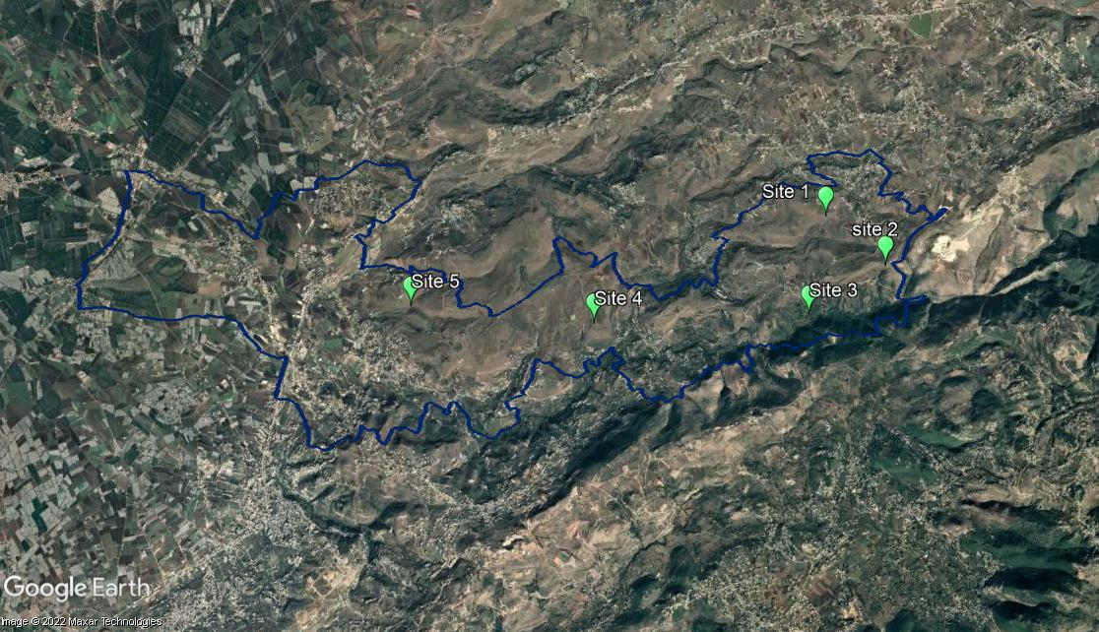

- UM Dreib EL Gharbi:

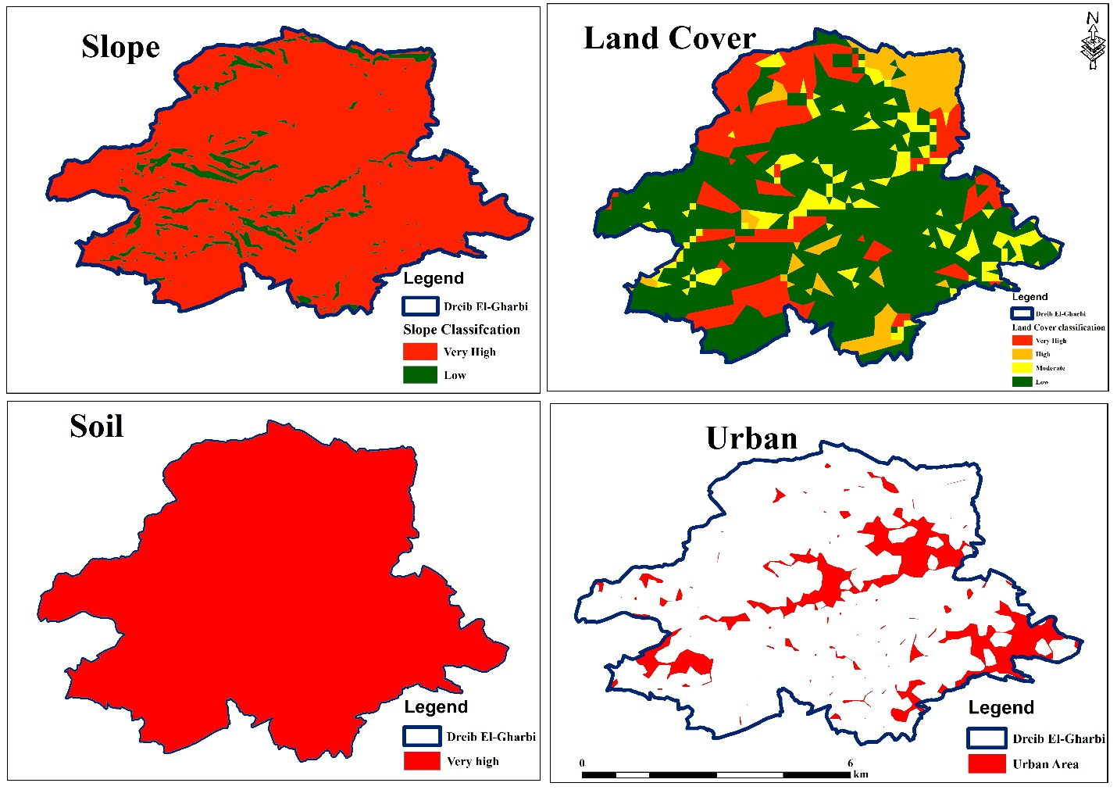

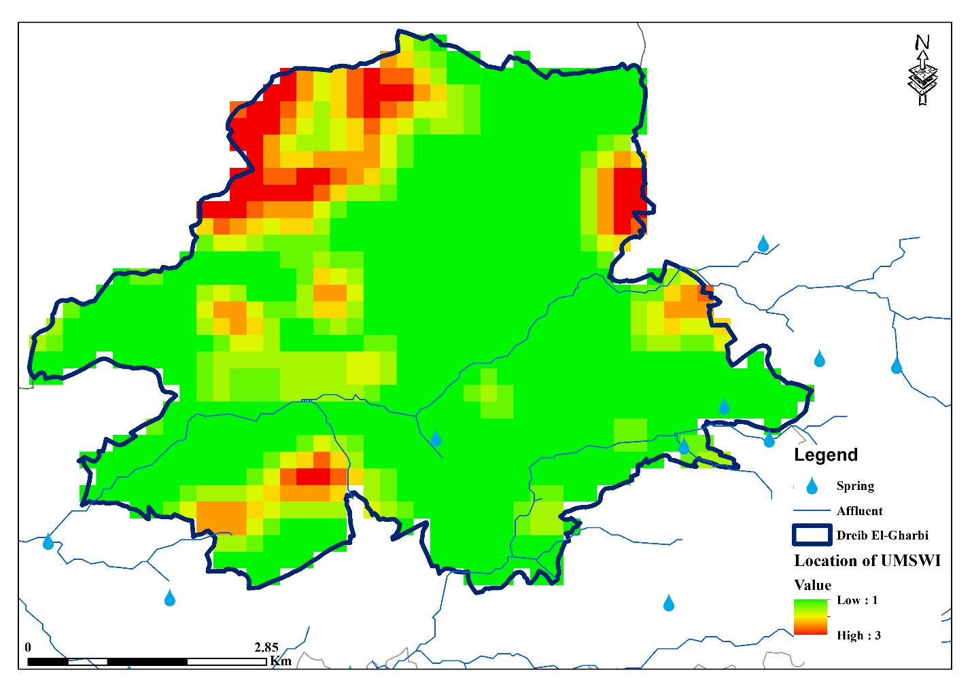

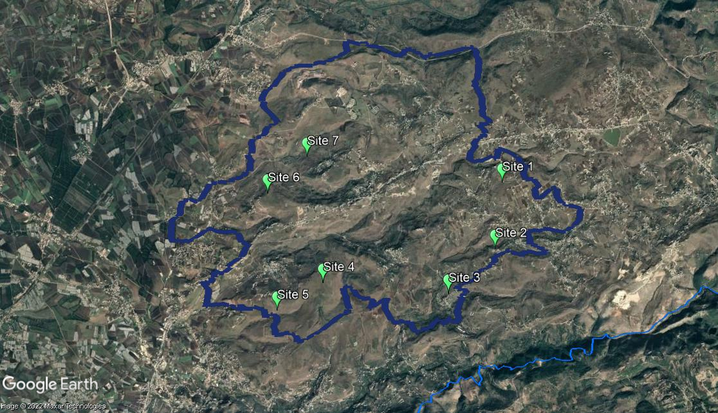

- UM Sahel Akkar:
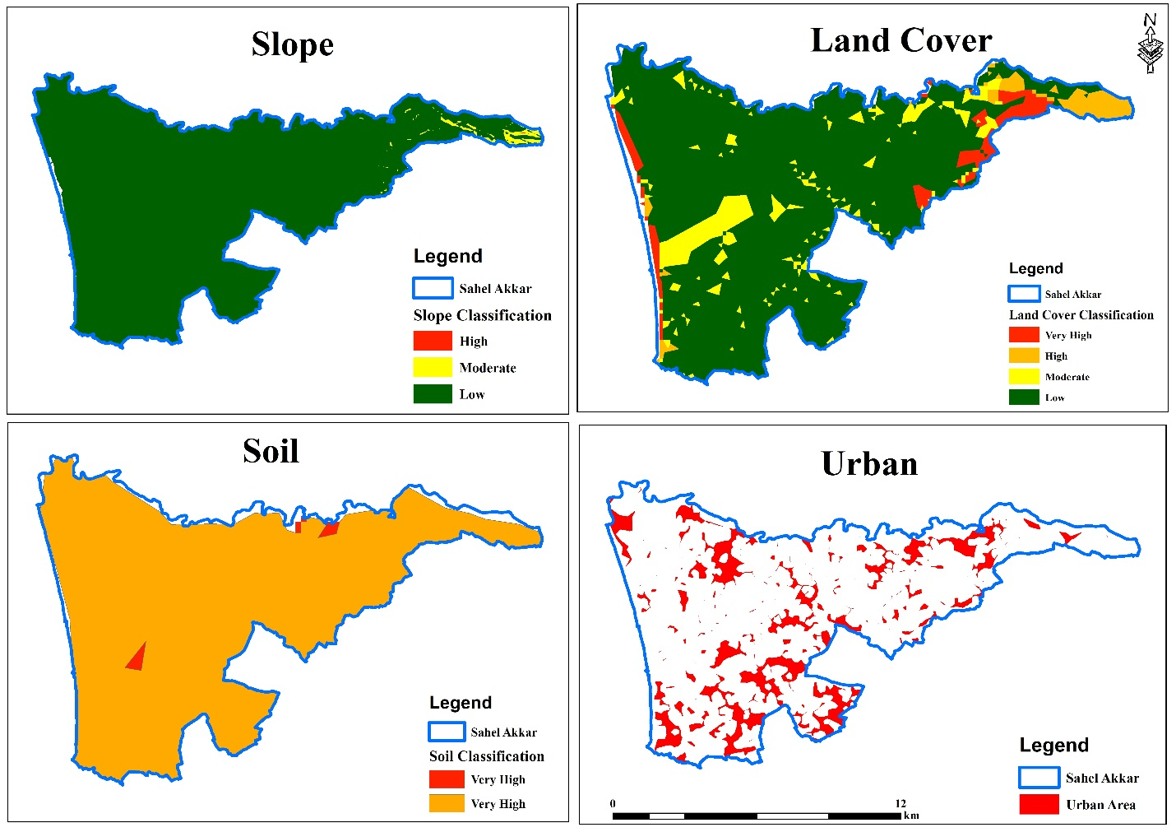

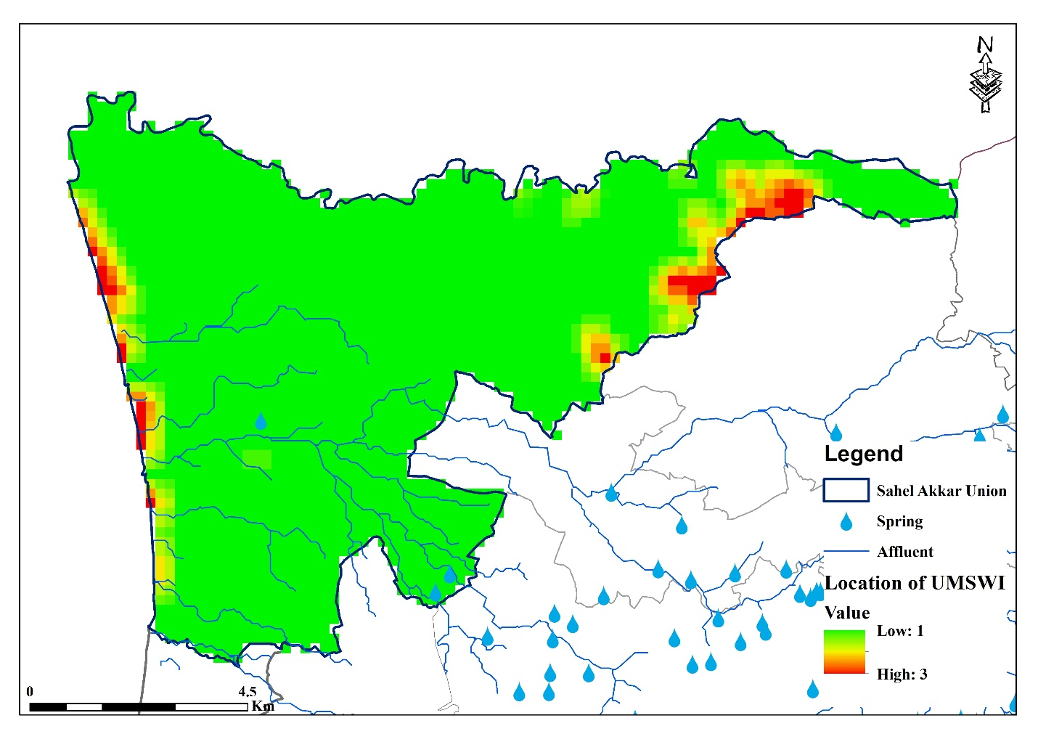

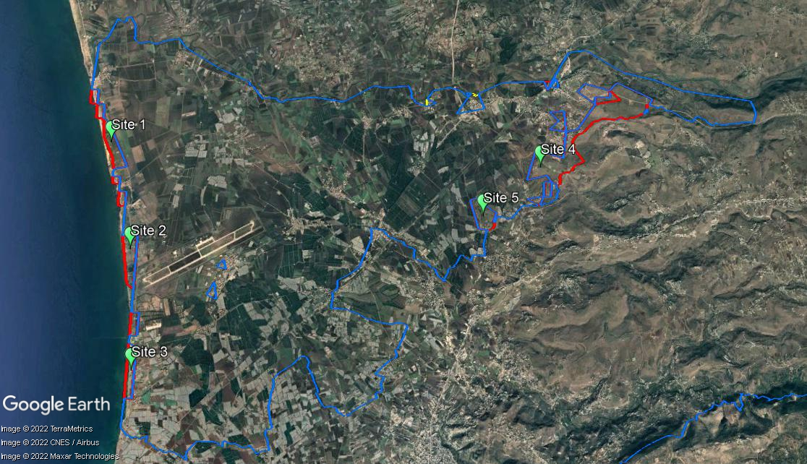

- UM Qobayyat:

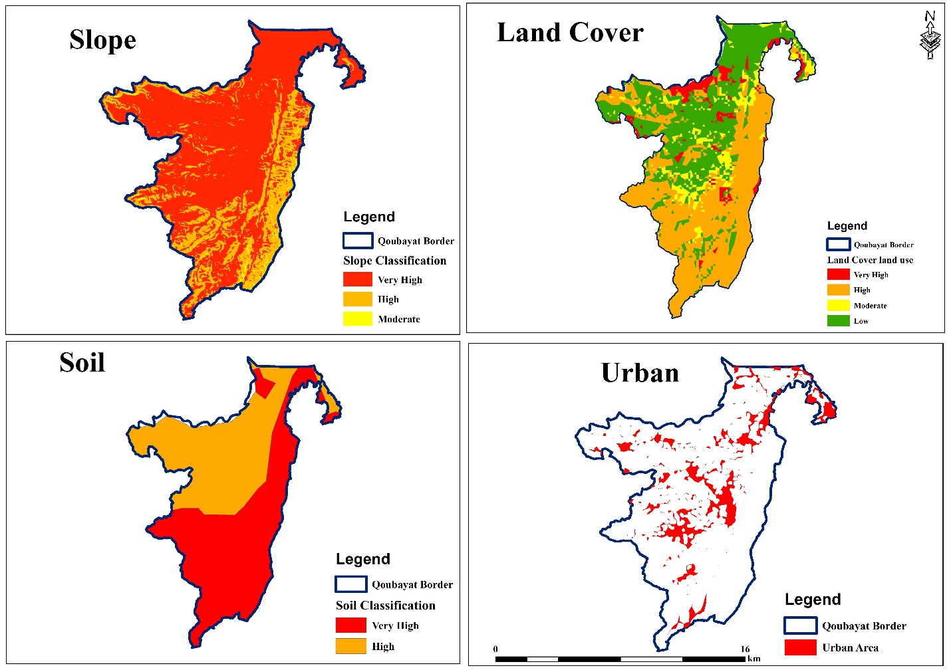

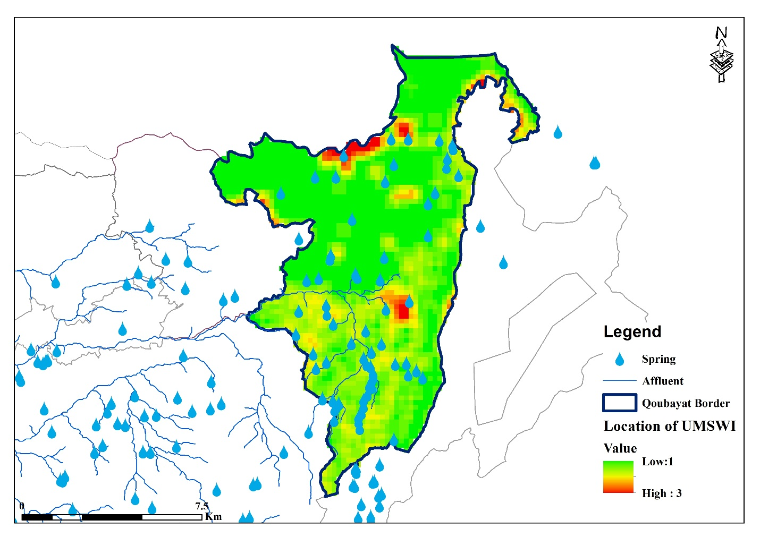

- UM Arka:

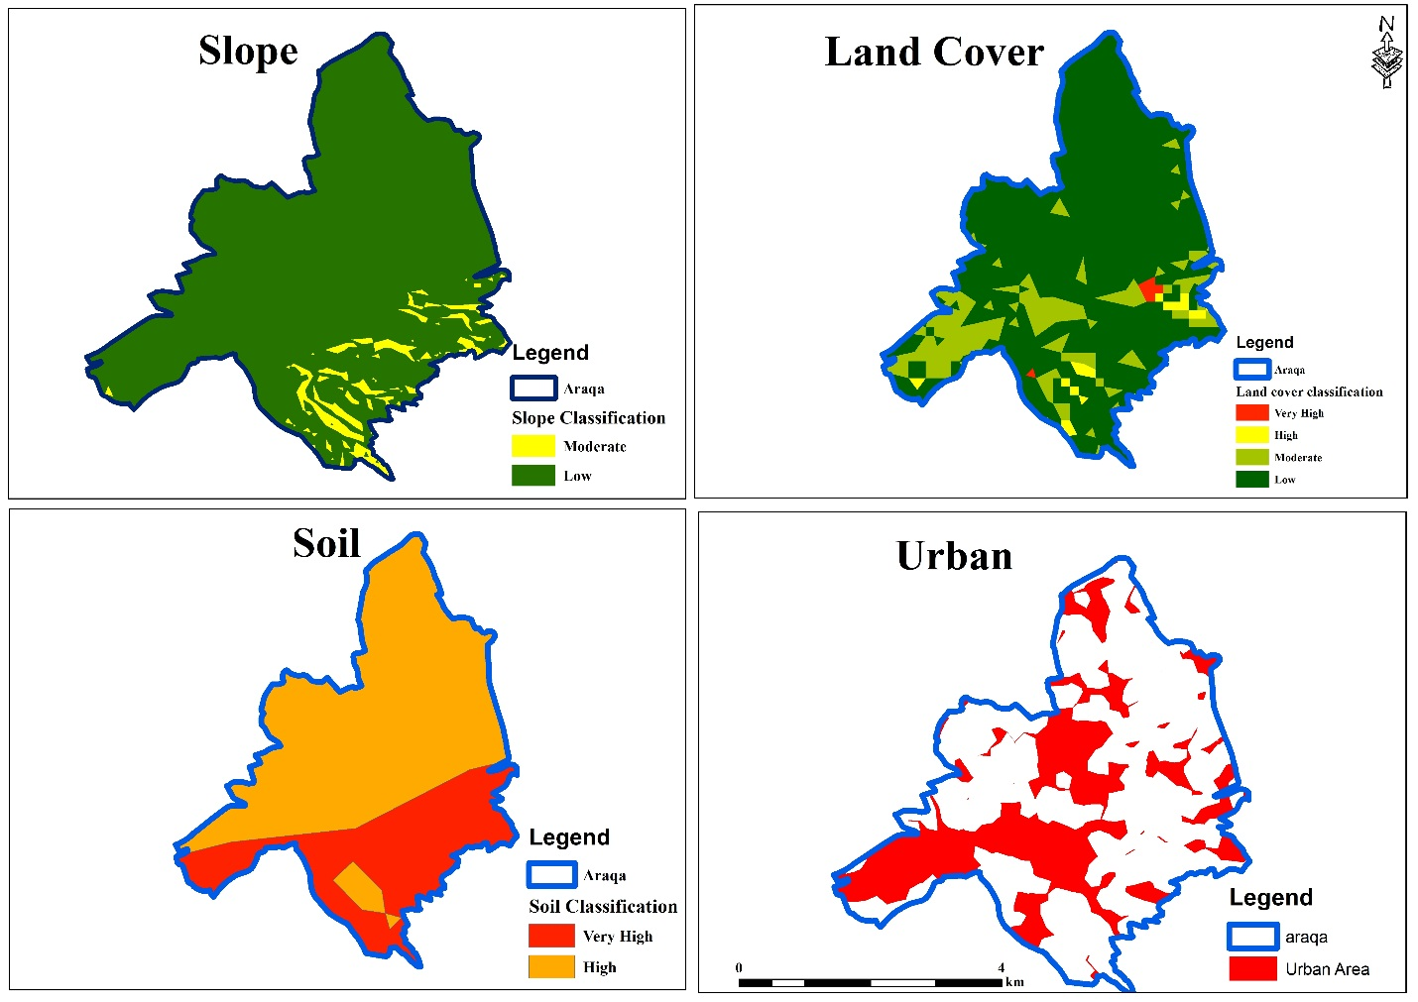

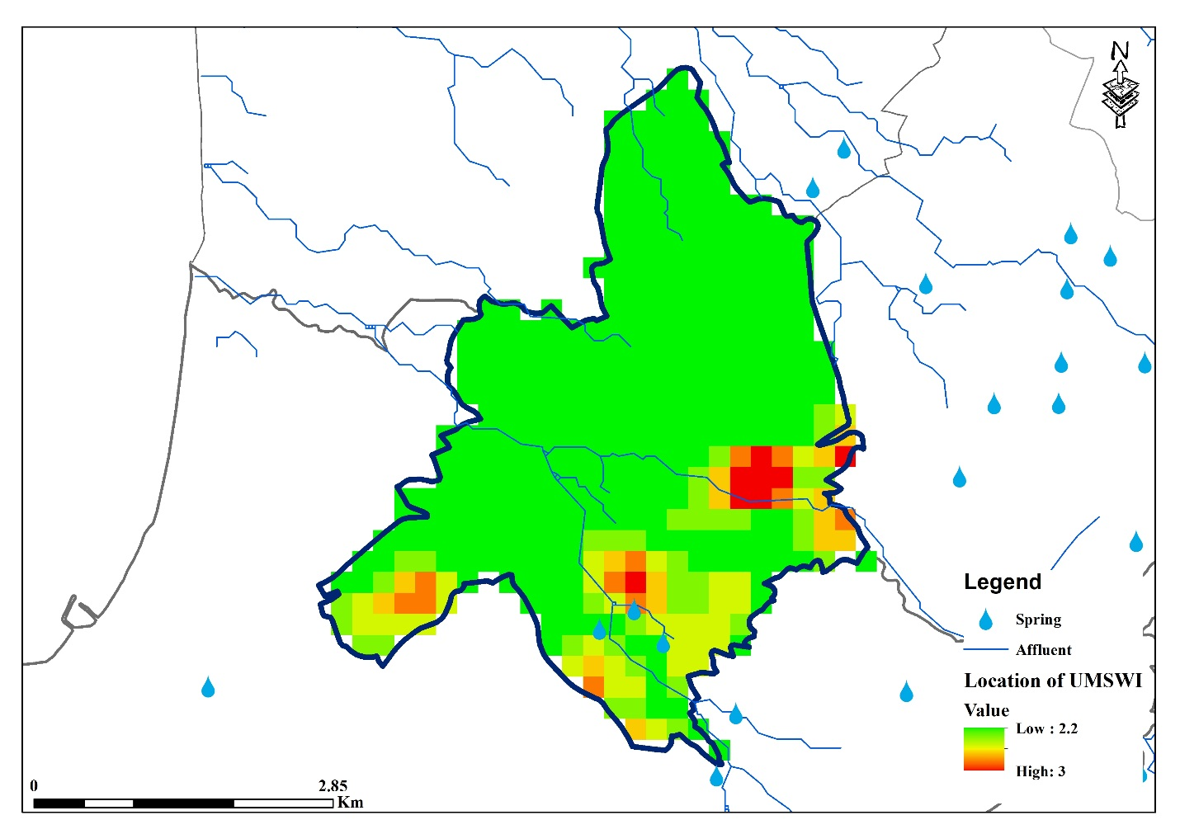

- UM Wadi Khaled:

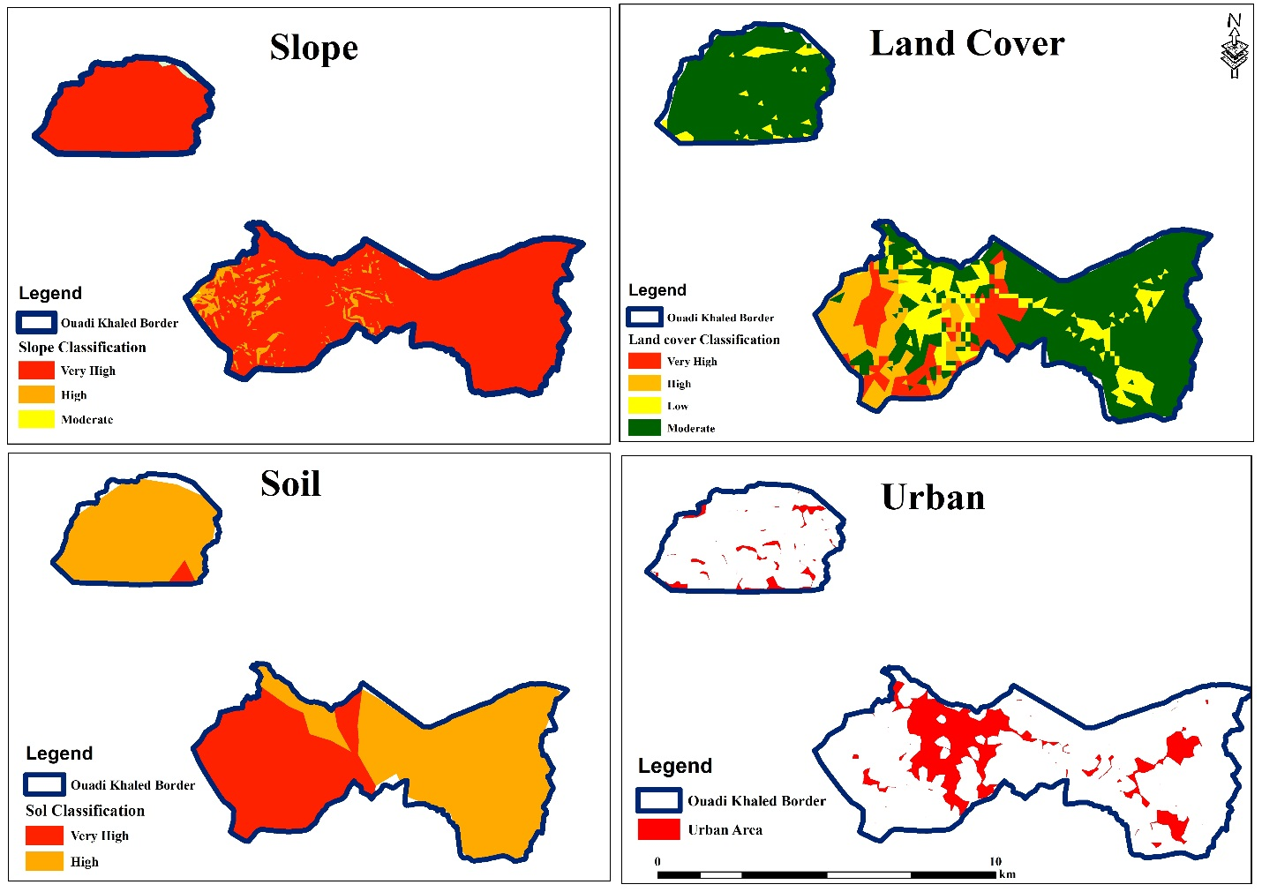

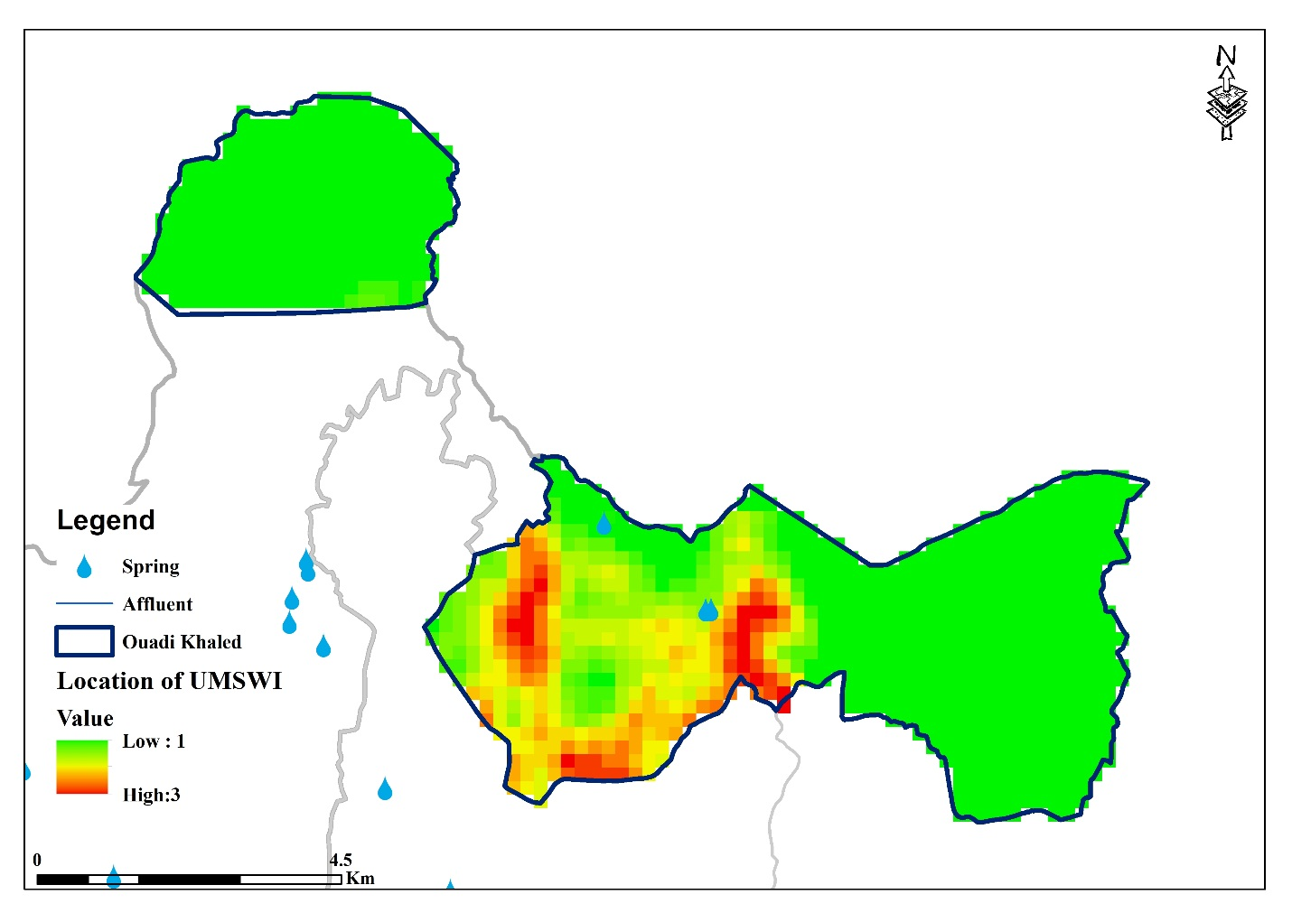

- UM Dreib Awsat:

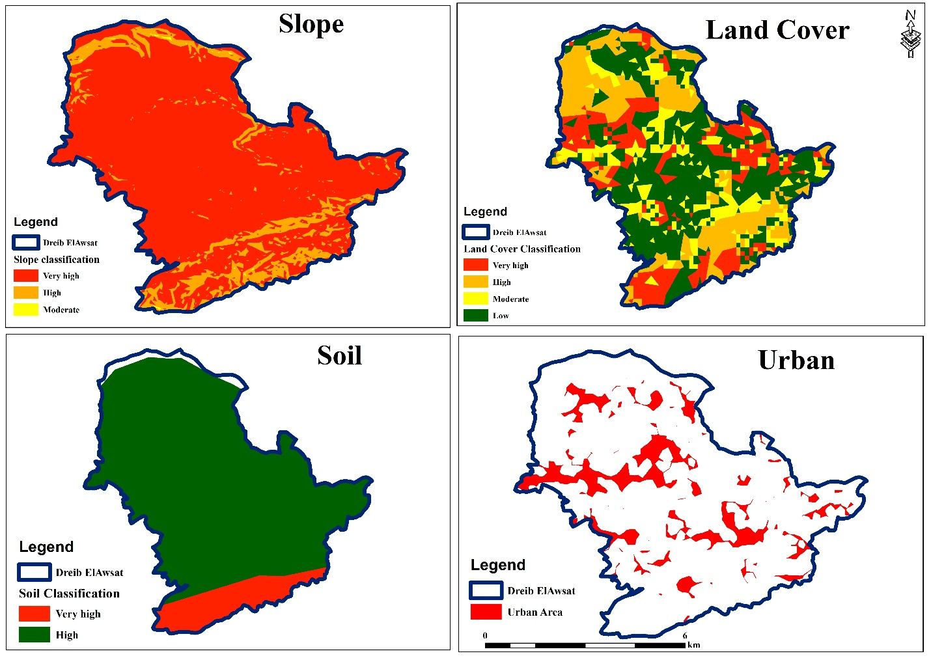

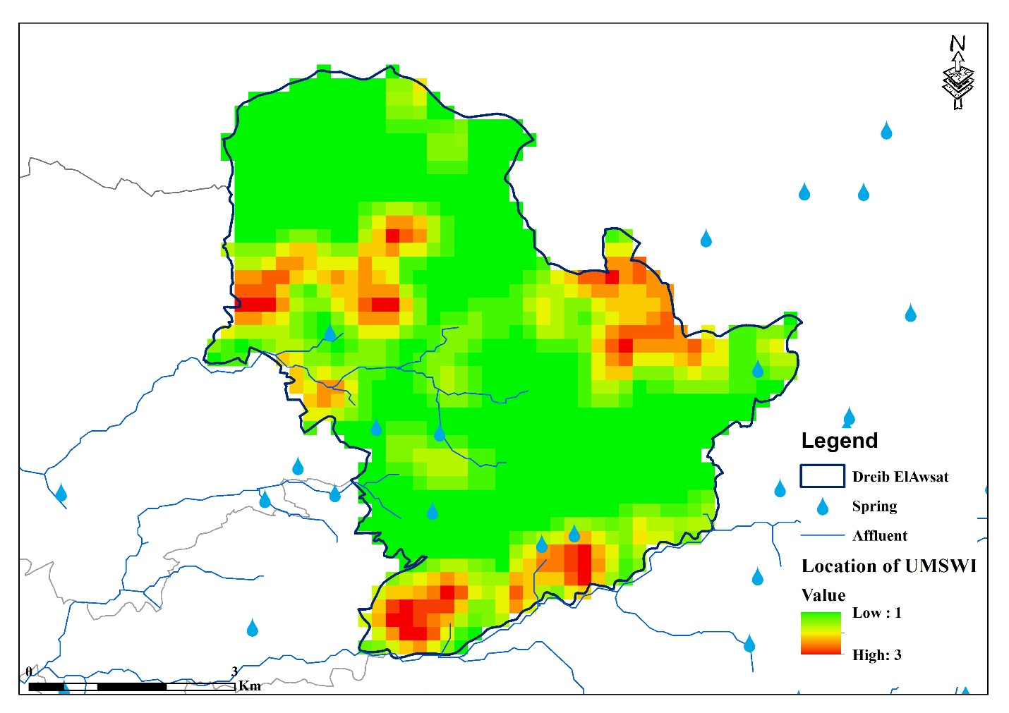

- UM Akkroum:

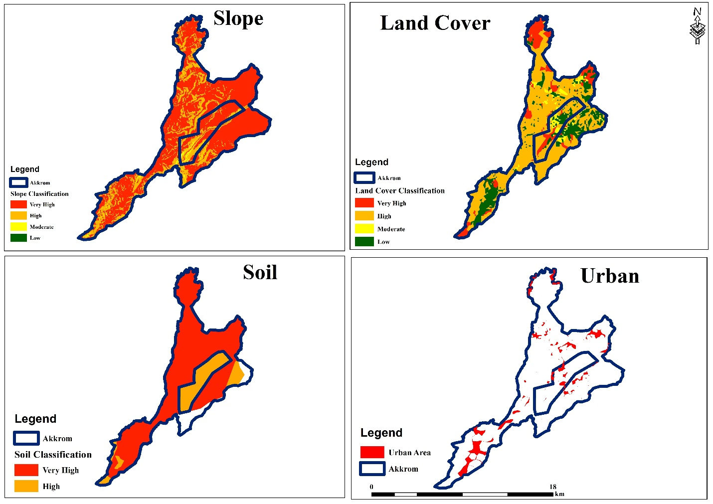

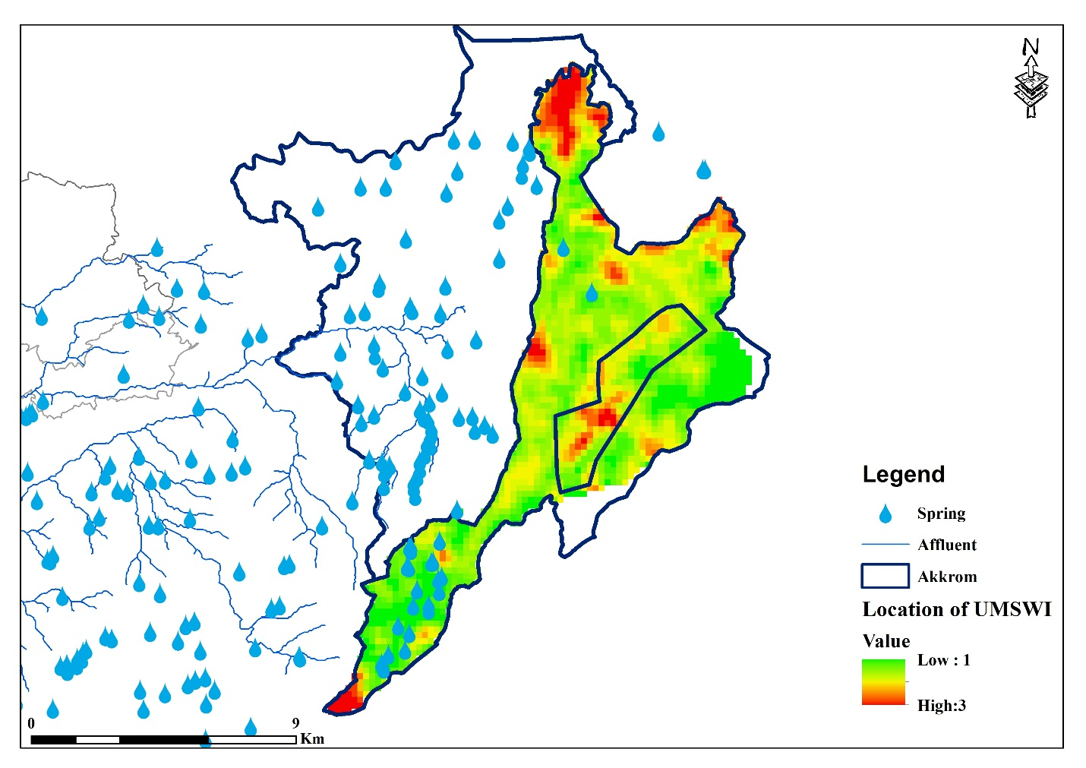

- UM Jord El Kayteh:

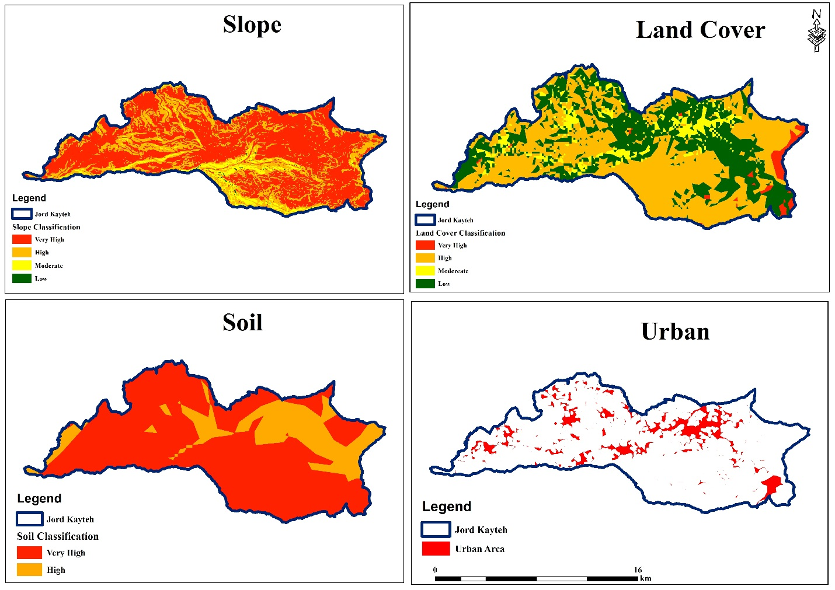

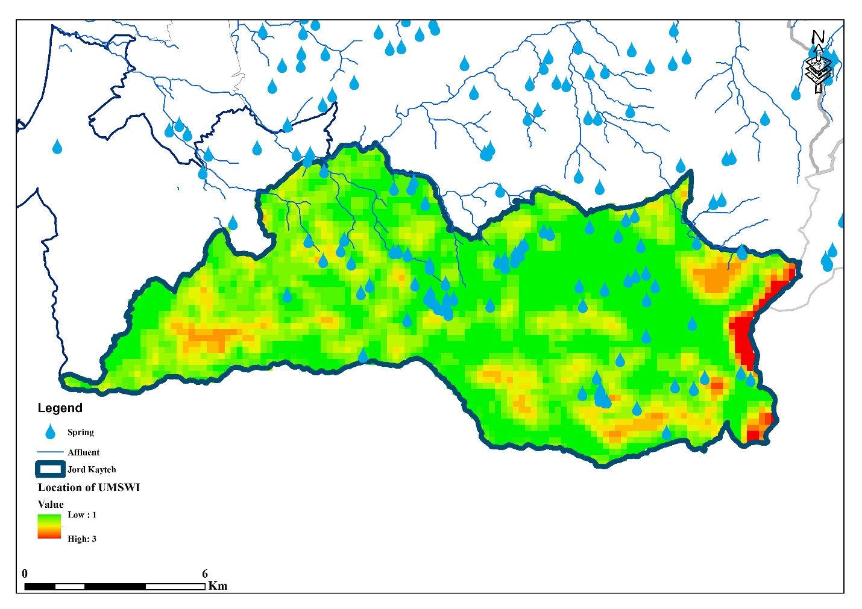

- UM Wassat El Kayteh:

