North Lebanon Roads Network and Public transport

Author: Maryam Abdel-karim

Last Update: 20.03.2020

Contents
1. Transportation 5
1.1 Roads 5
1.1.1 Motorways 5
1.2 Buses 6
1.3 Ferries 6
1.4 Taxis and services 6
1.4.1 Types of taxis in Lebanon 7
1.4.2 Carpooling 7
1.5 Airport 8
1.6 Cable Car 8
1.7 Rail transport 8
1.8 Port 9
2. Roads and highways, completed and ongoing projects 10
2.1. Tripoli - Syrian Border Connection 10
2.2. Sir ed Danniyeh-Jbab el Homr- Hermel: 11
3. Roads and highways under preparation projects 12
4. relevant government agency 14
5. Transport Corridors 15
6. Distance Matrix 16
7. Road Security 17
8. Weighbridges and Axle Load Limits 18
9. Road Class and Surface Conditions 19
10. Tripoli Projects 21
10.1. TRIPOLI BOULEVARD UNDERPASS PROJECT 21
10.2. CENTRAL TRIPOLI TRANSPORT MANAGEMENT PROJECT 24
PRESENT CONDITIONS AND PROBLEMS 24
PROPOSED BUS/TAXI SERVICE SYSTEM AND TERMINALS 26
ONE-WAY TRAFFIC SYSTEM 27
ON-STREET AND OFF-STREET PARKING 29
INTERSECTION IMPROVEMENT AND TRAFFIC SIGNALS 33
TRAFFIC SAFETY FACILITIES 43

Transportation
Transportation in Lebanon varies greatly in quality from the ultramodern Beirut International Airport to poor road conditions in many parts of the country. The Lebanese civil war between 1975 and 1990 and the 2006 Lebanon War with Israel severely damaged the country's infrastructure.
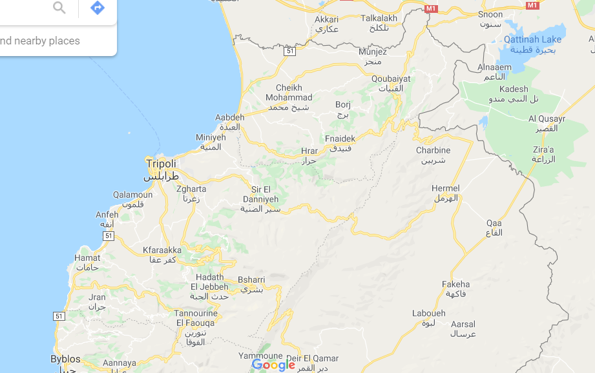

Roads
Lebanon has an extensive road network throughout the country, generally in good conditions, though it varies. The main roads in the north Lebanon are:
- Beirut - Byblos - Tripoli - Aarida
- Tripoli - Bsharri – Baalbek

Motorways
Part of the main road network have been updated to dual carriageway, four-lane motorways, which are the following in North Lebanon:
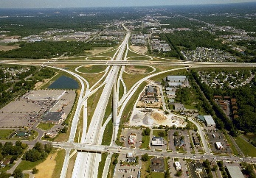
- Beirut - Tripoli. Length: 81 km.
- Tripoli - Khane. Length: 20 km

Buses
An overland trans-desert bus service between Beirut, Haifa, Damascus and Baghdad was established by the Nairn Transport Company of Damascus in 1923.
Beirut has frequent bus connections to other cities in Lebanon and major cities in Syria. The Lebanese Commuting Company, or LCC in short, is just one of a handful brands of public transportations all over Lebanon. On the other hand, the publicly owned buses are managed by le Office des Chemins de Fer et des Transports en Commun (OCFTC - is the Lebanese government authority which operates public transportation in Lebanon), or the "Railway and Public Transportation Authority" in English. Buses for northern destinations and Syria leave from Charles Helou Station.
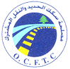
Buses are popular and inexpensive and can be stopped anywhere along the way simply by hailing.

Ferries
Apart from the international airport, the Port of Beirut is another port of entry. As a final destination, anyone can also reach Lebanon by ferry from Cyprus, or Greece or by road from Damascus, etc. The Port of Tripoli (Lebanon) is also a port of entry and ferries usually come from Taşucu, Turkey.
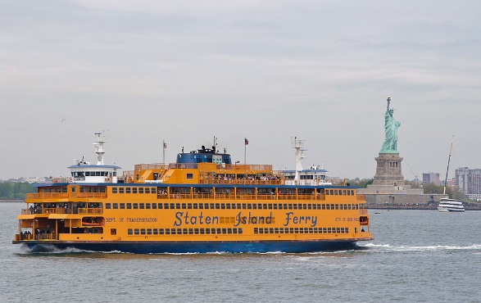

Taxis and services
In order to get from one place to another, people can either use a service or taxis. A "service" is a lot cheaper than a "taxi" as the passenger would be sharing the cab in the first place unlike the latter, where he would have the cab to himself.
Cabs can be recognized by their red license plates (indicating that it is licensed for public transportation). The driver would pull aside for if the person hails while seeing him. He will then ask for his destination and then will decide whether he will drive the passenger with the regular fare, an extra, or not at all.

Types of taxis in Lebanon

Service-taxis
One has to specify one's destination and enter the taxi only if one's destination corresponds to the itinerary of the Service-taxi. The driver stops to pick up additional passengers anywhere on the streets and drop them off generally in main squares and main streets. It remains advantageous with very low fares.
Local
LBP 2000 ($1.33) per person or LBP 4000 ($2.66) per person depending on how close/far the destination is. Prices within Beirut could vary depending on traffic and distance but overall should not exceed LBP 4000 per person (Maximum of LBP 5000 for Beirut outskirts). However, the driver could ask for more if the passenger intends to go to an area with high traffic.
Long Distance
Starts from LBP 5.000 ($3.33) and goes up from there.

Traditional Taxis
The driver must not pick up additional passengers. Most of these taxis are not equipped with meters, so it is important to negotiate the fare before embarking. The regular taxi fare starts at LBP 10,000 ($6.66).

Online services
Uber and Careem are both available in Lebanon as online services which are ordered online through the app and can be paid either online or by cash. These alternatives are sometimes cheaper than traditional taxis in Lebanon.

On-call taxis
Pick up people who have pre-booked by phone. They don't respond to hails in the street. They don't have a meter so passengers should ask the operator the price when they are booking the taxi, and double check with the driver at the end of the journey.

Carpooling
Carpolo App is an alternative mode of transportation in Lebanon. Upon downloading the app, users post their un-used seats and the app connects them with people who have matching rides. It is free for users on the public community and has private communities that can be accessed by invitation only. Carpolo uses gamification to incentivize drivers to list their empty car seats and offers incentives for carpoolers.

Airport
Rene Mouawad Air Base formerly and still sometimes known as Kleyate Airport used to be a military-civil joint airport in northern Lebanon, near the town of Kleyate and 6 kilometers (3.7 mi) from the Lebanese–Syrian border.
On January 2012, the Lebanese cabinet announced plans to restore the airport so that it will be used for cargo and low-cost airlines. Lebanese authorities who have visited the airport announced that the airport will encompass a 500-square-metre (5,400 sq ft) Duty Free area and that there is major consideration about connecting the airport to Tripoli and major cities using a modern railway. To date, however, nothing has come of these plans, and restoration of the airport has not yet begun.

Cable Car
No cable car (telepherique) in north Lebanon.

Rail transport
The Lebanese rail system is not currently in use, with services having ceased due to the country's political difficulties.

Port
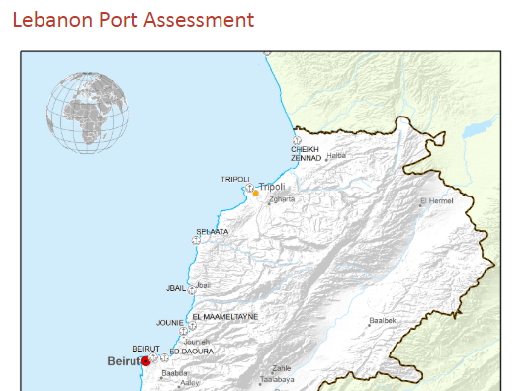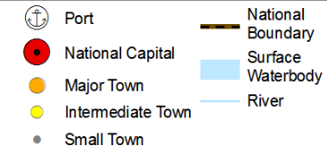
The Port of Tripoli is the second port in Lebanon after the Port of Beirut. It has an approximate area of 3,000,000 m2, with a water area of 2,200,000 m2, a land area of 320,000 m2, and a 420,000 m2 dump area adjacent to the current port, reserved for the future Container Terminal and Free Market Zone (which are under construction). Most shipments carry general goods and dry discharge such as iron, wood, and sugar, various kinds of beans, iron scrap, vehicles, and construction material. The Port of Tripoli also contains a Free Zone with an area of 150,000 m2. The Port is currently undergoing expansion projects, where a new 600 m long berth is being built for container trade, with a rear zone area of 1,200,000 m2. This zone has been approved by the Lebanese Parliament as a free economic zone. The Port of Tripoli is independent both administratively and financially, and is governed by the General Code for Public Institutions according to decree no 4513. The Port is managed by a Board of Directors composed of 5 members elected for 3 years.

Roads and highways, completed and ongoing projects
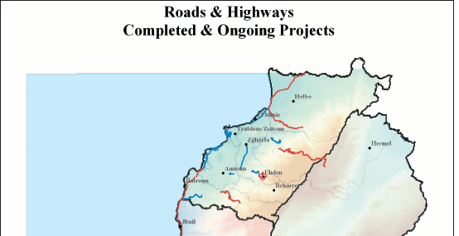
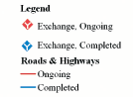
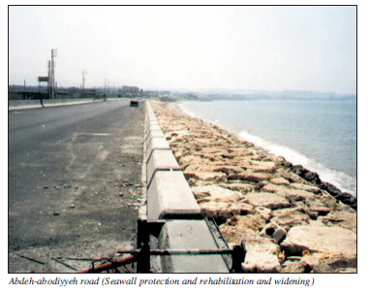

Tripoli - Syrian Border Connection
This project aims to improve the roads which connect North Lebanon with the Syrian border. It includes the construction of the eastern Tripoli ring road extending towards al Abdeh (20 kilometers to the north), and the widening and rehabilitation of two roads extending to Arida (along the coast), and to Abboudieh on the Syrian border. This project is financed by the Islamic Development Bank (IDB) and OPEC Fund for International Development (OFID). The contracts for Deir Ammar-al Abdeh road and al Abdeh- Homs/Abboudieh intersection have been awarded.

Sir ed Danniyeh-Jbab el Homr- Hermel:
Studies for these sections have been completed. However, the procedures for expropriation of lands are still going on. Funding was provided by the Arab Fund for Economic and Social Development. The contract for Sir ed Danniyeh- Jbab el Homr section has been awarded, and the Jbab el Homr-Hermel Section contract was awarded in the summer of 2004. In addition, the rehabilitation works of the Dael-lower Tannourine road is expected to be completed during 2005 (US$ 5.6 million).
Rehabilitation and development works of Tabarja-Chekka highway, financed by the European Investment Bank, were completed in the summer of 2004.
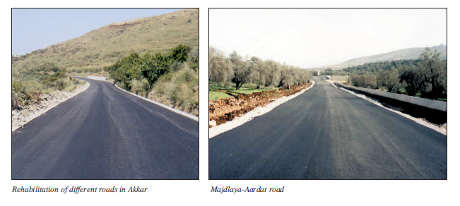
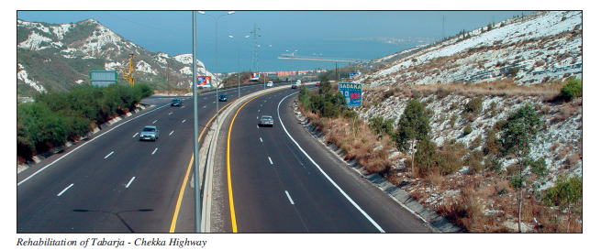

Roads and highways under preparation projects
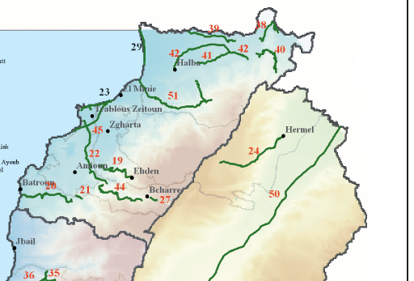
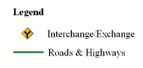
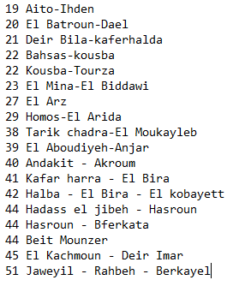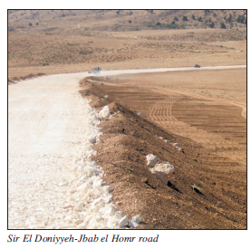

Rehabilitation of primary and secondary roads
Detailed studies for the rehabilitation of several sections of highways are complete. These sections are:
- Rehabilitation of Akkar roads: Studies and tender documents are under completion in phases. Awarding contracts will proceed as soon as funding becomes available.
- Options, feasibility and preliminary study for the Tripoli infrastructure development project.

Relevant government agency
The relevant government agency, the Ministry of Public Works and Transport in Lebanon is organized into four directorates:
- Directorate General of Land and Maritime Transport, responsible for setting, implementing and monitoring all policies related to land and maritime transport
- Directorate General of Roads and Buildings, which is responsible for the construction, rehabilitation, and maintenance of public roads and government buildings
- Directorate General of Civil Aviation, responsible for setting and implementing air transport policies within the country in compliance with international policies, and for controlling the air traffic within the Lebanese territory
- Directorate General of Urban Planning, responsible for setting and putting into practice land use policies
Additionally, the Council of Development and Reconstruction (CDR), and the Ministry of Public Works’ Rehabilitation and Reconstruction are responsible for road construction and maintenance in Lebanon.

Information on Road Authority contacts can be found in the following link:
https://dlca.logcluster.org/display/public/DLCA/4.1+Lebanon+Government+Contact+List

Transport Corridors
Lebanon has three operating corridors with Syria. These corridors are:
- Al Masnaa- Al-Jdeidah border entry point (at the eastern part of Lebanon) 60 km from Damascus and 110km from Beirut. This is the main corridor that connects the Lebanese and Syrian capitals.
- Al-Arida-Tartous border entry point (at the northwest end of Lebanon). This corridor is located at the coastal area and widely used for cargo transportation between Syria and Lebanon. It is 45km far from Tartous on the Syrian side and 170km far from Beirut on the Lebanese side.
- Al-Abboudiyeh - Al-Dabouseyah border entry point (at the northeast end of Lebanon). This corridor connects Homs governorate (from the Syrian side) with Tripoli (from the Lebanese side). It is widely used for cargo transportation (especially in-transit cargo to Iraq).
During the winters, road challenges due to heavy snow have temporarily affected the use of the international highway leading to the Lebanon-Syrai Al Masnaa Crossing, at Dahr al Baidar area. However, this is usually cleared by the Ministry of Public Works within a maximum of one day. On a few occasions the Beirut-Damascus highway has also been closed due to security reasons, but overall remains the most consistent transport corridor from Lebanon to Syria.
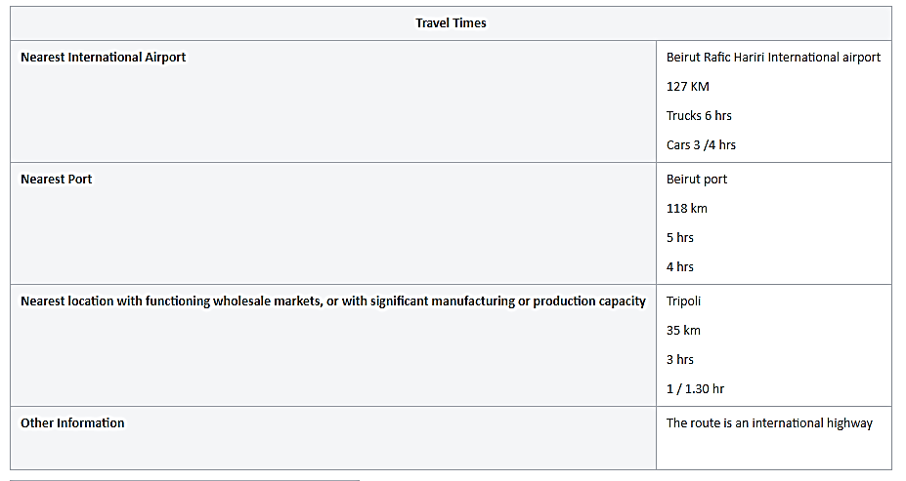

Distance Matrix
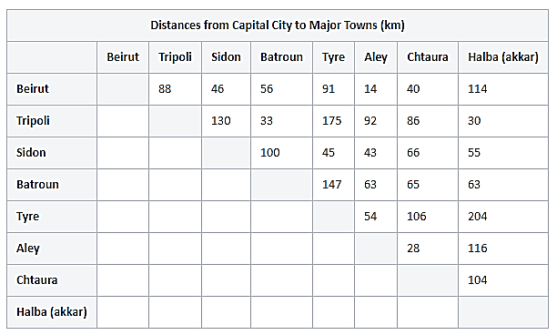
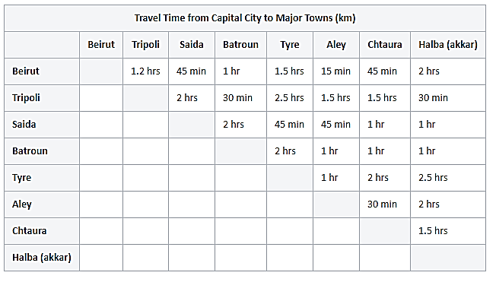

Road Security
Road Security: Good
Public transportation is generally safe. Emergency services in Lebanon are adequate. In case of a road accident, emergency numbers are 140 for the Red Cross and 125 for Civil Defence, and 112 for teh Police.

Weighbridges and Axle Load Limits
Since October 2014, in order to ease rush-hour congestion, a renewed plan by the government allows trucks to transport goods only from 10.00 hours to 14.30 hours and from 19.00 hours to 06:30 hours.
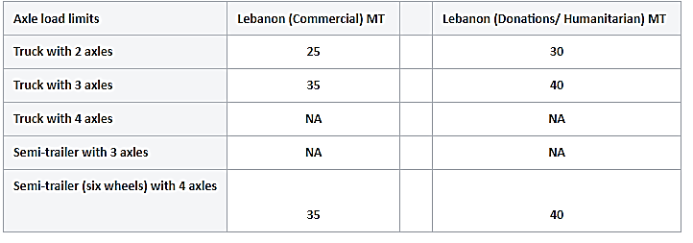

Road Class and Surface Conditions
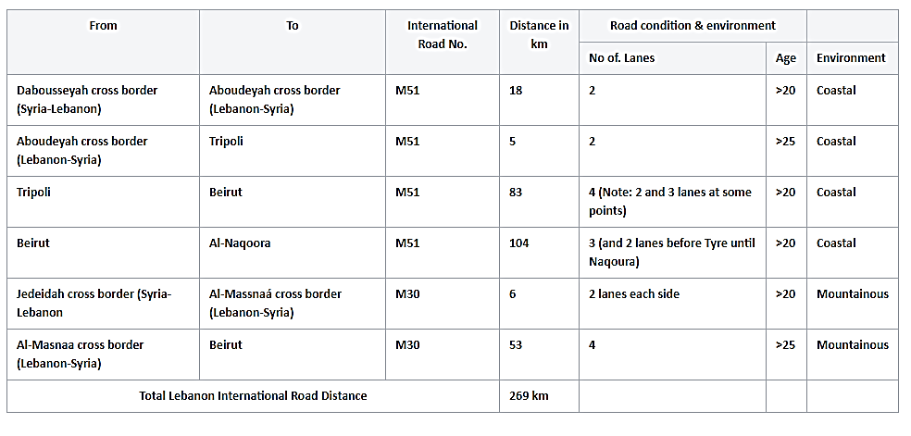

Tripoli Projects
This part is taken from a whole study with financial and numerical data. For more specific information, please have a look on the report presented in the site below:
https://openjicareport.jica.go.jp/pdf/11688538_02.pdf

TRIPOLI BOULEVARD UNDERPASS PROJECT
Tripoli Boulevard is functioning as the primary arterial street and at the same time as an international highway. It passes through the Central Urban Area of Tripoli where through and local traffic is concentrated. The section from Halim Abu Azz El-Deen Roundabout to Bisar Street (hereinafter referred to as the Central Section) is the most critical section in the Study Area in terms of traffic congestion and air pollution.
Present Condition of the Central Section:
- Road width: Dual 9.0 m carriageways with 4.0 m center median and 4.8 m sidewalk on both sides. Road right-of-way width is 42 m by the latest decree in 2001. It has 2 lanes with shoulder (or loading/unloading zone) on each direction.
- Intersections: There are 4 major intersections in the 775 m Section with an interval of 220 m to 295 m. Short interval between intersections is one of the causes of traffic congestion.
- Traffic volume: Tripoli Boulevard – 25,000 ~ 29,000 veh./day
- Intersecting Roads – 9,400 ~ 19,600 veh./day
- On-street parking: Shoulders on both sides are occupied by parked vehicles. One lane on each direction is frequently blocked by double parked vehicles, thus only one lane is effectively functioning as a travel way. Such condition is greatly reducing traffic capacity of the road.
- Travel speed: 8 ~ 20 km / hour.
- Level of service: F which means capacity is exceeded by traffic volume and requires urgent measures.
- Noise level: 100 ~ 105 dBA which is exceeded the standard of 72 dBA.
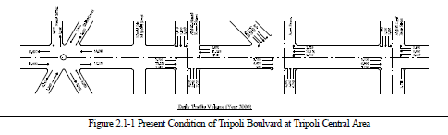
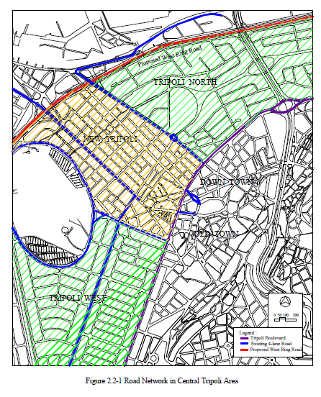
Alternatives Plans
Basically, a scheme of underpass is selected rather than overpass due to landscape and environmental considerations, as overpass schemes are opposed by all concerned authorities. Five alternatives are developed to select the optimum plan for implementation. Alternatives have different lengths and number of intersections to be under-passed, which will affect the cost and efficiency of the underpass.
- Scheme-1: To provide an individual underpass for each intersection A, B, C & D.
- Scheme-2: To provide a continuous underpass for the most congested intersections of B & C.
- Scheme-3: To provide a continuous underpass for three congested intersections of B, C & D.
- Scheme-4: To provide a continuous underpass for 3 intersections A, B & C.
- Scheme-5: To provide a continuous underpass for all 4 intersections A, B, C & D.

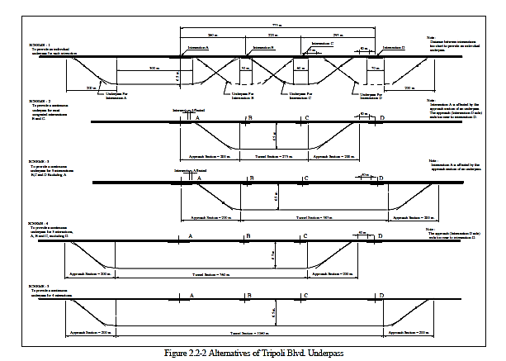
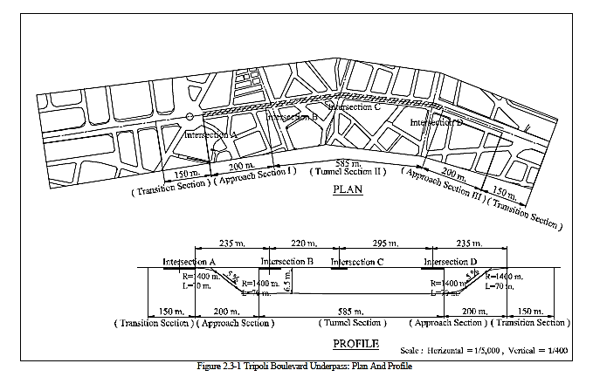
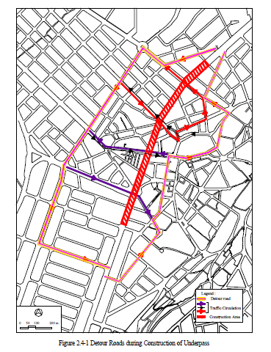

CENTRAL TRIPOLI TRANSPORT MANAGEMENT PROJECT

PRESENT CONDITIONS AND PROBLEMS
Central Tripoli which consists of Central Business District (CBD) and extended to cover all the near surrounding main commercial streets, touristic area, old town market area and shopping area along Abou-Ali River. New Tripoli is the busiest area in the Study Area with concentration of commercial and business activities as well as cultural and historical spots. Accordingly, people are concentrated and high volume of traffic is generated and attracted in the area. Present condition and problems are as follows as shown in Figure 3.1-1.
- Road Network and Road Space Utilization
- Roads are mostly narrow and road network is like a maze, particularly downtown and old city areas.
- Road space is not fully used for traffic purpose due to heavy on-street parking.
- There is no room for road widening or construction of new road due to high density roadside development.
- Inter-City Buses
- There is no off-street inter-city bus terminal, but existing roads are used as the inter-city bus terminal (or on-street inter-city bus terminal).
- Inter-city buses wait for passengers on a road until enough passengers boarded on it, thus traffic is severely disturbed.
- On-street inter-city bus terminals are concentrated along the busiest roads.
- Taxis
- There is no off-street taxi terminal stand. Taxis are parking on streets to get 4 or 5 passengers.
- Over-supply of taxi service is obvious. Many taxis cannot get passengers, but park on a street all day long.
- Taxis are concentrated at Public Garden and J. Abd El-Nasser Square areas.
- On-Street Parking
- Many vehicles park along streets, narrowing a road space for travel way.
- One-way Traffic Operation
- One-way traffic operation is being extensively adopted in the most of areas, this system is successful, but there are some areas where this system needs to be improved.
- Environmental Condition
- Due to concentration of traffic, its slow moving conditions, and many old-age vehicles, air quality is seriously deteriorated.
- Factors affecting Tourism Development
- Historical and cultural heritages are concentrated in the old city area. Proper parking areas, improvement of sidewalks and pedestrian roads and beatification of area are needed to attract more tourists.
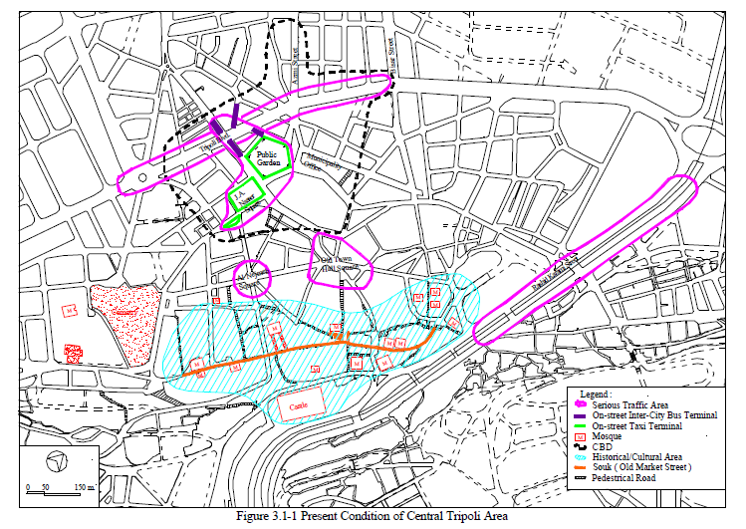

PROPOSED BUS/TAXI SERVICE SYSTEM AND TERMINALS
Bus/Taxi Service System needs to be planned in relation to provision of terminals. In the Master Plan, the following are recommended:
- Introduction of City Bus (Short term: 2001-2005).
- Construction of Behsass Terminal (Short term: 2001-2005).
- Construction of Bedaoui Terminal (Medium term: 2006-2010)
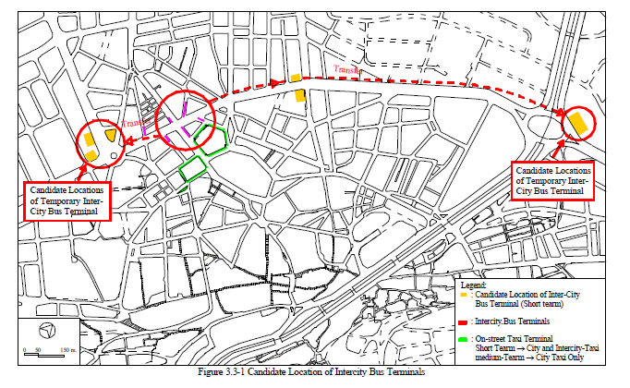

ONE-WAY TRAFFIC SYSTEM
Present One-Way Traffic System
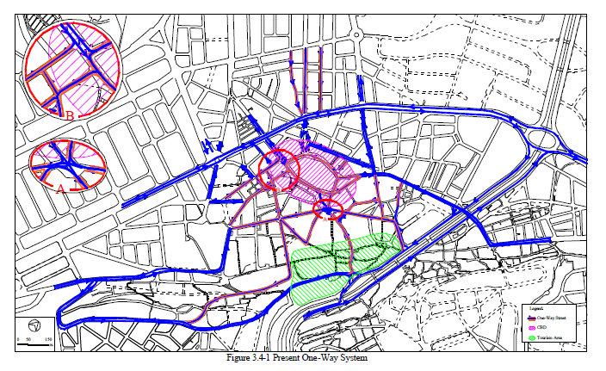
Proposed One -Way Traffic System
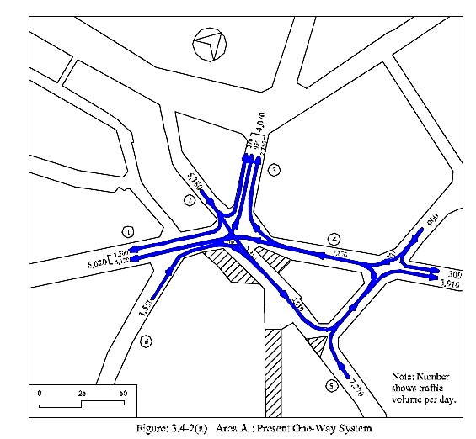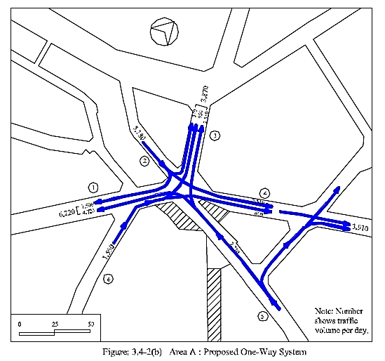
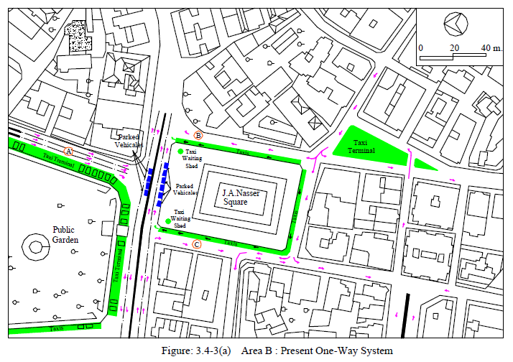
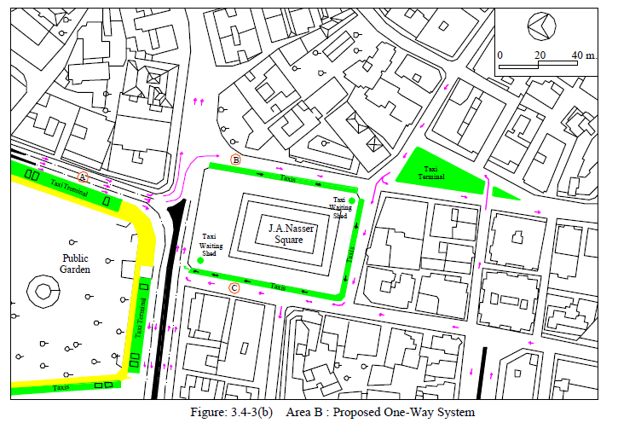
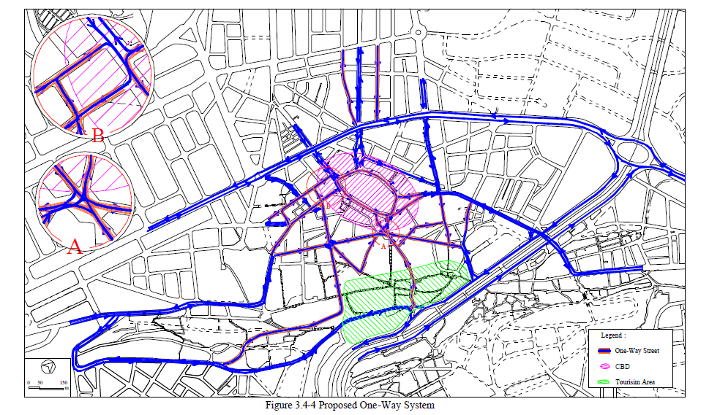

ON-STREET AND OFF-STREET PARKING
On-Street parking
Table 3.5-1 shows the results of the parking survey for the major corridors. The total number of vehicles parked during the working day from 8 A.M to 3 P.M. is 4,753 vehicles. The ratio of vehicles parked on sidewalk is 10% while the ratio of double parking is 15%. Table 3.5-2 shows a summary of these main findings.
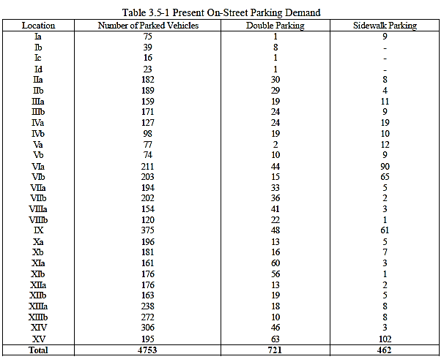
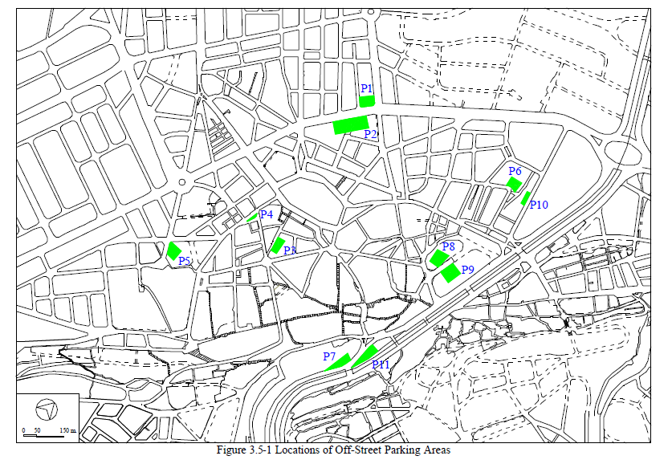
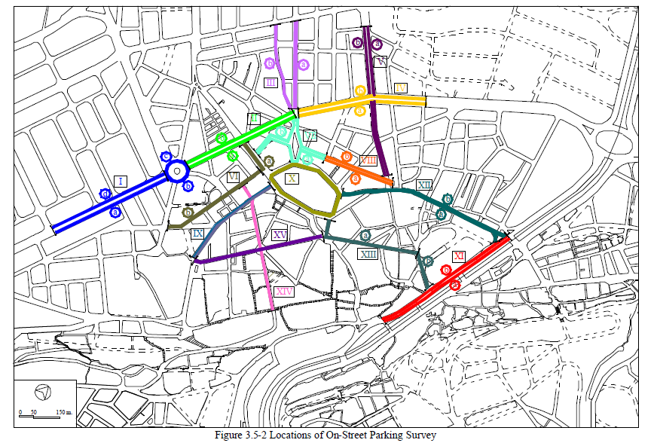The street inventory survey shows that the on-street parking supply is about 2,000 spaces. The presently parking condition based on the street inventory survey is shown in Figure 3.5-3.
Figure 3.5-4 shows the locations where double parking and parking on sidewalk are frequently or often observed. Based on this figure the following locations are highlighted as the locations with high demand.
- Sahet El-Tal
- El-Saraya El-Kadimah
- El-Nejma Square
- Tripoli Boulvard
- Around Tripoli Municipality
- Azmi Street
- El-Mitain Street
- Abou Ali River Near to the Old Market
Under the Master Plan Study the total present demand was estimated as 3,000 spaces. As mentioned, currently the on-street supply is about 2,000 spaces. That means under the current condition the central area needs at least additional 1,000 spaces without prohibition of the on-street parking. When the on street parking will be prohibited the central area will require 3,000 parking stalls. However, there are presently about 500 over supply off-street parking stalls which mean that the central area will be in need for an additional 2,500 stalls to manage the complete prohibition of on-street parking.
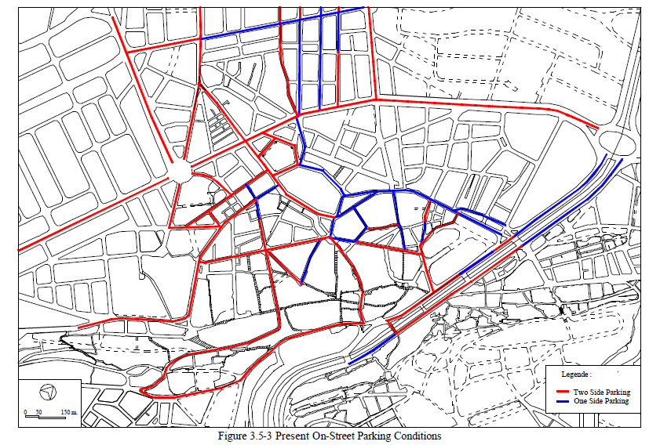
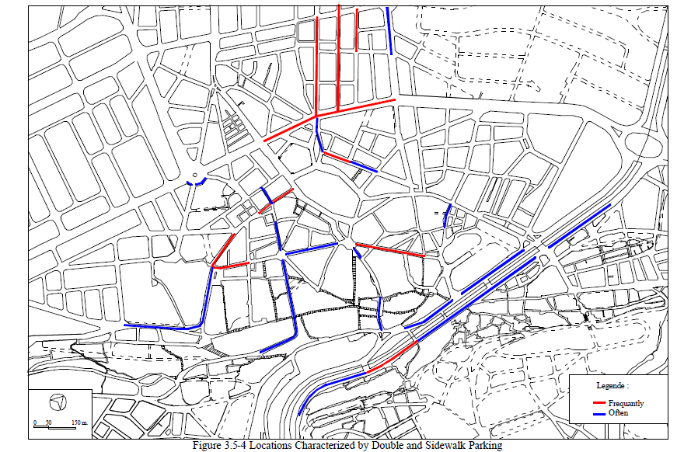

Off Street parking
The second stage survey for the all off-street parking areas within the downtown study area shows that there are 11 locations. The survey was carried out to estimate the supply on each location. The locations are shown in Figure 3.5-1. The capacity of each location and the total off-street parking capacity is shown in Table 3.5-6.
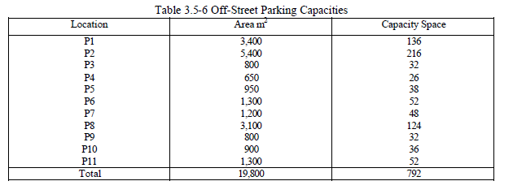
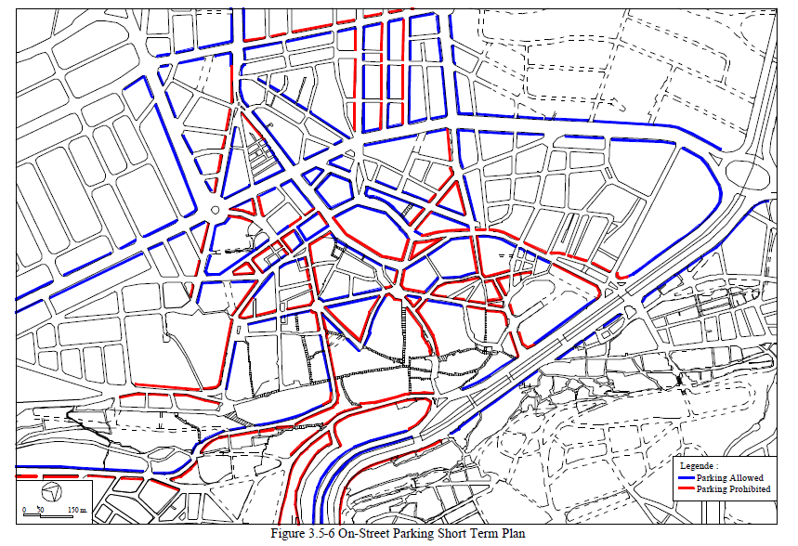
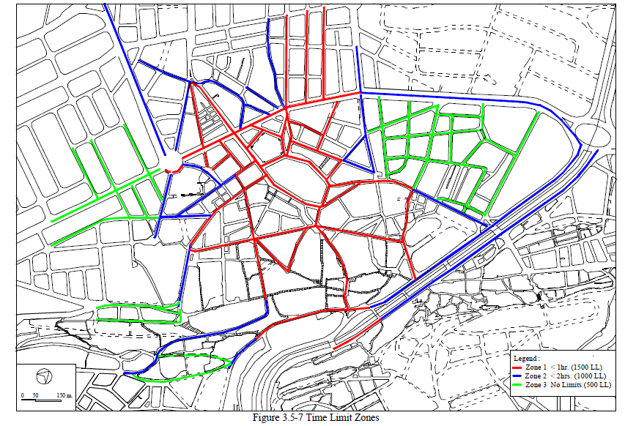

INTERSECTION IMPROVEMENT AND TRAFFIC SIGNALS
Present traffic circulation is shown early in Figure 3.4-1. The investigation highlighted two areas where traffic rerouting is required. The traffic circulation on the downtown area after the required rerouting is shown in Figure 3.4-4.
Due to this rerouting and construction of the Tripoli Boulvard underpass the intersections where improvements and traffic signals will be required during the Short-term Plan were selected as shown in Figure 3.6-1. There are eight locations where geometrical improvement and traffic signals will be required. Three of these locations are along the Tripoli Boulvard which are intersections numbers 16, 20 and 22. These three locations are already included in the traffic signal plan of the CDR. Concerning the improvements cost of these three intersections it will be included with the required cost for the constraction of the underpass.
From the other five locations, there are three already included in the traffic signal plan by the CDR which are intersection numbers 14, 17 and 23. However, only intersection number 17 is included in phase I of CDR plan. The others 14 and 23 are included in phase II. Therefore, these two intersections plus the intersections at Sahet El-Taal and Al Saraya Al Kadima must be considered in the phase I of CDR traffic signal plan.
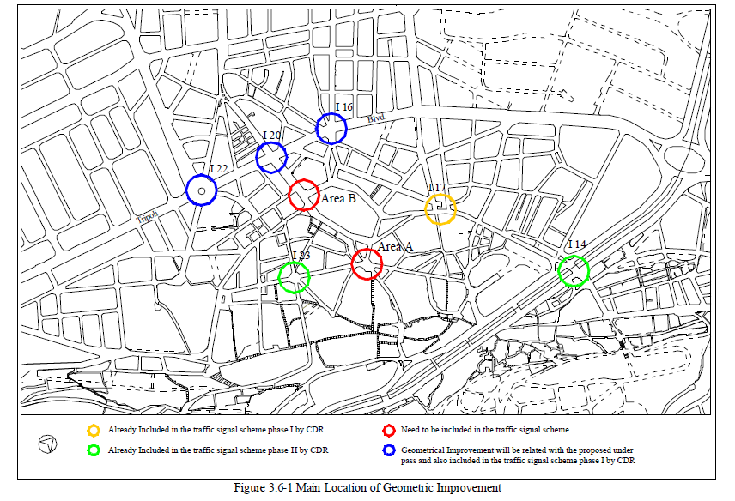
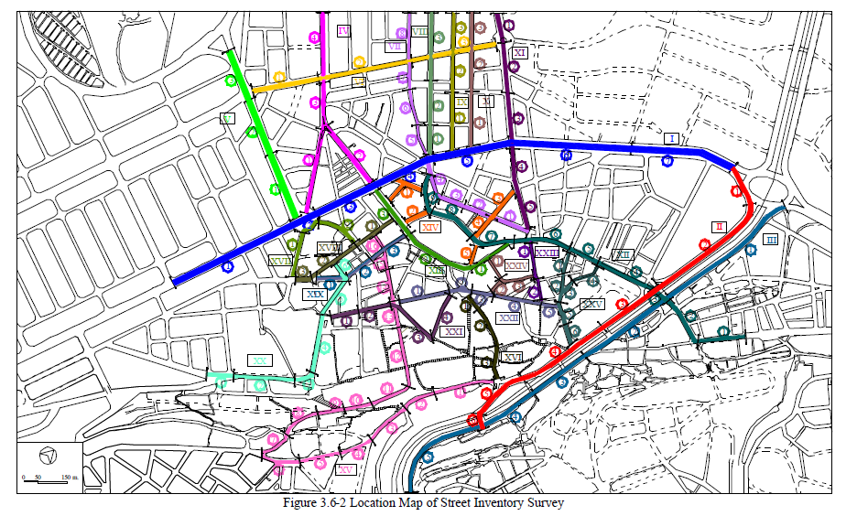
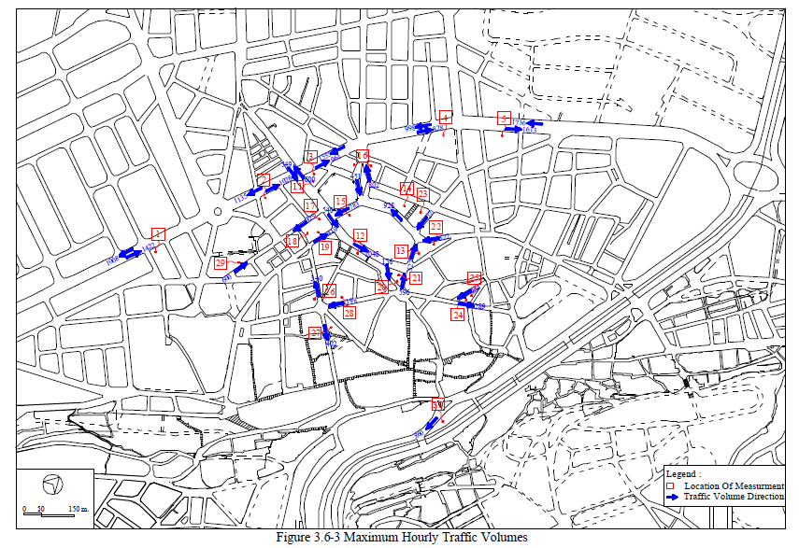
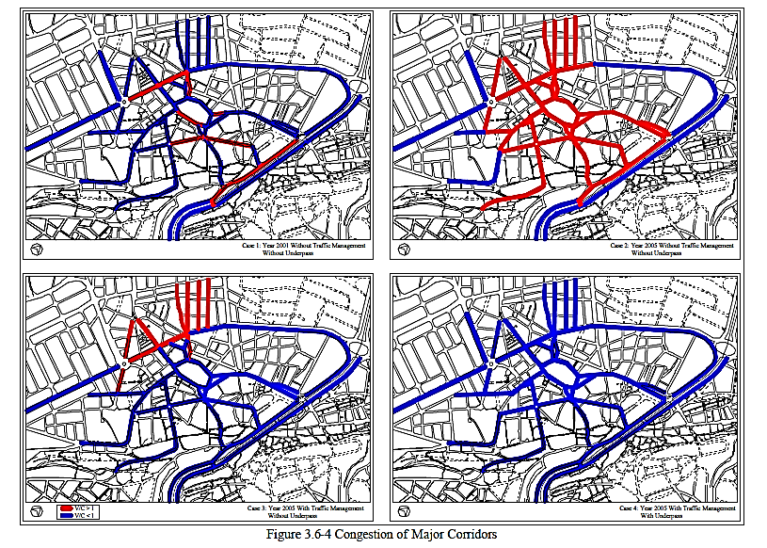
Intersection Improvement and Traffic Signals
During the Short-term Plan improvement of eight intersections have to be considered. There are three intersections will be related to the underpass project. For the other five intersections that their locations are shown in Figure 3.6-1 the geometrical improvement plan and traffic phasing system are shown in Figure 3.6-6 to 3.6-11. At Sahat El-Tal two alternatives have been considered as shown in Figure 3.6-10 and 3.6-11. The first one is much better for the smooth traffic circulation but it needs to cut and add some sidewalk areas. There is no problem with this plan. However, if the Tripoli Authority dislike to carry out this modification, the second alternative can be used.
In the geometrical planning the traffic re-routing was taken into consideration. The traffic circulations in these intersections are based on the proposed one-way system plan shown in Figure 3.4-4.
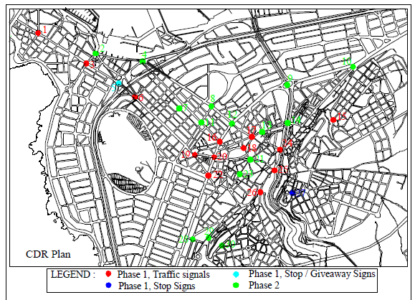
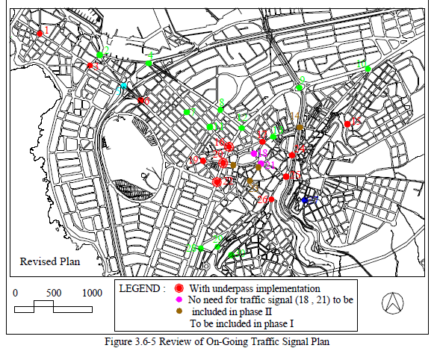
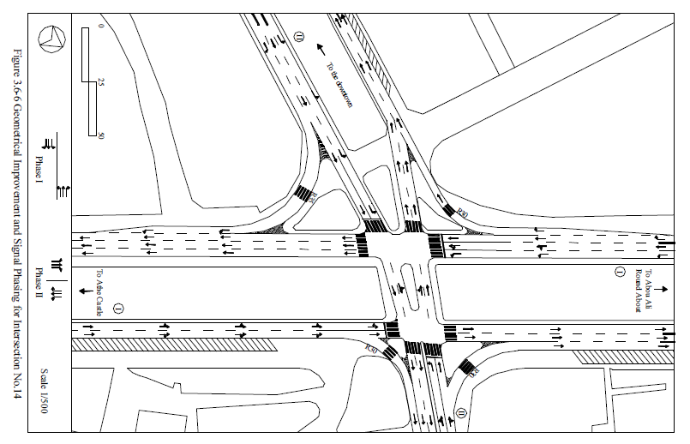
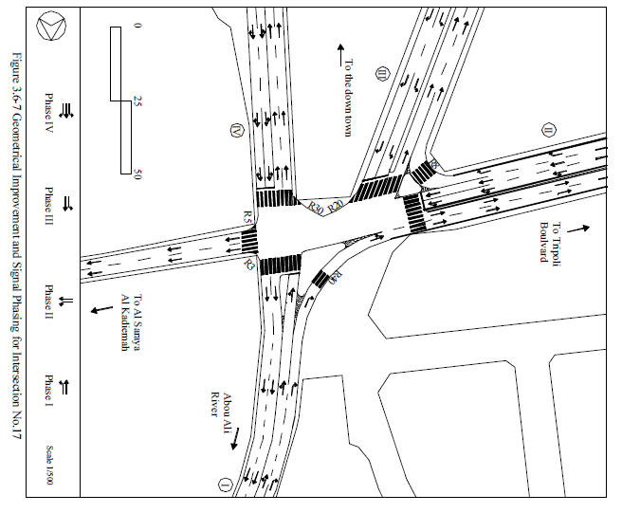

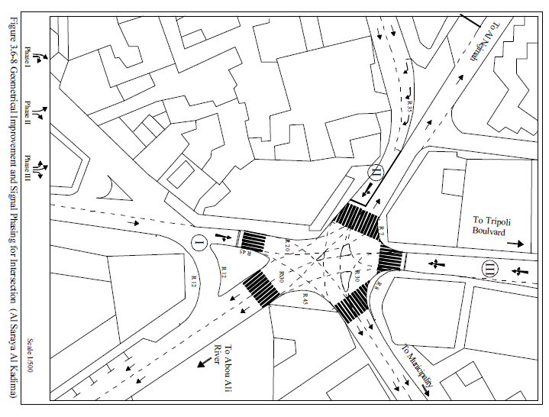

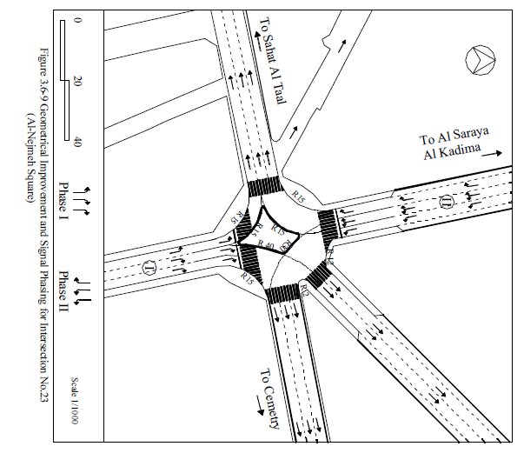
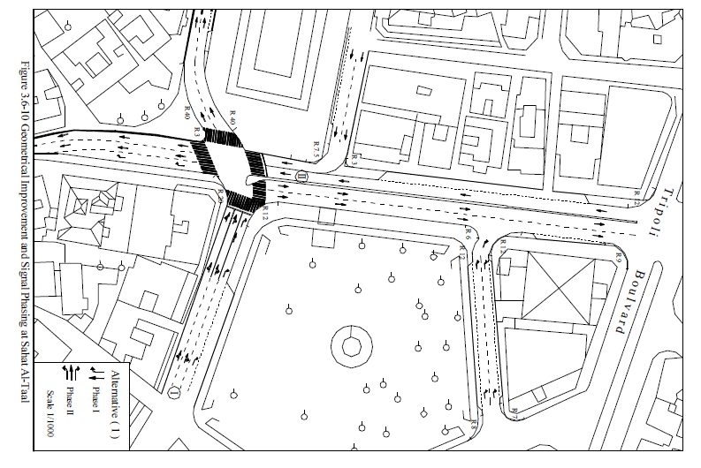
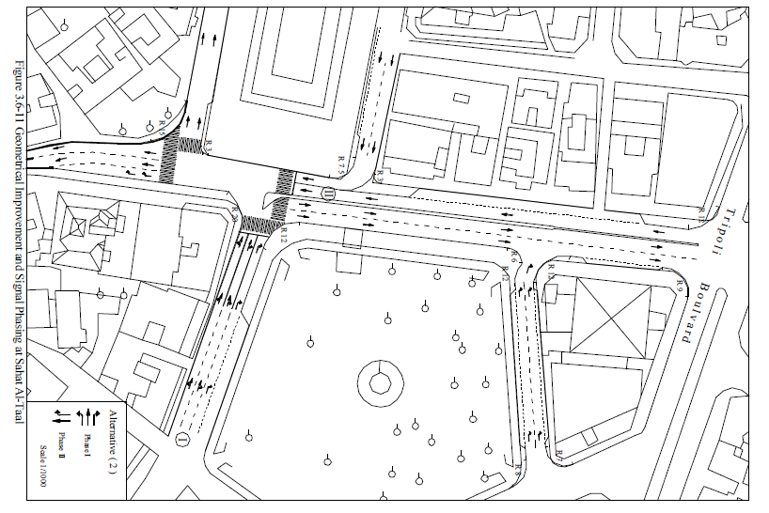

TRAFFIC SAFETY FACILITIES
Traffic safety must protect the road users including both vechile drivers and pedestrians. Recently Tripoli City suffer a considerable shortage in the traffic safety facilities such as pedestrain signals, guard rails, pedestrain over and under pass, and bad condition of sidewalk. The pavement condition can consider also under the saftey facilities since the bad pavement conditions are reduceing the control abilty of drivers. The bad pavement condition is preventing the application of the road marking that can severly affected the safety.
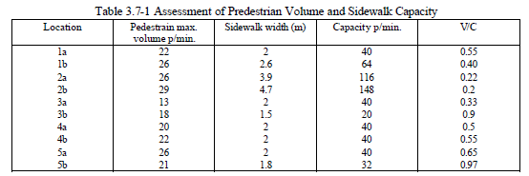
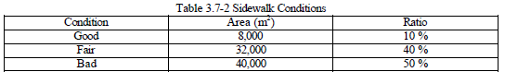
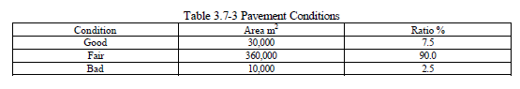
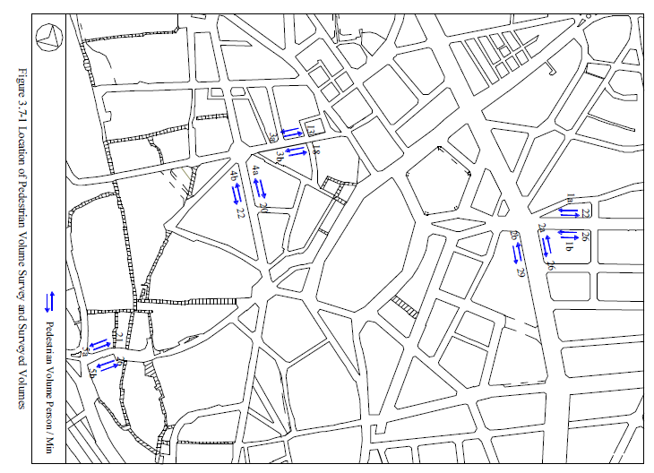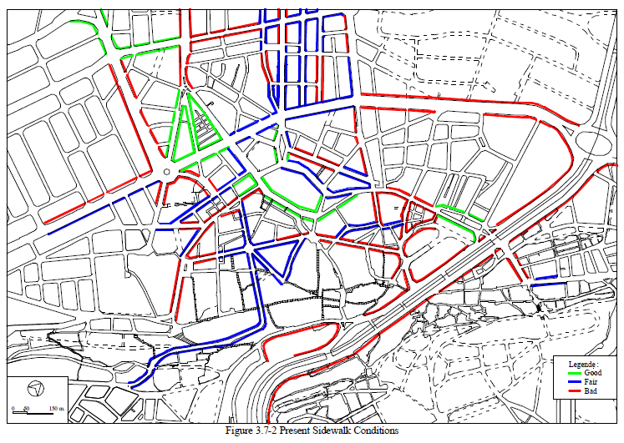
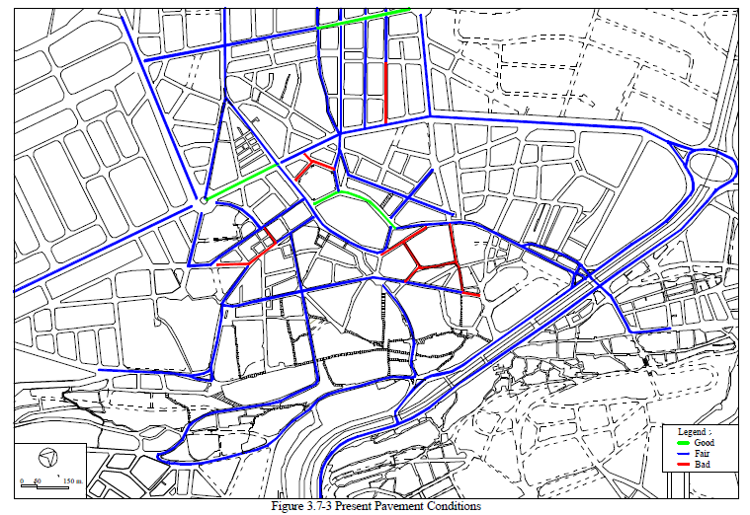
The investigation of present condition shows that the city is in need for the safety facilities improvement in the short and medium plans. The improvement for the city as a whole was clarified before under the Master Plan Study in Technical Report-4. For the downtown area the city will need to consider the following facilities during the Short-Term Plan:
- Sidewalk Improvement
- Pavement Improvement
- Guard Rails
Traffic Signs:
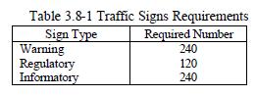
Pavement Marking:
There is no marking in all of the downtown area. In the field of the pavement marking the following marking types have been considered:
- Lane marking.
- Cross-walk marking.
- On-street parking.
- Off-street parking.
- Channelization.
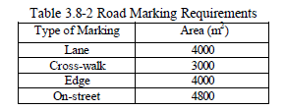
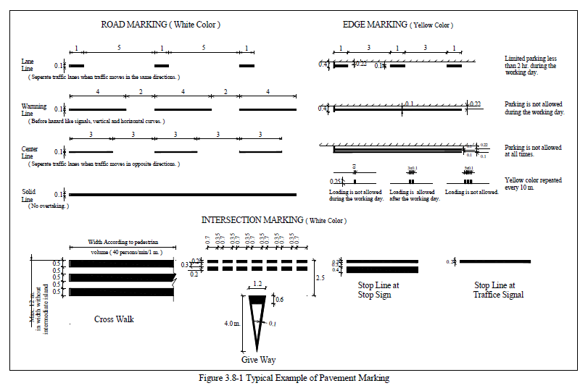

https://en.wikipedia.org/wiki/Rene_Mouawad_Air_Base#Future_development
https://dlca.logcluster.org/display/public/DLCA/2.1+Lebanon+Port+Assessment
http://www.cdr.gov.lb/eng/progress_reports/pr072005/Eroads.pdf
http://www.cdr.gov.lb/eng/progress_reports/pr072005/Eroads.pdf
https://dlca.logcluster.org/display/public/DLCA/2.3+Lebanon+Road+Network

