Maysaa kamardine

Inactives power plants in North Lebanon

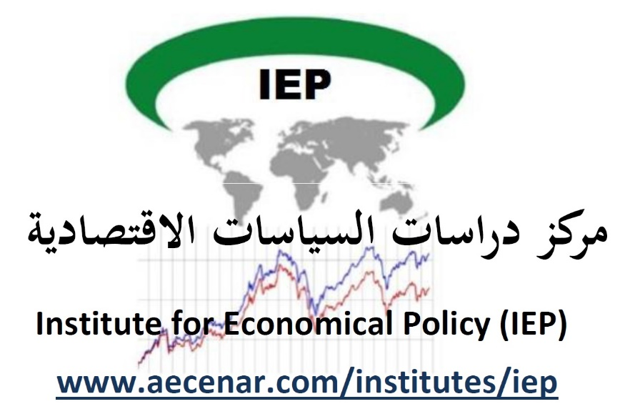

Contents
Inactives power plants in North Lebanon I
1 Thermal power plants and their installed and available capacity . 1
1.1 Investments in electricity. 3
1.2 The most important projects to be undertaken 3
2 MILESTONE OF EDL 5
2.1 The capacity and costs of production of existing power plants. 7
2.2 Operational goals of the national strategic plan for the sector deferred electricity (2019-2015) 7
2.3 Electricity production required in the short and long term with the corresponding transport works 8

Thermal power plants and their installed and available capacity .
(https://www.lebarmy.gov.lb/fr/content/participation-priv%C3%A9e-dans-le-secteur-de-l%E2%80%99electricit%C3%A9-au-liban)
About 87% of the electricity in Lebanon is of thermal origin and is produced by the two thermal power stations in Zouk and Jieh, by the two combined cycle power stations in Beddawi-Deir Ammar and Zahrani which, for lack of natural gas, are currently operating diesel oil from the two gas turbine power plants at Baalbeck and Tyr.
EDL produced around 8,056 GWh in 2006. Of the electricity produced by EDL, a significant part is lost due to technical losses in the network or theft. According to EDL statistics, technical losses amounted to around 15% in 2007 and the rest amounted to around 18% in the same year. This 18% non-technical loss translates into a loss of around $ 150 million and is partly explained by a weak billing system in the EDL and also by political interference in its operations. Actions are necessary and urgent. They include a revision of the billing system; an internal reorganization of the billing system; outsourcing of invoicing, as well as modernization of collection techniques.
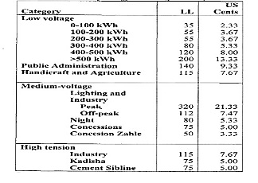
Sources: Leb. Hidrocarbon Strategy Study, 2004; World Bank, 2007/08; Banque Mondiale, 2008, p.77

Investments in electricity.
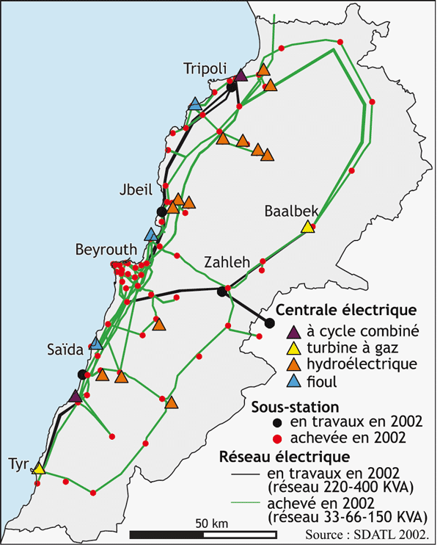

The most important projects to be undertaken
At the level of the Production Sector.
- Reparation for damage incurred following the 2006 Israeli assaults at the Jieh factory.
- Rehabilitation of the third and fourth production units at the Zouk factory.
- Rehabilitation of phases 1, 2 and 3 at the Zouk plant. The cost of these projects is estimated at $ 100 million
- Extension of the natural gas line between Baddawi and Zahrani, via the factories of Zouk and Jieh. The cost of this project is estimated at $ 150 million.

At the Transport Sector level.
- Construction of two main 220 KV high-voltage electricity transmission stations in Baalbeck and Saida. The cost of this work is estimated at around $ 12 million.
-Construction of a main high-voltage transmission station of 220 KV in Tripoli. The cost of the work is estimated at around 25 million dollars.
- Construction of a main high-voltage transmission station of 220 KV in Achrafieh. The cost of the work is estimated at around 25 million dollars
-Construction of a main 220 KV high-voltage electricity transmission station in the southern suburbs of Beirut with the installation of a high-voltage cable connecting the station to the current network. The cost of the work is estimated at around $ 31 million.
- Reinforcement of the 220 KV cable between Aramoun and Horch. The cost of the work is estimated at around $ 5 million.
- Strengthening of the internal network for the transmission of electrical energy, 66 KV, high voltage between Deir Nbouh and Marjayoun. The cost of the work is estimated at approximately $ 25 million.
- Implementation of the second phase of the 400 KV seven-year link line between Ksara and Syria. The cost of the project is approximately US $ 12 million.

At the level of the Distribution Sector.
- Reparation for the damage caused by the last Israeli aggressions against Lebanon in July 2006, in the distribution sector in all the Lebanese regions affected by the aggression.
- Supplying Lebanon's electricity with cables, transformers, partitions, pylons and accessories.
- The purchase of crane cars and cars to examine the damage of underground cables. All at an estimated cost of $ 50 million.
However, the execution of these projects will depend on the funding available. The government will need to carefully consider the safest way to partner with the private sector to finance investments.

MILESTONE OF EDL
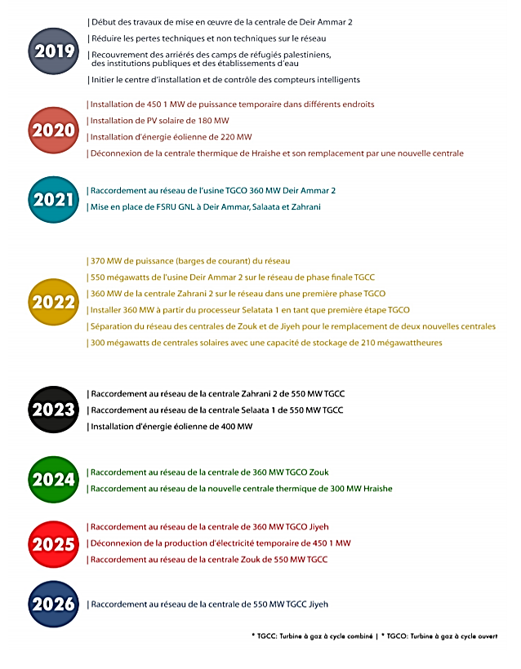
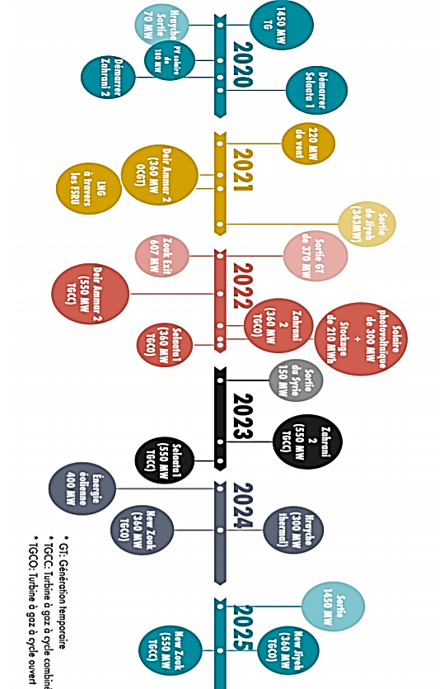

The capacity and costs of production of existing power plants.

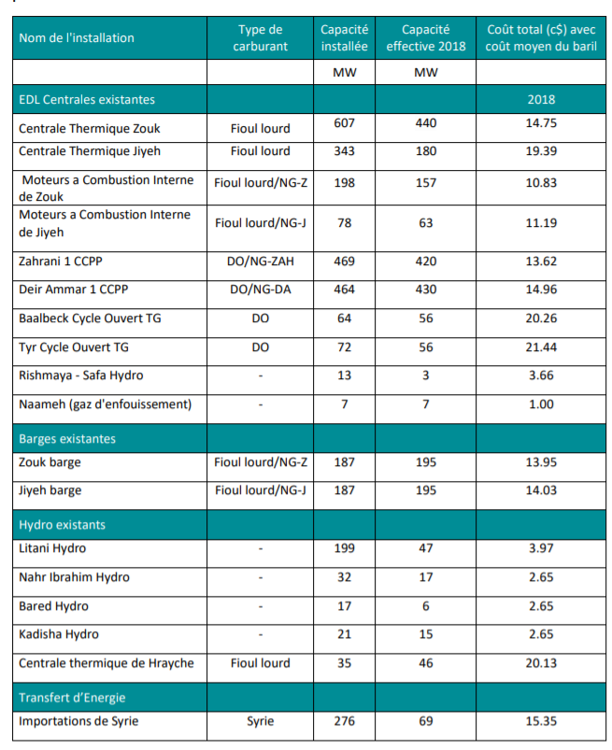

Operational goals of the national strategic plan for the sector deferred electricity (2019-2015)
The goals of the adjourned plan are divided into three factors, which if they remain unchanged, will contribute to the increase in the deficit during the coming years :
1- The technical and non-technical losses that it is envisaged to reduce from 34% in early 2019 to around 12% in late 2021 and this to through the implementation of transport and distribution projects and dealing with non-technical losses.
2- Improvement of the production system, in particular by the efficiency and the type of fuel used: the replacement of old plants by new plants, adding new ones power plants and conversion to natural gas.
3- The increase in the tariff to cover production costs, transport and distribution based on anticipated production for next five years.
To assess the effect of each factor on the current reality of EDL at Note that :
- Any reduction of 1% in technical or non-technical losses would result in a gain of 20 billion Lebanese pounds for EDL.
- Any increase in production capacity of 100 MW, although it would decrease the average cost of production, would result into a $ 60 million deficit increase based on EDL’s current rate (priced at $ 66 per barrel of crude oil).
- Any rate increase of 1 US ₵ / kWh would result in a $ 100 million deficit reduction

Electricity production required in the short and long term with the
corresponding transport works
