North Lebanon Roads Network and Public transport

Author: Maryam Abdel-karim

Last Update: 17.03.2020

Contents

1 Transportation 5
1.1 Roads 5
1.1.1 Motorways 5
1.2 Buses 6
1.3 Ferries 6
1.4 Taxis and services 6
1.4.1 Types of taxis in Lebanon 7
1.4.2 Carpooling 7
1.5 Airport 8
1.6 Cable Car 8
1.7 Rail transport 8
1.8 Port 9
2 Roads and highways, completed and ongoing projects 10
2.1 Tripoli - Syrian Border Connection 10
2.2 Sir ed Danniyeh-Jbab el Homr- Hermel: 11
3 Roads and highways under preparation projects 12
4 relevant government agency 14
5 Transport Corridors 15
6 Distance Matrix 16
7 Road Security 17
8 Weighbridges and Axle Load Limits 18
9 Road Class and Surface Conditions 19

Transportation
Transportation in Lebanon varies greatly in quality from the ultramodern Beirut International Airport to poor road conditions in many parts of the country. The Lebanese civil war between 1975 and 1990 and the 2006 Lebanon War with Israel severely damaged the country's infrastructure.
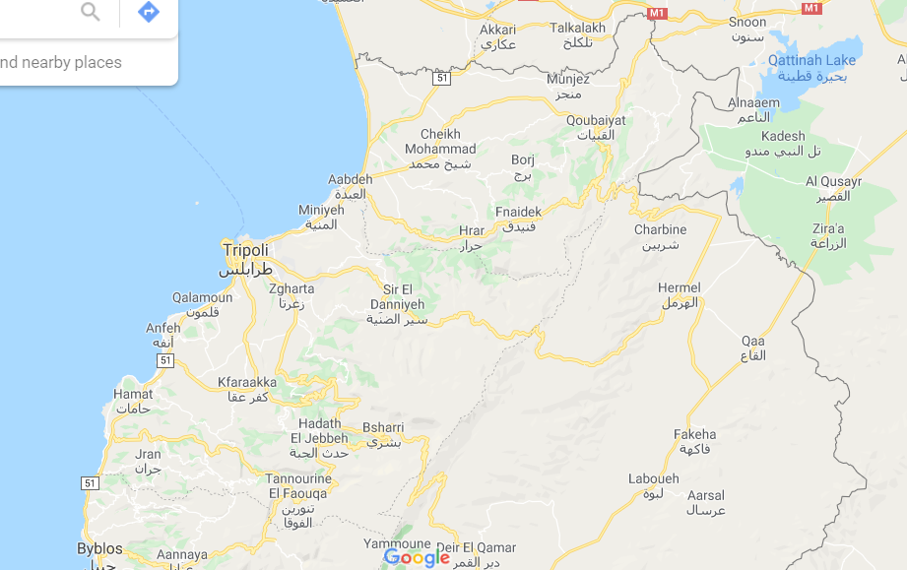

Roads
Lebanon has an extensive road network throughout the country, generally in good conditions, though it varies. The main roads in the north Lebanon are:
- Beirut - Byblos - Tripoli - Aarida
- Tripoli - Bsharri – Baalbek

Motorways
Part of the main road network have been updated to dual carriageway, four-lane motorways, which are the following in North Lebanon:
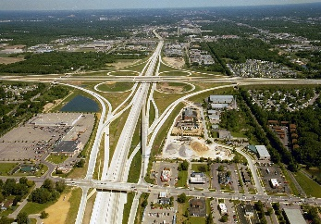
- Beirut - Tripoli. Length: 81 km.
- Tripoli - Khane. Length: 20 km

Buses
An overland trans-desert bus service between Beirut, Haifa, Damascus and Baghdad was established by the Nairn Transport Company of Damascus in 1923.
Beirut has frequent bus connections to other cities in Lebanon and major cities in Syria. The Lebanese Commuting Company, or LCC in short, is just one of a handful brands of public transportations all over Lebanon. On the other hand, the publicly owned buses are managed by le Office des Chemins de Fer et des Transports en Commun (OCFTC - is the Lebanese government authority which operates public transportation in Lebanon), or the "Railway and Public Transportation Authority" in English. Buses for northern destinations and Syria leave from Charles Helou Station.
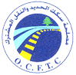
Buses are popular and inexpensive and can be stopped anywhere along the way simply by hailing

Ferries
Apart from the international airport, the Port of Beirut is another port of entry. As a final destination, anyone can also reach Lebanon by ferry from Cyprus, or Greece or by road from Damascus, etc. The Port of Tripoli (Lebanon) is also a port of entry and ferries usually come from Taşucu, Turkey.
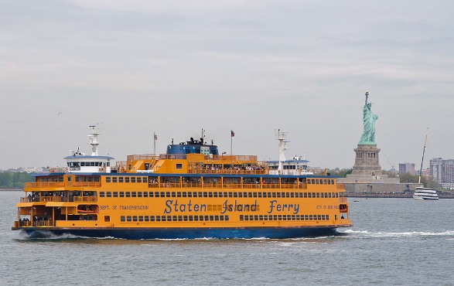

Taxis and services
In order to get from one place to another, people can either use a service or taxis. A "service" is a lot cheaper than a "taxi" as the passenger would be sharing the cab in the first place unlike the latter, where he would have the cab to himself.
Cabs can be recognized by their red license plates (indicating that it is licensed for public transportation). The driver would pull aside for if the person hails while seeing him. He will then ask for his destination and then will decide whether he will drive the passenger with the regular fare, an extra, or not at all.

Types of taxis in Lebanon

Service-taxis
One has to specify one's destination and enter the taxi only if one's destination corresponds to the itinerary of the Service-taxi. The driver stops to pick up additional passengers anywhere on the streets and drop them off generally in main squares and main streets. It remains advantageous with very low fares.
Local
LBP 2000 ($1.33) per person or LBP 4000 ($2.66) per person depending on how close/far the destination is. Prices within Beirut could vary depending on traffic and distance but overall should not exceed LBP 4000 per person (Maximum of LBP 5000 for Beirut outskirts). However, the driver could ask for more if the passenger intends to go to an area with high traffic.
Long Distance
Starts from LBP 5.000 ($3.33) and goes up from there.

Traditional Taxis
The driver must not pick up additional passengers. Most of these taxis are not equipped with meters, so it is important to negotiate the fare before embarking. The regular taxi fare starts at LBP 10,000 ($6.66).

Online services
Uber and Careem are both available in Lebanon as online services which are ordered online through the app and can be paid either online or by cash. These alternatives are sometimes cheaper than traditional taxis in Lebanon.

On-call taxis
Pick up people who have pre-booked by phone. They don't respond to hails in the street. They don't have a meter so passengers should ask the operator the price when they are booking the taxi, and double check with the driver at the end of the journey.

Carpooling
Carpolo App is an alternative mode of transportation in Lebanon. Upon downloading the app, users post their un-used seats and the app connects them with people who have matching rides. It is free for users on the public community and has private communities that can be accessed by invitation only. Carpolo uses gamification to incentivize drivers to list their empty car seats and offers incentives for carpoolers.

Airport
Rene Mouawad Air Base formerly and still sometimes known as Kleyate Airport used to be a military-civil joint airport in northern Lebanon, near the town of Kleyate and 6 kilometers (3.7 mi) from the Lebanese–Syrian border.
On January 2012, the Lebanese cabinet announced plans to restore the airport so that it will be used for cargo and low-cost airlines. Lebanese authorities who have visited the airport announced that the airport will encompass a 500-square-metre (5,400 sq ft) Duty Free area and that there is major consideration about connecting the airport to Tripoli and major cities using a modern railway. To date, however, nothing has come of these plans, and restoration of the airport has not yet begun.

Cable Car
No cable car (telepherique) in north Lebanon.

Rail transport
The Lebanese rail system is not currently in use, with services having ceased due to the country's political difficulties.

Port
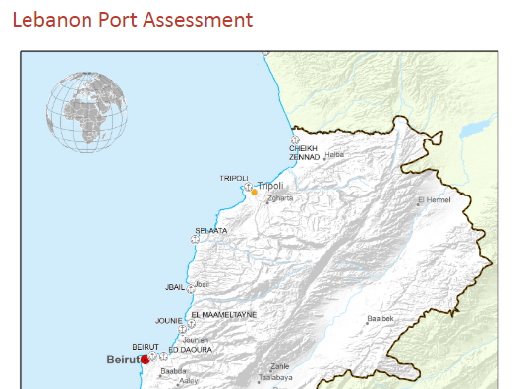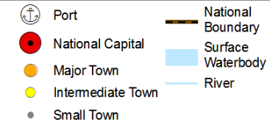
The Port of Tripoli is the second port in Lebanon after the Port of Beirut. It has an approximate area of 3,000,000 m2, with a water area of 2,200,000 m2, a land area of 320,000 m2, and a 420,000 m2 dump area adjacent to the current port, reserved for the future Container Terminal and Free Market Zone (which are under construction). Most shipments carry general goods and dry discharge such as iron, wood, and sugar, various kinds of beans, iron scrap, vehicles, and construction material. The Port of Tripoli also contains a Free Zone with an area of 150,000 m2. The Port is currently undergoing expansion projects, where a new 600 m long berth is being built for container trade, with a rear zone area of 1,200,000 m2. This zone has been approved by the Lebanese Parliament as a free economic zone. The Port of Tripoli is independent both administratively and financially, and is governed by the General Code for Public Institutions according to decree no 4513. The Port is managed by a Board of Directors composed of 5 members elected for 3 years.

Roads and highways, completed and ongoing projects
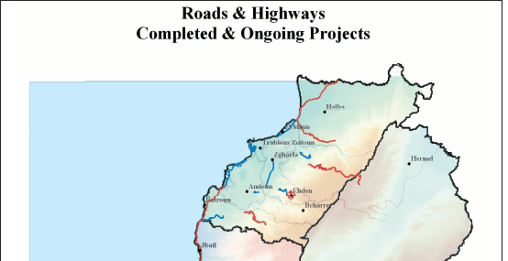
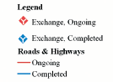
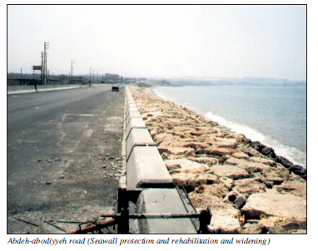

Tripoli - Syrian Border Connection
This project aims to improve the roads which connect North Lebanon with the Syrian border. It includes the construction of the eastern Tripoli ring road extending towards al Abdeh (20 kilometers to the north), and the widening and rehabilitation of two roads extending to Arida (along the coast), and to Abboudieh on the Syrian border. This project is financed by the Islamic Development Bank (IDB) and OPEC Fund for International Development (OFID). The contracts for Deir Ammar-al Abdeh road and al Abdeh- Homs/Abboudieh intersection have been awarded.

Sir ed Danniyeh-Jbab el Homr- Hermel:
Studies for these sections have been completed. However, the procedures for expropriation of lands are still going on. Funding was provided by the Arab Fund for Economic and Social Development. The contract for Sir ed Danniyeh- Jbab el Homr section has been awarded, and the Jbab el Homr-Hermel Section contract was awarded in the summer of 2004. In addition, the rehabilitation works of the Dael-lower Tannourine road is expected to be completed during 2005 (US$ 5.6 million).
Rehabilitation and development works of Tabarja-Chekka highway, financed by the European Investment Bank, were completed in the summer of 2004.
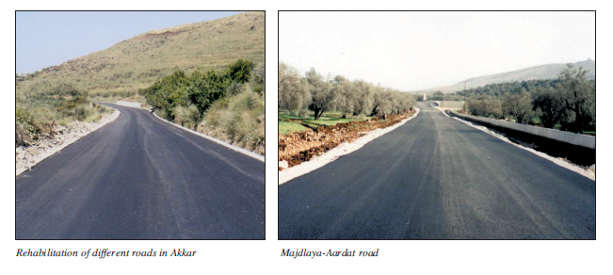
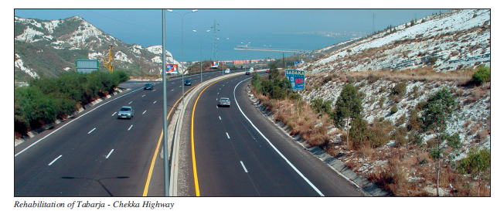

Roads and highways under preparation projects
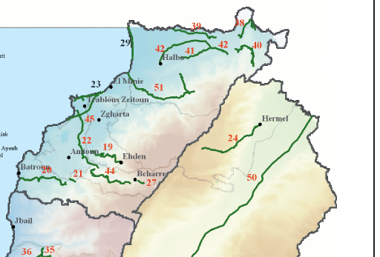
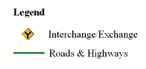
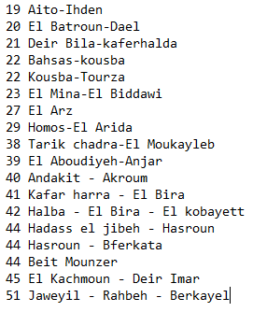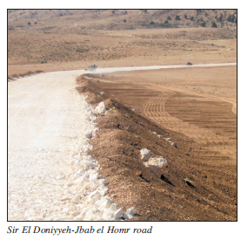

Rehabilitation of primary and secondary roads
Detailed studies for the rehabilitation of several sections of highways are complete. These sections are:
- Rehabilitation of Akkar roads: Studies and tender documents are under completion in phases. Awarding contracts will proceed as soon as funding becomes available.
- Options, feasibility and preliminary study for the Tripoli infrastructure development project.

relevant government agency
The relevant government agency, the Ministry of Public Works and Transport in Lebanon is organized into four directorates:
- Directorate General of Land and Maritime Transport, responsible for setting, implementing and monitoring all policies related to land and maritime transport
- Directorate General of Roads and Buildings, which is responsible for the construction, rehabilitation, and maintenance of public roads and government buildings
- Directorate General of Civil Aviation, responsible for setting and implementing air transport policies within the country in compliance with international policies, and for controlling the air traffic within the Lebanese territory
- Directorate General of Urban Planning, responsible for setting and putting into practice land use policies
Additionally, the Council of Development and Reconstruction (CDR), and the Ministry of Public Works’ Rehabilitation and Reconstruction are responsible for road construction and maintenance in Lebanon.

Information on Road Authority contacts can be found in the following link:
https://dlca.logcluster.org/display/public/DLCA/4.1+Lebanon+Government+Contact+List

Transport Corridors
Lebanon has three operating corridors with Syria. These corridors are:
- Al Masnaa- Al-Jdeidah border entry point (at the eastern part of Lebanon) 60 km from Damascus and 110km from Beirut. This is the main corridor that connects the Lebanese and Syrian capitals.
- Al-Arida-Tartous border entry point (at the northwest end of Lebanon). This corridor is located at the coastal area and widely used for cargo transportation between Syria and Lebanon. It is 45km far from Tartous on the Syrian side and 170km far from Beirut on the Lebanese side.
- Al-Abboudiyeh - Al-Dabouseyah border entry point (at the northeast end of Lebanon). This corridor connects Homs governorate (from the Syrian side) with Tripoli (from the Lebanese side). It is widely used for cargo transportation (especially in-transit cargo to Iraq).
During the winters, road challenges due to heavy snow have temporarily affected the use of the international highway leading to the Lebanon-Syrai Al Masnaa Crossing, at Dahr al Baidar area. However, this is usually cleared by the Ministry of Public Works within a maximum of one day. On a few occasions the Beirut-Damascus highway has also been closed due to security reasons, but overall remains the most consistent transport corridor from Lebanon to Syria.
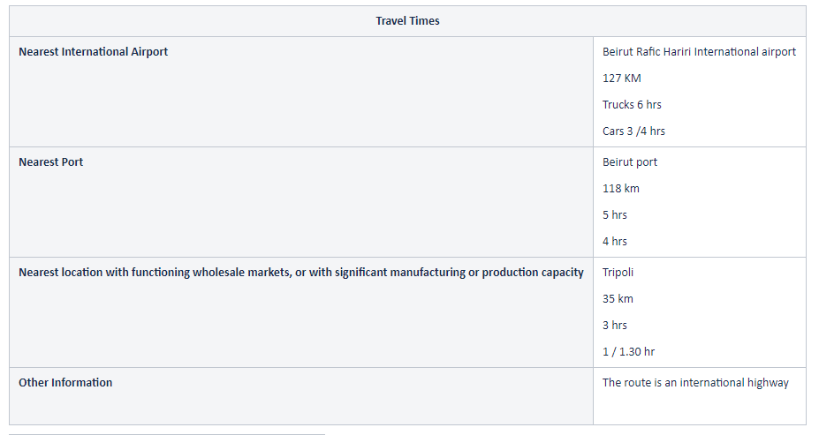

Distance Matrix
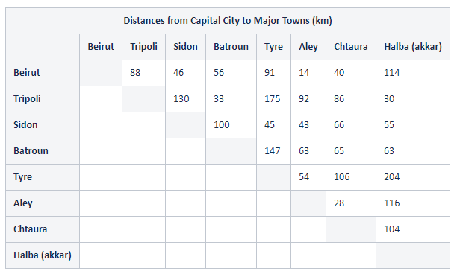
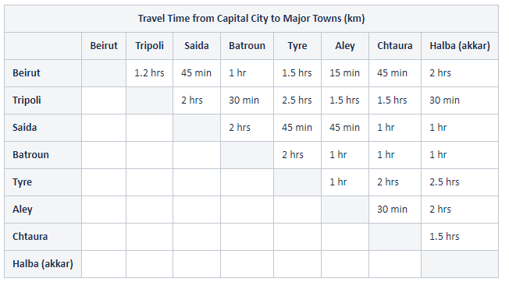

Road Security
Road Security: Good
Public transportation is generally safe. Emergency services in Lebanon are adequate. In case of a road accident, emergency numbers are 140 for the Red Cross and 125 for Civil Defence, and 112 for teh Police.

Weighbridges and Axle Load Limits
Since October 2014, in order to ease rush-hour congestion, a renewed plan by the government allows trucks to transport goods only from 10.00 hours to 14.30 hours and from 19.00 hours to 06:30 hours.
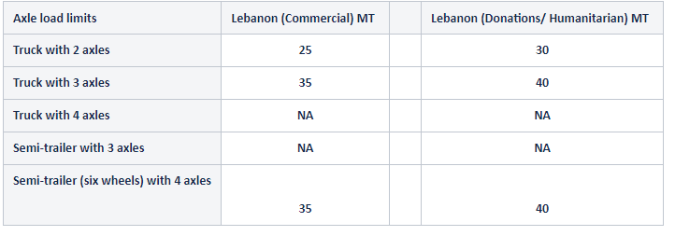

Road Class and Surface Conditions
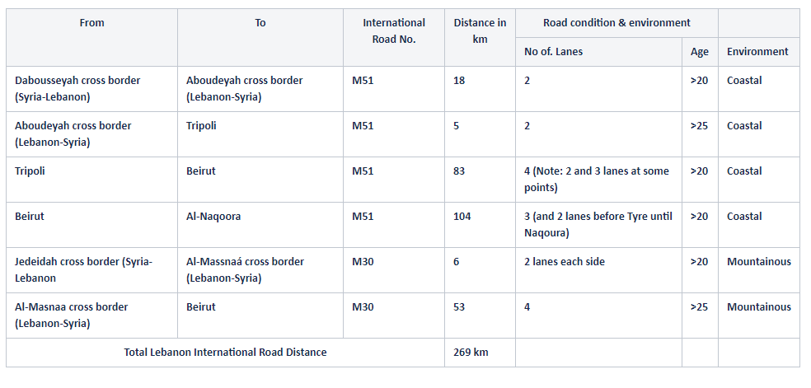

https://en.wikipedia.org/wiki/Rene_Mouawad_Air_Base#Future_development
https://dlca.logcluster.org/display/public/DLCA/2.1+Lebanon+Port+Assessment
http://www.cdr.gov.lb/eng/progress_reports/pr072005/Eroads.pdf
http://www.cdr.gov.lb/eng/progress_reports/pr072005/Eroads.pdf
https://dlca.logcluster.org/display/public/DLCA/2.3+Lebanon+Road+Network

