Maysaa Kamaredine

activities of foeign institutions in north Lebanon
Contents
1. USAID projects in Lebanon 1
(http://usaid.maps.arcgis.com/apps/MapJournal/index.html?appid=3a99a7abc6f541f883363b858814a675) 1
2. EU projects in lebanon 9
(https://eeas.europa.eu/delegations/lebanon/area/projects_en?page=2) 9
3. Uk aid projects(https://devtracker.dfid.gov.uk/countries/LB) 16
4. Unicef projects in Lebanon 26
(https://www.unicef.org/lebanon/search?force=0&query=projects%20in%20north%20lebanon&search_date_range_picker=&created%5Bmin%5D=&created%5Bmax%5D=&f%5B0%5D=content_group%3A75fa7bb3-112e-4e4d-9f0d-00334f2e4998) 26
5. UNDP projects in north Lebanon (https://www.lb.undp.org/content/lebanon/en/home/search.html?q=project+in+north+Lebanon) 41
6. AVSI projects in Lebanon 61
(https://www.avsi.org/doc/539/bd6df3de038d4370960193c379f342e1/) 61
7. FAO projects in Lebanon(http://www.fao.org/home/search/en/?q=project%20in%20north%20lebanon) 62
8. Projects of ILO (INTERNATIONAL LABOUR ORG)IN LEBANON 64
9. Civil society organizations CSO(https://eeas.europa.eu/archives/delegations/lebanon/documents/news/20150416_2_en.pdf) 66
10. Conclusion 69

USAID projects in Lebanon

(http://usaid.maps.arcgis.com/apps/MapJournal/index.html?appid=3a99a7abc6f541f883363b858814a675)
Budget for Lebanon from USAID: $141m

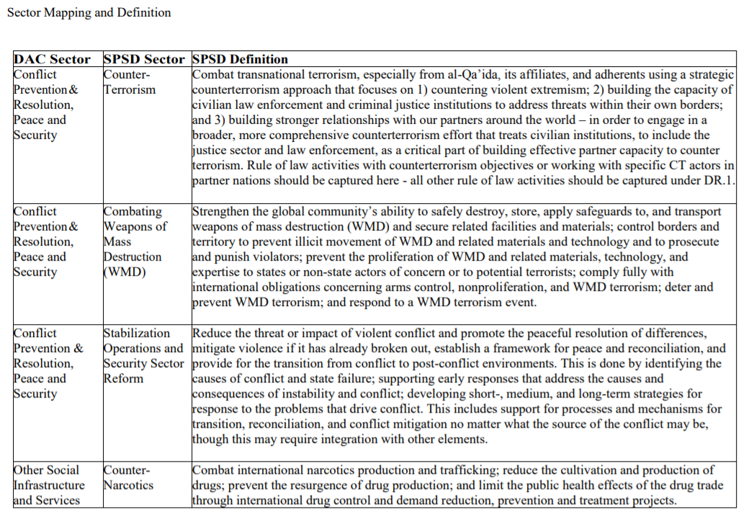

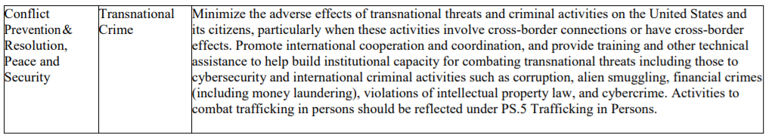
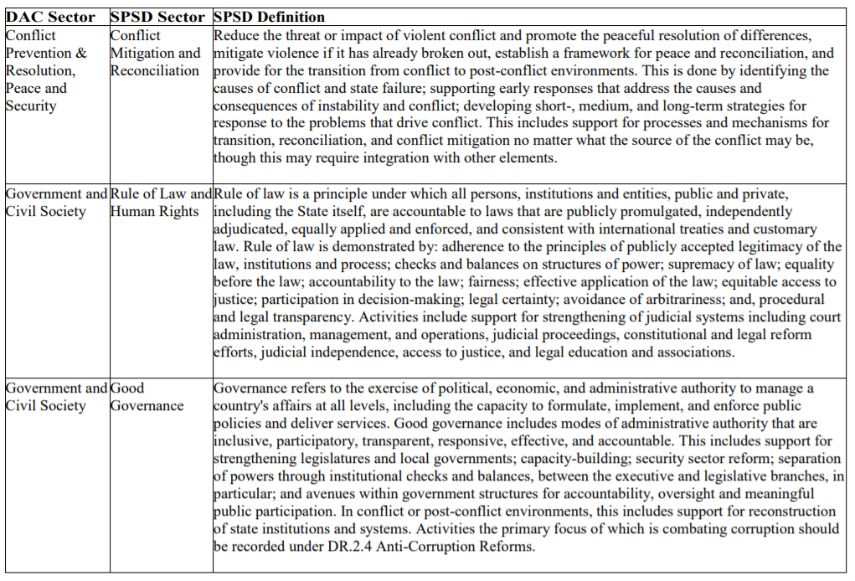
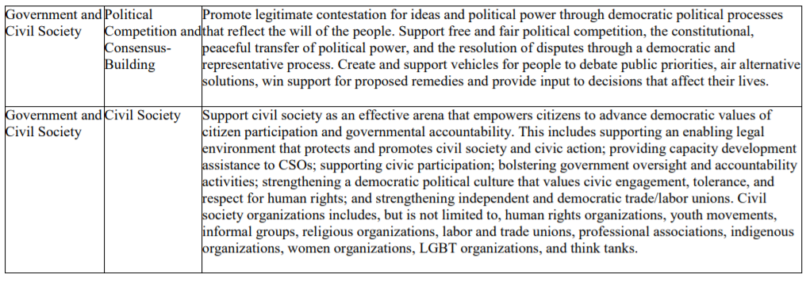
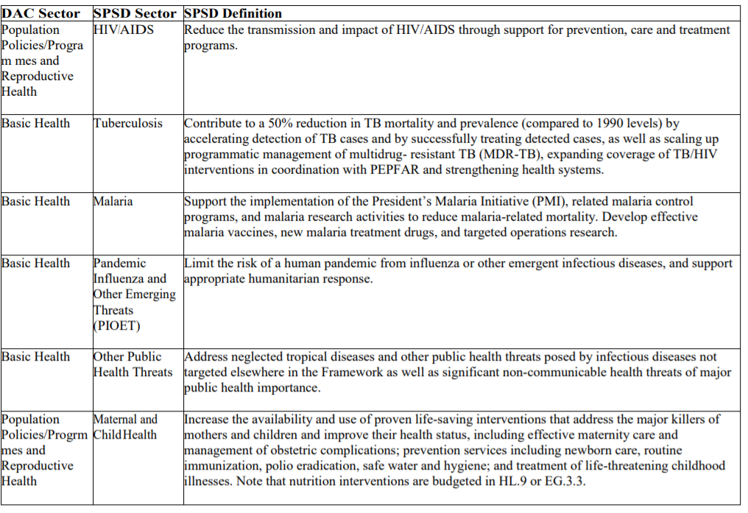
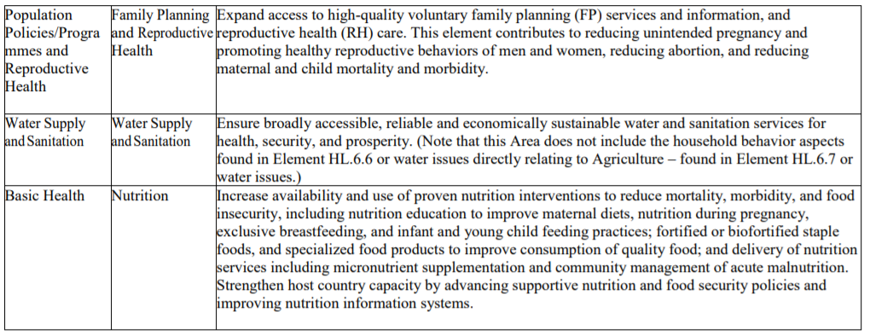
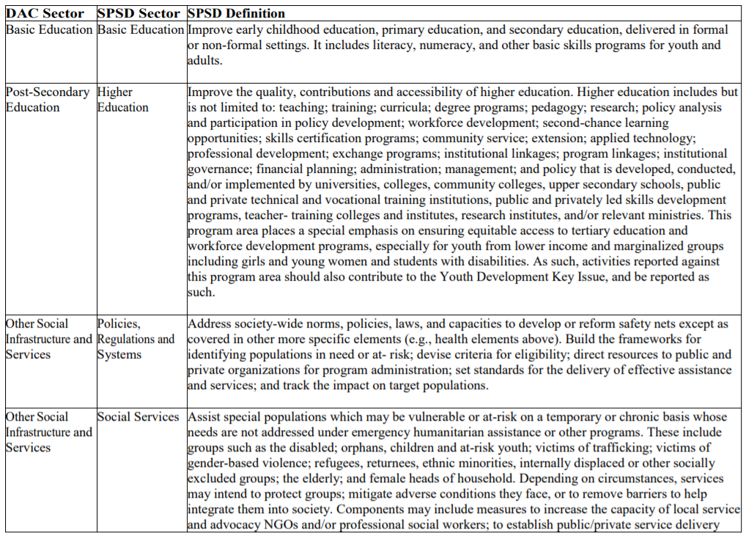
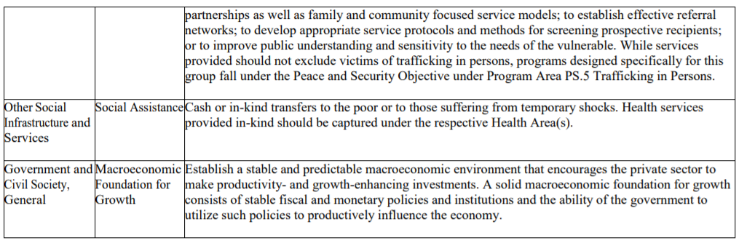
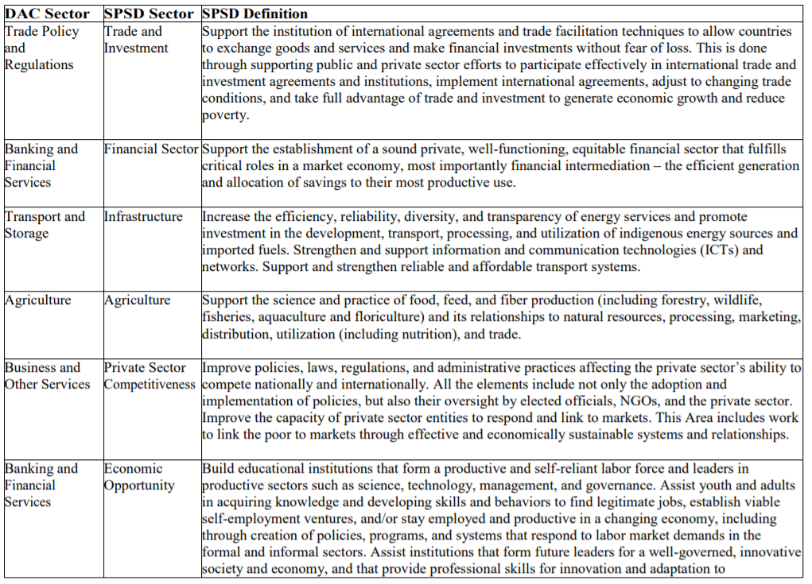
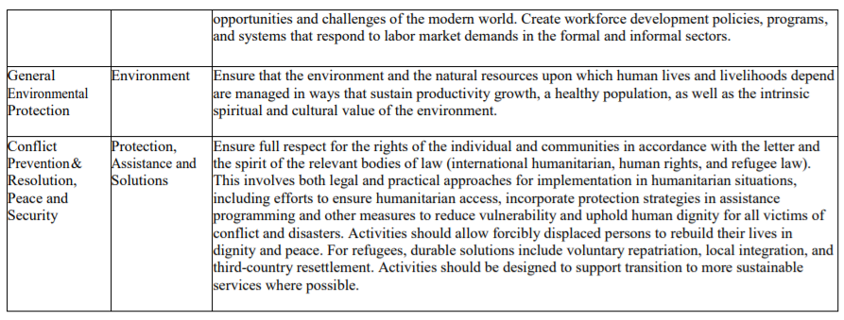
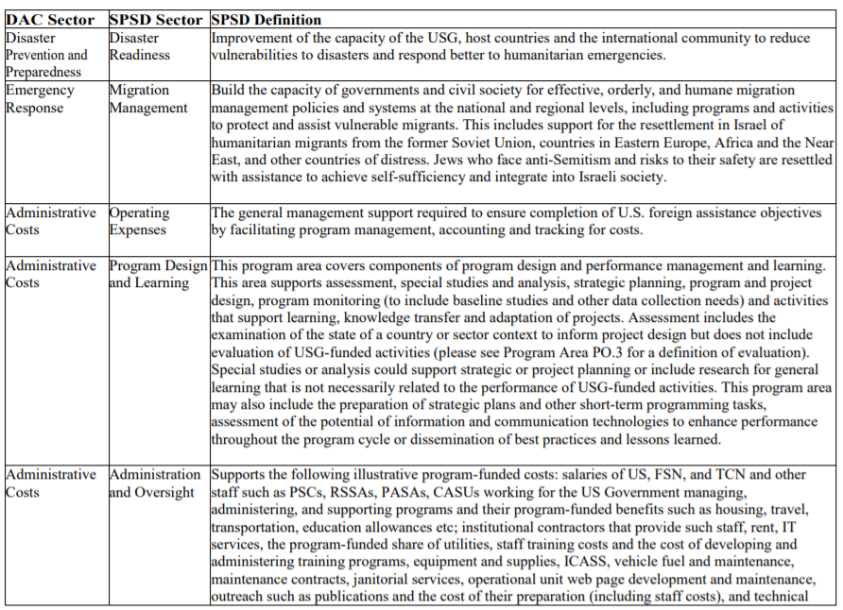
Sector | Budget(2014-2018) | people (all over Lebanon )
Education ,level unspecified |  | 5979
Basic education | 126801748 | 643539
Post-secondary education | 75775486 | 3620
Basic health | 1698642
Water supply and sanitation | 68680737 | 443815
Government and civil society | 3495781 | 195914
Conflict, Peace, and Security | 50856918 | 120
Other Social Infrastructure | 248430
Energy |  | 183336
Banking and Financial Service | 5543052 | 1285468889
Business and Other Services | 22432723 | 275
Agriculture | 22995612 | 1745
Industry | 24756982 | 2000
Trade Policy and Regulations | 33676 | 800
General Environmental Protection | 10473888 | 169190
Emergency Response | 48110731 | 2
Reconstruction Relief and Re | -20799
Disaster Prevention and Prep
Operating Expenses | 16333116
Program Design and Learning | 13379962
Administration and Oversight | 12538561

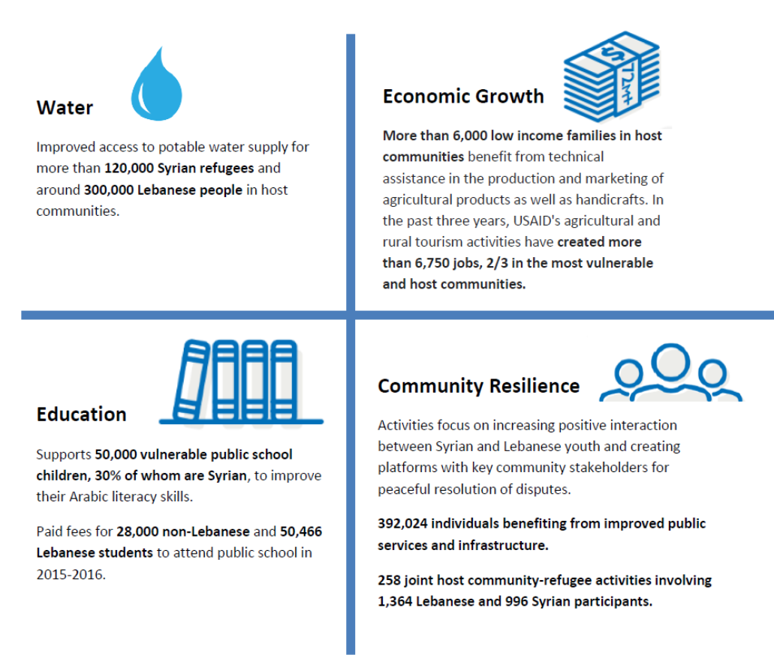

North Lebanon | Water | governace | Environment | Education | Economic  growth
Akkar |  | Bazbina:1,Tal bireh:2,Harare:1,Rahbe:1,Daher Laissine:1,Bebnine:1,Al Mhamara:1 | 1 actv | Akkar:70(distributed ),  Halba:3,  Qubayat:6,  Beqarzela:6 | Mechmech:5,  jdaidi:4  , Machta Hamoud:3,  Jdeidetqayteh:3,  Akkar:37,  Tall abbas:3,  Qochlok:4  Zouarib:4
Dennieh |  | Qarsita :5,deir Amar :2 |  | Minieh:12,Markabta:3, dennieh:33 | Siraldannieh:2,Kfar chillane:2,Deir Nbouh:1
Tripoli |  |  |  | Tripoli:29,Beddawi:11,Mina:18,jessrine :16,Tal:7,Zahrieh:1 | Tripoli Zeitoun :7, Ras Maska :7,  Kalamoun:3
Zgharta | 1 actv | 2 actvs | 1actv | 18 actvs | 13 actvs:  distributed
Dedde | 1 actv | 1 actv
Bcharre |  | 6 actvs |  |  | 5 actvs
Al koura |  | 3 actvs |  |  | 14 actvs :distributed

EU projects in lebanon

(https://eeas.europa.eu/delegations/lebanon/area/projects_en?page=2)
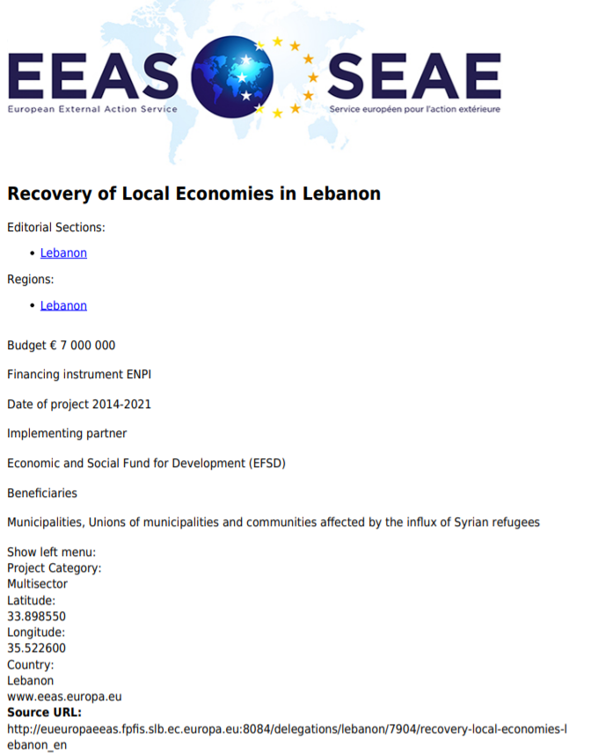

Bjb

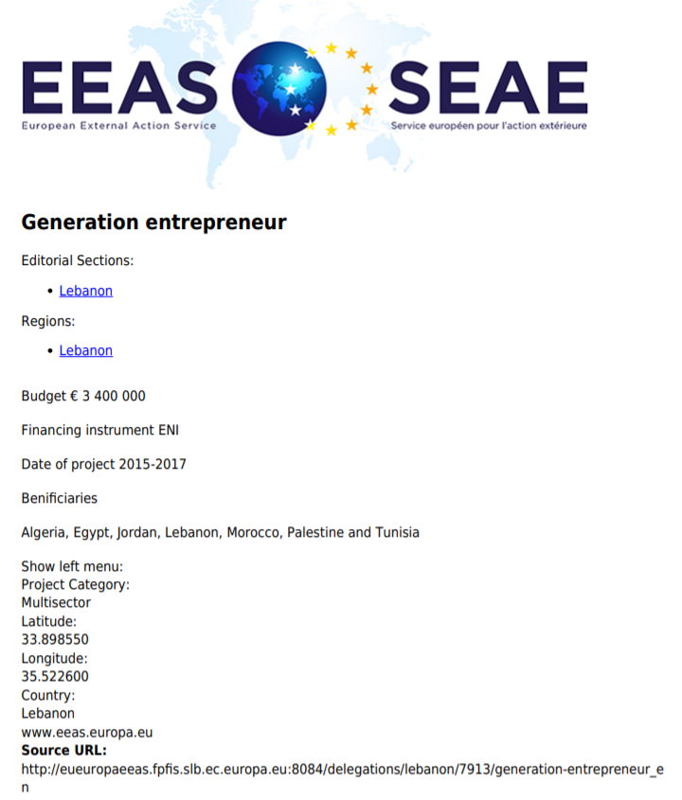
These programmes aim at improving the overall efficiency and effectiveness of Solid Waste Management (SWM) in areas of Lebanon most affected by the influx of Syrian refugees. The action will directly contribute to address the medium and longer term needs of the Lebanese communities in areas with high Syrian refugees concentrations for increased and improved waste disposal services, by (i) building and upgrading SWM infrastructure and equipment at local level and (ii) enhancing the overall management capacity of local administrations in the Solid Waste Management sector.
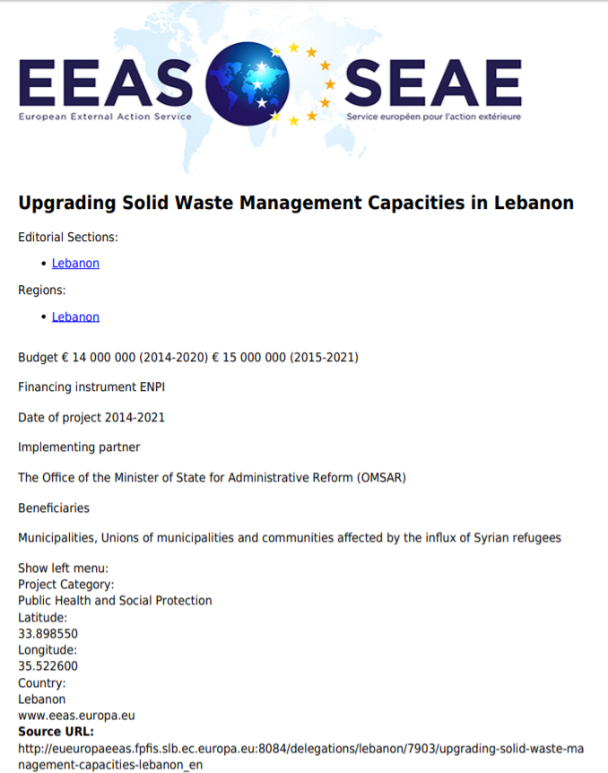
DFID will provide £21m over three years to support access to public primary and lower secondary education for Syrian and vulnerable Lebanese children, to improve the quality of education for all children enrolled in public schools.
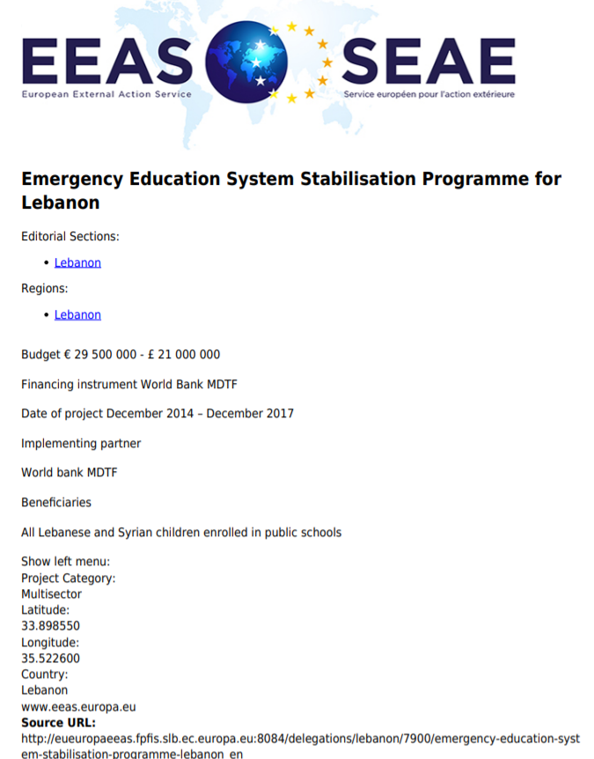
This programme enhances the municipalities’ ability to design and implement infrastructure projects for water supply, sanitation and solid waste disposal. Additionally, it strengthens the resilience of Syrian refugee communities and Lebanese host communities by upgrading municipal services especially with regard to Solid Waste Management. The Technical Assistance component of the project (€ 2.9 million) will provide institutional support to the Lebanese Administration to enhance the capacities at the municipalities’ level. It will specifically accompany the reform process in the area of municipal financing by increasing the management and technical capacities both at central and local levels while at the same time providing support to selected Unions of Municipalities in preparing local development plans.
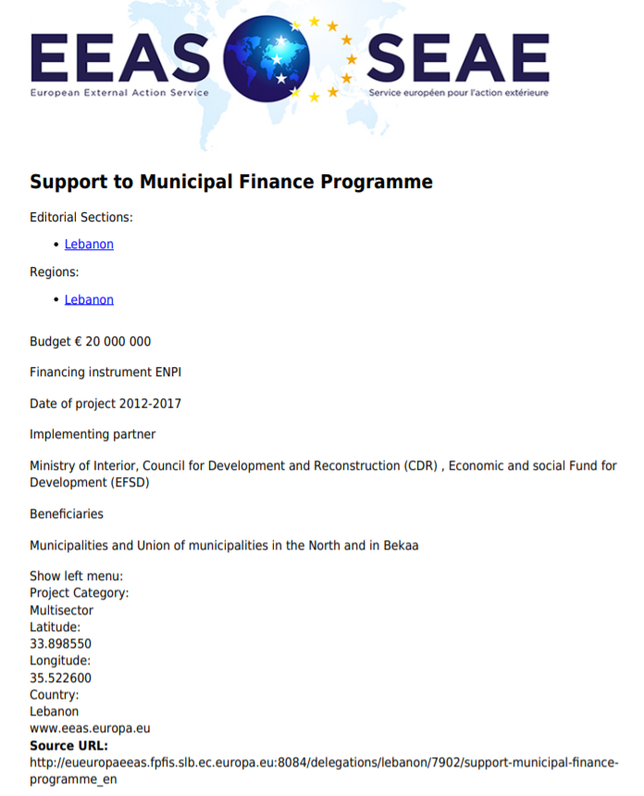

Uk aid projects(https://devtracker.dfid.gov.uk/countries/LB)

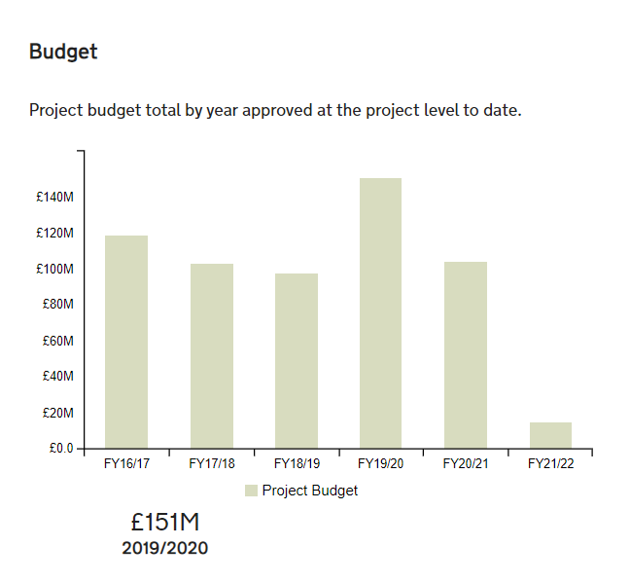
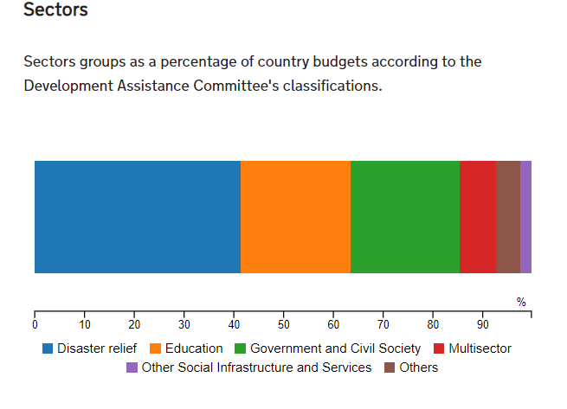
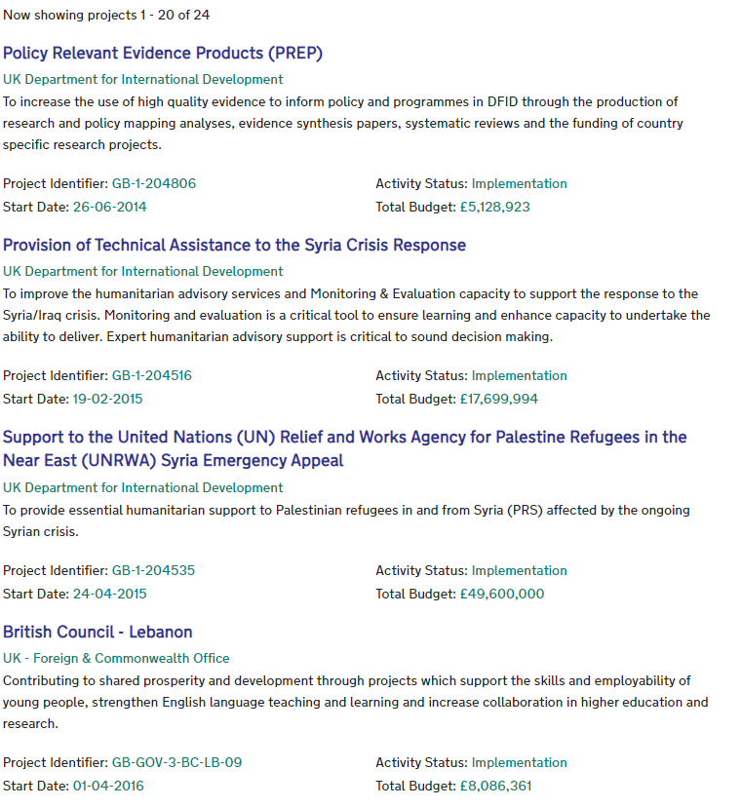
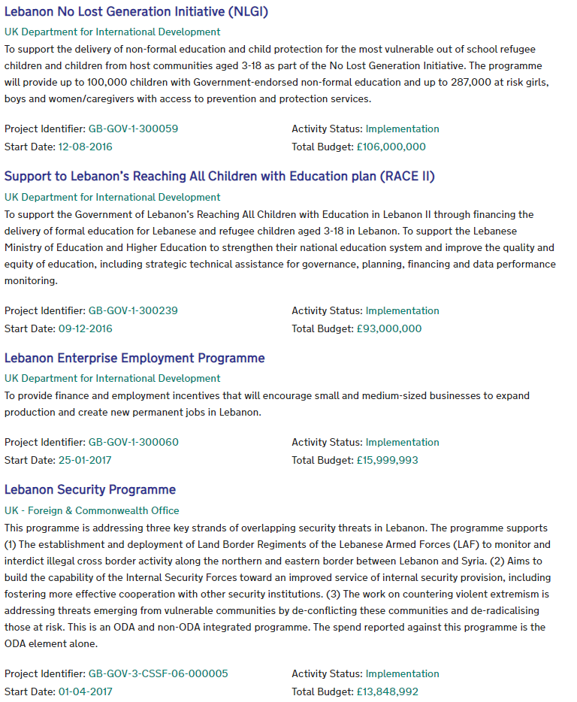
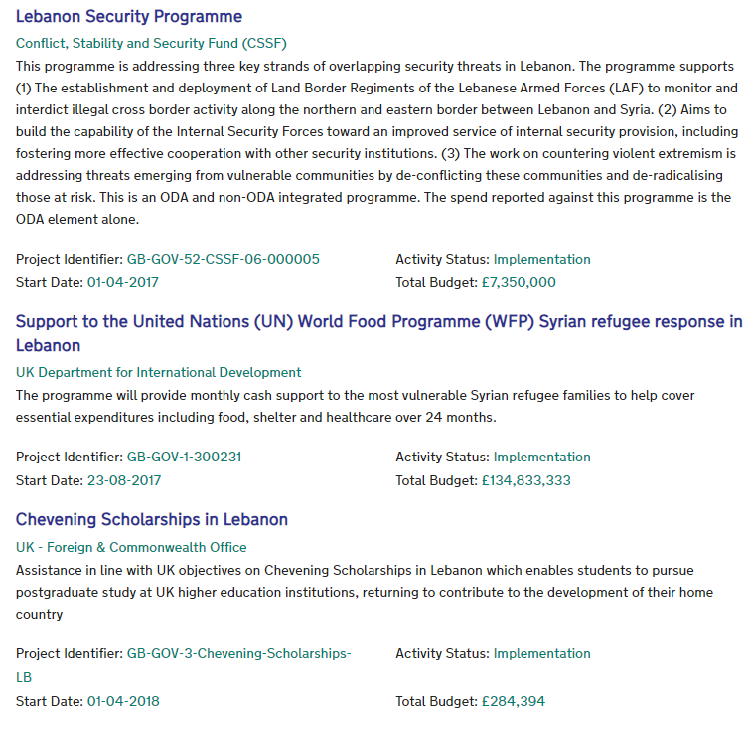
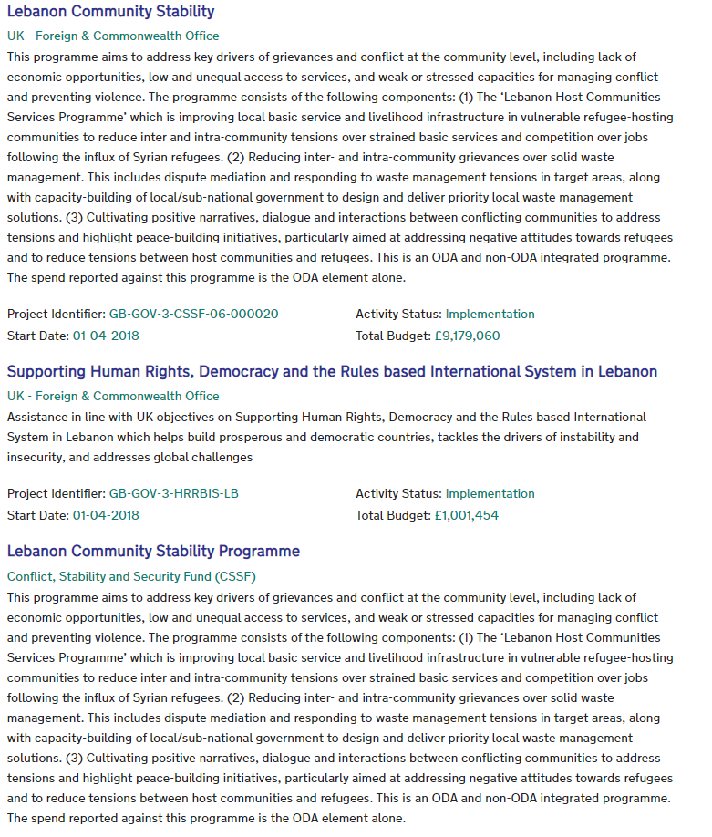
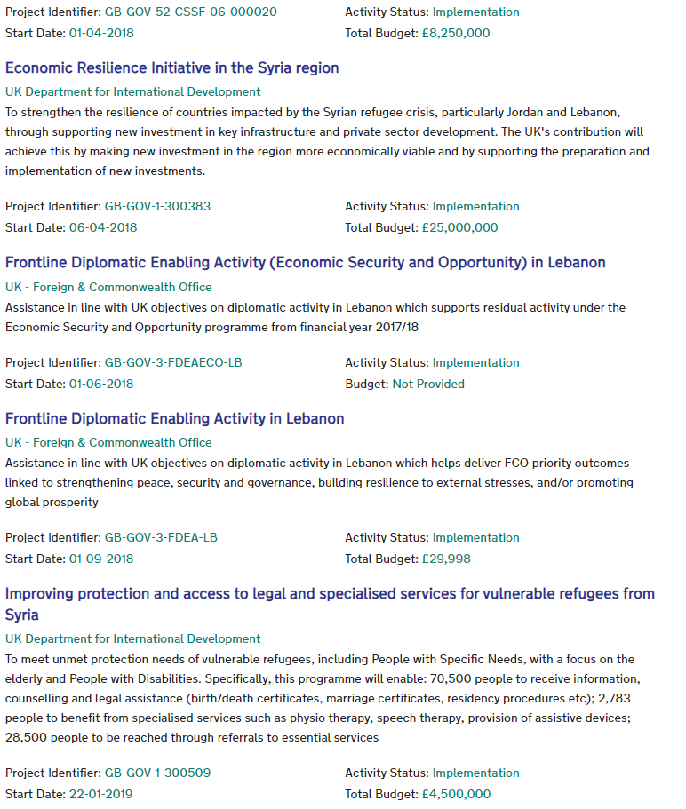
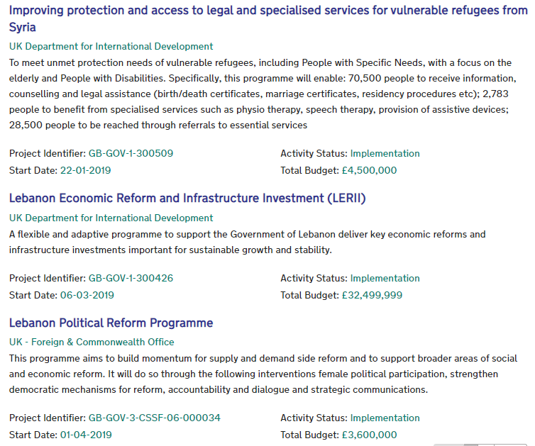
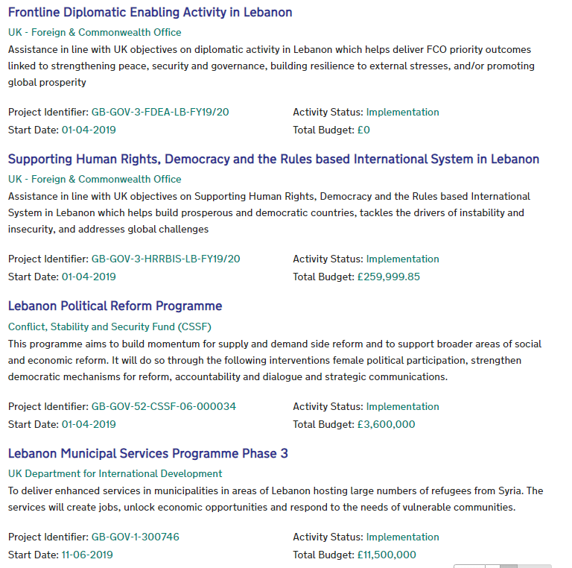

Unicef projects in Lebanon

(https://www.unicef.org/lebanon/search?force=0&query=projects%20in%20north%20lebanon&search_date_range_picker=&created%5Bmin%5D=&created%5Bmax%5D=&f%5B0%5D=content_group%3A75fa7bb3-112e-4e4d-9f0d-00334f2e4998)
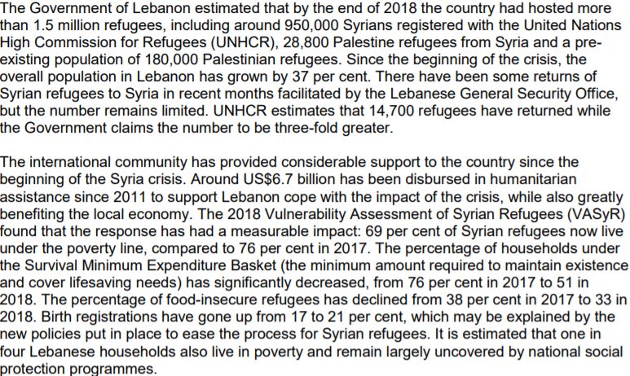

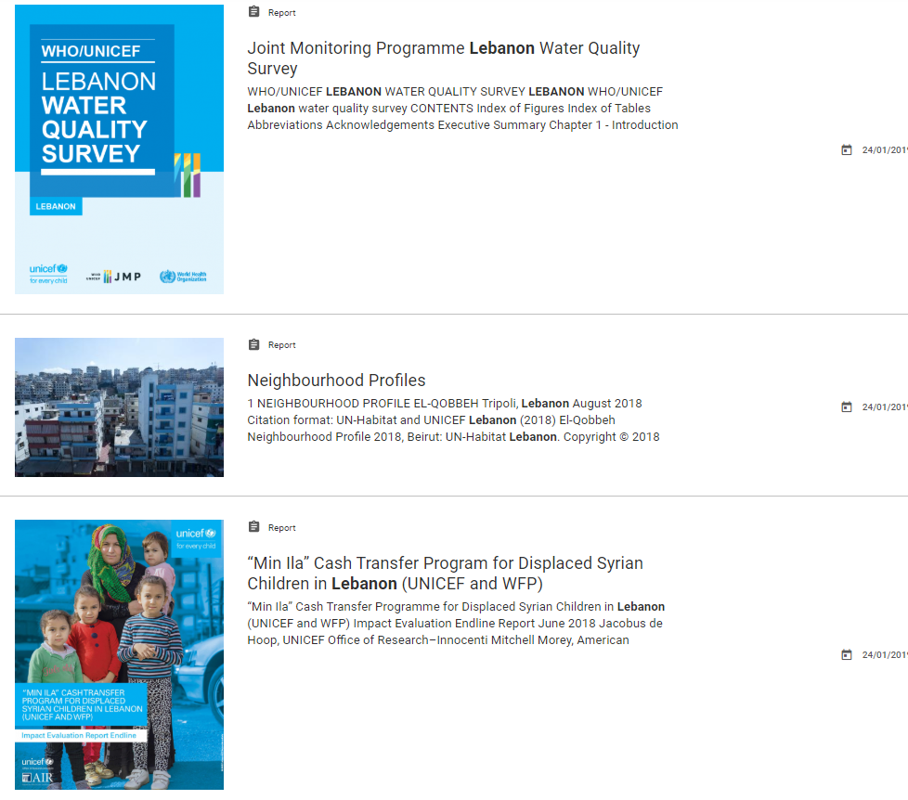
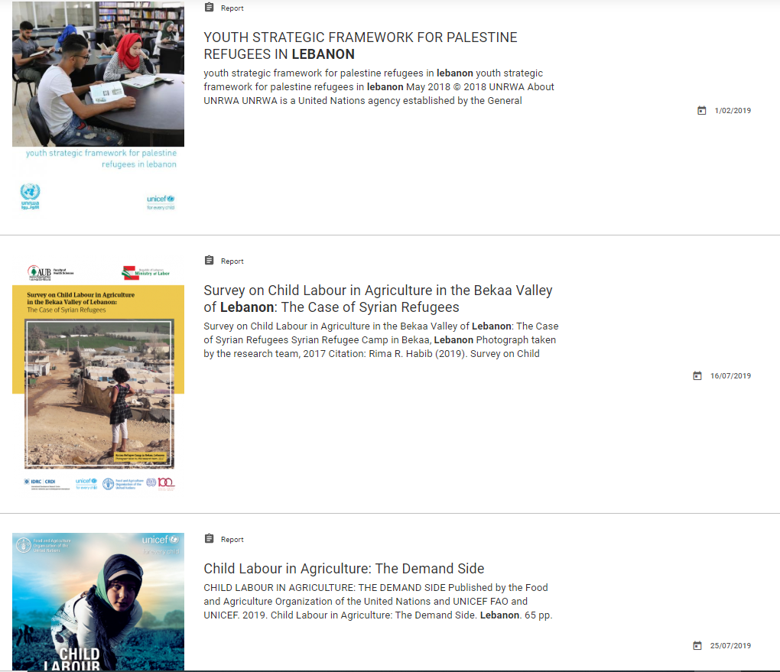
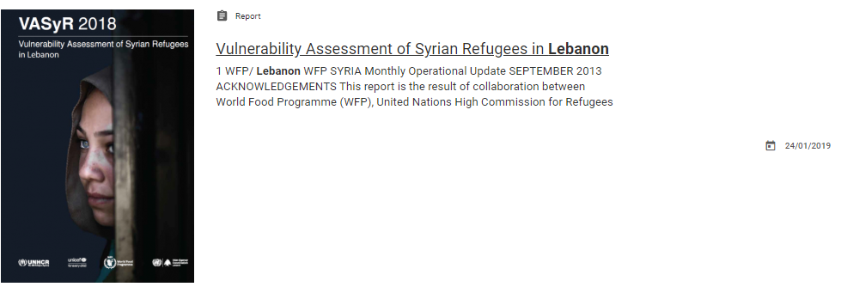

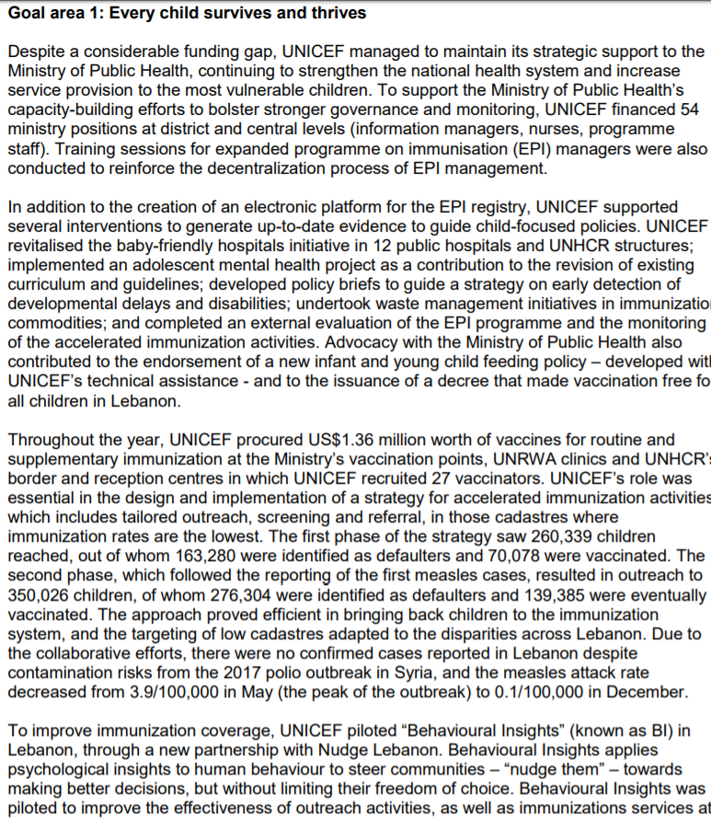
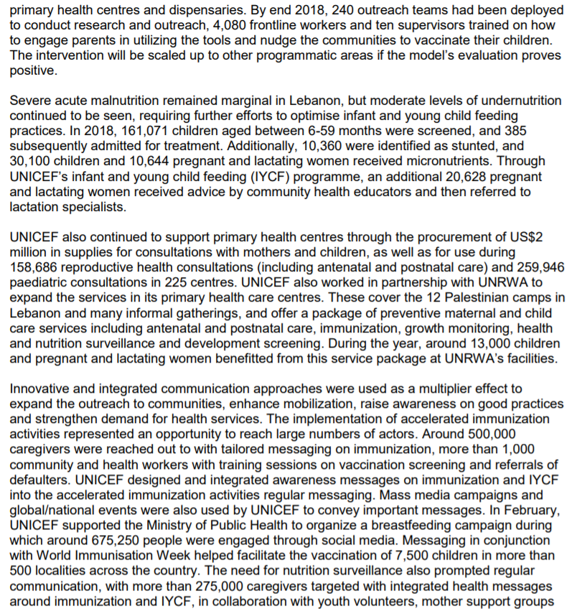
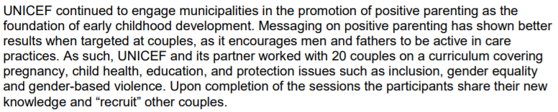
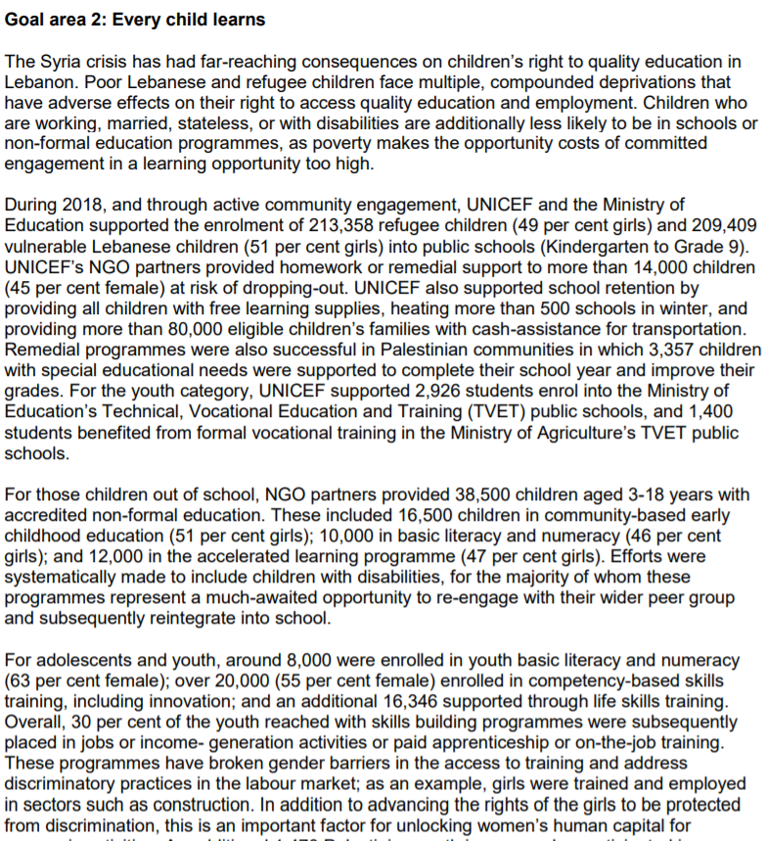
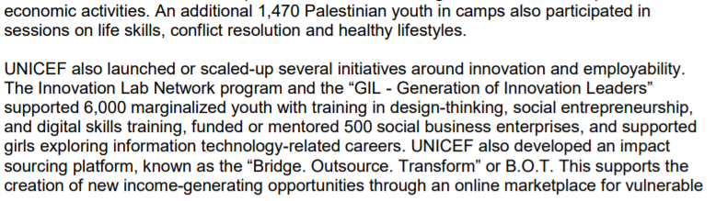
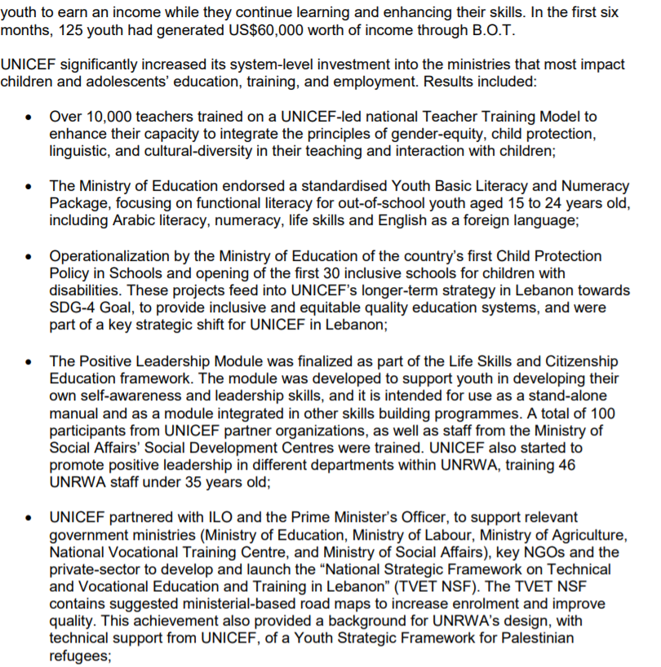
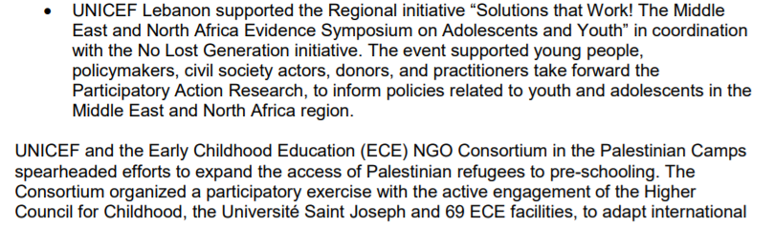
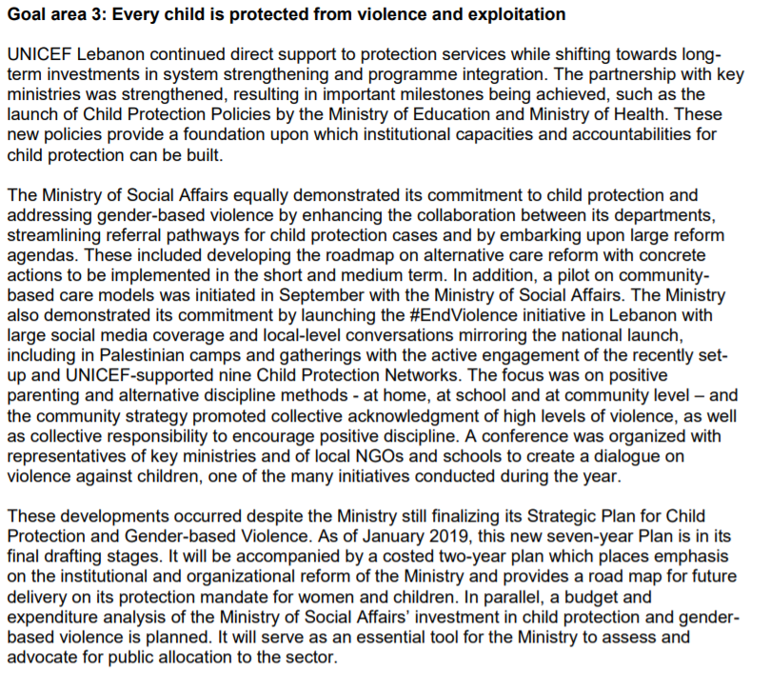
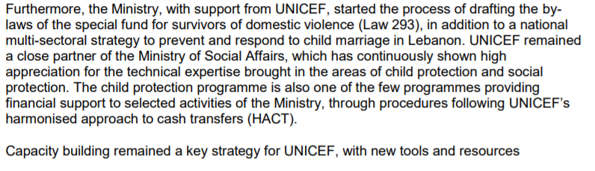
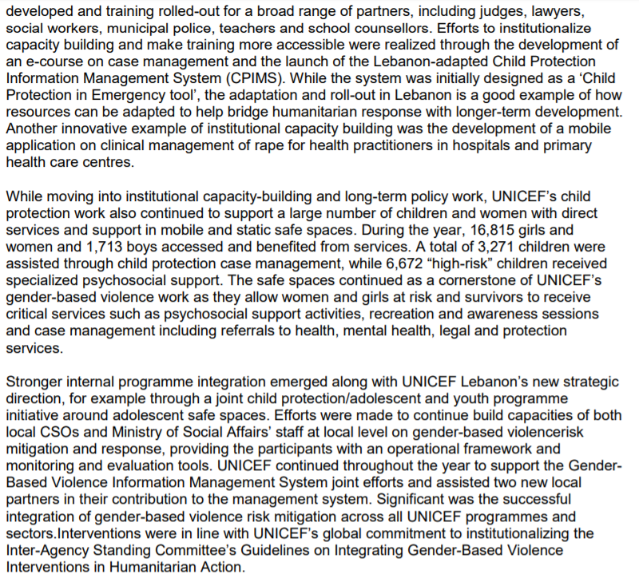
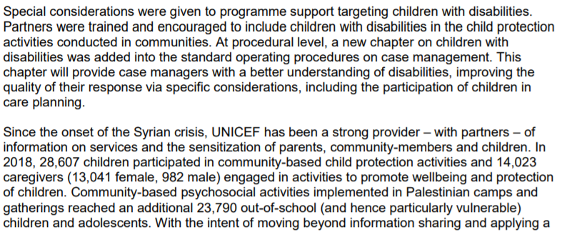
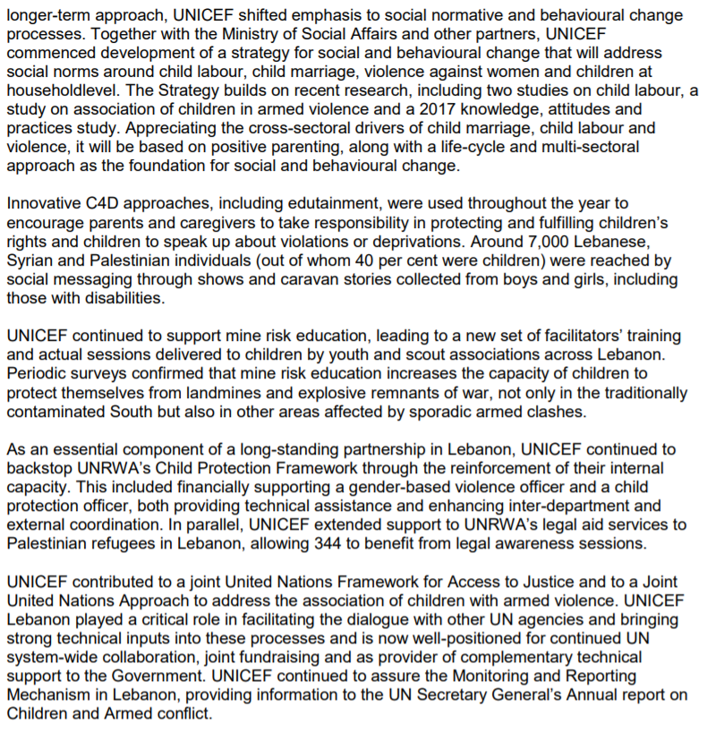
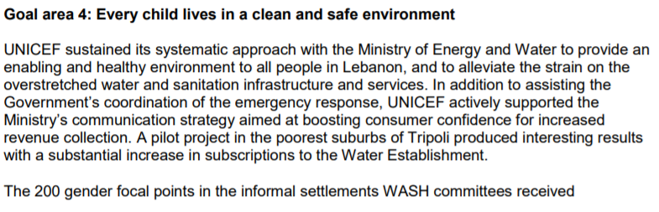
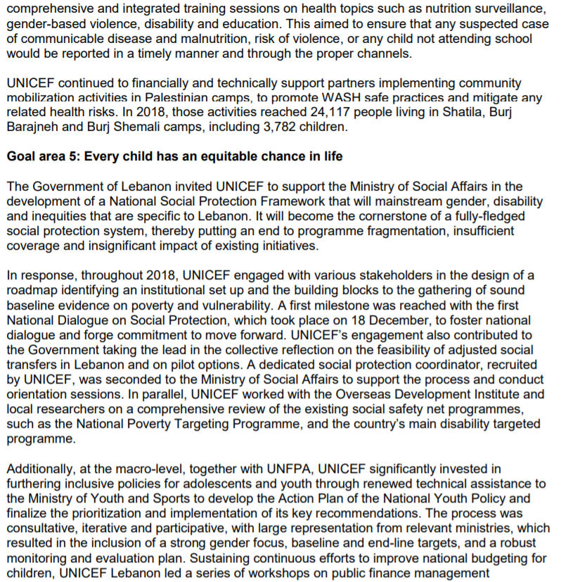
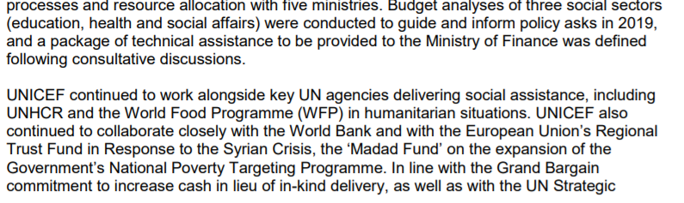
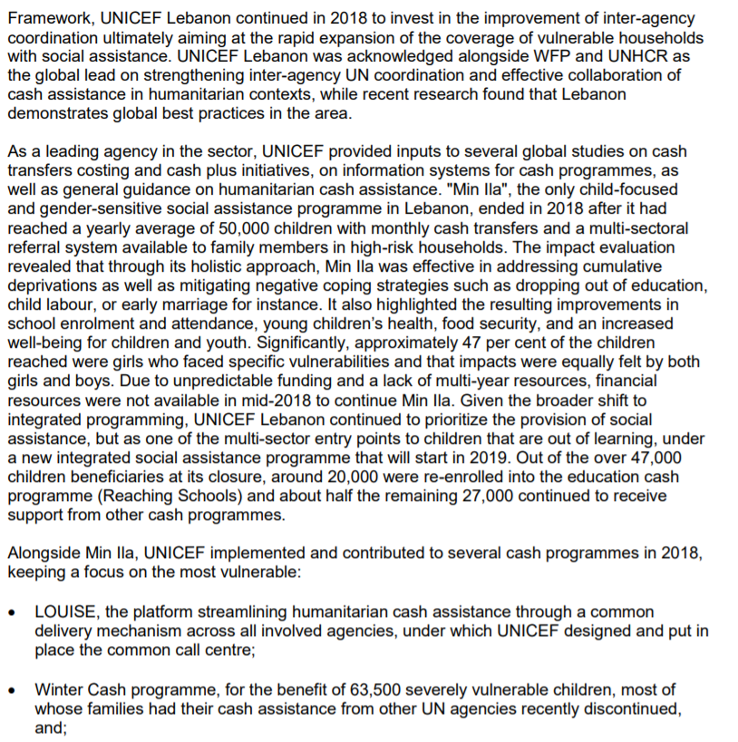
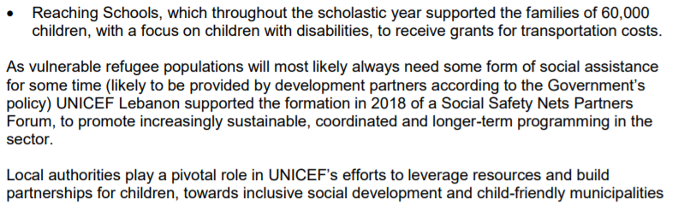
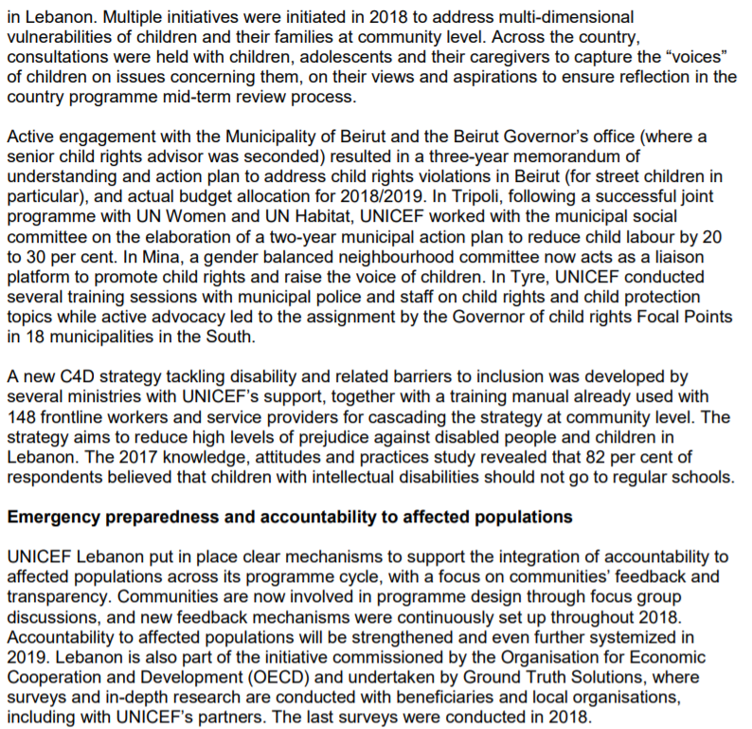
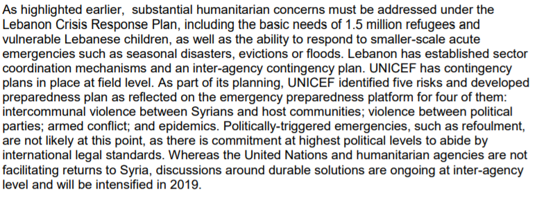
Example of Project in progress from UNICEF:
Name | Team member | Area | Budget | Duration of the project
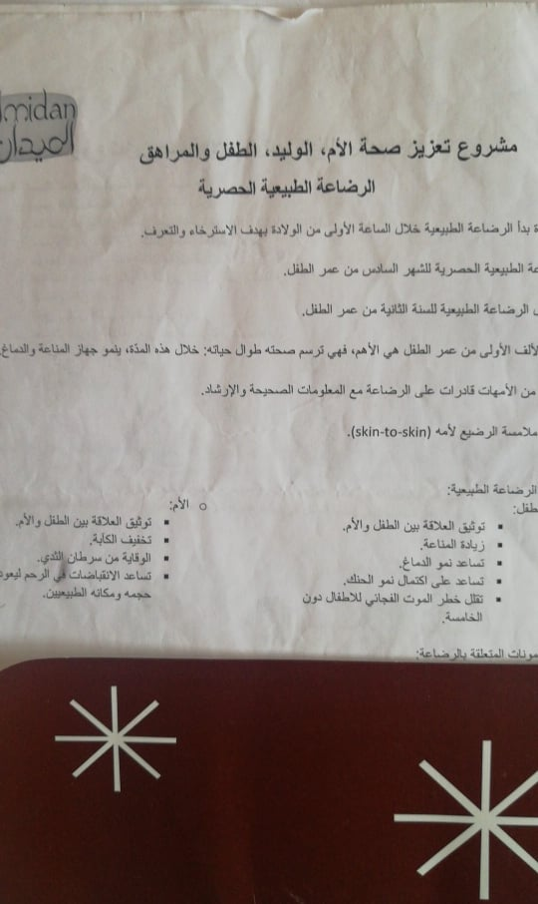 | Staff:30 | Tal  Al Mina  Zgharta  Majdalaya  Meryata  Abi samra  Hadadin | ~ $150k | 4 months(January-April 2020)

UNDP projects in north Lebanon (https://www.lb.undp.org/content/lebanon/en/home/search.html?q=project+in+north+Lebanon)

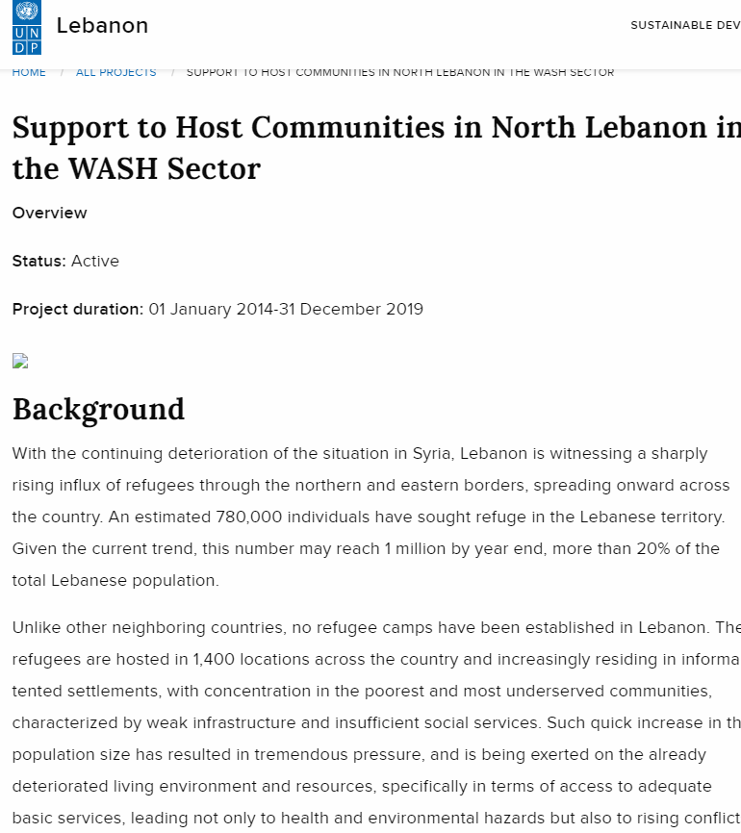
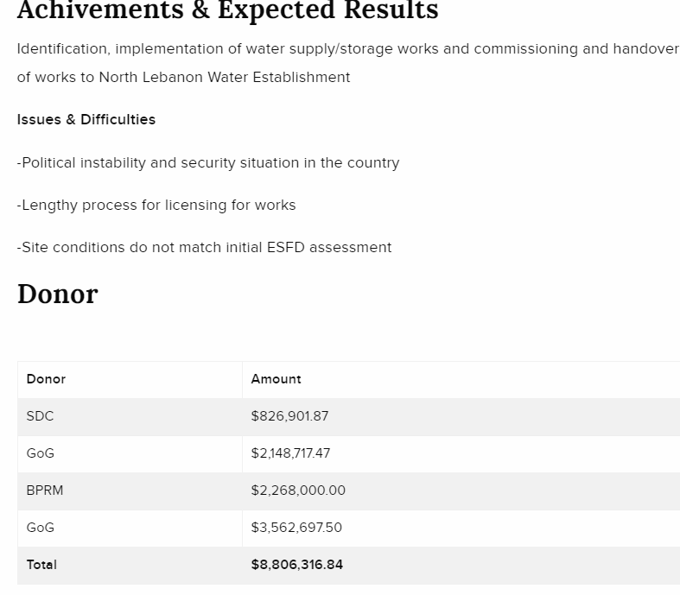
Area
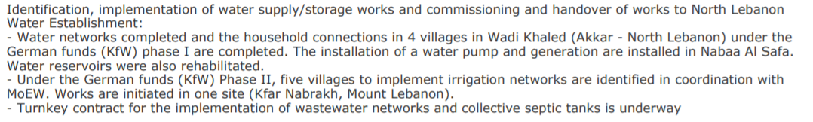
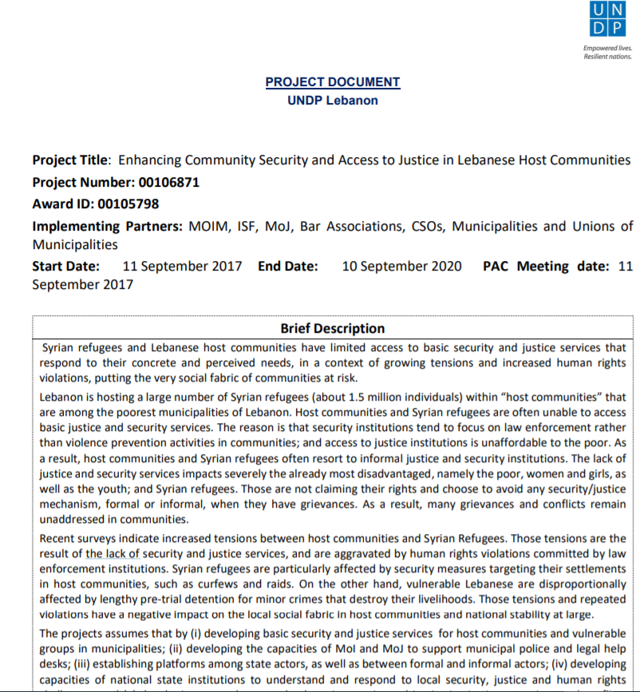
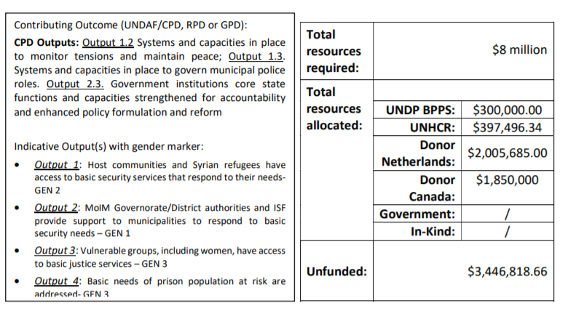
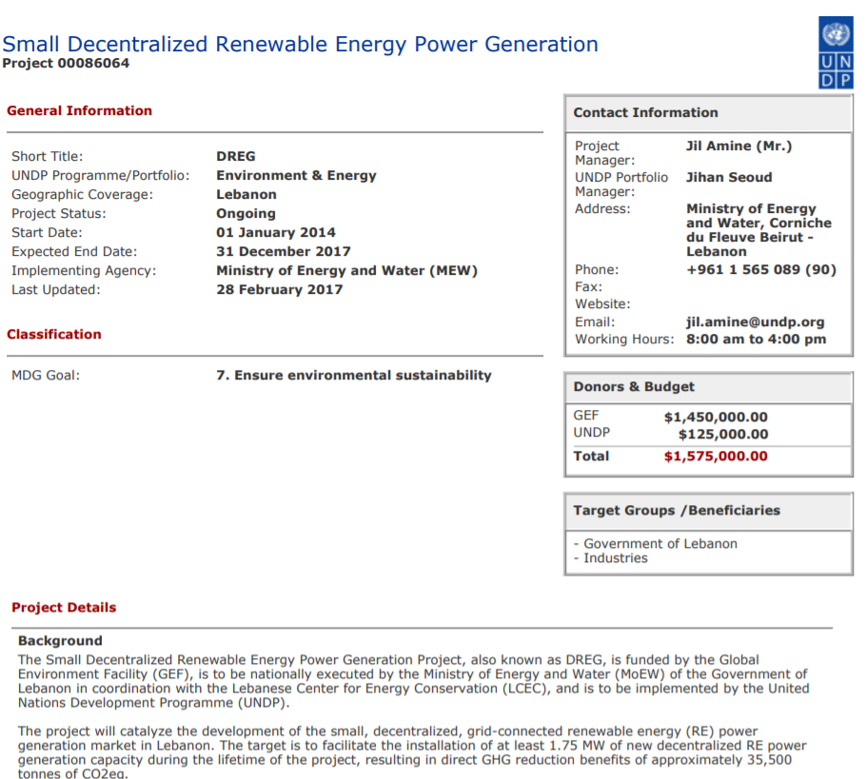
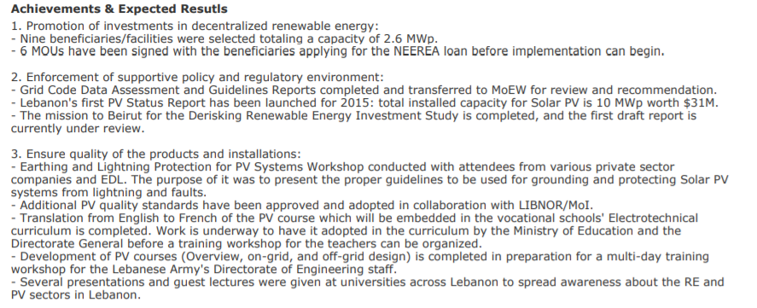
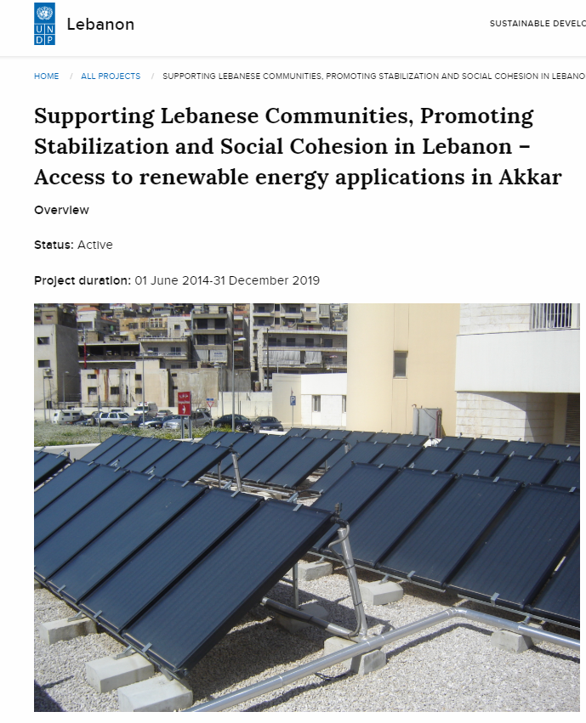
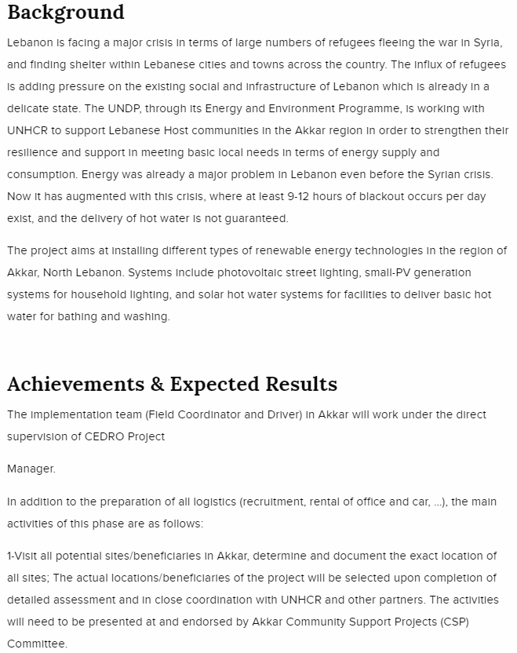
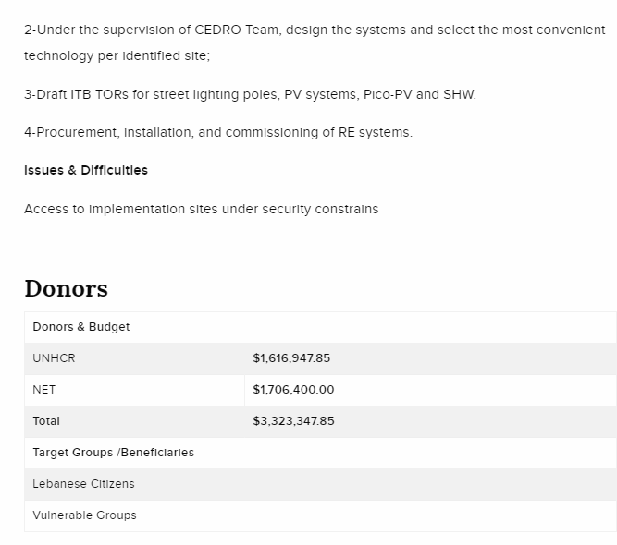
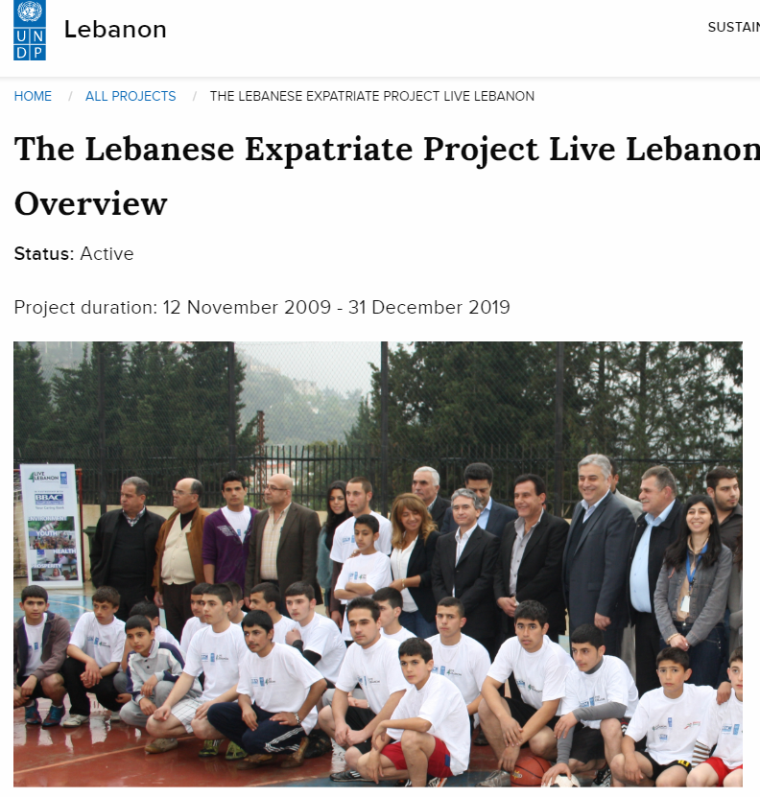
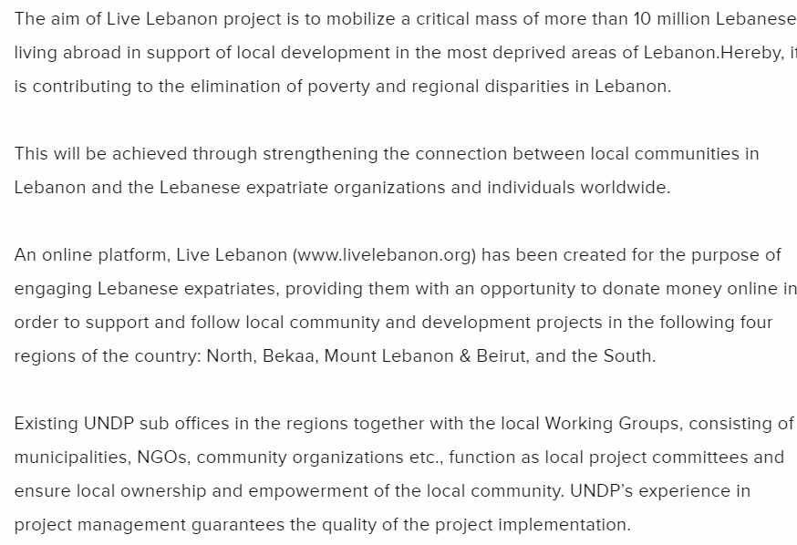
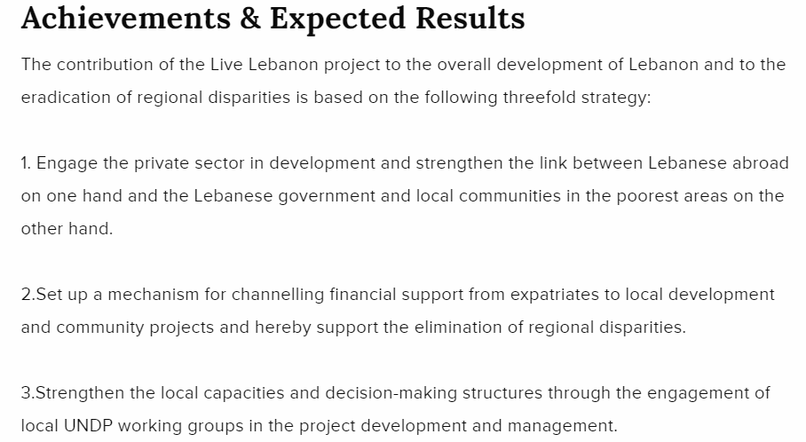
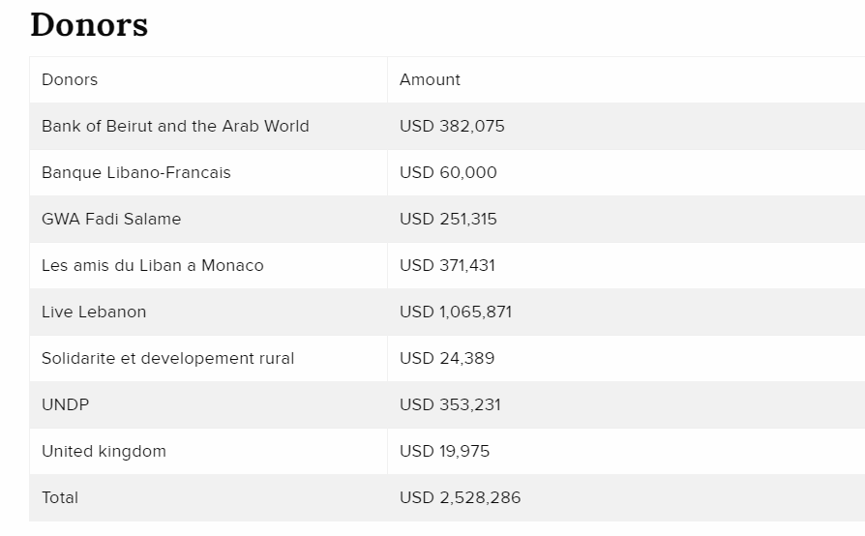
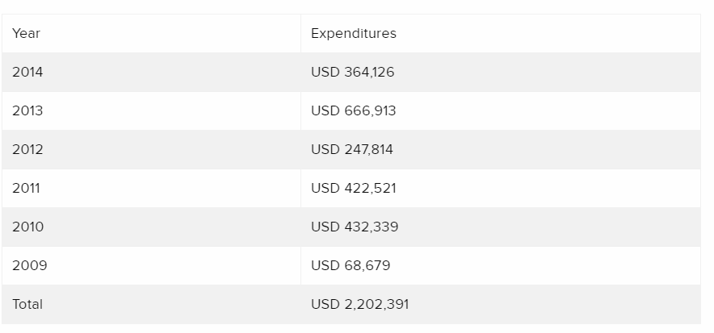
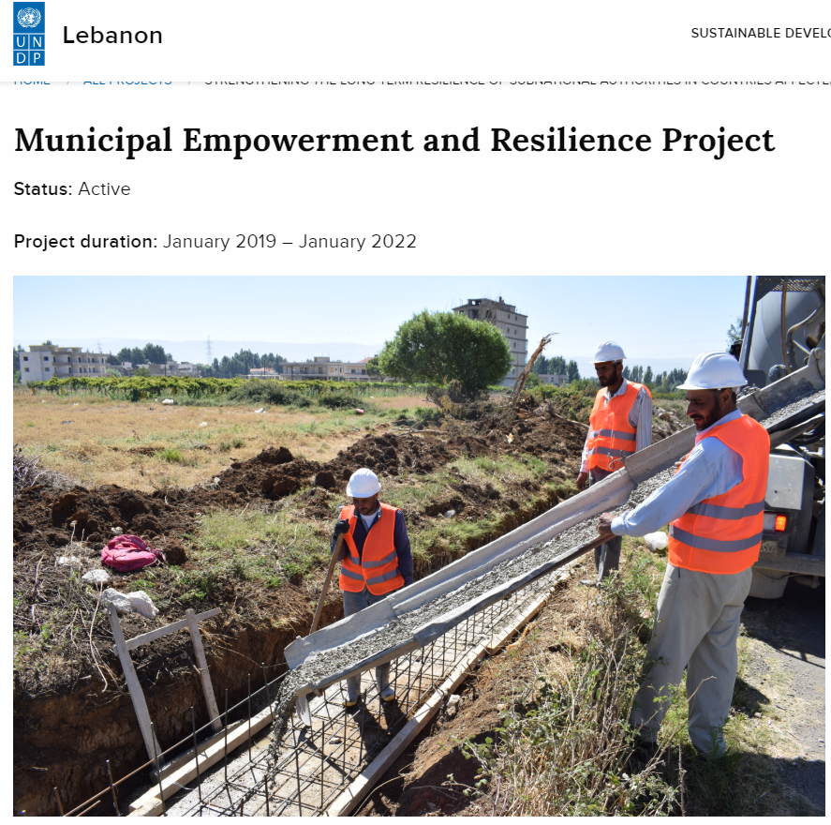
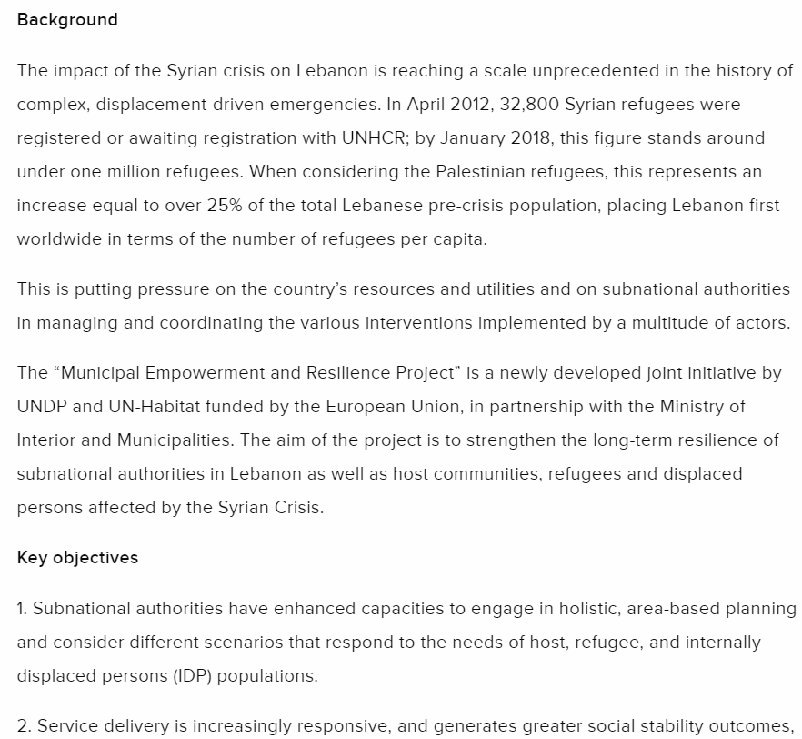
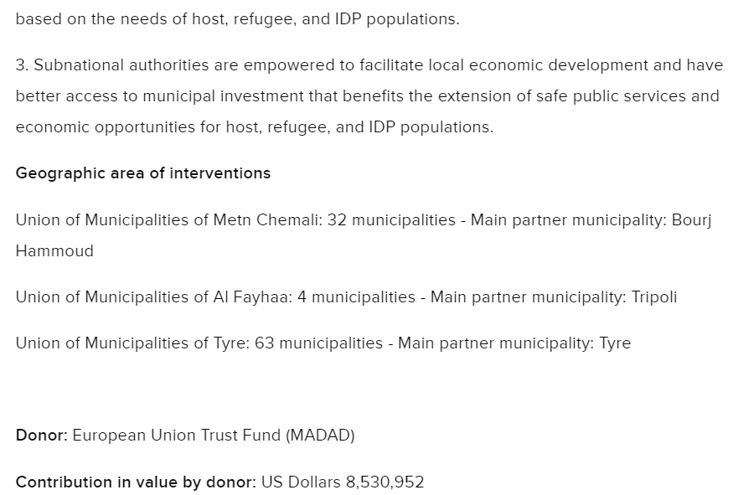
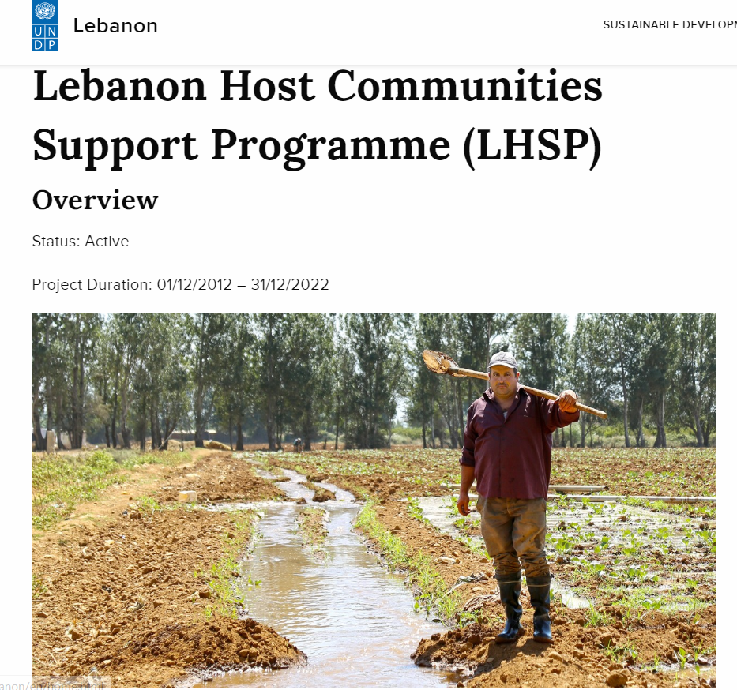
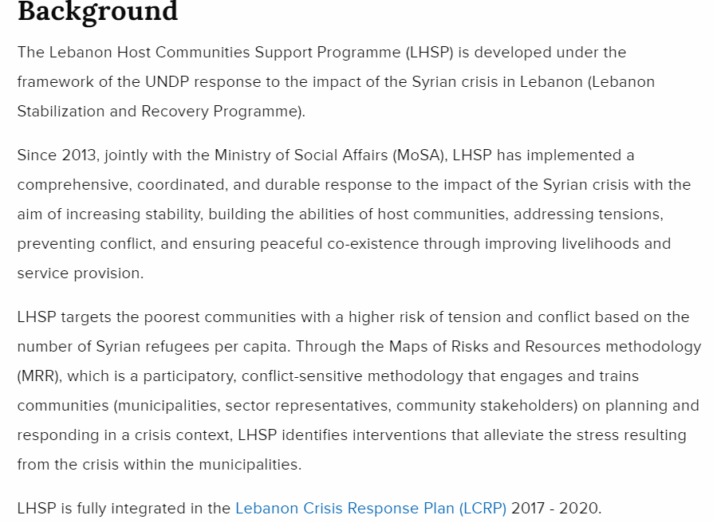
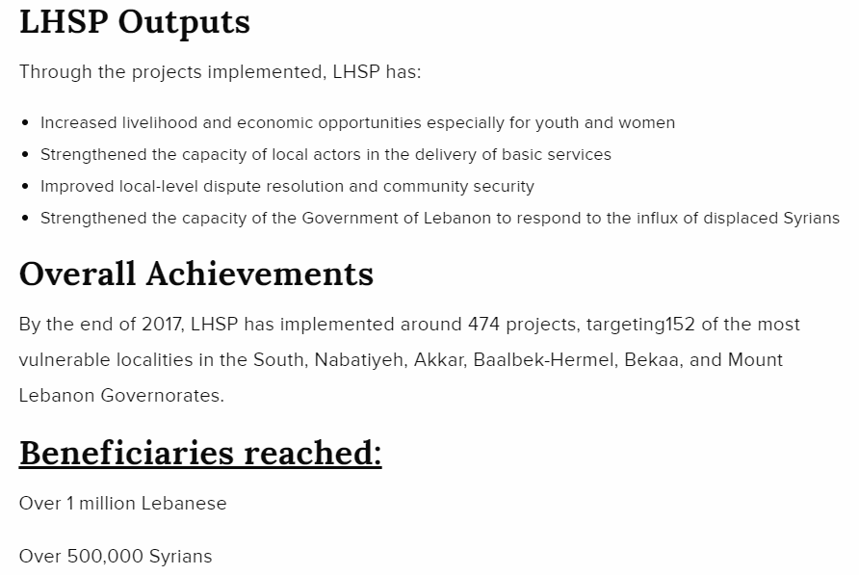
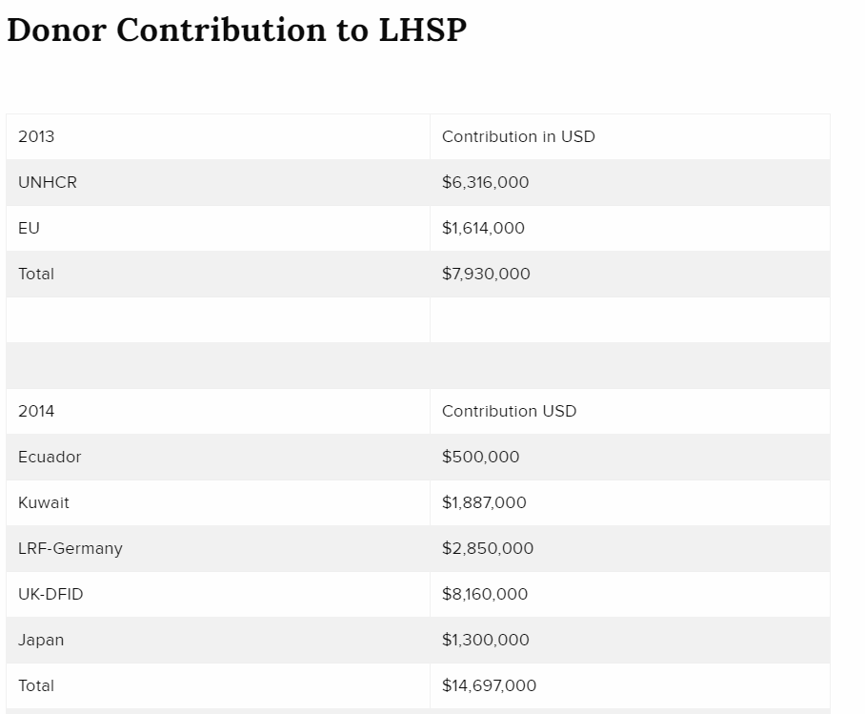
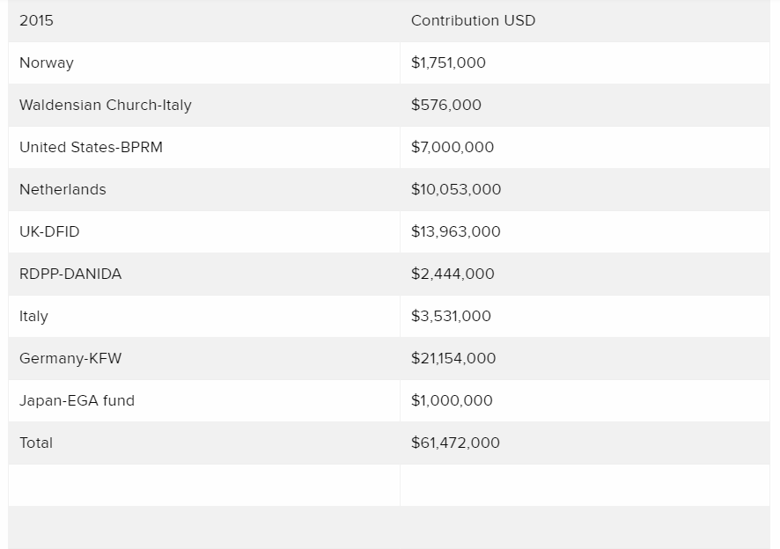
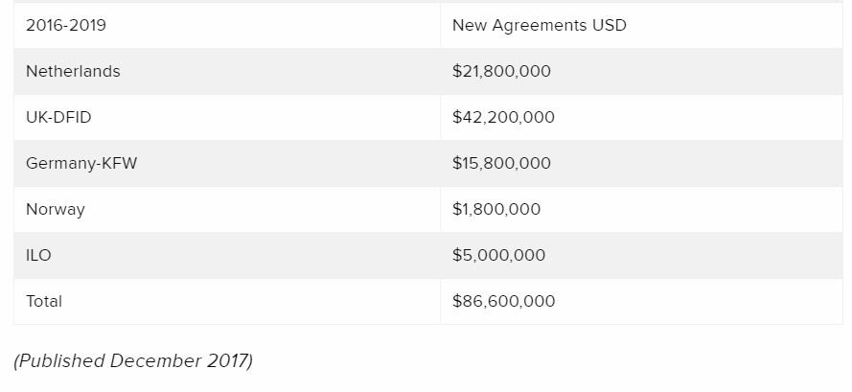

AVSI projects in Lebanon

(https://www.avsi.org/doc/539/bd6df3de038d4370960193c379f342e1/)
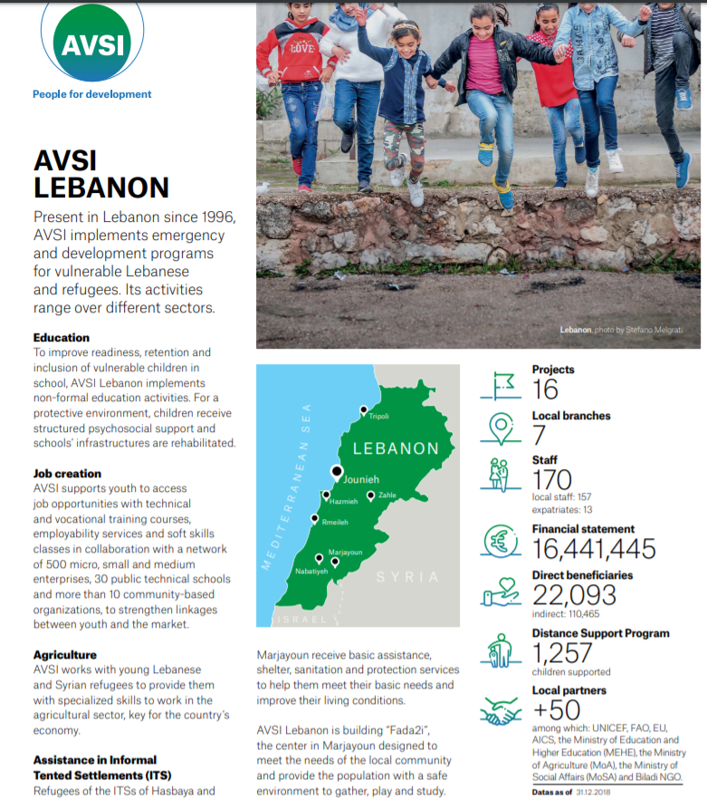

FAO projects in Lebanon(http://www.fao.org/home/search/en/?q=project%20in%20north%20lebanon)
Supporting livelihoods in Akkar
On the second day, El Khatib and the official delegation travelled to Akkar north of the country, touring mountainous areas where FAO, in cooperation with the Lebanese Ministry of Agriculture, supports agricultural livelihoods and job creation through investment in land reclamation and water reservoirs. The FAO project in northern Lebanon boosts the Ministry's Green Project, which helps small-scale farmers improve their income by reclaiming arable land and using better irrigation methods.
The project represents a successful strategy aimed at increasing investments in the host communities while supporting the livelihoods of the refugees. It creates many jobs for unskilled Lebanese and Syrian labourers alike.
By the end of 2018, the Akkar project supported 813 farmers, 21 percent of them women, and created 62,912 temporary jobs, which is equivalent to 55,000 seasonal jobs every year. Some 267.4 hectares of land were reclaimed, and around 30,000 trees were planted. The project also puts 125 cubic meters of irrigation water under the disposal of farmers in those regions.
)
On the second day, El Khatib and the official delegation travelled to Akkar north of the country, touring mountainous areas where FAO, in cooperation with the Lebanese Ministry of Agriculture, supports agricultural livelihoods and job creation through investment in land reclamation and water reservoirs. The FAO project in northern Lebanon boosts the Ministry's Green Project, which helps small-scale farmers improve their income by reclaiming arable land and using better irrigation methods.
The project represents a successful strategy aimed at increasing investments in the host communities while supporting the livelihoods of the refugees. It creates many jobs for unskilled Lebanese and Syrian labourers alike.
By the end of 2018, the Akkar project supported 813 farmers, 21 percent of them women, and created 62,912 temporary jobs, which is equivalent to 55,000 seasonal jobs every year. Some 267.4 hectares of land were reclaimed, and around 30,000 trees were planted. The project also puts 125 cubic meters of irrigation water under the disposal of farmers in those regions.

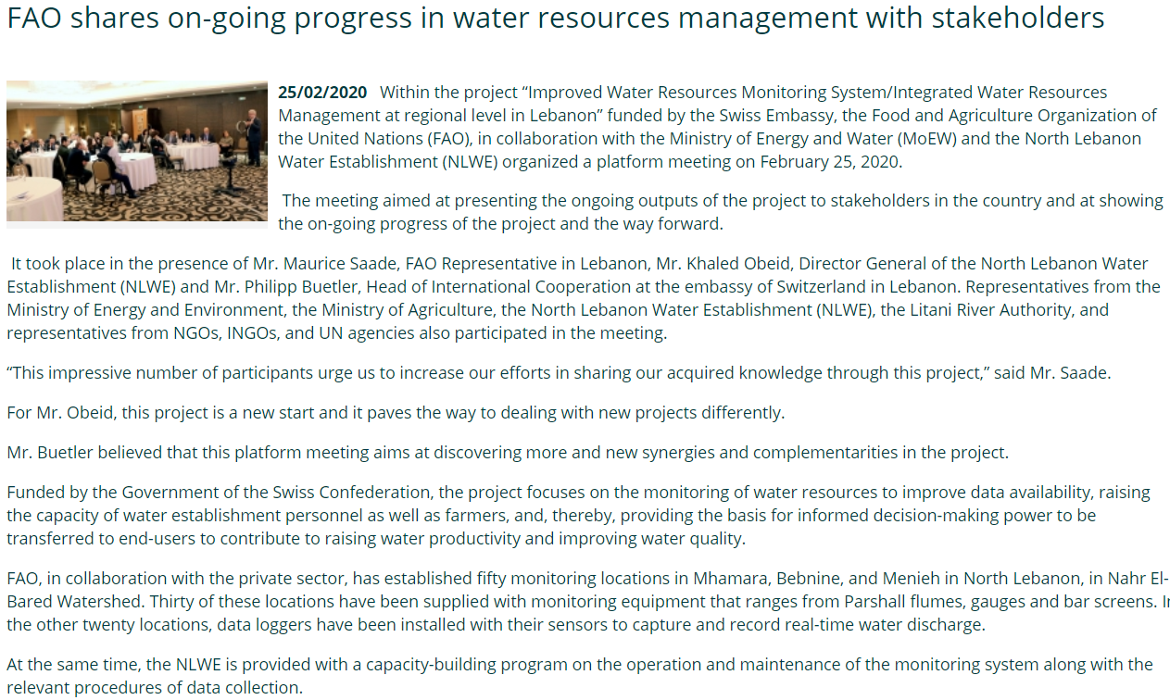
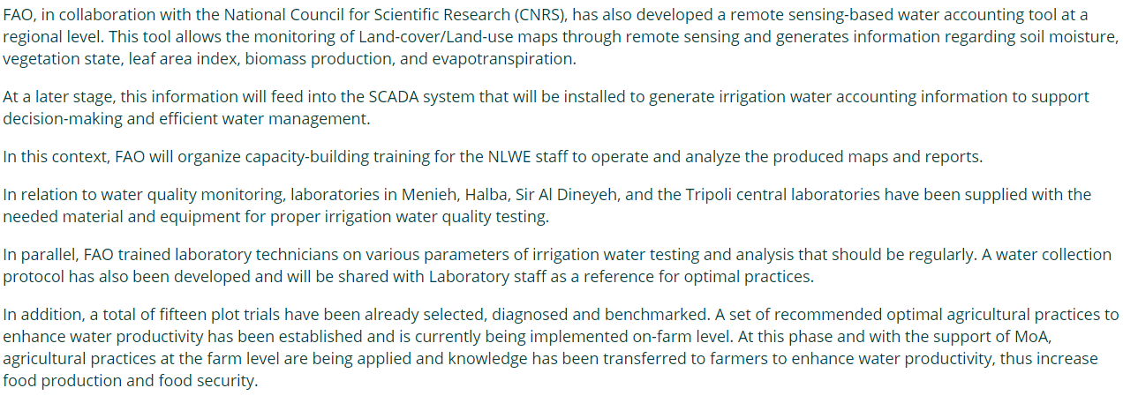

http://www.fao.org/lebanon/programmes-and-projects/project-list/en/
budget :$50.5 m
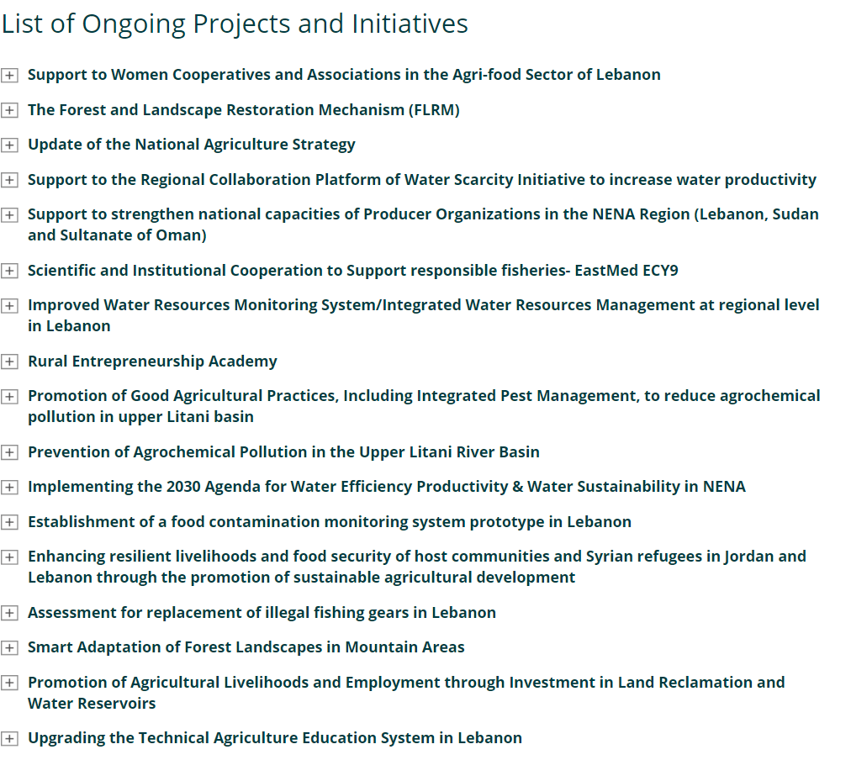

Projects of ILO (INTERNATIONAL LABOUR ORG)IN LEBANON
https://www.ilo.org/global/lang--en/index.htm
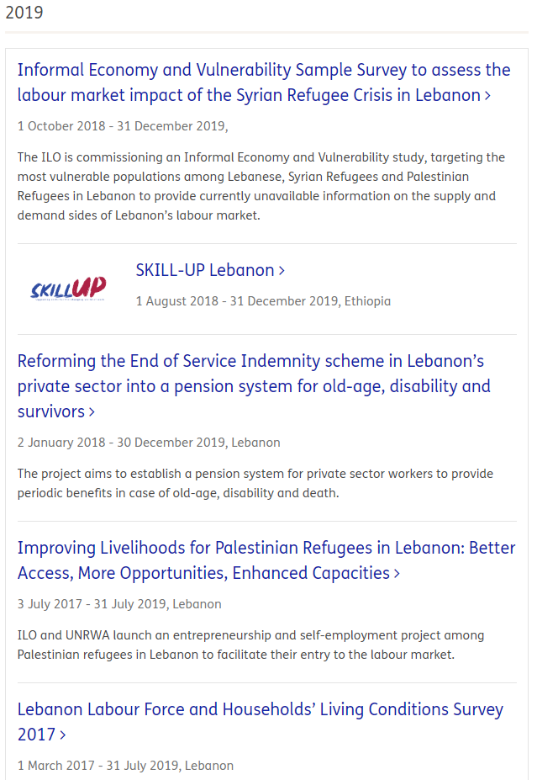
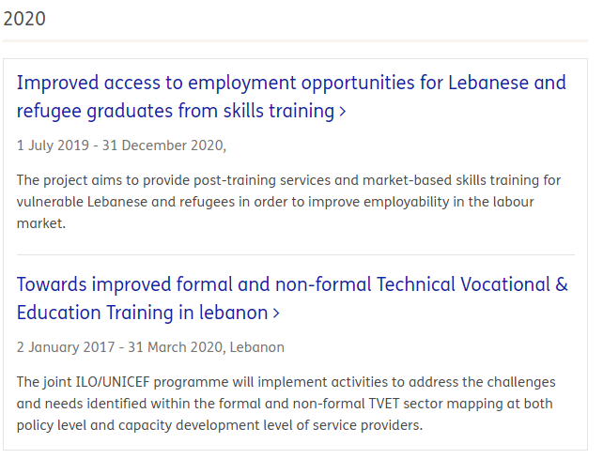

Civil society organizations CSO(https://eeas.europa.eu/archives/delegations/lebanon/documents/news/20150416_2_en.pdf)

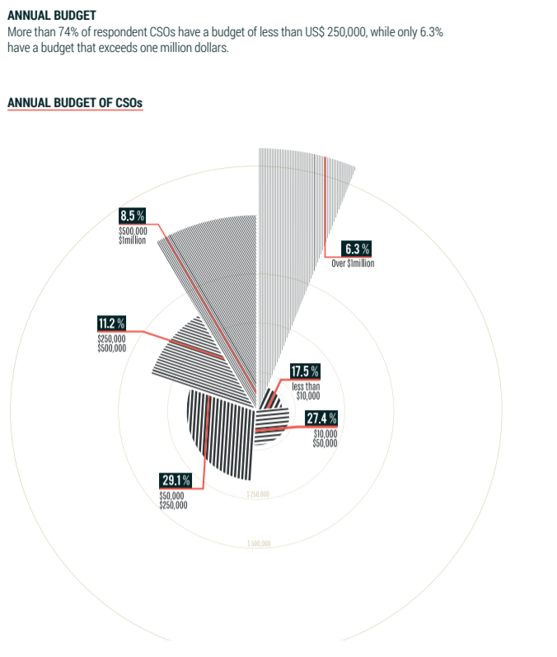
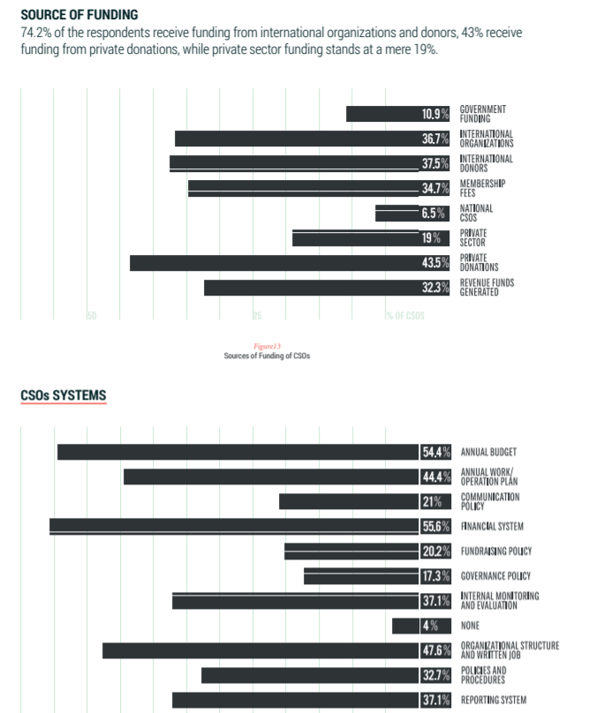

Conclusion
بعد الاطلاع على مختلف نشاطات الجمعيات الدولية الناشطة في لبنان والتي اصبحت اكثر اهمية بعد الازمة السورية ,تجدر الاشارة أنها تركز على دعم المجتمعات المستضيفة واللاجئين التمركزين وغير المتمركزين ضمن المخيمات من جهة وعلى صعيد الوازارات (الداخلية والبلديات-الصحة-التربية-البيئة-الطاقة والمياه ) من جهة أخرى.
المحاور التي تهتم بها الجمعيات هي :
1-توفيربعض الشبكات لتأمين مياه الشرب , وبعض شبكات الانارة.
2-النمو الاقتصادي :من خلال خلق فرص عمل لا سيما للموظفين والمستهدفين من المشاريع (الزراعة ,الاشغال اليدوية)
3-التعليم:التعليم الابتدائي والثانوي والجامعي ,تدريبات لتحسين المهارات الحياتية (life skills,communication skills,professional skills)
نستخلص انها مشاريع قصيرة المدى ,ذو منفعة وقتية اذ ما تم الاستمرار في تطويرها ومتابعة نتائجها على كافة الاصعدة
خصوصا انها تركز على تمكين الموارد البشرية.

