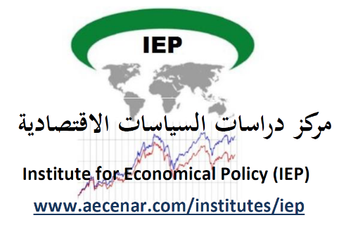

North Lebanon Water management

Author: Maryam Abdel-karim

Contents
1. Lebanon’s water sector: problem statement and underlying issues 3
2. Shortcomings on the Lebanese water infrastructure and management fronts 5
3. Lebanon’s Water Sector value chain 5
4. Demand/Supply Forecast 8
4.1. Demand 8
4.2. Supply 15
5. State of water resources 17
6. Lebanon’s Water Resources 18
6.1. Surface water 18
6.2. Underground Water 19
7. Lebanon’s Organization of water sector 19
7.1. Ministry of Energy & Water (MOEW) 20
7.2. Regional water establishment 21
7.3. Local Committee 22
8. Completed and ongoing projects 24
10. Water extraction 26
11. Water treatment steps 26
12. Water distribution system 28
12.1. Infrastructure 28
12.1.1. Pipes 28
12.1.2. Pipe-Network Configurations 28
12.1.3. Storage Tanks and Reservoirs 29
12.1.4. Pumps 29
12.1.5. Valves 30
12.1.6. Hydrants 30
13. Applying a System Dynamics Approach 31
14. Conclusion 31

- Lebanon’s water sector: problem statement and underlying issues
Despite its relatively high per capita water endowment (1,000m3 /capita, making the country the fourth best-endowed in MENA), Lebanon is already using two thirds of its available water resources, high by global standards (averaging 10-30% for other regions), and there is significant groundwater mining. There is a seasonal mismatch between supply (at its peak in the rainy winter) and demand (peaking in the hot, dry summer months). Factors exacerbating this seasonal water imbalance are the very low water storage capacity (6% of total resources, compared to the MENA average of 85%), the deficiency of water supply networks and, on the demand side, fast rising demand from the municipal and industrial sectors. These seasonal imbalances are likely to lead to chronic water shortages. Already, dry season shortages are emerging and water quality is deteriorating. If no actions are taken to improve efficiency, manage demand and increase storage capacity, the country would depend in the long run on mined groundwater or on high cost desalination for incremental resources.
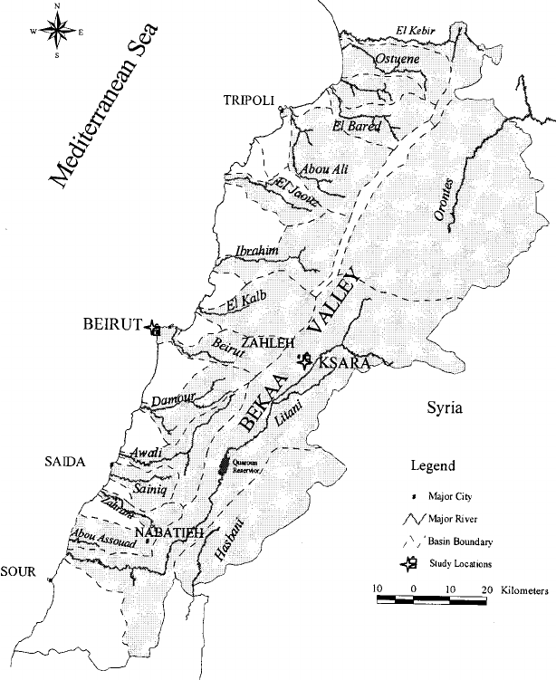

- Shortcomings on the Lebanese water infrastructure and management fronts
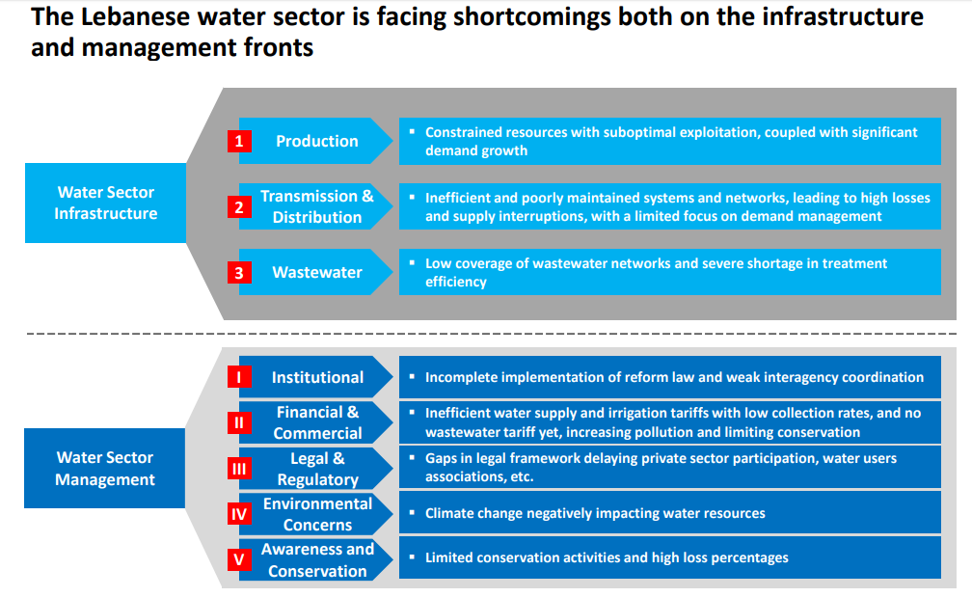
- Lebanon’s Water Sector value chain
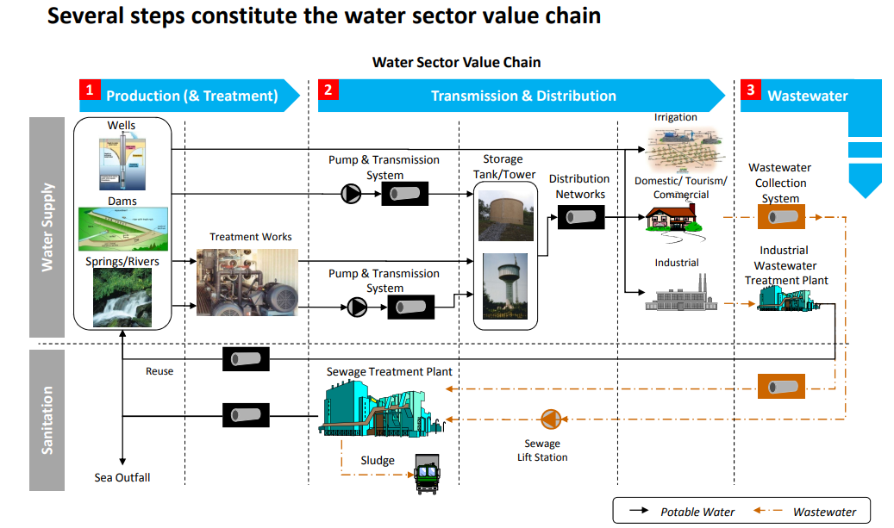
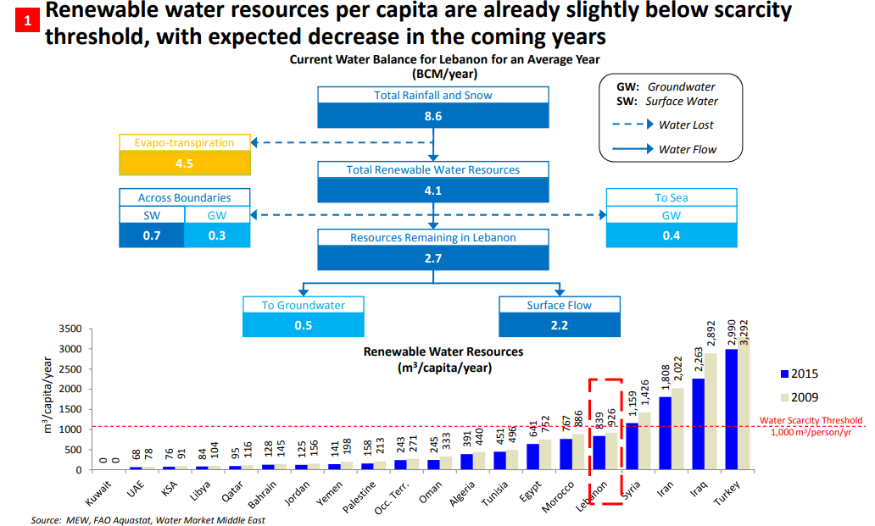
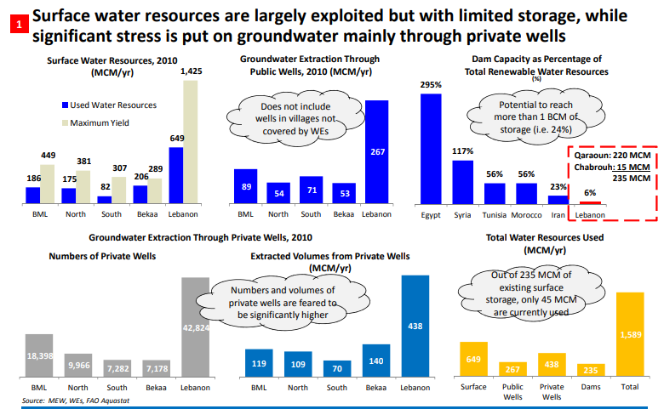
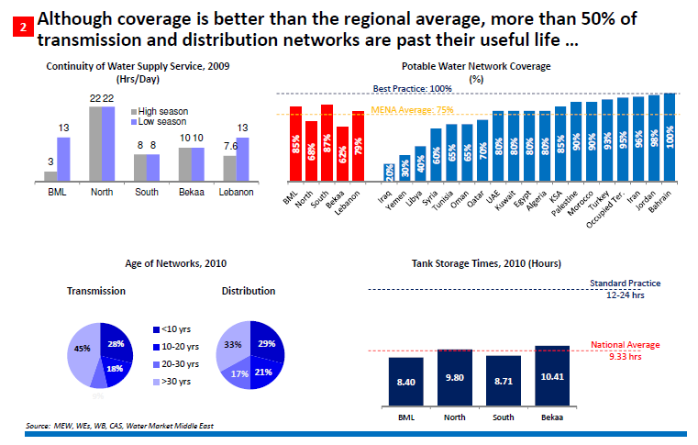
يعتبر عمر الامدادات والانابيب كبير جدا وهي بحاجة الى صيانة.
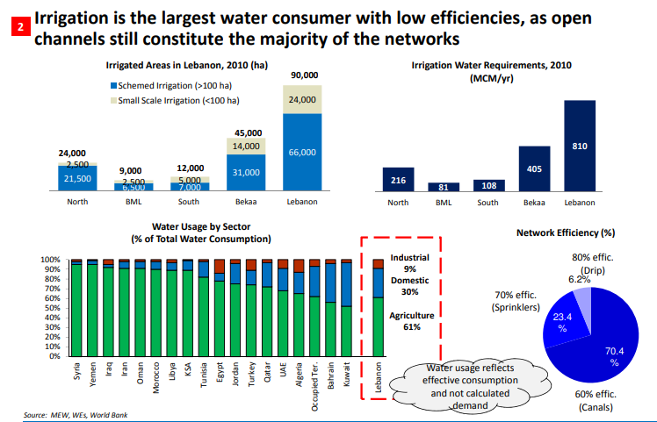
الزراعة هي المستهلك الرئيسي للمياه وتعتبر طرق الري التقليدية المستخدمة حاليا من اهم أسباب هدر الموارد.
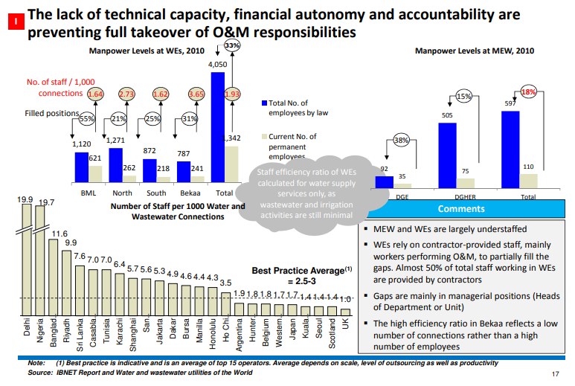
نلاحظ نقص حاد باليد العاملة في هذا القطاع.
- Demand/Supply Forecast
  - Demand
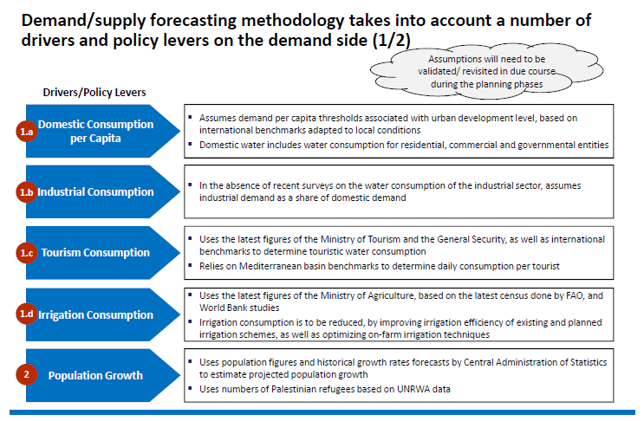
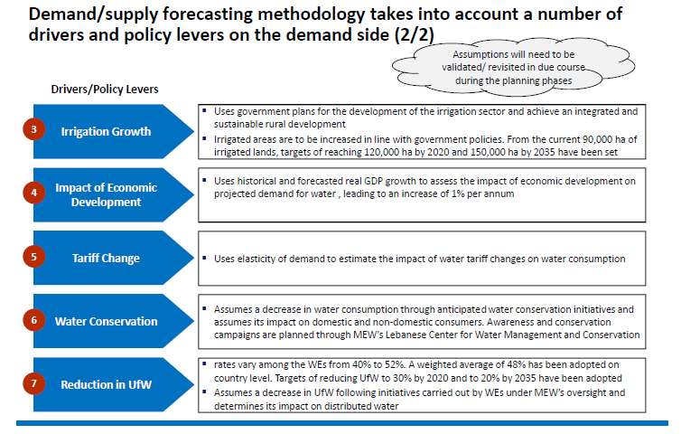
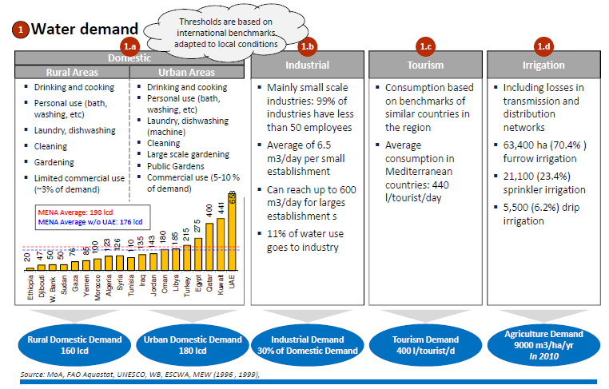
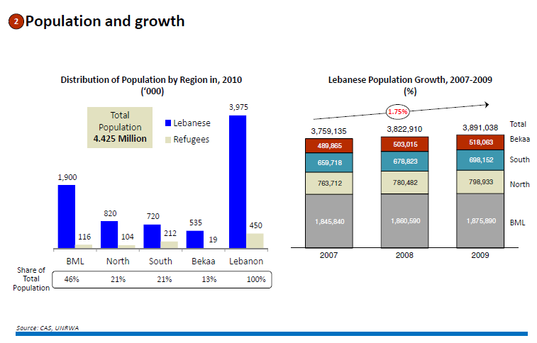
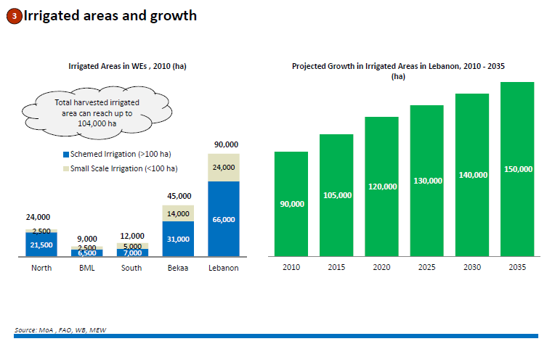
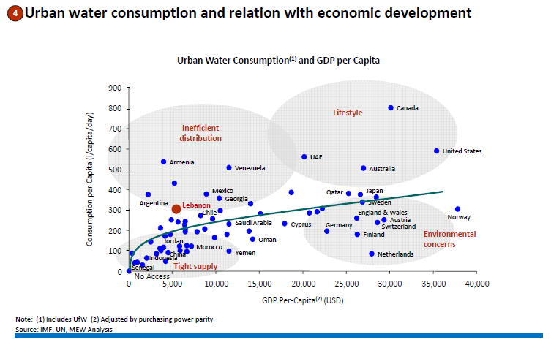
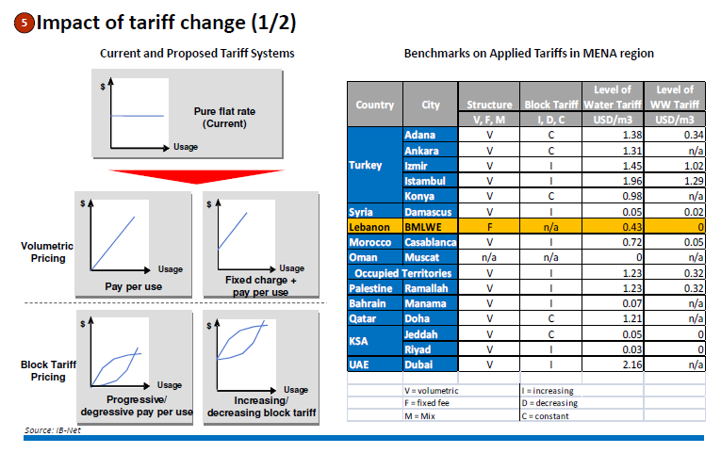
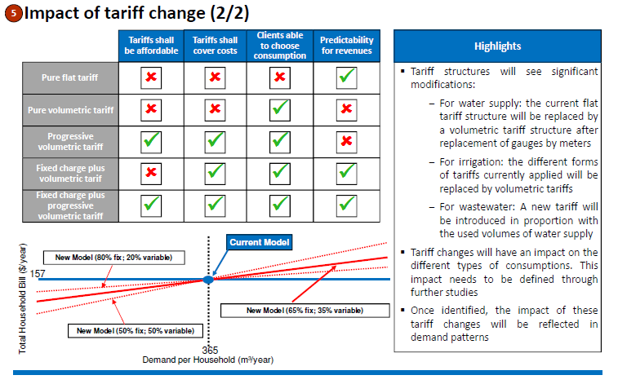
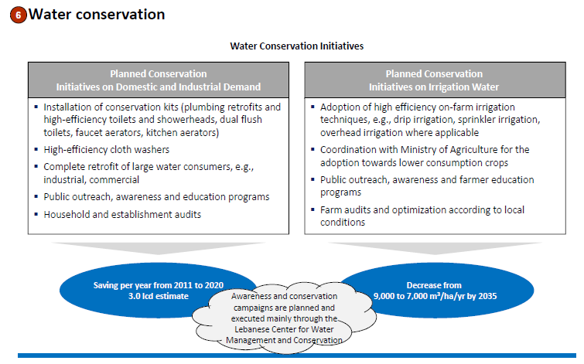
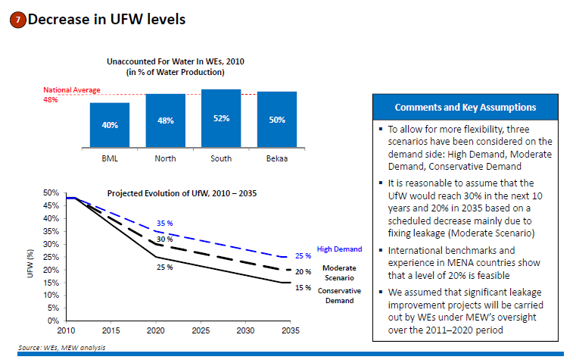
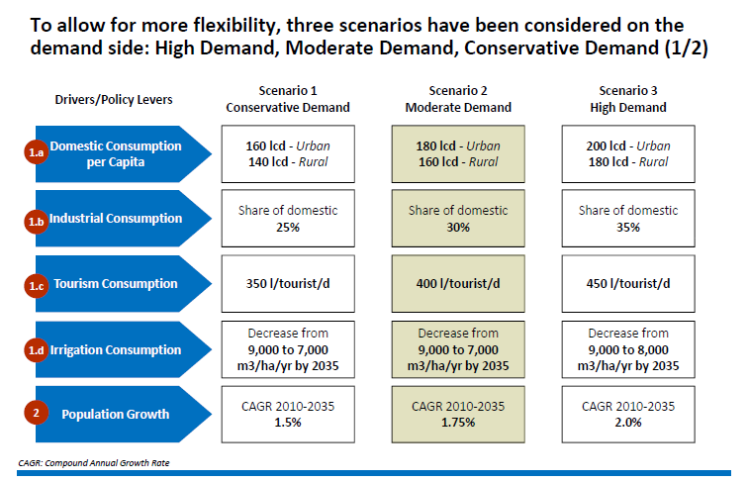
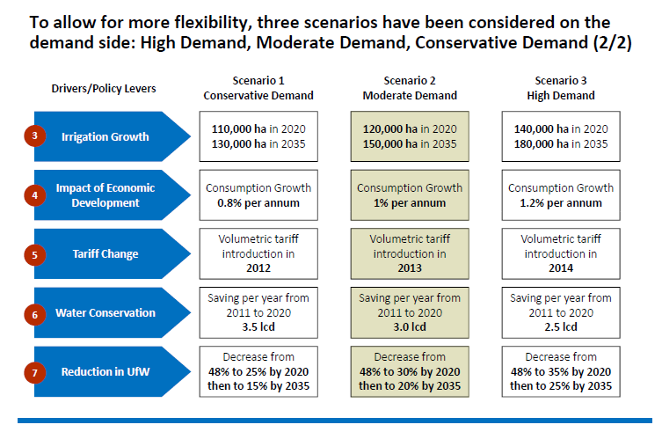
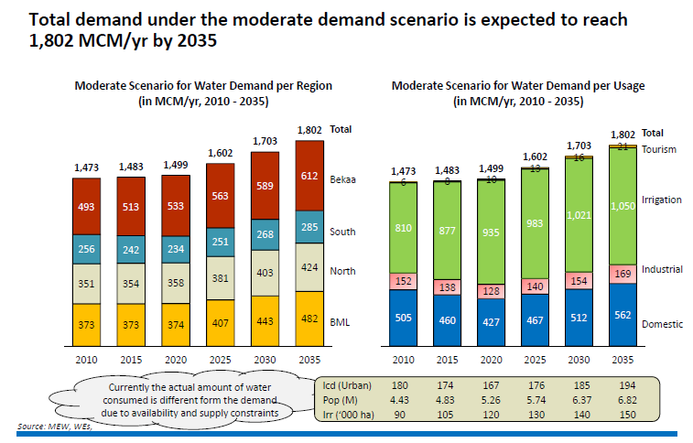
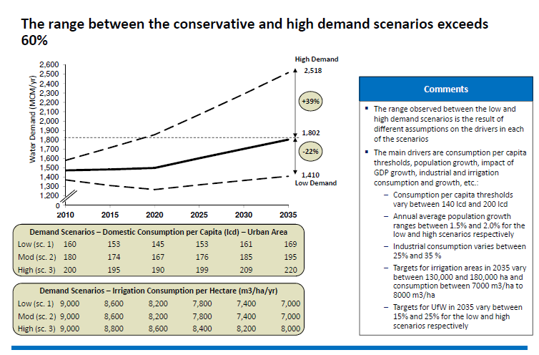
  - Supply
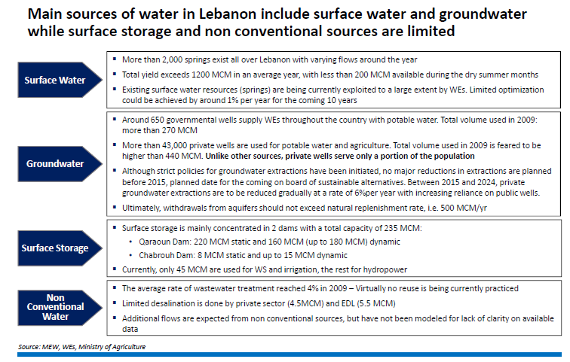
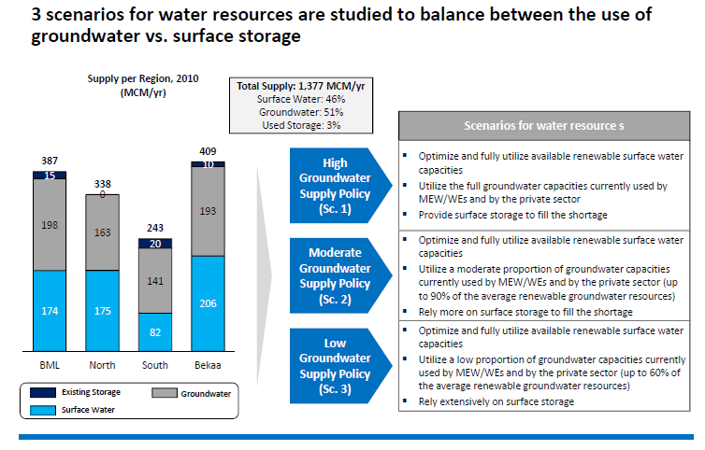
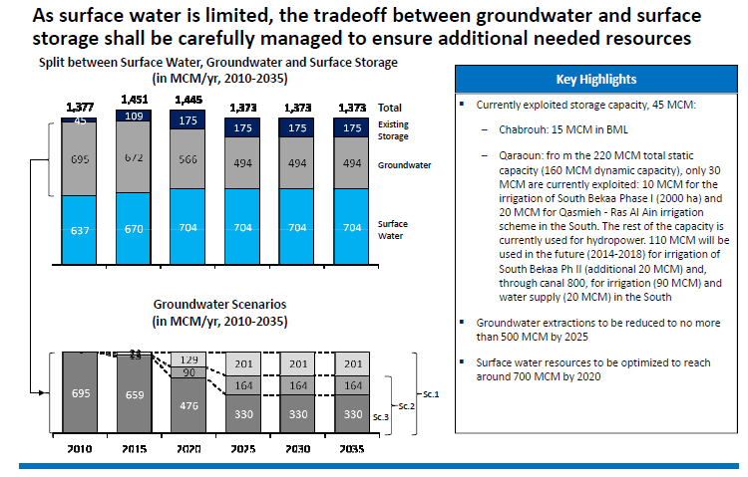

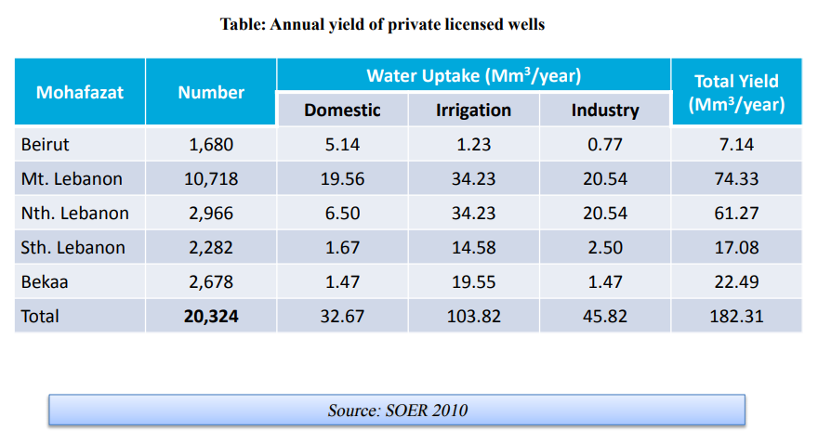
- State of water resources
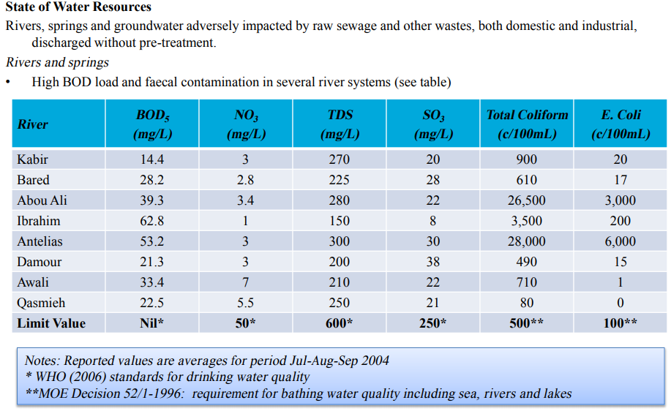

- Lebanon’s Water Resources

  - Surface water
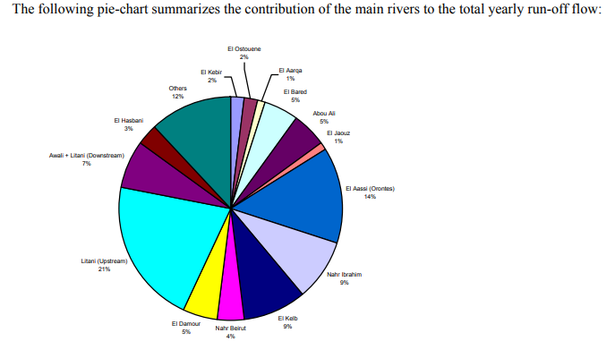
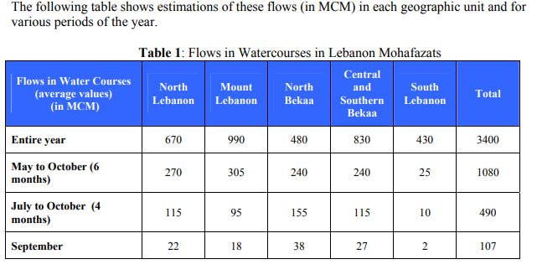
  - Underground Water
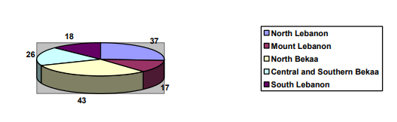
Referring to all water sectors, it is noticed that:
- The water available from the springs is no longer sufficient especially in dry seasons.
- The administration and individuals have overused underground water. Most of the projects studied lately by the administration are based on drilling wells.
- The over usage of underground water has led to the following facts:
  - A decrease in spring flows limits the use for potable water and irrigation.
  - A decrease in the water level in the underground reservoirs.
  - The intrusion of sea water and the increase of salinity in the wells on the coast.
From what has preceded, one can clearly see the necessity of storing winter water to be used in dry seasons. Due to this fact the work plan calls:
- First:
- To prepare detailed hydrogeological plans for underground water
- To study the possibility of storing underground water
- To maximum reduce the intrusion of sea water
- To study all the necessary infrastructures to insure artificial feeding of underground water.
- Second:
- To study the possibility of water storage from the rivers in Lebanon from dams and hill lakes
- To execute the construction of dams and hill lakes in regions where their feasibility has been proven.
- Lebanon’s Organization of water sector
Numerous governmental, Ministries and autonomous and semi-autonomous agencies are involved in the water sector planning and management in Lebanon. Their responsibilities are interrelated and therefore it is difficult to discern a clear authoritative system linking promulgated decrees to the corresponding and appropriate agencies (MOEW, LRA, RWE, MOA, CDR, GP, etc.). The political power and interest involvement in the country at the institutional level led to this chaotic situation. The historical and actual perspectives concerning the main institutions involved in the water sector are described here below.
  - Ministry of Energy & Water (MOEW)
Created in 1966, the Ministry of Hydraulic and Electrical Resources (MOHER), now MOEW since 2000, has the following mandates:
- protect and develop hydraulic natural resources;
- assume jurisdiction over the water resources in Lebanon;
- study supply and demand, and global situation of the water resources in Lebanon;
- prepare the national water master plan;
- design, implement and operate large hydraulic facilities;
- conserve and control the water resources including surface and underground water;
- exercise administrative supervision over the WAs and the LRA.
MOEW has two General Directorates: The largest of the two: The Directorate General of Hydraulic and Electric Resources (DGHER) is responsible for research, studies and implementation of large-scale projects. The second one is the Directorate General for Operations (DGO) is responsible for overseeing the public establishment, for administration and financial aspects and for mines and quarries. MOEW exercises administrative supervision over the RWA, the autonomous Water Boards and Local Committees through the Directorate General of Operations (DGO). MOEW has about 212 staff against 578 assumed positions including 60 engineers. Due to the ban on new recruitment by the public sector, 26 the average age of MOEW staff is quite high. In recent years, some new recruitment and transfer from the other ministries were made on exceptional basis. MOEW's average yearly budget is about US$85 million and irrigation represents ten percent of this total budget.
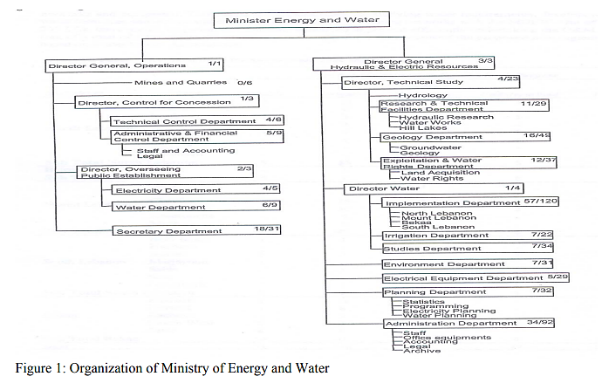
  - Regional water establishment
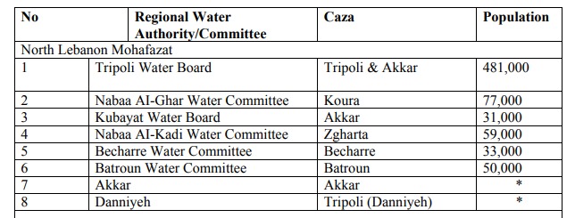
Table 7: Regional Water Authorities in Lebanon

Local Committee
Table 8 describes the 209 Local Committees (LCs) with their locations and functions. These Committees were mainly established after the civil unrests of the 1980s. In general, the role of these Committees is restricted to the operation, maintenance rehabilitation and renovation of the networks and equipment. This keeps the responsibility for studying water requirements, 28 development of water resources and design and execution of extension of existing networks with the MOEW. Out of these 209 LCs, there are 25 Irrigation Committees, which are at present efficiently undertaking the O&M tasks (out of a total of 120). These Committees could easily form the nucleus of the proposed new organization based on Water User’s Associations.
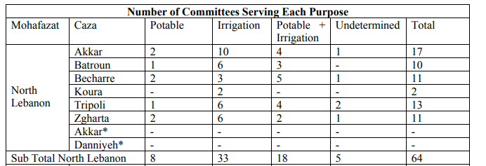
Table 8: Local Water Committees formed between 1984 and 1990
In 1998, a new decree was issued organizing all Regional Water Authorities into four authorities: North Lebanon, Beirut & Mount Lebanon, South Lebanon and Bekaa (table 9).
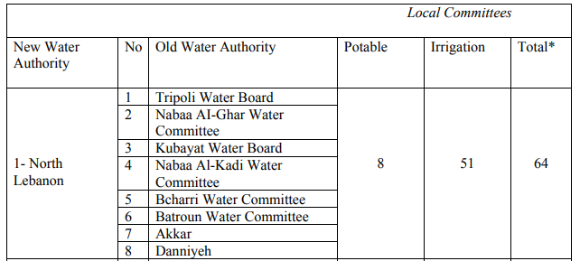
* Including undetermined Committees.
Table 9: recently created water authorities

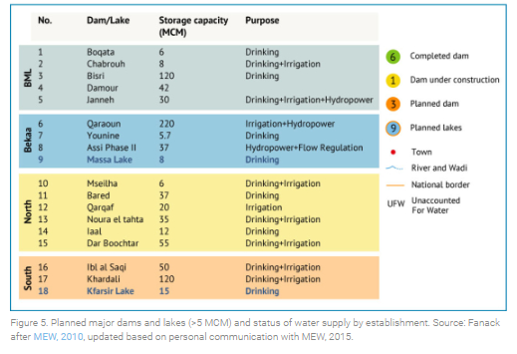
- Completed and ongoing projects

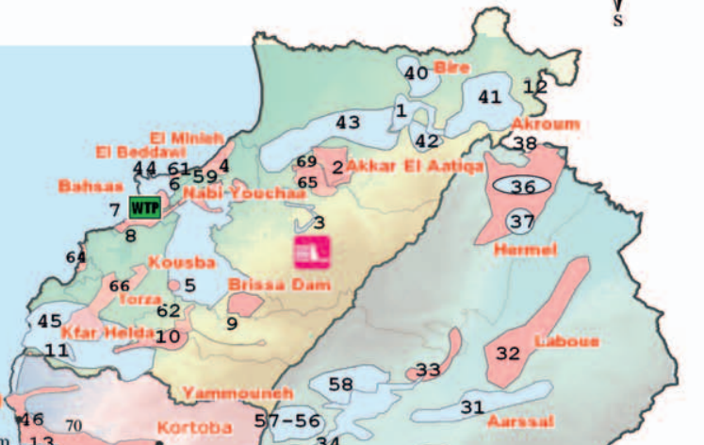

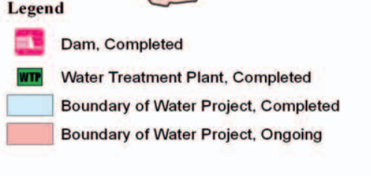

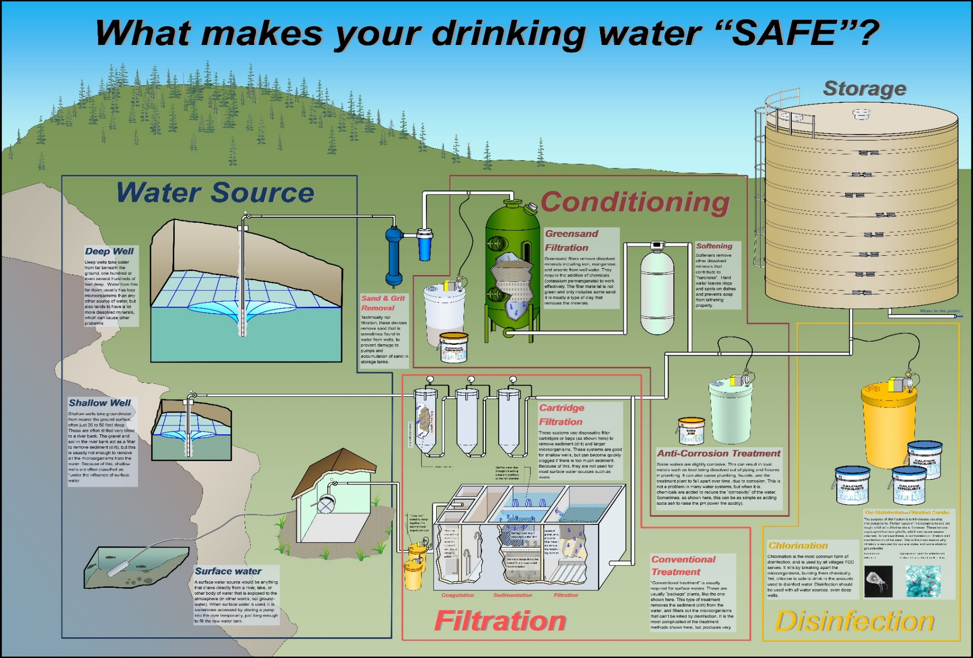
- Water treatment scheme

- Water extraction

Depending upon where you live, there are two basic ways that water gets to your house. If you live in the country on a farm, your water probably comes from a deep well located on your property. If you live in a small town or larger city, however, you most likely get your water from a public water supply.

If your water comes from a public water supply, then you will pay fees to a public water utility based upon how much water you use. Your water use is measured by a water meter located in your home or on your property.
Public water utilities provide water to large numbers of customers by one of two means: surface water or ground water. Ground water is located deep underground in veins of water known as aquifers. It must be accessed by drilling a deep well and then pumping it to the surface. If you have a private well on your property, you are using ground water from an aquifer.
Surface water, on the other hand, is found at the surface of Earth in lakes, rivers, and streams. A public water utility accesses surface water by building an intake to draw water to a location where it can be analyzed, treated, and then pumped out to customers.
Most public water utilities tend to rely upon surface water sources. Millions of people around the world use ground water wells, though. Overall, both sources provide about half of the world's drinking water.

Regardless of its source, water must be analyzed to ensure it's safe to drink. Public water utilities filter and treat water with certain chemicals to remove impurities and make sure your drinking water is safe to use.

Filtered and treated water that's safe to drink (called potable water) is then stored in a reservoir from which it gets pumped through underground pipes (called water mains) to your house. A water pipe known as a service lateral line connects that water main to your house plumbing and brings the water right to your faucet when you turn it on.

Public water utilities also keep plenty of water in storage in case of emergencies. You may have noticed big water tanks located on the high hills in your town and surrounding communities. These water tanks hold thousands upon thousands of gallons of water that can be used in case of fires and water main leaks.
- Water treatment steps
Drinking water sources are subject to contamination and require appropriate treatment to remove disease-causing agents. Public drinking water systems use various methods of water treatment to provide safe drinking water for their communities. Today, the most common steps in water treatment used by community water systems (mainly surface water treatment) include:
- Coagulation and Flocculation
Coagulation and flocculation are often the first steps in water treatment. Chemicals with a positive charge are added to the water. The positive charge of these chemicals neutralizes the negative charge of dirt and other dissolved particles in the water. When this occurs, the particles bind with the chemicals and form larger particles, called floc.
- Sedimentation
During sedimentation, floc settles to the bottom of the water supply, due to its weight. This settling process is called sedimentation.
- Filtration
Once the floc has settled to the bottom of the water supply, the clear water on top will pass through filters of varying compositions (sand, gravel, and charcoal) and pore sizes, in order to remove dissolved particles, such as dust, parasites, bacteria, viruses, and chemicals.
- Disinfection
After the water has been filtered, a disinfectant (for example, chlorine, chloramine) may be added in order to kill any remaining parasites, bacteria, and viruses, and to protect the water from germs when it is piped to homes and businesses.

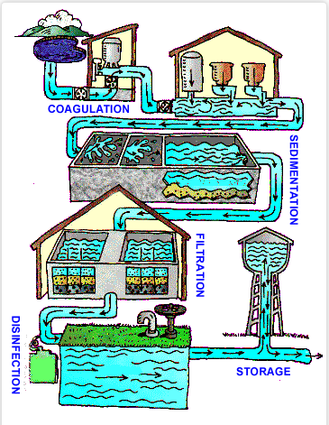

- Water distribution system

Distribution system infrastructure is generally the major asset of a water utility. The American Water Works Association (AWWA, 1974) defines the water distribution system as “including all water utility components for the distribution of finished or potable water by means of gravity storage feed or pumps though distribution pumping networks to customers or other users, including distribution equalizing storage.” These systems must also be able to provide water for no potable uses, such as fire suppression and irrigation of landscaping.
  - Infrastructure
Distribution system infrastructure is generally considered to consist of the pipes, pumps, valves, storage tanks, reservoirs, meters, fittings, and other hydraulic appurtenances that connect treatment plants or well supplies to consumers’ taps. The characteristics, general maintenance requirements, and desirable features of the basic infrastructure components in a drinking water distribution system are briefly discussed below.
    - Pipes
The systems of pipes that transport water from the source (such as a treatment plant) to the customer are often categorized from largest to smallest as transmission or trunk mains, distribution mains, service lines, and premise plumbing. Transmission or trunk mains usually convey large amounts of water over long distances such as from a treatment facility to a storage tank within the distribution system. Distribution mains are typically smaller in diameter than the transmission mains and generally follow the city streets. Service lines carry water from the distribution main to the building or property being served. Service lines can be of any size depending on how much water is required to serve a particular customer and are sized so that the utility’s design pressure is maintained at the customer’s property for the desired flows. Premise plumbing refers to the piping within a building or home that distributes water to the point of use. In premise plumbing the pipe diameters are usually comparatively small, leading to a greater surface-to-volume ratio than in other distribution system pipes.
The three requirements for a pipe include its ability to deliver the quantity of water required, to resist all external and internal forces acting upon it, and to be durable and have a long life (Clark and Tippen, 1990). The materials commonly used to accomplish these goals today are ductile iron, pre-stressed concrete, polyvinyl chloride (PVC), reinforced plastic, and steel.

    - Pipe-Network Configurations
The two basic configurations for most water distribution systems are the branch and grid/loop (see Figure 1-3). A branch system is similar to that of a tree branch, in which smaller pipes branch off larger pipes throughout the service area, such that the water can take only one pathway from the source to the consumer. This type of system is most frequently used in rural areas. A grid/looped system, which consists of connected pipe loops throughout the area to be served, is the most widely used configuration in large municipal areas.
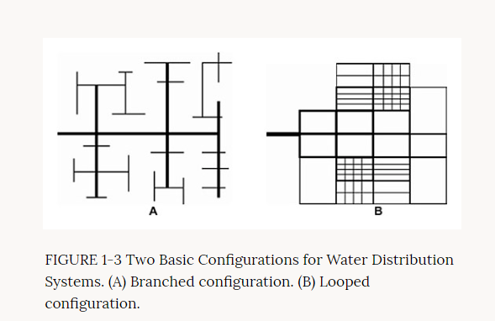
    - Storage Tanks and Reservoirs
Storage tanks and reservoirs are used to provide storage capacity to meet fluctuations in demand (or shave off peaks), to provide reserve supply for fire-fighting use and emergency needs, to stabilize pressures in the distribution system, to increase operating convenience and provide flexibility in pumping, to provide water during source or pump failures, and to blend different water sources. The recommended location of a storage tank is just beyond the center of demand in the service area (AWWA, 1998). Elevated tanks are used most frequently, but other types of tanks and reservoirs include in-ground tanks and open or closed reservoirs. Common tank materials include concrete and steel.
    - Pumps
Pumps are used to impart energy to the water in order to boost it to higher elevations or to increase pressure. Pumps are typically made from steel or cast iron. Most pumps used in distribution systems are centrifugal in nature, in that water from an intake pipe enters the pump through the action of a “spinning impeller” where it is discharged outward between vanes and into the discharge piping. The cost of power for pumping constitutes one of the major operating costs for a water supply.
Therefore, it is very important that pumps have a high degree of efficiency and are maintained properly. To guarantee safe water quality, cross connection of drinking water and waste removal systems must be avoided.
Main pumping stations, which supply water to the distribution system, are located near the water treatment facility or a potable water storage facility, and pump directly into the piping system. Pumps that pump directly into transmission lines and distribution systems are sometimes called high lift pumps.

Booster pumps are additional pumps used to increase pressure locally or temporarily. Booster pumps stations are usually remotely located from the main pump station, as in hilly topography where high-pressure zones are required, or to handle peak flows in a distribution system that can otherwise handle the normal flow requirements.
There are generally two types of pumps used for potable water pumping applications.
- The vertical turbine pump (line shaft and submersible types)
- The centrifugal horizontal or vertical split case pump designed for water-works service.
Pump discharge capacity:
- If the pump is used directly to supply water without a reservoir, the capacity must be equal to the peak hour demand.
- If the water distribution system has a reservoir, the pump capacity must be equal to the maximum daily demand.
Pump selection:
- If the pumping water level is less than 6 meters, use a centrifugal pump (maximum suction lift = 6 meters).
- If the pumping water level is from 6-20 meters, use jet pumps or a submersible.
- If the PWL is greater than 20 meters, use a submersible or a vertical line shaft turbine pump.
Power supply for pumps:
Electric, gasoline or diesel engines are commonly used as power sources for pumps. The electric motor is, however, the most favored power source because of its reliability, relatively low power cost, and environmental considerations like cleanliness, relatively low noise, and low pollutant emissions. An electrical pump may also be driven with solar power. Heat sensors installed in the windings during manufacturing should protect electric motors. These sensors shut the motor off in case of low voltage or change in phase before damage can be done.

    - Valves
The two types of valves generally utilized in a water distribution system are isolation valves (or stop or shutoff valves) and control valves. Isolation valves (typically either gate valves or butterfly valves) are used to isolate sections for maintenance and repair and are located so that the areas isolated will cause a minimum of inconvenience to other service areas. Maintenance of the valves is one of the major activities carried out by a utility. Many utilities have a regular valve-turning program in which a percentage of the valves are opened and closed on a regular basis. It is desirable to turn each valve in the system at least once per year. The implementation of such a program ensures that water can be shut off or diverted when needed, especially during an emergency, and that valves have not been inadvertently closed.
    - Hydrants
Hydrants are primarily part of the firefighting aspect of a water system. Proper design, spacing, and maintenance are needed to insure an adequate flow to satisfy fire-fighting requirements.

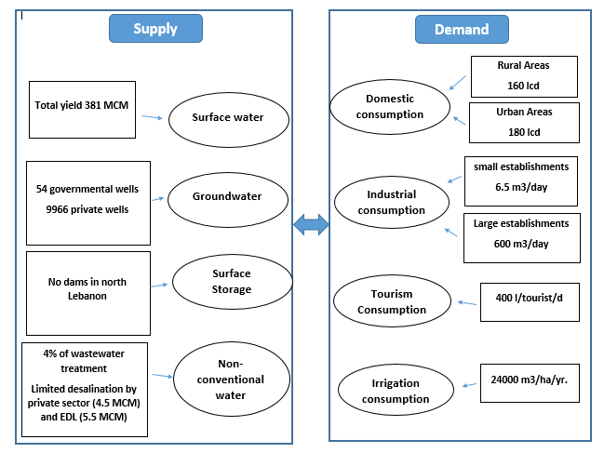
Applying a System Dynamics Approach

- Conclusion
يعتبر واقع الموارد المائية في شمال لبنان جيد حاليا الا ان القطاع يعاني من مشاكل عدة أهمها:
-الهدر (امدادات وانابيب قديمة جدا)
- التلوث (استخدام المواد الكيماوية وتسرب مياه الصرف الصحي واختلاطها بمياه الشفة)
-استخراج الماء الغير منتظم (حفر الابار بطريقة عشوائية)
-عدم استغلال مياه المسطحات والتركيز على حفر الابار
كل هذه المشاكل قد تؤدي فيما بعد الى خطر انخفاض منسوب المياه الجوفية وبالتالي نقص في الموارد المائية.

http://www.databank.com.lb/docs/National%20Water%20Sector%20Strategy%202010-2020.pdf
https://unstats.un.org/unsd/envaccounting/workshops/Beirut2012/Beirut2012-11.PDF
https://water.fanack.com/lebanon/water-infrastructure/#_ftn14
http://www.cdr.gov.lb/eng/progress_reports/pr102014/Ewater.pdf
https://www.tananachiefs.org/wp-content/uploads/2016/10/2016-TCC-Poster-Water-treatment.jpg
https://www.cdc.gov/healthywater/drinking/public/water_treatment.html
http://dl.mozh.org/up/Drinking%20Water%20Distribution%20Systems%20-%20Assessing%20and%20Reducing%20Risks-National%20Research%20Council-.pdf
https://sswm.info/sswm-university-course/module-2-centralised-and-decentralised-systems-water-and-sanitation-1/pumping-stations
http://dl.mozh.org/up/Drinking%20Water%20Distribution%20Systems%20-%20Assessing%20and%20Reducing%20Risks-National%20Research%20Council-.pdf

