Multistage electrolysis design by FreeCAD _ Stage 1

Stage 1 is divided for 3 parts:
- Part 1 : electrolysis
- Part2 : Add CO2 to the electrolyte solution
- Part 3 : distillation of mixture

Stage 1 _ Overview
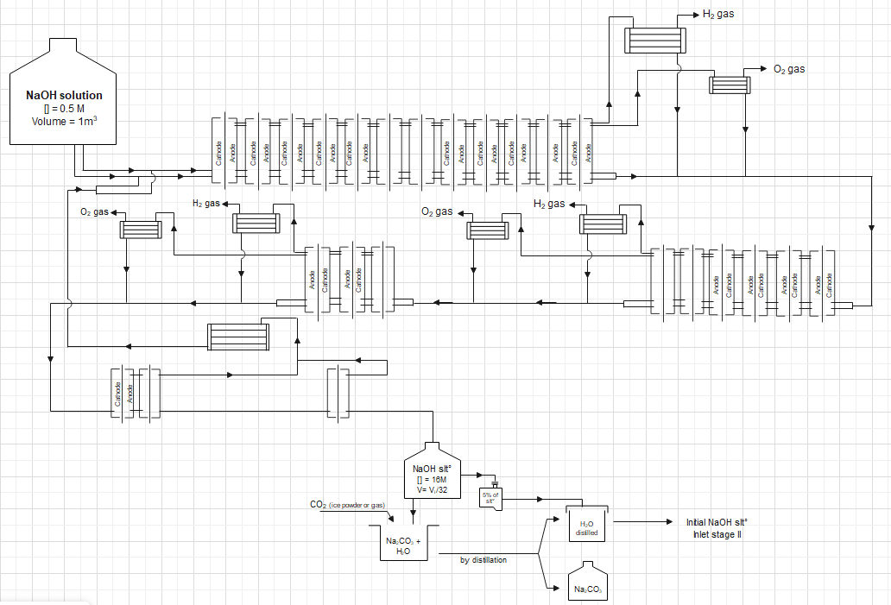
*N.B.: this Overview is not complete; it lacks pumps, compressors, sanitary installations for cooling water as well as electrical connections.

Part 1 : Electrolysis
Electrolysis in stage 1 is divided to 5 steps. Step 1, 2 & 3 the production of hydrogen & oxygen separately, while each step 4 & 5 in which produces hydrogen and oxygen mixture to be burned.
In this report, designs for each step of electrolysis multistage will be represented.

- Electrolysis step 1, 2 & 3 _ All components -compressed-

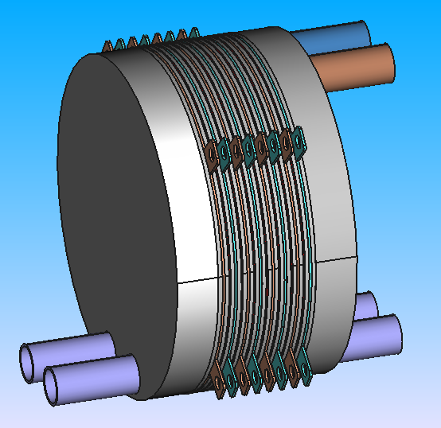

- Electrolysis step 1, 2 & 3 _ All components -explosed-
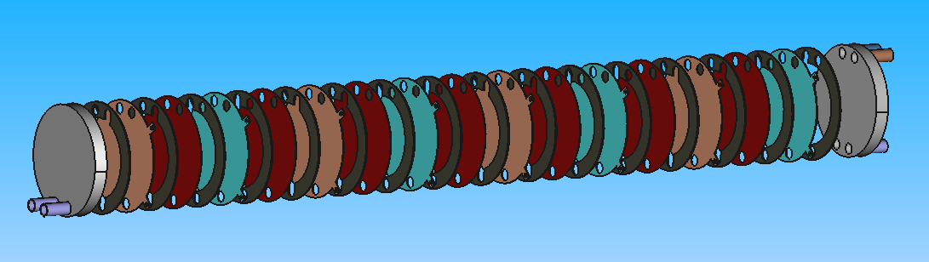

- Electrolysis step 1, 2 & 3 _ End plate1 (inlet solution)
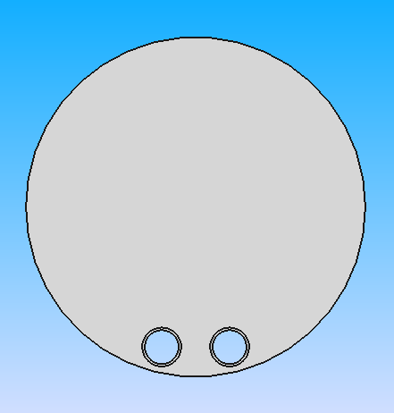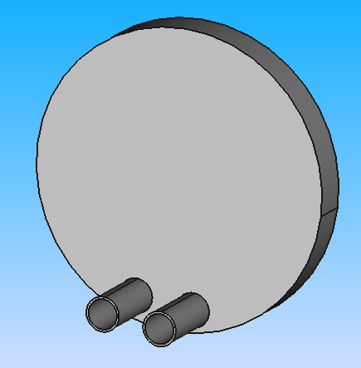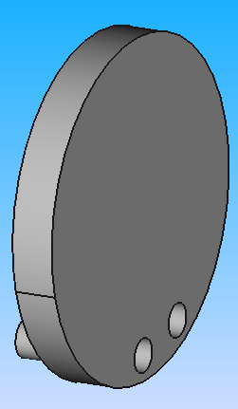

- Electrolysis step 1, 2 & 3 _ Gasket
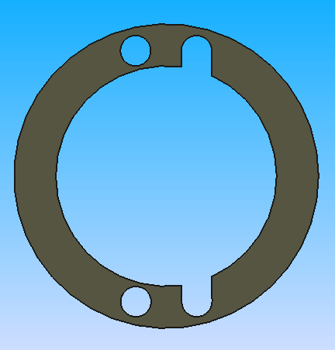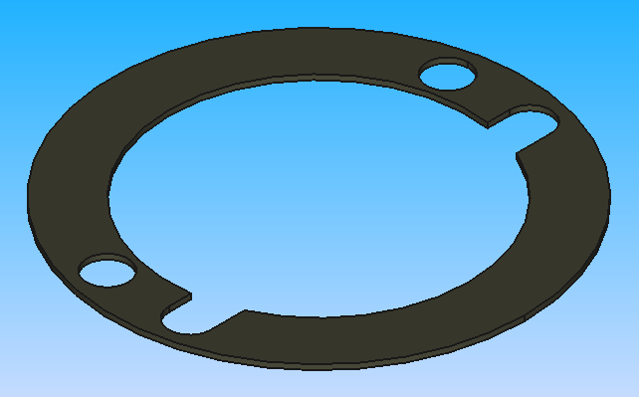

- Electrolysis step 1, 2 & 3 _ Electrode
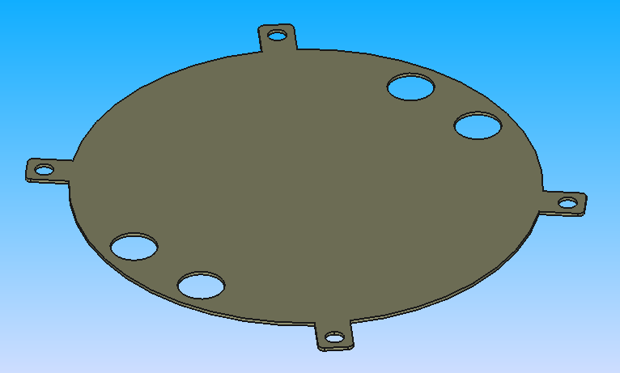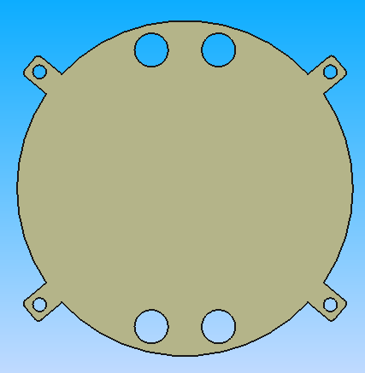

- Electrolysis step 1, 2 & 3 _ Membrane
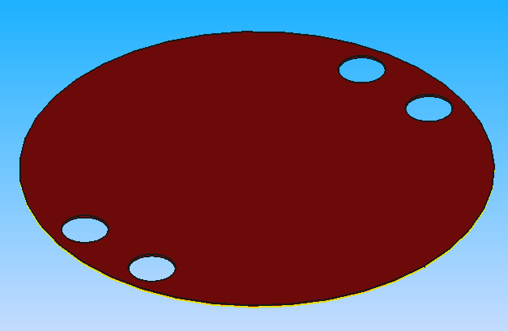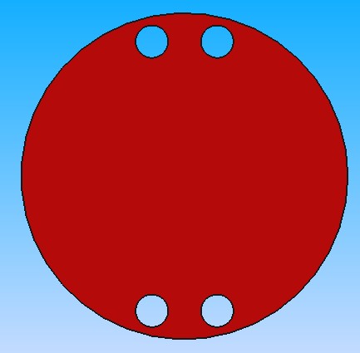

- Electrolysis step 1, 2 & 3 _ End plate2 (Outlet solution)
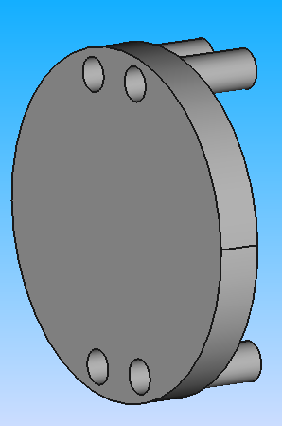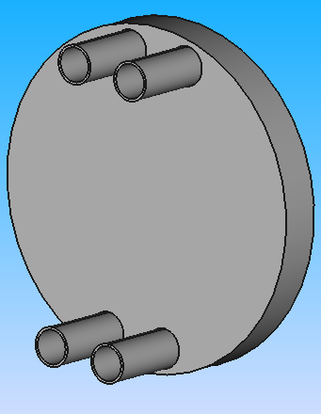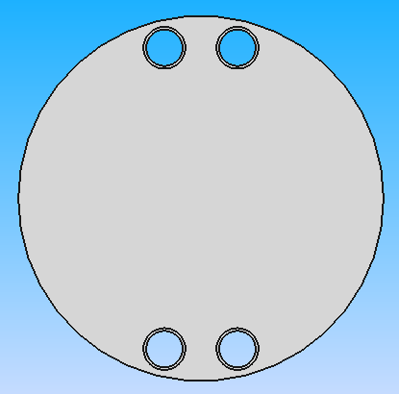

- Electrolysis step 4 & 5 _ All components -compressed-
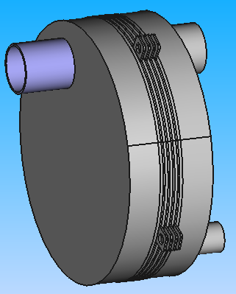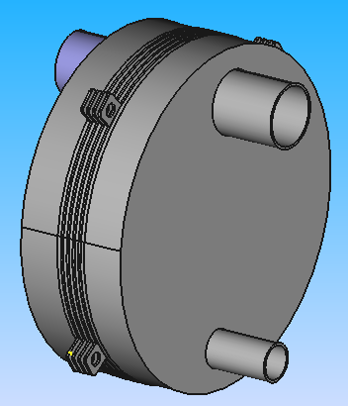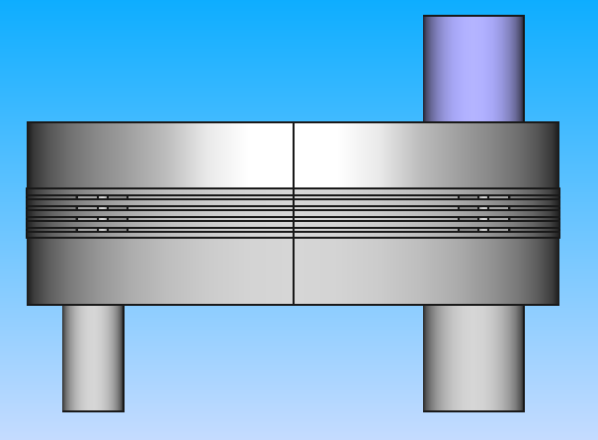

- Electrolysis step 4 & 5 _ All components -Explosed-
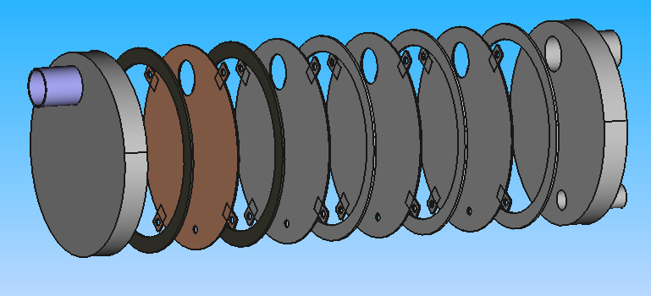

- Electrolysis step 4 & 5 _ End plate1 (Intlet solution)
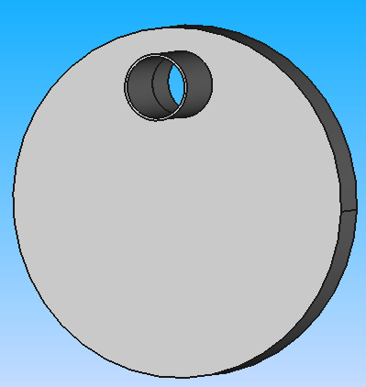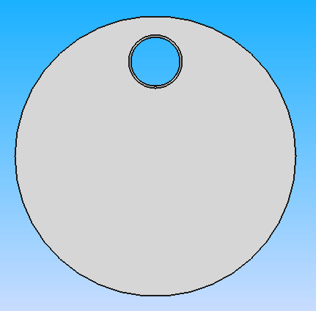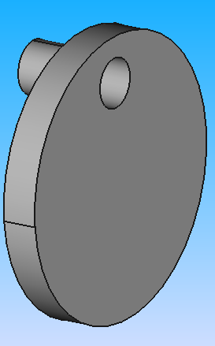

- Electrolysis step 4 & 5 _ Gasket
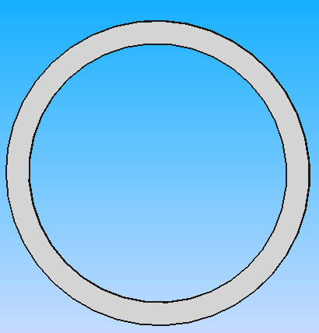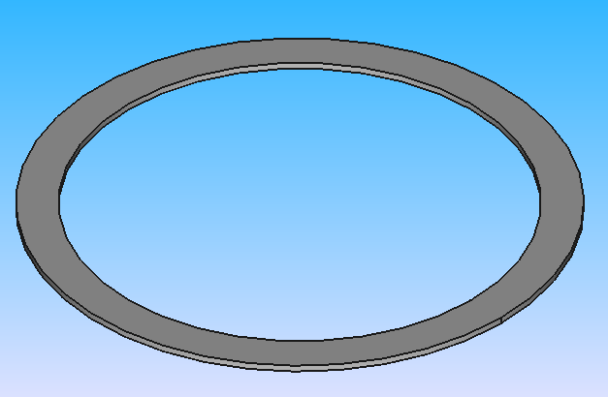

- Electrolysis step 4 & 5 _ Electrode
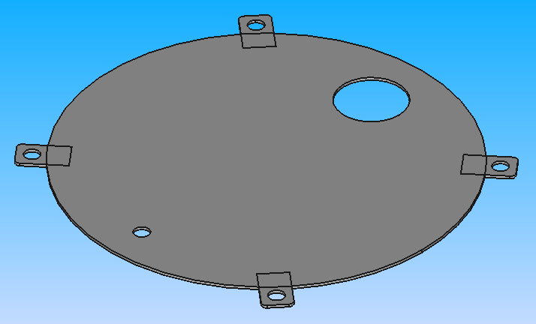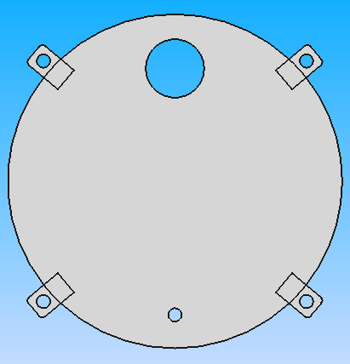

- Electrolysis step 4 & 5 _ End plate2 (Outlet solution)
