Fuel / Oxidizer Mixing Test Rig

Some basics concerning working with Raspberry and flow sensor

Step 1 reading book about Raspberry and C++
Reading a book about raspberry pi and how to write code in C ++
The link of this book:
https://bbooks.info/b/w/8873f497932991f0a46529d6b98eea3373f9ad81/exploring-the-raspberry-pi-2-with-c.pdf

Step 2 Watch on YouTube a video related to LED control
The title of this video: writing to GPIO pins in C using wiringPi on the raspberry Pi

Step 3 Writing C++ code on Raspberry pi

Step 4 Hardware integration
We installed a resistor with LED on breadboard and connected it on Raspberry PI
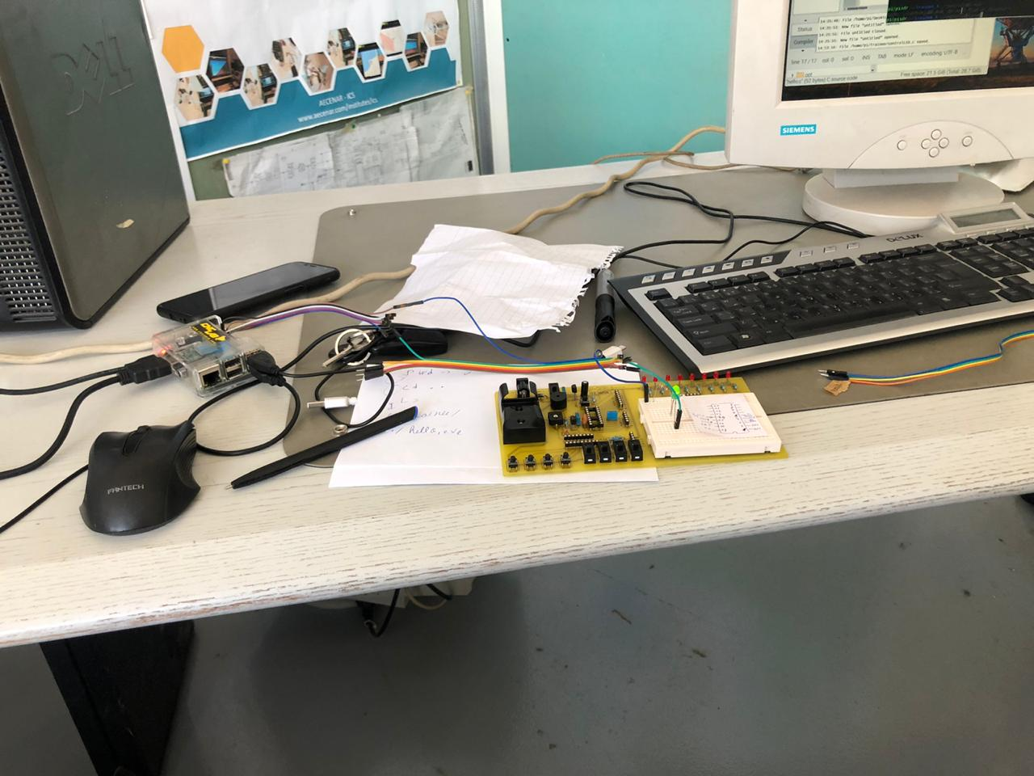

Step 5 Running
Some pictures while working and controlling the LED:
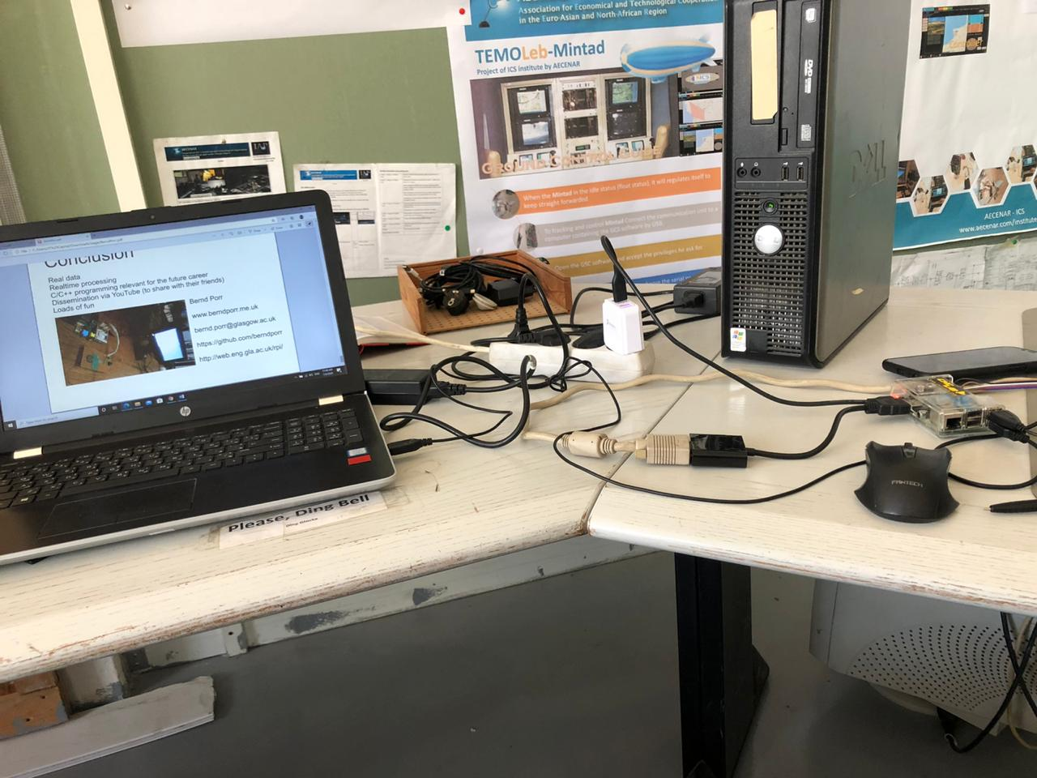

Flowmeter buyed from CNCLab
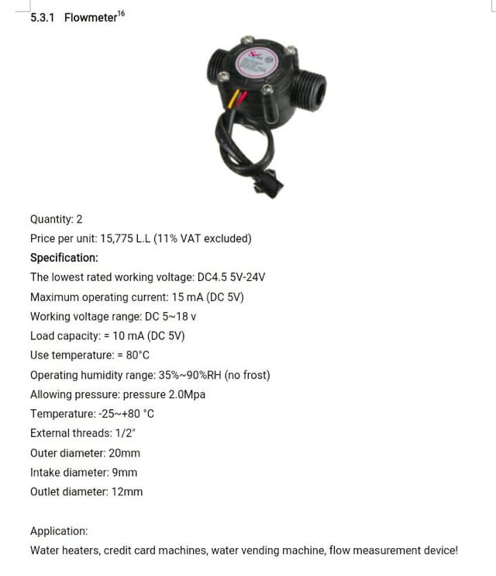

Raspberry GPIO pins

Some basics connerning Python programming with Raspberry

Step 1: write code in new script to control led
لأنه الكود الاسهل ولقد تم نجاح هذا الاختبار والكود موجود بالأسفلLED قمنا باختبار Python codeكوننا جدد على
Attention: using this raspberry pi you must focus to GPIO.setmode(GPIO.BCM) NOT .BOARD

Step 2: Hardware
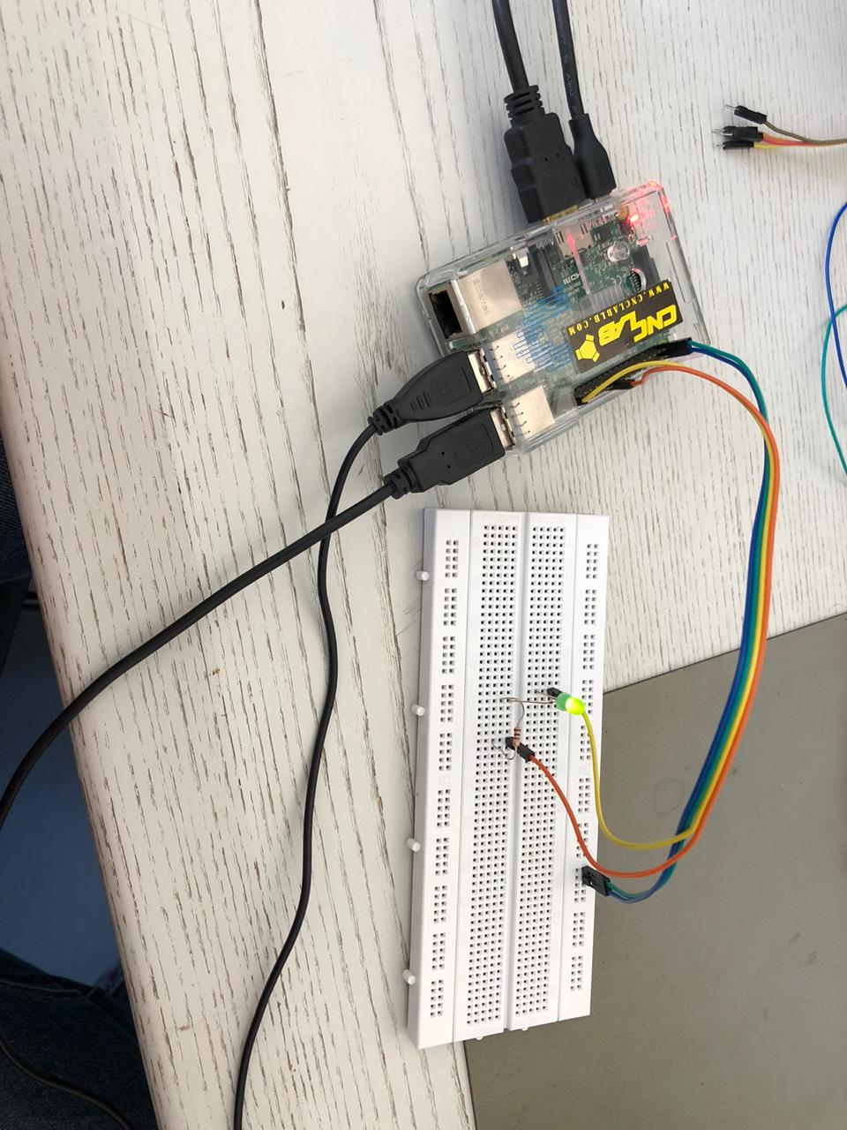

Testing code for flow meter
The flow sensorاليوم كتبنا كود لنقوم بتشغيل
#!/usr/bin/env python
#flowsensor.py
import RPi.GPIO as GPIO
import time, sys

FLOW_SENSOR = 23

GPIO.setmode(GPIO.BCM)
GPIO.setup(FLOW_SENSOR, GPIO.IN, pull_up_down = GPIO.PUD_UP)

#global count

#count = 0

def countpulse(channel,start_counter):
print ("Bismillah")
print (channel)
# global count
start_counter = 1
count = 0
if start_counter == 1:
count += 1
#print count
#flow = count / (60 * 7.5)
#print(flow)
channel= GPIO.add_event_detect(FLOW_SENSOR, GPIO.FALLING, callback=countpulse)

while True:
try:
start=count - 1
time.sleep(1)
start=count - 1
flow = (count * 60 * 2.25 / 1000)
print ("The flow is:" , flow)
#%.3f Liter/min' % (flow)
count = 0
time.sleep(5)

except KeyboardInterrupt:
print ('\ncaught keyboard interrupt!, bye')
print ("No flow")
GPIO.cleanup()
sys.exit()

countpulse (1,2)
New test of flow meter sensor
import RPi.GPIO as GPIO
import time, sys
pulse_pin = 25
GPIO.setmode(GPIO.BCM)
GPIO.setup(pulse_pin, GPIO.IN,pull_up_down = GPIO.PUD_UP)

def countPulse1(channel1):
count+=1
print("Number of revolution of wheel of flow sensor:")
print(count)

GPIO.add_event_detect(pulse_pin, GPIO.RISING, callback=countPulse1)

try:
while True:
print("Inside while starting")
time.sleep(10)
print("Inside while ending")
time.sleep(10)
except keyboardInterrupt:
print ('\ncaught keyboard interrupt!, bye')
GPIO.cleanup()
sys.exit()

- Today, we're going to modify the code to suit our work with a flow meter sensor
- We will also connect the sensor to the raspberry pi and we will try to reach a result
- We'll also connect the valve to the raspberry pi and we'll control it
- We will write all the writing work on the word

Working with oscilloscope
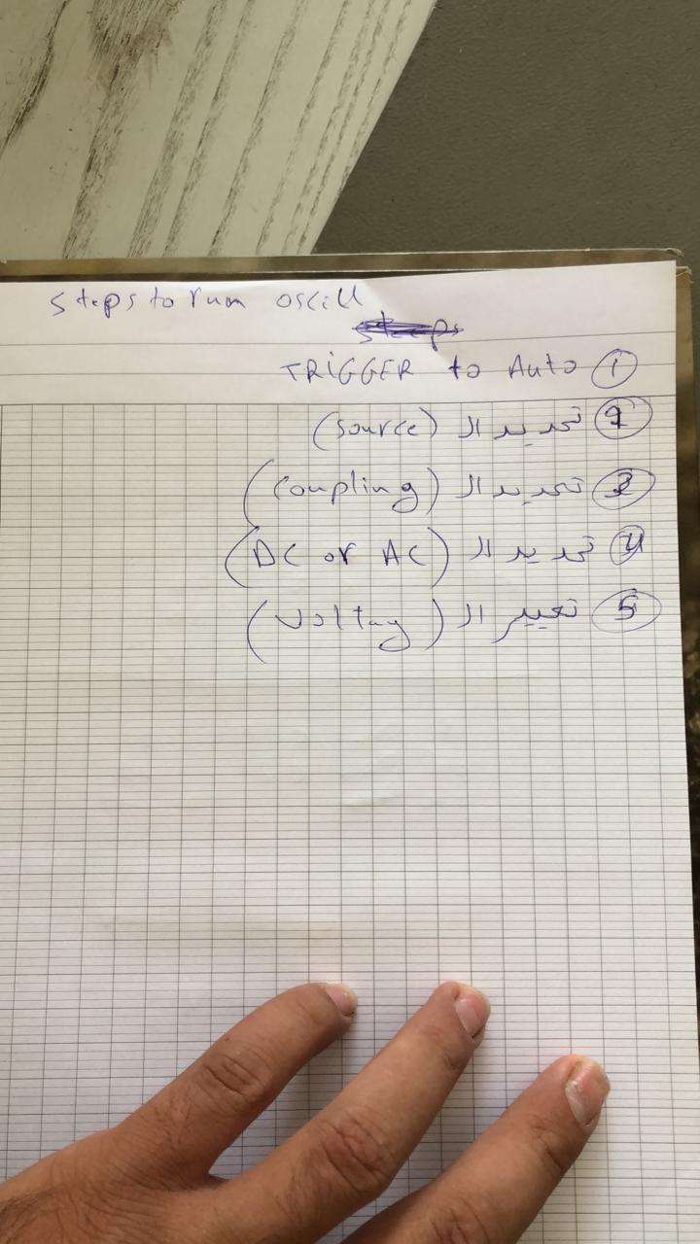

Python program for flow sensor

Hardware for flowmeter sensor:
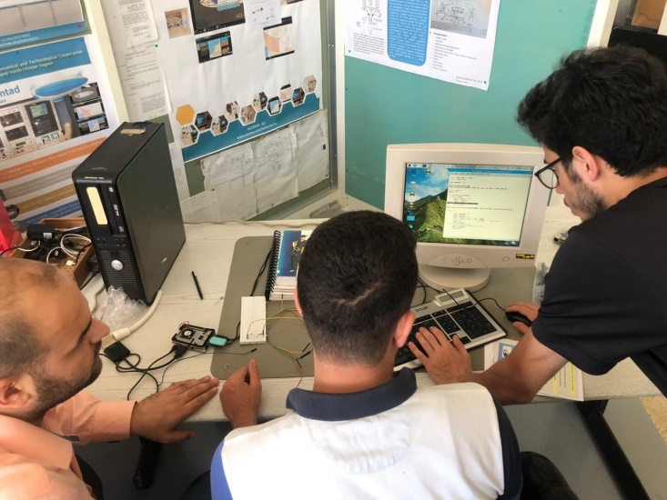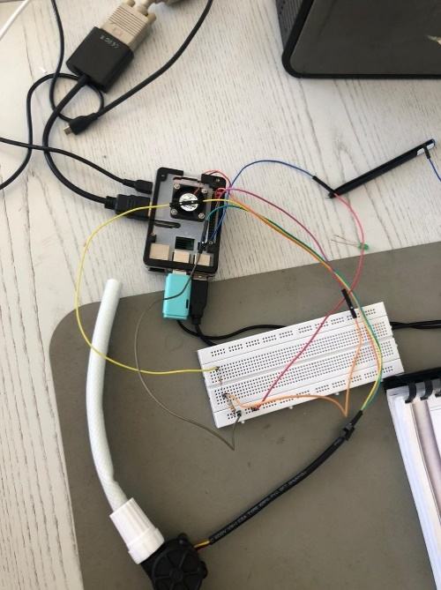

The code of flow meter sensor:
import RPi.GPIO as GPIO
import time, sys

FLOW_SENSOR = 23

GPIO.setmode(GPIO.BCM)
GPIO.setup(FLOW_SENSOR, GPIO.IN, pull_up_down = GPIO.PUD_UP)

global count
count = 0

def countPulse(channel):
global count
if start_counter == 1:
count = count+1
# print count
# flow = count / (60 * 7.5)
# print(flow)

GPIO.add_event_detect(FLOW_SENSOR, GPIO.FALLING, callback=countPulse)

while True:
try:
start_counter = 1
time.sleep(1)
start_counter = 0
flow = (count * 60 * 2.25 / 1000)
print "The flow is: %.3f Liter/min" % (flow)
count = 0
time.sleep(5)
except KeyboardInterrupt:
print '\ncaught keyboard interrupt!, bye'
GPIO.cleanup()
sys.exit()

Running test result

Pins of raspberry pi 3
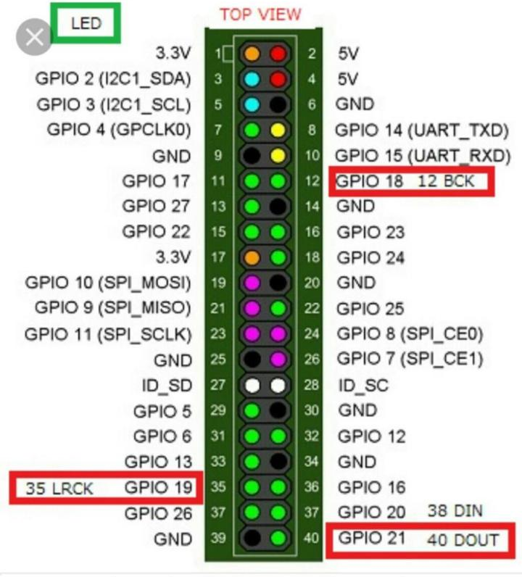

Python code for servo motor (automatic valve, variant 1)

The code for servor motor
# Import libraries
import RPi.GPIO as GPIO
import time

# Set GPIO numbering mode
GPIO.setmode(GPIO.BOARD)

# Set pin 11 as an output, and set servo1 as pin 11 as PWM
GPIO.setup(11,GPIO.OUT)
servo1 = GPIO.PWM(11,50) # Note 11 is pin, 50 = 50Hz pulse

#start PWM running, but with value of 0 (pulse off)
servo1.start(0)
print ("Waiting for 2 seconds")
time.sleep(2)

#Let's move the servo!
print ("Rotating 180 degrees in 10 steps")

# Define variable duty
duty = 2

# Loop for duty values from 2 to 12 (0 to 180 degrees)
while duty <= 12:
servo1.ChangeDutyCycle(duty)
time.sleep(1)
duty = duty + 1

# Wait a couple of seconds
time.sleep(2)

# Turn back to 90 degrees
print ("Turning back to 90 degrees for 2 seconds")
servo1.ChangeDutyCycle(7)
time.sleep(2)

#turn back to 0 degrees
print ("Turning back to 0 degrees")
servo1.ChangeDutyCycle(2)
time.sleep(0.5)
servo1.ChangeDutyCycle(0)

#Clean things up at the end
servo1.stop()
GPIO.cleanup()
print ("Goodbye")

Hardware
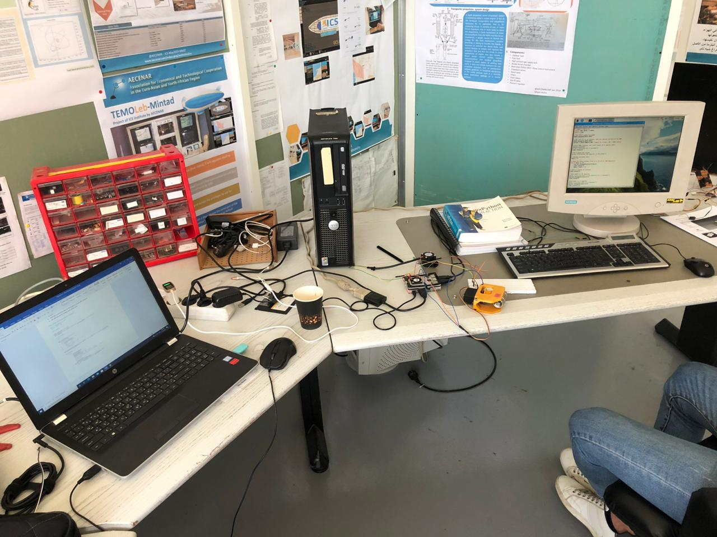

The code for the servo motor and flow sensor:
# Import libraries
import RPi.GPIO as GPIO
import time, sys

FLOW_SENSOR = 23
SERVO = 11

# Set GPIO numbering mode
GPIO.setmode(GPIO.BCM)

# Set pin 23 as input for the flow sensor
# Set pin 11 as an output, and set servo1 as pin 11 as PWM
GPIO.setup(FLOW_SENSOR, GPIO.IN, pull_up_down = GPIO.PUD_UP)
GPIO.setup(SERVO, GPIO.OUT)

global count
count = 0
start_counter = 0

def countPulse(channel):
global count
if start_counter == 1:
count = count+1
# print count
flow = count / (60 * 7.5)
# print(flow)

servo1 = GPIO.PWM(11,50) # Note 11 is pin, 50 = 50Hz pulse

GPIO.add_event_detect(FLOW_SENSOR, GPIO.FALLING, callback=countPulse)

#start PWM running, but with value of 0 (pulse off)
servo1.start(0)
print ("Waiting for 2 seconds")
time.sleep(2)

#Let's move the servo!
print ("Rotating 180 degrees in 10 steps")

# Define variable duty
duty = 2

# Loop for duty values from 2 to 12 (0 to 180 degrees)
while duty <= 12:
servo1.ChangeDutyCycle(duty)
time.sleep(1)
duty = duty + 1

# Wait a couple of seconds
time.sleep(2)

# Turn back to 90 degrees
print ("Turning back to 90 degrees for 2 seconds")
servo1.ChangeDutyCycle(7)
time.sleep(2)

#turn back to 0 degrees
print ("Turning back to 0 degrees")
servo1.ChangeDutyCycle(2)
time.sleep(0.5)
servo1.ChangeDutyCycle(0)
time.sleep(2)

while True:
try:
start_counter = 1
time.sleep(1)
start_counter = 0
flow = (count * 60 * 2.25 / 1000)
print ("The flow is: " + str(flow) + " Liter/min" )
count = 0
time.sleep(2)
except KeyboardInterrupt:
servo1.stop()
print ("caught keyboard interrupt!")
GPIO.cleanup()
print ("Goodbye")
sys.exit()

Hardware of servo motor and flow sensor:
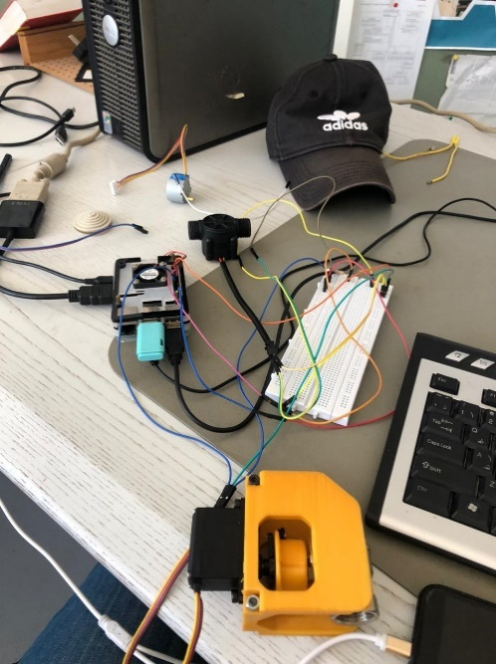

DC motor for automatic valve (on-off of a relay) (automatic valve, variant 2)

References of control DC motor:
https://www.aranacorp.com/en/control-a-dc-motor-with-raspberry-pi/

Hardware
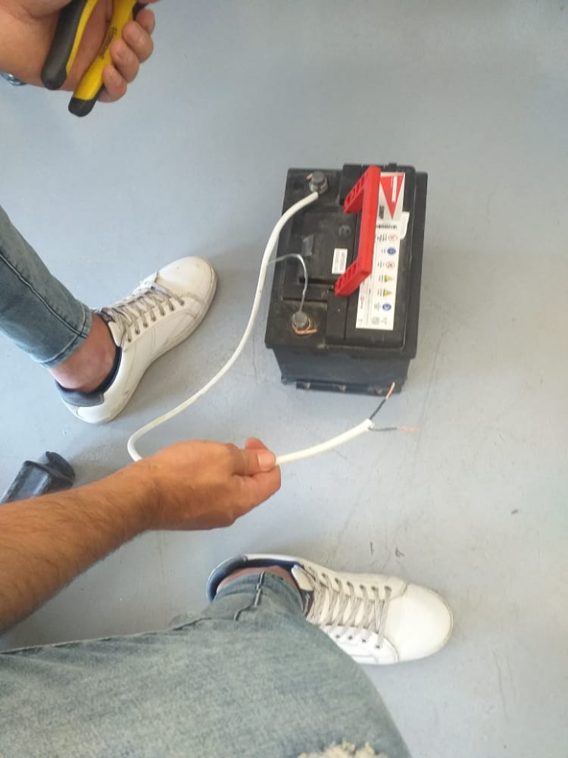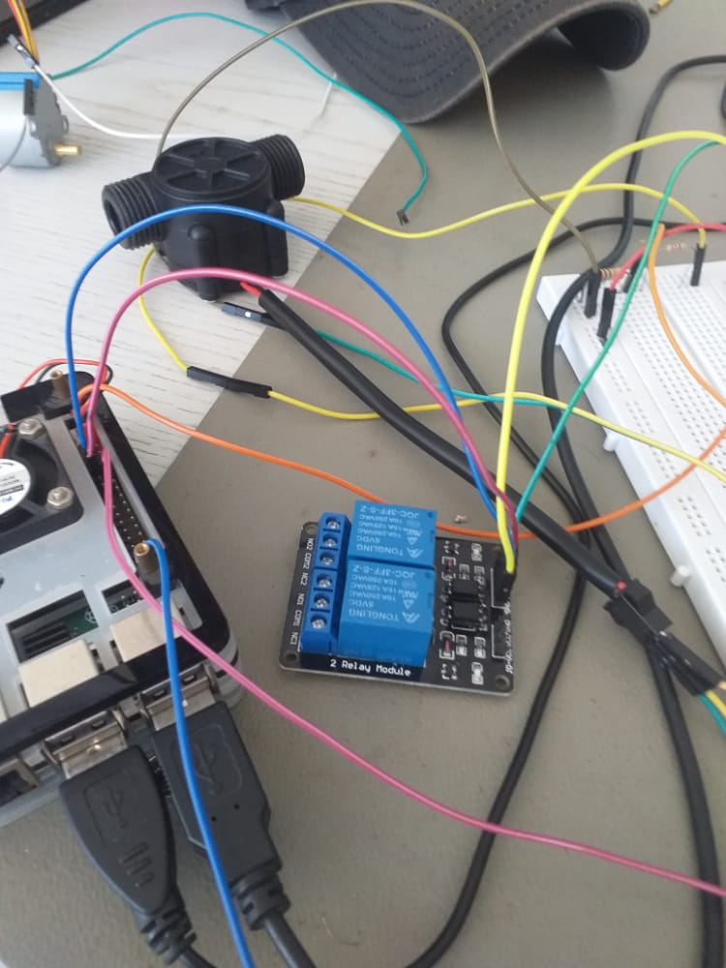

The code
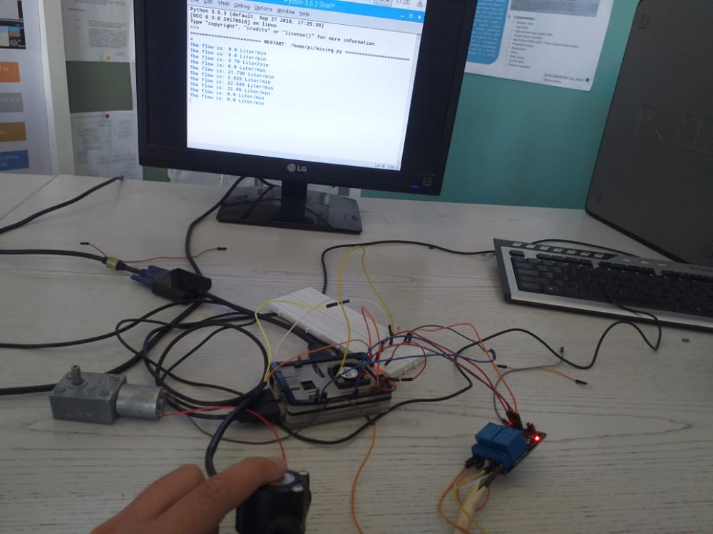

Testing
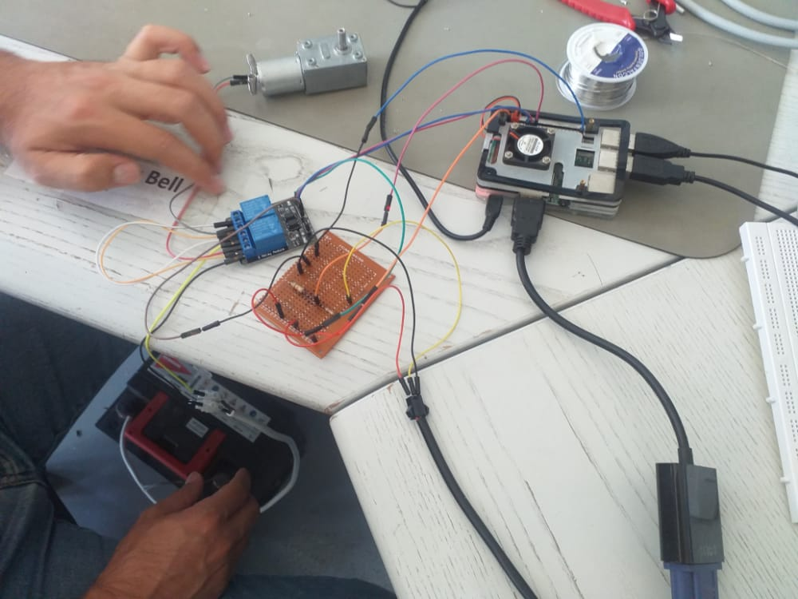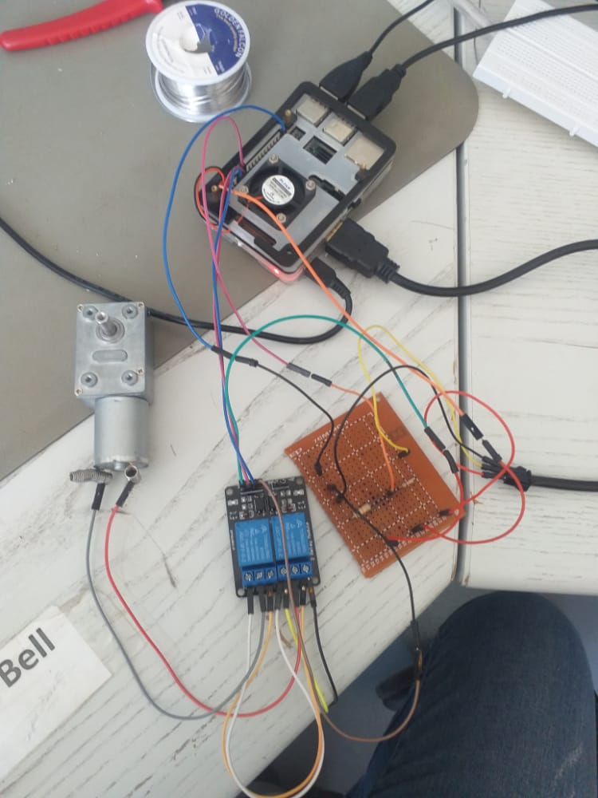

System integration Mixing Control (Mechanical, Hardware & Software)
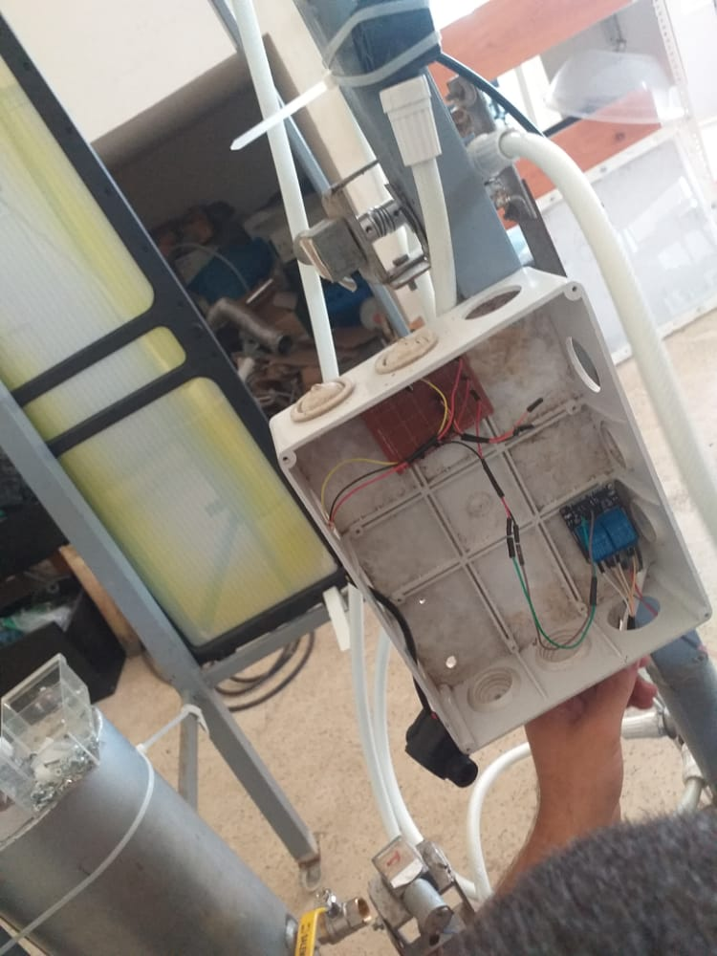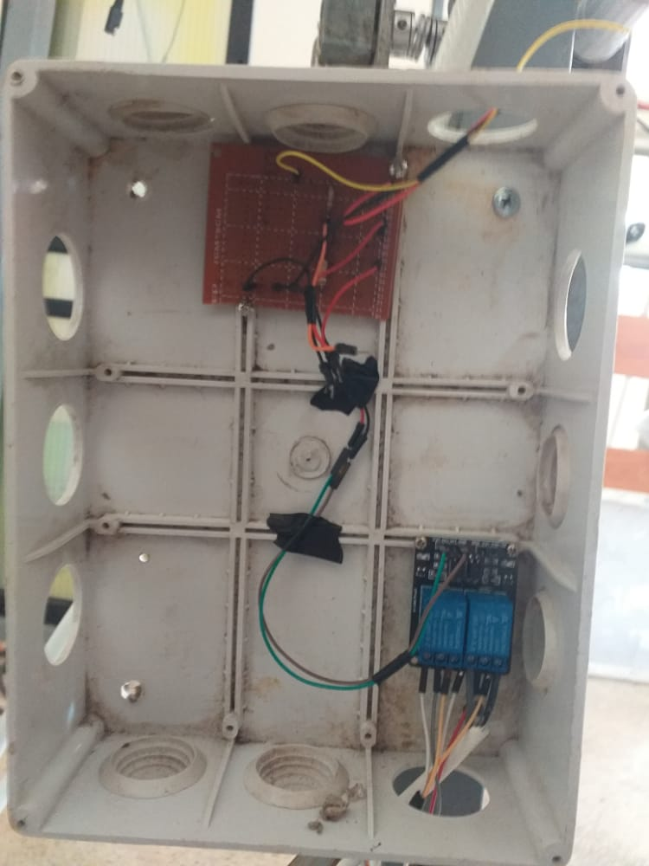

Code
import RPi.GPIO as GPIO
import time, sys
RELAY_2_GPIO = 27
FLOW_SENSOR = 23
RELAY_1_GPIO = 17
GPIO.setmode(GPIO.BCM)
GPIO.setup(FLOW_SENSOR, GPIO.IN, pull_up_down = GPIO.PUD_UP)
GPIO.setup(RELAY_1_GPIO, GPIO.OUT) # GPIO Assign mode
GPIO.setup(RELAY_2_GPIO, GPIO.OUT)
GPIO.output(RELAY_1_GPIO, GPIO.LOW)
GPIO.output(RELAY_2_GPIO, GPIO.LOW)

global count
count = 0

def countPulse(channel):
global count
if start_counter == 1:
count = count+1
# print count
flow = count / (60 * 7.5)
# print(flow)

GPIO.add_event_detect(FLOW_SENSOR, GPIO.FALLING, callback=countPulse)

while True:
try:
start_counter = 1
time.sleep(1)
start_counter = 0
flow = (count * 60 * 2.25 / 1000)
print ("The flow is: " + str(flow) + " Liter/min" )
if flow == 0: # 0.0
GPIO.output(RELAY_1_GPIO, GPIO.LOW)
GPIO.output(RELAY_2_GPIO, GPIO.LOW)
elif flow < 15: # 1.9
GPIO.output(RELAY_1_GPIO, GPIO.LOW)
GPIO.output(RELAY_2_GPIO, GPIO.HIGH)
elif flow < 20: # 2.1
GPIO.output(RELAY_1_GPIO, GPIO.LOW)
GPIO.output(RELAY_2_GPIO, GPIO.LOW)
else:
GPIO.output(RELAY_1_GPIO, GPIO.HIGH)
GPIO.output(RELAY_2_GPIO, GPIO.LOW)
count = 0
time.sleep(5)
except KeyboardInterrupt:
print ("caught keyboard interrupt!")
GPIO.cleanup()
sys.exit()

Mixing control
نحن نريد التحكم بنوعين من السوائل لذلك هذه الخطوة ستكون مشابهة للخطوة الأولى فهي عبارة عن تحكم بكمية السائل الذي نحتاجه
سنحتاج بهذا العمل الى
- 2 relays for DC motors (automatic valves, variant 2)
- Raspberry pi
- Battery 12v
- Wires
- Flow sensor

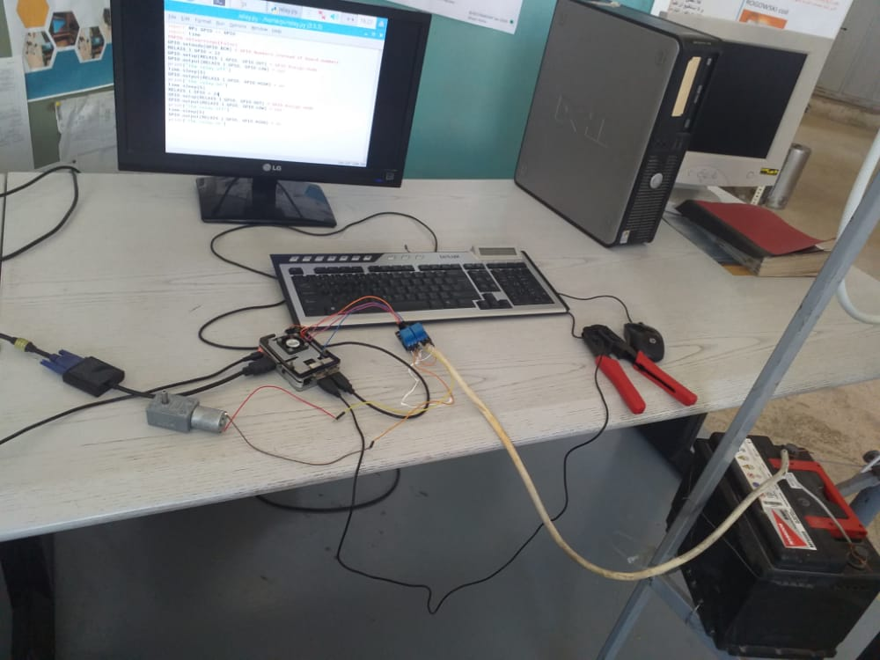

The code
import RPi.GPIO as GPIO
import time, sys
RELAY_2_GPIO = 27
FLOW_SENSOR = 23
RELAY_1_GPIO = 17
GPIO.setmode(GPIO.BCM)
GPIO.setup(FLOW_SENSOR, GPIO.IN, pull_up_down = GPIO.PUD_UP)
GPIO.setup(RELAY_1_GPIO, GPIO.OUT) # GPIO Assign mode
GPIO.setup(RELAY_2_GPIO, GPIO.OUT)
GPIO.output(RELAY_1_GPIO, GPIO.LOW)
GPIO.output(RELAY_2_GPIO, GPIO.LOW)

global count
count = 0

def countPulse(channel):
global count
if start_counter == 1:
count = count+1
# print count
flow = count / (60 * 7.5)
# print(flow)

GPIO.add_event_detect(FLOW_SENSOR, GPIO.FALLING, callback=countPulse)

while True:
try:
start_counter = 1
time.sleep(1)
start_counter = 0
flow = (count * 60 * 2.25 / 1000)
print ("The flow is: " + str(flow) + " Liter/min" )
if flow == 0: # 0.0
GPIO.output(RELAY_1_GPIO, GPIO.LOW)
GPIO.output(RELAY_2_GPIO, GPIO.LOW)
elif flow < 15: # 1.9
GPIO.output(RELAY_1_GPIO, GPIO.LOW)
GPIO.output(RELAY_2_GPIO, GPIO.HIGH)
elif flow < 20: # 2.1
GPIO.output(RELAY_1_GPIO, GPIO.LOW)
GPIO.output(RELAY_2_GPIO, GPIO.LOW)
else:
GPIO.output(RELAY_1_GPIO, GPIO.HIGH)
GPIO.output(RELAY_2_GPIO, GPIO.LOW)
count = 0
time.sleep(5)
except KeyboardInterrupt:
print ("caught keyboard interrupt!")
GPIO.cleanup()
sys.exit()

Pressure Sensor
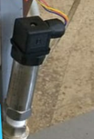
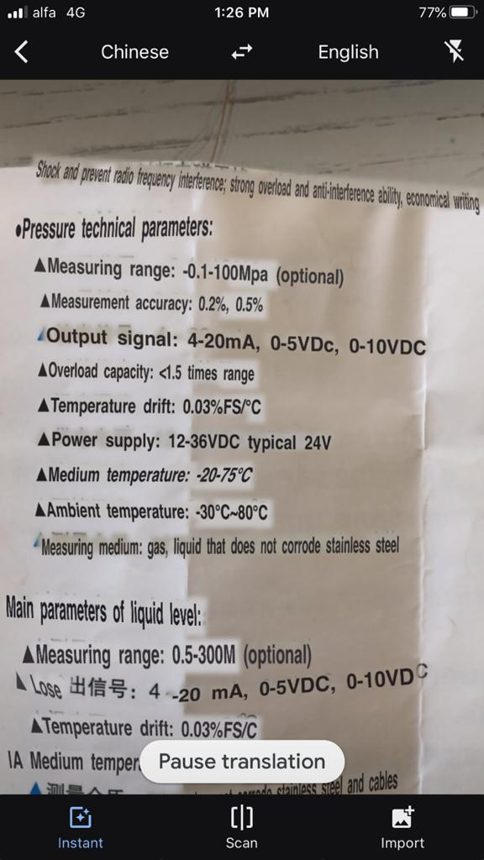
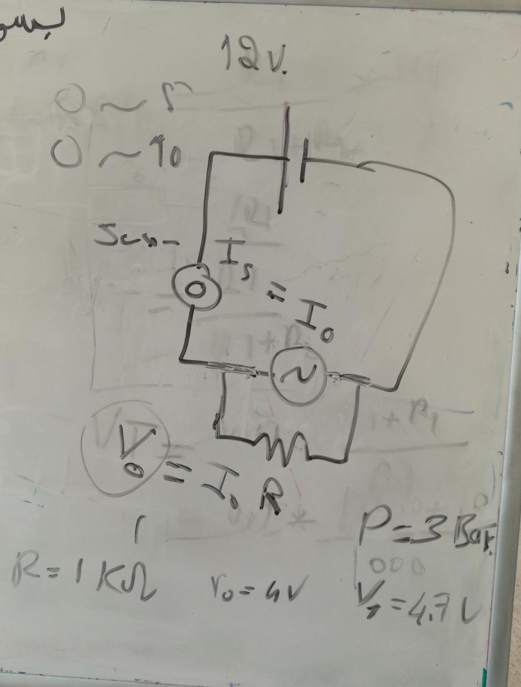

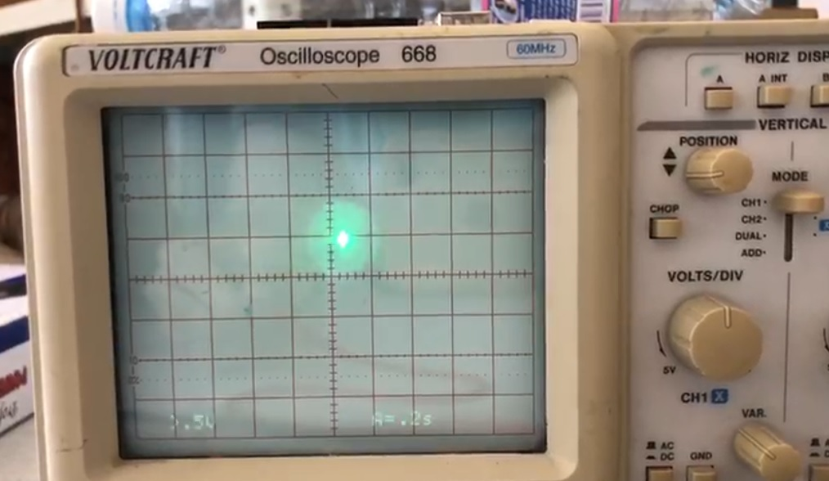 | High pressure
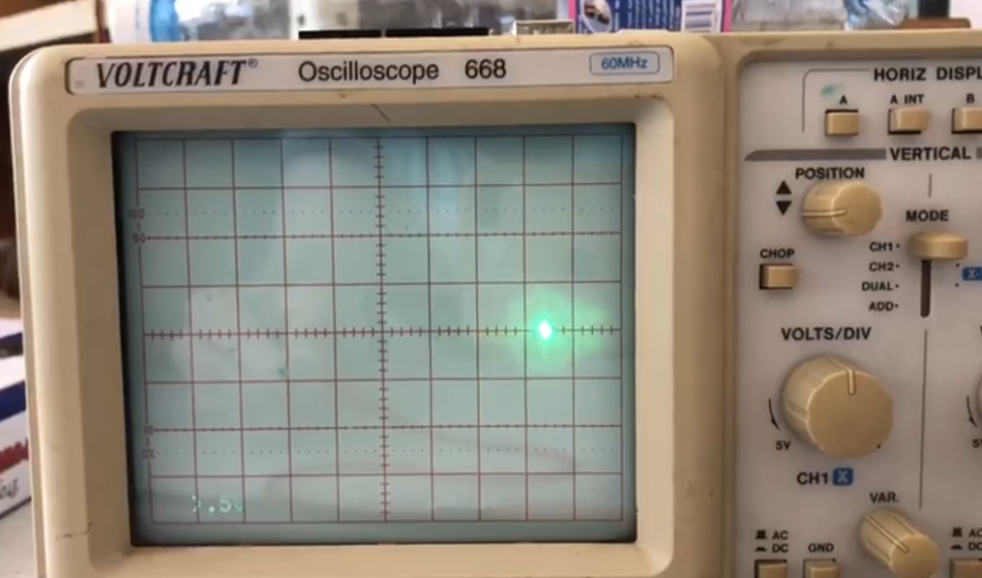 | Low pressure

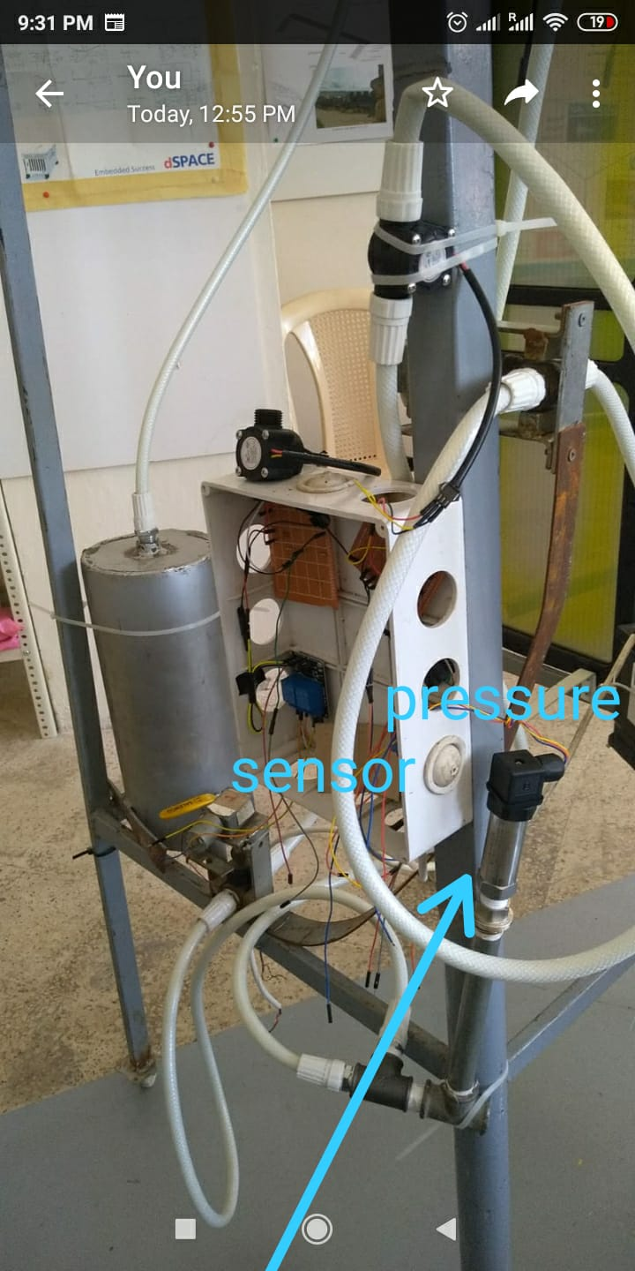
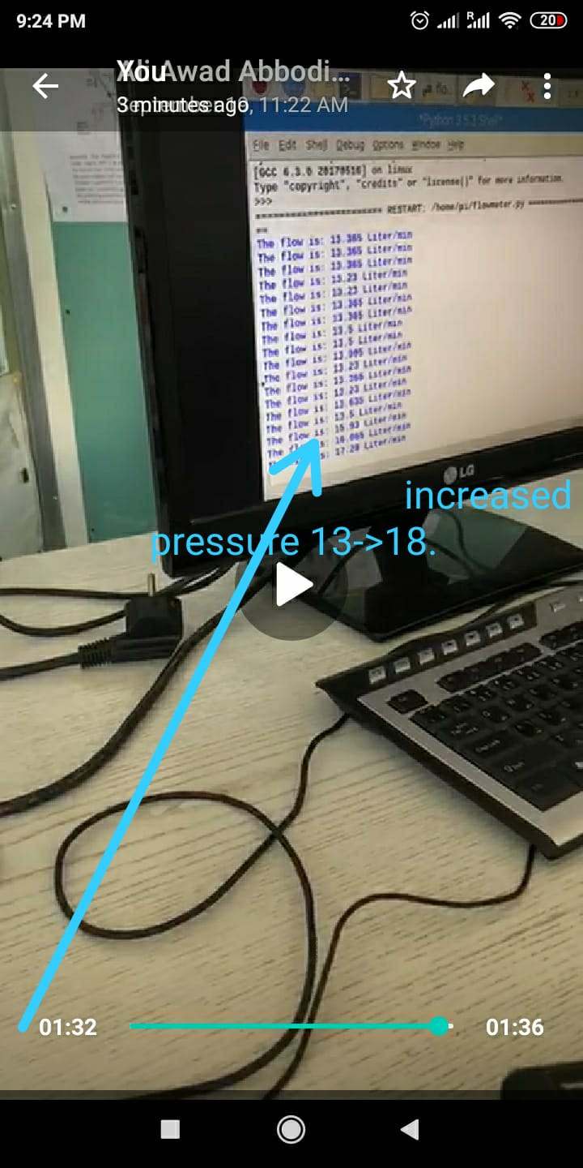

Code for pressure sensor

Pressure
import RPi.GPIO as GPIO
import time, sys

FLOW_SENSOR = 26
lps = adafruit_lps35hw.LPS35HW(i2c)
GPIO.setmode(GPIO.BCM)
GPIO.setup(FLOW_SENSOR, GPIO.IN, pull_up_down = GPIO.PUD_UP)

while True:
print("Pressure: %.2f hPa" % lps.pressure)
print("Temperature: %.2f C" % lps.temperature)
print("")
time.sleep(1)

Pressure sensor
import RPi.GPIO as GPIO
import time, sys
FLOW_SENSOR = 26
GPIO.setmode(GPIO.BCM)
GPIO.setup(FLOW_SENSOR, GPIO.IN, pull_up_down = GPIO.PUD_UP)
global count
count = 0

global pressure
pressure = 0.0001
if pressure >= 0.0001:
print(0.0001)

Combustion Control
2 flowsensor ودمجه مع ال Pressure sensorالهدف القادم هو إضافة
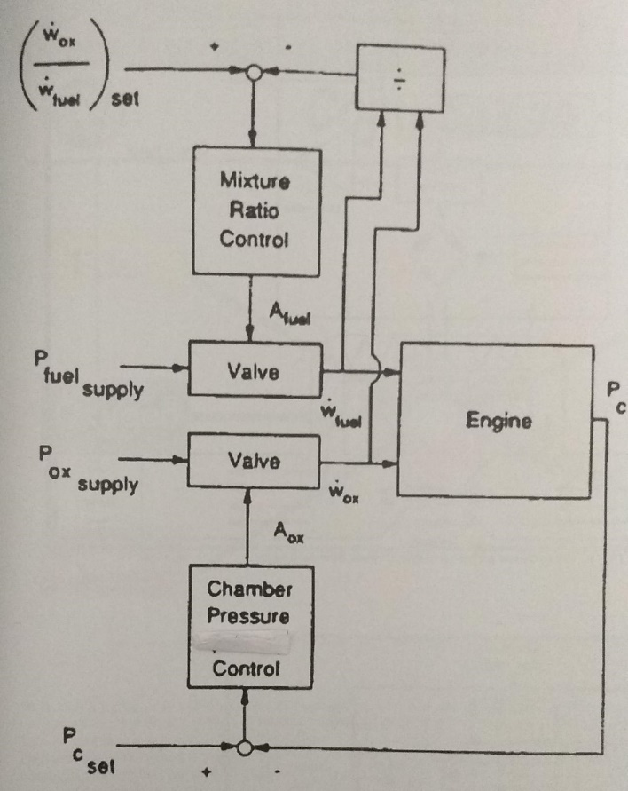
لقد قمنا اليوم تقريبا بنفس العمل السابق لأننا بحاجة الى تحكمين للوصول الى هدفنا و قد قمنا بتجربة ناجة و الهدف الان تركيب جمبع القطع
Automatic valve with DC motor
Flow sensor
Automatic valve with DC motor
Pressure sensor

Based on Trainee Report of Ali Ibrahim and Ali Awad, August 2020

