Methane liquidification
EP 2 251 625 A2
EUROPEAN PATENT APPLICATION

- LNG Proprieties

- LNG has the best safety record of all fossil fuels: Not flammable or explosive in liquid form
- Noncorrosive and nontoxic
- Evaporates quickly and completely leaving no fire hazard puddle
- LNG is refrigerated around -160˚C
- Volume reduction 600 times with the same calorific capacity
- LNG is composed mainly from methane (more than 90%)
- The liquefaction factory consumes nearly 10% of the natural gas while functioning
- The LNG will be stocked at an atmospheric pressure in storages made from concrete or metallic tanks, possessing double wall and thermal insulation.
- The principals LNG exporters are: Qatar, Australia, Malesia, Nigeria and Indonesia (more than two-thirds)
- The principals LNG importers are: Japan, South Korea, China. Stable and stored at low pressures
- The process of producing LNG is in three steps.
Feed gas from the interior
Step 1- Treatment (Remove CO2, Water (H2O) and mercury from the Feed Gas) | Acid gas (mainly carbon dioxide), water and mercury are removed from the gas delivered to Oman LNG. This clean-up” is a necessary step to enable liquefaction of the natural gas and a safe product for our customers.
Step 2 – Removal of “Condensates”(Remove heavier hydrocarbons (NGL’s) by Fractional Distillation) | Condensates (natural gas Liquids made up mainly of pentane and hexane) are removed by Fractional Distillation of the feed Gas after treatment.
Step 3 – Liquefaction of Natural Gas(Cool remaining light hydrocarbons to-162ºC to liquefy) | The gas (now mainly methane) is sent to the Main Cryogenic Heat Exchange (MCHE), where it condenses to liquid at -162°C. The liquid is sent to special storage tanks awaiting shipment by LNG vessels to customers in Asia and Europe.

- LNG Production diagram

US5053209A
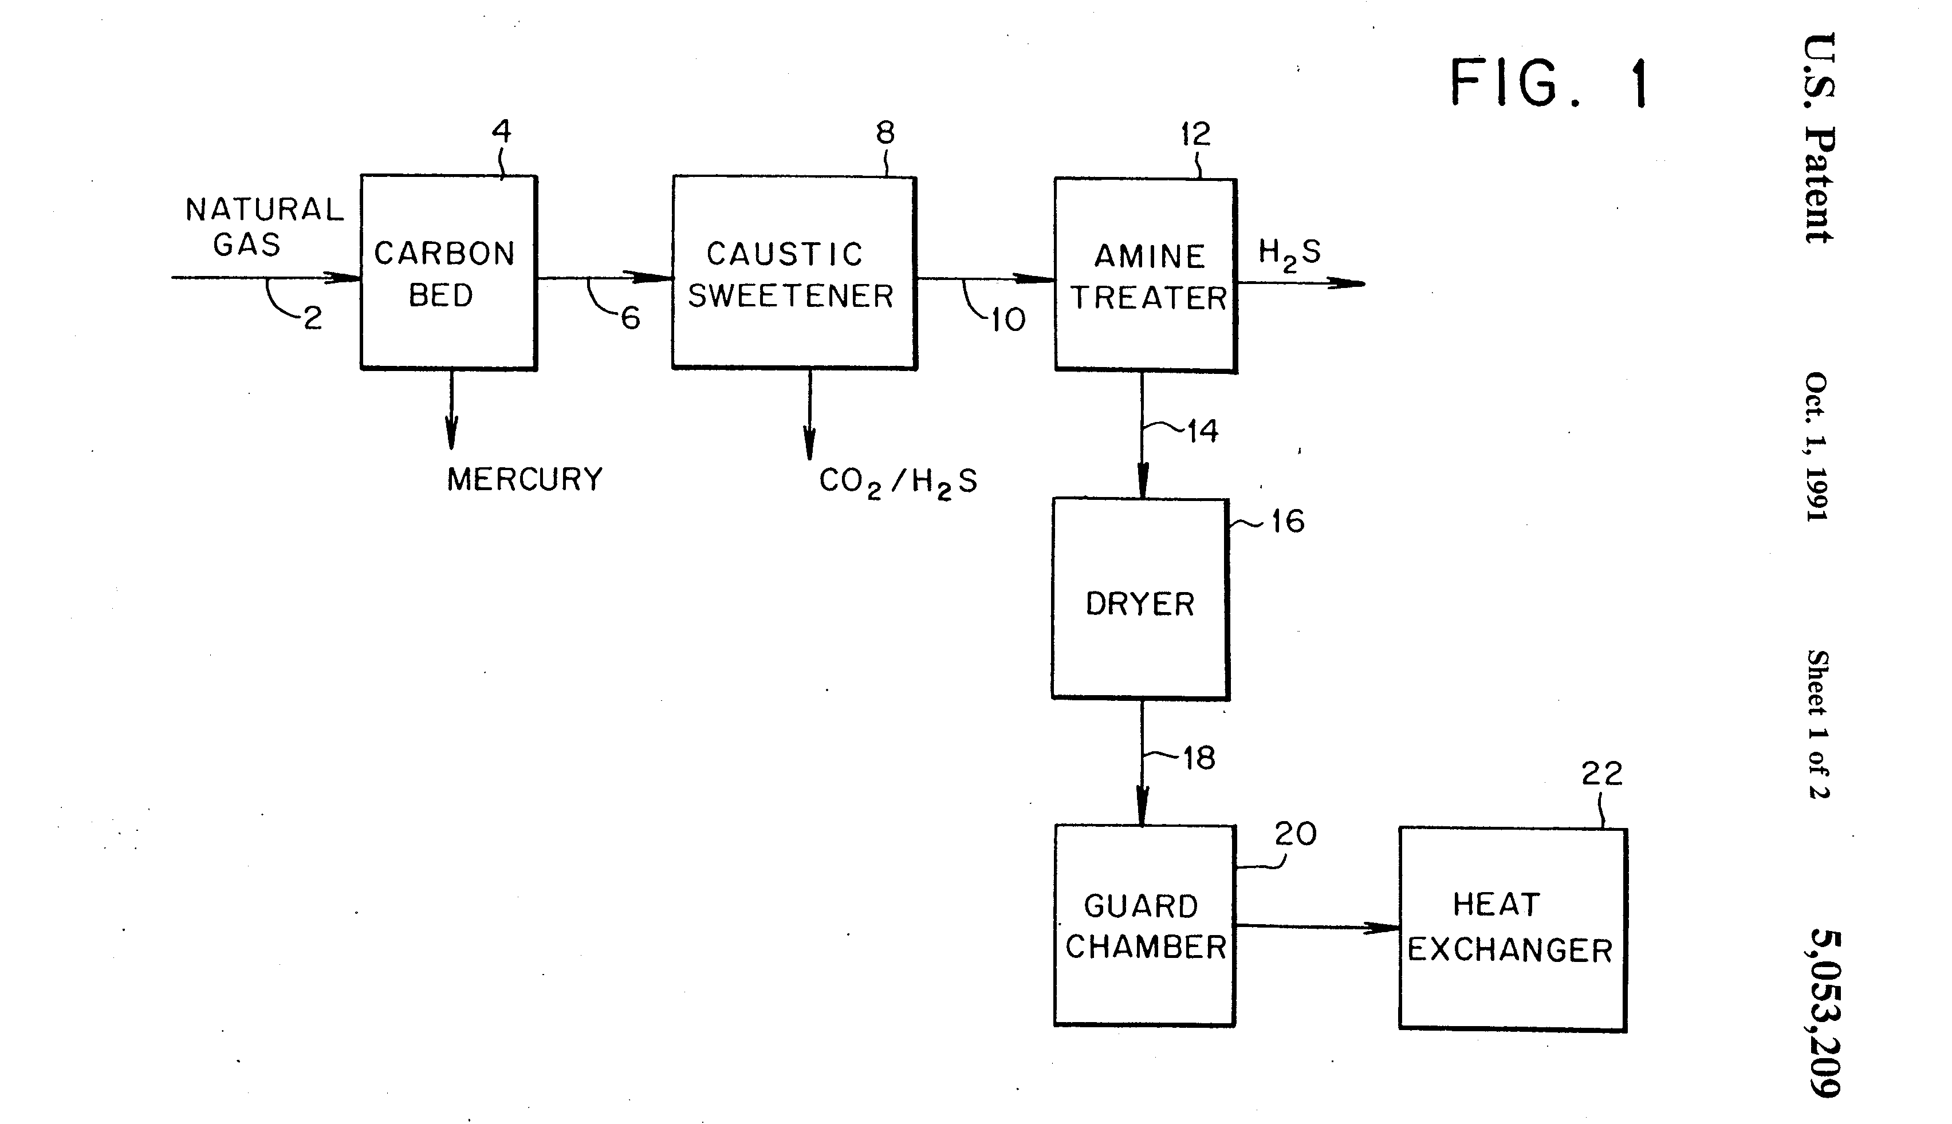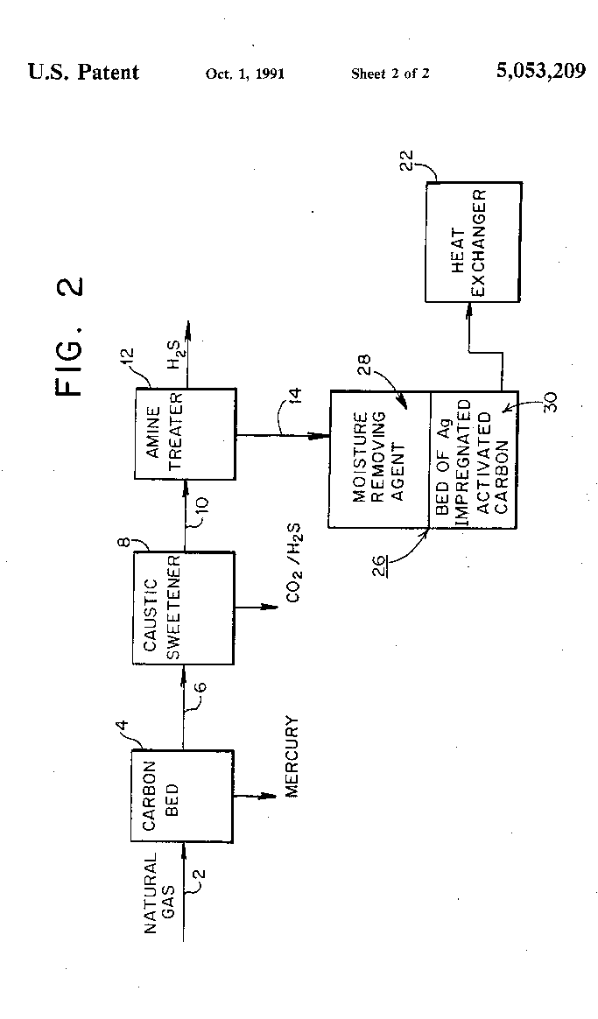

SUMMARY OF THE INVENTION
In a broad sense this invention comprises a process for treating raw natural gas prior to liquefaction which comprises (a) passing a stream of raw natural hydrocarbon gas or liquid through a zone containing activated carbon impregnated with sulfur, at conditions effective to remove mercury from said natural gas; (b) passing the effluent stream of natural gas thus treated through a sweetening zone operating at conditions effective to remove carbon dioxide and hydrogen sulfide and/or then passing the effluent stream through an amine treating system where additional hydrogen sulfide is removed, (c) subsequently passing the effluent through a drier or dehydrator where water vapor is removed and (d) finally passing the effluent through a heat exchanger to a further product treatment zone. In this invention there is positioned in the flow line, preferably downstream of the dehydrator, or dryer, a body of activated carbon, silica, alumina, or silica-alumina supports, which can be honeycomb shaped, extrudate, granules, beads, and pellets containing free silver in an active state such that it forms an amalgam with mercury. The silver preferably is deposited in a dispersed form on activated carbon, or even more preferably on gamma alumina, although other supports can be used such as silica, other aluminas such as alpha or beta, and silica-alumina. This technique is particularly useful in removing the residual mercury still remaining in the gas stream even after it has been treated under optimum operating conditions by equipment located upstream.
- Natural Gas Treatment
  - Step1: Mercury removal
DETAILED DESCRIPTION OF THE INVENTION
In the prior art the most popular absorbent used to remove mercury is sulfur loaded on activated carbon. The reaction between the sulfur and mercury is:
2Hg+S.sub.2 →2HgS
The optimum operating temperature has been determined to be about 170° F.
The substrate utilized in the method of this invention is metallic silver dispersed preferably on activated carbon or on gamma alumina. Other usable support materials include other types of alumina, silica, silica-alumina, silicates, aluminates and silica aluminates, as well as synthetic and natural zeolites, to increase the metal surface area to greater than 0.01m₂ /g to improve activity for mercury removal. The concentration of silver metal on the activated carbon or gamma alumina should be between 0.1 and 20 percent by weight (preferably between 1 and 5 percent). The silver can be dispersed onto the carrier by impregnation, co-precipitation or other well-known methods. The absorbent can be in the form of extrudate, beads, pellets and granules. Pressure drop across a body of absorbent can be minimized by using absorbent in the form of honeycomb, or "multi-lobe" configuration.

EXAMPLE
An adsorbent consisting of silver deposited on gamma alumina was prepared by saturating the gamma alumina with an aqueous solution of silver nitrate, drying and calcining the impregnated alumina, and then reducing the silver nitrate to free metallic silver by contacting the alumina with formaldehyde. The adsorbent contained approximately 5 percent by weight of silver. An initial test of the adsorbent in which 0.1 gram of the adsorbent was contacted with 100 milliliters of air equilibrated with mercury indicated that 98 percent of the mercury in the air was removed.

  - Step2: Treatment CO2 removal
Amine Units
Amine-based solvents are an effective method for processing acid gas, from natural gas, associated gases or unconventional gas sources which have varying compositions of hydrogen sulfide and carbon dioxide. Depending on the composition of raw gas, we implement formulated or generic amine based solvents for an optimal selective processing plant.
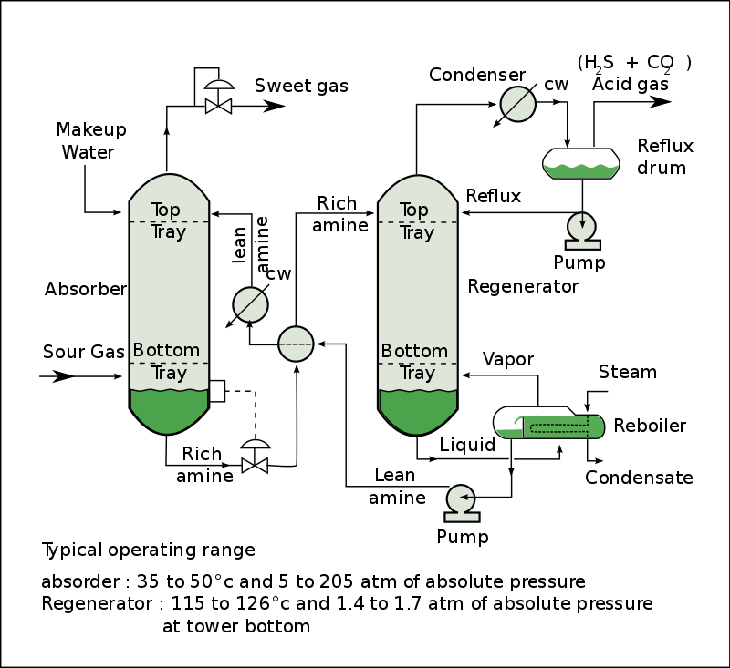
Acid Gas Removal Amine Wash
Membrane Technology
In case of carbon dioxide rich gas, meeting product specifications requests a particularly efficient method of removing carbon dioxide. In collaboration with Air Liquide Advanced Separations/Porogen, Air Liquide Engineering & Construction offers hollow fiber membrane technology for selective permeation of carbon dioxide while minimizing hydrocarbon losses. This technology combines high permeability with high hydrocarbon resistance, making it an attractive option for bulk carbon dioxide removal. In addition, the operation is highly flexible, it requires little maintenance, making it ideal for remote and offshore locations

Cryogenic technology
For natural gas with high CO₂ content, Cryogenic technology, alone or in combination with the Air Liquide membrane technology, can produce pipeline specification natural gas. High CO₂ partial pressure favors the partial CO₂ condensation and making its separation from natural gas even easier. The CO₂ and heavy hydrocarbons condense in the cold box and are collected at high pressure. This Air Liquide Engineering & Construction proprietary technology also allows Natural Gas Liquids recovery with almost no additional cost.

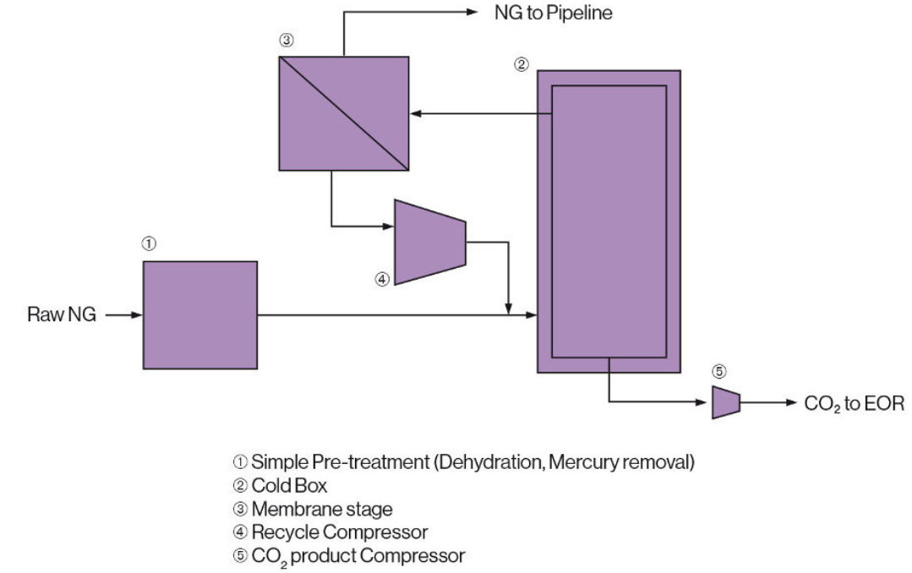
CO2 Removal Cryocap

Step 3: Water removal (Glycol dehydration)

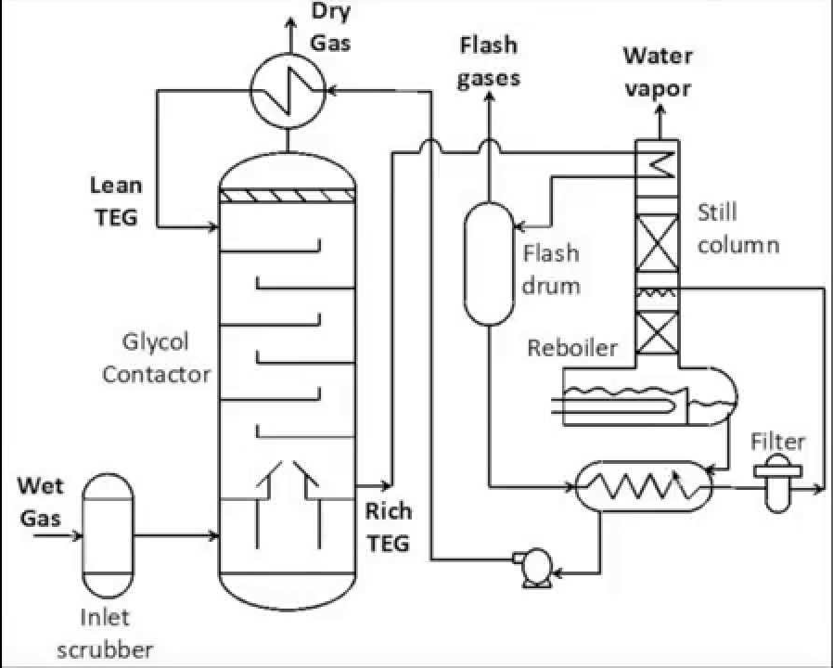

The wet gas enters the inlet scrubber to remove solid particles. Then it will pass to the glycol contactor. In the contactor the flow of wet NG will meet with the lean Triethylene glycol (TEG). During the contact in the contactor the TEG will be invested by water and flows out of the bottom out of the contactor. The Rich TEG continue to the internal heat exchanger which is incorporated at the top of the still column in the regeneration section of the adsorption unit then it flows to the flash drum where the flash gases are released and separated from the stream. The TEG then runs to the cold side of the TEG-TEG heat exchanger. Just afterwards, the warm TEG is filtered then runs into the regeneration system where it’s spread in the still column. From there the TEG runs into the reboiler. The regeneration energy is around 282 kj/L of TEG, the temperature should not exceed the decomposition temperature of the TEG. The regenerated TEG is pumped to the hot side of the TEG-TEG heat exchanger and the NG-TEG heat exchanger at the top of the contactor.

- Pre-cooled liquefaction process of natural gas

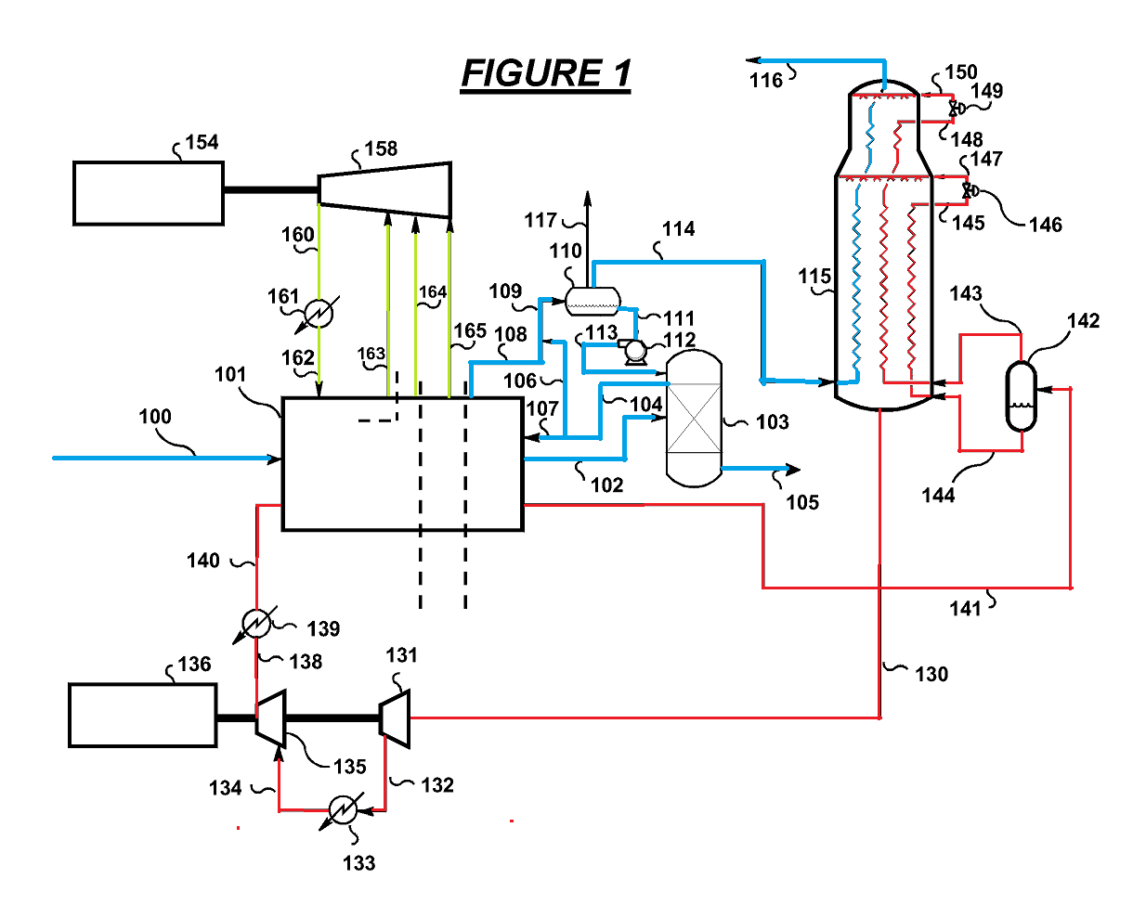
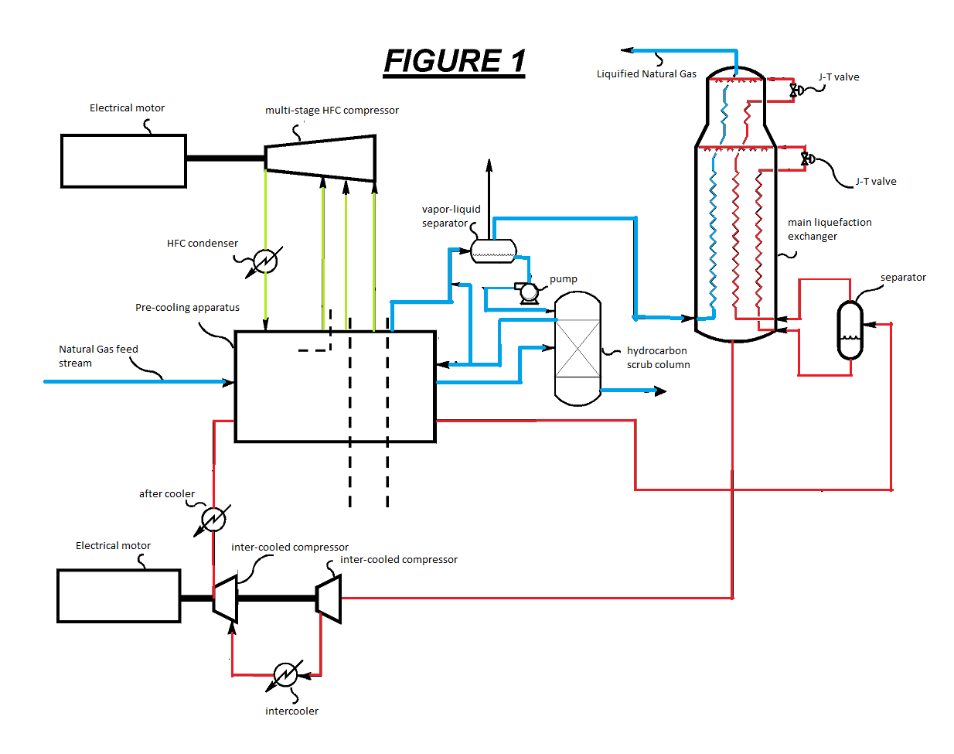
100: natural gas feed stream
101: pre-cooling apparatus
102: pre-cooled stream
103: hydrocarbon scrub column
104: stream
105: heavy hydrocarbon stream
106,107: stream
108: partially condensed feed stream
109: stream
110: vapor-liquid separator
111: liquid stream
112: pump
113: cold liquid reflux stream
114: vapor stream
115: the main liquefaction exchanger
116: stream
117: methane make-up stream
130: low pressure, warm main liquefaction refrigerant stream
131, 135: inter-cooled compressors
132, 134, 138: stream
133: intercooler
136: driver (electrical motor or gas turbine)
139: after cooler
140: high pressure fluid stream (P: 30-80 bara)
141: pre-cooled stream
142: separator
143: lighter refrigerant stream
144: heavier refrigerant stream
145: stream
146, 149: J-T valve
147,150: cryogenic refrigerant stream
148: stream
154: multi-shaft gas turbine
158: multi-stage HFC compressor
160: stream
161: HFC condenser
162: sub-cooled HFC stream
163, 164, 165: combined stream
Description:
Step 1: Returning to Figure 1, a natural gas feed stream (not shown) is pre-treated for removal of heavy hydrocarbon oils, particulates, CO2, and H2S before being sent to driers (not shown). Drying may be performed using sea water cooling if the sea water is substantially below 22°C or can be performed using the HFC refrigerant. After cooling the natural gas feed stream to a temperature between 22-25°C, the natural gas feed stream is then sent to drier beds where moisture is removed (not shown). The dehydrated natural gas feed stream 100 is then sent to be pre-cooled at pressures ranging between 30-85 bara. Pre-cooling of dehydrated natural gas feed stream 100 is performed in 1-5 cooling stages in series, for example, represented by the pre-cooling apparatus 101. Figure 1 illustrates a 3-stage pre-cooling system. These serial cooling stages use an HFC refrigerant at sequentially descending temperatures by lowering J-T valve pressures making the HFC refrigerant supplied to the cooling stage (n) colder than that supplied to the cooling stage (n-1), for example. The greater the number of cooling stages, the greater the efficiency of pre-cooling due to close approaches of the cooling curve. If there are a total of (n) HFC pre-cooling stages, then the feed cools in (n-1) stages to yield the pre-cooled stream 102.
Step2: Pre-cooled stream 102 may then be sent to a hydrocarbon scrub column 103 which scrubs away heavier (C3+) components of the feed using a cold liquid reflux stream 113 in order to adjust the heating value of the final LNG. A bottoms stream 105 is sent either to a fractionation train or to storage (not shown). It should be noted that due to space constraints on FPSOs, the heavy hydrocarbon stream 105 exiting the scrub column 103 may be potentially shipped and fractionated at a LNG receiving terminal. If fractionation is undertaken on the FPSO platform, one aspect of the current invention also allows for the HFC refrigerant to supply refrigeration to condensers of the various columns (such as a deethanizer) that may be involved in a fractionation train.
Step 3: Stream 104, taken from the scrub column 103, constitutes the lighter overhead stream. Part of stream 104 (i.e., stream 107) may be partially condensed using the HFC pre-cooling apparatus 101. The partially condensed feed stream 108 may then be combined with the uncondensed portion of stream 104 (i.e., stream 106) to form stream 109 and then sent to a vapor-liquid separator 110 which disengages the vapor from the liquid. The liquid stream 111 from the vapor-liquid separator 110 may then be pumped in pump 112 back into scrub column 103 as stream 113 to act as the column reflux.
Step 4: The HFC pre-cooling refrigerant may be used to supply all of the scrub column reflux condenser 110 duty without the need to use the main liquefaction refrigerant for such purpose. Using the HFC pre-cooling to supply all of the scrub column reflux condenser 110 duty will improve the efficiency of the system since typically cooling duties supplied by the typical hydrocarbon refrigerants require much higher incremental compression power than the HFC refrigerant. This is because of the significantly lower compressibility factors of typical HFC’s when compared with lighter hydrocarbon refrigerants like CH4 and C2H6. Use of the HFC pre-cooling to supply all of the scrub column reflux condenser 110 duty also reduces the size of the main liquefaction exchanger 115 and simplifies control issues and plant layout.
Step 5: Vapor stream 114 from the scrub column reflux condenser 110 may be sent to the cryogenic section of the plant that fully condenses and sub-cools vapor stream 114 to form LNG product stream 116. The cryogenic section comprises the main liquefaction exchanger 115. In the cryogenic section, either a refrigerant consisting of mixed hydrocarbons with 0-30 mole% N2 or pure N2 may be used, for example. In one embodiment, the main liquefaction refrigerant may be a mixture containing 0-30% N2 and hydrocarbons such as methane (0-50%), ethane (0-75%), and butanes (0-50%). In another embodiment, the main liquefaction refrigerant may be a mixture comprising a first stream of methane derived from a natural gas stream, a second stream, where the second stream is an ethane enriched stream that is predominantly ethane, and a third stream, where the third stream is a nitrogen enriched stream that is predominantly nitrogen. The methane stream can be derived from natural gas in one of two ways. If natural gas stream 100 (illustrated in Figure 1) is lean (i.e., contains more than 90 mole % methane and less than 3 mole % propane) then a part of that stream may be used to make up the mixed refrigerant. If natural gas stream 100 (of Figure 1) is not lean (i.e., contains more than 3 mole % propane) then it may be pre-cooled against the HFC in pre-cooling apparatus 101, scrubbed in a scrub column 103 (of Figure 1) that removes excess propane and other heavier hydrocarbons, and pre-cooled further to produce the methane make up stream 117 (of Figure 1). This procedure ensures that the methane make up stream used to make the mixed refrigerant contains low enough amounts of propane for safety.
The use of propane, which is considered to be unfavorable for use on the FPSO due to the possibility of formation of flammable clouds at surface level, may be eliminated, or nearly eliminated when using HFC’s as a pre-coolant.
Step 6: The main liquefaction exchanger 115 may be a wound coil exchanger, a plate-fin exchanger, or any other exchanger typical for cryogenic service. Vapor stream 114 may enter the main liquefaction exchanger 115 where it is condensed and sub-cooled and exits as LNG product stream 116 at a temperature between -140°C to -170°C and pressure between 30-85 bara, for example.
Step 7: The condensed and sub-cooled LNG product stream 116 may be further processed by reducing its pressure in a liquid expander (not shown) or a flash valve (not shown) to around 1.2 bara, forming flash gas and a liquid LNG product. The LNG product may be subsequently sent to storage, for example.
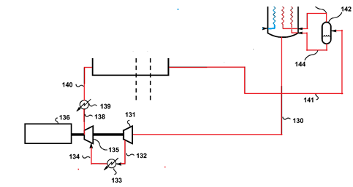
Step 8: The low pressure, warm main liquefaction refrigerant stream 130 may be sent to a sequence of inter-cooled compressors 131, 135 where the stream 130 is first compressed in compressor 131 to form stream 132, cooled in intercooler 133 to form stream 134, further compressed in compressor 135 to form stream 138, and then further cooled in aftercooler 139 to emerge as a high pressure fluid stream 140. Compressors 131 and 135 are driven by driver 136. Driver 136 can be an electrical motor or a gas turbine. High pressure fluid stream 140 may be at pressures ranging between 30-80 bara and a temperature dictated by: (1) the coolant used in the intercooler 133 and aftercooler 139; and (2) the size of the intercooler 133 and aftercooler 139. While Figure 1 illustrates the mixed refrigerant compression system having one intercooler 133 and one aftercooler 139, multiple intercoolers and aftercoolers may be implemented, for example. The coolant used in the intercooler 133 and aftercooler 139 may be air, or typically for FPSO applications, sea water, or fresh water, which is in turn cooled by sea water, for example.
Step 9: The cooled high pressure refrigerant stream 140 may be pre-cooled using pre-cooling apparatus 101 resulting in pre-cooled stream 141. Pre-cooled stream 141 may be separated into lighter refrigerant stream 143 and heavier refrigerant stream 144 in separator 142. The lighter refrigerant stream 143 may then be condensed and sub-cooled in the main liquefaction exchanger 115 to form stream 148, expanded in J-T valve 149 to generate cryogenic refrigerant stream 150 having a temperature between -180°C to -120°C, before it is then vaporized in the main liquefaction exchanger 115. The heavier refrigerant liquid stream 144 may also be sub-cooled in the main liquefaction exchanger 115 to form stream 145 where it may then be expanded in J-T valve 146 to generate cryogenic refrigerant stream 147 to also be vaporized in the main liquefaction exchanger 115. The current process may also include a hydraulic expander (not shown) before J-T valve 146 to improve efficiency.
The combined cryogenic refrigerant streams 147, 150 boil at successively higher temperatures while flowing down the main liquefaction exchanger 115 before eventually exiting the exchanger as the vapor stream 130 at or slightly above dew point thereby completing the refrigeration loop.

Microchannel heat exchanger (MCHE- main heat exchanger in LNG plant)
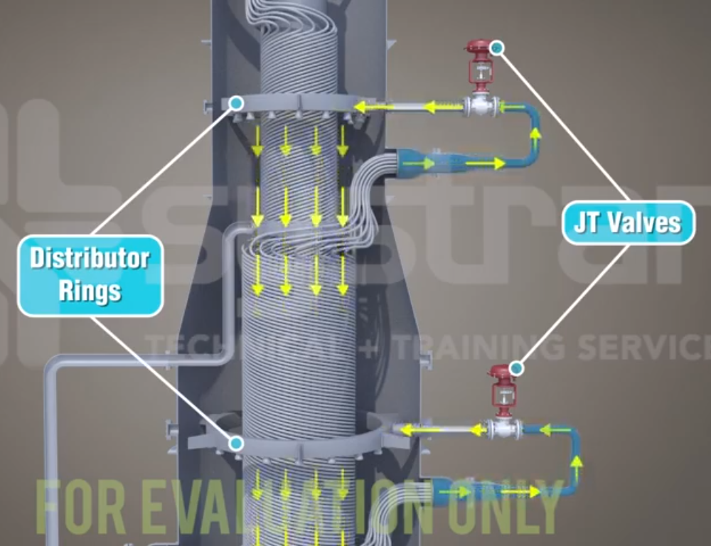
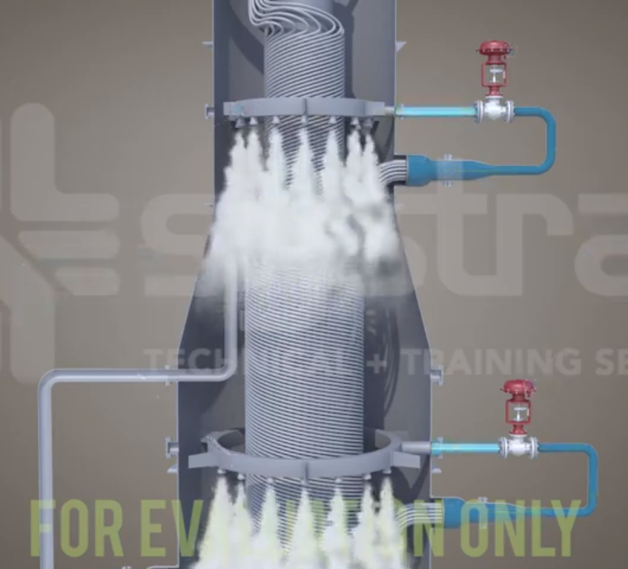
The MCHE is a spiral wound heat exchanger consisting of bundles with thousands of tubes to provide sufficient surface area needed for a close temperature approach between the inlet gas and the cooling medium. These bundles can be classified as warm and cold bundles and are arranged in a vertical shell with the warm bundle on the bottom and the cold on top.
The high pressure mixed refrigerant is first cooled by propane and is subsequently separated into light and heavy mixed refrigerant streams. The high pressure mixed refrigerant and feed gas streams flow upward through the tube side of the MCHE while the high pressure mixed refrigerant undergoes a series of flashes dramatically reducing the temperature. The cold flashed mixed refrigerant flows counter current (shell side) to cool both the inlet gas and the inlet mixed refrigerant. A final cooling stage is accomplished through a J-T valve or hydraulic expander to further cool the liquid and remove any excess nitrogen. At this stage, the gas stream is fully liquefied to -160°C, and is pumped to storage. The warm vaporized MR stream is taken off the bottom (shell side) of the exchanger and enters the first stage suction of the MR compressor. The compressed MR is first cooled with air or water followed by propane before returning to the MCHE to repeat the process.
Thermal Design
A Spiral wound heat exchangers (SWHEs) is generally used in LNG plant.
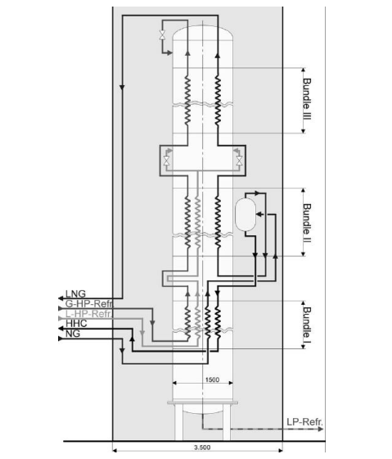
Cold Box Bundle Arrangement
(gaseous high pressure refrigerant (G-HP-Refr.))
As to suit process requirements three bundles are arranged in series, installed in a common shell. Each bundle has a diameter of 1,325 mm and the total installed heating surface amounts to 3,900 m². Bundle no. 1 is used to liquefy heavy hydrocarbons of the natural gas stream. Bundle no. 2 leads to partial liquefaction and in bundle no. 3 total liquefaction and sub-cooling to around –162°C are achieved. Each bundle has a separate distribution system for the shell side MRC.
Mechanical Design
All parts of the exchanger are in aluminum alloys whereby particular care was taken to select the appropriate alloys for critical items. Design pressure for the shell side is 28 barg due to overall plant conditions and for the tube sides 48 barg. Design temperature is +55 / -175°C.
The SWHE is designed in such a way that each of the three tube bundles has its own mandrel, support star, distributor system and shroud. Each bundle is hanging freely on several support arms via special shaped support bars so that shrinkage and expansion of the tube bundle due to rapid temperature changes during start-up or shut-down occurs with a minimum of stress between tube bundle and shell.
Each tube bundle is to be wrapped into a shroud which is seal-welded on the upper side to the shell to avoid any by-pass of refrigerant between bundle and shell.
The bottom section of the SWHE is designed so that it can be used as a separator. As the SWHE had to be installed in a cold box all bonnets and nozzles had to be designed for adequate elevation and orientation in particular in view of interconnecting piping and wall penetrations. The cold box was designed to accommodate the SWHE with a diameter of 1,500 mm and a total height of 28,600 mm including separator, all interconnecting piping, control valves, drains, vents and all instrumentation.
Manufacturing
First the mandrels with support arms and the drilled tube sheets placed in their final position were fabricated and assembled.
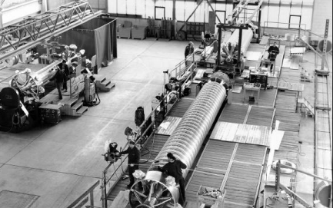
Three Bundles during Winding
Then the tubes were wound helically on the mandrel with a constant pitch and the winding direction being changed at each layer. Spacer bars were installed between each layer to provide the required spacing. Each tube was wound individually as to ensure proper line-up of the tubes. Particular attention was paid to keeping unsupported length of tubes between bundle and tube sheet within given limits. The bundle winding was performed in parallel on three winding benches. The tube ends on the tube sheets were then prepared for welding. A special welding process was developed for this rather critical welding seam and applied with excellent results.
After the three tube bundles had been wrapped into shrouds they were assembled with the prefabricated shell sections and completed to one exchanger. As soon as the pneumatic pressure tests on shell and tube sides had been carried out, the SWHE was installed in the cold box.
Prefabricated pipe sections were connected to exchanger, separator and valves. The instrumentation was installed followed by an additional pneumatic pressure test for all systems. Finally, the completed cold box was sealed and prepared for transport.
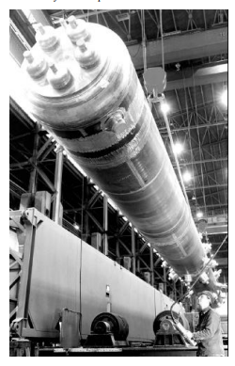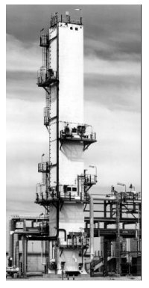
SWHE Installation into Cold Box The SWHE Cold Box
OPERATION AND PERFORMANCE
To demonstrate and prove the thermodynamic and hydraulic design as well as the mechanical integrity the exchangers are equipped with a large number of flow -, temperature -, pressure - and pressure difference indicators. As a special feature about 30 calibrated temperature indicators are installed in the three bundles to compare predicted with actual temperature profiles of the SWHE. These temperature indicators provided a complete detailed picture of the temperature profiles of each bundle.

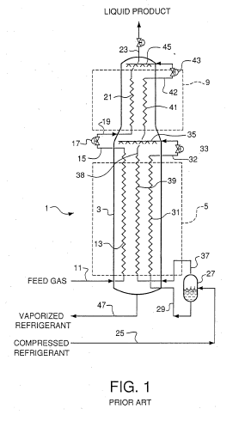
A main heat exchanger of a type known in the natural gas liquefaction field is shown in the schematic drawing of Fig. 1. This particular exchanger utilizes two coil wound bundles for the final cooling and liquefaction of a pretreated natural gas feed. Main heat exchanger 1 comprises pressure vessel 3, warm heat exchange zone 5, and cold heat exchange zone 9. A first coil wound heat exchanger bundle is utilized in cold heat exchange zone 5 in which a feed gas provided in line 11 is initially cooled in tube circuit 13 against a vaporizing refrigerant (later described) on the shell side of the bundle. Tube circuit 13 represents multiple tubes which are part of a coil wound bundle, wherein the bundle also includes tube circuits 31 and 39 as described later. Tubes typically may be made of aluminum. Feed gas in line 15 which has been cooled and at least partially condensed optionally is reduced in pressure across throttling valve 17.
The reduced-pressure feed then flows via line 19 into tube circuit 21 in cold heat exchange zone 9, wherein the feed is further cooled and withdrawn as product via line 23.
[0026] A two-phase compressed refrigerant, typically a multicomponent refrigerant containing light hydrocarbons and optionally nitrogen, is supplied via line 25 from a refrigerant compression system (not shown) and flows into phase separator 27. Refrigerant liquid is withdrawn via line 29, subcooled in tube circuit 31, and reduced in pressure across throttling valve 33. Optionally, a hydraulic expansion turbine may be used to extract work from the refrigerant liquid prior to throttling valve 33.
[0027] The refrigerant from throttling valve 33 is combined with refrigerant flowing downward from cold heat exchange zone 9 (described later) and the combined refrigerant is distributed via distributor 35. The combined refrigerant flows downward over the outer or shell side of the coil wound bundle therein while vaporizing and warming to provide a portion of the refrigeration for cooling the feed gas in tube circuit 13 as earlier described. In addition, the vaporizing refrigerant provides some of the refrigeration to subcool the refrigerant vapor in tube circuit 31 and to cool the liquid refrigerant in tube circuit 39 (described below).
[0028] Vapor refrigerant is withdrawn from separator 27 via line 37, is cooled and may be partially condensed in tube circuit 39 in warm heat exchange zone 5, and finally passes through tube circuit 41 in cold heat exchange zone 9, wherein it is liquefied and optionally subcooled. This refrigerant is reduced in pressure across throttling valve 43 and distributed via distributor 45 in cold heat exchange zone 9. This refrigerant flows downward over the outer or shell side of the coil wound bundle and vaporizes to provide a portion of the refrigeration for cooling the feed gas in tube circuit 21 as earlier described. In addition, the vaporizing refrigerant provides some of the refrigeration to cool the refrigerant in tube circuit 41. Distributor 45 is shown schematically and may include means for phase separation and distribution of separate vapor and liquid refrigerant streams to heat exchange zone 9. Two-phase refrigerant leaving the shell side of cold heat exchange zone 9 enters warm heat exchange zone 5 and joins with the refrigerant discharged from throttling valve 33. The combined refrigerant is distributed via distributor 35 and flows downward over the outer or shell side of the coil wound bundle in warm heat exchange zone 5. The refrigerant is typically totally vaporized upon reaching the bottom of heat exchanger pressure vessel 3, and is withdrawn as vapor via line 47. This vapor is compressed in the refrigerant compression system (not shown) and optionally precooled to provide the two-phase cooled compressed refrigerant via line 25 as earlier described.
[0030] Tube circuits 13, 31, and 39 in warm heat exchange zone 5 are parts of a single coil wound tubing bundle which is installed in warm heat exchange zone 5 of heat exchanger pressure vessel 3. This coil wound tubing bundle can be fabricated by methods known in the art of coil wound heat exchanger fabrication in which groups of long aluminum tubes of similar length are helically wound about an axial central core or mandrel. The mandrel may be a cylindrical pipe having a length, outer diameter, and wall thickness which impart the required structural strength to support the desired layers of tubing. In one method of bundle fabrication, solid rods may be wound helically about and in contact with the mandrel, spacers may be installed on the wound rods parallel to the mandrel axis, and then tubes may be helically wound in a first layer in contact with the spacers.

