Characterization, modeling, and development of an innovative fuel cell
In order to obtain Professional Master in Energetic Physics
Prepared by : Razan Youssef Kaddour.

Last Update: 13.05.2024 10:05

Table of Contents
Fuel cell I
Preface 1
1 Introduction 3
1.1 NLAP Electrolysis / Fuel Cell Project 3
1.2 Master Thesis Task 3
1.2.1 Ebene 3 sdfhdksjfhkj sdhfkjdhskjf dkjfhkjsdhjf 3
2 Basics 5
2.1 Overview 5
2.2 Introduction 5
2.3 The elements constituting the fuel cell 5
3 Contribution 15
3.1 Integration and Test of Actual ICPT Monostage Electrolysis/Fuel Cell System 15
3.1.1 Fuel Cell Design 15
3.1.2 Fuel Cell Realization 15
3.1.3 Fuel Cell Process Control System 15
3.1.4 System Test of Actual ICPT Elextrolysis/Fuel Cell System 15
3.1.5 Design Optimization (with MATLAB) 15
4 Results and Discussion 16
5 Conclusion and Fuutre Work 17
Literature 19

Preface
Text

Introduction

NLAP Electrolysis / Fuel Cell Project

Master Thesis Task
Characterization, modeling, and development of an innovative fuel cell
The training focuses on the characterization of a fuel cell and the establishment of a test bench to measure the performance of the cell (voltage, current, power, efficiency). An electrolyzer is installed within the NPAL (North Lebanon Alternative Power) laboratory as a source of hydrogen production which will be stored in specific tanks. The second step consists of developing a mathematical model to simulate the behavior of the fuel cell and carry out measurements under different conditions (temperature, pressure, gas flow, etc.). Finally, the last step will be an analysis of the data obtained to identify the strong and weak points of the cell, based on the results of the characterization and modeling, and propose solutions for improving the fuel cell. Required Skills : • knowledge of fundamental concepts of electrochemistry and fuel cells • Ability to model electrochemical systems • Experience in programming (Matlab) • Ability to write scientific reports Training place: • The internship takes place within the NPAL (North Lebanon Alternative Power) laboratory.

Ebene 3 sdfhdksjfhkj sdhfkjdhskjf dkjfhkjsdhjf

Basics

Overview
- Introduction.
- . The elements constituting the fuel cell.
- . Fuel cell components .
- . Fuel cell operating principle.
- . Types of fuel cell.
- . Fuel cell applications.
- . Advantage of fuel cell.
- . Disadvantages of fuel cell.
- . Principle of proton exchange membrane .
- .Basic chemistry and thermodynamics of fuel cells.

Introduction
A fuel cell is a device that directly converts the chemical energy of a fuel into electricity, usually through an oxygen-reduction reaction .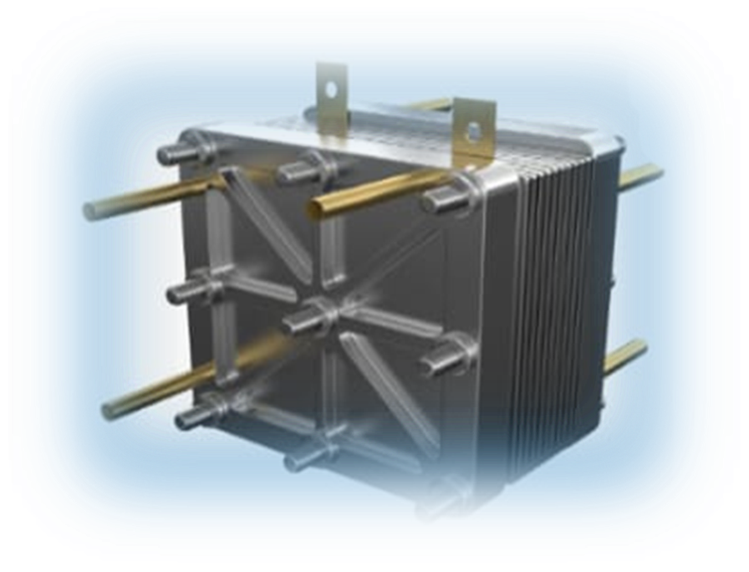

The elements constituting the fuel cell

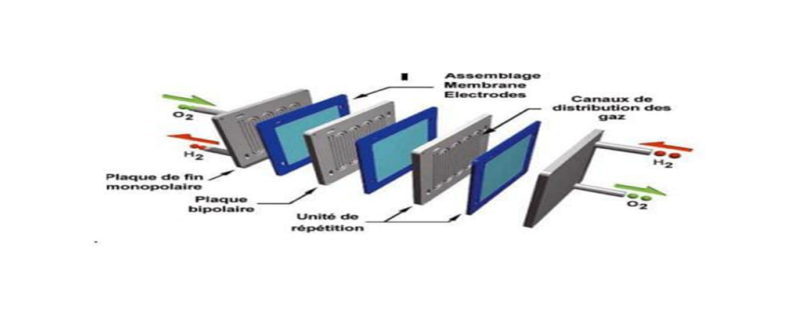

3) Fuel cell components .
. Anode: Where the fuel (H₂) reacts or “oxidizes” and release
electrons
Negative post of the fuel cell. It generally consists of a chemically treated metal such as platinum.

. Cathode: Where the “reduction” of oxygen (O ₂ ), generally in the air, occurs .
Fuel cell positive post. Leads the ēs back from the external circuit to the catalyst $\frac{1}{2}\text{O}$₂ +2H ⁺ +2ēs H ₂ O
. Electrolyte : The electrolyte is a substance which allows the passage of ions between the two electrodes while blocking the electrons
. End Plates : End plates are conductive plates that collect electrons from the anode and cathode and conduct them to an external circuit .

4) Fuel cell operation .

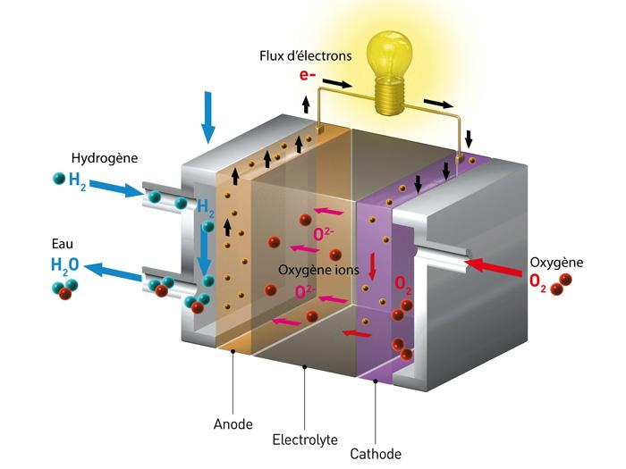
The H2 molecule comes into contact with the platinum catalyst, it divides into 2 H+ ions and 2 electrons. The ēs are conducted through the anode.
Run through the external circuit (do useful work like turning a motor) and return to the cathode side of the fuel cell. Form 2 oxygen atoms each, with a strong negative charge.
A negative charge attracts H+ 2ions across the membrane.
. Combines with an oxygen atom and 2 ēs from the external circuit to form a water molecule (H2O).

5) Fuel Cell Type:

. Alkali (AFC).
. Solid oxide (SOFC).
. Methanol and direct ethanol (DMFC) and (DEFC).
. Molten carbonate (MCFC).
. Phosphoric Acid (PAFC).
. membrane proton exchanger (PEM)
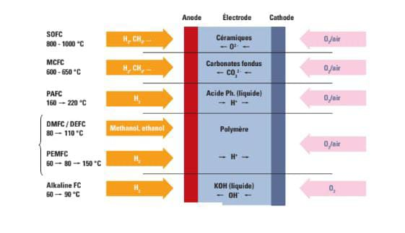
The most common in fuel cells is PEM (proton exchange membrane or PEMFC.

6) Fuel cell application:

. Electric vehicles : Fuel cells can power electric vehicles with greater range and shorter recharge times than conventional batteries.

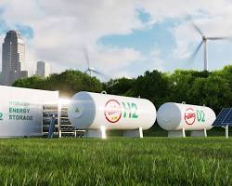
. Stationary electricity generation : Fuel cells can be used to generate electricity for homes, buildings or power grids .

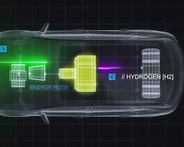
. Portable applications: Fuel cells can power portable devices, cell phones and power tools.
7) Advantage of fuel cell :
. Clean electricity production : No direct polluting emissions .
. High yield​​ : More efficient conversion of fuel into electricity than traditional combustion engines .
. Environment : Produces heat and water.
. Reliable : Some moving parts to wear or break .

8) Disadvantages of fuel cell :
. High cost .​
. Sustainability .
. Fuel storage : Hydrogen can be difficult to store and transport .
9) Principle of PEM:
1. Electrochemical reactions:
Take place at the interface between the electrolyte and the membrane, on the surface of the catalysts.
2. Hydrogen side (anode):
Hydrogen splits into protons (H+) and electrons (e-).
The protons pass through the selective membrane towards the cathode.
Electrons flow through the external circuit, producing an electric current.
3. Oxygen side (cathode):
Oxygen splits into oxygen ions (O2-) and releases electrons (e-).
Protons and electrons recombine with ions
Oxygen to form water (H2O).
Water and excess oxygen are drained from the cell.

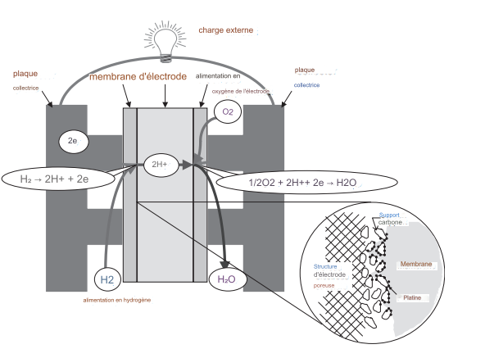
9) Principle of PEM:

Figure: Operating principle of a PEM fuel cell .
10) Basic chemistry and thermodynamics of fuel cells :

A fuel cell is an electrochemical energy converter - it directly converts the chemical energy of the fuel, usually hydrogen, into electrical energy. As such, it must obey the laws of thermodynamics

Base Reaction : Electrochemical reactions in fuel cells occur simultaneously on both sides of the membrane - the anode and the cathode. The basic reactions of the fuel cell are as follows:
At the anode: H2​ 2H ⁺ +2ē

At the cathode: $\frac{1}{2}$O ₂ + 2H ⁺ + 2ē H ₂ O

Overall: H ₂ + $\frac{1}{2}$O ₂ H ₂ O

These reactions may have several intermediate steps, and there may be some (unwanted) side reactions, but for now, these reactions accurately describe the main processes in a fuel cell.

Contribution

Integration and Test of Actual ICPT Monostage Electrolysis/Fuel Cell System

Fuel Cell Design
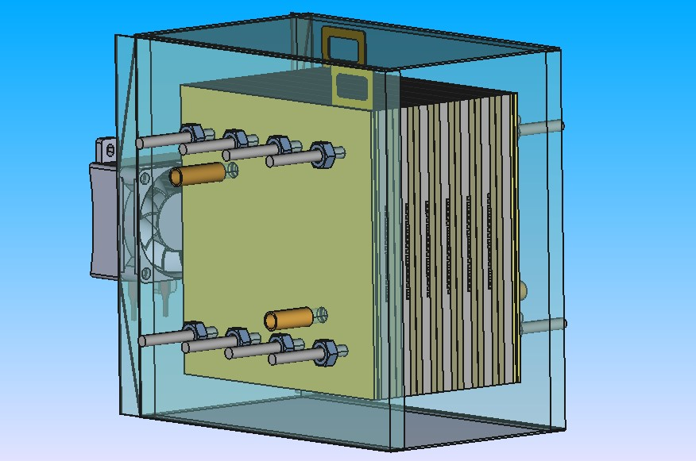
Source: https://aecenar.com/index.php/institutes/icpt/icpt-fuelcell/fuel-cell-system-concept-system-design/fuel-cell-mechanical-design

Fuel Cell Realization

Fuel Cell Process Control System

System Test of Actual ICPT Elextrolysis/Fuel Cell System

Design Optimization (with MATLAB)

Results and Discussion
Test

Conclusion and Fuutre Work

Literature
Eintrag im Literaturverzeichnis (Formatvorlage: Literaturverzeichnis).

