Electrochemical Synthesis of Ammonia: Progress and Challenges

Abstract:
Ammonia, as an essential chemical and a promising fuel, has been predominantly synthesized by the Haber-Bosch process since the beginning of the 20th century. However, the harsh conditions, high energy consumption, and large carbon footprint of this century-old process enforce human being to develop clean and sustainable ammonia synthesis technologies. The electrochemical synthesis of ammonia has advantages of mild operating conditions, zero emission of carbon dioxide, capability to store renewable electricity in chemical bonds, and possibilities for distributed ammonia production. Benefiting from these merits, the electrochemical synthesis of ammonia is expected as a promising alternative to the Haber-Bosch process and has been extensively explored. Research on the electrochemical synthesis of ammonia by nitrogen reduction reaction (NRR) can be principally divided into several aspects including the development of catalysts, innovations on the configurations of electrolytic cells, strategies to improve the selectivity, and verification of ammonia synthesis results. Moreover, the electrochemical reduction of nitrogenous pollutants has also been attempted to produce ammonia. In this review, we summarize the recent progress on these points and conclude with perspectives on challenges and future directions of electrochemical ammonia synthesis.

Introduction
Ammonia is a key chemical widely used in modern industry and agriculture as well as a promising carbon-free energy carrier with high hydrogen content (17.6 wt. %), high energy density (4.25 kWh/L), and ease of storage and transportation [1-3]. The predominant route of ammonia synthesis, Haber-Bosch process, is one of the greatest achievements of the 20th century. However, this process requires a pure hydrogen precursor primarily produced from strongly endothermic steam-methane reforming. Also, it operates at elevated temperatures (400-500 ºC) and pressures (10-30 MPa) to kinetically accelerate the reaction and shift the equilibrium favorably. As a result, it consumes 1-2% of the total energy worldwide and releases ~420 Mt of CO₂ annually [4, 5]. In addition, the large-scale and centralized Haber-Bosch plant requires huge capital investment and results in severe regional distribution imbalances [6]. To this end, scientists have been dedicated to developing facile ammonia synthetic methods that can be operated under mild conditions to replace the energy-intensive and unsustainable Haber-Bosch process. Up to now, approaches such as chemical looping [7], organometallic [8], biomimetic [9], photocatalytic [10], and (photo)electrochemical [11] have been proposed. Among these approaches, the electrochemical synthesis of ammonia is emerging as a compelling alternative to the Haber-Bosch process, benefiting from its mild operating conditions, zero emission of carbon dioxide, capability to store renewable electricity in chemical bonds, and possibilities for distributed ammonia production.
During the electrochemical NRR, NRR and hydrogen evolution reaction (HER) take place at the cathode and compete with each other, which can be expressed as follows [11-13].
In acidic electrolytes:
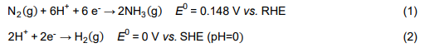
In basic electrolytes:
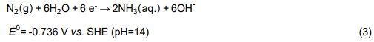
The challenges facing electrochemical NRR mainly come from the following two aspects. Firstly, N₂ features high bonding energy (941 kJ mol⁻¹), large energy gap (10.8 eV), high ionization potential (15.8 eV), negative electron affinity (-1.9 eV), and ultralow solubility in water (6.8 × 10⁻⁴ M, 1.01×10⁵ Pa, 298 K), which hinders the reduction of N₂ both thermodynamically and kinetically [4, 14]; Secondly, the electrochemical NRR has been plagued by low selectivity since its emergence. The electrochemical NRR and HER both can occur from a thermodynamic point of view and their equilibrium potentials are close to each other. However, the electrochemical NRR is a multi-step process that involves six electrons and six protons, and has suffered from sluggish kinetics. By contrast, the HER is a two-electron process, which is much more kinetically preferred. Consequently, the selectivity of electrochemical NRR is usually very low, which means high energy expenditure and lack of industrial competitiveness. The challenges make the electrochemical synthesis of ammonia from nitrogen particularly difficult and trigger research interests including the development of catalysts [11], innovations on the configurations of electrolytic cells [15, 16], strategies to improve the selectivity [17], and verification of ammonia formation results [18].
On the other hand, human activities add ~150 million metric tons of N every year to nature. This significantly alters the natural N cycle and results in deposition of undesired reactive N (NO₃⁻, NO₂⁻, NO₂, NO, N₂O, etc.) in the environment, which is known as nitrogenous pollutants and responsible for a variety of cascading environmental damages [1, 19]. To reduce the environmental impacts, removal of nitrogenous pollutants has been widely investigated in the environmental field albeit with N₂ as the target product instead of NH₃ [20]. Compared with N₂, nitrogenous pollutants are much more reactive and can be reduced more easily from the thermodynamic viewpoint [12, 21]. Considering the extraordinary difficulty of nitrogen fixation, it seems feasible to recycle these exhausts into valuable NH₃. On this account, researchers conducted investigations on electrochemical synthesis of ammonia employing nitrate, nitrite, or NO as the feedstock [22-24], which is emerging as a new category of electrochemical ammonia synthesis.
The electrochemical synthesis ammonia is developing at an unprecedented speed, which makes the summary and update of relevant progress especially imperative. Although several reviews have been reported recently, they have different emphases such as strategies for catalyst design and system optimization [11, 25-31]. This review is aimed at providing a concise but comprehensive overview on the latest progress in electrochemical synthesis of ammonia. Firstly, we summarize the latest works on electrochemical nitrogen reduction to ammonia. Then, recent developments on the electrochemical nitrogenous pollutants reduction to ammonia are briefly introduced. Finally, we point out the opportunities and challenges in this field.

Electrochemical synthesis of ammonia from NRR

Mechanisms of electrochemical NRR
The catalytic reduction of nitrogen usually involves three steps:
- adsorption of nitrogen molecules onto the catalyst surface
- the dissociative or associative breaking of N≡N bond and hydrogenation
- desorption of the generated ammonia.
It is generally believed that the industrial Haber-Bosch process evolves through a dissociative mechanism. Taking Fe-based catalysts as an example, 2 to 5 Fe atoms first interact with N2 in a side-on mode and break the N≡N bond into nitrogen adatoms. H-H bonds in H₂ simultaneously rupture on the catalyst surface and then react with N adatoms to form NH₃ (Fig. 1a) [32]. However, the direct broken of the N≡N bond is extremely difficult and requires a large amount of energy. The electrochemical NRR and the catalytic process of nitrogenases both occur at mild conditions that don’t favor direct N≡N bond breaking. Therefore, discussions on their mechanisms focus mainly on the associative mechanism during which the N≡N bond gradually breaks as the hydrogenation of N proceeds until an ammonia molecule is released. The associative mechanism can be subdivided into distal, alternating, and enzymatic pathways. For the distal pathway, N₂ adsorbs onto the surface of catalysts in an end-on mode. The N atom remote from the adsorption site is consecutively hydrogenated first and then hydrogenation of the other N atom occurs (Fig. 1c) [13]. For the alternating pathway, N₂ adsorbs onto the surface of catalysts in an end-on mode and then N atoms in N₂ are hydrogenated alternately (Fig. 1b and Fig. 1d).
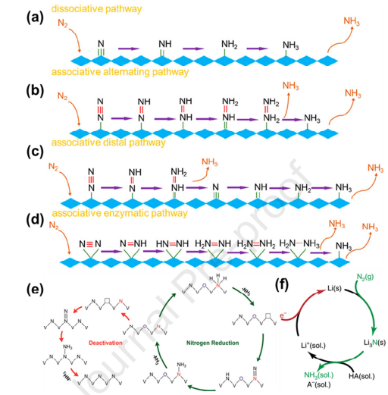
Figure 1 Schematic diagrams of possible mechanisms for electrochemical NRR. (a) Dissociate pathway, (b) associate-alternating pathway, (c) associate-distal pathway, and (d) associate-enzymatic pathway. Reprinted with permission from [33]. Copyright (2019) American Chemical Society. (e) Reactivity (MvK) and deactivation mechanisms of VN0.7O0.45. Reprinted with permission from [35]. (f) Li-mediated mechanism. Reprinted with permission from [16]. Copyright (2020) Nature Publishing Group.
To date, most of the discussions on the mechanisms of electrochemical NRR have been based on density functional theory (DFT) calculations. Nevertheless, experimental studies on the mechanisms of electrochemical NRR are of great importance because they can provide direct evidence for the nitrogen reduction process, which is helpful to clarify the principles of electrochemical NRR and dispel doubts about the results. Considering this, Yao et al. monitored the reaction intermediates of electrochemical NRR on Ru thin film and the Rh/C catalyst employing surface-enhanced infrared-absorption spectroscopy (SEIRAS) and/or differential electrochemical mass spectroscopy (DEMS) [38, 39]. The results revealed that intermediate N₂H_{x} (0≤ y ≤2) was detected on the Ru thin film and Rh/C catalysts. Therefore, it can be known that both the Ru thin film and Rh/C catalyst catalyze NRR through the associative mechanism following a two-electron transfer pathway. Additionally, it is encouraging that an increasing number of works on catalyst development are using in-situ characterizations (such as in situ X-ray diffraction and Raman spectra) to investigate the mechanisms of electrochemical NRR and validate their catalytic results [35, 40-43]. However, it should be paid attention that the dominance of HER during the electrochemical NRR may interfere with the results of these in-situ characterizations [4].

2.2 Computational studies on electrochemical NRR
As mentioned above, the reduction of nitrogen is of great difficulty. Catalysts can change the reaction pathway, lower the energy barrier, and thus accelerate the rate of electrochemical NRR. It is precisely because of this that the development of high-performance catalysts will always be the key to make breakthroughs in electrochemical NRR. For the entire field of catalysis, the development of catalysts was once completely dependent on experimental research and conducted in an empirical manner. In the past decades, the advances in the fields of computation and modelling gradually changed this situation. Nowadays, computational catalysis has become a valuable companion of experimental research due to its capabilities of free energy calculations, kinetic analysis, and catalyst design [44]. In this section, we summarize the principles and progress in computational research on electrochemical NRR.
At the early stage of the 20th century, the French chemist Sabatier proposed that the optimal catalyst should bind atoms or molecules moderately because too weak binding makes the activation process difficult while too strong binding results in poisoning of the catalysts [45]. This principle provided a qualitative criterion of the optimal catalyst but lacked predictive power because it was not clear which quantity should be used to represent the “bond strength” between the intermediate and the catalyst. Afterwards, it turned out that scaling relations exist universally in the adsorption energies of different intermediates/transient states that determine the reaction rate, which means that the associated variables can be reduced to one [46]. The generality of the scaling relation significantly reduces the dimensionality of calculations and makes the quantitative implementation of the classical Sabatier principle possible.
Taking the electrochemical NRR as an example, nitrogen adsorption energies on catalysts can act as the single variable/descriptor of ammonia synthesis activity and a volcano-type diagram of catalytic activity vs. nitrogen adsorption energy on different transition metal catalysts (Fig. 2a) can be obtained [45]. Then, the d-band model further revealed the reason why scaling relations exist between different variables is that the adsorption energies of different intermediates depend linearly on the surface electronic structure of the catalysts. The adsorbates hybridize with the surface d electrons of transition metal catalysts to form bonding and anti-bonding states during the adsorption process. The interaction between adsorbates and catalysts is closely related to the filling degree of anti-bonding states of the adsorbates, which in turn depends on the position of the d-band center of transition metal catalysts relative to the Fermi level. Generally, the higher the d band center relative to the highest occupied states at the Fermi energy, the interaction becomes stronger [45, 46]. The d-band center theory has been widely used to interpret the electrochemical NRR results, as will be discussed later in section 2.3.
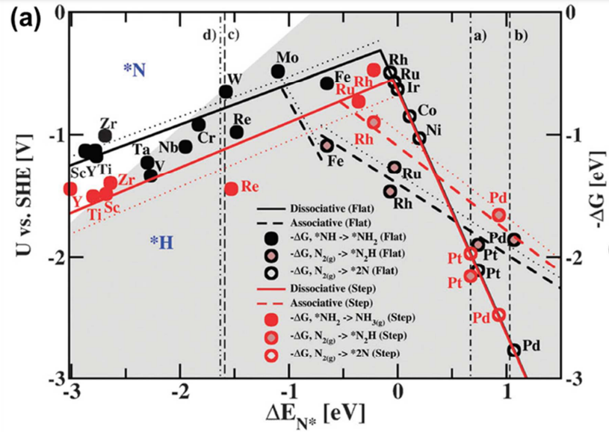
Figure 2 (a) Volcano diagrams of electrochemical NRR on stepped (red) and flat (black) transition metal surfaces through a Heyrovsky type reaction with (dashed lines) and without (solid lines) H-bonds effect. The grey-shaded area represents that the surface of catalysts will likely be covered with H-adatoms. Reprinted with permission from [47]. Copyright (2012) The Royal Society of Chemistry.
Specifically, Skulason et al. theoretically evaluated the electrochemical NRR on flat and stepped surfaces of transition metal catalysts [47]. Results revealed that Mo, Fe, Ru, and Rh were the most active surfaces but the competition of HER would seriously affect the NRR performance.
By contrast, early transition metals such as Ti, Zr, Sc, and Y bind nitrogen more strongly than protons and thus a significant ammonia production was expected (Fig. 2a).
Subsequently, Howalt et al. investigated highly under-coordinated transition metal nanoclusters for electrochemical NRR using DFT calculations in combination with the computational standard hydrogen electrode.
The results indicated that Mo and Fe are the most promising candidates for electrochemical NRR through the associative mechanism [48]. Abghoui et al. identified VN, ZrN, NbN, and CrN as the most promising mononitrides for electrochemical NRR through DFT based analysis and studied their stability against poisoning and decomposition. The results revealed that single-crystal surfaces were required for ZrN, NbN, and CrN to be stable while the rocksalt (100) facet of polycrystalline VN could catalyze electrochemical NRR through the MvK mechanism to avoid decomposition [49].
As stated above, the scaling relationship of different variables in a reaction can significantly reduce the dimensionality of calculations. However, it also makes the catalysts design a compromise process between different competing factors [45, 50].
The work of Montoya et al. indicated that the electrochemical NRR performance was severely limited by the linear scaling between the energetics of *N₂H and *NH₂, and the use of bifunctional surfaces was considered to tune these two parameters independently [51]. Zhang et al. stated that the use of 2,6-lutidinium (LutH⁺) could selectively stabilize *N₂H and break the scaling relationship [52]. With the rise of single-atom catalysts, the electrochemical NRR on transition metal single-atoms anchored on different supports such as nitrogen-doped carbons [53, 54], graphene [55-57], carbon nitride (C₃N₄) [55, 58], black phosphorene [59], boron monolayer [60], graphdiyne [61], Mxenes [62], molybdenum disulfide (MoS₂) [63], and platinum disulfide (PtS₂) [64] gradually becomes a computational research hotspot. Moreover, transition metal dimers or trimers are increasingly considered as the candidates for electrochemical NRR benefiting from their synergetic effect between different metal atoms, possibility to circumvent the scaling relations, higher metal-atom loading, more flexible active sites, etc.
For instance, Chen et al. reported that transition metal double-atom catalysts with C₂N (Fig. 2b) as the support (TM₂-C2N) such as Mn₂-C₂N (Fig. 2d) are more suitable for electrochemical NRR compared with their single-atom counterparts (TM-C₂N, Fig. 2c) according to the DFT calculation results [65].
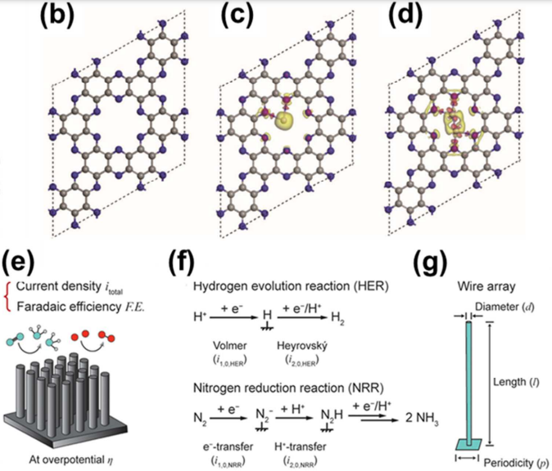
Fig.2 (b) Structure of C₂N, (c) single transition metal atoms supported on C₂N, and (d) double transition metal atoms supported 269 on C₂N. The yellow and red shadows denote electron loss and accumulation, respectively. 270 The gray, blue, and purple balls represent C, N, and Mn atoms, respectively. Reprinted 271 with permission from [65]. Copyright (2018) Wiley-VCH.
Guo et al. sampled both homonuclear and heteronuclear metal dimers supported on 2D expanded phthalocyanine. Ti₂Pc, V₂-Pc, TiV-Pc, VCr-Pc, and VTa-Pc were predicted to have strong capability to suppress HER with favorable limiting potentials for electrochemical NRR [66].
Hu et al. investigated the effects of coordination atoms (C, N, O, P, and S) on the electrochemical NRR performance of bimetallic pairs supported on graphene and the results indicated that carbon was the optimal coordination atom [67]. The work of Chen et al. revealed that transition metal trimers supported on the heterostructure of graphdiyne and graphene could achieve higher loading amount, improved dynamic stability, and better catalytic performance compared with single atoms or dimers [68].
DFT is a workhorse of first-principles-based simulation in catalysis and has been used in nearly all of the computational studies mentioned above. However, the high computational cost has greatly limited its application. By contrast, machine learning is the practice of building models from data, which can avoid time-consuming processes and reveal reaction processes in a short time, thus accelerating the catalyst development [50, 69].
Recently, Kim et al. reported a work that used machine learning to evaluate the electrochemical NRR performance on L1₂ intermetallic crystals and predicted that V₃Ir (111), Tc₃Hf (111), V₃Ni (111), and Tc₃Ta (111) were stable candidates that may exhibit improved catalytic performance compared with the reference Mo (110) [70].
Zafari et al. investigated the electrochemical NRR performance of transition metal single-atom catalysts anchored on B-doped graphene using machine learning [71]. The results revealed that the chromium single-atom catalyst with a CrB₃C₁ structure exhibited the best performance with a minimal potential of 0.13 V and high selectivity.
Besides electronic structure, morphologies of the electrodes also may greatly affect the electrochemical NRR performance but few of the computational studies have taken them into account. In this regard, Hoar et al. proposed a machine learning model (Fig. 2e, f, and g) to explore the morphology influence of micro/nanowire array electrodes on the performance electrochemical NRR [72].
Fig.2 Microkinetic model including (e) 272 measures of efficacy, (f) models for electrochemical NRR and HER, and (g) electrode 273 geometry definitions. Reprinted with permission from [72]. Copyright (2020) American 274 Chemical Society
Overall, plenty of progress has been made on the computational studies for electrochemical NRR as depicted above but there also remains many challenges to be overcome.
- Firstly, the improvements in the accuracy of computational studies are required to avoid wrong results and misleading the development of catalyst.
- Secondly, the current computational studies for electrochemical NRR usually adopt simplified models with the major concern on the electronic structure of catalysts and there is an urgent need to develop multi-scale approaches that incorporate the effects of temperature, pressure, electrolytes, etc.
- Lastly, the advances in computational science and development of new methods are urgently needed to enable the large-scale screening of catalysts.

Experimental explorations on catalyst development
Besides the computational research, a lot of experimental efforts have also been made to achieve these goals. The elements used in the catalysts for electrochemical NRR can be divided into three groups:
- noble metals such as Au, Ru, Rh, Pd, Pt, Ag, and Ir;
- non-noble metals such as Y, Sc, Ti, Zr, V, Cr, Nb, Mo, Fe, Co, Mn, Ni, Cu, W, Re, Sn, Sb, Bi, La, Ce, and Dy;
- non-metal elements such as B, C, N, O, F, P, S, Se, and Te.
These elements can derive many sorts of catalysts for electrochemical NRR, including metals, metal alloys, transition metal carbides, nitrides, oxides, and sulfides, carbon materials, black and red phosphorous, Mxene, covalent organic frameworks (COF), C₃N₄, etc.
Herein, the catalysts are classified (noble metal catalysts, non-noble metal catalysts, and metal-free catalysts) and summarized to shed light on the development tendency of catalysts for electrochemical NRR. Considering that a number of the early reported catalysts have been reviewed for many times, herein we give priorities to the latest and representative ones.

2.3.1 Noble metal catalysts
Although the membership is not well-defined, it is generally supposed that noble metals include silver, gold, and platinum group metals (Ru, Rh, Pd, Os, Ir, and Pt). As a whole, there are plenty of investigations on Au, Ru, Rh, and Pd while reports on Ag, Os, Ir, and Pt are sporadic for electrochemical NRR [73-77].
Due to the high cost of noble metals, it is necessary to take atomic utilization into account. Therefore, single-atoms, nanostructures, and alloys are the most investigated noble metal catalysts.
Recently, Xu et al. prepared nanoporous palladium hydride (np-PdH) through dealloying of Al₈₀Pd₂₀ and in-situ hydrogen injection (Fig. 3a) [40].
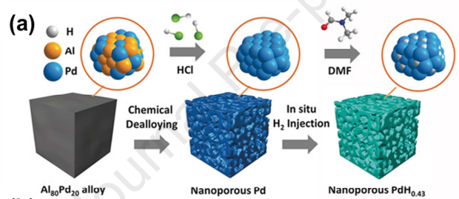
Fig. 3 (a) Preparation process of np-PdH.
Isotopic deuterium labeling experiments revealed that the outmost hydrogen atoms in np-PdH participated in the electrochemical NRR and a lattice hydrogen involved reaction pathway was proposed (Fig. 3b).
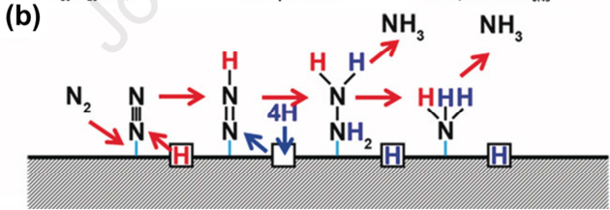
Fig. 3 (b) Lattice hydrogen involved reaction pathway 327 proposed for electrochemical NRR on np-PdH.
Hydrogen doping of np-PdH improved the internal electron concentration and shifted the d band center towards the Fermi level, leading to stronger adsorption of intermediates and enhanced catalytic activity. The electrochemical NRR performance improved with the increase of hydrogen content in np-PdH. The np-PdH_{0.43} exhibited the best performance with a highest FE of 43.6% and NH₃ yield rate of 20.4 µg h⁻¹ mg_{cat}⁻¹, respectively, at -0.15 V vs. RHE in 0.1 M phosphate buffer solution (Fig. 3c and Fig. 3d).
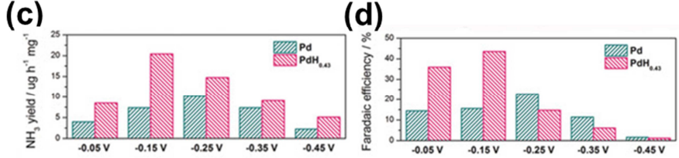
Fig. 3 (c) Ammonia yield rate and (d) FE of electrochemical NRR on np-Pd and np-PdH0.43 at different potentials. Reprinted with permission from [40]. Copyright (2020) Wiley-VCH.
Tong et al. optimized the NRR catalytic activity of PdCu through a crystal phase engineering strategy [78]. The prepared PdCu nanoparticles loaded on carbon powder transited from face-centered cubic (FCC) to body-centered cubic (BCC) phase through annealing in Ar/H₂ atmosphere. The NRR catalytic performance of BCC PdCu outperforms FCC PdCu with a maximum NH₃ yield rate of 35.7 µg h⁻¹ mg_{cat}⁻¹ and a FE of 11.5% at -0.1 V vs. RHE in 0.5 M LiCl. Surface valence band spectra indicated that the transformation of PdCu from FCC to BCC uplifted the d-band center towards the Fermi level, leading to enhanced N₂ adsorption and catalytic activity. DFT calculation results revealed that the Cu 3d band in BCC PdCu bridged the electron-transfer coulomb gap of Pd 4d and boosted the electronic activities of Pd 4d for NRR.
Yang et al. proposed a generalized surface chalcogenation strategy to boost the electrochemical NRR performance of noble-metal nanocrystals (Pt, Pd, Ru, and Rh) [79]. A series of noble metal selenide/chalcogenides were prepared, all of which exhibited enhanced performance compared with their counterparts without chalcogenation. For Rh-Se nanocrystals, selenation created additional Rh³⁺ species on the surface and upshifted the d-band center to the Fermi level, which can enhance the adsorption of N₂ and inhibit the HER process. As a result, the Rh-Se nanocrystals exhibited significantly enhanced ammonia yield rate (175 µg h⁻¹ mg_{Rh} ⁻¹), FE (13.3%), and stability (18 h) compared with the pristine Rh nanocrystals.

2.3.2 Non-noble metal catalysts
Low reserves and high cost of noble metals severely restrict their application. By contrast, non-noble metals are abundant and low-cost. Moreover, nitrogenases in the nature contain non-noble metals including Fe, Mo, and V. Therefore, plenty of studies have been carried out in search of efficient non-noble metal catalysts for electrochemical NRR, as will be discussed below.
Inspired by the nitrogenase MoFe protein, researchers have developed many kinds of Mo-based catalysts for electrochemical NRR such as Mo thin films [80], MoS₂ [81], Mo₂C [82], and single Mo atoms [83].
For MoS₂, Mo atoms in the basal plane are blocked by S atoms on both sides and thus only Mo atoms in the edge plane act as active sites for electrochemical NRR. To expose more molybdenum atoms and activate the basal plane of MoS_{2-x}, Zhang et al. recently fabricated Co-doped MoS_{2-x} polycrystalline nanosheets with abundant S vacancies (Vs) on carbon cloth substrate [84]. Through Co doping, the S/Mo ratio decreased markedly, indicating a substantial increase of S vacancies in Co-doped MoS_{2-x}. For the undoped MoS_{2-x}, N₂ adsorbed to the center of Vs and interacted with three Mo atoms (Fig. 4a), resulting in a reaction energy barrier of 1.62 eV.
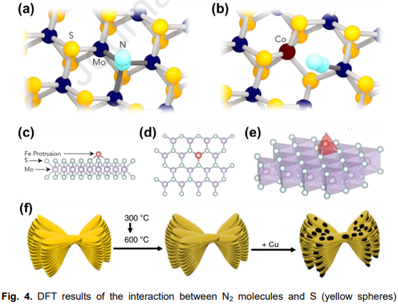
Fig. 4. DFT results of the interaction between N₂ molecules and S (yellow spheres) vacancies (VS) on (a) undoped MoS_{2-x} and (b) Co-doped MoS_{2-x}. For MoS_{2-x}, one N₂ molecule (light blue spheres) binds with three Mo atoms (dark blue spheres) near the VS. After Co doping, N₂ binds to one of the Mo atoms near the VS. Reprinted with permission from [84]. Copyright (2019) American Chemical Society. Schematic views of SACs-MoS₂-Fe-Y: (c) side-view, (d) top-view, and (e) perspective-view. Reprinted with permission from [43]. Copyright (2020) Elsevier B.V. (f) Preparation process of a typical Cu/PI catalyst. Reprinted with permission from [92]. Copyright (2019) Nature Publishing Group.
By contrast, the adsorbed N₂ bound to one Mo atom for Co-doped MoS_{2-x} (Fig. 4b) and the reaction energy barrier reduced to 0.94 eV, leading to enhanced NRR performance. In this work, Co atoms exist as an interior dopant for MoS₂. By contrast, Li et al. conjugated single-atomic Fe protrusions onto the surface of MoS₂ (Fig. 4c, d, and e) and made use of the high curvature of this structure to induce interfacial polarization field between the single-atomic Fe protrusions and N₂ molecules [43]. The generated interfacial polarization field can drive the injection of electrons from Fe into the antibonding orbitals of N₂ and make the splitting of N₂ easier. The electrochemical NRR performance of the prepared catalysts was tested in a flow cell using gas diffusion electrodes (GDEs) and ultrahigh performance (ammonia yield rate: 97.5 ± 6 µg h⁻¹ cm⁻², FE: 31.6% ± 2%) that exceeded all of the reported MoS₂ based catalysts was obtained for SACs-MoS₂-Fe-2.0 with 2 at.% of Fe loading.
Iron-base catalyst is another research hotspot and a variety of iron-base catalysts such as the SACs-MoS₂-Fe-2.0 depicted above [43], Fe₃O₄ [85], α-Fe@Fe3O4 [86], FeOOH [87], Fe-N-C [88], and FeS_{x} [89] have been reported.
Recently, Zhang et al. prepared a Janus Fe-SnO₂ catalyst for bifunctional N₂ fixation, i.e. NRR and N₂ oxidation reaction (NOR) [90]. Lattice-doped Fe and single-atom Fe anchored by oxygen vacancies coexisted in Fe-SnO₂. Computational and experimental results revealed that the Fe single atoms anchored on SnO₂ played as the active sites while the lattice-doped Fe could improve the electrical activity of SnO₂, leading to outstanding activity for both NRR and NOR. An ammonia yield rate of 82.7 µg h⁻¹ mg_{cat}⁻¹ and a FE of 20.4% were obtained for NRR while a NO₃⁻ yield rate of 42.9 µg h⁻¹ mg_{cat}⁻¹ and a FE of 0.84% were obtained for NOR. In the reported Fe single atoms immobilized onto carbon materials, Fe usually coordinates with N or C atoms. To enrich the types of coordination atoms for Fe single atoms and obtain high electrochemical NRR performance, Zhang et al. prepared a Fe single-atom catalyst anchored onto lignocellulose-derived carbon through a Fe-(O-C₂)₄ coordination configuration, and an ammonia yield rate of 32.1 µg h⁻¹ mg_{cat}⁻¹ and FE of 29.3% were obtained [91].
Reports on Cu based catalysts for electrochemical NRR are relatively few perhaps because of its weak N2 adsorption and high activity towards nitrogenous pollutants reduction. Recently, Lin et al. reported Cu-based electrocatalysts for electrochemical NRR by tuning the electronic structure of Cu [92]. Copper nanoparticles were loaded onto semi-conductive polyimide nanoflowers (Fig. 4f) which can attract electrons from copper, leading to rectifying contact at the interface and electron-deficient copper particles. According to the DFT calculation results, the electron deficiency of Cu nanoparticles enhanced the polarization of N₂ and reduced the Gibbs free energy change of NRR. Also, OH tends to adsorb onto electron-deficient Cu nanoparticles, which can retard the HER process in alkaline electrolytes. As a result, the Cu/PI-300 catalyst, in which Cu nanoparticles have the most pronounced electron deficiency, exhibited the best NRR performance with an NH₃ production rate of 12.4 µg h⁻¹ cm⁻² (loading amount: 5 mg cm⁻²) and a FE of 6.56% at -0.4 V vs. RHE in 0.1 M KOH. Zang et al. prepared copper single-atoms supported on nitrogen doped carbon for electrochemical NRR, which exhibited high performance in both acidic and alkaline electrolytes [93].

