Electrochemical Synthesis of Ammonia: A Low Pressure, Low Temperature Approach*
About half of the people on this planet exist because of the human mastery of nitrogen.1 The earth’s soil and natural processes simply could not support seven billion people without modern chemistry enabling the production of reactive nitrogen compounds from stubbornly inert nitrogen gas. All biological processes depend on nitrogen. It is an essential component of chlorophyll, proteins, and genetic material. For millions of years, plants have relied on natural mineralization, nitrogen fixing bacteria, or animal waste as their source of more reactive nitrogen in the soil. Over this past century, however, the plants we eat have increasingly relied on chemically synthesized fertilizers to keep up with demand. In fact, nearly half of the nitrogen in our bodies may have originated in a factory2 — where we have bent this inert gas to our own human wills. The story of how we came to “make bread from air” demonstrates how science and engineering can respond to a large societal problem, and impact the entire globe for the coming centuries.
In the mid 1800s, mining of fertilizers became more common as demand increased. Explorers even went searching for guano deposits, large quantities of sun-baked avian excrement full of nitrogen and phosphorous. This “white gold” became so important agriculturally that it was mentioned in U.S. President Millard Fillmore’s 1850 State of the Union Address, and in 1856 the U.S. Congress passed the Guano Island Act.3 The guano industry eventually fell to more reliable nitrate salt deposit mining. By the end of the century, scientists had raised the alarm about an impending societal problem — the increasingly large demand for nitrogen compounds and the limited supply.4 Scientists began attempting to fix atmospheric nitrogen, resulting in the industrialization of various processes in the early 1900s. In 1909, Fritz Haber demonstrated the feasibility of his technique, producing ammonia from nitrogen and hydrogen gas at high temperatures and pressures over a catalyst. Carl Bosch transformed this bench scale demonstration into an unprecedented industrial process as an engineer at BASF, resulting in commercial production in 1913.5 Ultimately known as the Haber-Bosch process, it rose to be the most economical way to manufacture fertilizer, and remains so today. This process earned both men a Nobel Prize and enabled exponential world population growth, shown in Fig. 1.
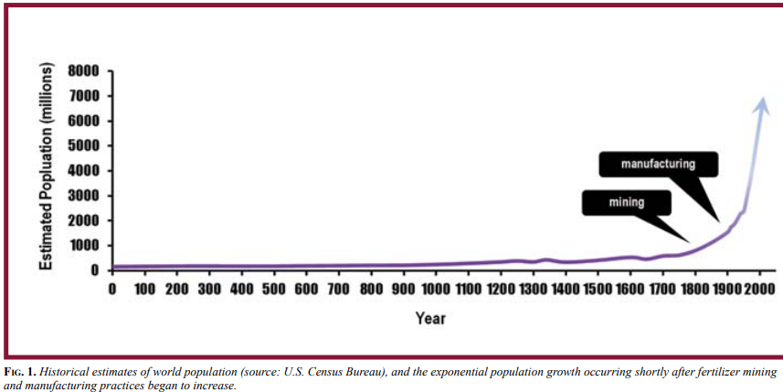
Today, the Haber-Bosch process involves the heterogeneous reaction of nitrogen (N₂) obtained from air, and hydrogen (H₂) obtained from fossil fuels. The process occurs at high pressure (150–300 atm) and high temperature (400–500 °C) over an iron-based catalyst. It is one of the most impactful developments in human history, but it comes at a price. Converting the highly inert N₂ to fertilizer is energy intensive, and accounts for about ~1% of the world’s annual energy consumption.6 In addition, the fossil fuel reforming of natural gas to hydrogen results in substantial carbon dioxide (CO2) emissions. According to the U.S. Greenhouse Gas Inventory, total CO2 emissions from ammonia production were 10.2 million metric tons of CO₂ equivalents in 2013, accounting for ~3% of the world’s greenhouse gas emissions.7 Additional emissions are incurred because of the need to transport the ammonia from a large centralized plant. The extreme conditions and pre- and post-processing steps combined with the low equilibrium conversion (~15%), which requires gas-recycling, makes these facilities highly capital intensive. These centralized plants are installed at a cost of more than $1 billion per plant, inhibitive for some countries that need fertilizer. As fossil fuels dwindle, and concerns rise over increasing greenhouse gas emissions, more sustainable and economical ammonia production methods will be required to support growing world demand for fertilizer.

The Electrochemical Production of Ammonia
One alternative approach to solve the ammonia problem is to use electricity to drive the ammonia production reaction, decreasing the need for high pressure and heat,8-10 and reducing energy demand. The concept of using electricity to drive nitrogen reactions and fertilizer production is not new. As early as 1901, Bradley and Lovejoy were attempting to pass electrical sparks though the air to make nitric acid on a commercial scale.11 However, the electricity costs proved to be too high and their process was abandoned. Today, methods exist to more efficiently utilize the energy input for an electrochemical process. Recently, a multi-scale simulation model found that energy consumption of an electrolytic process could easily match the Haber Bosch process.10 The intrinsic design of electrochemical systems allows oxidation and reduction reactions to be separated, enabling a wider range of chemistries,12 and potentially more selective catalysts that can be used for each reaction. This flexibility in chemistries and catalysts may eliminate the need to use highly purified inlet streams, allowing air to be the nitrogen source.13,14
A successful electrolytic ammonia process would enable a new nitrogen fertilizer industry based on networks of distributed-scale, near-point-of-use production plants, as illustrated in Fig. 2.
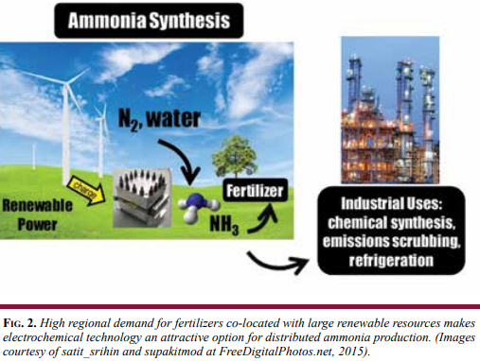
This electrically driven process is compatible with intermittent operation and enables utilization (and monetization) of renewable electricity without the need for transmission capacity expansion. To the extent that renewable electricity is utilized to drive the process, CO₂ emissions would be eliminated from the production step, and further reduction of emissions would be realized through the reduced need for ammonia transport. Since electrochemical technology based on flow cells is highly scalable, products could support a range of small to mid-sized farms, or could be designed on a larger scale to distribute ammonia locally for multiple farms. As megawatt (MW)- scale electrolysis systems are already becoming a reality at companies such as Proton OnSite, localized ammonia production at relevant scales is not hard to envision. There is also a natural synergy in using distributed wind power for fertilizer production. In the U.S. Plains and Upper Midwest, excess wind production capacity, transmission limitations, and high regional demand for N-fertilizers combine to create excellent economic drivers for this technology. Additionally, there are many other industrial uses for ammonia besides agricultural fertilizers. Ammonia is used to synthesize a variety of chemicals including urea, nitric acid and pharmaceutical compounds. It is also important in emissions capture as well as refrigeration, and could be used in a fuel cell for electricity generation. This flexibility in use makes ammonia an attractive renewable energy storage option.
Despite these potential advantages, only a few major studies have been conducted on electrochemical ammonia generation devices to date. Some groups are leveraging oxide conductors13,15-17 for electrochemical production of ammonia, and others are using proton conductors. Proton exchange membrane (PEM) materials are well established and have been recently incorporated into a number of ammonia synthesis devices.18-23 In addition, the Energy and Environmental Research Center (EERC) in Grand Forks North Dakota has also some highly relevant work in this area, with demonstration of large reductions in energy usage by using an integrated acid-based electrochemical-thermal ammonia production process that operates at a reaction temperature of 200–400 °C.24 Work at elevated temperatures (200 °C) has also been conducted using nanoscale Fe₂O₃ in molten hydroxide and basic electrolyte.13,17
While the work to date is incredibly promising for the advancement of electrolytic ammonia production, two major problems arise: high temperatures and acidic environments. High temperatures make the process less practical for consumer use, or rapid intermittent operation with renewable energy. In addition, the acidic environments require costly materials of construction compared to a basic environment and severely limit the options for catalyst materials, potentially eliminating many highly active and selective catalysts from the design. While PEMs have shown extremely long lifetimes and fast ion transport in other electrochemical applications, ammonia is a weak base, and it is expected that it will react with acidic membranes to reduce proton conductivity18 and, speculatively, membrane lifetime. In contrast, using alkaline chemistry reduces the membrane reactivity with ammonia, enables low-cost materials of construction, and allows the utilization of a wider array of low-cost and active catalysts. For these reasons, alkaline exchange membranes (AEMs) are an attractive alternative to PEMs for electrochemical ammonia synthesis.

An Alkaline Exchange Membrane-based Ammonia Generation Device
State of the art AEMs have ionic conductivities comparable to commercially available PEMs; even though the hydroxide anion is twice the size of a hydrated proton, structure diffusion can be extremely fast in these systems.25 In addition, AEM materials are generally stiffer and easier to handle than PEM materials of similar thickness, allowing thinner AEMs and offsetting the lower conductance. The use of less raw material also results in less costly membranes.
Recently, AEMs have been successfully demonstrated in ammonia fuel cells,26-28 but there is no significant published work on AEM utilization for ammonia synthesis to date. Collaborative work between Proton OnSite, Lauren Greenlee at the National Institute of Standards and Technology (NIST), and Andrew Herring at Colorado School of Mines (CSM) was conducted to show ammonia could be produced in an AEM-based device. Figure 3 shows the schematic of the electrochemical cell developed.
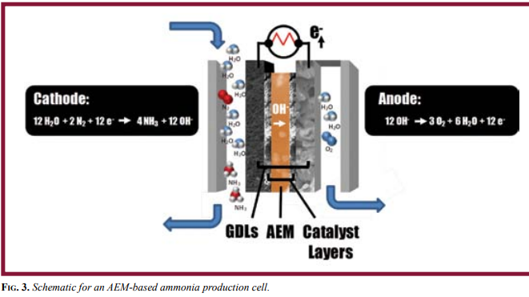
The feed gas stream is humidified air fed to the cathode, where N₂ and water (H₂O) combine with electrons to form hydroxide (OH⁻) and NH₃. The key enabler in the device is the AEM which selectively conducts OH⁻ to the anode where the ions form O₂ and H₂O, and enable the advantageous basic cell environment. The end result is an ammonia enriched air stream depleted of small amount of N₂ and H₂O. Catalyst coated gas diffusion layers (GDLs) serve as the electrodes for the device, forming a gas diffusion electrode (GDE). This electrode approach allows a variety of cathode materials to be explored without using high heat to bond the electrode to the temperature-sensitive AEM material.

The Need for Selective Catalysts
A primary challenge for the development of AEM-based low temperature ammonia technology is the lack of catalyst materials that are optimized for both activity and selectivity. The field of catalyst development for electrochemical ammonia synthesis is small but growing, with ammonia production demonstrated on a variety of electrode materials from precious metals such as platinum18 and ruthenium9,29 to non-precious metal-based copper, iron, and nickel materials.20,30,31
Most recently, Licht and co-authors demonstrated significantly higher ammonia production rates and faradaic efficiencies in a molten hydroxide electrolyte cell with a nano-Fe2O3 catalyst and at slightly elevated temperatures (105 °C–200 °C).13,18 Initial theoretical modeling efforts by Howalt, Skúlason and co-authors32,33 (Fig. 4, volcano plot representation of theoretical predictions) suggested that while ruthenium may be optimal for nitrogen reduction, several nonprecious metals such as iron, nickel, and cobalt might be useful especially in combination.
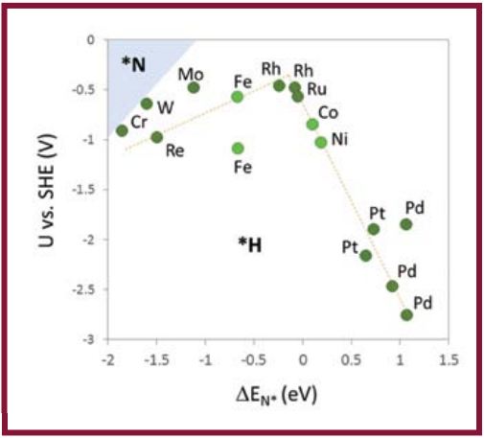
Fig. 4. A volcano plot predicting metal performance for nitrogen electroreduction. Data are plotted for the applied potential (U) required as a function of the binding energy (E) of the N atom onto the metal surface. Theoretical predictions include multiple associative and dissociative mechanisms for N2 reduction and are based on single metal surfaces. The optimal metals are shown at the peak of the volcano (dotted yellow line), and the region for preferential nitrogen adatom (*N) adsorption is shaded in blue. The white region indicates preferential hydrogen adatom (*H) adsorption. Adapted from Figure 7 of [33].
These predictions certainly support initial experimental results cited herein. However, the theoretical modeling also points out a key issue: all of the metals examined fall within the region where hydrogen atoms will preferentially adsorb over nitrogen atoms. In other words, hydrogen evolution from water electrolysis will preferentially occur instead of ammonia synthesis. This conclusion from theoretical predictions provides a primary explanation for the observed low faradaic efficiencies (typically less than 1%, apart from results reported by Licht and co-authors); most of the catalytic activity of the metal catalyst is going towards hydrogen evolution instead of nitrogen reduction.
Licht and co-authors13,17 conducted a series of experiments to explain their high efficiency (~35%) and the mechanism for nitrogen electroreduction to ammonia in an alkaline electrolyte. In particular, they showed that the presence of water, in addition to air or nitrogen gas, is necessary to achieve high ammonia production efficiency. The group also showed that the ammonia production efficiency is dependent on the applied potential that is used for the reaction and can be limited by the available surface area of the nanoscale catalyst. These results point to a mechanism that is dependent on the hydrogen atoms present in water molecules, and the water-splitting reaction, as the hydrogen source for nitrogen electroreduction. However, at potentials above the theoretical potential for water electrolysis, a portion of the hydrogen produced from water electrolysis preferentially forms hydrogen gas instead of reducing nitrogen. As the potential increases, the portion of H atoms going to hydrogen gas continues to increase, effectively decreasing the ammonia production efficiency.
In terms of a developed technology that can efficiently electrochemically produce ammonia with a reasonable physical footprint and compete with the Haber-Bosch process, the current produced at low applied potentials is too small. Therefore, it is necessary for an actual AEM device to operate at potentials potentially well above the onset potential of water electrolysis. Herein lies the essential challenge in catalyst development for nitrogen electroreduction and other similar electrochemical reactions: the catalyst must be both selective and active for the target reaction to allow for realistic operating conditions.
The results reported by Licht and co-authors experimentally demonstrate this need where ammonia synthesis was limited by available surface area of their catalyst and by the lack of selectivity of their catalyst to preferentially reduce nitrogen to ammonia instead of evolve hydrogen.
The combination of selectivity and activity is an opportunity for the field of nanostructured materials, where properties such as phase, electronic structure, morphology and surface structure can potentially be controlled. It is likely that a combination of optimal metals and designed nanostructure will be necessary to achieve concurrent selectivity and activity for nitrogen electroreduction in a catalyst material.
There is evidence elsewhere in the field of electrochemical catalysis that nanostructured materials result in performance and selectivity enhancements, most notably in the large and growing bodies of literature focused on the development of low-poisoning, high-activity oxygen reduction reaction catalysts and catalysts for methanol electrooxidation.34-48 Lessons learned thus far from theory and experiment point towards the potential successful use of non-precious metals in multi-metallic nanostructured materials for enhanced electrocatalytic performance.

Experimental Progress
To date, the Proton, NIST and CSM team has proven the feasibility of an alkaline membrane electrolyzer as an ammonia generator, conducted successful nanoparticle synthesis, and has shown improved catalyst efficiency for Fe, FeNi and Ni nanoparticles over Pt black (Fig. 5).
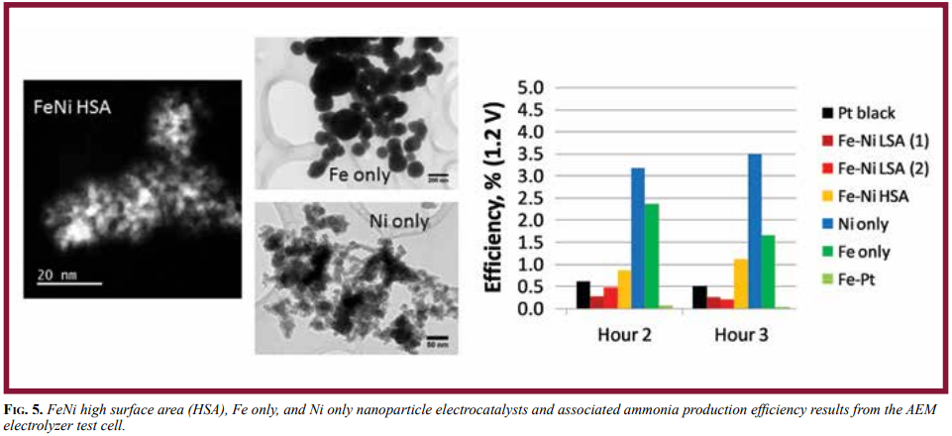
Fig. 5. FeNi high surface area (HSA), Fe only, and Ni only nanoparticle electrocatalysts and associated ammonia production efficiency results from the AEM electrolyzer test cell.
To enable the screening of promising cathode catalyst materials, and prove the AEM-based ammonia generation concept, Proton designed and built an AEM system based on a lab-scale, 25 cm² test cell.
- The screening efforts have revealed Fe only materials to be highly active, but unstable. Conservative estimates of initial efficiency are as high as 41%. However, this efficiency is short lived, and decreases to single digit efficiency in a matter of hours.
- Ni only materials behave oppositely. They have demonstrated single digit efficiencies initially, with good relative stabilities with time.
- Interestingly, the Fe-Ni materials appear to have a combination of both Fe and Ni properties, and differences in performance may be attributable to differences in composition.
For example, low surface area (LSA) samples have degrading efficiency with time (more Fe like), whereas the high surface area (HSA) sample have increasing efficiency with time (more Ni like). This indicates that a good approach to catalyst optimization would include tuning the morphology to get the benefits of the Fe efficiency, while protecting it with Ni to gain stability.
The operational performances of the Fe and Ni-based nanocatalysts in the AEM system were compared to relevant literature values, and the Haber-Bosch process. Table I outlines the results.
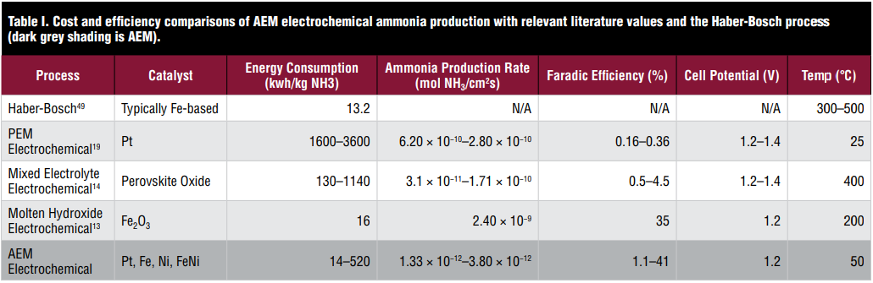
One important highlight of Table I is that the conservative estimate of the initial efficiency for Fe only particles (41% efficient) translates to an equivalent energy consumption rate to the Haber-Bosch process. It is important to note that this high efficiency was also achieved with FeNi HSA particles at NIST, in their solution-based 3-electrode tests. These results establish proof-of-concept that the AEM technology is capable reaching the performance necessary to replace the current HaberBosch process, while operating at low temperatures and pressures and without emitting CO₂.
While the ammonia production rate is lower than in other technologies, the AEM technology stands out as having the most potential for efficient ammonia production at low temperatures. The low ammonia production rate currently achieved is attributable to low current densities. Approaches to increase the current density include membrane development toward thinner and more conductive materials, as well as catalyst development toward selective and stable materials at higher voltages, because reducing the overpotential of the reactions ultimately will allow for greater current densities and greater selectivity versus hydrogen production.

The Future
A mere century ago, we were faced with a dwindling supply of fertilizer, a potential global crisis. Using science and engineering, Fritz Haber and Carl Bosch responded to the problem with unimaginable success. Similarly, today, we face the reality of dwindling fossil fuels, and the increased amount of by-products in our atmosphere because of their use, a potential global crisis. However, we can take heart in the fact that we have a demonstrated capacity to think our way out of potential disaster — we have been here before. Surely, many innovations will occur in response to this new potential crisis, including a new way to make fertilizer.
Several key challenges remain to enable AEM-based electrochemical ammonia production technology including:
- optimizing the catalyst for selectivity and activity
- optimizing the membrane for OH⁻ transport and durability
- achieving higher efficiency with electrochemical cell design (e.g., electrode optimization).
If successful, this technology will transform how our food is grown, how our energy is used, and potentially allow greater access to fertilizers globally. If the Haber Bosch process makes “bread from air,” the proposed electrochemical solution will do so even more truly, potentially using wind energy to drive the process, with air that will be cleaner as a result.

Acknowledgments
The authors acknowledge the generous support from the United States Department of Agriculture (USDA) for the work described in this article. Additional support came in the form of a Small Business Diversity Postdoctoral Research Fellowship, sponsored by the National Science Foundation (NSF) and administered by the American Society for Engineering Education (ASEE), which supported Julie Renner at Proton OnSite.
Many individuals contributed to the success of demonstrating AEM-based ammonia generation including Morgan George, Judith Manco, Andrew LaMarche Luke Dalton, Chris Capuano, and Nem Danilovic at Proton OnSite. NIST collaborators who provided critical expertise in catalyst material development included Nicholas Bedford and Nikki (Goldstein) Rentz. Proton also acknowledges Mike Reese and Doug Tiffany from the University of Minnesota for their conversations about the economic analysis. The authors acknowledge Taylor J. Woehl and Roy H. Geiss for TEM imaging support.

