Performance of a Small-Scale Haber Process

Abstract
This work identifies a benchmark for the performance of a small-scale ammonia synthesis plant powered by wind energy. The energy used is stranded, far from urban centers but near locations of fertilizer demand. The wind energy drives the pressure swing absorption of air to make nitrogen and the electrolysis of water to make hydrogen. These are combined in the small-scale continuous Haber process to synthesize ammonia. Analysis of small plant runs presented in this paper permits an assessment of how the current production rate is controlled by three resistances: catalytic reaction, ammonia separation by condensation, and unreacted gas being recycled. Measured catalytic reaction rates are consistent with separate experiments of chemical kinetics and with published reaction mechanisms. The condensation rates predicted are comparable with literature correlations. These rate constants now supply a rigorous strategy for optimizing this scaled-down, distributed ammonia plant. Moreover, this method of analysis is recommended for future small-scale, distributed manufacture plants.

Introduction
Since the early 1900s, the supply of natural fertilizers has not allowed food production adequate for the growing population. Synthetic ammonia, invented by Fritz Haber and commercialized by Carl Bosch, provided the synthetic nitrogen fertilizer required for significant increases in food production around the world1,2. After a century of intensive development, this Haber-Bosch process is still the basis for producing more synthetic fertilizer. It is one of the greatest technical innovations known. In addition, in the middle of the 20th century, Norman Borlaug’s research improved wheat varieties, resulting in additional food production. This “Green Revolution” required vastly increased amounts of nitrogen fertilizer, with an associated increase in fossil fuel consumption and carbon emissions. Ammonia is also discussed as an environmentally friendly route to storage of wind energy4,5. Thus the Haber-Bosch process and the Green Revolution lead to a new challenge for the 21st Century: to continue increasing food production while using clean energy, avoiding release of greenhouse gases, and supporting farming for the next generation6,7.
We are exploring technologies to make fertilizer using wind power rather than fossil fuels. Such wind-driven ammonia plants will be much smaller than those currently used8,9. The plants will use wind to make electricity and then to make ammonia locally. This implies process development in a different direction than that practiced in the traditional chemical industry10,11. Such traditional development centers on building bigger plants, which are cheaper because they operate at larger scale. For processes based on fossil fuels, such larger scales make good sense.
In contrast, in this work, we are developing plants which will not be based on fossil fuels drawn from a tanker or a pipeline. Such small plants use renewable wind energy to make small amounts of ammonia for a local market, and so represent distributed manufacture, rather than the centralized manufacture chosen for hydrocarbon feedstocks12. We have three objectives in this effort. First, we want to see how the small plant performs as a basis for future technical improvements. Second, we want to explore new ways to separate the ammonia made. Third, we want to study where such small plants should be located. This paper is concerned only with the first of these objectives, the small ammonia plant. Companion papers report efforts on new separations and on plant location13. Together, the papers are a first step towards a benchmark for judging how much advantage these small plants can offer.
To see why such an environmentally respectful process may make sense, consider the wind resources and the fertilizer needs shown in Figures 1 and 2 14,15. The wind resources in Figure 1 are greater in the more heavily shaded regions of the map. These resources are greatest in the regions with small population density, so the energy they promise is often called “stranded energy”: it is too far from major population centers to be used without excessive losses in transmission. At the same time, the fertilizer demand, that is, where ammonia is most needed, is in the same regions of the country as the stranded energy, as Figure 2 shows. This is one reason why projects converting wind to ammonia may make sense: the energy is there, but will not be used directly by concentrated populations for electricity.
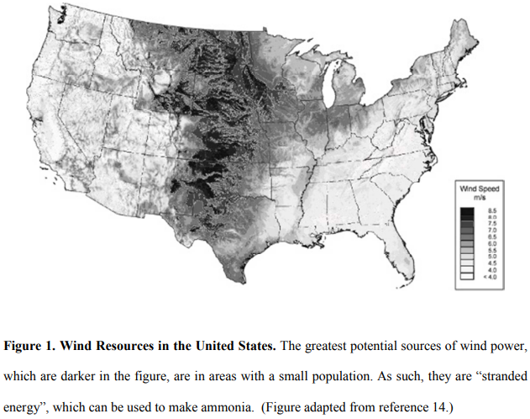
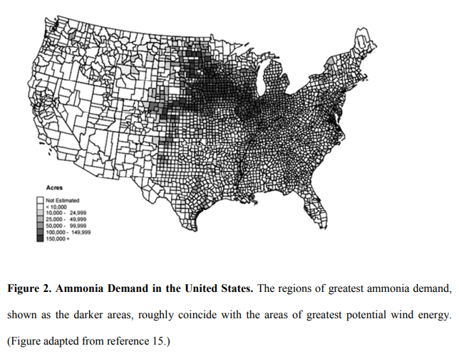
We have already demonstrated the promise of farm-scale, wind-based, environmentally benign ammonia synthesis in a unique facility: the Renewable Hydrogen and Ammonia Pilot Plant, the first local farm-to-coop scale system for fertilizer production. An analysis of the first technical data from this facility, dedicated in summer 2013 at the West Central Research and Outreach Center (WCROC) in Morris, MN, is reported here. It is a scaled down version of the conventional ammonia synthesis process; however, it does not use fossil fuels, but rather wind energy.
In other respects, this small-scale process is conventional, as shown schematically in Figure 3. Hydrogen and nitrogen enter the process in the upper right hand corner, are combined with recycled gases, and are fed to a compressor. The resulting gas mixture flows through one side of a heat exchanger to a heater and then into the reactor. The reaction, catalyzed by a conventional ammonia synthesis catalyst, increases the amount of ammonia in the exiting gas mixture, which is now cooled when it flows through the other side of the heat exchanger. The gas mixture is then further cooled to condense liquid ammonia, which is removed in the separator. Gases that are not condensed are returned to the compressor.
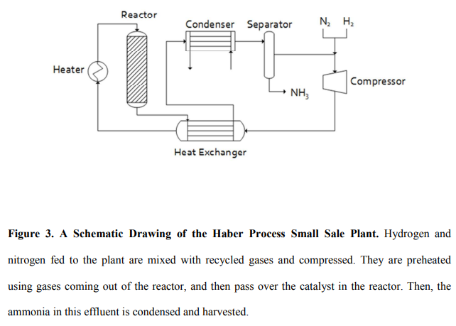
In the remainder of this paper, we report a model and data for this process to check whether they are consistent with the optimal production rates. We then discuss how these results can guide our search for optimized small-scale, distributed ammonia production.

Theory
To guide our analysis of the results found from the small plant, we derive an approximate model based on the schematic drawing shown in Figure 3. In this derivation, we assume that the process is in steady state; and that the reactor and condenser gases are well mixed, so that the concentrations exiting these regions have the same concentrations as those present in these regions16,17. This implies that average nitrogen concentration in the reactor equals the nitrogen concentration at the exit. While this is certainly untrue if most of the nitrogen entering the reactor reacts in a single pass, it is much more nearly true when little reacts in a single pass, so that the amount recycled is large relative to the amount reacting. As we will show, this is the case for this plant.
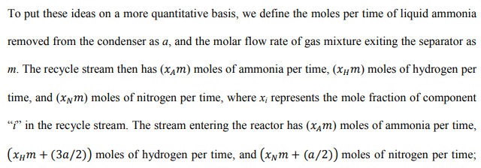
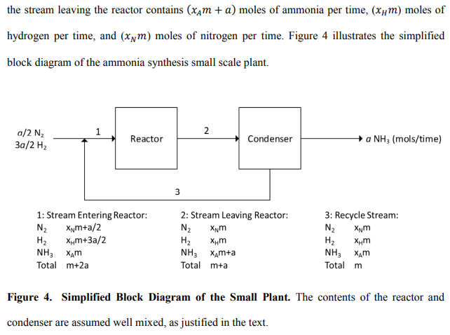
We next supplement these mass balances with rate equations on the reactor and the condenser. For the chemical kinetics in the reactor, the balance on ammonia is:
where k_{R} is the linearized apparent catalytic reaction rate constant, V_{R} is the volume of catalyst, x_{A}* is the ammonia mole fraction at equilibrium, and the quantity in square brackets is the ammonia mole fraction actually in the reactor. If x_{A}* equals this actual mole fraction, the reaction reaches equilibrium. The details of the lineariziation and of finding the numerical values of the rate constant are shown in the results section below.
This equation is a major approximation, not only because of the assumption of good mixing in the reactor. It also implicitly assumes that the reaction is first order. This isn’t true: for example, in the widely quoted Temkin-Pyzhev equation18-21, the forward rate of reaction depends nonlinearly on the partial pressures of ammonia, nitrogen, and hydrogen. Here, by approximating this quantity as a single (k_{R}V_{R}) with dimensions of moles per time, we acknowledge that this rate constant will vary not only with temperature and catalyst volume, but also with mole fractions in the reactor and with the reactor pressure.
The second balance, on the condenser, is also at steady state:
where k_{c} is the mass transfer coefficient between the bulk vapor; X_{A} is the ammonia mole fraction; X_{A}⁰ is the equilibrium mole fraction at the cold condenser wall, equal to the saturation vapor pressure divided by the total pressure; and A_{c} is the condenser’s interfacial area. Like k_{R}V_{R}, the quantity k_{c} A_{c} has the dimensions of moles per time; unlike k_{R}V_{R}, it depends only weakly on temperature and more strongly on physical factors like flow and surface geometry. The approximation of mass transfer as a first order process is much less severe than the corresponding approximation of reaction kinetics. Nevertheless, k_{c} may be a weak function of (X_{A}-X_{A}⁰) because of free convection.
We now combine Equations 1 and 2 to find the ammonia production a in terms of the known concentrations X_{A}* and X_{A}⁰ – each of which is known at the temperature and pressure of the reactor and condenser, respectively. From Equation 2,
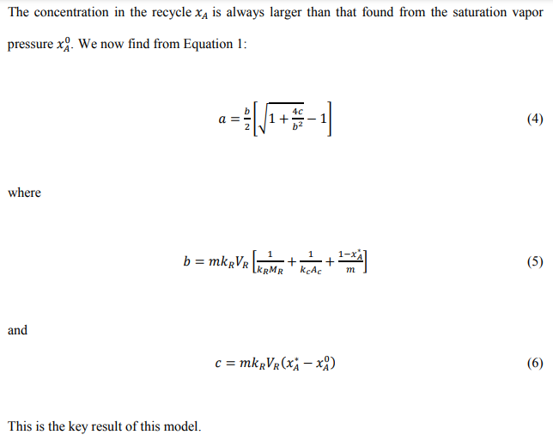
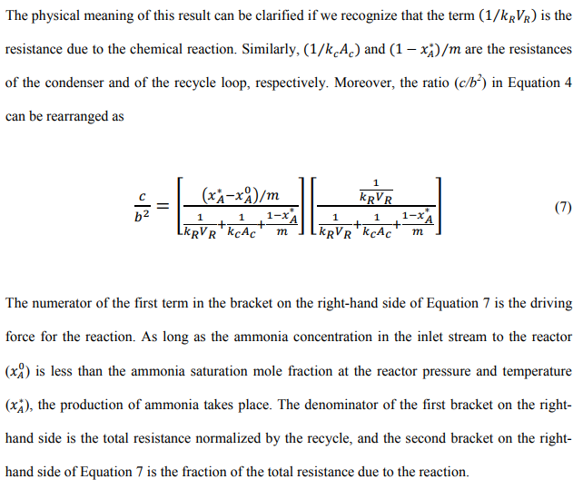
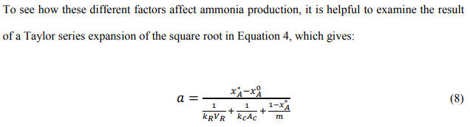
This behavior is observed in many rate processes with recycle and separation: the amount produced is proportional to the overall driving force divided by the total resistance17. The total resistance is the sum of the resistances of reaction, condensation, and recycle. Phrased in other terms, it is a weighted harmonic average of the speeds of these three steps, so that the slowest speed has the biggest effect on the rate of ammonia production. If the reactor is undersized or operating at too low a temperature, we will see the reactor resistance dominating. If the condenser is undersized, we will see the condenser resistance dominating; and if the recycle rate is too low to take full advantage of the unit operations, we will see the recycle resistance dominating. We will use this model and these results to analyze the experimental plant runs described next, and hence to explore how this small-scale plant can be made more productive. In pursuing this case study, we recommend this procedure for the analysis of other such small-scale, distributed processes.

Experimental

Plant Details
The ammonia synthesis plant that is the key to these experiments is shown schematically in Figure 3. The entire system is powered by electricity either produced by a 1.65 MW wind turbine (Vestas, Hedeager 42, Denmark) or from the local utility (Ottertail Power Company, Fergus Falls, MN). Nitrogen is produced by an Innovative Gas Systems NS-10 pressure swing adsorption system (Grosseto, Italy). The nitrogen it produces, which is greater than 99.9% pure, is stored at ambient temperature of 165 bar pressure in 18 tanks, each with a volume of 0.05 m3 (Norris Cylinder Company, Longview, TX). Hydrogen, which is manufactured by a Proton Onsite Hogen H6 (Wallingford, CT), is over 99.9% pure after it is dried across phosphorus pentoxide. It is stored at ambient temperature and 165 bar pressure in 54 0.050 m3 tanks identical with those for nitrogen. Both these systems function properly; occasionally the hydrogen production was marginally less than the amount required for the synthesis.
The nitrogen and hydrogen flow through orifice meter (Imperial Flange & Fitting Company Inc., Los Angeles, CA) into the main system, where they are combined with recycled gases coming from the separator. These mixed gases, at 83 bar, enter a RIX Industries 4VX1BG-1.7 (Benicia, CA) compressor. The exiting gases leave at a pressure of about 145 bar and flow to a train of four double pipe heat exchangers, where they are warmed using the gases that are discharged from the reactor. The inner pipe of each heat exchanger (Sep-pro Systems Inc., Houston, TX) has an inside diameter of 0.013 m and a length of 20.3 m, giving a total interfacial area of 0.83 m² . These gases, now at the pressure of about 145 bar, flow to a 20 kW heater (Sep-pro Systems Inc., Houston, TX) where they can be heated to reactor temperature.
The hot gases then flow to the reactor (Consolidated Inc., Gary, IN). The reactor is 2.23 m long and 0.203 m in diameter, sealed with a metal O-ring made out of stainless steel. Tightening this O-ring to avoid leaks requires considerable care using hydraulic torqueing of the bolts that secure the top flange to the reactor body. Within the reactor, the catalyst is contained in an annular basket (Consolidated Inc., Gary, IN) 1.8 m long, and 0.152 m outer diameter. To load the catalyst, the top flange is removed and the catalyst is dumped into the basket. The reagent gas feeds into the lumen of this annular space and flow radially out through the catalyst. The particular catalyst used is AmoMax-10 (Sud-Chemie, Louisville, KY). The gases exiting from the reactor flow back through the shell side of the heat exchanger, and so pre-heat the reactive feed.
These gases now flow to the condenser. The condenser (Sep-pro Systems Inc., Houston, TX) has 1 tube 8.4 m long and 0.013 m in diameter, giving a condenser surface area of about 0.34 m². A refrigeration skid (Sep-pro Systems Inc., Houston, TX) drives the refrigerant, R-404A (Copeland, Sidney, OH), through a 8.4 m long and 0.025 m diameter outer shell around the condenser tube. It operates at about -20°C. The resulting gases exit from the condenser at a temperature around -17°C and flow to the separator, a flash drum. The flash drum separates the ammonia liquid. Ammonia separated in the flash drum exits the plant through a solenoid valve and flows to a larger storage tank. The ammonia collected is stored in an 11.7 m³ storage tank (WestMor Industries, Morris, MN) at a pressure of 10 bars. The uncondensed gases are mixed with the incoming feed and recycled back into the compressor to start the process again.
The piping used for this plant is made from two different material: carbon steel and stainless steel. Most tubing is purchased from Swagelok (Chaska, MN). Embrittlement with hydrogen is always a problem. All tubing is fixed inside the pilot skid. Unless the tubing is stressed, the risk of leaking is very small. However, the corrosive nature of ammonia worsens the situation. Typically, in the tubing through which the hot gas mixture is transported between heat exchanger and reactor, stainless steel 316L is employed because it is more resistant toward corrosion by hot ammonia. In the tubing through which the low temperature gas mixture is transported between heat exchanger, separator and compressor, carbon steel is used. Carbon steel has higher resistance toward high pressure with longer life time in the presence of hydrogen.
The chief difficulties in start-up were plumbing the vent ports on the mixed gas compressor and leaks throughout the skid. Holes on the side and bottom of the reactor, which had been drilled for testing, also leaked and so were welded shut by a certified R-stamp welder. Some of the equipment also had material that was not compatible with ammonia and had to be replaced or repaired. Significant effort was required to understand and program the control systems.
Now that the small plant is capable of producing extended runs at steady state, we are able to subject its performance to the analysis described in the theory section.

Laboratory Kinetic Experiments:
In order to estimate the reactor resistance, we needed to test the catalyst used in the small plant. This was accomplished using a lab-scale reactor, using the same catalyst. The reactant gases N2 and H2, of ultrahigh purity, were purchased from Matheson (New Brighton, MN). The stainless steel reactor was tubular, 0.38 m long and 6.4 mm in diameter. The first and last 0.13 m of the reactor was filled with stainless steel wool, and the catalyst was packed in the middle. The catalyst, the same as in this small plant, with the nominal size range of 1.5-3 mm, is also stabilized with an oxygen-rich protective layer. The reactor used an Omega ceramic heater (CRFC-36/115-A, Stamford, CT), equipped with an Omega multiramp PID controller (CN96211TR) to control the temperature. The inlet and outlet gas temperatures and the reactor surface temperature were measured using K-type thermocouples connected to an Omega signal conditioner (DRG-SC-TC). The system pressure was recorded using a WIKA pressure transducer (50426877, Lawrenceville, Georgia) with 0-10V dc output.
The experiments were carried out in circulation batch with a variable piston pump (Model: PW2070N, PumpWorks, Minneapolis, MN). Data were recorded every second using a National Instruments Labview program, which also controlled the mass flow controllers which injected known volumetric flows of reactant gases into the reactor. Before each test, the system was tested for leaks for three hours, using nitrogen at 1500 psi. To remove the oxidized protective layer and activate the catalyst, the system was pressurized at 200 psi with 500 cm3 /min (STP) hydrogen. The temperature was slowly raised for 27 hours to reach to 723K. The hydrogen flowed through the catalyst bed for at least 24 hours at this temperature. After activation, the system was kept under nitrogen.

Results
Our analysis centers on five runs carried out in the small-scale plant for times ranging from four to 43 days. The runs had the reactor exit temperatures around 565K, and pressures around 115 bar. More specific parameters are given in Table I. While the runs differ slightly, they produce similar results; for illustration, we discuss in detail only the run begun on October 29, 2014, judging it to be typical.
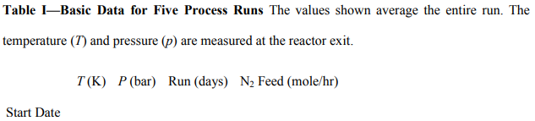
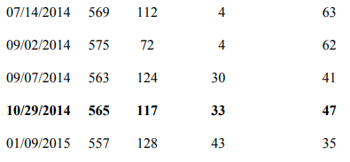
The temperature and the recycle obtained for the run of Oct. 29 are shown in Figure 5. During the first three days, there were excursions not only in temperature and pressure but also in recycle rate. Additionally, we observed a small spike in pressure on days 18-21, which is mainly due to the difficulty associated with controlling the small plant operation. As a result, we discarded the data obtained on days 1-3 and 18-21 and concentrated our analysis on two divided periods on days 4-18 and on days 21-33.
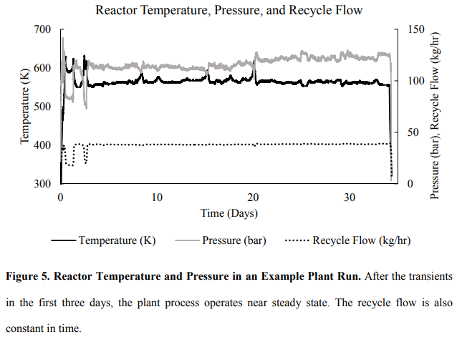
The data in Figure 5 shows that the small plant is operating near to steady state. The pressure is almost constant, varying by less than five percent. The recycle rate is also nearly constant, fluctuating by seven percent. The temperature shows greater excursions, by as much as fifty degrees. These excursions seem uncorrelated with the pressure and the recycle flow. Such lack of correlation may reflect control of the synthesis by chemical reaction, as explored in the discussion section below.
The feeds of hydrogen and nitrogen are in a ratio of 3:1, the ratio consistent with the reaction’s stoichiometry. While these data show steady operation over days, the feeds are subject to considerable variation over hours, as shown in Figure 6. The fluctuations in nitrogen flow rate, which are smaller, may be caused by changes in the pressure swing adsorption unit, which are not completely damped out by the storage tank for the nitrogen. The larger fluctuations in hydrogen are due primarily to the operation of the electrolysis unit. Occasionally, the electrolysis unit appeared not to supply hydrogen at the rate needed by the small plant. When this happened, we reduced the nitrogen flow rate. Still, even with these occasional variations, the temperature, pressure, and recycle rate remained relatively constant, as shown by the data in Figure 5.
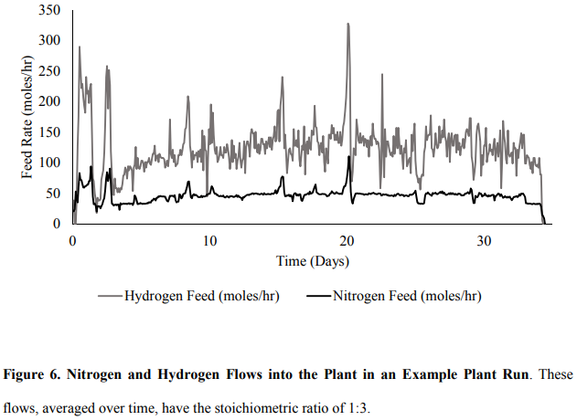
We now turn to the inferences of the data in Figures 5 and 6 using the model developed in the theory section above. These are shown in Table II for the earlier and later periods of the experiment begun on 10/29/14. The second column in Table II includes the average feed rates of nitrogen and hydrogen. There is no ammonia in this fresh feed. The third, fourth, and fifth columns in the table give the flows at the different points within the process. These internal flows are greater than the amounts of nitrogen and hydrogen actually fed, as is characteristic of most ammonia synthesis plants. To get fast kinetics, the reactor temperature and pressure should be high. However, the high temperature producing the fast kinetics also means the conversion at equilibrium is limited. This means that large amounts of unreacted gases must be separated from the ammonia produced, which, in this case, is removed by condensation. In addition to the unreacted hydrogen and nitrogen, there will also be a substantial amount of ammonia that is not removed in the condenser. As a result, the total recycle stream here is around twenty times the new feed stream, as values in the Table II show. This is true in both the experiments between days 4 and 18 and the experiments between days 21 and 33.
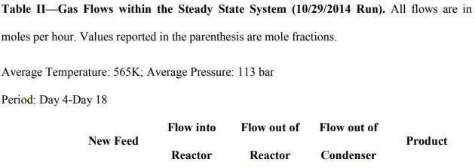
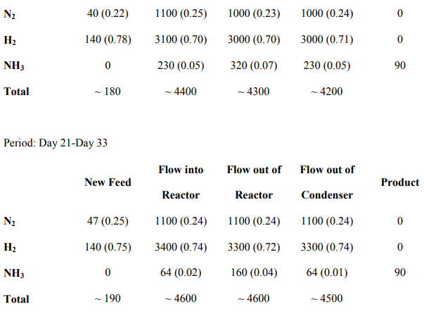
Regrettably, the plant does not currently contain the instrumentation to measure these flows more directly. While the orifice meters measuring the nitrogen and hydrogen flows are operating at Reynolds numbers about 5000, where calibration is difficult, we believe that orifice measurements are reliable. The flow of the recycled gases is seventy percent of the maximum flow possible in this pump, consistent with the design.
In the future, we plan to modify the equipment to allow higher temperatures; to ensure the nitrogen and hydrogen flows are accurate; and to measure the concentrations in the recycle stream. Part of the point of the analysis in this paper is to check our intuition that: a) the current production rate is limited by the reaction; and b) that the other components of the system will be able to accommodate increased production if the reaction rate is increased.
Finally, before we discuss these results, we need to report our laboratory measurements of ammonia kinetics vs. those predicted from literature sources, summarized as the Temkin-Pyzhev equation. This comparison is given in Figure 7, where our measurements at the temperatures and pressures shown are compared with those expected from other references19-22. The figure shows that agreement is good (R²=0.98). We will use these values in the estimates of the different resistances to ammonia synthesis in discussion of the small plant performance that follows.
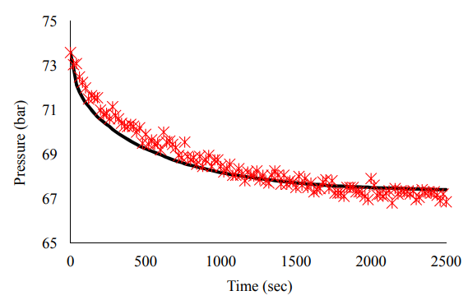
Figure 7. Laboratory-measured vs. Literature-calculated Reaction Kinetics at 723K. The rates measured from laboratory kinetic experiments (shown by markers) in this work agree with

Discussion
The results above show that the small plant works and can produce extended runs of data logging at steady state. It makes ammonia with wind energy. It does so with nitrogen made by pressure swing adsorption of air, and with hydrogen from the electrolysis of water. The pressures used are near those specified in the design, though the reactor temperature is about 100K less than the temperature of a conventional reactor as originally sought.
Still, these early results supply a template on how to proceed. They should allow us to detail the costs for small-scale ammonia synthesis. Indeed, we have already made an early economic analysis of these data11. We have used these results to start to identify where small plants for distributed ammonia production would be located13.
Nonetheless, the core of this paper is the exploration of technical limitations and opportunities for this small-scale technology. We have a sound start, but there is a shortfall in the intended ammonia production. We assume that this is probably the result of the limited temperature achieved in the reactor. We got a temperature of about 565K; the design target was 670K. Had we been able to achieve this higher temperature, we might expect a corresponding increase in ammonia production - as long as the separator and the recycle can keep up with the increased production. We discuss this exploration with some rigor, next.
Our immediate efforts to extend this technology combine these preliminary experiments with the analysis suggested by the model developed above. This model, summarized in Equation 4 or 8, predicts that the ammonia synthesis by the entire process is proportional to an overall rate constant times an overall driving force. The overall rate constant is a harmonic average of the three rate constants of the reaction, of the ammonia separation, and of the recycle. The overall driving force is the ammonia concentration X_{A}* that would exist at equilibrium minus the ammonia concentration X_{A}⁰ in the vapor in the condenser.
The values of the three rate constants merit careful consideration, for they are the key by which the process will be improved. For instance, it would not make sense to take measures to increase the reactor temperature if we find that the overall production rate is limited by the separator capacity. In each case, we linearize the rate constants for small deviations from equilibrium.

Linearized rate constant for reaction
The rate constant for the reaction is the most complex. This reaction rate is most often correlated using the Temkin-Pyzhev equation18-21:
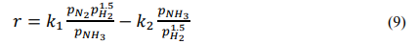
This equation is rewritten by defining the following variables:
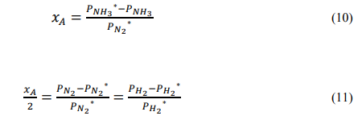
Linearization using the Taylor series for small values of x simplifies this:
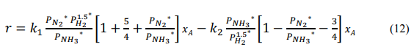
Subtracting the concentrations at equilibrium gives:
where kR is a linearized overall rate constant with dimensions of moles of ammonia per catalyst volume per time. We used two different approaches to calculate this linearized reaction rate constant for the plant reactor’s temperature. The first approach was to calculate the linearized rate constant for each temperature, plot the log of these constants vs. the reciprocal of temperature, and use the data to extrapolate to find the rate constant of the plant process at 565K. The Arrhenius plot that results is shown in Figure 8. This first approach gives a value for kR of 0.67 mol/L hr. Because there are 12L of catalyst, the characteristic rate constant (kRVR) is 14 mol/hr. The second approach was to plot the Arrhenius equation for k1 and k2 and extrapolate to find the values at the plant temperature. Then we used the extrapolated values to calculate the k1 and k2 at 565K. Then we used Equation 13 and found the linearized kR. While this gave a value of 0.23 mol/L hr, smaller than the first method, the fit of the plots was poorer. As a result, we used the first approach to calculate the values used in our analysis. Finally, the small plant system contains n₀ =113 moles of gas mixture actually present in the system. Thus the characteristic time for the reaction is 14 hrs.
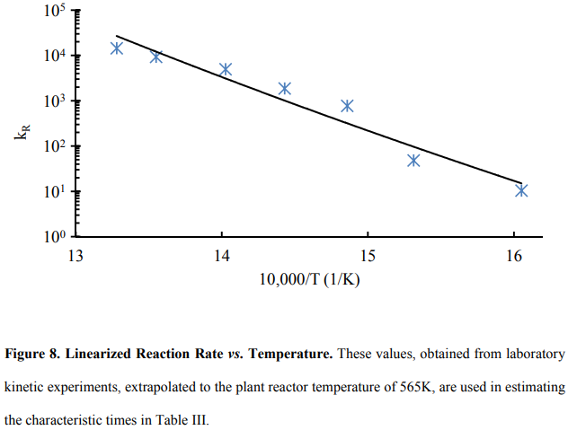

Characteristic rate constant for condensation
We next turn to the second rate constant of the small plant process, that associated with the condenser. The condensation rate will be affected both by the rate of mass transfer on the reactive gas side, and by the heat transfer on the refrigerant side. At present, we have no basis for deciding which of these rates is more important. From the Chilton-Colburn analogy22, we suspect that they will be similar in size. As a result, we decided to make our first estimates based on heat transfer, because the correlations are better developed.
Our estimate of this rate, then, begins with the overall heat transfer coefficient U:
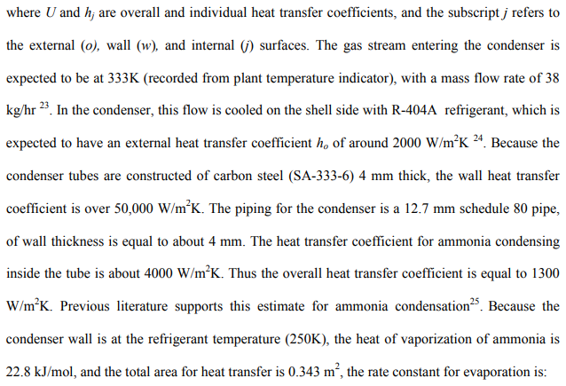
Again, the apparatus contains 113 moles of gas mixture, so the characteristic time for the condenser is 0.020 hrs. This is much shorter than the reaction time.

Characteristic rate constant for recycle
The third rate constant that affects the process is that associated with the recycle pump. The equilibrium mole fraction at the operating pressure and temperature of 565K and 117 bar is 0.58. Because the data show that recycle flow rates around 4400 mol/hr, the pumping characteristic time for the 10/29/2014 run is defined as:
This is smaller than both the reaction time and the heat transfer time.

Comparing characteristic rate constants as characteristic time constants
To explore the meaning of these times more completely, we turn to the summary of results in Table III. This table shows more complete data for the five runs in mentioned in Table I, identified with the dates in the first row. The results for the experiment started on 10/29/14 are those detailed above and shown in boldface. However, all five experiments give similar results. The second and third rows of the table give the temperature and pressure of the experiments. The fourth and fifth rows give the moles per hour recycled in the process (m) and the total number of moles actually present in the reactor, n₀. Rows six and seven give the mole fractions at equilibrium of ammonia in the reactor and in the condenser, respectively; the difference between these values is the overall driving force for the process, as summarized in Equation 8. Row seven gives the temperature in the condenser. Most importantly, rows 8-10 give the times for the three rates of reaction, condensation, and recycle. We use the total number of moles of gas in the plant to fashion these as characteristic times. The longest time, which corresponds to the slowest step, will control the overall rate of the process; this would be the characteristic time associated with principal resistance to the overall plant production rate.
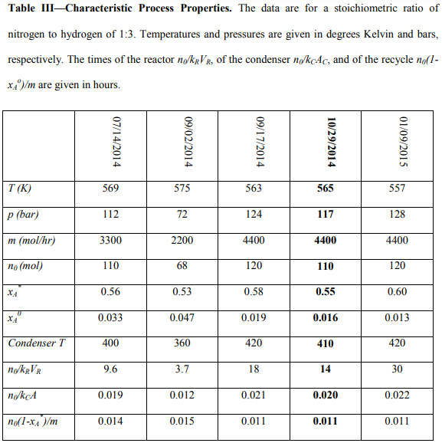
Under the process conditions used so far, the unit operation dominating the rate of production is the reactor. Upon reflection, this is not surprising. A review of the operating logs shows that the reactor operating temperatures used in the runs to date have been substantially below those characteristic of the use of this catalyst in conventional plants (ca. 700K). We also see that the other two characteristic times of the condenser and of the recycle are three orders of magnitude smaller– they are well capable of handling increased production rates. If the reaction temperature could be increased to 700K, the characteristic time of the reaction rate constant would equal that estimated for the condenser, and the plant performance would be closer to optimal. This optimum might be found at lower temperatures if, as expected, the condenser time includes resistance to mass transfer in the ammonia, as well as heat transfer resistance in the refrigerant; only the latter contribution is considered above.
In this case study, our analysis suggests that the recycle and separation capacity of the current small plant are more than adequate to accommodate increased reactor performance. However, we note that the separation or recycle capacity may well be judged limiting in other cases, and they are felt to influence broad sections of the chemical industry17 .
This simple method of analysis, we suggest, should be useful for many current efforts to produce small-scale, distributed manufacturing processes. We note that the principles guiding downscaling are not as familiar as those for scale-up, in large part because the economic driving forces can be unusual (e.g., stranded power, zero-carbon incentives) and also in part because the capital cost is often governed by custom-manufacture. Thus it is useful to analyze prototype small plants to optimize operation.

Conclusion
In this work, we present a benchmark for the performance of a small-scale ammonia synthesis with zero-carbon footprint. Stranded wind energy supplies the energy for this process, and the feed is provided from renewable resources. Such a process can satisfy fertilizer demand in distant locations with limited access to conventional energy resources. Generally, controlling small-scale processes is difficult, and this process is not operating at its best conditions. To further understand the ammonia synthesis in our small-scale Haber-Bosch plant and determine the optimal conditions for operating, we simplified ammonia production process to three main steps operating in series: reaction, separation and recycle. This simplified model successfully predicted the performance of different units, and gives information regarding each region.
Our laboratory-scale kinetic studies along with our linearized reaction rate show that the chemical reaction is rate-limiting. Our analysis indicates that the catalytic reaction resistance of the currently operating plant is at least three orders of magnitude larger than the condensation and recycle resistances, respectively. Our kinetic studies support the suggestion that increasing the reaction temperature to approximately 700K leads to a reaction resistance with the same order of magnitude as condensation resistance. In this instance, we have shown that there is no reason to be concerned that the increased production rate might not be accommodated by the separator or the recycle capacities. Such a straightforward model may help us to understand the design of other small-scale processes in the future.
