Calculation pressure of pipes
Pipes working pressure calculator
Equation: P = (2*S*T)/((O.D.-2*T)*S_{F})
Where: P = Fluid Pressure (psi)
T = Pipe wall thickness (in)
O.D. = Pipe outside diameter (in)
S_{f} = Safety factor (General Calculations 1.5 – 10, Use 1 For Bursting Pressure)
S = Material strength (psi)
Ultimate Tensile strength or Yield strength can be used.
Ultimate should be used to determine the bursting pressure.
Yield can be used for estimating pressures at which permanent deformation begins.
1Mpa=144.55psi

In our case, We have 2 types of pipes: one made of aluminum (Al) and the other of copper (Cu). In the table below, information about these two types of pipes
Material | Aluminum (Al) | Copper (Cu)
O.D. [in] | 0.3228 | 0.37874
T [in] | 0.037385 | 0.047244
S [psi] | 1450.3774 | 30457.9262
S_{f min} | 1.5 | 1.5
S_{f max} | 10 | 10
P [psi] (S_{f min}) | 655.84 | 15186.75
P [psi] (S_{f max}) | 4372.24 | 101244.97
P [bar] (S_{f min}) | 45.22 | 1047.09
P [bar] (S_{f max}) | 301.46 | 6980.60

Aluminum Pipe Equations Formulas Design Calculator

Solving for pressure rating
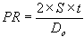

note:
Under most cases, S = 7500 pound/inch² for aluminum

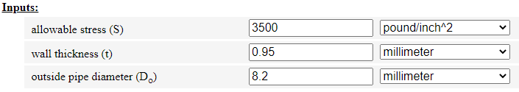
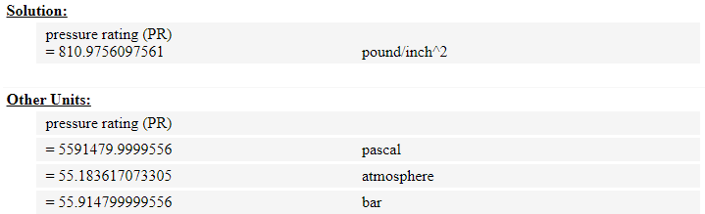

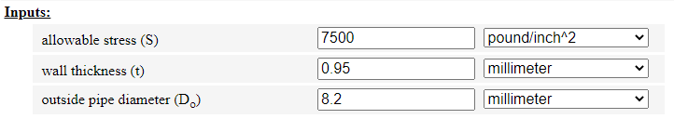
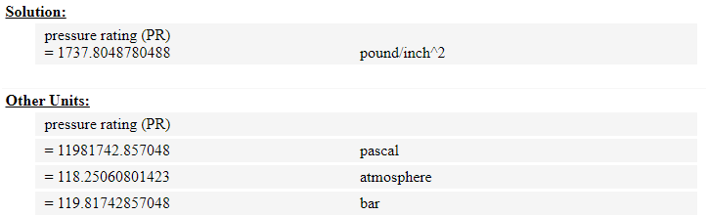

Our technical calculators can calculate weight, working pressures, copper tube thickness and wall diameter requirements.
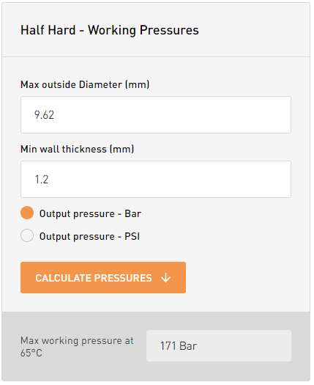

Prototype design
Initially, it was suggested to replace the main cycle (open oxygen cycle for liquefaction of oxygen) with a closed cryogenic cycle running on nitrogen gas for liquefaction of oxygen. This is due to the increased cost of the oil-free oxygen compressor, but it turned out later that nitrogen gas also needs an oil-free compressor, and for this reason we decided to return to the basic suggestion attached below.
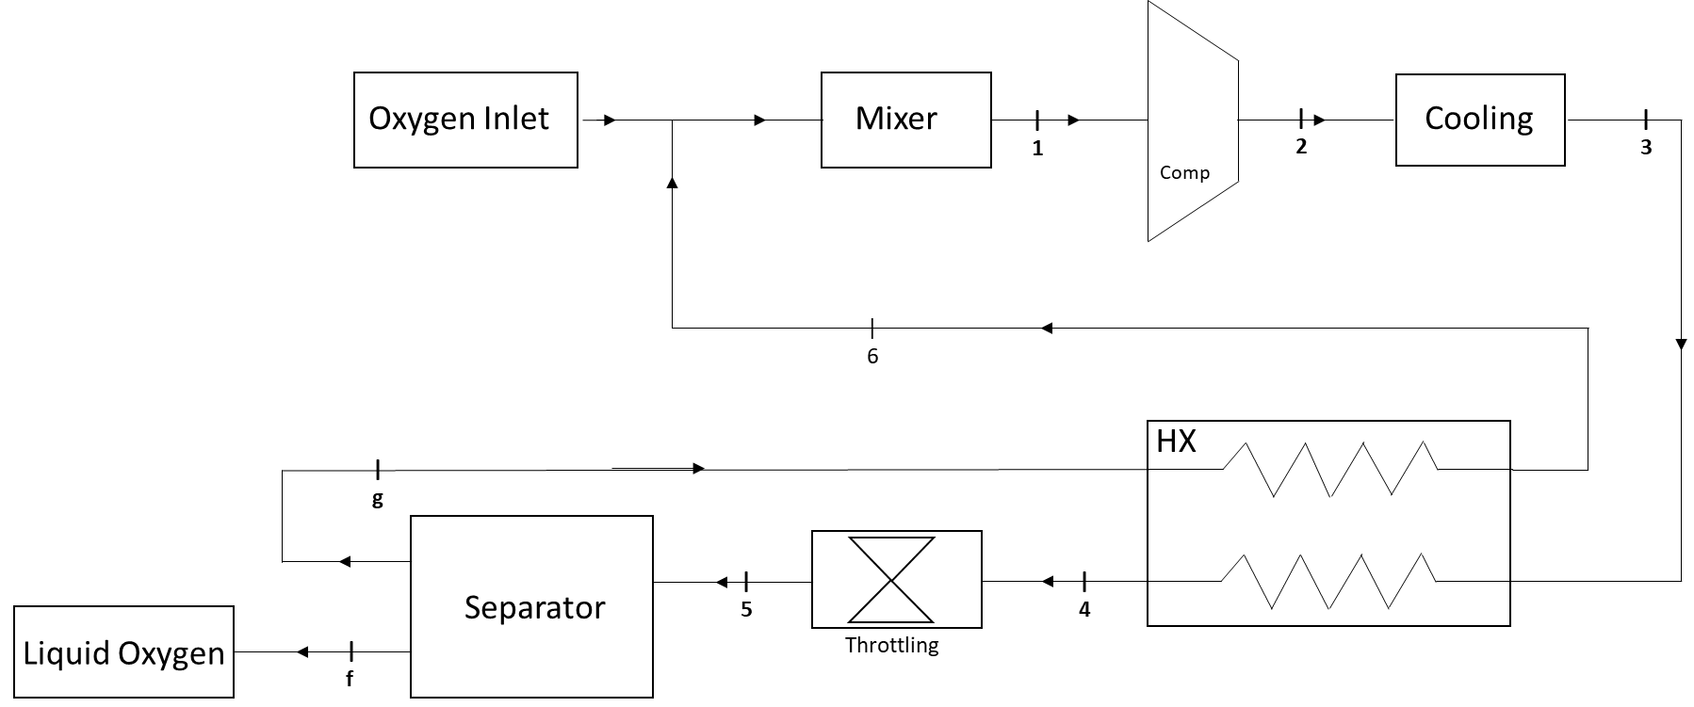

In our prototype, we decided to dispense with the heat exchanger in order to avoid expensive materials and manufacturing costs. However, through the theorical study, it was found that we will face a problem in reaching the required liquefaction temperature, in addition to the compressor failure due the low gas temperature at the compressor inlet.
Therefore, the following was decided:
- Selection of an oil-free oxygen compressor suitable for previously installed pipes.
- Recalculation of the oxygen liquefaction cycle.
- Heat exchanger
  - HX Design
  - Materials to manufacture
  - Total costs
- Determining the type of insulation suitable for the system
- Manufacture of the HX and its installation in the system
- Resizing of expansion valve
- Design and manufacture of separator and gas mixer
- Completing all required connections and placing the sensors (timer, pressure and temperature sensors) in their appropriate places.
- Connect the oxygen gas bottles needed for the experiment
- Putting the insulation materials in its proper place in the system
- Doing the first experiment.
Cooling component
In our system, the “Kelvinator” refrigerator has been adopted as a condenser for the compressor outlet. The second refrigeration cycle in the Kelvinator works with refrigerant R-503. This refrigeration cycle needs to be filled with refrigerant R-503. Due to its unavailability in the market, it was replaced with refrigerant R-508b, due to its compatibility with compressor oil.

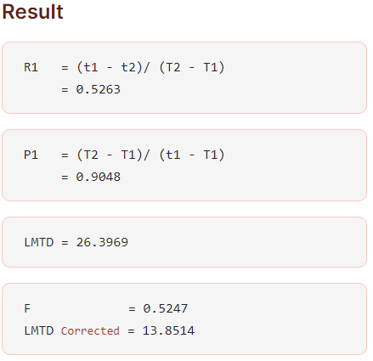
HX design
Case 1 : 2 shell 4 tube Tema E

Stream 1
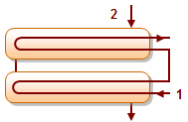
Inlet temperature (T1) : 195
Outlet temperature (T2) : 100
Stream 2
Inlet temperature (t1) : 90
Outlet temperature (t2) : 140

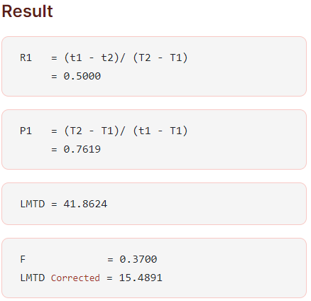
Case 2 : 1 shell 2 tube Tema E

Stream 1
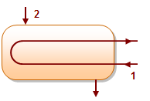
Inlet temperature (T1) : 195
Outlet temperature (T2) : 115
Stream 2
Inlet temperature (t1) : 90
Outlet temperature (t2) : 130

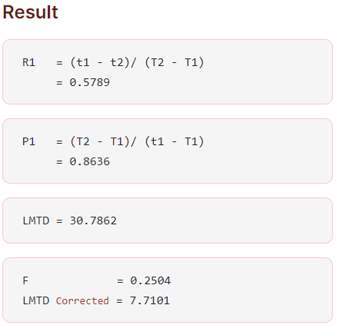
Case 3 : 1 shell 3 tube Tema E

Stream 1
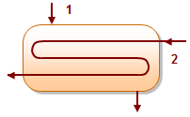
Inlet temperature (T1) : 205
Outlet temperature (T2) : 110
Stream 2
Inlet temperature (t1) : 95
Outlet temperature (t2) : 150

Case 4 : 1 shell 3 tube Tema E

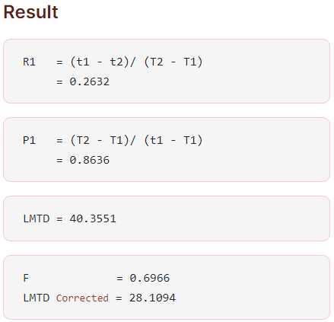
Stream 1
Inlet temperature (T1) : 205
Outlet temperature (T2) : 110
Stream 2
Inlet temperature (t1) : 95
Outlet temperature (t2) : 120

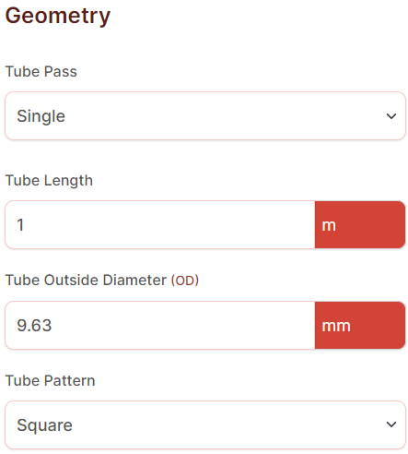
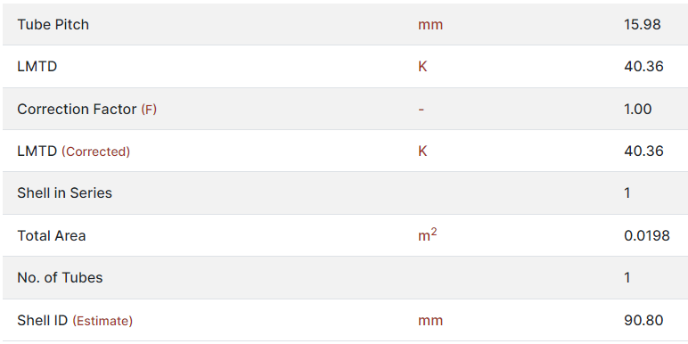
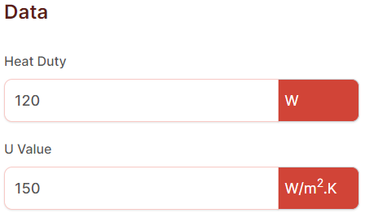

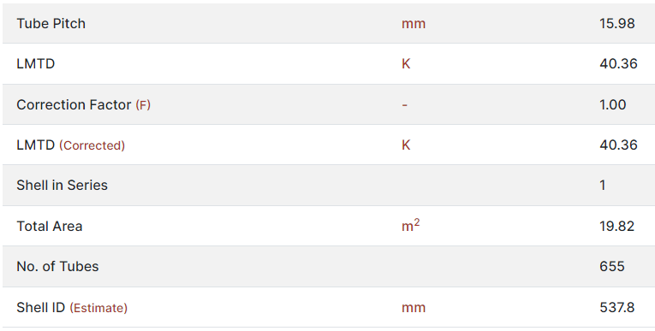
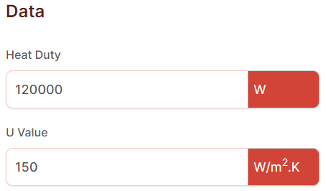

What is Cryogenic Piping?

Properties of Common Cryogenic Materials
Materials that have established themselves as suitable cryogenic piping materials are provided in Table-2 below:
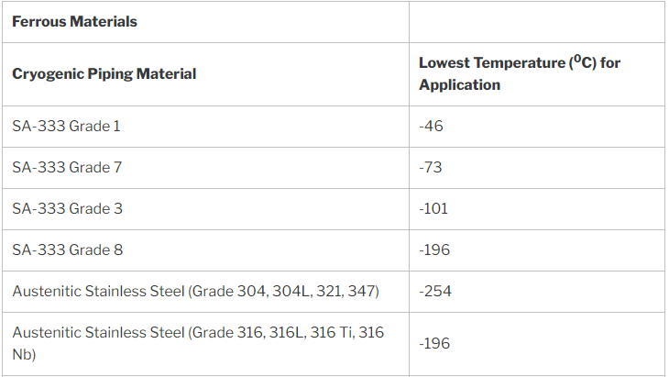
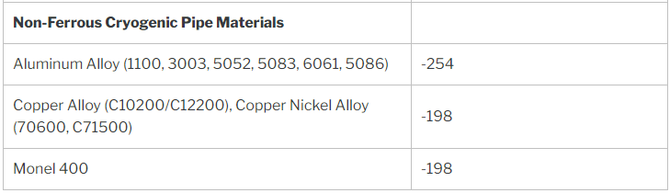
Several non-metallic materials like Grafoil, Mineral wool, Fiberglass, Polyurethane, Styrofoam, Perlite, Viton, Glass reinforced Teflon, etc serves as various components in cryogenic piping applications.

Cryogenic Piping Standards and Cryogenic Piping Design Guide
ASME B31.3 is the main governing standard for designing cryogenic piping systems. The usual cryogenic piping design considerations are:
- Pipe Sizing is done using normal pressure drop criteria. A drop in pressure can create flashing of part of the liquid which may result in two-phase flow. So, if a similar situation arises, the two-phase flow must be considered for sizing. However, for oxygen gas piping, the fluid velocity is also considered during pipe sizing.
- As the ambient temperature is hotter than the cryogenic liquid temperatures, there will be continuous heat leaks to the cryogenic pipeline and piping system which must be considered during the design.
- Extended stem valves are used to keep the operator at ambient temperature.

Cryogenic Piping Insulation
All frequent use cryogenic piping and pipeline systems are insulated using anyone of the following cryogenic insulation types:
- Expanded foams (Example, Foamglass, polyurethane)
- Powder Insulation (Example, Perlite)
- Vacuum Insulation
- Evacuated powder & fibrous insulation
- Opacified powder insulation
The main aim of the cryogenic piping insulation system is to create a vapor barrier to keep atmospheric moisture from leaking into the insulation space. This moisture permeates insulation and then condenses. Which significantly increases the corrosion changes in the lines. Also, build-up of water or ice may occur which in turn, results in lowered performance. Whenever the insulation has been compromised, the thermal efficiency is lost and energy consumption increases. So, high energy consumption can be reduced by using adequate insulation materials. the vapor barrier system must keep atmospheric moisture from entering the insulation space and freezing against the cryogenic lines.
Whenever a cold system is required, the entire system shall be fully insulated including the piping components, piping/tubing of instead instruments, drains, equipment nozzle, and supports. Cryogenic insulation is applied in multiple layers.

Cryogenic Piping Supports
As a matter of their extremely low temperature, extremely superior insulation property, durability, and stable function are required for cryogenic pipe supporting devices. While designing the cryogenic supports we have to consider structural characteristics, design load, other requirements, and economical aspects for each shoe, guide, stop, and trunnion. We must clarify the behavior of cryogenic piping including pipe support, during normal operation they should also take warm-up and cool-down conditions into account. There are problems encountered in the system such as higher displacement due to the thermal expansion and contraction, pipes insulation, embrittlement of materials, icing around or between the supports, rapid changes of phase due to large heat fluxes.
Cryogenic Pipe Supports shall meet the following requirements.
- Lighter weight
- High reliability in water & resistance to oil and corrosion
- High weather tightness
- They must have physical strength against compression, bending, and shearing
- Suitable for mass production
- Low water absorption
- Heat and flame resistance
- Must incorporate a molded heavy density layer bonded with stainless steel.
Cold insulation supports are usually made from:
- High-Density polyurethane foam
- Phenolic foam insulation
- Polyisocyanurate or PIR
Supports shall meet the design requirements in respect of compressive strength under sustained load, thermal conductivity coefficient of friction service temperature, and flammability. Even considering the unexpected thermal bowing and fluctuations of flow rate pipe, the support span for cryogenic piping shall be much shorter than that of hot insulated piping, support shall be immediately adjacent to any change in direction of piping.
Cryogenic supports will be equipped with advanced temperature-resistant technology that protects pipes in extreme cold. Cold climates are critical for pipe supports they aren’t built to withstand the elements. Worse yet, pipes are fragile in frigid environments, and ice formation can wear down both pipes and supports, also must be designed to support pipes in temperatures as low as -320°F. They will encapsulate the fragile insulation used in these piping systems.
To stop the thermal transfer from the interior of pipes to surrounding structures they must be nonconductive. Foam insulated cores are given to some shoes to naturally keep pipes from sudden temperature changes of heat transfer. By keeping heat inside pipes, can save energy and stop the ice formation that can destroy pipes. A cold shoe is a support used for cryogenic applications where the heat transferred to the surface is not relevant and can be used for temperatures right down to -300˚ Fahrenheit.

** 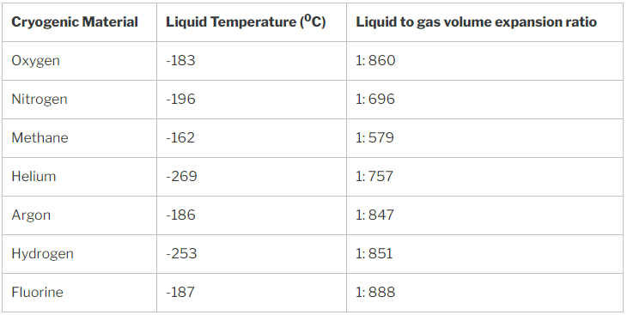

https://www.ajdesigner.com/phpaluminumpipe/pressure_rating_equation.php#ajscroll
https://lawtontubes.co.uk/technical-calculators/pressure-calculators/
https://checalc.com/solved/LMTD_Chart.html
https://whatispiping.com/cryogenic-piping/

