**Solar Charge Controller**

# Introduction: This board is made to charge the battery from solar panels, and give the output load.

# Objective: to safely charge and discharge the battery from the solar panels, and give the load a direct output from solar panel.

# Equipment and Roles:

**SOLAR CHARGER:**

**Figure 1: Schematic satellite charge battery**

**Diode D1:** Polarity protection diodes**.**

**Current Sensor U1, U2:** Fully Integrated, Hall Effect-Based Linear Current Sensor IC with 2.1 KVrms Isolation and a Low-Resistance Current Conductor.

**Capacitors C1, C2:** Use the capacitive reactance value of a capacitor to determine the actual voltage drop from voltage divider.

**Capacitors Cbyp1, Cbyp2:** Added to an amplifier circuit in order to allow AC signals to bypass the emitter resistor.

**Capacitors Cf1, Cf2:** Component that temporarily stores electrical energy and then release it.

**Resistance R1, R2, R5, R6:** Create reference voltages, or to reduce the magnitude of a voltage so it can be measured.

**Resistance R3, R7:** To reduce the voltage of the collector of transistor.

**Resistance R4, R8:** To stops the transistor drawing too much current from the IO pin.

**Diode D2, D3:** Polarity protection diodesagainst voltage surges.

**Heat sink U6, U7:** To cool down the circuit elements.

**Transistors T1, T­2:** Switch (low voltage) to allow current to pass to the MOSFET through the order of the controller.

**Transistors Q1, Q2:** Switch (high voltage) to allow current to pass to the MOSFET through the order of the T1, T2.

**Fuse FH1:** Protects a system or equipment from overload and short-circuit faults by cutting off the power to them.

**Buck converter (5v/4A & 12v/3A):**

**Resistance R13, R16:** To reduce current flow.

**Resistance R14, R15, R17, R18:** Create reference voltages, or to reduce the magnitude of a voltage so it can be measured.

**LED L5v, L12v:** Light emitting diodes to know we have 5V and 12V.

**Capacitors C3, C8:** To filter high frequency noise of (+5V/+12V).

**Capacitors C4, C9:** To filter low frequency noise of (+5V/+12V).

**Capacitors C5, C12:** to filter Vc from Vin.

**Capacitors C6, C10:** To filter low frequency noise of (+5V/+12V).

**Capacitors C7, C11:** To filter high frequency noise of (+5V/+12V).

**Diode D4, D5:** To dispose of the energy stored in the inductor when buck converter stops working.

**Voltage regulators U3, U4:** to reduce the voltage.

**Inductor L1, L2:** to limit power loss to heat and while minimizing current ripple.

**Controller:**

**Controller STM32F:** Control the input/output. To read output of the current Sensors, and Control the charging and discharging of the battery.

**Resistance R9, R10, R11, R12:** Create reference voltages, or to reduce the magnitude of a voltage so it can be measured.

**Power Distribution:**

**Port U3:** Input**/**Output port of the charge control unit.

**Port USB1:** 5V/3A output port.

**Header Auto Manual:**

**Table 1: equipment’s specifications.**

**Port J1:** Jumper Auto/Manual between controller order or +5V direct.

* The equations used for the solar charger:

* $A_{0}=\frac{R_{2}}{R_{2}+R_{1}}×V_{solar}$.(eq.1)

This equation to decrease V solar from 24V to 3.3V for input of controller.

* $A_{1}=\frac{R_{4}}{R_{4}+R_{3}}×V_{battery}$. (eq.2)

This equation to decrease V battery from 12V to 3.3V for input of controller.

* The equations used for the controller:
* $I_{sol}=\frac{R_{9}}{R_{9}+R_{10}}×A_{3}$. (eq.3)

This equation to decrease A3 from 5V to 2.5V for input of controller

* $I_{load}=\frac{R_{12}}{R_{12}+R_{11}}×A_{2}$. (eq.4)

This equation to decrease A2 from 5V to 2.5V for input of controller

* The equation used for the buck converter 5V/4A:
* $V_{out}=1.25×(1+\frac{R_{14}}{R_{15}})$. (eq.5)

This equation given from the datasheet of buck convertor.

* The equation used for the buck converter 12V/3A:
* $V_{out}=1.25×(1+\frac{R_{17}}{R_{18}})$. (eq.6)

This equation given from the datasheet of buck convertor.

# PCB Layout:

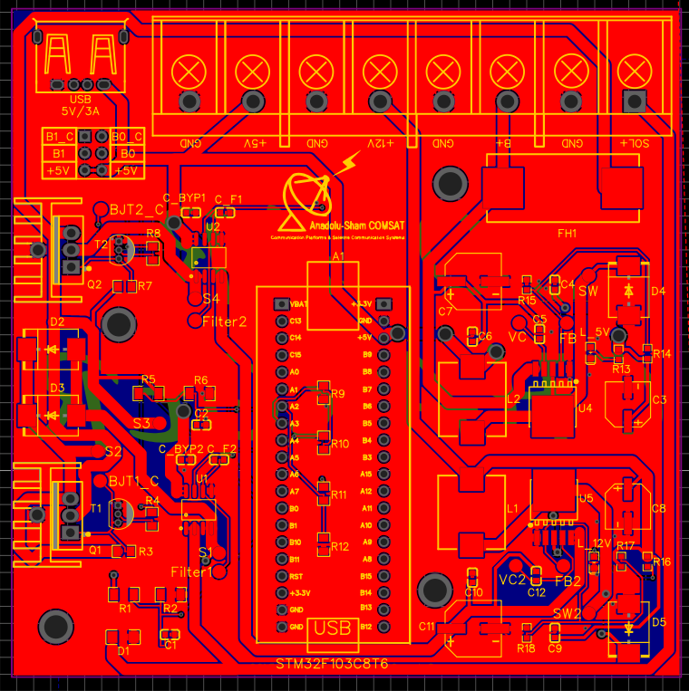

**Figure 2: PCB satellite charge battery**

**Figure 3:PCB satellite charge battery-Top Layer**

**Figure 4: PCB satellite charge battery-Top Layer**

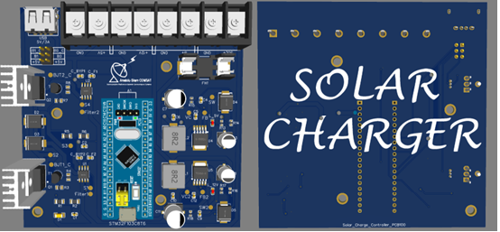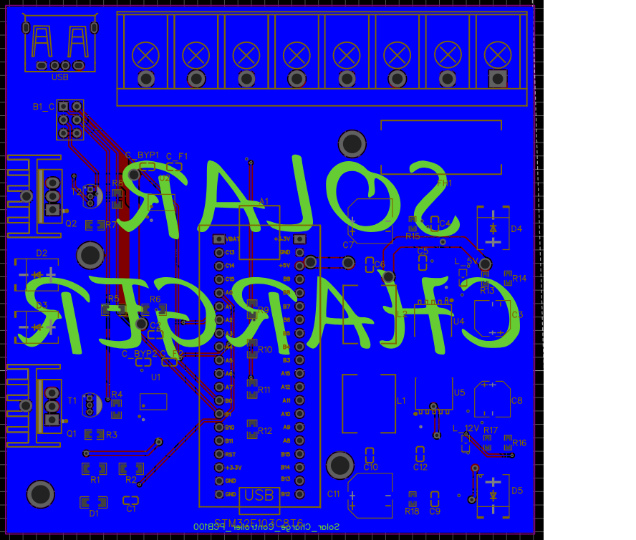**Figure 4: PCB satellite charge battery-Bottom Layer**

**Figure 5:PCB satellite charge battery-Top/Bottom Layer(3D)**

* The power wires have width of 1.7mm and all the other wires have width of 0.3mm, based on the equation: $I=K×∆T^{0.44}×{(W×H)}^{0.725}$. (eq.7)
* I: Maximum current in A.
* K: 0.024 for internal traces or 0.048 for external traces.
* $∆T$: Temperature rise above ambient in $℃$.
* W: Width in mils.
* H: Height in mils.
* The Pads To facilitate the installation of the board.
* The copper layer acts as a GND for the board elements, to easily connect GND.

# Principles of operation:

* In solar energy systems, we have 3 types of Power supplying: On-grid, Off-grid and hybrid.
* On-grid: Transfer power from solar panels to load only.
* Off-grid: Transfer power from solar panels to battery only, and from battery to load.
* Hybrid: Transfer power from solar panels to battery and load, and from battery to load in the absence of solar power.
* We have 2 types of charge controller systems: MPPT or PWM.
* MPPT: Maximum power point tracking controller.
* PWM: Pulse width modulation controller.
* The hybrid solar energy system was chosen, because during the peak of solar energy supplying the load takes the extracted power from the solar panels directly, and stops the work of the batteries while charging it. Thus preserving the life span of the batteries.
* The PWM controller was chosen as well, because the PWM controller is the cheaper, the simpler and the smaller choice for the charge control unit. (Efficiency is not the biggest priority of CubeSAT).
* A current sensor U1/U2 is used to read the current and give it to the controller, so it can be used to decide the duty-cycle for the transistor T1/T2. If T1/T2‘s base has sufficient voltage from controller, it gives a signal to open the gate of transistor Q1/Q2. This allows the current to flow from the solar panel to the battery/load.
* A voltage sensor A0 /A1 is a voltage divider circuit, that can detect the voltage by stepping down it across two resisters in series, and feeding it to the controller in which it will use (eq.1)/(eq.2) to calculate the voltage.
* The buck converter 5V-4A/12V-3A steps down the voltage from 24V/1A to 5V-4A/12V-3A. U4/U5 is responsible for this process while the capacitors are for filtering the noises of the input. Second part the inductor to stabilize the current and capacitors to stabilize the voltage from circuit by the diode that will prevent an open circuit when the load in removed. Third part, the voltage divider to provide a feed back to the buck convertor if the voltage is 5V/12V. Finally, the LED L5v /L12V to indicate the presence of 5V/12V.
* Port U3 has Sol+ input port from solar panels, B+ input/output port for battery, +5V and +12V output ports to give two size output voltage for CubeSAT.
* Port USB1 is a 5V power supply to charge smart devices.
* Port J1 is to test the effectiveness of the solar charger and the buck converter 5V manually without the use of the Controller.

# Software:

* Programed the STM32F by C language program to read the inputs and give the order to outputs.
* **Flowchart:**

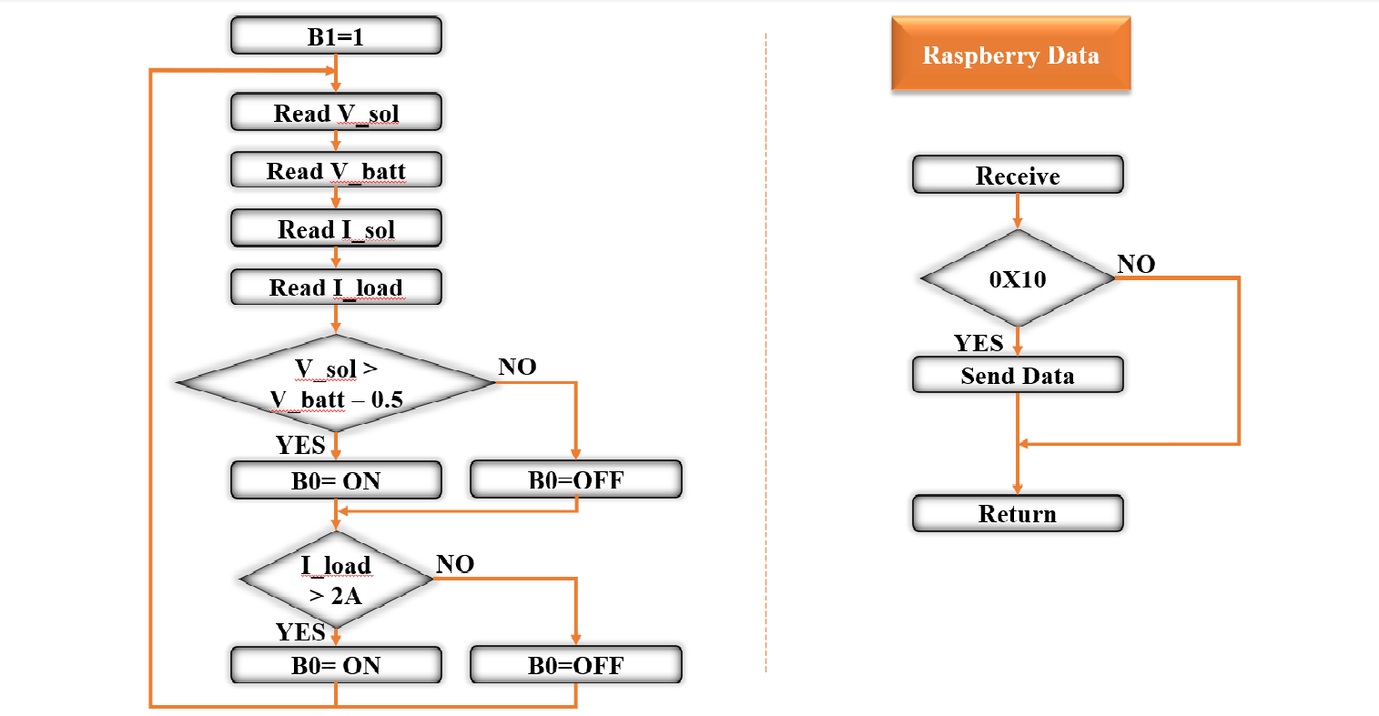

**Figure 6: Flowchart**

**B0:** gate of STM32F connected to MOSFET charger.

**B1:** gate of STM32F connected to MOSFET load.

**V-sol:** Voltage sensor connect to STM32F by A0 gate.

**V-bat:** Voltage sensor connect to STM32F by A1 gate.

**I-sol:** Current sensor connect to STM32F by A3 gate.

**I-load:** Current sensor connect to STM32F by A2 gate.

**0X10:** gate of Raspberry.