MASTER THESIS
In order to obtain the

PROFESSIONAL MASTER
Energetics

Insured by:
Faculty of Sciences of the Lebanese University

Presented and defended by:
Omar Ali Zreika

On October, 2024
Title

Mass Spectrometer for Detection of Toxic Metals in Municipal Waste Incineration Flue Gas

Supervisor
Dr. Samir Mourad

Reviewers
Dr. Ahmad El Mol
Dr. Wassim Shmaysem
Table of Contents
ACKNOWLEDGEMENTS 4
ABSTRACT 5
CHAPTER 0: INTRODUCTION 6
CHAPTER I: BASICS 7
1. Mass Spectrometer Principle 7
1.1. Ionization Source 7
1.2. Acceleration Zone 8
1.3. Deflection Zone 9
1.4. Detection of Ions 10
2. Electromagnetism 11
2.1. Magnetic Permeability 11
2.2. Calculations and Discussion 13
2.3. Single Solenoid Coil 15
2.4. Simple Simulation 16
2.5. Biot-Savart Law 19
3. Purification of Iron 19
3.1. Needed Materials 20
3.2. The Electrolytic Refining Process 21
3.3. Drawbacks 22
4. Annealing 22
4.1. History of Annealing 22
4.2. Annealing Process 23
4.3. Annealing & Permeability 24
CHAPTER II: ELECTROMAGNETIC CONCEPTIONS 25
1. Multi-solenoid Unit 25
1.1. Prototype Design 25
1.2. Simulation Part 26
2. C-shaped Unit 28
2.1. Fundamental Principles of Electromagnetism 28
2.2. Design Assembling 33
2.3. The Simulation Conditions of the Iron Core 34
2.4. Calculation of the Mass of Copper 38
2.5. CAD Design 39
CHAPTER III: REALIZATION, TESTS & DISCUSSION 40
1. Realization 40
1.1. Annealing Process 40
1.2. Iron Cleaning 44
1.3. Core Construction 45
46
1.4. Winding the Coil 46
2. Tests and Results 49
2.1. Single Solenoid Testing 49
2.2. Electromagnet C-shaped Testing 51
55
2.3. Calibrating Mass Spectrometer with Known Material Probes 56
CHAPTER IV: CONCLUSION & PERSPECTIVES 59
List of References 60
List of Figures 62
List of Tables 64

ACKNOWLEDGEMENTS

This thesis would not have been possible without the support and the guidance of people who, in various ways, contributed their invaluable assistance to the preparation and completion of this project. I am deeply grateful to all those who made this endeavor possible.
I am deeply grateful to my supervisor, Mr. Samir Mourad, and his organization, AECENAR, for their cooperation and support, as well as for providing me with the essential tools throughout this journey.
I would like to express my heartfelt gratitude to my friend and companion on this journey.
Mr. Majd El Moussa has played a pivotal role in providing me with innovative ideas.
Throughout our collaboration, he has demonstrated remarkable patience.
also like to thank Mr. Ali Dib; without his assistance, this project would have been impossible.
Finally, I would like to express my heartfelt gratitude to Mr. Abdallah Kassem (Abou Omar) for his unwavering support during challenging times.
The success of all the tests in the project would not have been possible without his assistance. I would like to express my heartfelt gratitude and appreciation to each and every one of you.
Thank you from the bottom of my heart.

ABSTRACT
The mass spectrometer is a critical tool in research, with numerous applications, particularly in detecting toxic gases emitted during waste combustion. This analytical process consists of several stages, beginning with the ionization of the gases, followed by their acceleration and subsequent deflection, ultimately leading to their detection to ascertain both the type and mass of the gases present. The design and optimization of the electromagnet within the deflection zone are essential for facilitating this deflection. The findings of this research have been subjected to comprehensive analysis and discussion concerning the principles of electromagnetism.

CHAPTER 0: INTRODUCTION
In Lebanon, we are currently facing a crisis in energy generation.
Therefore, one of AECENAR's most significant projects was the construction of a power generation facility, specifically an incinerator, designed to generate energy through the combustion of waste.
Burning waste produces emissions of toxic and carcinogenic gases, making it essential to purify these gases to prevent the release of harmful substances into the atmosphere.
AECENAR has installed an electrostatic filter to purify the gases emitted during incineration; however, the Municipality requires evidence that no toxic emissions are present. This is where the mass spectrometer detector plays a crucial role.
This system can detect and identify the types and quantities of gases produced based on their mass.
This project was initiated two years ago by students Asmaa El Mir and Rouwayda El Sakka. However, it remains incomplete, particularly the magnetic sector, which is essential for gas detection.

The structure of this thesis is outlined below:

In the first chapter, we introduced the fundamental principles of mass spectrometry and its critical role in gas detection. Furthermore, we discussed magnetic permeability and presented various methods to enhance it. Additionally, we explained the simulation of the magnetic field and the effects of ferromagnetic cores on it.

In the second chapter, we explored electromagnetic concepts and conducted a simulation, along with a straightforward comparison between two systems: the multi-solenoid and the C-shaped coil. Based on the simulation results, we drew our conclusions.

In the third chapter, we began the realization of the electromagnetic system through a series of processes. Ultimately, we constructed the system and conducted tests on it.

Finally, we reached our conclusion in the last chapter.

CHAPTER I: BASICS

Mass Spectrometer Principle
Mass spectrometers analyze the distinct fragments or ions produced by organic molecules by bombarding the compound with electrons to create positively charged ions.
The resulting mass spectrum displays each ion as a peak. [1]
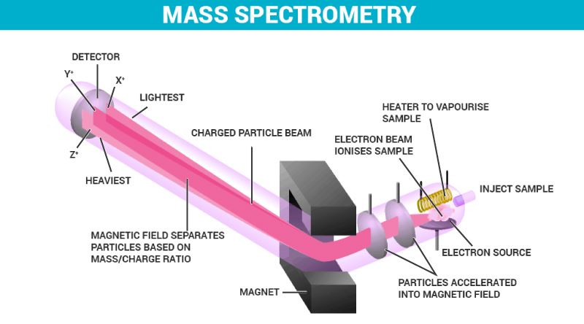
MS consists of four main parts: the ionization source where the molecules get ionized, the acceleration zone where ions gain higher velocity, the deflection determined by the mass-to-charge ratio (m/z), and finally, the detection part which is proportional to the abundance of ions (see Figure 1). 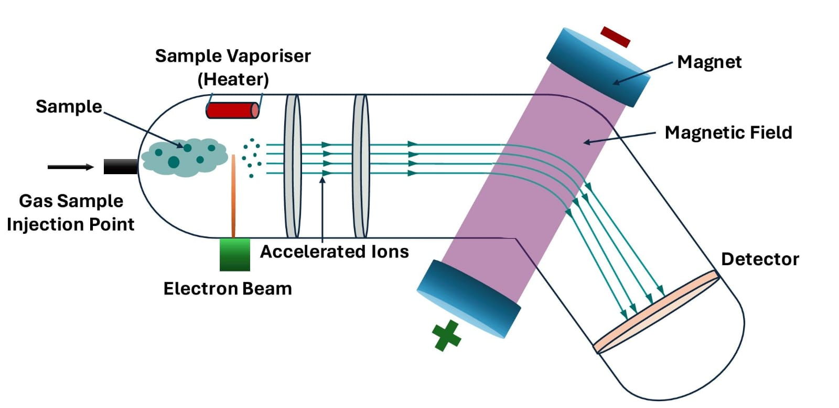
Figure 1: Schematic representation of the principle of mass spectrometry

Ionization Source
The ionization source is a device that can be used in several methods and techniques to ionize molecules. The method chosen depends on the type of the sample, such as gas, liquid, or solid. Since our project focuses on toxic gases, electron impact ionization [2] is the suitable method in our case (see Figure 2).The sample should be in a gaseous phase to enter the ion source. In this situation, we use a heated filament made of tungsten to collide with the gaseous sample molecules and generate positive ions. Since it is much more difficult to remove more than one electron, most of the ions will have a charge of +1.
It is important to note that the ion source must be evacuated to prevent contact with air molecules. [3]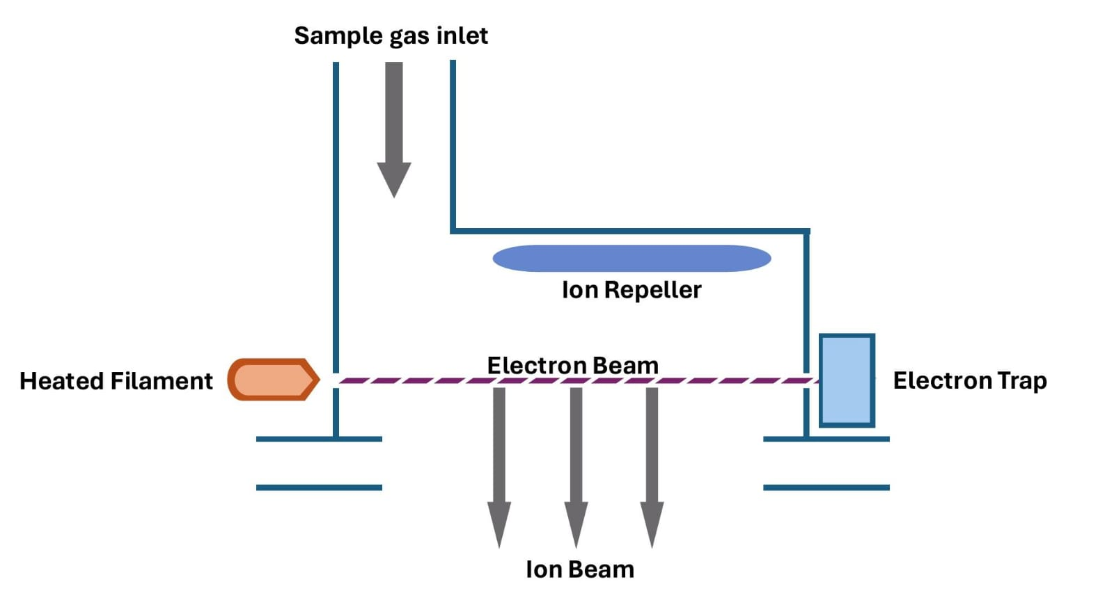
Figure 2: Schematic representation of the ionization chamber

Acceleration Zone
The positive ions are pushed out by the ion repeller, which is a positively charged plate (see Figure 2). Subsequently, they pass through the acceleration zone, where they are subjected to an intense electric field specifically designed to accelerate them and increase their kinetic energy.
The acceleration zone is created by three plates that are gradually charged negatively, with the first disc being strongly negative (300 V), generating a powerful electric field that propels the positive ions towards the last disc.
As the ions progress towards the subsequent discs, they continue to be accelerated by the electric field until they reach the final disc, which is neutral and acts as a ground (see Figure 3).
The precise control of the electric field between the discs ensures optimal focusing of the positive ions, preventing any undesired dispersion or deflection. An intermediate disc, also negatively charged (150 V) but at a reduced intensity compared to the first disc, ensures a gradual acceleration of the positive ions. This stabilization in their trajectory allows them to pass to the third disc, which acts as a final barrier, enabling the positive ions to reach the region of the mass spectrometer dedicated to their analysis.
We should note that all positive ions will have the same kinetic energy after acceleration. [4]
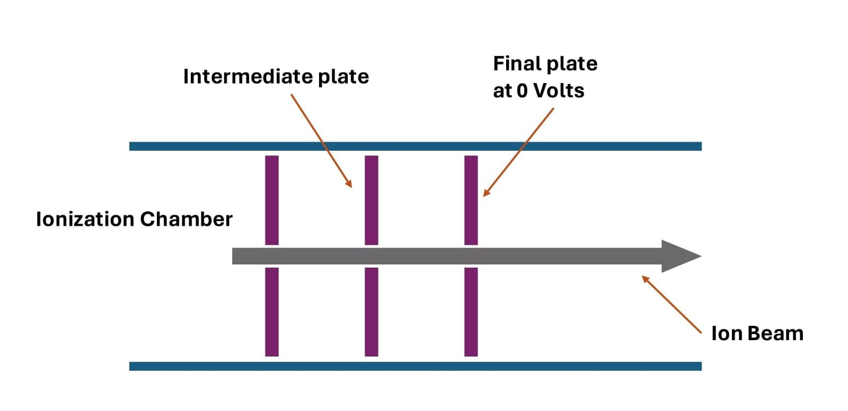
Figure 3: Schematic representation of the acceleration plates

Deflection Zone
The deflection zone in a mass spectrometer is a crucial step for separating ions based on the mass-to-charge ratio (m/z), allowing us to identify each chemical species in our sample.
The ions emerging from the ionization source enter a region with a uniform magnetic field, causing them to experience a magnetic force that deviates them from their initial trajectory.
Ions with higher m/z ratios will experience less deflection compared to ions with lower m/z ratios. This difference enables us to separate ions based on their masses. Since most ions carry the same charge of +1, the extent of deflection will be determined by the mass of the ions. [5]
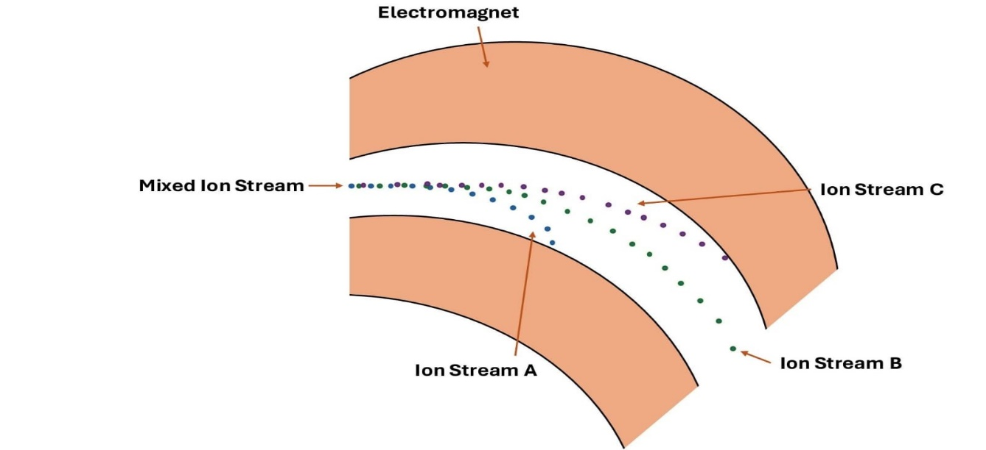
The path of the ions is typically curved with a radius R. This trajectory is governed by either Biot-Savart's law or the Lorentz force. [6]
Figure 4: Deflection of a mixed ion stream under magnetic field
In other words, the heavier the ions, the less they deflect. Furthermore, they will require a stronger magnetic field to deflect them. For example, we recognize that ion stream C is heavier than B, which is heavier than A. (see Figure 4).

Detection of Ions
In the realm of mass spectrometry, the detection stage holds significant importance as it pertains to the identification of ions that have traversed the mass analyzer's pathway.
The detector plays an essential role in converting ions into a detectable and usable signal.
Once sorted by the mass analyzer, the ions enter the detection zone where the detector is located. This component is designed to capture the physical characteristics of the ions, including their kinetic energy, electric charge, and mass. Mass spectrometers utilize a variety of detector types, each with unique advantages tailored to the specific requirements of the analytical application. Furthermore, the selection of the detector is influenced by the design of the instrument itself. [7]
When an ion reaches the collector, its charge is neutralized by an electron transferring from the metal to the ion. The flow of electrons generated in the wire is identified as an electric current, which can be amplified and recorded. The level of detected current increases with the increasing number of arriving ions.
We should announce that the Faraday cup detector design is complete and ready for testing. [4](see Figure 5).
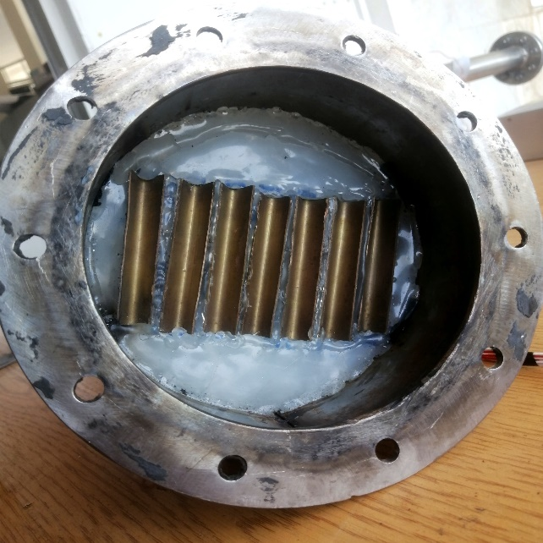
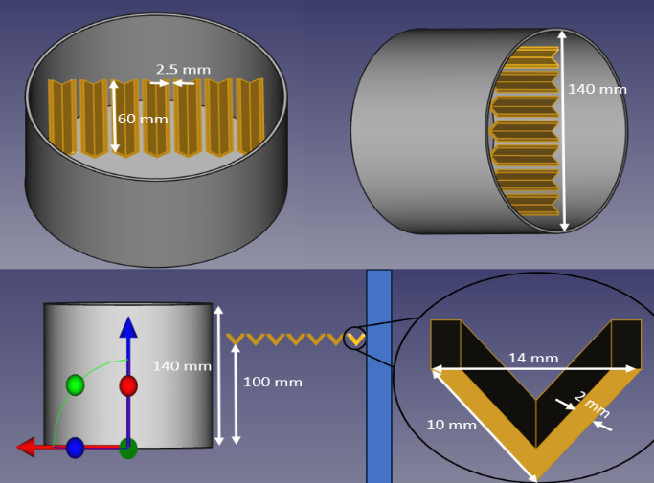

Figure 5: Module 5 of the Faraday cup

Electromagnetism
As mentioned earlier, we cannot deflect ions without a magnetic field, and it must be strong enough to deflect the heavy ions emitted from the toxic gases.
The previous tests indicate that the Helmholtz coil is not effective in generating a strong magnetic field (0.2 T). [4]
Based on the famous formula of the magnetic field:

B=μnI

In the equation, B represents the magnetic flux density in Tesla, μ stands for the permeability in Henry per meter, n denotes the number of turns per meter, and I represents the electrical current in Amperes.
We have the ability to manipulate these elements to achieve the magnetic flux density we desire. The challenge lies in the variability of permeability among different ferromagnetic cores. Conversely, achieving high permeability would reduce the need for high levels of other factors such as the number of turns (n) and current (I).

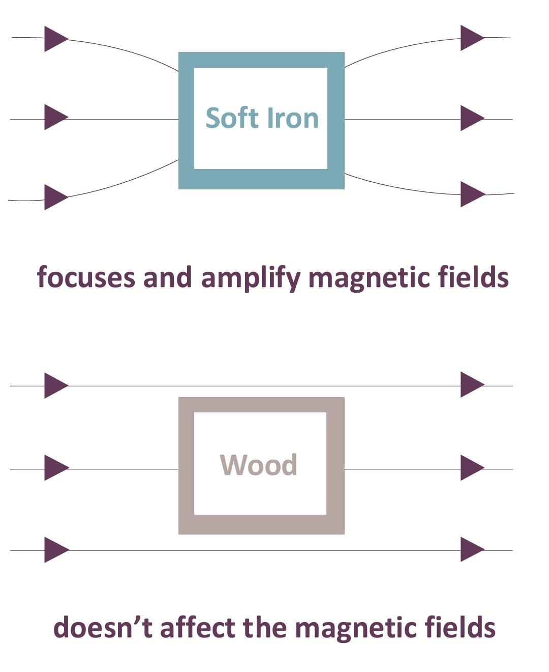
Magnetic Permeability
In electromagnetism, permeability refers to a material's ability to concentrate magnetic fields, indicating how easily a material can become magnetized (see Figure 6).
We denote μ_{r} as the relative permeability compared to free space (μ₀ = 4π x 10⁻⁷ Henry/meter).
Figure 6: The affection of permeability on the magnetic field
μ_{r} = μ/μ₀ (The relative permeability of free space is μ_{r} = 1)
Different types of permeability can be identified based on the characteristics of changes in B and H, where H represents the magnetic field strength in amperes per meter. The relationship between magnetic permeability and this change is described by a formula:
μ = ΔB/ΔH
The relative permeability (μ_{ferro}) of magnetic materials (ferromagnets) is significantly greater than that of non-magnetic materials such as vacuum (μ_{vac}), diamagnets (μ_{dia}), paramagnets (μ_{para}), and superconductors (μ_{sup}) (see Figure 7). [8]

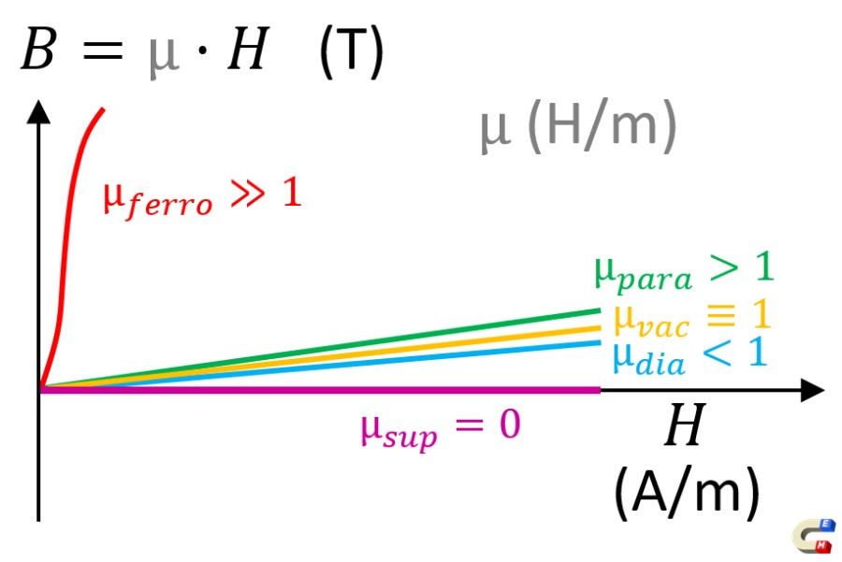
Figure 7: B-H curve illustrating the varying permeability of different materials

In simpler terms, ferromagnetic materials are ideal for constructing an electromagnet.
This works best when they are operating below the saturation point, where the relative permeability is at its peak (see Figure 8).

We can observe that the permeability of ferromagnetic materials decreases as they approach saturation, and this relationship is non-linear with the applied excitation.
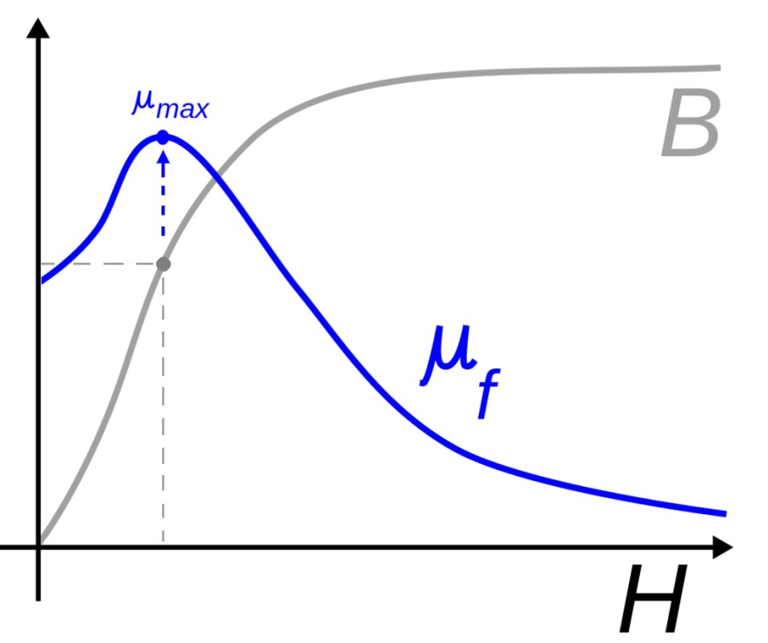
Figure 8: B-H curve showing the saturation point of magnetic permeability

Calculations and Discussion
The previous calculation shows that we need a magnetic flux density of 0.2 Tesla [4]based on the following formulas:
$$r=\sqrt{2mU}∕qB^{2}$$
$$v=\sqrt{2qU∕m}$$
Where$r$ is the radius of curvature and$v$ is the velocity. We have found that
for $B$= 0.2 Tesla and $U$ = 300 V, the velocity will be provided in the following table:
Type of gas | Mass $m$ (Kg) | Radius$r$ (m) | Velocity $v$ (m/s)
HCL | 5.76 x 10⁻²⁶ | 0.073 | 40.8 x 10³
HF | 3.2 x 10⁻²⁶ | 0.056 | 54.7 x 10³
SO₂ | 10.24 x 10⁻²⁶ | 0.098 | 30.6 x 10³
Hg | 32 x 10⁻²⁶ | 0.173 | 17.3 x 10³
Table 1: Mass, radius of curvature and velocity for different ions

Since our project focuses on toxic gases, a heavy ion such as lead (Pb), which has a mass of 34 x 10⁻²⁶ Kg, will have a radius of 17.8 cm, exceeding the range (see Figure 9).
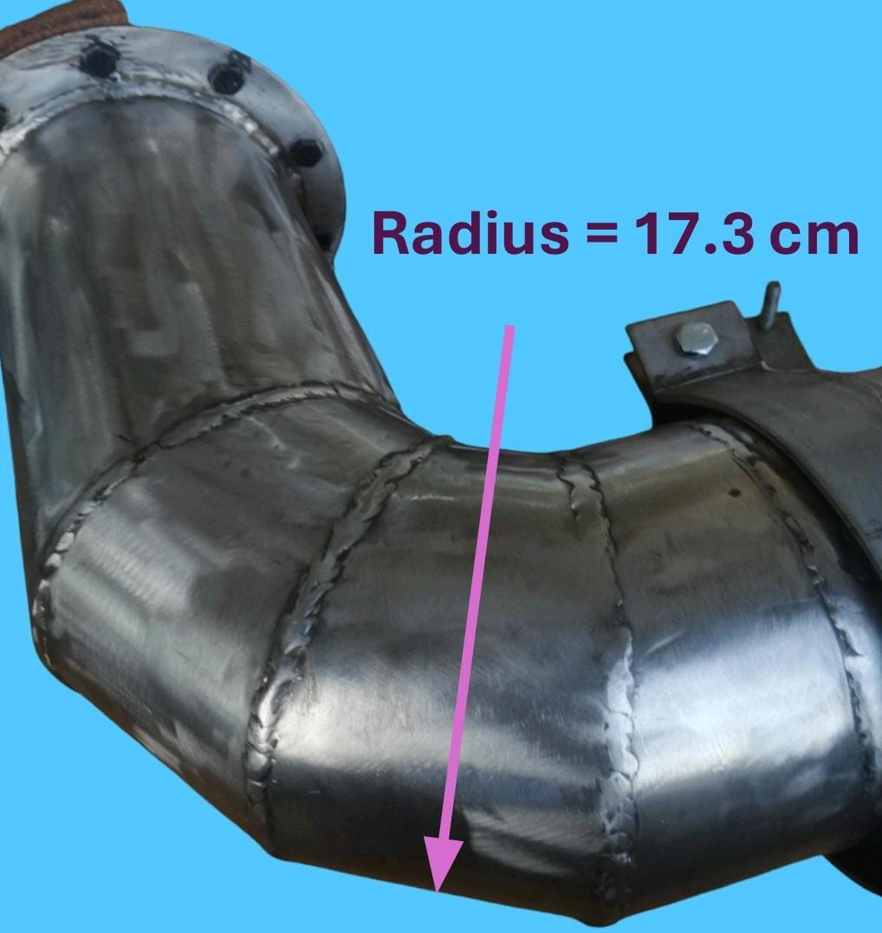
Figure 9: The maximum radius in the deflection zone for the mass spectrometer

Therefore, we must repeat the calculation to find the ideal solution for the system.
In general, reducing the potential difference and magnetic flux density will enhance the economic benefits of the project.
Furthermore, decreasing the magnetic flux density will make the manufacturing of the electromagnet easier and less expensive.
To reduce the magnetic flux density, we need to decrease the velocity of the ions, which implies reducing the voltage in the acceleration plates.
Taking, for example, $U$ = 20 V and $B$ = 0.06 Tesla, the table will be as follows:

Type of gas | Mass $m$ (Kg) | Radius $r$ (m) | Velocity $v$ (m/s)
HCL | 5.76 x 10⁻²⁶ | 0.063 | 10.5 x 10³
HF | 3.2 x 10⁻²⁶ | 0.047 | 14.1 x 10³
SO₂ | 10.24 x 10⁻²⁶ | 0.084 | 7.9 x 10³
Hg | 32 x 10⁻²⁶ | 0.149 | 4.4 x 10³
Pb | 34 x 10⁻²⁶ | 0.153 | 4.3 x 10³
Table 2: Mass, radius of curvature and velocity for different ions included Pb

Reducing the potential difference will decrease the velocity of the ions in the acceleration zone, but the velocity is still sufficient, as we can observe.

Single Solenoid Coil
A solenoid is essentially a coil of wire, typically made of copper. When an electrical current flows through the wire, it generates a magnetic field, similar to how a magnet works (see Figure 10).
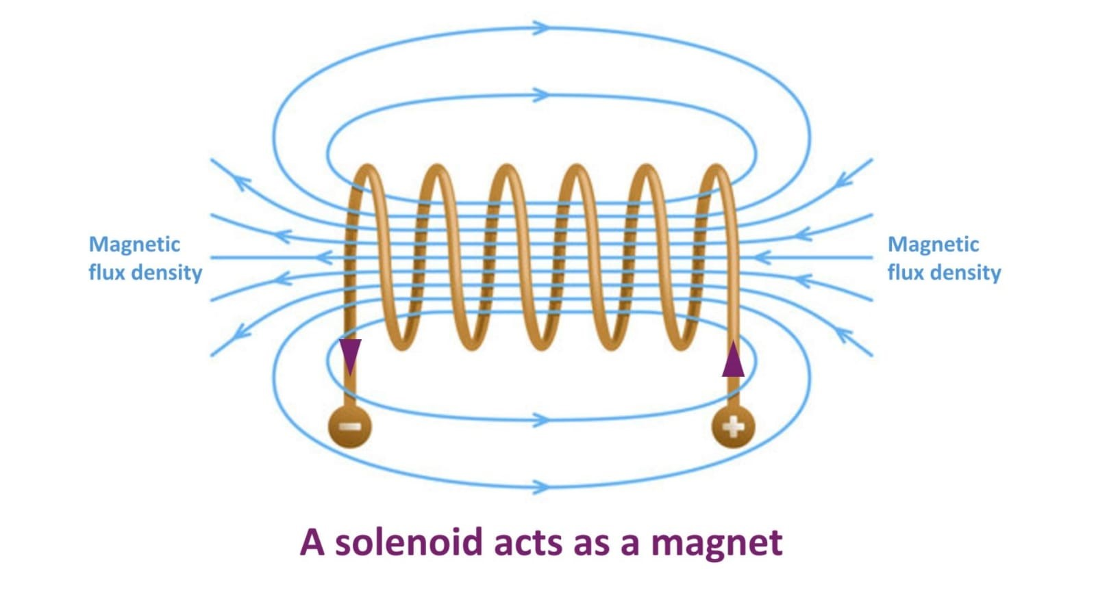
Figure 10: Magnetic Flux in a Solenoid
The solenoid often has a cylindrical shape, which helps to create strong and uniform magnetic field.
Despite this, there may be variations in design. Solenoids have the potential to feature
a D-shaped frame customized for specific applications. However, the prevailing perception of a solenoid usually corresponds to that of an elongated, cylindrical coil. [9]

Simple Simulation
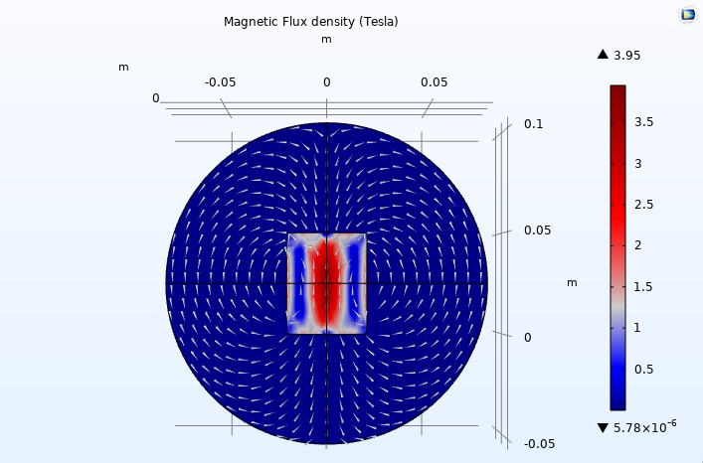
Figure 11: A Simulation of a Single Solenoid

We used COMSOL Multiphysics to simulate a simple design consisting of a single solenoid with a cylindrical shape (4 cm in diameter and 5 cm in height).
We used 200 turns, a relative permeability of 200, and 6 amperes, and that was the result for the 2D plane (see Figure 11).
The white arrows represent the flow of the magnetic field to determine its direction and uniformity.
We can observe that the maximum magnetic flux density is depicted in red in the center, gradually decreasing in intensity towards blue.
The simulation was conducted again with two solenoids positioned 15 8 cm apart to analyze the magnetic field between them (see Figure 12).
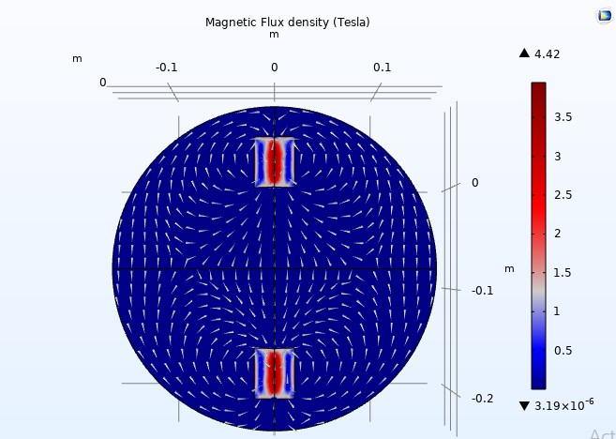
Figure 12: A Simulation of Two Solenoids

As we can see, the magnetic field is uniform only in the middle, which is insufficient for our application. By employing additional solenoids, we can attain an even more uniform magnetic field.
The simulation indicates that the magnetic field density is insufficient to achieve a 60 mT (0.06 Tesla) strength between the two solenoids.
When we increase the relative permeability to 3000, we observe that the maximum magnetic flux density also increases (4.42 Tesla to 65.9 Tesla) (see Figure 13).

But how can we determine the effect of permeability outside the coils where the relative permeability is one? This will be known after the following simulation.

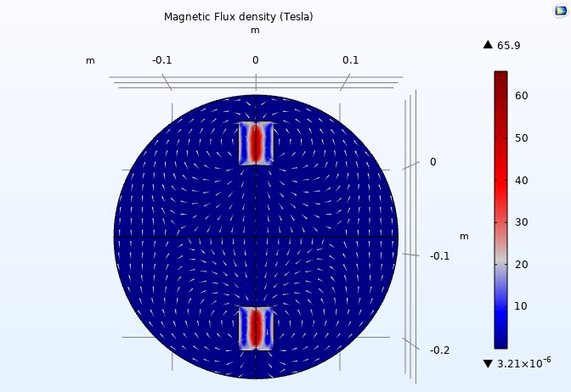
Figure 13: A 2D Simulation of Two Solenoids with 3000 relative permeability
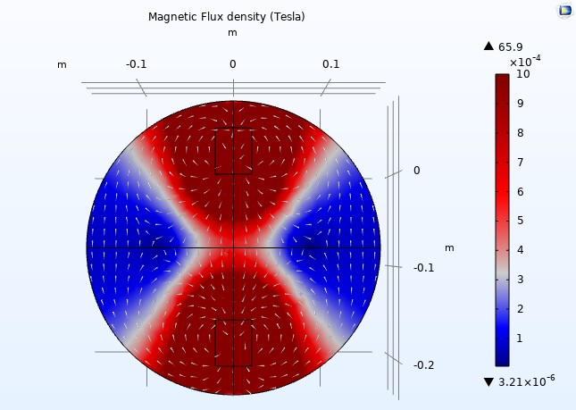
Figure 14: Relative permeability is 3000
Figure 15: Relative permeability is 200
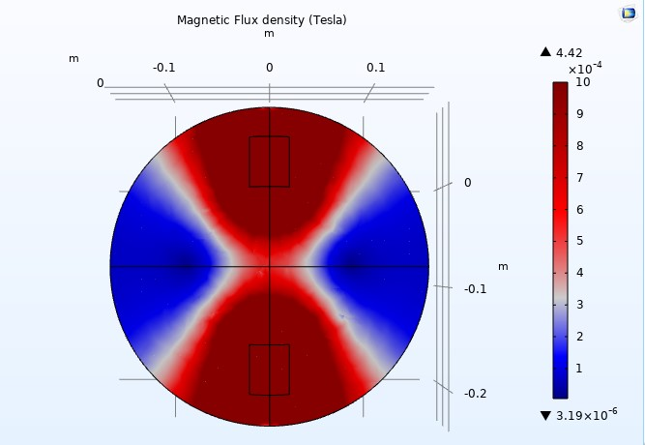
We adjusted the scale to a maximum magnetic flux density of one milliTesla (1 mT) to illustrate the color distribution outside the coils (see Figure 14). When we reduced the relative permeability to 200, the arrow volumes representing the magnetic fields nearly disappeared, indicating a loss of uniformity; however, there was no change in the magnetic flux outside the solenoids, where the color remained consistent (see Figure 15). Nevertheless, we were able to observe the arrow volumes again by readjusting the arrow scale.

Biot-Savart Law
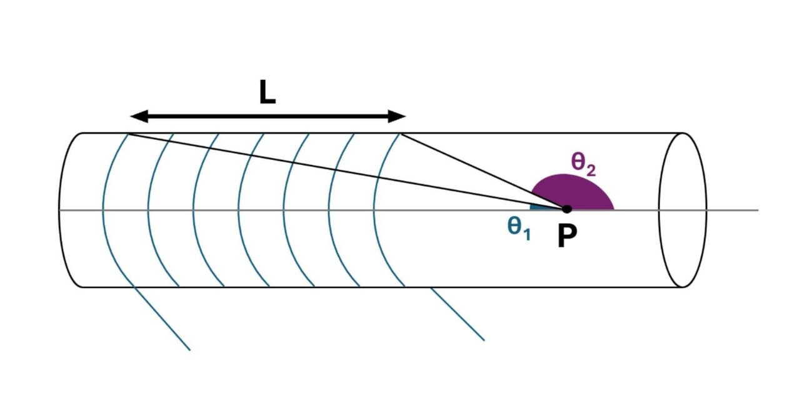
According to Biot-Savart's law, the magnetic field density at point P, which is on the axis of the center of the solenoid (see Figure16), is equal to:
Figure 16: The two angles formed by a point P located outside the solenoid.

$$B=NIμ \left(\cos{θ_{1}}+cosθ_{2}\right)∕2L$$
As we observe, cosθ₂ is always negative outside the solenoid since θ₂ is greater than 90 degrees, while cosθ₁ is always positive.
In general, when θ belongs to [0, π], if θ increases, cosθ decreases. Therefore, increasing the radius of the solenoid will decrease the difference between cosθ₁ and cosθ₂, thus increasing the overall magnetic field.
But the effect of increasing the radius will be negligible for a point far away from the solenoid and at the center of the solenoid since B = NIμ.

Purification of Iron
The purity of iron is an important factor to consider because pure iron is more effective in magnetic fields due to its high permeability.
So, in order to remove impurities from iron, there are several methods, each with its own advantages and disadvantages, to produce pure iron. [10]
We chose to use the electrolytic refining method, which involves an electrolysis cell. The impure iron serves as the anode, while on the cathode side, we use another iron that will be purified. [11]

Needed Materials

Electrolysis Cell
To purify iron, we use an electrolysis cell, which is a container capable of handling the electrolyte solution and separating the anode from the cathode. The container is often made of acrylic.

Power Source
We will need a DC power supply to deliver a constant current with sufficient voltage to drive the electrolysis process. The specific voltage and current requirements will depend on the cell setup and the desired purity of iron.

Impure Iron Anode
The iron you want to purify acts as the anode. The size and shape of the iron will depend on the amount you wish to purify.

Iron Electrolyte Solution
This is a crucial component in the process. Iron(II) chloride (FeCl₂) is a popular choice due to its good solubility and availability.

The Cathode
The cathode is where the purified iron will deposit. It is typically made of a thin sheet of iron, which is commercially available as high-purity iron.

The Electrolytic Refining Process

Preparing the Electrolysis Cell
We fill the cell with an ionic electrolyte solution, such as FeCl₂ in this case. Next, we submerge the impure iron anode and the cathode into the solution, ensuring that they remain separated. To minimize the dissolution of anode material into the cathode compartment, a diaphragm can be employed.

Applying a DC Current
We must connect the power source to the electrodes. The anode will be connected to the positive terminal, while the cathode will be connected to the negative terminal.

Electrolysis
When the current is applied to the cell, chemical reactions occur.
At the anode side, oxidation takes place: Fe → Fe²⁺ + 2e⁻.
The iron atoms from the impure iron anode lose electrons and dissolve into the solution as Fe²⁺ ions.
At the cathode, reduction occurs: Fe²⁺ + 2e⁻ → Fe.
The Fe²⁺ ions from the electrolyte solution gain electrons and deposit on the cathode as pure iron atoms (see Figure 17).
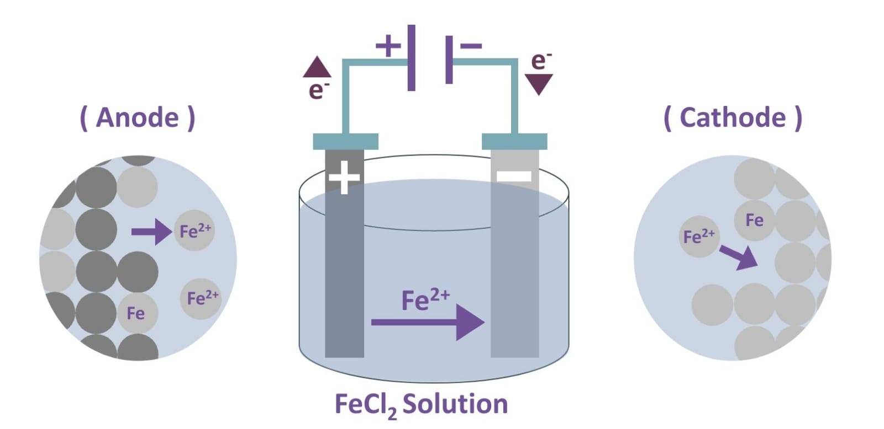
Figure 17: The Electrorefining Method of Iron

Drawbacks
Electrorefining is technically feasible for small-scale iron purification; however, it is not the most practical option for several reasons. Its efficiency is relatively low compared to other methods, and it requires significant energy consumption to transport the iron ions. In this context, we must either employ an alternative purification method or purchase high-purity iron (99.5%) and undergo the electrolytic refining process to achieve even higher purity (99.9%).

Annealing
The annealing process is a heat treatment method used to reduce the hardness and enhance the ductility and toughness of various steels, cast iron, and alloys. This technique involves heating the material above its recrystallization temperature, which promotes the formation of new grains and enables the reorientation of existing grain structures. [12]

History of Annealing
Annealing involves heating to a specific temperature and then cooling at a controlled rate. Historically, annealing was discovered around the 12th century when the word originated from the Middle English term "anelen," which means to set on fire or bake. In Europe, it was discovered through advances in blacksmithing that annealing alters the properties of steel and iron. [13]
Blacksmiths discovered that by heating iron to a specific temperature and then rapidly cooling it, the iron would become stronger and more durable.
The metal heat treatment techniques were developed in the Middle Ages when medieval blacksmiths discovered a process that involved reheating quenched metal to a lower temperature and then cooling it slowly. This enhancement made weapons and armor more effective in wars.
The Industrial Revolution in the 18th and 19th centuries led to the development of the annealing process as we know it today. This process involves heating metal to a high temperature and then allowing it to cool slowly. Subsequently, heat treatment methods have continued to evolve up to the present day. [14]

Annealing Process
The annealing process consists of three distinct stages: an initial recovery phase, a subsequent recrystallization phase, and a final grain growth phase. [12]
During the recovery phase, a metal is heated to a specific temperature below its melting point using a programmable furnace or oven to regulate the temperature. Typically, nitrogen is purged as an inert gas to prevent the oxidation of the metal. [15]
During the recrystallization phase, the metal is heated to the desired temperature and held for a specific duration, which varies based on the desired properties.
This phase involves the reorganization of the crystal structure and the initiation of new grain structures. During the grain growth stage, the size of both newly formed and existing grains increases once the cooling process commences. The phase composition, crystal grain size, and growth are determined by factors such as the cooling rate, atmosphere, and material grade (see Figure 18).

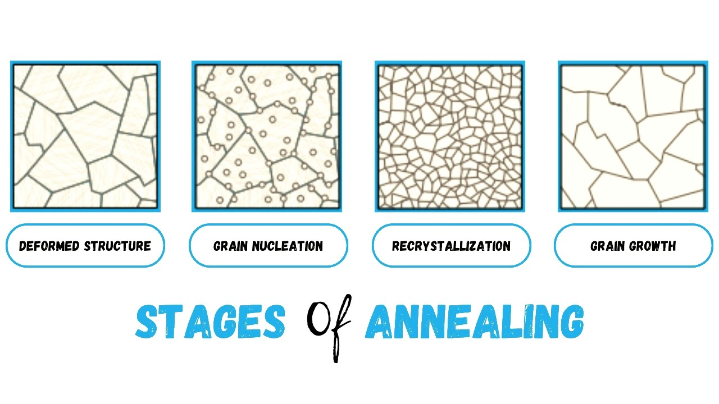
Figure 18: The Different Stages of the Annealing Process

Annealing & Permeability
Annealing can enhance the initial magnetic permeability of metals. By subjecting the metals to high temperatures during annealing, the permeability can be significantly increased. The extent of this increase is influenced by various factors, including the temperature applied, the rate of cooling, and the duration of soaking.
Typically, metal permeability increases with higher temperatures, as evidenced by superior results at 1180°C compared to 1093°C. Additionally, longer soaking times contribute to enhanced permeability, with a six-hour hydrogen annealing process yielding higher permeability levels than a two-hour anneal. [16]

CHAPTER II: ELECTROMAGNETIC CONCEPTIONS

Multi-solenoid Unit
Multi-solenoid unit is an electromagnet specifically designed to produce a more uniform magnetic field across a large air gap and throughout a relatively extensive volume.

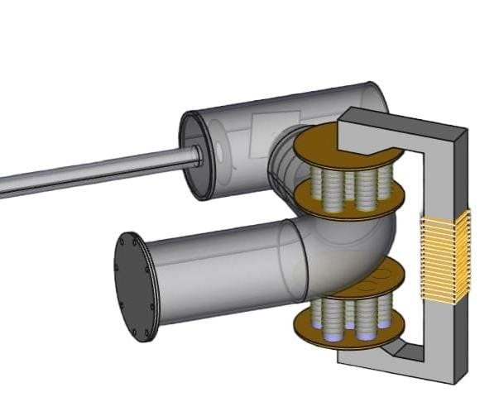
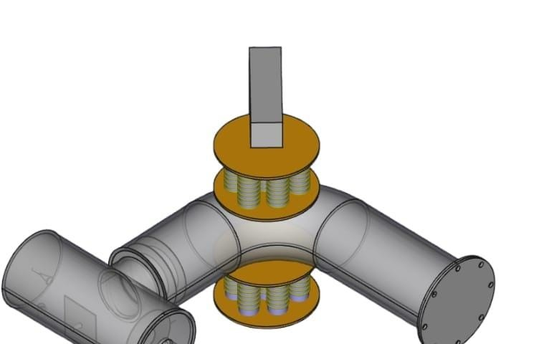
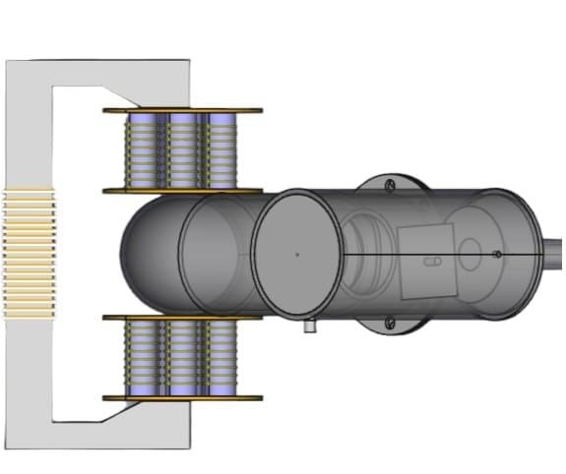
Prototype Design
Figure 19.3: Electromagnet view 3
Figure 19.2: Electromagnet view 2
Figure 19.1: Electromagnet view 1

We used Computer-Aided Design (CAD) to construct a basic prototype of an electromagnet that utilizes a multi-solenoid unit (see list of Figures 19).
In this design, the overall magnetic field magnitude depends on the strength of each individual solenoid. Adding more solenoids does not increase the magnetic flux magnitude but increases its volume while maintaining uniformity.
Each solenoid must induce a magnetic field in the same direction.

Simulation Part
The magnetic field must fill the entire area inside the vacuum tube. To determine this, we conducted a simulation for a multi-solenoid system. We used two cylindrical coils with a radius of 6.25 cm and 500 turns each, with a relative permeability of 200 and an electrical current of 6 amperes. The coils were positioned 15.8 cm apart (see Figure 20).
As we can observe, the magnetic field is almost uniform but less than 5 mT.
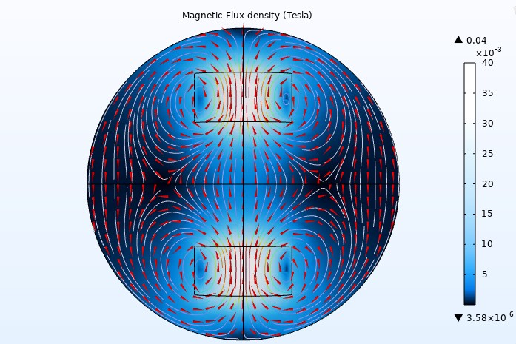
Figure 20: A 2D simulation of two solenoids with a diameter of 12.5 cm.

To clearly observe the effects of the multi-solenoid system, we utilized ten solenoids instead of two (see Figure 21).
Each solenoid has a radius of 1.75 cm, with a distance of 1 cm between each pair of solenoids, creating a 12.5 cm diameter, which matches the diameter of the previous simulation and with the same conditions.
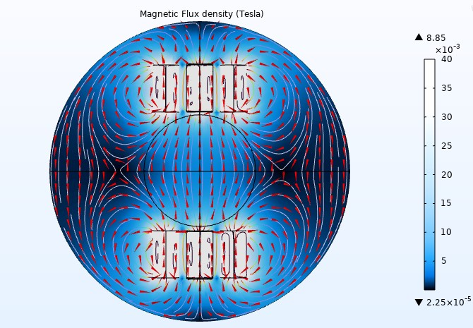
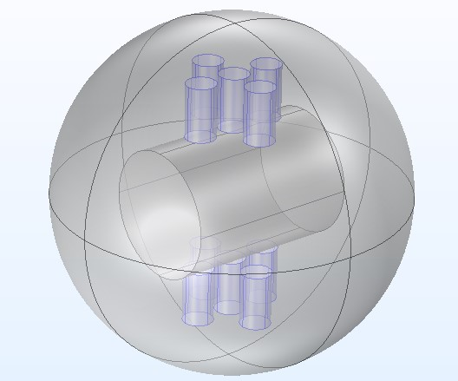
However, we observe that the magnetic field inside the vacuum tube is now almost uniformly distributed compared to before, with a slight increase in strength (see Figure 22).
Figure 21: Ten solenoids are used on a cylindrical vacuum tube.

Figure 22: The 2D simulation utilizing arrow volumes

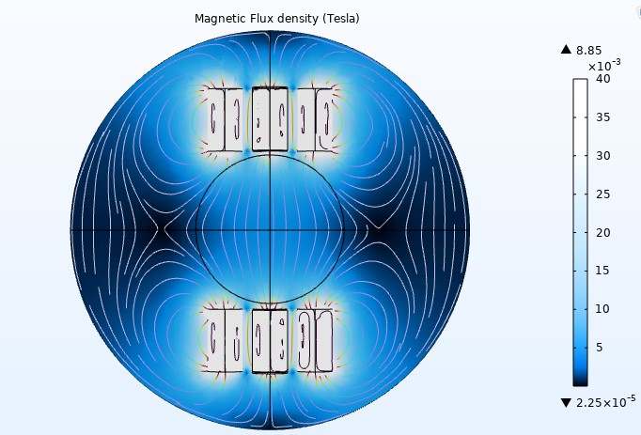
The color inside the vacuum tube is nearly uniform, light blue, indicating a consistent magnetic flux density in the Tesla simulation measurement (see Figure 23).
Figure 23: The 2D Simulation without arrow volumes

In conclusion, the multi-solenoid system can generate a uniform magnetic field, but it is too weak, which poses challenges in achieving 60 mT.

C-shaped Unit
One of the most common components in the magnetic sector is the C-shaped coil, an electromagnet that focuses the magnetic field within the gap area based on an electromagnetic circuit.

Fundamental Principles of Electromagnetism
It can be observed that the air gap volume is the region where we aim to achieve the desired magnetic field (see Figure 24).

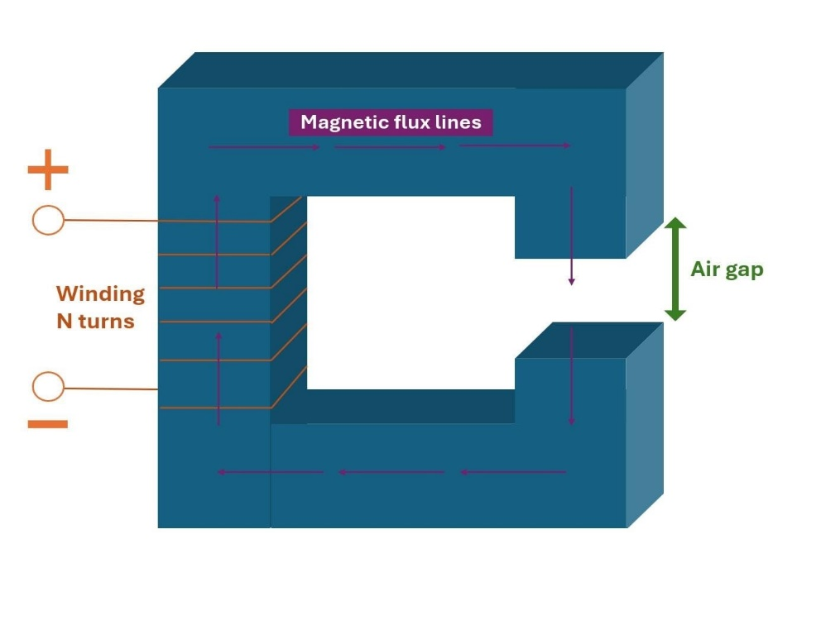
Figure 24: The C-shaped core was taken from one side of the transformer.

The equation for magnetic flux density, denoted as ( B ), can be derived from the fundamental principles of electromagnetism:

Φ = BA
Φ: magnetic flux (Weber)
A: surface area that the flux going through (m²)
B: magnetic flux density (T)

Now, we have another equation that is directly related to the fundamental characteristics:

Ni = Φ (ℛ_{g}+ℛ_{c})

N: number of coil turns (turn)
i: current going through the coil (A)
ℛ_{c}: Reluctance of the core (A.turn/Wb)
ℛ_{g}: Reluctance of the air gap (A.turn/Wb)
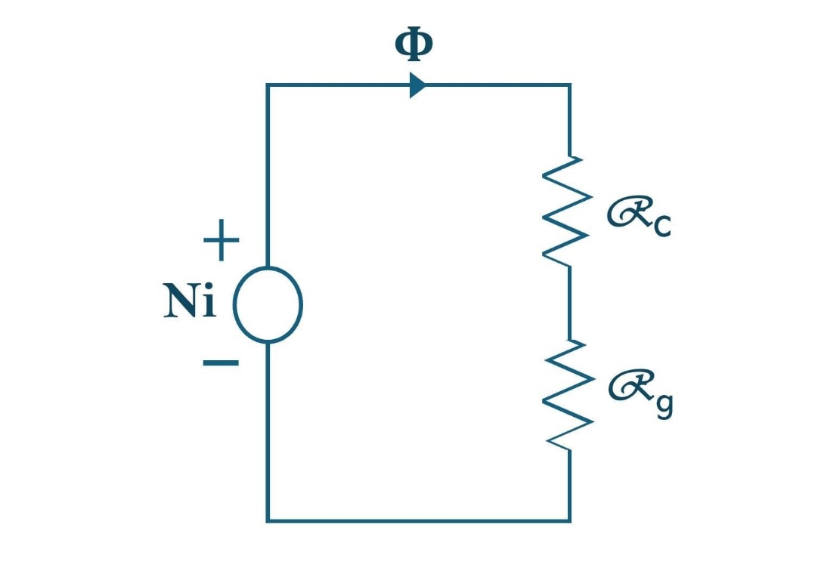
The magnetic system can be transformed into a magnetic circuit (see Figure 25), and the equations used are analogous to Ohm's Law.
Figure 25: The magnetic circuit of a C-shaped core

We can deduce from the equations that reducing the total reluctance (ℛ_{c} + ℛ_{g}) will increase the magnetic flux (Φ), which, in turn, will enhance the strength of the magnetic flux density.

ℛ_{c}= L_{c}/A_{c}μ_{c}
ℛ_{g}= L_{g}/A_{g}μ_{g}

L_{c} represents the mean length of the core, while A_{c} denotes its cross-sectional area. Additionally, L_{g} indicates the length of the air gap in meters, and A_{g} represents the cross-sectional area with a 5% correction applied (see Figure 26).
μ_{c} represents the core permeability, while μ_{g} denotes the permeability of free space (μ₀).
From these equations, we can conclude that reducing the lengths of both the core and the air gap will lead to a decrease in reluctance (see Figure 27).

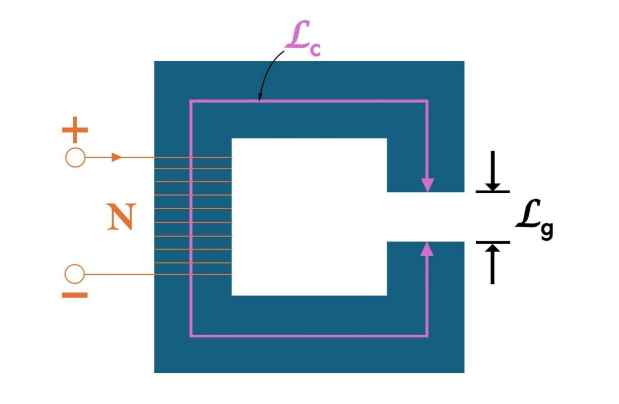
Figure 26: The C-shaped core showing the mean core length
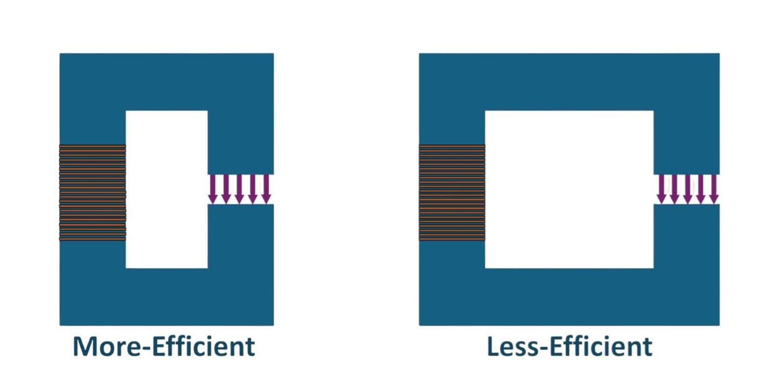
Figure 27: The efficiency comparison of two C-Shaped modules

By combining the equations, we obtain the following result:

Ni = BA (ℛ_{g}+ℛ_{c})

Substituting ℛ_{g} and ℛ_{c} with their respective values:

Ni = BA ( (L_{g}/A_{g}μ_{g})+ (L_{c}/A_{c}μ_{c}) )
or
N= BA ( (L_{g}/A_{g}μ_{g} )+ (L_{c}/A_{c}μ_{c} ) )/ i

In the air gap, the useful magnetic flux tends to bulge outward, resulting in a slight increase in area—approximately 5%, depending on the size of the gap and the geometry of the core. This phenomenon is known as fringing.
This implies that A_{g} = A_{c} + 5% of A_{c}, which can be expressed as A_{g} = 1.05A_{c}.
Therefore, we will have:

N = B ((1.05L_{c} /μ_{c} )+(L_{g} /μ_{g} ))/ i

adding in account that μ_{c} = μ_{r}μ₀ = μ_{r}μ_{a}
then the equation will be:

N = B (1.05L_{c}+μ_{r}L_{g})/μ_{c}i

At a very high permeability (μ_{r}), the minimum number of turns required is as follows:

N = BL_{g}/μ₀i

For a magnetic field strength (B) of 0.06 Tesla, with a length (L_{g}) of 15.8 cm, and a current of 6 A, the minimum number of turns required is 1,258.

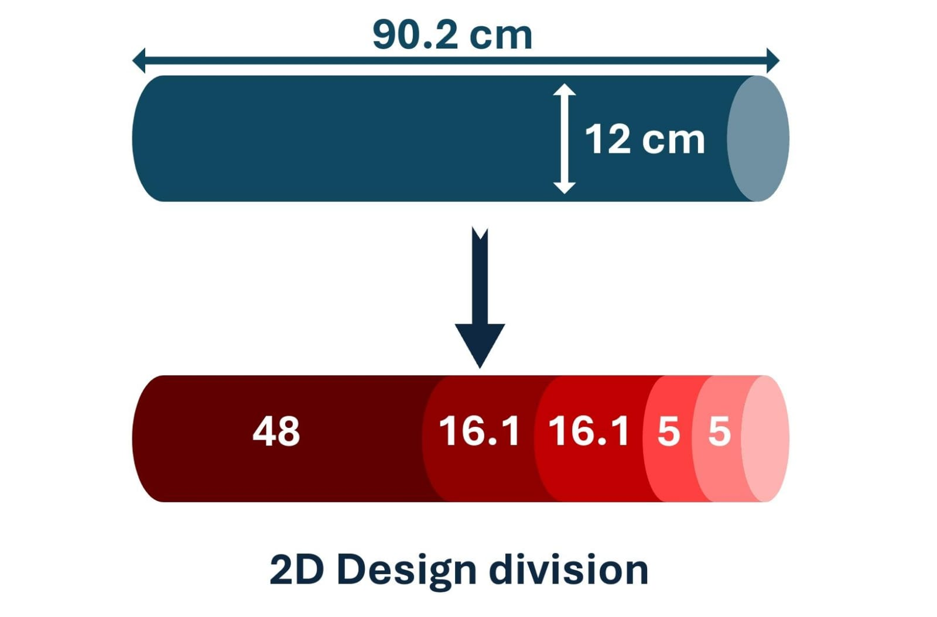
Design Assembling
Figure 28: The cutting plan for the iron bar

Since we do not have a cubic iron core, we will utilize a cylindrical core with precise dimensions to construct our assembly (see Figure 28), we will purchase an iron bar with 12 cm diameter and a length of 90.2 cm, and then we will cut it to five sections, the biggest one with 48 cm, two sections with 16.1 cm and the last two sections with 5 cm each.
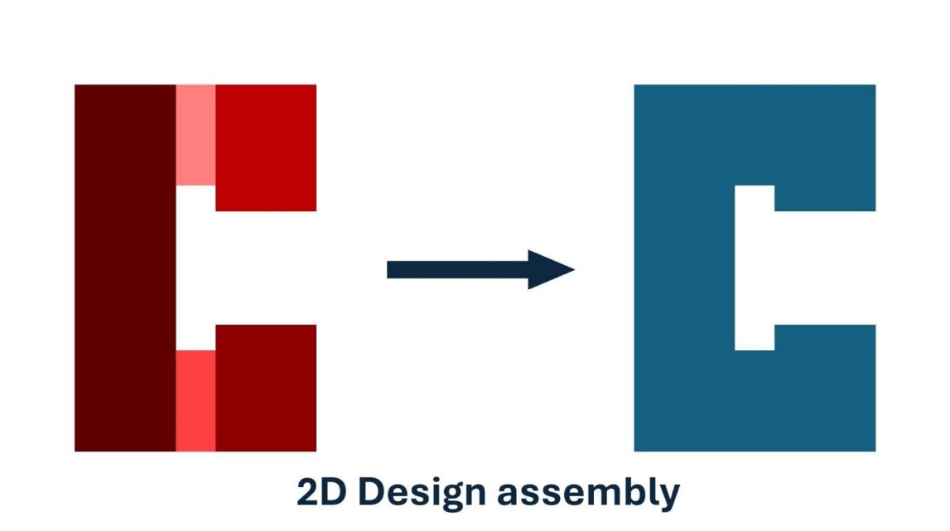
Finally, we will assemble the iron into a C-shape (see Figure 29), as specified in the plan with an air gap of 15.8 cm.
Figure 29: The assembling plan for the C-shape core

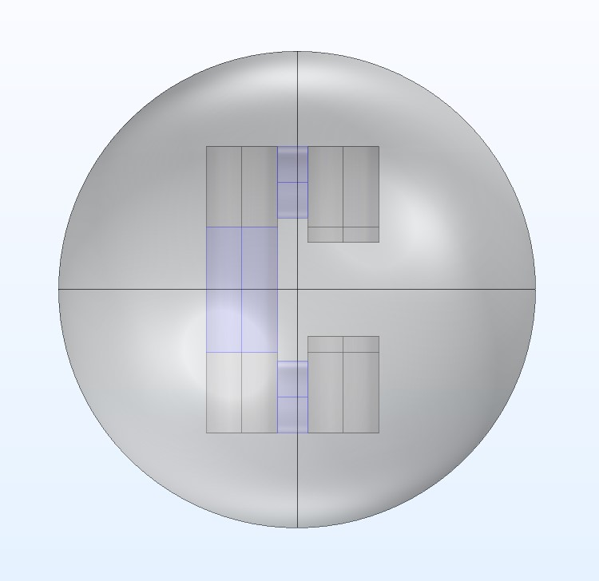
The Simulation Conditions of the Iron Core
Figure 30: The C-shaped core illustrates the region where we wrap the copper

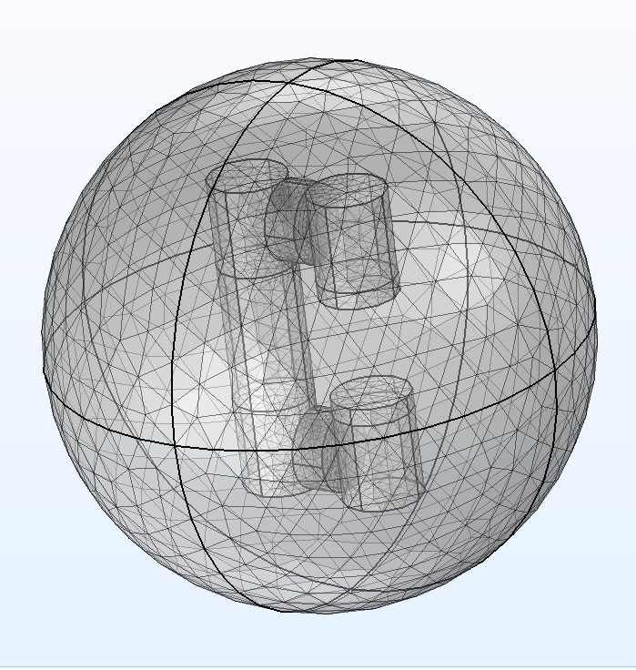
First and foremost, we developed a simulation of our C-shaped iron core. The colored sections indicate the locations of the coils (see Figure 30). Subsequently, we conducted the meshing process, which is a software-based simulation for Finite Element Analysis (FEA) (see Figure 31).
Figure 31: The meshing process before simulation
The properties of iron are presented in the table below:
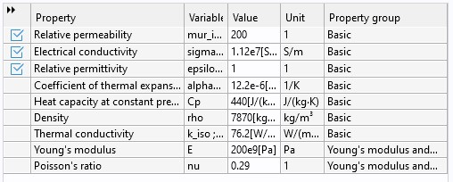
Table 3: Properties of the Iron Core: Establishing Permeability

The total number of turns required to achieve a magnetic field strength of 0.06 T at the air gap, using a 9 A electric current, is 3,500 turns. The largest coil on the left side contains 1,500 turns, while each of the two coils located above and below contains 1,000 turns.
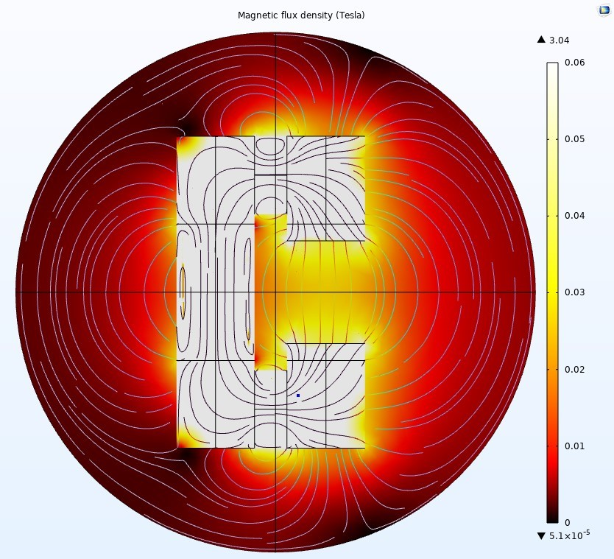
We conducted simulations using a variety of permeabilities (see list of Figures 32).
Figure 32.1: Relative permeability is 20
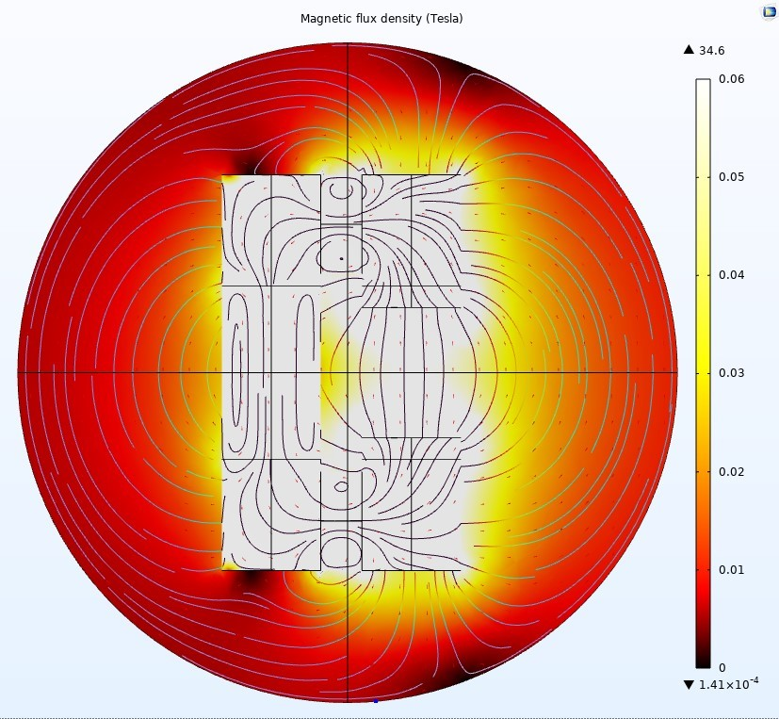
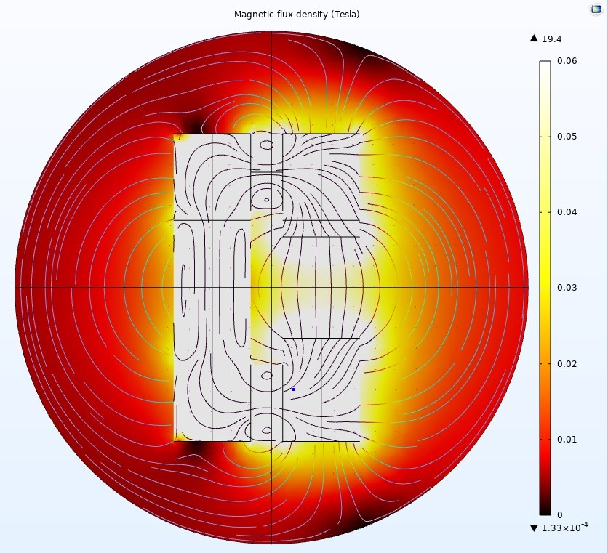
Figure 32.3: Relative permeability is 200
Figure 32.2: Relative permeability is 100
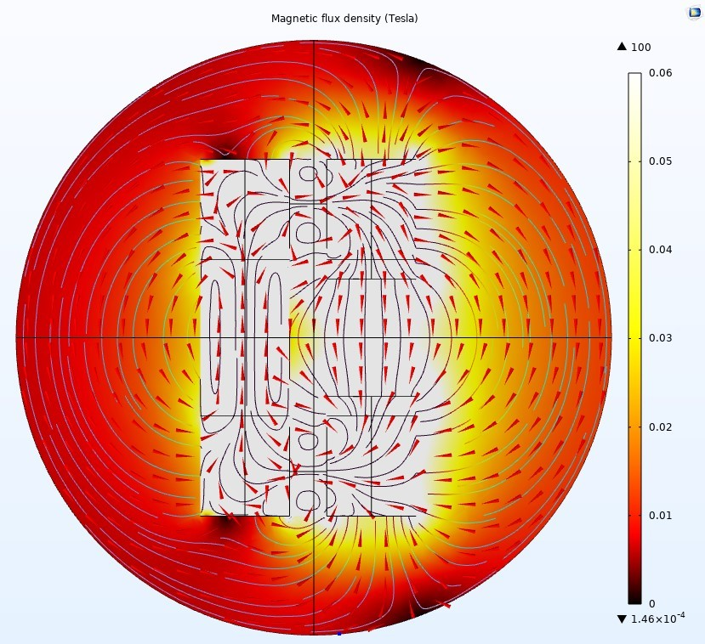
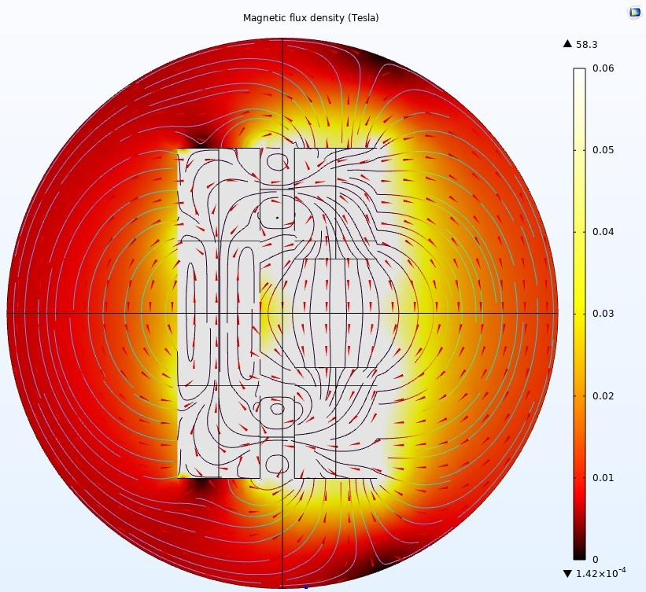
Figure 32.5: Relative permeability is 1000
Figure 32.4: Relative permeability is 500
The simulation results indicate a significant magnetic field density, denoted as "B" (measured in Tesla), within the core. The density increases from a maximum of 3.04 Tesla at a relative permeability of 20 to a maximum of 100 Tesla at a relative permeability of 1,000. Additionally, we observed a variation in the volume of the magnetic field vectors.
However, in the air gap, the magnetic field density varies from 0.02 Tesla to 0.06 Tesla, which may seem like a significant decrease.
Nevertheless, this variation is quite normal, as the permeability of iron is x times greater than that of air, so it is essential to maintain a high flux density in the core to achieve the desired flux density in the air gap.
In conclusion, the C-shaped module is more user-friendly because it effectively generates a stronger magnetic field while ensuring a uniform distribution of that field, which is more beneficial for our project.

Calculation of the Mass of Copper
The equations used to measure the mass of copper are:

m_{c} = ρ_{c} x V_{c}
V_{c} = A_{c} x L_{c}

m_{c} is the mass of copper
ρ_{c} is the density of copper
V_{c} is the volume of copper
A_{c} is the cross-sectional area of copper
L_{c} is the length of wire of copper

ρ_{c} is given by 8960 kg/m³
for a diameter of 12cm L_{c} will be 12 x π x 10⁻² m

For a wire with A_{c} = 2mm²
V_{c} = 2 x 10⁻⁶ x 12 x π x 10⁻² = 0.754 x 10⁻⁶ m³
m_{c} = 8960 x 0.754 x 10⁻⁶ = 0.006755 kg
for 2000 turns:
Total mass = 2000 x 0.006755 = 13.51 kg
for 1500 turns:
Total mass = 1500 x 0.006755 = 10.1325 kg

This calculation seems to contain an error. We made 25 turns using a copper wire with a cross-sectional area of 2 mm², and the weight was 0.3 kg.
For 1,500 turns, this is equivalent to 60 sets of 25 turns each. Therefore, 0.3 multiplied by 60 equals 18 kg.
This value is significantly greater than 10.1325 kg.

CAD Design
Here is a CAD design we created for the C-shaped coil (see Figure 33).
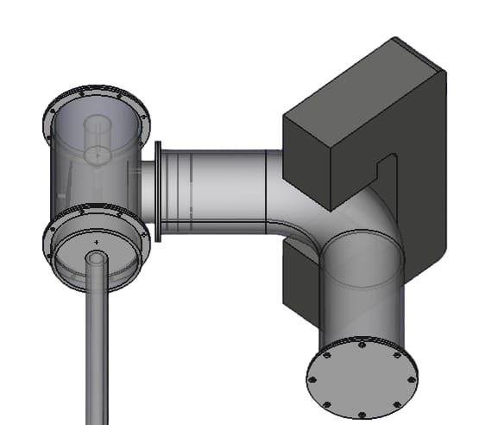
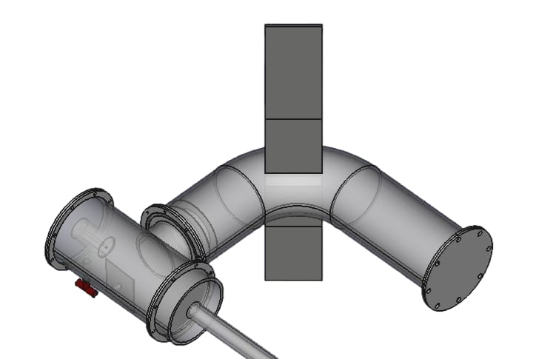
Figure 33: CAD design of the C-shaped coil from two perspectives

CHAPTER III: REALIZATION, TESTS & DISCUSSION

Realization
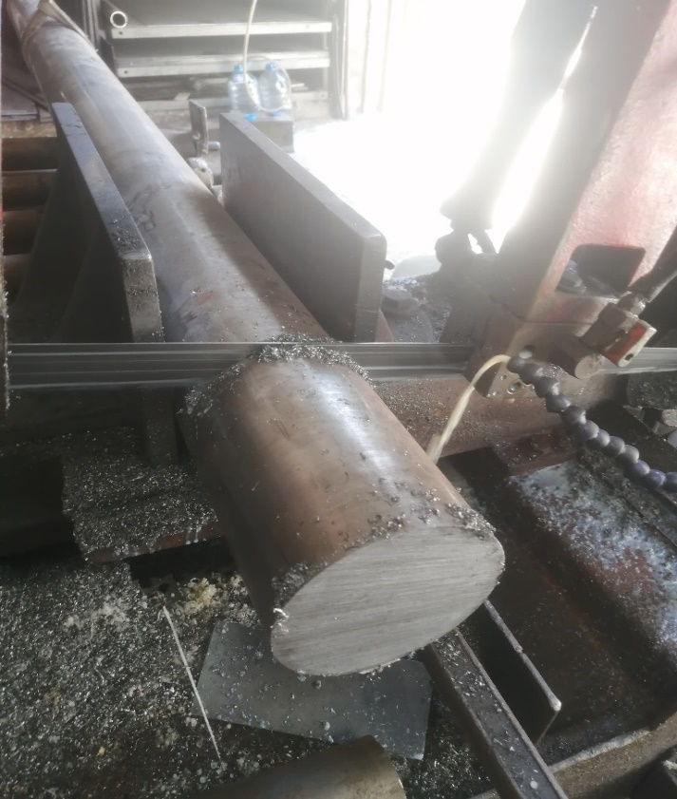
We purchased an iron bar weighing 84 kilograms from "Nawfal and Khawli" and proceeded with the cutting process according to the specified dimensions. The liquid is used to prevent the iron from overheating and to facilitate easier cutting (see Figure 34).
Figure 34: The cutting process for the iron

Annealing Process
Once the iron is prepared, we proceed with the annealing process to enhance its permeability. We utilize a muffle furnace, which allows us to achieve extremely high temperatures using a temperature sensor (see Figure 36).
We have confirmed that the furnace is completely sealed and ready to proceed with the annealing process (see Figure 35).

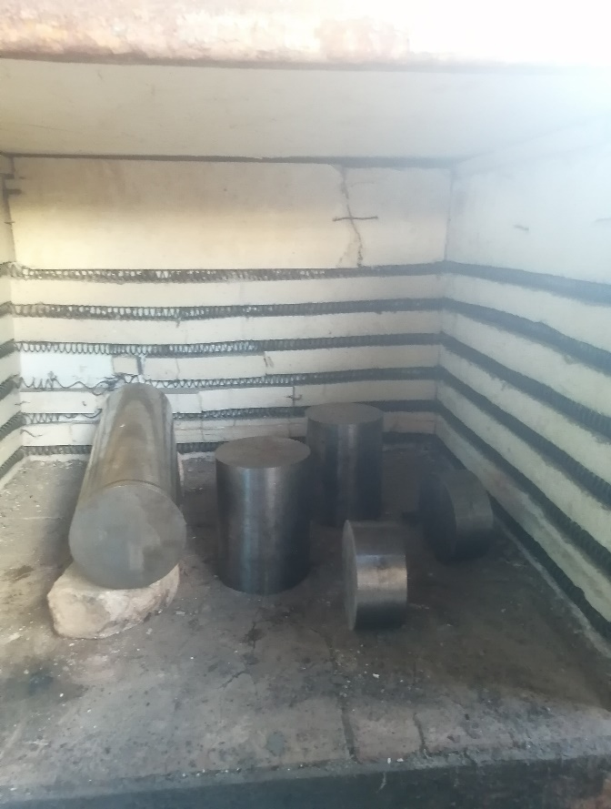
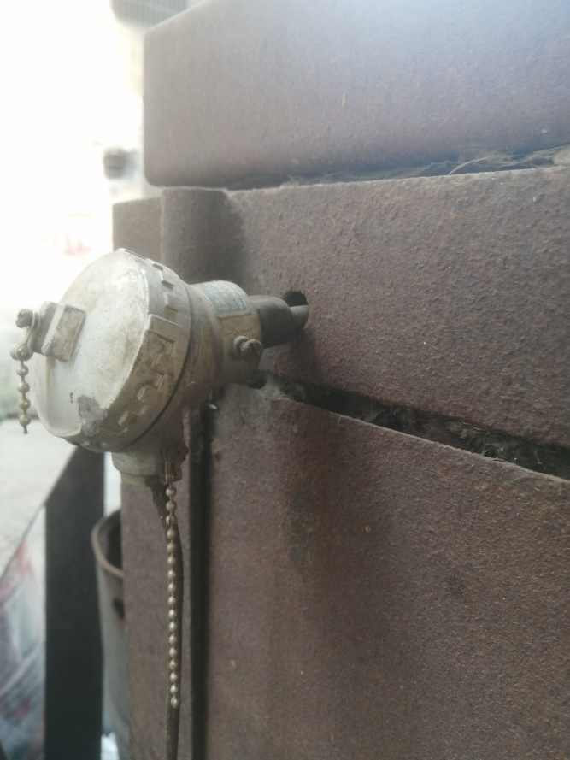
Figure 35: The iron bars inside the furnace

Figure 36: The temperature sensor

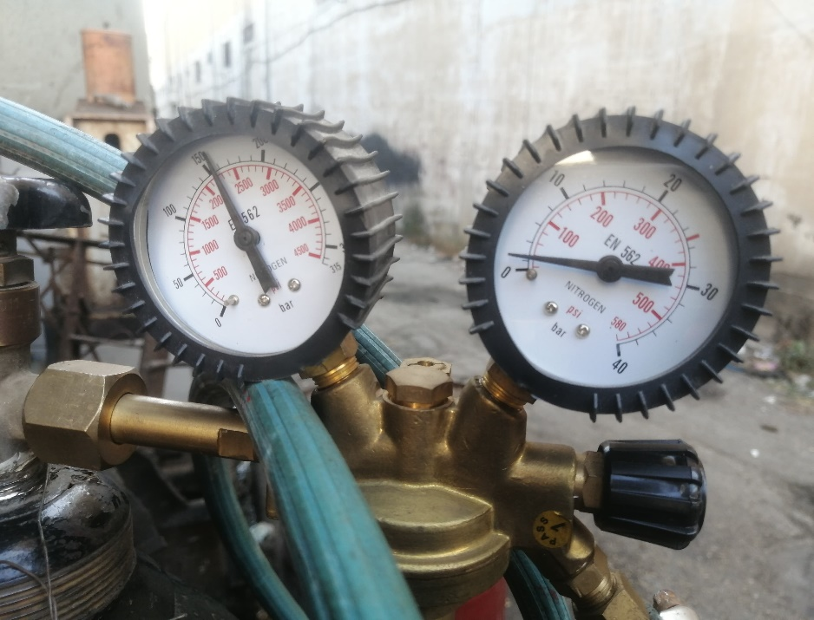
We purged the nitrogen from the furnace using an inert gas to prevent the oxidation of iron by air. The gauge on the left side indicates the amount of nitrogen in the bottle, while the gauge on the right displays the volume of gas that has been purged, which is slightly smaller (see Figure 37). We must continue purging throughout the entire annealing process.
Figure 37: The nitrogen bottle filled with 150 bar
We began heating the iron in the furnace. It took approximately one and a half hours to reach the desired temperature of 870 degrees Celsius which is logical, as the optimal temperature depends on the material’s structure [17]. The green number indicates the target temperature, while the red number represents the actual temperature
(see Figure 38).
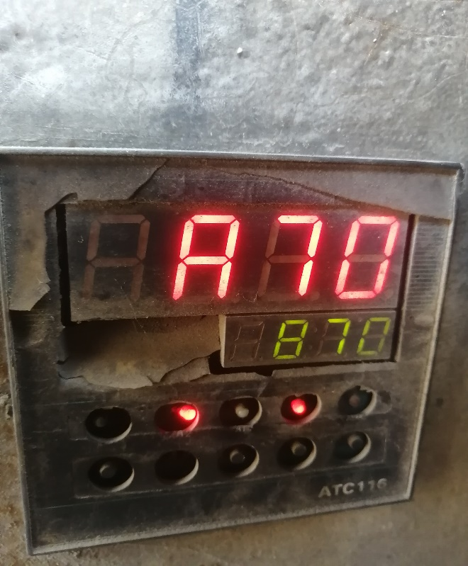
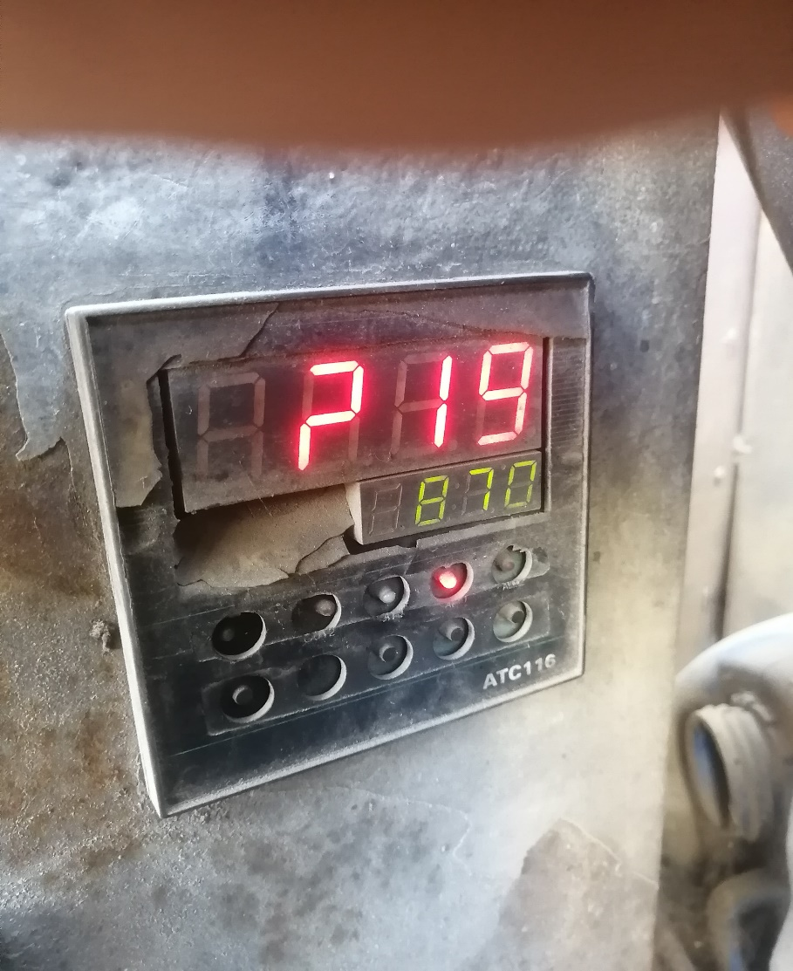
We left it there for approximately one hour before turning off the furnace and keeping it closed to allow the iron to cool slowly and uniformly.
Before
After
Figure 38: Numerical panel shows the temperature inside the furnace

We observed that we consumed approximately 100 bars of nitrogen gas throughout the entire annealing process (see Figure 40), leaving the iron in the furnace until the following day.
The outer shell of iron must be cleaned before beginning the construction of our C-shaped core.

We observed that the iron exhibited some burnt impurities resulting from the heating process it underwent. The taller iron bar took a longer time to cool, which is expected due to its size and the amount of heat it absorbed (see Figure 39).

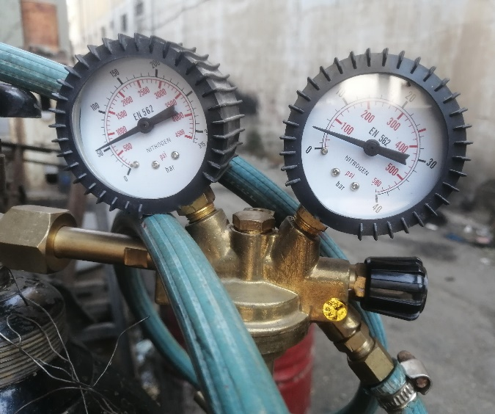
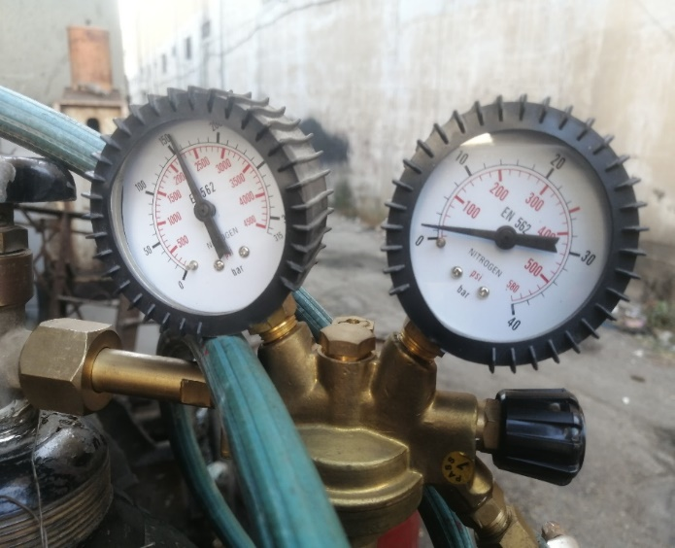
Figure 39: The iron bars depending on the cutting plan after the annealing process
Figure 40: Comparison between of nitrogen amount before and after annealing
After
Before
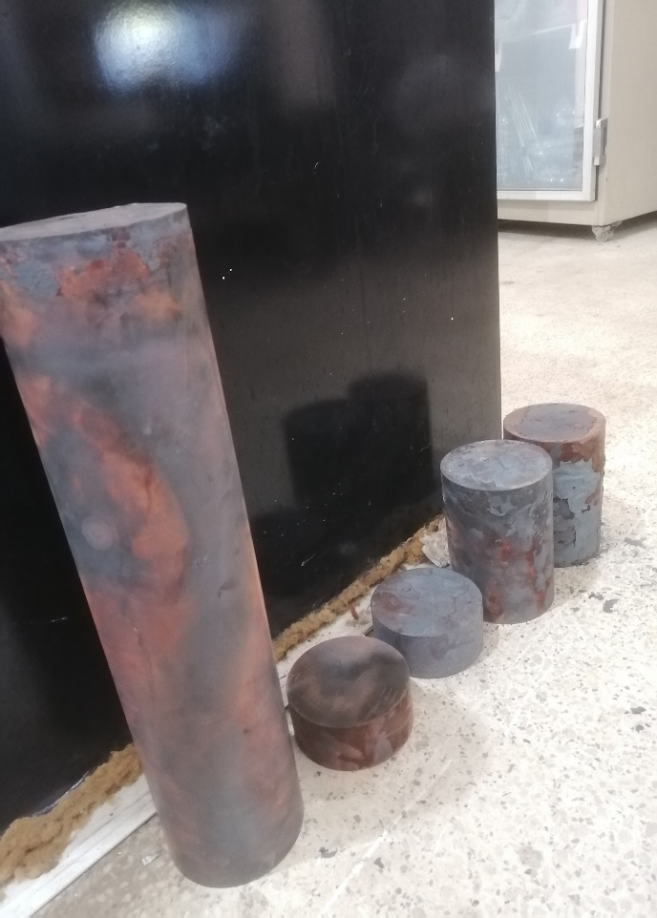

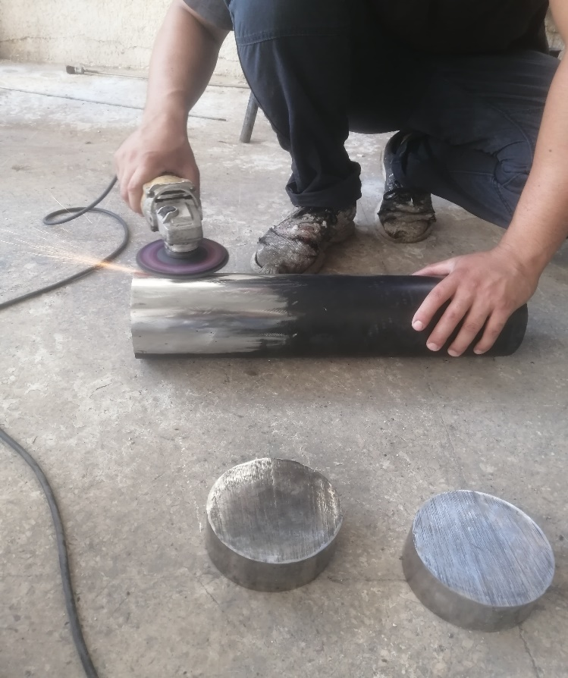

Iron Cleaning
Figure 41: Polishing the iron from the black impurities from smaller to larger parts

The first step after annealing was to clean the outer shell of the iron, removing any burnt remnants and polishing it until it was completely free of black impurities. We began with the smaller sections before advancing to the larger ones (see Figure 41).
The difference can be observed in the accompanying figures (see Figure 42).
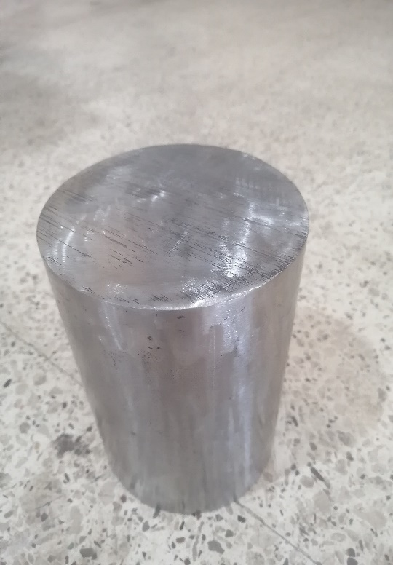
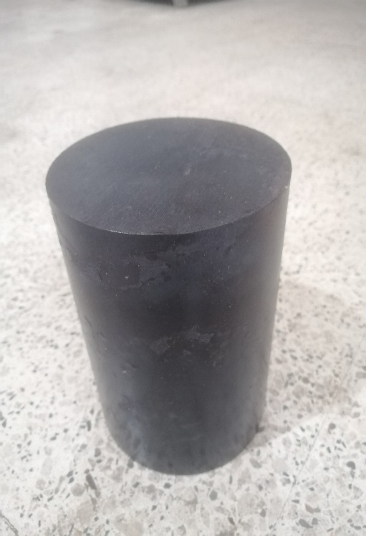
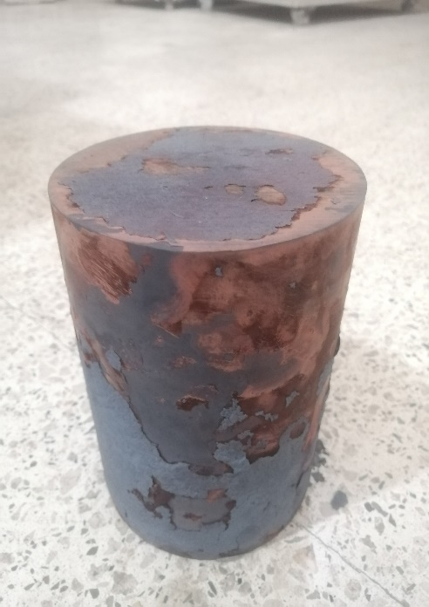
Cleaning the iron is essential for the successful construction of the C-shaped core, as impurities can hinder the construction process.
Figure 42: The difference steps of cleaning the heated iron

Core Construction
After ensuring that the iron was thoroughly cleaned, we commenced the welding process to fabricate our C-shaped iron core.
We placed the larger section of iron on two concrete blocks and began welding the smaller components to it (see Figure 43).

Figure 43: A factor was welding the iron

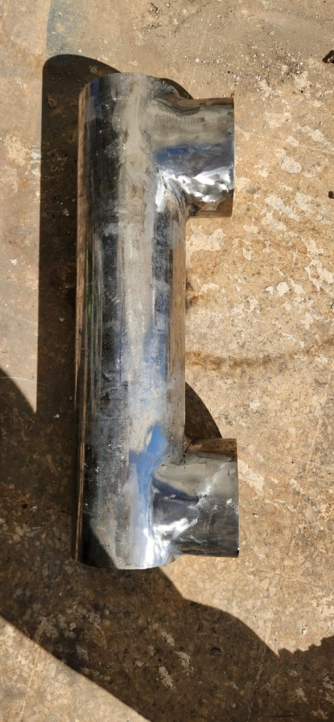
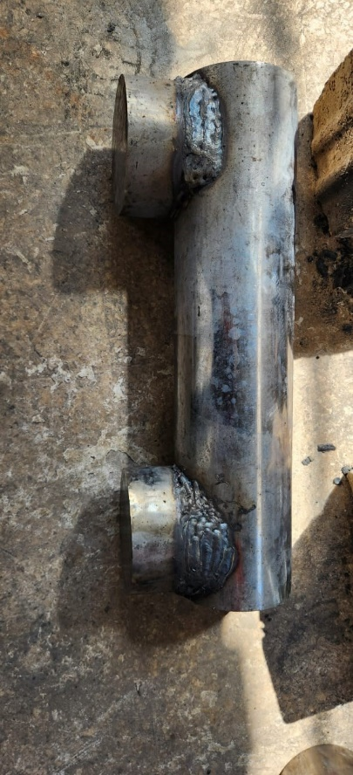

Figure 44: Welded iron before and after polishing
After completing the welding process, we began polishing to remove the burnt impurities that resulted from welding. Consequently, the three sections now appear as a single cohesive unit (see Figure 44).
The iron core was shaped according to the design specifications. We welded four small iron bars to facilitate handling the core (see Figure 45), which weighed approximately 84 kilograms.
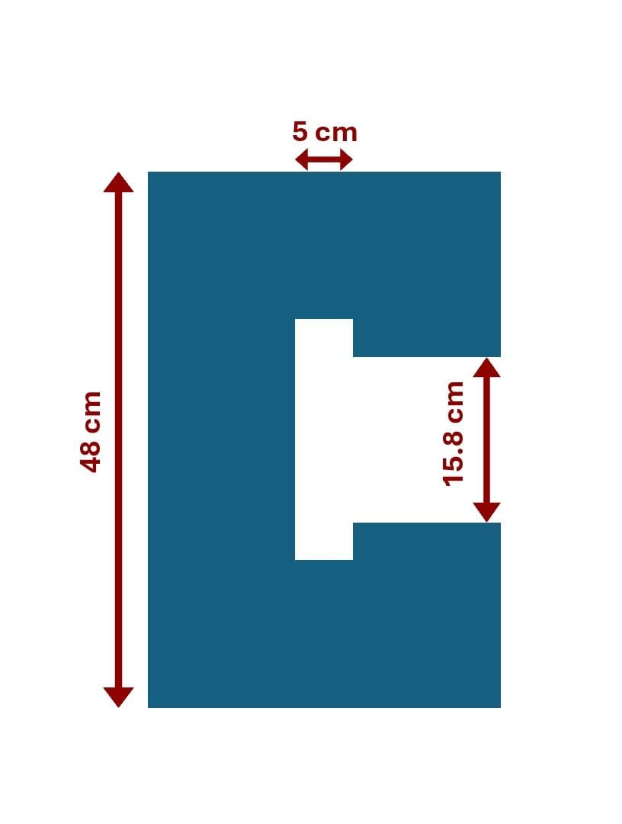
When we completed the welding, the iron core was prepared to proceed with winding the copper.
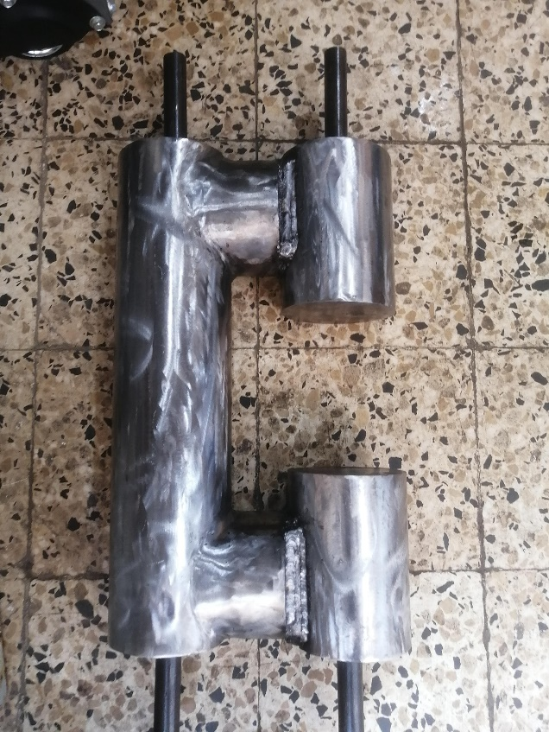

Figure 45: C-shaped iron core and its 2D characteristics

1.4. Winding the Coil
We began winding the core with copper wire that has a cross-sectional area of 2 mm². First, we covered the core with insulating paper, and then we continued winding the wire on top of it.
The winding process was challenging; it was performed manually (see Figure 46) and required a significant amount of time due to the heavy weight of our core, which made the winding machine impractical.

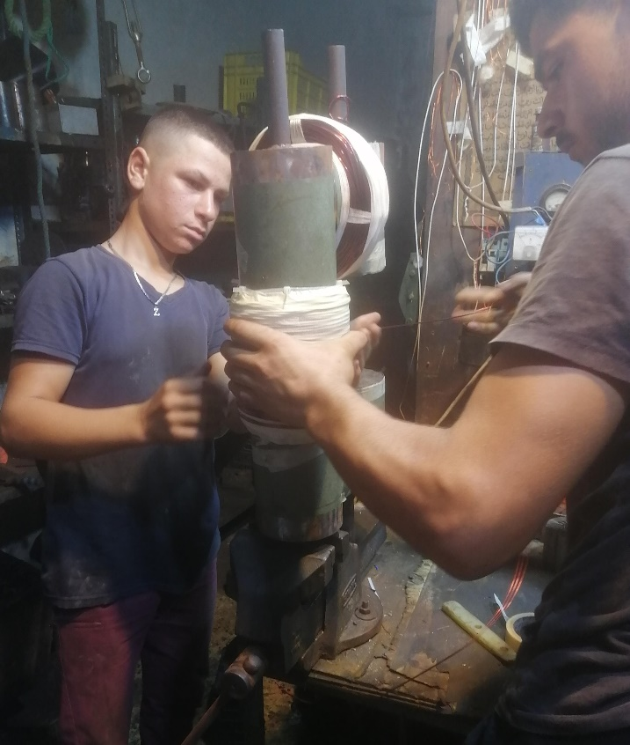
Figure 46: Factors that wind the copper around our C-shaped core

We calculated the required number of turns using the equation:

N = B (1.05L_{c}+μ_{r}L_{g})/μ_{c}i

We found for a B = 0.06 Tesla, L_{c} = 90.2 cm, L_{g} = 15.8 cm, i = 6A and for μ_{r} =25
We require 1,558 turns; however, we have observed that this figure does not align with the simulation results, which indicate that a greater number of turns and a significantly higher relative permeability are necessary. This discrepancy arises from the fact that the iron is circular rather than rectangular, as is the case with transformers.
As a result, this equation is applicable only for very small air gaps.
Finally, we have completed winding our electromagnet, achieving a total of 1,530 turns. Due to the dimensions of the deflection zone tube, there is no capacity for additional turns.
Considering the weight of the electromagnet, which is approximately 104 kilograms (with the copper component weighing around 20 kilograms), we constructed a specialized stand to support it (see Figure 47).

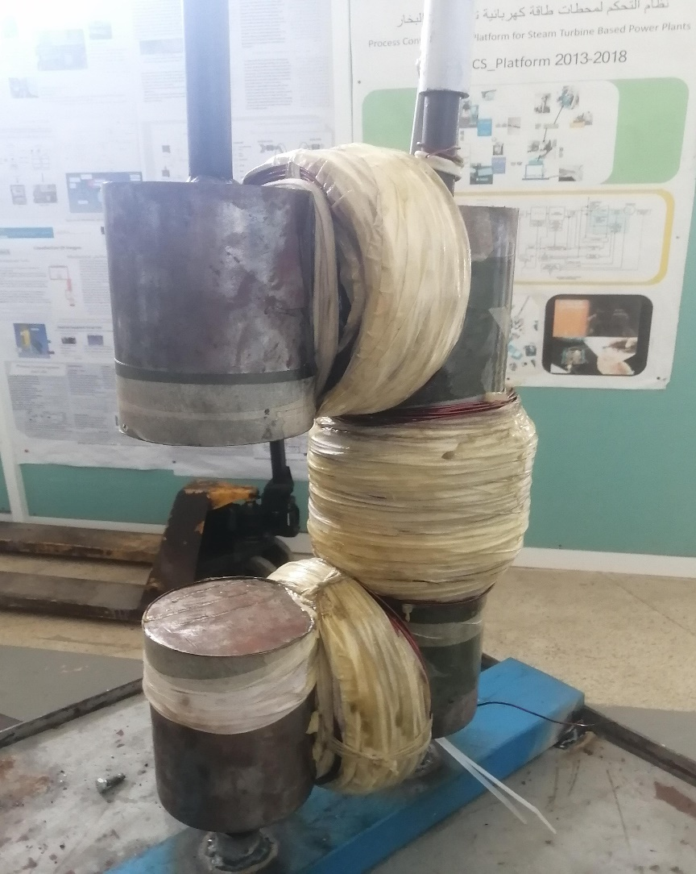
Figure 47: The C-shaped Electromagnet
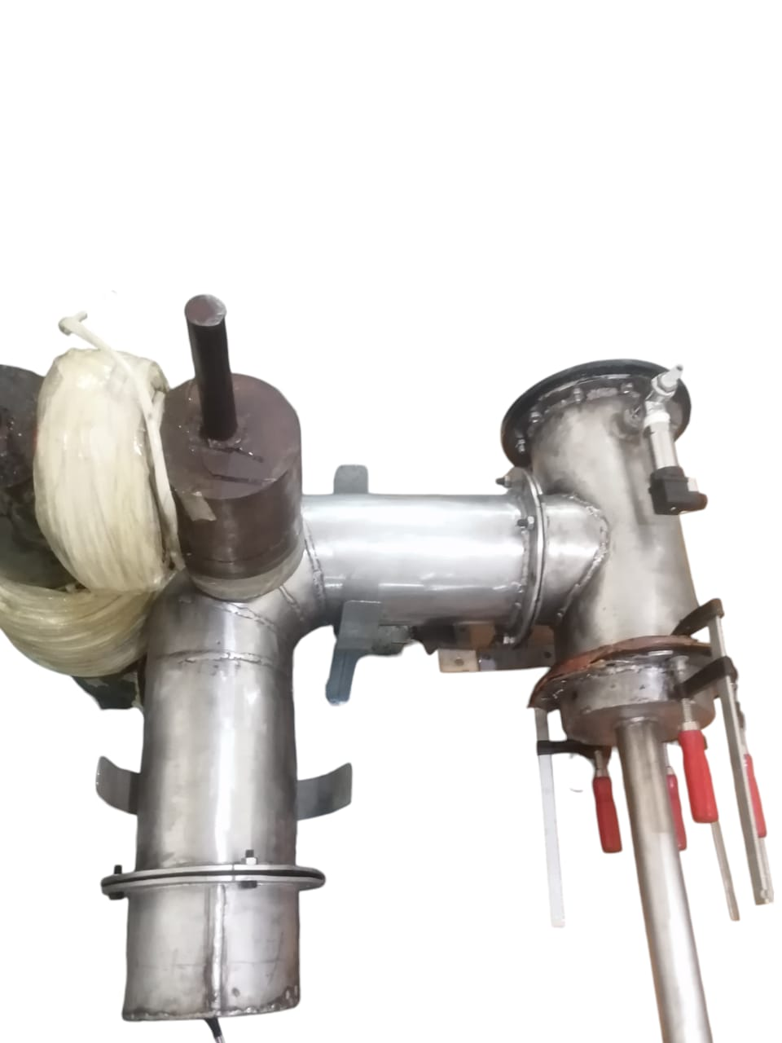
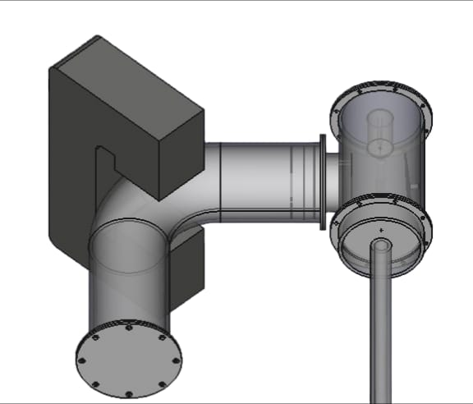
R = 6 cm
1o cm
11 cm
Figure 48: Comparison between the real and CAD designs
The primary difference between the CAD design and our electromagnet is the cross-sectional area, which is circular. Although we were unable to use a rectangular iron core due to its unavailability in the market, the air gap and overall dimensions are nearly identical, as can be observed (see Figure 48).
A _{rectangle} = 11 x 10 = 110 cm²
A _{circle} = π x 6² = 113 cm²

Tests and Results

Single Solenoid Testing
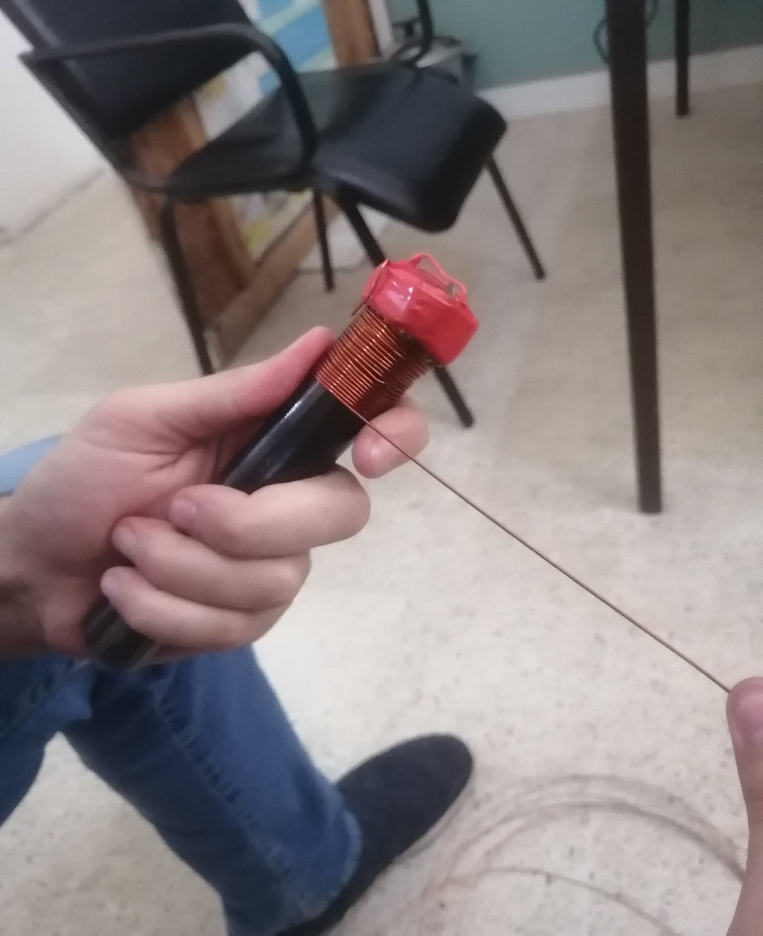
We took a small piece of iron measuring 16.1 cm in length and 2 cm in diameter to investigate the strength of the magnetic field both with and without the iron core. To conduct this experiment, we constructed a coil consisting of 115 turns of copper wire, supported by two holders, one at each end (see Figure 49).
Before
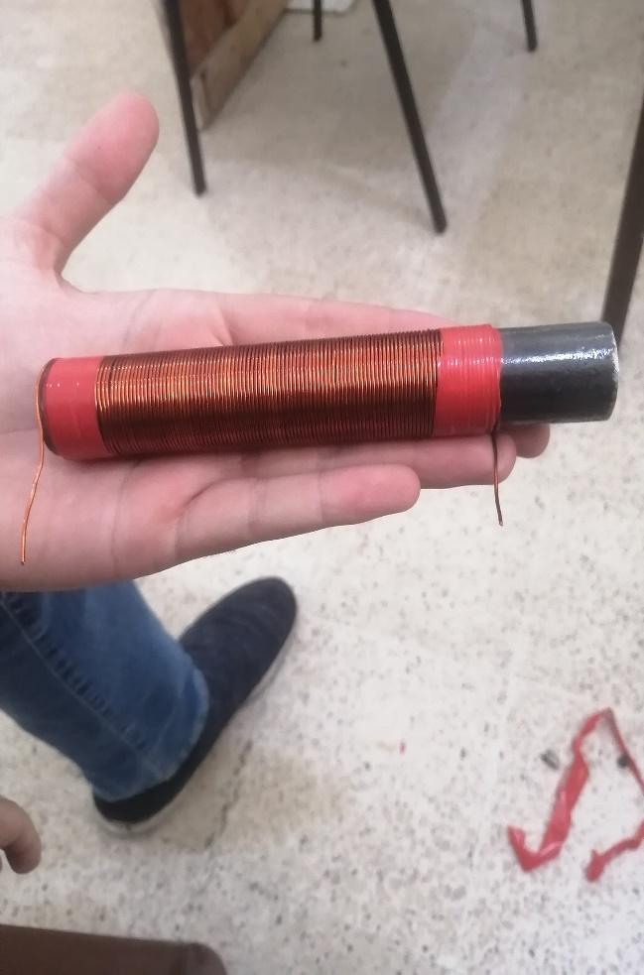
Figure 49: The small iron section with 5cm, before and after winding the copper

After

We required a power supply, a multimeter, and a teslameter to initiate the testing process. After preparing the necessary equipment (see Figure 50), we began measuring the current in the wire, which was 3.5 amps. The results indicated that for a 2.7 cm segment of iron, we achieved a magnetic field strength of 8.4 mT (see Figure 51).
In contrast, when measuring a 2.7 cm air gap, the teslameter recorded only 2.3 mT.
This difference is logical, given the relative permeability of iron compared to that of air.

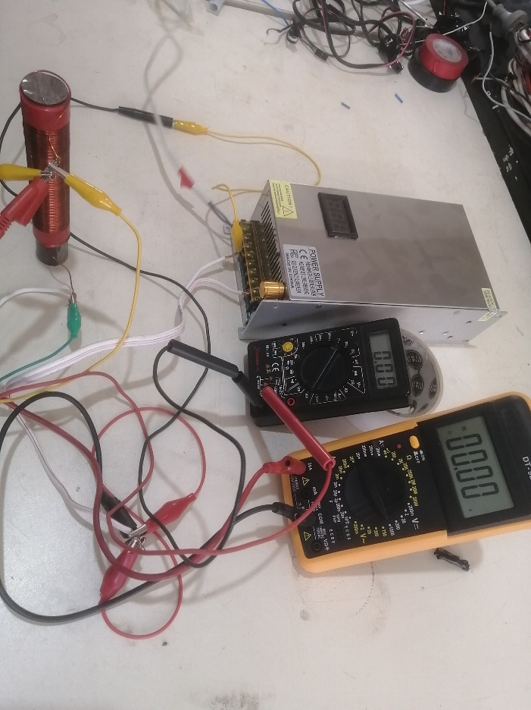

Figure 50: The system is ready for testing
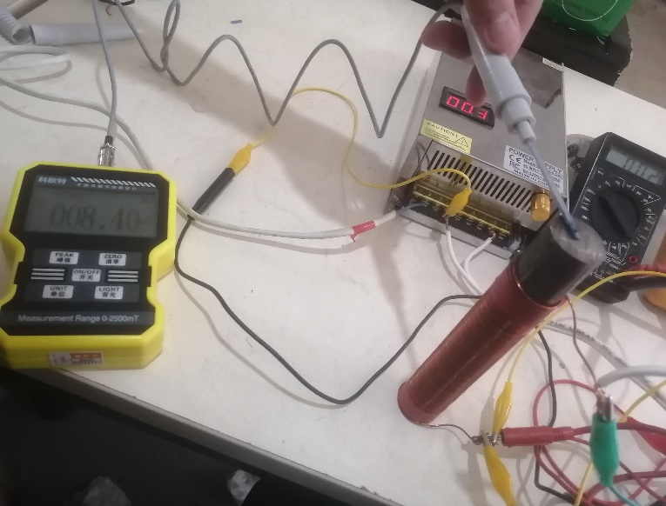

Figure 51: The teslameter indicates a magnetic field strength of 8.4 milliteslas.

We can simply see the difference in the following table:
 | Current I | Magnetic Field B
2.7 cm of iron | 3.5 A | 8.4 mT
2.7 cm of air gap | 3.5 A | 2.3 mT
Table 4: A comparison between air gap and an iron core effect on the magnetic field

Electromagnet C-shaped Testing

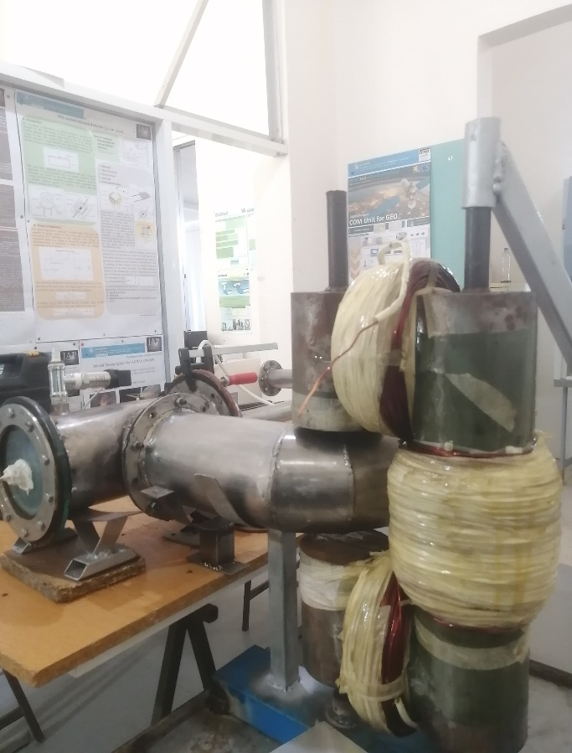
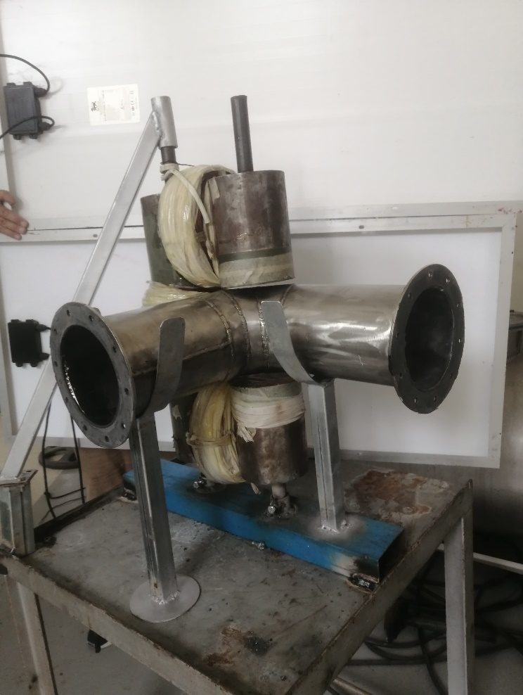
Once we completed the construction of the C-shaped electromagnet, it was ready to be tested for its magnetic field in the air gap.
Figure 52.1: C-shaped electromagnet along the mass sector tube
Figure 52.2: Fitting the mass sector tube in the air gap
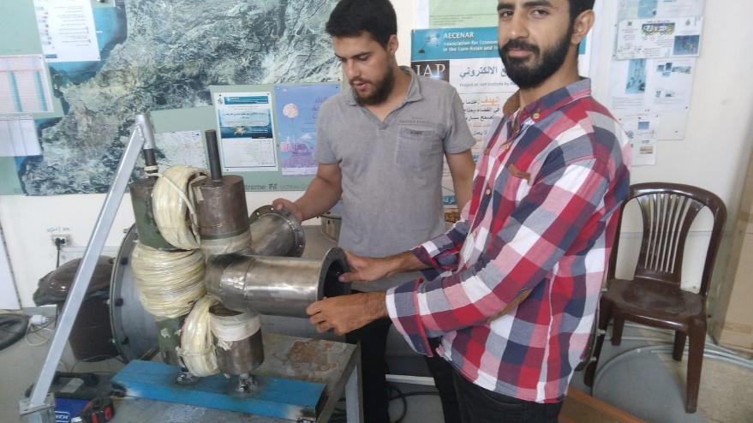

Figure 52.3: C-shaped electromagnet along the mass sector tube in the mass spectrometer

Magnetic Field without Pipe Test

Requirements:
- Mechanical Requirements:
The C-shaped electromagnet is constructed from iron shaped into a C configuration, wound with copper wire, and includes an air gap specifically designed to accommodate the mass sector tube (see list of Figures 52).
- Electrical Requirements:
The electrical supply must be adjustable until the desired outcome is achieved.
- Magnetic Requirements:
The C-shaped electromagnet must produce a magnetic field within the mass sector tube.
The C-shaped electromagnet must produce a magnetic field of 0.06 Tesla.

Test Specification:

Step | Step description | Desired result
Pre-Condition | The system is powered off
Turning on the system | Activating the C-shaped electromagnet using a power supply | Achieving a magnetic field  (B = 0.06 Tesla)
Turning off the system | Deactivating the C-shaped electromagnet | The magnetic field has ceased.
Post-Condition | The system is powered off

System Test and Results:

Test 1:
Step | Step description | Desired result | Result
Pre-Condition | The system is powered off
Turning on the system | Activating the C-shaped electromagnet using a power supply | Achieving a magnetic field  (B = 0.06 Tesla) | Negative
Turning off the system | Deactivating the C-shaped electromagnet | The magnetic field has ceased. | Positive
Post-Condition | The system is powered off

Analyzing the results of the test:
We measured the magnetic field at the center of the air gap, where the ions are expected to move. We observed that applying a current of 6 amperes results in a teslameter reading of 50 millitesla (see Figure 53), which is insufficient for our project. However, this serves as a solid starting point, as we need to achieve a magnetic field of 60 millitesla, necessitating an additional 10 millitesla.
So, all we can do is enhance the current situation; in this manner, we can attain the desired result.
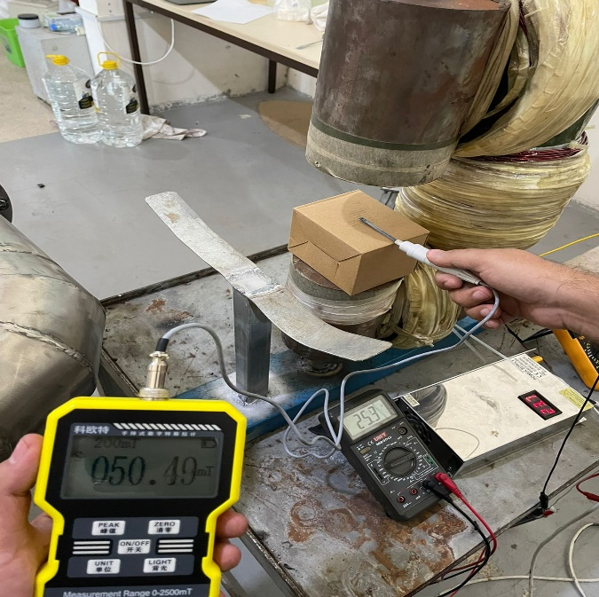

Figure 53: The teslameter displays a reading of 50 millitesla
Test 2:
Step | Step description | Desired result | Result
Pre-Condition | The system is powered off
Turning on the system | Activating the C-shaped electromagnet using a power supply | Achieving a magnetic field  (B = 0.06 Tesla) | Positive
Turning off the system | Deactivating the C-shaped electromagnet | The magnetic field has ceased. | Positive
Post-Condition | The system is powered off

Analyzing the results of the test:
We successfully achieved our target of 60 millitesla (see Figure 55) by increasing the current to 7.5 amperes (see Figure 54). Fortunately, the copper wire can safely handle approximately 9 amperes before reaching a critical threshold. However, at 7.5 amperes, the results were optimal.
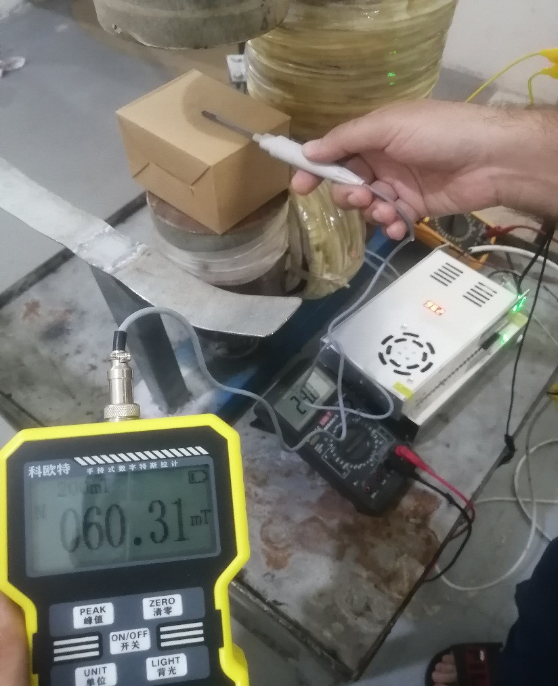
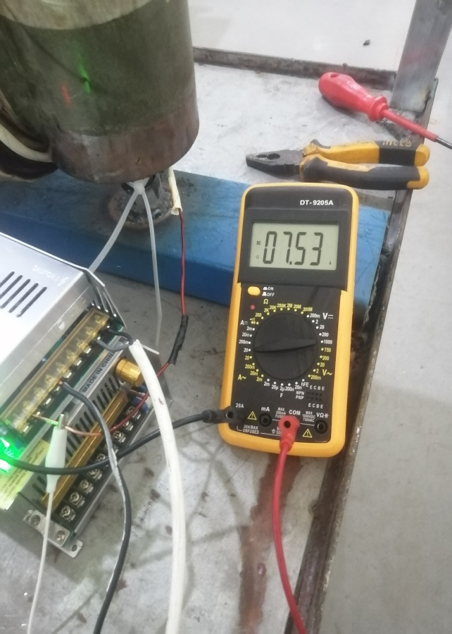
Figure 54: The multimeter displays a reading of 7.5 amperes

Figure 55: The teslameter displays a reading of 60 millitesla

All ferromagnetic materials exhibit the phenomenon of hysteresis. [18] We observe a small residual magnetic field of approximately 1 millitesla (see Figure 56).
Consequently, our C-shaped core becomes magnetized, indicating that its permeability has increased even further.
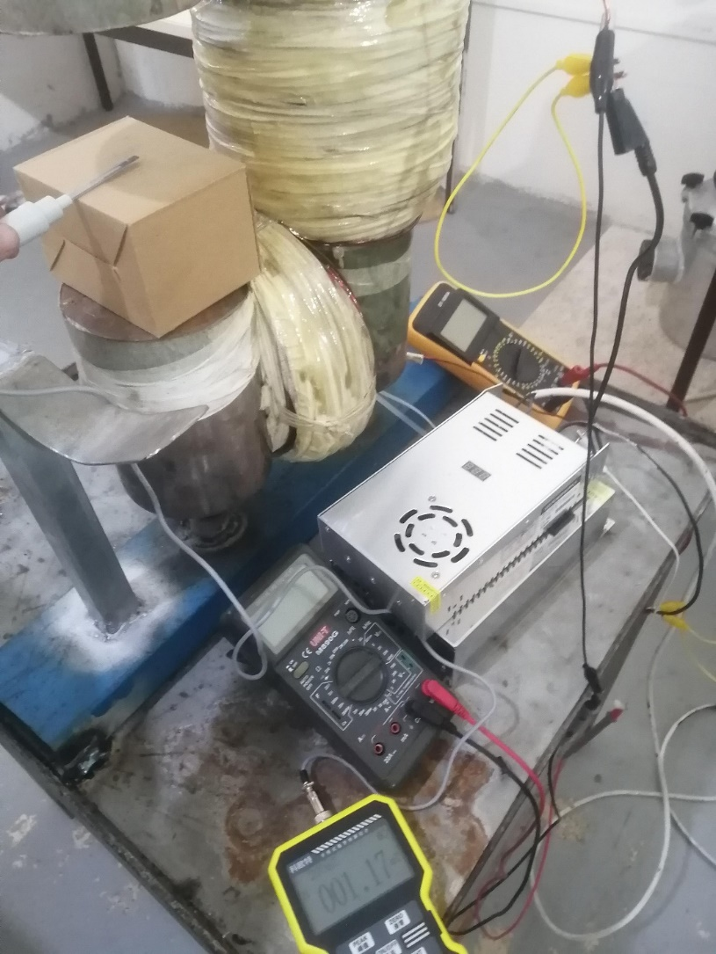

Figure 56: System is off and the teslameter displays a reading of 1 millitesla

Magnetic Field in Open Pipe Test
This test is identical to the previous one; however, the key difference is that the mass sector curve tube is now positioned within the air gap of the electromagnet, enabling us to take measurements.

Calibrating Mass Spectrometer with Known Material Probes

3.1. Process Control System
It is important to identify the sensors and actuators that will be connected to the PLC (see Figure 57); therefore, we will install them in the control panel. Program the PLC using “DELTA WLPSoft” software.
Create the graphical user interface (GUI) using C#.NET. we should note that the addresses in the Programmable Logic Controller (PLC) program differ from those in the C# code.
Reason: Improved clarity and technical accuracy by expanding the acronym.
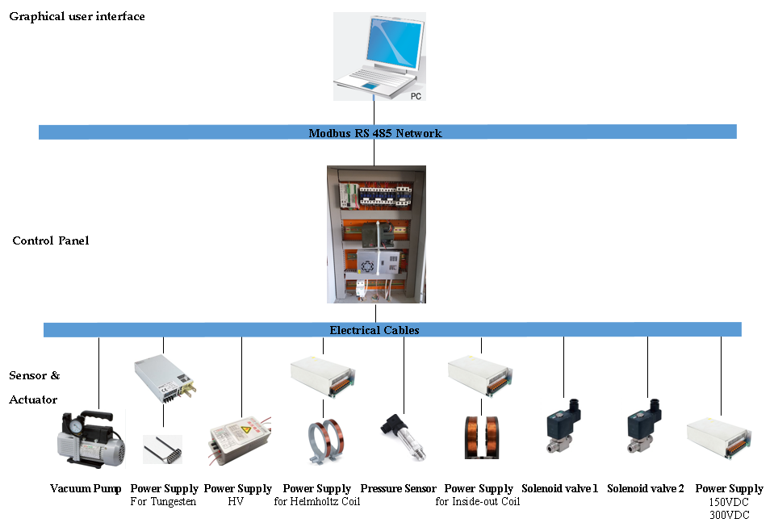

Figure 57: The required sensors and elements in the process control system

3.2. System Test Specification

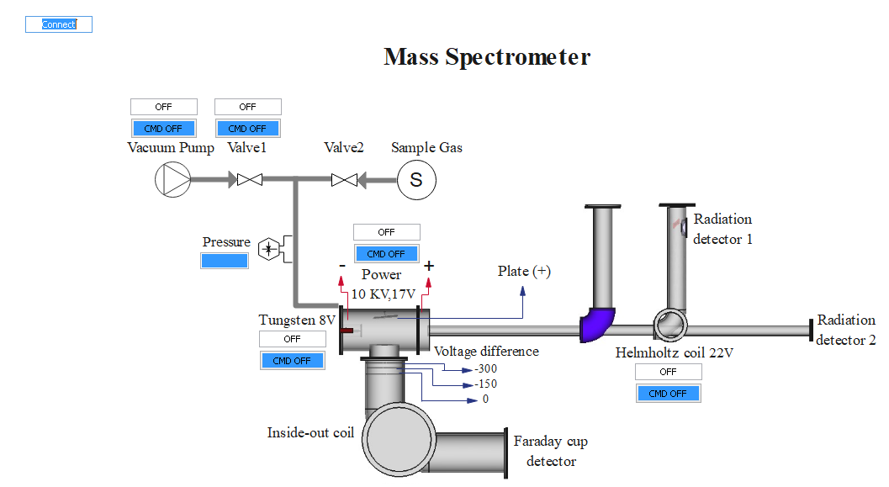

-20 V
0 V
-10 V

Figure 58: System specification

This test will not be conducted due to time constraints; however, we would like to present the test specifications. To enhance understanding, we provide a description of the current process control system:
Action | Expected result
Turn on the valve V1 and the pump | V1 is open, 95% Vacuum
Turn on the Power Supply P4 and P9 | Continuous Power (17V)
Burn the Tungsten by supplying it with P9 | Get electrons around the Tungsten  (the lamp will light)
Connect the power supply P9 to the first plate | The first plate positively charged attracts the electrons towards it
Turn off the pump and the valve V1 | The air stopped and V1 is closed
Turn on the detector | Detector is running
Turn on the valve (V2) for a few minutes | The electrons will collide with the atoms of the vapour sample  (Get ions with charge (+1))
Turn on P8 and P5 | Continuous power (20 V)
Turn on the electromagnetic Coil | Get magnetic field (B=0.06 T)
Connect the power supply P8 (10V) to the second plate | The second plate positively charged repulses the ions out of the ionization chamber, and the ions enter the tube
Connect the power supply P5 to the three plates in the tube | The ions that entered the tube will be accelerated
Ions will be subjected to a magnetic field of B= 0.06 T when they pass through the curve | The detector gives a signal (this indicates that the ions left the ionization chamber, entered the tube, accelerated by the plates, deflected by the magnetic field, and were detected)
Turn off P5, the detector and the electromagnetic Coil | Ions acceleration stops, no signal will appear. Detector is not running.  Magnetic field stops
Turn off P8, P9 and P4 | The second and the first plates are no longer charged and the lamp will turn off

CHAPTER IV: CONCLUSION & PERSPECTIVES

We successfully constructed our electromagnet while taking economic factors into account. Initially, we aimed for a more ambitious target of 0.2 T across an air gap of approximately
15 cm; however, this goal proved to be both challenging and costly.

Consequently, we established a more affordable and achievable target of 0.06 T across the same air gap, which is ideal for our purposes, at the same time the acceleration zone will require a lower voltage of 20 V, compared to 300 V.

Although the process control system developed by AECENAR is ready for testing, a computer software program must be employed for gas detection.

Additionally, we need to utilize a high-performance pump capable of achieving an ultra-high vacuum of 10⁻⁷ bar to facilitate the ionization of ions and ensure that the volume inside the mass spectrometer is thoroughly evacuated, we can achieve this by using multiple high-vacuum pumps in series, and then the mass spectrometer will be completed and ready for the detection of toxic gases.

List of References

[1] | J. &. A. F. &. S. M. &. A. J. &. N. L. Ahamad, "Ahamad, Javed & Ali, Faraat & Sayed, Manjoor & Ah Basic Principles and Fundamental Aspects of Mass Spectrometry," 2022.
[2] | S. Medhe, "Ionization Techniques in Mass Spectrometry: A Review," 23 6 2018.
[3] | P. M. V. R. &. A. R. Barron, "Principles of Mass Spectrometry and Modern Applications".s licensed CC BY 4.0.
[4] | A. E. MIR, "Asmaa EL MIR, Évolution de dispositif de spectromètre de masse pour la détection des gaz de combustion des déchets municipaux," 2022-2023.
[5] | W. Harris, "How Mass Spectrometry Works," 1 January 1970. [Online]. Available: HowStuffWorks.com. [Accessed 22 May 2024].
[6] | "Mass spectroscopy Chapter 13," University of Calgary.
[7] | S. Medhe, "Mass Spectrometry: Detectors Review. Annual Review of Chemical and Biomolecular Engineering," 2018.
[8] | S. Zurek, " Magnetic permeability," Encyclopedia Magnetica.
[9] | "Linear Solenoid - Classic Line LCL-D. Kendrion Solenoids Impulse Automation Ltd.".
[10] | M. Uchikoshi, "Metal purification method and metal refinement method," 21 May 2002.
[11] | T. K. M. a. M. I. Kekesi, ". "Ultra-high purification of iron by anion exchange in hydrochloric acid solutions."Hydrometallurgy," 13 January 2002.
[12] | S. Sild, " Annealing Explained – Definition, Process and Benefits. Fractory," 2024 January 26.
[13] | "Annealing: Definition, Purpose, How It Works, and Stages".
[14] | "A Historical Journey Through the Evolution of Metal Heat Treating".
[15] | "What Gases Work Best for Annealing?," nexAir, 16 March 2022.
[16] | Lin, "Controlling annealing and magnetic treatment parameters to achieve high permeabilities in 55 Ni-Fe toroid cores," July 2001.
[17] | Y. Z. R. Z. T. He, "Effect of Annealing Temperature and Time on the Magnetic Properties and Magnetic Anisotropy of a Temper-Rolled, Semi-processed Non-oriented Electrical Steel," 2024.
[18] | .. K. S. I. Altpeter, "Materials Characterization Using Nondestructive Evaluation (NDE) Methods," 2016.

List of Figures
Figure 1: Schematic representation of the principle of mass spectrometry 7
Figure 2: Schematic representation of the ionization chamber 8
Figure 3: Schematic representation of the acceleration plates 9
Figure 4: Deflection of a mixed ion stream under magnetic field 9
Figure 5: Module 5 of the Faraday cup 10
Figure 6: The affection of permeability on the magnetic field 11
Figure 7: B-H curve illustrating the varying permeability of different materials 12
Figure 8: B-H curve showing the saturation point of magnetic permeability 13
Figure 9: The maximum radius in the deflection zone for the mass spectrometer 14
Figure 10: Magnetic Flux in a Solenoid 15
Figure 11: A Simulation of a Single Solenoid 16
Figure 12: A Simulation of Two Solenoids 17
Figure 13: A 2D Simulation of Two Solenoids with 3000 relative permeability 18
Figure 14: Relative permeability is 3000 18
Figure 15: Relative permeability is 200 18
Figure 16: The two angles formed by a point P located outside the solenoid. 19
Figure 17: The Electrorefining Method of Iron 22
Figure 18: The Different Stages of the Annealing Process 24
Figure 19.3: Electromagnet view 3 25
Figure 19.2: Electromagnet view 2 25
Figure 19.1: Electromagnet view 1 25
Figure 20: A 2D simulation of two solenoids with a diameter of 12.5 cm. 26
Figure 21: Ten solenoids are used on a cylindrical vacuum tube. 27
Figure 22: The 2D simulation utilizing arrow volumes 27
Figure 23: The 2D Simulation without arrow volumes 28
Figure 24: The C-shaped core was taken from one side of the transformer. 29
Figure 25: The magnetic circuit of a C-shaped core 30
Figure 26: The C-shaped core showing the mean core length 31
Figure 27: The efficiency comparison of two C-Shaped modules 31
Figure 28: The cutting plan for the iron bar 33
Figure 29: The assembling plan for the C-shape core 33
Figure 30: The C-shaped core illustrates the region where we wrap the copper 34
Figure 31: The meshing process before simulation 34
Figure 32.1: Relative permeability is 20 35
Figure 32.3: Relative permeability is 200 36
Figure 32.2: Relative permeability is 100 36
Figure 32.5: Relative permeability is 1000 37
Figure 32.4: Relative permeability is 500 37
Figure 33: CAD design of the C-shaped coil from two perspectives 39
Figure 34: The cutting process for the iron 40
Figure 35: The iron bars inside the furnace 41
Figure 36: The temperature sensor 41
Figure 37: The nitrogen bottle filled with 150 bar 41
Figure 38: Numerical panel shows the temperature inside the furnace 42
Figure 39: The iron bars depending on the cutting plan after the annealing process 43
Figure 40: Comparison between of nitrogen amount before and after annealing 43
Figure 41: Polishing the iron from the black impurities from smaller to larger parts 44
Figure 42: The difference steps of cleaning the heated iron 44
Figure 43: A factor was welding the iron 45
Figure 44: Welded iron before and after polishing 45
Figure 45: C-shaped iron core and its 2D characteristics 46
Figure 46: Factors that wind the copper around our C-shaped core 47
Figure 47: The C-shaped Electromagnet 48
Figure 48: Comparison between the real and CAD designs 48
Figure 49: The small iron section with 5cm, before and after winding the copper 49
Figure 50: The system is ready for testing 50
Figure 51: The teslameter indicates a magnetic field strength of 8.4 milliteslas. 50
Figure 52.1: C-shaped electromagnet along the mass sector tube 51
Figure 52.2: Fitting the mass sector tube in the air gap 51
Figure 52.3: C-shaped electromagnet along the mass sector tube in the mass spectrometer 51
Figure 53: The teslameter displays a reading of 50 millitesla 53
Figure 54: The multimeter displays a reading of 7.5 amperes 54
Figure 55: The teslameter displays a reading of 60 millitesla 54
Figure 56: System is off and the teslameter displays a reading of 1 millitesla 55
Figure 57: The required sensors and elements in the process control system 56
Figure 58: System specification 57

List of Tables
Table 1: Mass, radius of curvature and velocity for different ions 14
Table 2: Mass, radius of curvature and velocity for different ions included Pb 15
Table 3: Properties of the Iron Core: Establishing Permeability 35
Table 4: A comparison between air gap and an iron core effect on the magnetic field 50

