


MEMORY

In order to obtain the

RESEARCH

In

PIRM: Physics of Radiation-Matter Interaction

Presented and Supported by:

Asmaa Ahmad El Mir

Thursday, October 8, 2015

Title

Evolution of mass spectrometer device for the detection of combustion gases from municipal waste

Supervisor
Prof. Ahmad Osman
Readers
Dr. Hamed Khatib
Dr. Adnan Naja

Lebanese University-Faculty of sciences

TABLE OF CONTENTS
TABLE OF CONTENTS 2
ACKNOWLEDGMENTS 4
SUMMARY 5
ABSTRACT 5
CHAPTER 0: INTRODUCTION 6
CHAPTER I: Basics 8
1. Fundamentals of Mass Spectrometer 8
1.1. The need for emptiness 9
1.2. Sampling 10
1.3. Ionization 12
1.4. Acceleration 14
1.5. Deflection 15
1.6. Detection 17
2. Pump 19
3. Helmholtz coil with soft iron 20
3.1. Definition 20
3.2. Characteristics 21
3.3. Mathematical formula 22
3.4. Manufacturing conditions 23
4. Detector 24
CHAPTER II: Mechanical Design 25
1. Design of the mass spectrometer 26
1.1. Fundamental Precepts 26
1.2. Computer-Aided Design (CAD) 27
1.3. Implementation 32
2. Detector Design 37
2.1. Fundamental Precepts 37
2.2. Computer-Aided Design (CAD) 38
2.3. Implementation 44
2.4. Faraday Cut Detector Amplification Circuit 45
3. Design of Helmholtz coil with soft iron 48
3.1. Fundamental Precepts 48
3.2. CAD 50
3.3. Implementation 51
CHAPTER III: Tests and Discussion 53
1. Helmholtz coil test with iron 53
2.1. Requirements 53
2.2. System Test Specification 53
2.3. System Test and Results 54
2. Mass spectrometer test 62
3.1. Requirements 62
3.2. System Test Specification 63
2.3. System Test and Results 72
CHAPTER IV: CONCLUSION AND PERSPECTIVES 78
Bibliography 79
LIST OF ABBREVIATIONS 81
LIST OF SYMBOLS 82
LIST OF FIGURES 84
LIST OF TABLES 86
INDEX 87
APPENDICES 88
1. Annex 1 88
2. Annex 2 88

THANKS

I wish to express my deep gratitude to all those who contributed to the completion of this master's thesis. I sincerely thank God for granting me the health and determination necessary to complete this work.
I would also like to express my gratitude to Dr. Samir Mourad for his warm welcome to the AECENAR center and for his valuable support in obtaining the equipment necessary for the completion of my project.
My thanks also go to Dr. Ahmad Othman for his careful monitoring throughout this process, as well as for agreeing to supervise my project.
I am grateful to all members of the AECENAR center who contributed to the development, improvement, and implementation of my project. In particular, I would like to thank my colleague Abdullah Kassem (Abu Omar) for his crucial role in managing the electrical aspects of the project, as well as my colleague Majd Al-Moussa for his assistance in designing the detector.
A special thank you goes to my family, whose unwavering support and encouragement have been of crucial importance in persevering with this project.
Finally, I cannot express my gratitude enough to my friend Rouwayda Sakka, who has been a constant source of comfort and support throughout this training. Her presence and words have created a positive atmosphere, even during the most difficult times. I pray that our journey together will be a success for both of us.

SUMMARY
The mass spectrometer represents a fascinating field for researchers. It finds a variety of applications, particularly in the detection of toxic gases emitted during waste combustion. This process involves passing these gases through several stages, beginning with their ionization, then their acceleration and deflection, finally arriving at the detector to identify the type and quantity of gas present. The design and improvement of this device was followed by multiple experiments, the results of which were thoroughly analyzed and discussed.

ABSTRACT
The mass spectrometer represents an intriguing field for researchers. It finds a wide range of applications, particularly in detecting toxic gases emitted during waste combustion. This process involves the passage of these gases through several stages, starting with their ionization, followed by their acceleration and deflection, ultimately reaching the detector to identify the type and quantity of gases present. The design and improvement of this device were accompanied by numerous experiments, the results of which underwent thorough analysis and discussions.

CHAPTER 0: INTRODUCTION

In light of the waste crisis in Lebanon and the state's inability to find solutions to this problem, as well as the economic collapse that hinders the securing of electricity for the population, the AECENAR Scientific Research Center, based in Tripoli, mobilized one of its departments, the "ENERGY Department", to look into the production of electricity by burning municipal waste. However, being aware that this combustion produces toxic gases requiring elimination in order to preserve the health of the population, the use of a mass spectrometer is essential. The latter will play a key role in ensuring the detection of these gases prior to filtration, as well as confirming their elimination after the filtration process. This master's thesis in physics therefore focuses on the evolution of the mass spectrometer device for the detection of gases emitted during the combustion of municipal waste.

The structure of this dissertation is organized as follows:
In the first chapter, we will introduce the fundamental concepts of the mass spectrometer, focusing on its operating principles and its role in analyzing gases emitted during the combustion of municipal waste. In addition, we will examine in detail the toxic gases most frequently emitted during this process, highlighting the risks they pose to the environment and public health.
In the second chapter, we will discuss the design and manufacturing of the mass spectrometer device adapted to our study. We will detail the various manufacturing steps, focusing on the technical specifications necessary to meet the specific needs of municipal waste combustion gas detection. Advanced design and engineering techniques will also be presented to optimize the performance of the mass spectrometer in this particular application.
In the third chapter, we will detail the test specifications and the methodology implemented to evaluate the performance of the mass spectrometer device in the detection of municipal waste combustion gases. We will present in detail the measurement parameters, experimental conditions, and procedures used during the tests. Emphasis will be placed on the rigor of the test protocols to ensure reliable and reproducible results.
In the fourth chapter, we will present the results obtained from the tests carried out and discuss them in detail. We will analyze the performance of the mass spectrometer device in detecting municipal waste combustion gases, examining the sensitivity, selectivity, and accuracy of the method. We will also discuss possible limitations of the device and areas for improvement. In addition, we will put the results obtained into context by comparing them with similar studies conducted previously. This discussion will allow us to draw solid conclusions about the effectiveness of the mass spectrometer device in detecting toxic gases from municipal waste combustion and to identify future research perspectives in this field.
Finally, we will discuss the future prospects of this prototype.

CHAPTER I: Basics

In order to identify the types of toxic gases present before the filtration process, as well as to confirm their absence post-filtration, it is essential to develop a mass spectrometer. In this section, we will cover the fundamentals of the mass spectrometer, focusing on the necessary magnetic field requirements, the appropriate selection of the detector and the suitable pump.

Fundamentals of Mass Spectrometer

The mass spectrometer is a fundamental analytical device for producing ions from a sample, separating them and detecting them qualitatively and quantitatively [1] .
This separation occurs based on the different trajectories of ions moving at various ratios (mass/charge) in an electric and/or magnetic field. Atoms must first be converted into ions to be deflected by a magnetic field, while electrically neutral particles do not experience this deflection.
The process takes place in four main stages: ionization, acceleration, deflection and electronic detection of the ion beam passing through the machine.
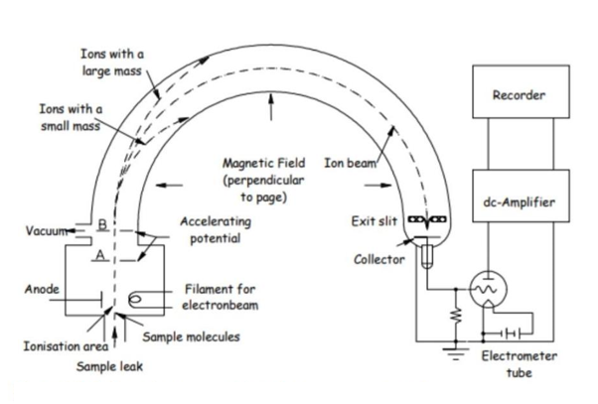
Figure I. 1:Représentation schématique d'un spectromètre de masse

The need for emptiness

Achieving high-quality vacuum in mass spectrometry is of paramount importance to ensure accurate and reliable measurements. Vacuum is essential to create an environment free of air molecules that could interfere with the ions generated during ionization. Indeed, the presence of air can cause collisions between ions and air molecules, altering their trajectories and potentially leading to erroneous results or degraded instrument performance.
The amount of vacuum required varies depending on the type of mass spectrometer used and the desired performance. To efficiently remove air molecules from the analysis chamber and maintain a high vacuum, mass spectrometers use sophisticated pumping systems. Typically, an ultrahigh vacuum level is preferred, with extremely low pressures ranging from 10-6 ^{to} 10-9 ^{millibars} . [2]

Sampling

Our main objective in this process is to characterize the toxic gases emitted during waste combustion. To do this, we will begin by acquiring a sample of a reference gas, such as HCl, to calibrate our instrument and assess its detection sensitivity. Once this reference is established, we can proceed with the controlled introduction of the toxic gases generated during waste combustion.
Sampling plays a fundamental role in mass spectrometry because it prepares the sample (whether gaseous, liquid, or solid) for subsequent analysis. This crucial step allows for the identification and quantification of compounds present in the sample.
Several sampling methods are available in mass spectrometry, each suited to specific sample types and applications. When the sample is gaseous, direct injection is particularly relevant. This technique involves directly introducing a small amount of the gaseous sample into the ionization chamber of the mass spectrometer (~ 20 ml of HCl gas for a volume of V=6185 cm ³ ), usually through a controlled valve or orifice. [3]
The direct injection process is broken down into several key steps:
- Sample preparation: The gas sample is pre-stored in a reservoir under controlled pressure, usually in a perfectly sealed gas cylinder. Ensuring the purity of the sample, free from contaminants, is crucial.
- Valve Selection: Select an appropriate valve for introducing the gas sample. High-quality valves designed for vacuum applications are essential to minimize leaks and maintain vacuum in the ionization chamber.
- Valve Preparation: Ensure the valve is clean and in good condition. Any contamination or damage could cause leaks or vacuum disturbances.
- Proper Connections: Connect the valve inlet to your gas sample source and connect the valve outlet to the mass spectrometer's ionization chamber.
- Valve Control: The valve must be controlled to allow precise opening and closing. This can be done manually or automatically, depending on your equipment and needs.
- Vacuum Check: Before introducing the sample, ensure that the vacuum system is operational and that the ionization chamber is under vacuum. This may require the use of appropriate pumps to evacuate air and residual gases.
- Sample Introduction: Open the valve in a controlled manner to allow gas to enter the ionization chamber. Be sure to monitor the pressure in the ionization chamber to avoid disturbing the vacuum.
Maintaining a higher pressure in the reservoir relative to the ionization chamber is essential to ensure efficient sample introduction.
- Flow Control: The flow rate of incoming gas can be controlled by adjusting the valve opening. Too high a flow rate can disrupt the vacuum or cause unwanted interference, while too low a flow rate can result in longer analysis times.
- Valve Closure: Once sample introduction is complete, close the valve in a controlled manner to stop the gas flow. Ensure that the pressure in the ionization chamber returns to appropriate levels.

Ionization

After the sample is introduced into the mass spectrometer, it is transported to the ionization chamber, which houses the tungsten filament, an electron trap plate, and an ion repeller plate. In this chamber, the tungsten filament is heated by applying a voltage, generating electrons. The role of the positively charged electron trap plate is to attract these electrons towards it, allowing the highly energetic electrons to bond with molecules in the sample gas and strip one or more electrons, forming positive ions. The majority of these positive ions have a charge of +1 because it is more difficult to strip more electrons from an already positive ion. Then, a slightly positively charged metal plate, the ion repeller, expels these ions from the ionization chamber, transporting them to the next stage of the analysis process. [1]
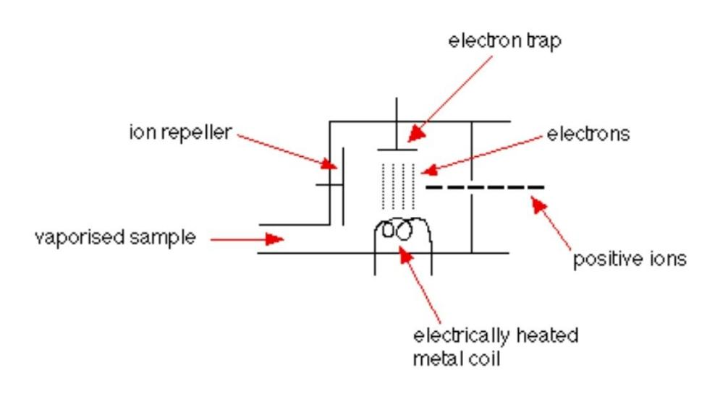
Figure I. 2:Chambre d'ionisation du spectromètre de masse

It should be noted that several ionization methods are available, but our choice fell on the electron impact method [4] , the details of which were presented in the previous paragraph. This method was favored for its advantages in our analysis context.
In order to guarantee the exclusive obtaining of +1 charge ions, it is imperative that the kinetic energy of the electrons colliding with the gases is between the first specific ionization energy and the second specific ionization energy of each gas. In order to respect these conditions, a voltage of 17 V will be applied between the tungsten filament and the electron trap , allowing the electrons to acquire a kinetic energy of 17 ev [5] , as shown in the table below. This approach ensures efficient ionization of target gases while avoiding the formation of ions with a charge other than +1.

Gas type | 1st ionization energy (IE1) in ev | 2nd ionization energy (IE2) in ev
HCl | 12.74 [6] | 35.6 [6]
HF | 15.77 [8] | 34.97 [9]
SO ₂ | 12.3 [7] | 33.5 [7]
Hg | 10.44 [10] | 18.57 [11]
Table I. 1 : Ionization energy of certain types of gas
The first ionization energy (IE1) represents the minimum energy required to remove an electron from a neutral atom or molecule, thus transforming it into a positive ion.

Acceleration

In the acceleration zone of the mass spectrometer, positive ions from the ionization chamber are subjected to an intense electric field designed specifically to accelerate them and increase their kinetic energy.
This acceleration gives the ions a high speed, allowing them to pass through the rest of the spectrometer with significant kinetic energy [12] . For this acceleration, a clever arrangement of three stainless steel discs is used, each equipped with a central orifice for the passage of positive ions. These discs are progressively negatively charged [13] , with the first disc being strongly negative (300 V), generating a powerful electric field that vigorously drives the positive ions towards the last disc. Progressing to the following discs, the ions continue to be accelerated by the electric field until the last disc, charged at zero, acts as a ground. This precise control of the electric field between the discs ensures optimal focusing of the positive ions, avoiding any unwanted dispersion or deviation. An intermediate disc, also negatively charged (150 V) but with reduced intensity compared to the first disc, ensures a progressive acceleration of the positive ions, stabilizing them in their trajectory and thus allowing their path towards the third disc, which acts as a final barrier, allowing the positive ions to reach the region of the mass spectrometer dedicated to their analysis.
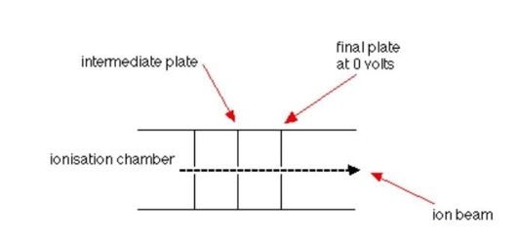
Figure I. 3:Zone d'accélération des ions d'un spectromètre de masse

Deflection

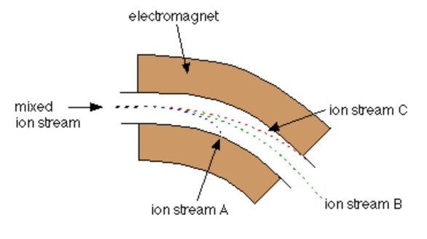
Figure I. 4:Zone de déflection d'un spectromètre de masse

The deflection zone within a mass spectrometer is a key step in separating ions based on their mass/charge ratio (m/z). This step plays a fundamental role in analyzing samples and identifying the different chemical species present.
As ions emerge from the ionization source, they enter a uniform magnetic field where a force is exerted on them due to their electric charge and moving speed. This magnetic force causes the ions to deviate from their original trajectory.
The degree of ion deflection depends on their mass-to-charge ratio (m/z) as well as their kinetic energy. Ions with a higher m/z ratio experience less deflection than those with a lower m/z, allowing them to be separated according to their respective masses in the mass spectrometer. [14]
The trajectory of ions in the magnetic field is generally curved, following circular orbits of radius R. This trajectory is governed by the principles of the "Biot-Savart law" or the "Lorentz force". As a result, ions with identical charge but different m/z values have distinct radii of curvature, resulting in their spatial separation.
It is relevant to consider all ions with a charge of 1+ to simplify the analysis, since the majority of ions passing through a mass spectrometer have this charge. Thus, the m/z ratio is directly equivalent to the mass of the ion.

Consider an ion of mass m and charge q, accelerated by a potential difference U in the ion source. The kinetic energy at the exit of the ion source is Ec=(mv ² /2) =qU.
Figure I. 5: Orientation de la force magnétique sur un ion en mouvement
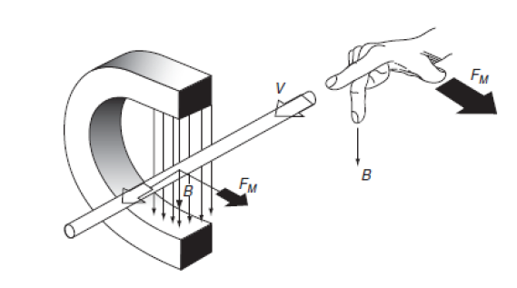
If the magnetic field has a direction perpendicular to the speed of the ions, the latter will experience a force F=qvB.
As the ions follow a circular orbit of radius R, the centrifugal force balances the magnetic force:
qvB = (mv ² /R) or mv = qBR.
The ions at the exit of the ion source then give:
(mv ² ) = 2qU; therefore m/q = (R ² B ² )/2U. [12]
U and R are constant, hence the separation according to B ² .

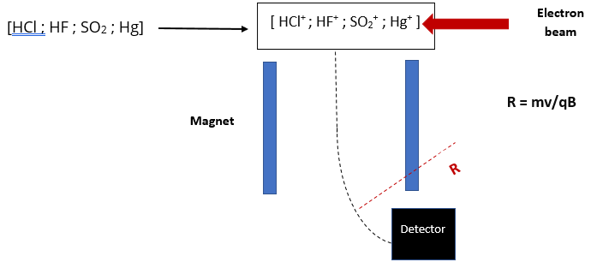

Figure I. 6 : Deviation of the trajectory of ions under the effect of the magnetic field

We have established the expressions R = (m*2*U / q*B ² ) ^{1 /2} and v = (2*q*U / m) ^{1/2} , where R represents the radius and v represents the speed. For a magnetic field of intensity B = 20 * 10 ⁻² T and a potential difference U = 300 V, we can deduce the corresponding values of the radius and the speed as shown below:

Gas type | Mass m (kg) | Radius R (m) | Speed v (cm/s)
HCl | 5.76 * 10 ⁻²⁶ | 0.073 | 408
HF | 3.2 * 10 ⁻²⁶ | 0.056 | 547
SO ₂ | 10.24 * 10 ⁻²⁶ | 0.098 | 306
Hg | 32 * 10 ⁻²⁶ | 0.173 | 173
Table I. 2 : Characteristics of some types of gases

Detection

The detection phase in a mass spectrometer represents a fundamental step during which the ions, coming from the mass analyzer, are measured and recorded in order to generate the final mass spectrum. At the heart of this step, the predominant role of the detector lies in the transformation of the ions into a detectable and usable signal.
After being separated by the mass analyzer, the ions enter the detection zone where the detector is located. This detector is designed to capture the physical characteristics of the ions, including their kinetic energy, electrical charge, and mass. Mass spectrometers use various types of detectors, each offering specific advantages and adapting to the specifics of the analytical application being performed. Furthermore, detector selection is based on the design of the instrument itself.
Only the ion stream is conveyed through the device to the ion detector. The other ions, on the other hand, collide with the walls, resulting in electron capture and neutralization. Ultimately, these neutralized ions are removed from the mass spectrometer via the vacuum pump.
When an ion reaches the collector, its charge is canceled by an electron jumping from the metal to the ion. This interaction creates a gap among the electrons in the metal, and electrons in the wire move to fill this gap. The flow of electrons generated in the wire is identified as an electric current, which can be amplified and recorded. The level of the detected current increases with the increasing number of arriving ions.
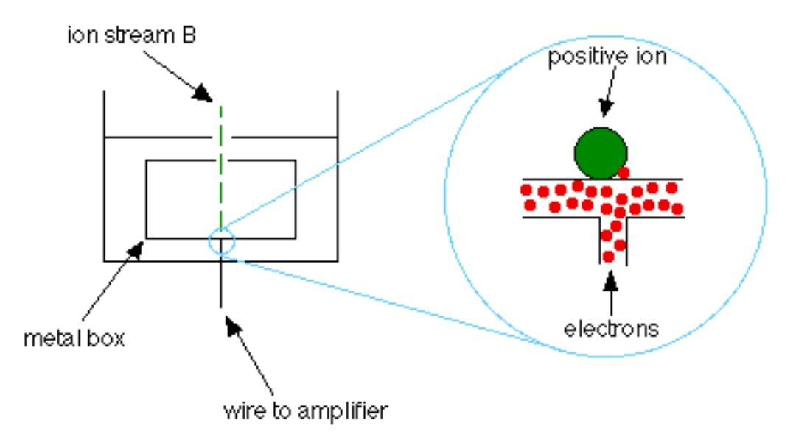

Figure I. 7: le processus de détection au niveau microscopique

Various strategies are implemented for ion detection, although this operation remains anchored in the fundamental parameters of the ions, such as their charge, mass or velocity.

Pump

Pressure range  [Pa] | Pressure range  [mbar] | Pressure range  [ mtorr ] | Empty
10 ⁵ – 10 ² | 1 bar – 1 mbar | 750 torr – 750 mtorr | Low Vacuum (LV)
10 ² – 10 ⁻¹ | 1 – 10 ⁻³ | 750 – 0.75 | Average vacuum (MV)
10 ⁻¹ – 10 ⁻⁵ | 10 ⁻³ – 10 ⁻⁷ | 0.75 – 7.5 * 10 ⁻⁵ | High vacuum (HV)
< 10 ⁻⁵ | < 10 ⁻⁷ | < 7.5 * 10 ⁻⁵ | Ultra-high vacuum (UHV)
Table I. 3 : Pressure ranges in vacuum technology [15]

Maintaining an optimal vacuum level in a mass spectrometer is of great importance to ensure accurate and reliable measurements. High vacuum (HV) is essential to prevent residual gas molecules from interfering with the ions being analyzed in the spectrometer, which could disrupt the results.
In general, the pressure inside the mass spectrometer must be maintained at very low levels, typically between 10 ⁻⁵ and 10 ⁻⁸ torr. This means that the density of residual gas molecules in the spectrometer chamber must be extremely low to reduce unwanted collisions with the ions being analyzed.
To create the required vacuum, special vacuum pumps are used. Typically, two pumping stages are used to generate the high vacuum required by the mass spectrometer. Rotary vane pumps, with pumping rates of approximately 4 to 16 m³/h, are commonly used to create an intermediate level vacuum. They are then connected to high-performance vacuum pumps, such as turbo molecular pumps, oil diffusion pumps, or cryopumps, to achieve the required high vacuum. These pumps work in tandem to compress atmospheric pressure down to the high vacuum of 10 ⁻⁴ to 10 ⁻⁵ Pa, with a total compression factor in the range of 10 ⁹ to 10 ¹⁰ . [15]
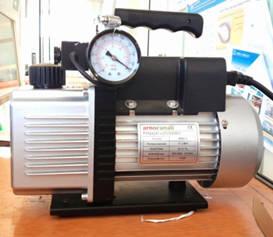
However, due to constraints such as the unavailability of this configuration in our center and its high cost, we chose to use an Arnocanali-type pump already present on site. It is important to note that this pump does not fully meet the requirements of our mass spectrometer. Its use could lead to various significant problems, including insufficient vacuum performance, a risk of contamination due to the presence of oil, less favorable noise and vibration levels, limited durability, as well as the need for substantial modifications to adapt it to our specific application.
Figure I. 8: Pompe de type Arnocanali

Helmholtz coil with soft iron

To distinguish between gas types, a crucial preliminary step is to subject them to deflection. This procedure directs each gas in a specific direction, giving them distinct trajectories. To accomplish this, the use of a magnetic field is imperative. The choice of magnet, particularly in terms of uniformity, perpendicular alignment relative to the ion velocity, and downward orientation, led us to favor the use of a Helmholtz coil equipped with soft iron.

Definition

The Helmholtz coil with soft iron is a device used in physics to create a uniform and constant magnetic field in a specific area of space. It consists of two identical circular coils, positioned symmetrically on either side of a central axis, at a distance equivalent to their own radius [16] . The key element of this type of coil is the integration of soft iron cores inside the coils. The presence of this material is crucial to enhance the intensity of the magnetic field [17] . Soft iron has a great ability to effectively concentrate and guide magnetic field lines through itself due to its high magnetic permeability. By incorporating it into the winding, it reduces field losses to the outside and improves field uniformity, thus ensuring an even distribution of magnetic forces. In addition, it helps maintain the stability of the magnetic field by minimizing external disturbances.

Features

The main characteristics of Helmholtz coils with soft iron are:
- Two identical coils: A Helmholtz coil usually consists of two identical coils, usually circular in shape, each having the same number of turns and the same radius.
- Fixed Distance: The two coils are spaced a specific distance apart, called the intercoil distance, so that the resulting magnetic field is uniform in a specific area between the two coils.
- Uniform magnetic field: The main purpose of a Helmholtz coil is to create a uniform magnetic field in the region between the two coils. This allows experiments or measurements to be performed in a constant magnetic environment.
- Series Configuration: Helmholtz coils are usually wired in series, so that the electric current flows in the same direction through both coils, thus producing a strengthened magnetic field in the central region.
- Precise control: By adjusting the electric current flowing through the coils and the inter-coil distance, it is possible to precisely control the intensity and direction of the magnetic field in the central area.
- Magnetic field amplification: Soft iron increases the magnetic permeability of the system, meaning it makes it easier for magnetic field lines to pass through the material. This has the effect of amplifying the magnetic field in the central region between the coils.
- Magnetic field concentration: Soft iron can channel magnetic field lines, "steering" them more through the central region between the coils. This can potentially lead to an increase in magnetic flux density in this region. [16] .

Mathematical formula

The formula for calculating the magnetic field at the center of the gap between the two Helmholtz coils is given by the equation:

B=$\frac{μ0 I N {R'}^{2}}{2({R'}^{2}+{\left(x-{\left(\frac{d'}{2}\right)}^{2}\right)}^{\frac{3}{2}}}$ [16]

This formula is derived from the Biot-Savart law and allows the calculation of the magnetic field at any point on the central axis of the coils as a function of the physical parameters of the configuration.
The integration of soft iron cores into the Helmholtz coil requires consideration of the relative permeability coefficient of this material. Thus, we will complete the previously stated rule with µ _{r} [17] :

B=$\frac{µ I N {R'}^{2}}{2({R'}^{2}+{\left(x-{\left(\frac{d'}{2}\right)}^{2}\right)}^{\frac{3}{2}}}$
With µ = µ _{r} µ ₀ .

Manufacturing conditions

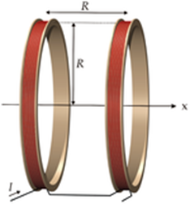
Precision in the manufacture of Helmholtz coils is crucial to ensuring a uniform magnetic field. It is essential that the coils have identical geometric specifications, such as the number of turns and the current flowing through them. The use of highly conductive materials with low resistance helps minimize energy losses and ensure optimal performance. Precise coil alignment and spacing equivalent to the radius are determining factors for achieving a uniform magnetic field between them. In addition, meticulous coil insulation is necessary to prevent current leakage and unwanted electromagnetic interference. [16]
Figure I. 9: Schéma représentant d'une bobine de Helmholtz
The addition of soft iron cores introduces additional considerations into the manufacturing process. It is essential to select a high-quality soft ferromagnetic material, such as mild steel, with high magnetic permeability and low coercivity. The cores must be precisely integrated into the coil structure, ensuring they are properly aligned to maximize their impact on magnetic permeability. They must also be securely fixed in place to prevent movement during coil use. In addition, it is imperative to ensure adequate electrical insulation between the soft iron cores and the coils to prevent short circuits. [17]

Detector

In a mass spectrometer, a variety of detectors are used to quantify the ions generated following sample ionization. One of these detectors, the Faraday cup, is based on the principle of measuring the electric current induced by the impact of ions on a conductive surface. More specifically, the Faraday cup consists of a metal electrode placed in front of the ionized analyte. When the ions collide with the surface, they transfer their charge, generating a current proportional to the number of incident ions. [18]
However, it is essential to note that the Faraday cup has certain limitations compared to other newer detectors. On the one hand, its sensitivity is relatively lower, especially compared to dynode detectors that can detect lower ion concentrations. On the other hand, there is a possibility of losing some electrons, which can lead to a decrease in measurement accuracy.
Despite these drawbacks, we chose the Faraday cup because of its inherent advantages. It offers accurate and reliable measurements and is ideal for a wide range of ionizable compounds. Furthermore, its simple design makes it economical and easy to manufacture. Our decision was also driven by budgetary constraints that prevented us from considering other types of detectors, the costs of which would have exceeded our research budget. [19]

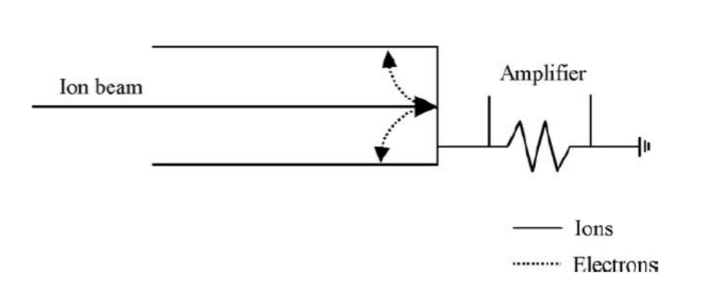
Figure I. 10: Diagramme schématique d'une coupelle de Faraday

After the crucial detection phase by this detector, the generated signal requires an amplification step to improve its detection and ensure accurate measurements. This amplification is essential to overcome the limitations related to the initial signal sensitivity. A specialized electronic amplifier is used for this purpose, allowing the amplitude of the detected ion signal to be increased. Subsequently, the amplified signal undergoes a detailed analysis process. Filtering steps can be applied to eliminate any unwanted noise or interference, thus ensuring optimal data quality. Then, if necessary, a signal conversion can be performed to prepare it for further computer analysis. This step is crucial to extract valuable quantitative and qualitative information from the initial signal. Recorded and ready for analysis, the data provided by the Faraday cup detector allows for reliable and accurate results in the mass spectrometer, thus contributing to the rigor and validity of the entire research experiment. [19]

CHAPTER II: Mechanical Design

In this chapter, we will explore two distinct areas. The first will focus on mechanical design, covering essential elements such as fundamental principles, the use of Computer-Aided Design (CAD), and the implementation phase. The second will focus on automation, which encompasses the automated collection and analysis of data through the use of computerized systems.

Mass spectrometer design

Fundamental Precepts

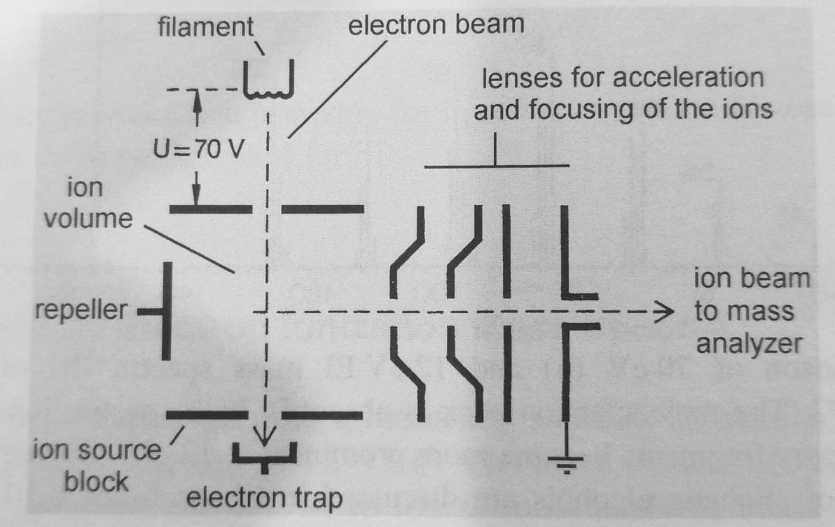
Figure II. 1: Disposition schématique typique d'une source d'ions
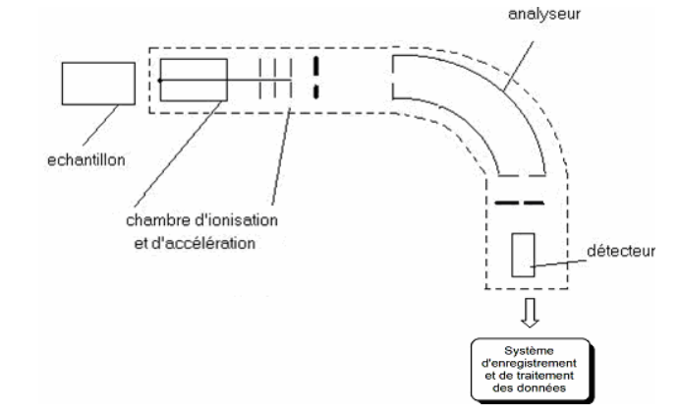
Figure II. 2: Séquence des étapes dans un spectromètre de masse

The two aforementioned illustrations illustrate the trajectory of ions through different stages, starting with the gas ionization phase inside the ionization chamber. The ions then progress to the acceleration zone before entering the deflection section, and finally end up in the detection zone. Based on this principle, a similar design was developed, encompassing these four crucial phases.
Within the ionization chamber, a sample of residual gas containing harmful compounds such as HCl, HF, SO2 and Hg is introduced. There, this gas is positively ionized by a collision with electrons emanating from a tungsten filament, carrying a kinetic energy of 17 eV. Following this ionization process, the ions are repelled by an ion repellent plate, prompting them to enter the acceleration phase.
At this stage, the ions wait in front of three negative potential plates – 300, 150 and 0 volts respectively – before progressing to the deflection phase. There, they are subjected to a 0.2 T magnetic field created by an inverted coil. This magnetic field causes the ion trajectories to deviate, so that each ion follows a specific path based on the m/z (mass/charge) ratio. Subsequently, the ions are captured by a "Faraday cup" type detector during the detection phase.

Computer Aided Design (CAD)

To develop the mass spectrometer model, we used "FreeCAD" software.
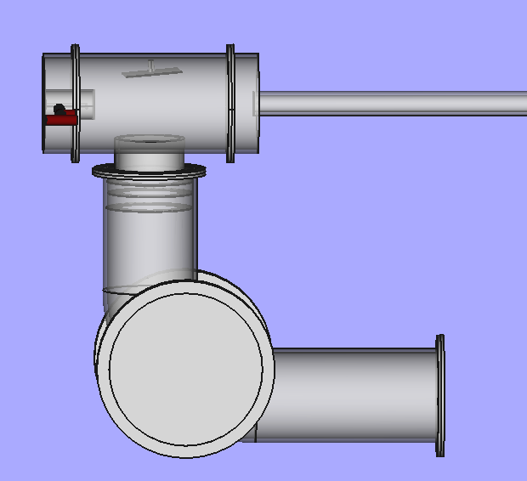
Figure II. 3: Conception du modèle du spectromètre de masse

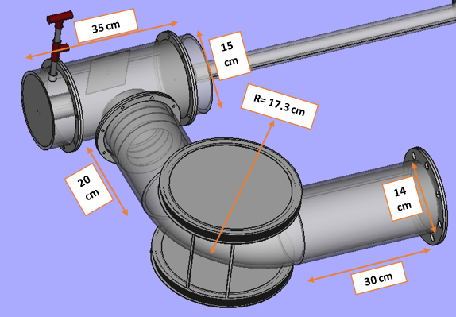
Figure II. 4: Mesures spécifiques du modèle de spectromètre de masse

- Ionization chamber
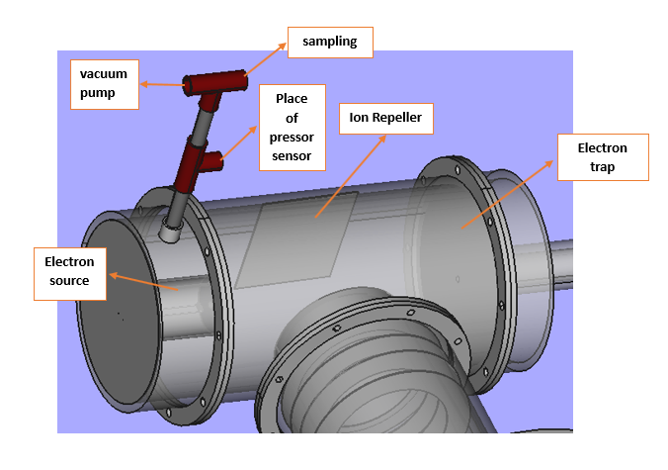
Figure II. 5: Les composants de la chambre d'ionisation

- Acceleration zone
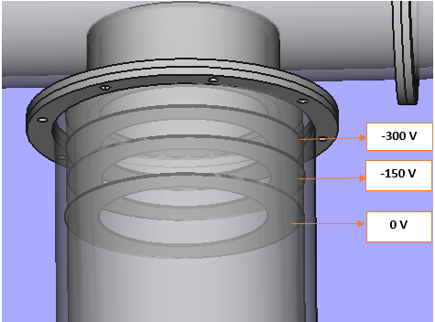
Figure II. 6: Répartition de la tension sur les plaques d'accélération

- Deflection zone
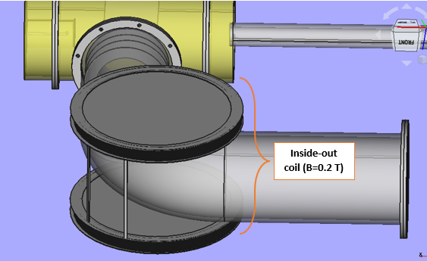
Figure II. 7: La présence de la bobine de Helmholtz dans la zone de déviation

- Detection zone
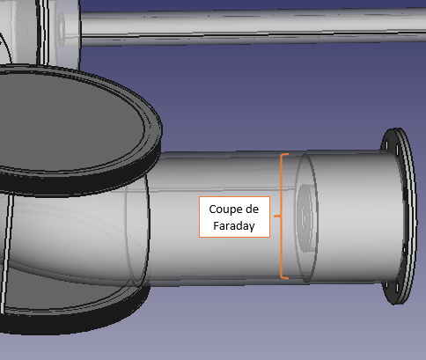
Figure II. 8: Position du détecteur du type Coupelle de la Faraday dans la zone de déflection

Realization

Due to its advantageous properties, such as resistance to corrosion, heat, ease of maintenance and shaping, as well as its long durability, stainless steel proves to be an optimal choice [13] . In addition, it has low reactivity with gases, such as HCl, HF, SO ₂ , Hg, compared to other materials. Considering the easy availability of this type of metal within the center, we made the decision to manufacture our mass spectrometer from stainless steel. This option fits perfectly with our objective of ensuring the quality and durability of our equipment.

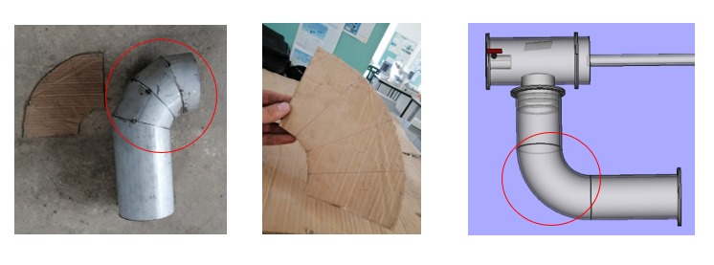
The elbow shown below, which will act as the deflection zone in the mass spectrometer, was designed taking into account all the trajectories that the ions will follow when subjected to the magnetic field. This ensures that all ions will follow their path without risk of collision or loss.
Figure II. 9: Le tube courbé où le champ magnétique est applique′

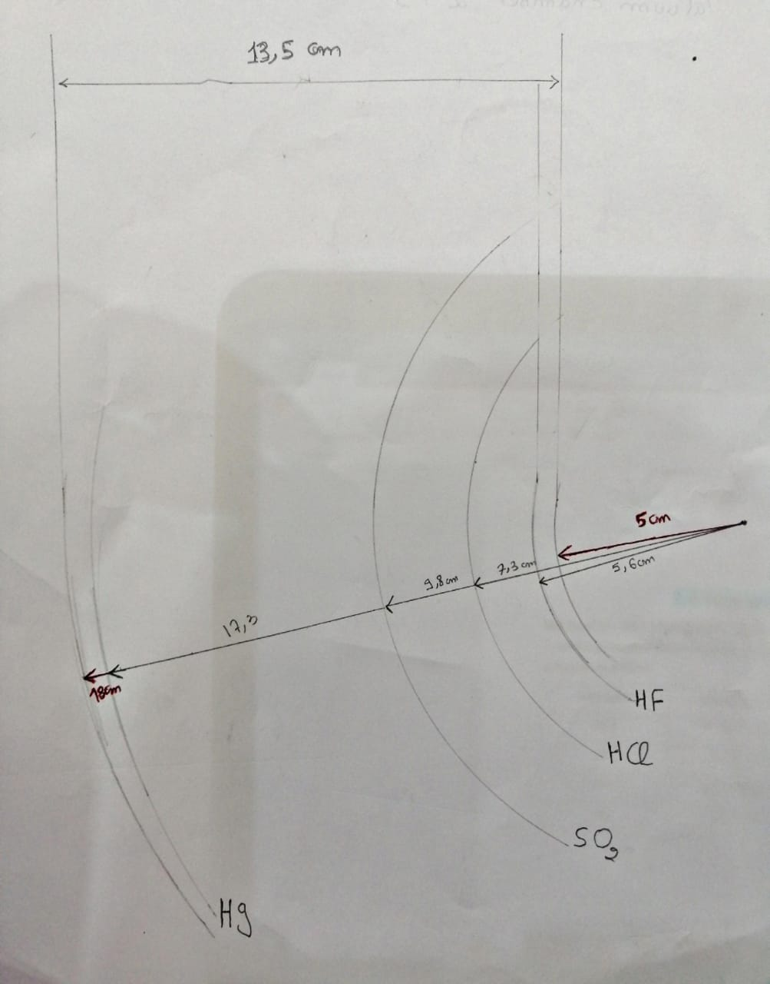
Section (1.5. Deflection) specified the radii of each ion. Using this data, we calculated the difference between the largest and smallest radius. As a result, we made an elbow with a diameter greater than this difference, and with a curvature of 17.3 cm, thus ensuring the inclusion of all possible trajectories.
Figure II. 10: Les trajectoires des ions sous l'influence du champ magnétique

The component in question, made available by the AECENAR Centre, was used and adapted to ensure the function of ionization chamber within the mass spectrometer.
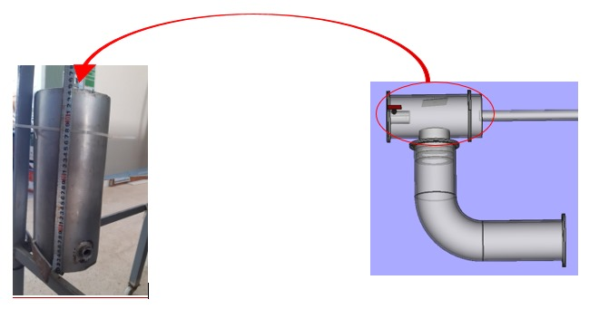
Figure II. 11: Longueur de la chambre d'ionisation (~35 cm)
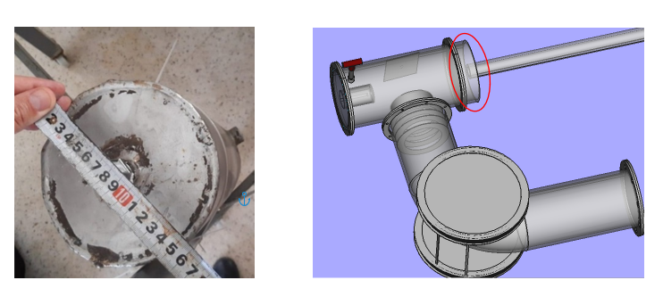
Figure II. 12: Diamètre en coupe transversale de la chambre d'ionisation (~ 15 cm)
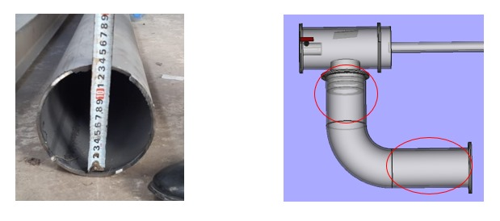
Figure II. 13: Diamètre en coupe transversale de deux tubes horizontaux (~ 14 cm)

In the diagrams shown below, flanges play a fundamental role in ensuring a secure connection between two components. They provide easy assembly and disassembly, ensuring a robust connection. They also allow for the isolation of specific sections if necessary. In terms of importance, flanges contribute significantly to the structural integrity, safety, and flexibility and adaptability of systems. [13]

Figure II. 14 : Fabrication of flanges for the various mass spectrometer components

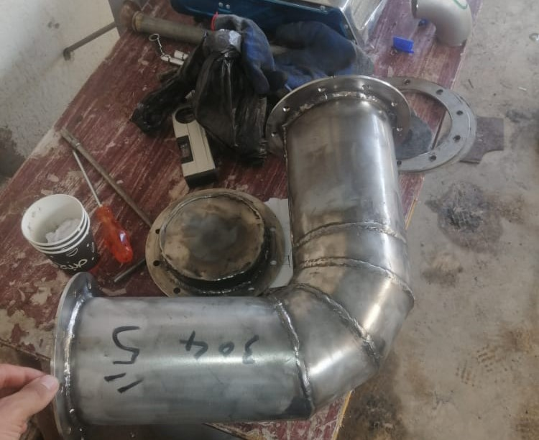

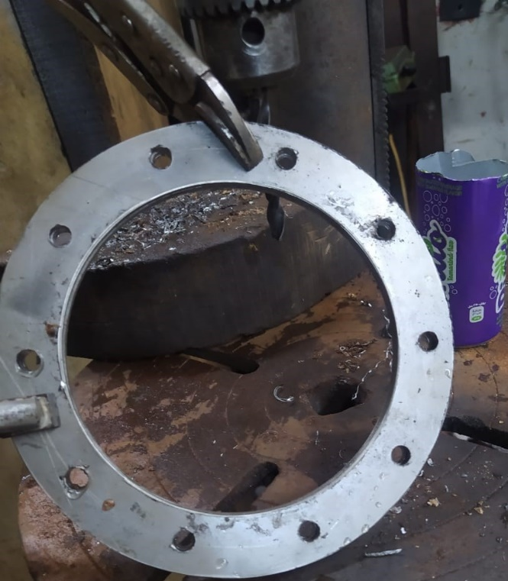
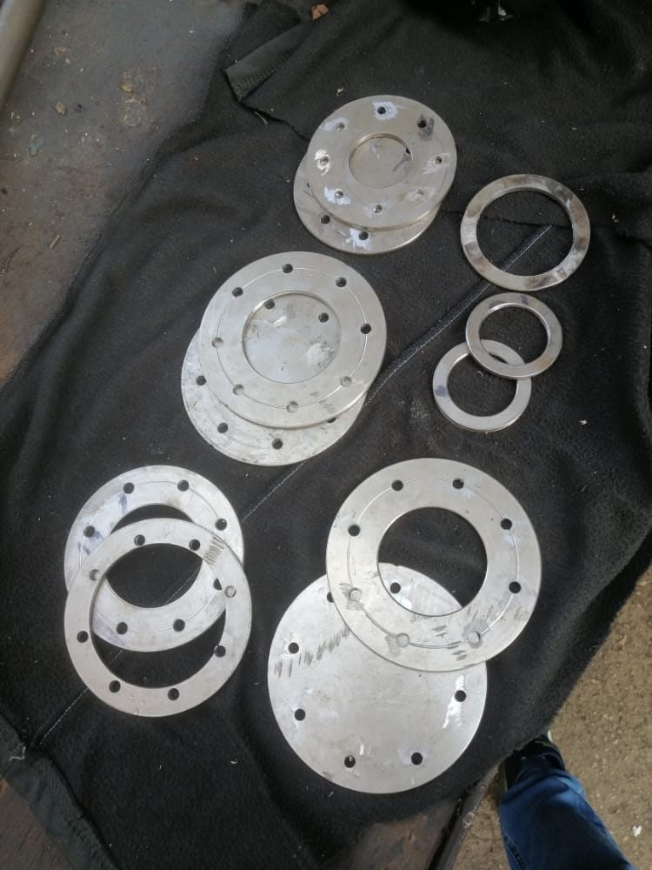

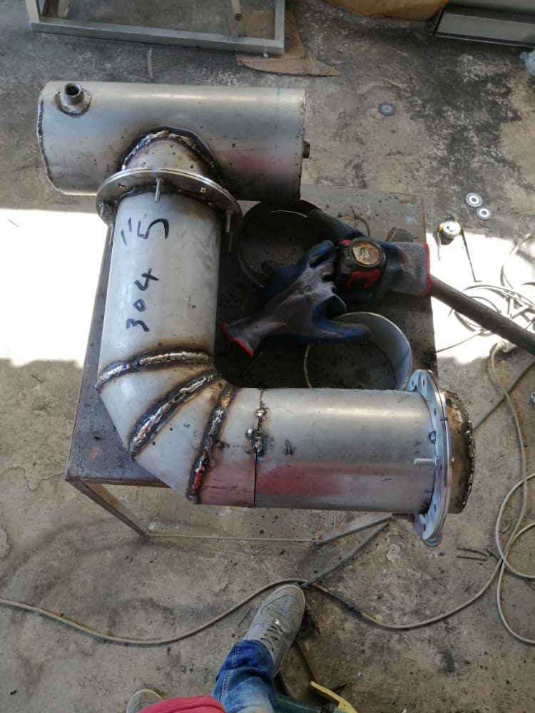

Figure II. 15 : Mass spectrometer manufacturing and assembly steps

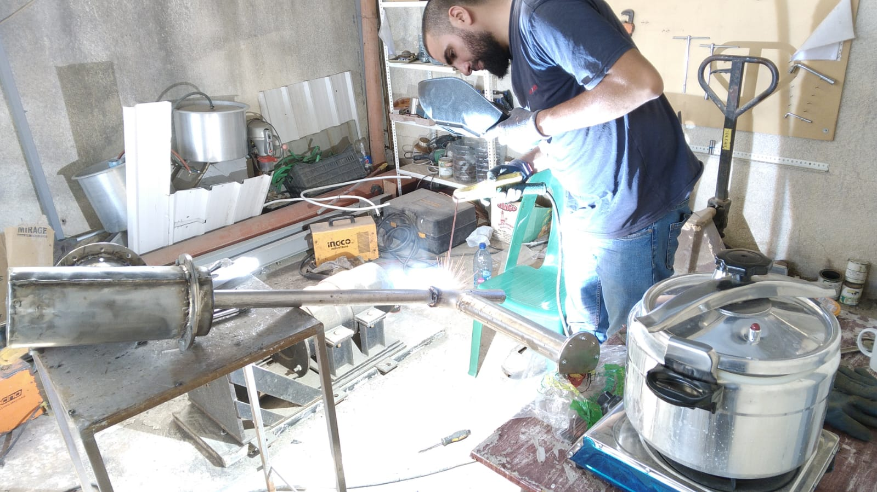
Figure II. 16: La soudure pendant la fabrication du spectromètre de masse

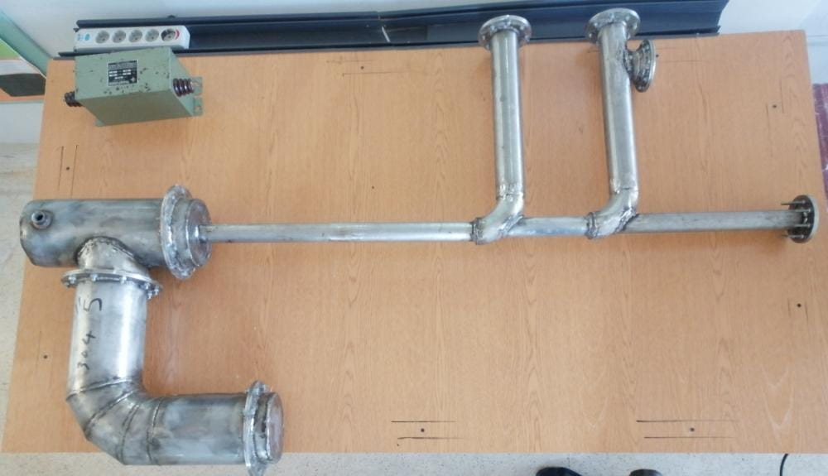
Figure II. 17: Le prototype assemblé intègre également le spectromètre de masse

Detector design

Fundamental Precepts

A Faraday Cup is a detector that detects the presence of charged particles by accumulating them on the surface of the detector.
The Faraday Cup operates based on the principles of electrochemistry and the conservation of electric charge. The electrochemical process is the fundamental principle behind the Faraday Cup. When charged particles, such as ions or electrons, encounter a conductive surface (the cup's collection surface), they can transfer their charge to that surface. This charge transfer is facilitated by an electrochemical reaction between the charged particles and the conductive material of the cup's electrode. This reaction creates a potential difference between the electrodes and the current-integrating circuit, which induces an electric current that flows through an external circuit connected to the cup. This current is proportional to the number of charged particles collected by the cup. By measuring this electric current, the number of charged particles that impacted the cup's surface can be determined. [18]
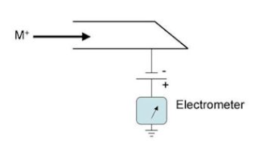
Figure II. 18 : Principle of the Faraday cup
The design of the Faraday Cup is one of the factors that will determine whether it will function as intended. This report will discuss the modules that have been studied so far.

Computer Aided Design (CAD)

In this section, we will examine the development of the Faraday dish model. This may be motivated by constraints related to the availability of materials required for its manufacture, or to meet the specific requirements of our project, thus requiring adjustments to the model.
Model #1
The original model is renowned for its notoriety in the field of Faraday cups. It is distinguished by a cylindrical brass cup, optimized to minimize electron losses during reflection within the cup. [20]
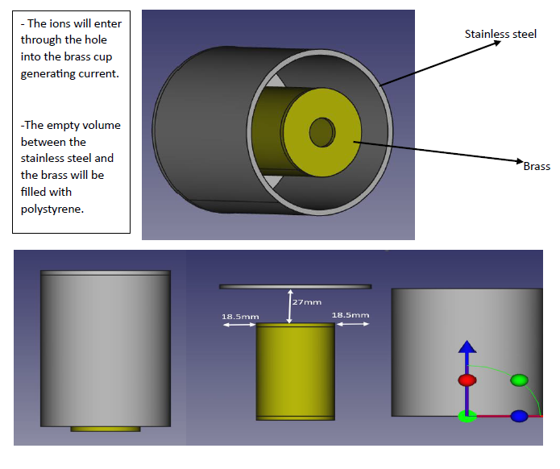
Figure II. 19: Première proposition de conception [18]

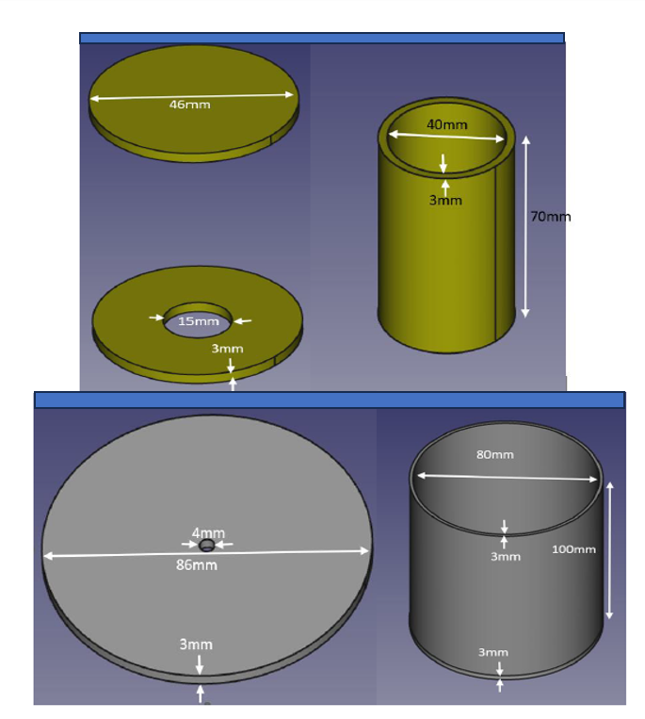
Figure II. 20: Mesures du premier modèle

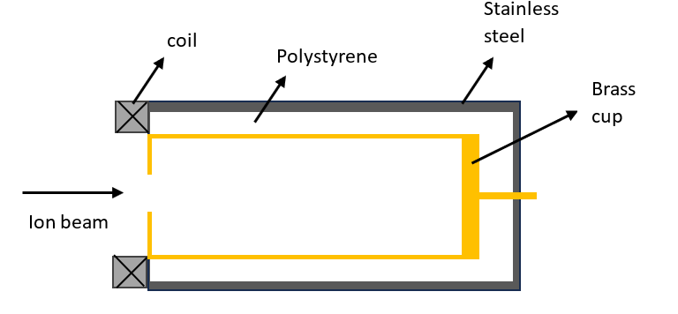
The challenge we faced in creating this prototype was the complexity of adjusting the brass cylinder to the necessary size, in addition to the delicacy required when soldering the brass components, given that it does not withstand the high temperatures inherent in the soldering process. Therefore, we chose to focus on the second model.
Figure II. 21: Section transversale du module 1

Model #2

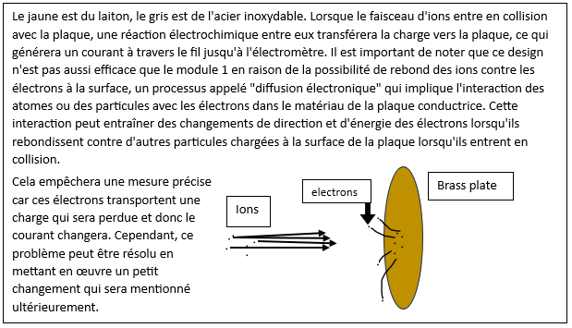
Figure II. 22: Le mode de fonctionnement du deuxième modèle [21]
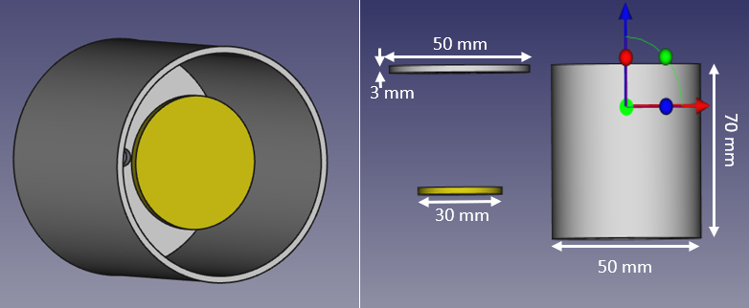
Figure II. 23: Mesures du deuxième modèle

Model #3
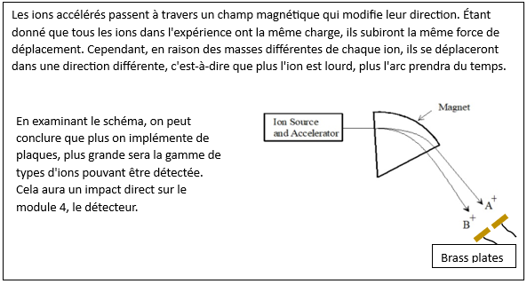
Figure II. 24: Le Fonctionnement du Deuxième Modèle [20]

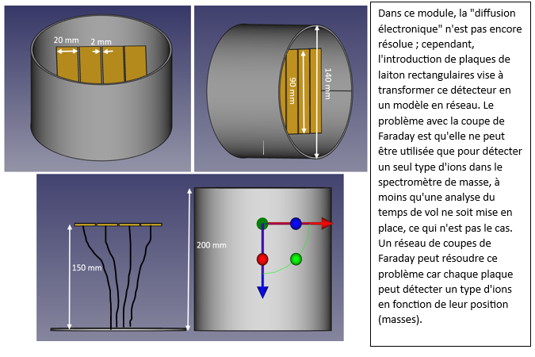
Figure II. 25: Mesures du troisième modèle

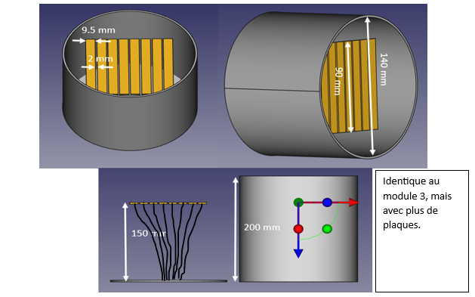
Model #4
Figure II. 26: Mesures du quatrième modèle

Model #5
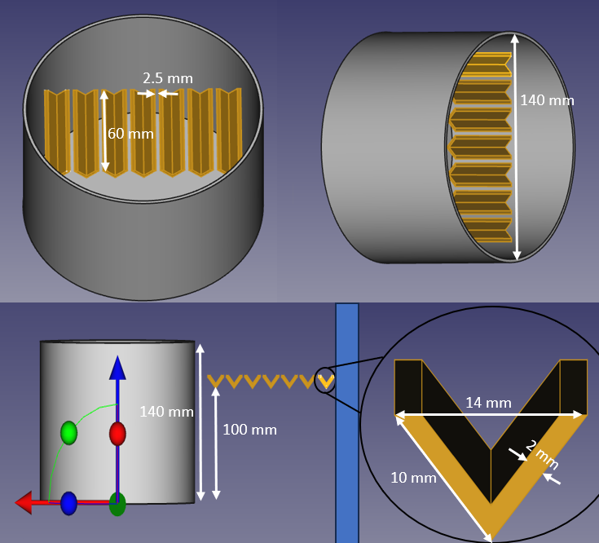

Figure II. 27: Mesures du cinquième modèle
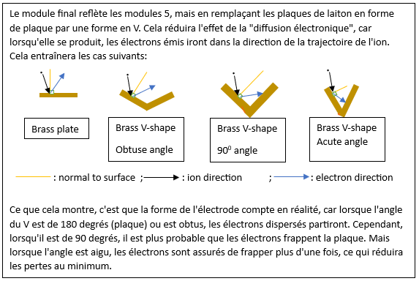

Figure II. 28: Le fonctionnement du cinquième modèle

Realization

The attached photograph illustrates the making of the second model of the Faraday dish. Starting with the simplest to make, we first ensure that it can capture charges, before proceeding to the manufacture of the model most suited to our project. This Faraday dish consists of a stainless steel cylinder, with a brass plate placed in the center and an insulating material between the two to ensure fixation.
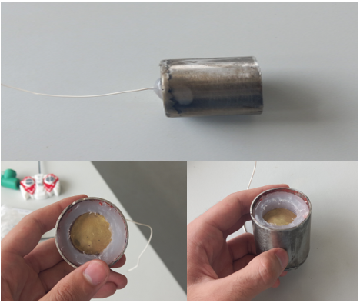
Figure II. 29: Conception Miniaturisée du Deuxième Modèle

Faraday Cut Detector Amplification Circuit

Introduction

By opting for the Faraday cup design, we anticipate an extremely low current at the cup output. This underlines the need to integrate an amplification circuit to increase this signal to a detectable and usable level. In the mass spectrometer under development, the particles of interest undergo ionization, thus transforming each molecule into a positively charged ion, having lost an electron. Therefore, for significant ion currents, an ion (+1) carries a charge of 1.6 x 10 ⁻¹⁹ Coulombs. This means that one ion per second is equivalent to 1.6 x 10 ⁻¹⁹ A, or 1.6 x 10 ⁻⁴ fA.

Equipment and roles
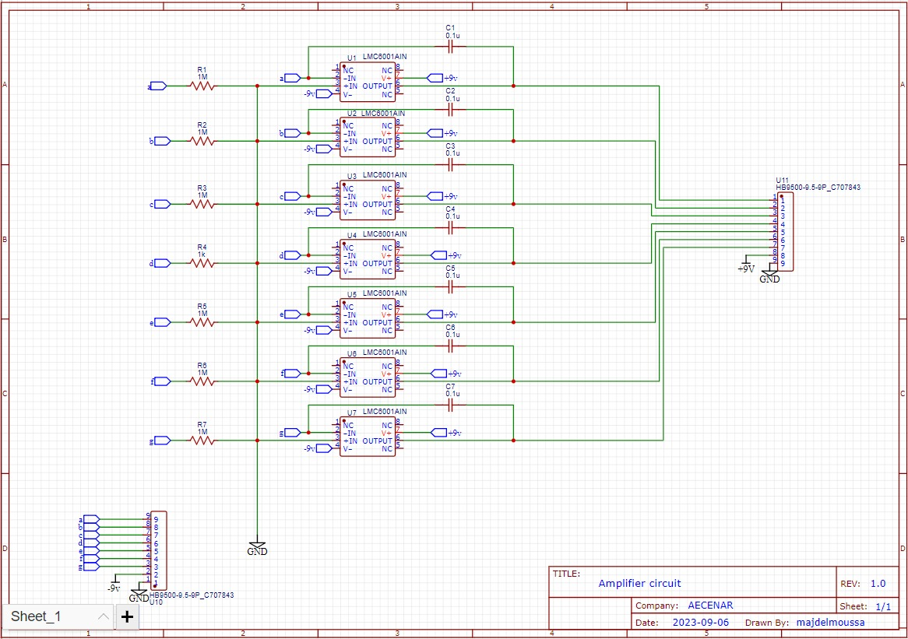
Figure II. 30: Schéma du circuit de l'amplificateur pour la coupelle de Faraday

Printed Circuit Board (PCB) Design
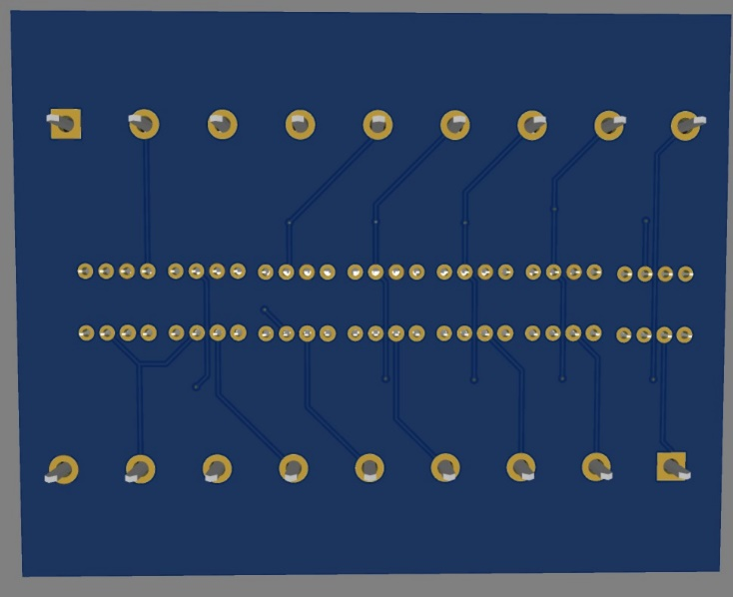
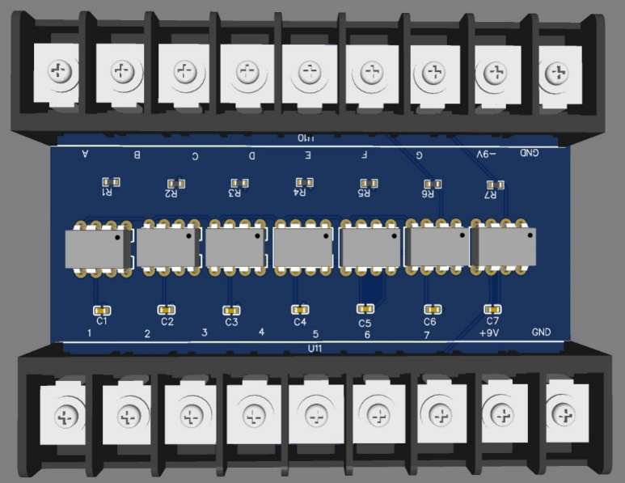
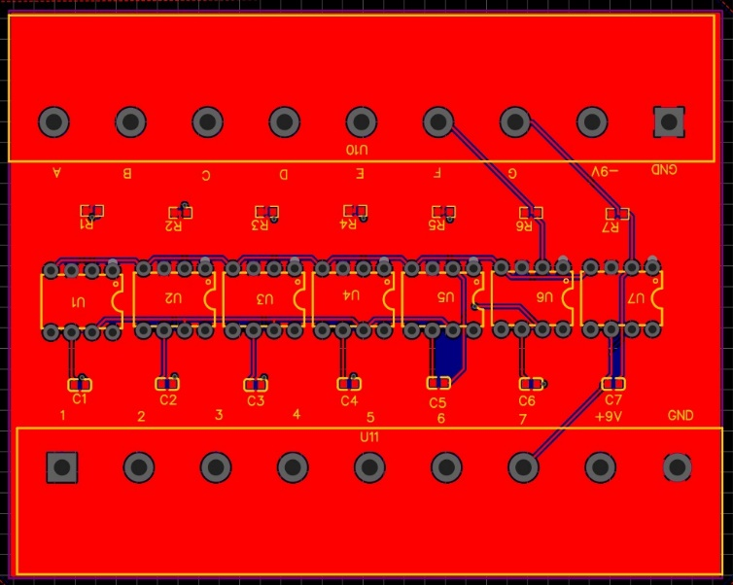

Figure II. 31 : The front-back image of the amplifier circuit (3D)
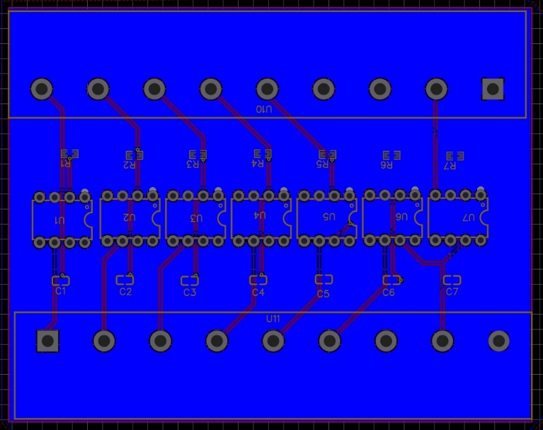

Figure II. 32 : The front-back image of the amplifier circuit with the copper layers

Amplifier circuit

Operational Amplifiers U ₁₋₇ : Operational amplifiers, or op-amps, are circuit elements that can be used for several tasks. Here, they amplify voltage signals from Faraday cups so that they can be recorded and stored.
Resistors R ₁₋₇ : The current created by the Faraday cups will induce a potential difference across these resistors, which will then be amplified by the op-amps.
Capacitors C ₁₋₇ : Capacitors are used to reduce the effect of external noise on the signal from the cuts.
Port U ₁₀₋₁₁ : Input/output port of the amplification circuit.

Calculations and figures

About the LMC 6001 Operational Amplifier:
Input bias current (max) = 25 fA
Your (voltage offset at 25°C) (max) = 0.35 mV
Total supply voltage (+5 V = 5, ±5 V = 10) (max) = 15.5 V
Total supply voltage (+5 V = 5, ±5 V = 10) (min) = 4.5 V
Voltage gain for strong signals (A) = 1400V/mV or 1400000 times the input.
So if the input is 1nV, the output will be 1.4mV.

The LMC 6001 A1 operational amplifier was chosen for this application due to its high sensitivity and low amplifier noise. Its common mode rejection ratio (CMRR) is 83 dB, which means that the op-amp can effectively reject common mode signals (internal noise).
This is a desirable value for precision and sensitive applications. It means that the op-amp can amplify differential signals (out-of-phase signals on the inputs) while attenuating common-mode signals (in-phase signals on the inputs).


Figure II. 33: Amplificateur opérationnel

Helmholtz coil design with soft iron

Fundamental Precepts

Proper design of Helmholtz coils requires strict adherence to essential conditions that form the basis of their development. This section focuses on the fundamental principles of Helmholtz coil design, highlighting the crucial elements for optimal manufacturing and ensuring superior performance.
- Consistent Twin Coil Characteristics
It is imperative that the coils have identical geometric characteristics, number of turns, and electrical current. This strict uniformity ensures the harmonious alignment of the generated magnetic field, thus contributing to optimal performance.
- Alignment and Spacing Accuracy
Precise parallel alignment, combined with radius-equivalent spacing, is essential to achieve uniform magnetic field distribution across the core of the device. This rigorous arrangement eliminates any unwanted asymmetry.
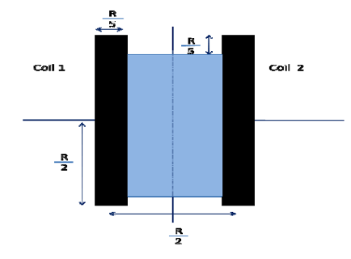
- Sizing of the Coiled Section
Figure II. 34: Quelques conditions de fabrication de la bobine de Helmholtz
For optimum performance, the dimensions of the wound section in terms of width and depth should not exceed one tenth of the coil diameter (D/10). This measurement ensures consistent winding and prevents unwanted distortions of the magnetic field.
- Selection of Good Conductive Materials
The choice of materials for the coils is crucial. Using materials such as 1 mm thick copper wire, which allows good current flow and has low resistance, is essential to minimize energy losses and optimize coil operation.
- Careful Insulation
Proper coil insulation is essential to prevent current leakage and unwanted electromagnetic interference. Good insulation allows the coils to operate independently and prevents unwanted external influences. Therefore, the use of a specific type of plastic is recommended.
- Adding Iron
The incorporation of iron into the Helmholtz coil significantly contributes to increasing the magnetic field, thus avoiding the need to excessively increase the number of turns. This helps to optimize the efficiency of the device.

CAD
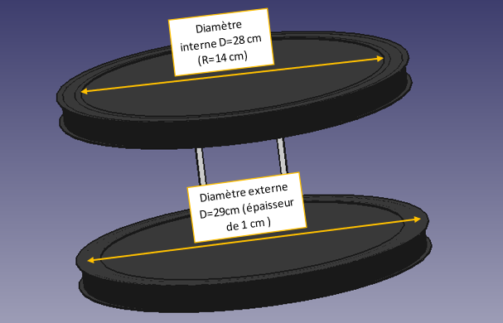
Figure II. 35: Quelques mesures du modèle de la bobine de Helmholtz avec fer
To develop the model of the Helmholtz coil, we used the software "FreeCad".
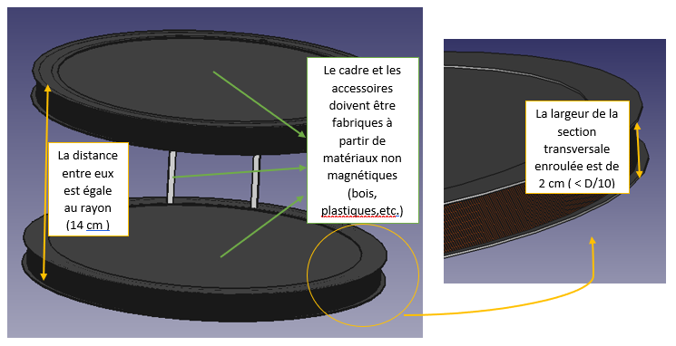
Figure II. 36: Quelques caractéristiques du modèle de la bobine de Helmholtz avec fer

Realization

To exploit the Helmholtz coil formula while ensuring the required diameter and meeting our need for a significant magnetic field, it is important to consider the constraint related to the electric current that can be supplied to the coil. This implies a high number of turns, exceeding 4000, which can be difficult to achieve. In order to reduce this number, we opted for the addition of ferrous material inside the coil. This approach increases the magnetic field while requiring a lower number of turns. It should be noted that soft iron is the preferred material in such projects, but due to its limited availability, we undertook an experiment comparing two commonly available types of iron: ordinary iron, accessible to all, and the type used in transformers, known for its beneficial effect on the magnetic field.
We have: B= $\frac{µ I N {R'}^{2}}{2({R'}^{2}+{\left(x-{\left(\frac{d'}{2}\right)}^{2}\right)}^{\frac{3}{2}}}$with R′=14 cm, x=7.5 cm, d′=14 cm.
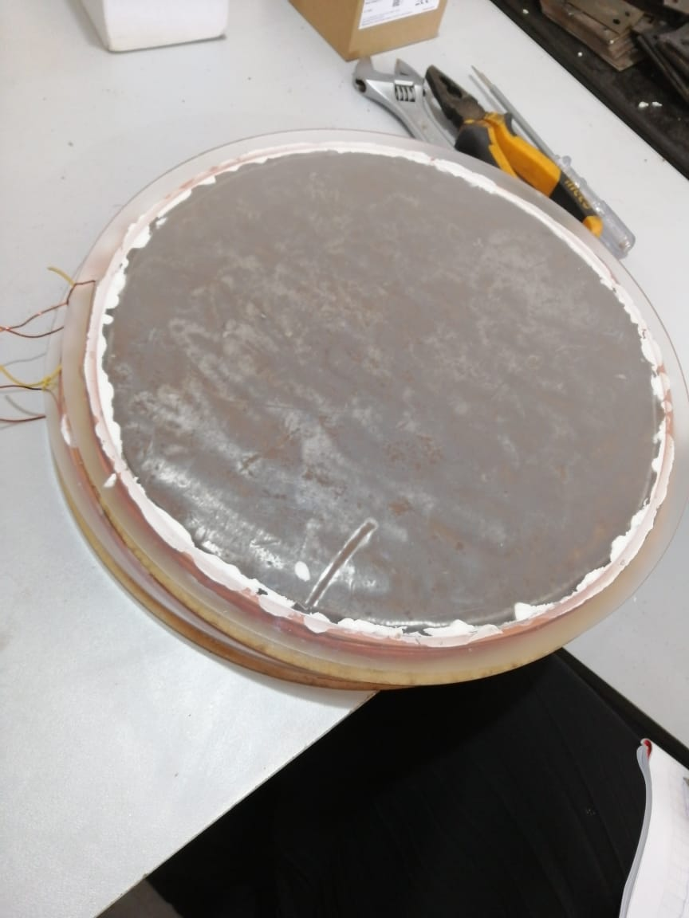
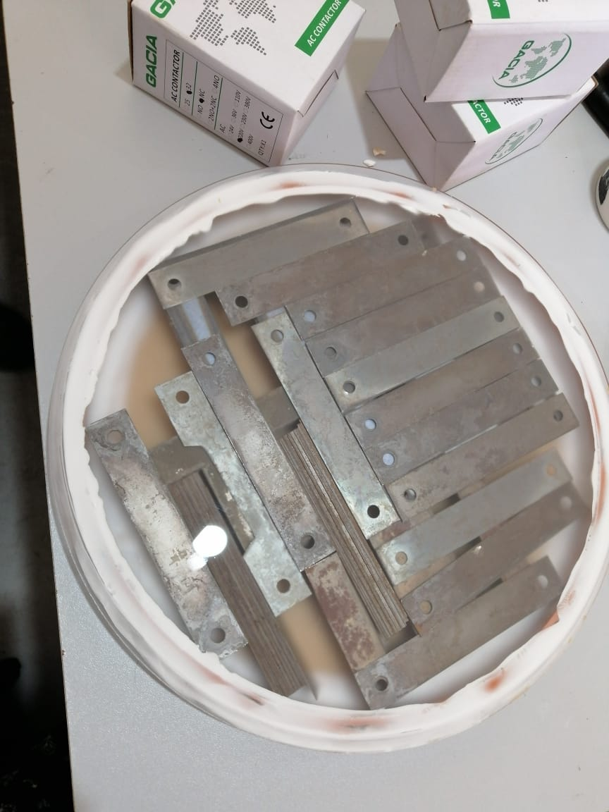
The permeability of iron will be determined from the experiment. The parameters I and N will be adjusted until a magnetic field of 0.2 Tesla is obtained.
Figure II. 37: l'emplacement du fer ordinaire dans la bobine de Helmholtz
Figure II. 38: L'emplacement du fer spécifique des transformateurs dans la bobine de Helmholtz

CHAPTER III: Tests and Discussion

Helmholtz coil test with iron

2.1. Requirements

- Mechanical requirements:
The Helmholtz coil should be made of two plastic pieces, with iron inside, and copper strips wrapped around it.
- Electrical requirements:
The power supply will be variable until we achieve the desired result .
- Magnetic requirements:
The Helmholtz coil must be able to generate the magnetic field on the bent tube.
The Helmholtz coil must be able to generate a magnetic field of 0.2 T.

2.2. System Test Specification

Stage | Description of the stage | Expected result
Precondition | The system is off
Turn on the system | Turn on the Helmholtz coil by supplying it with a corresponding power supply | Obtain a magnetic field (B = 0.2 T)
Turn off the system | Turn off the Helmholtz coil | The magnetic field stops
Postcondition | The system is off

2.3. System Test and Results

- Test 22.09.23
Stage | Description of the stage | Expected result | Result
Precondition | The system is off
Turn on the system | Turn on the Helmholtz coil by supplying it with a corresponding power supply | Obtain a magnetic field (B = 0.2 T) | Negative
Turn off the system | Turn off the Helmholtz coil | The magnetic field stops | Positive
Postcondition | The system is off
Analysis of test results:
In this experiment, we used iron similar to that found in transformers. We connected them optimally and inserted them inside each flat coil. We set the number of turns to N = 10. At each step, we gradually increased the voltage, which caused an increase in the current as well as the magnetic field. This process was repeated until the value B = 0.6 mT << 200 mT was reached.
I (A) | 0.58 | 1.14 | 1.72 | 2.32 | 2.88 | 3.41 | 3.98 | 4.53 | 5.63 | 6.13 | 6.62 | 7.15 | 7.62 | 8.62
U (v) | 0.25 | 0.5 | 0.75 | 1 | 1.25 | 1.5 | 1.76 | 2 | 2.5 | 2.75 | 3 | 3.26 | 3.51 | 4
B (mT) | --- | --- | --- | 0.2 | 0.25 | 0.28 | 0.31 | 0.34 | 0.42 | 0.45 | 0.48 | 0.51 | 0.53 | 0.6

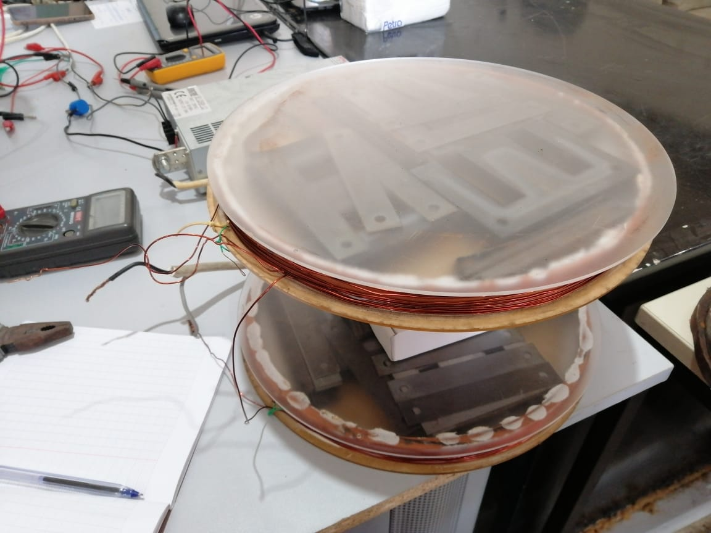
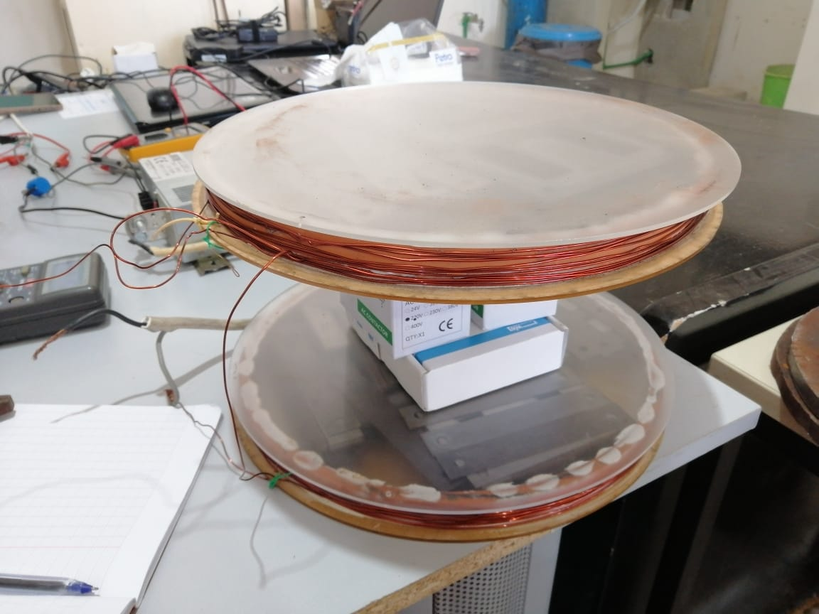

Figure III. 1 : Arrangement of the transformer iron at a distance of 14 cm in each of the flat coils
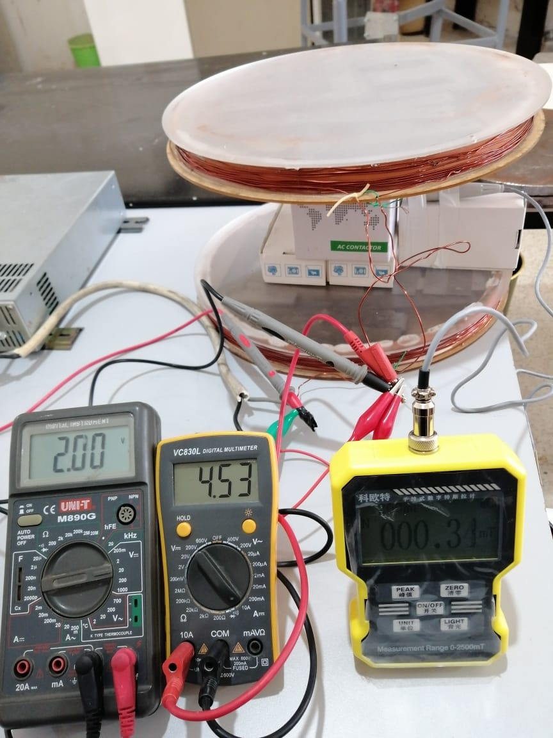
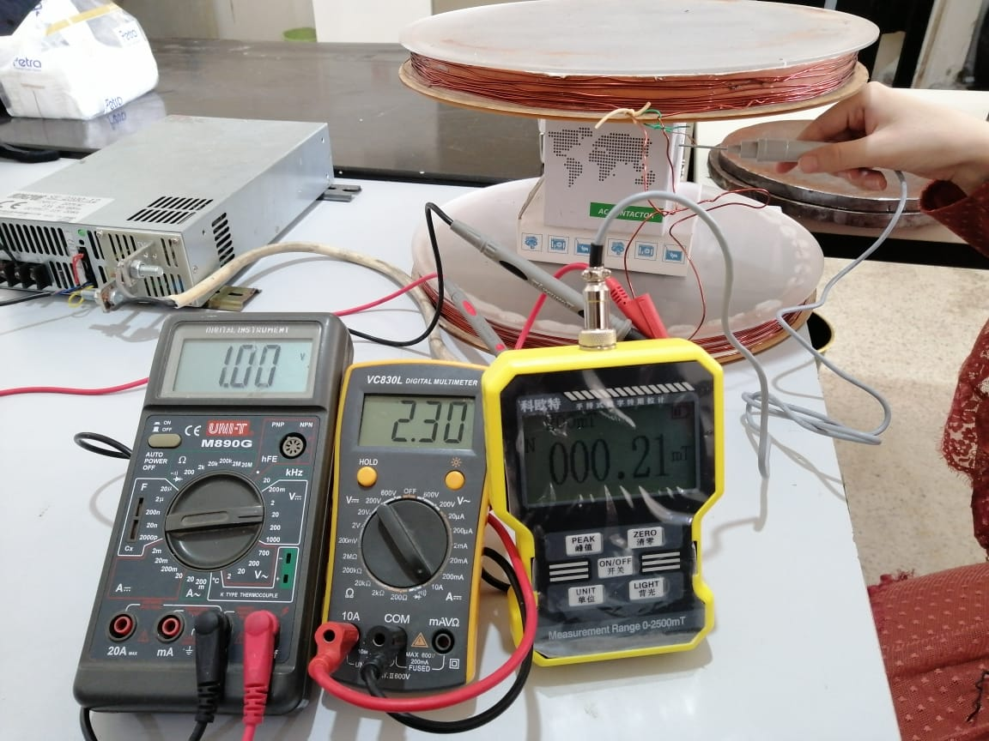

Figure III. 2 : Measurement of the magnetic field at the center of the Helmholtz coil using the transformer iron
What we need to do:
-We will change the type of iron.
-We will change the location of the iron each time.
- Test 09.10.23
In this study, variations were made to the type of ferrous material used and its location, while maintaining a constant number of turns, N = 10.
- In the first phase of the experiment, an ordinary iron plate with a diameter of 28 cm and a thickness of 1.5 cm was used. Only one of these plates was positioned in each flat coil. By modulating the voltage at each iteration, results similar to those obtained in the previous experiment regarding the value of magnetic induction (B) were observed. The maximum value reached was B = 0.6 mT << 200 mT.
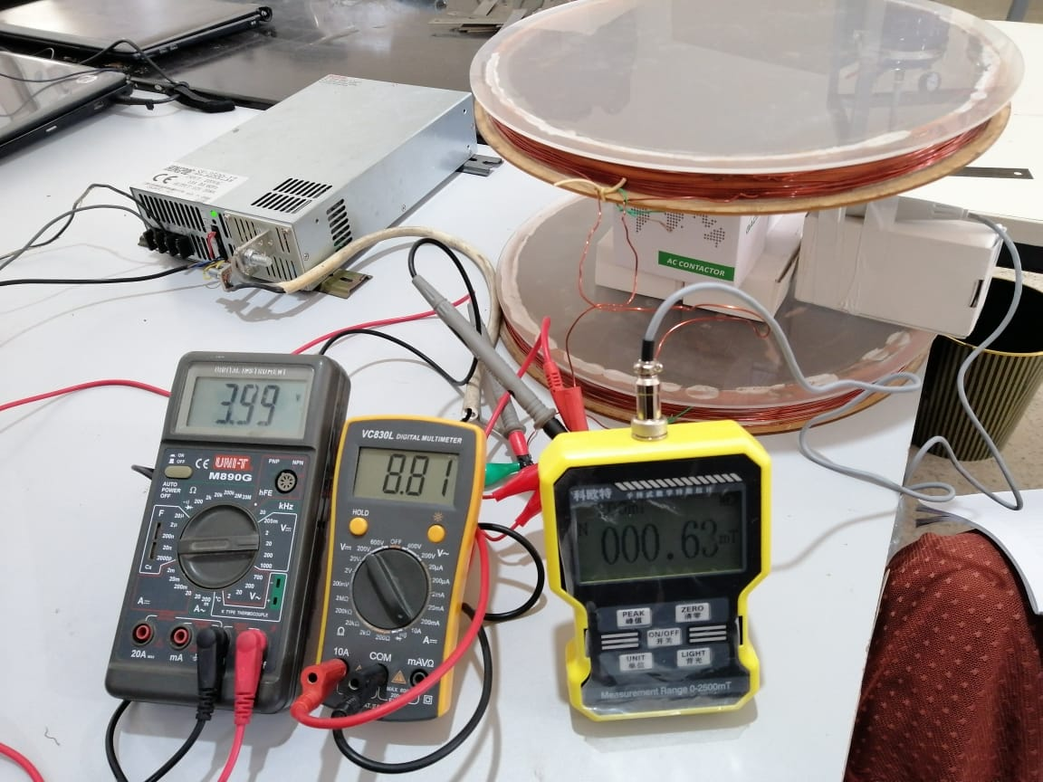
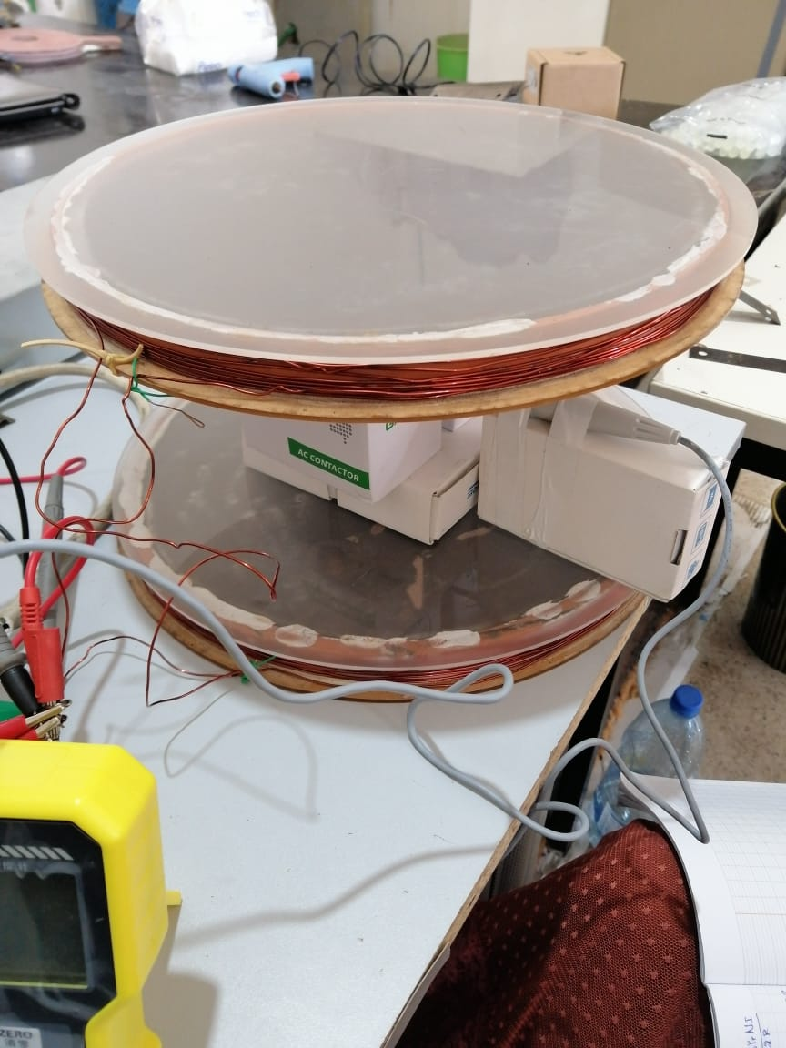
Figure III. 3 : Measurement of the magnetic field using two ordinary iron plates 28 cm in diameter and 1.5 cm thick

- In order to study the influence of iron on the magnetic field, a second experiment was conducted using Helmholtz coils without having iron inside the flat coils. We will then proceed to a comparison with the results obtained in the previous experiment.

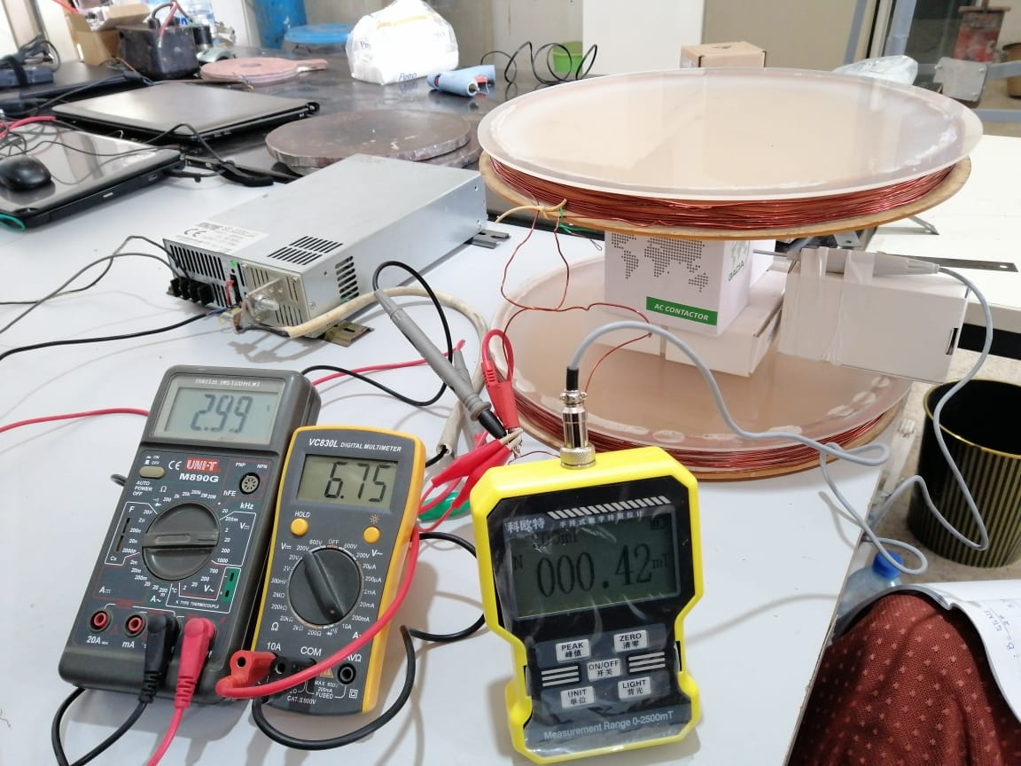
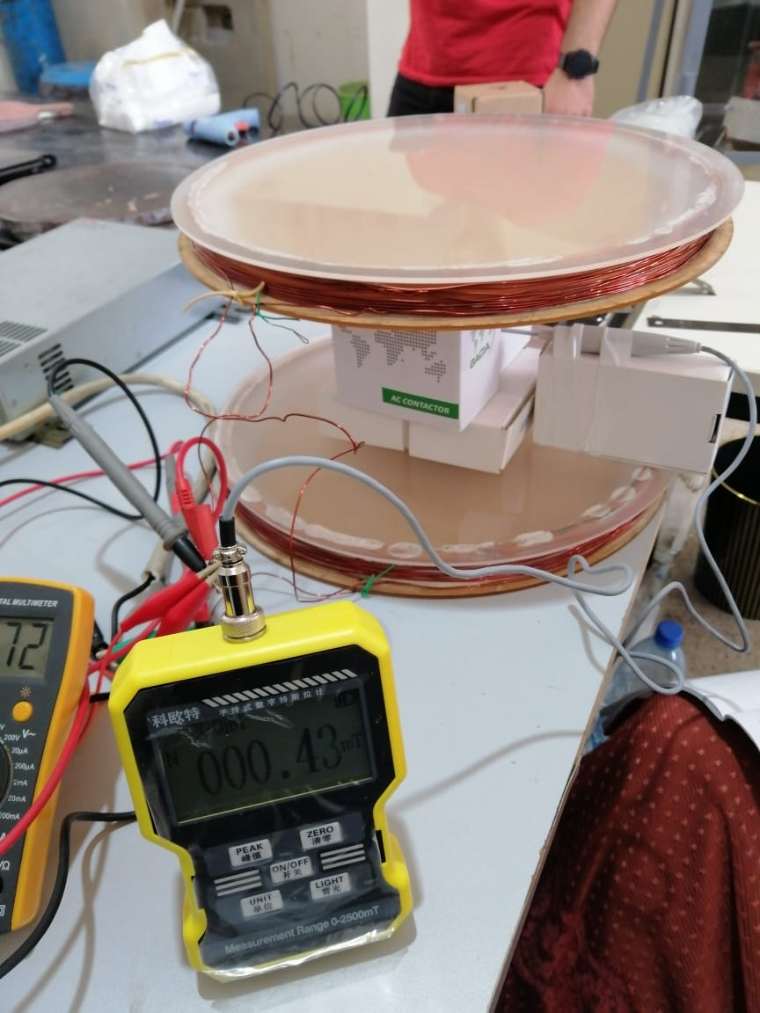

Figure III. 4 : Evaluation of the magnetic field in the absence of ferromagnetic material

In this comparison, we have chosen only two voltage values:
For V = 3 v, I = 6.72 A, we obtain B = 0.42 mT.
For V = 4 v, I = 8.69 A, we obtain B = 0.53 mT.
The observed difference between the experiment with and without iron amounts to approximately 0.06 mT, thus demonstrating that the influence of iron is extremely low.
- At this point we adjusted the iron layout according to the diagrams shown below.
Despite the change in the position of the iron, the result remains almost unchanged. We were unable to increase the intensity of the magnetic field.

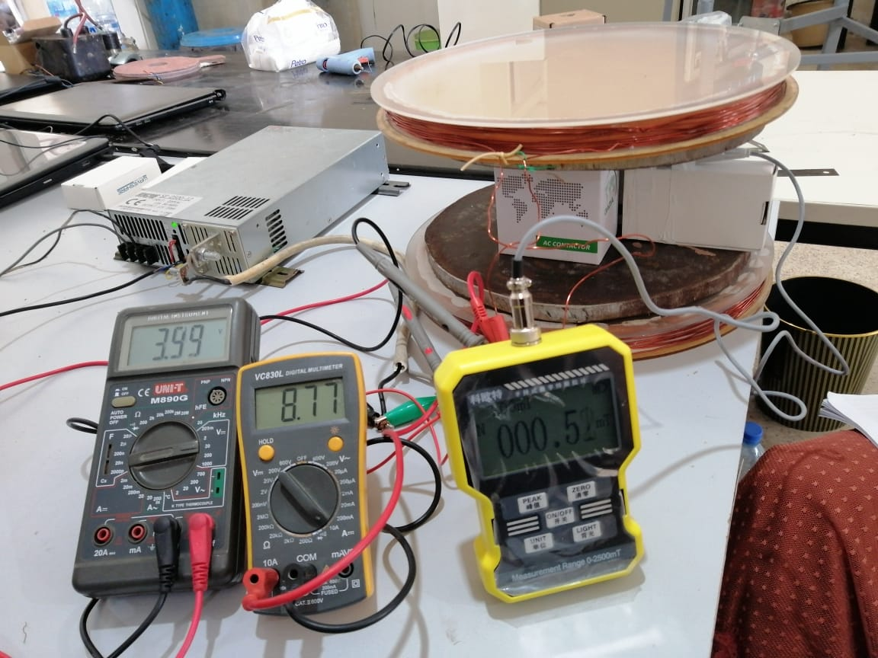
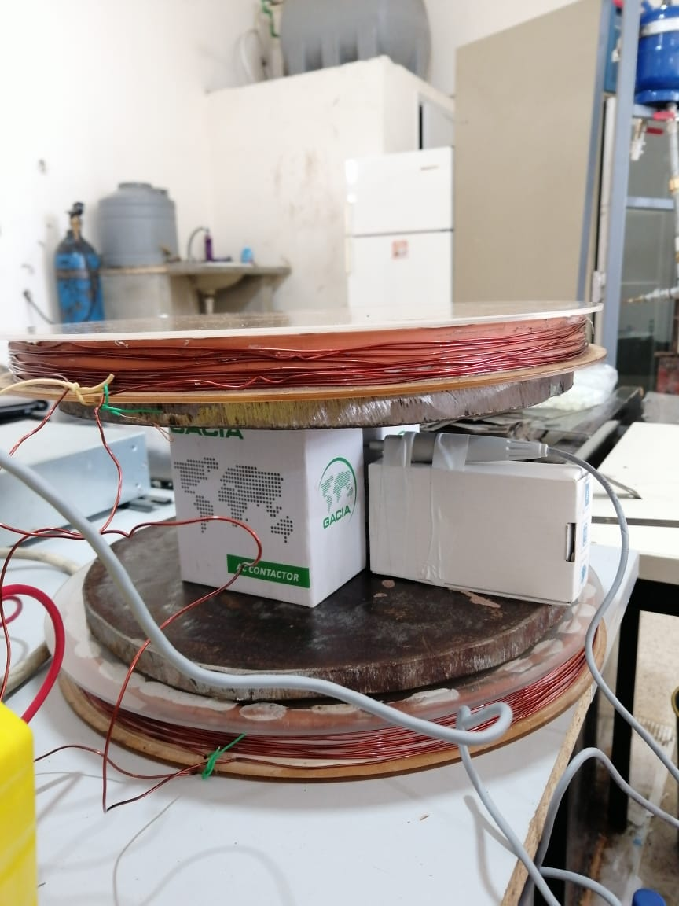

Figure III. 5 : Evaluation of the magnetic field when inserting two ordinary iron plates inside the space separating the flat coils of the Helmholtz coil
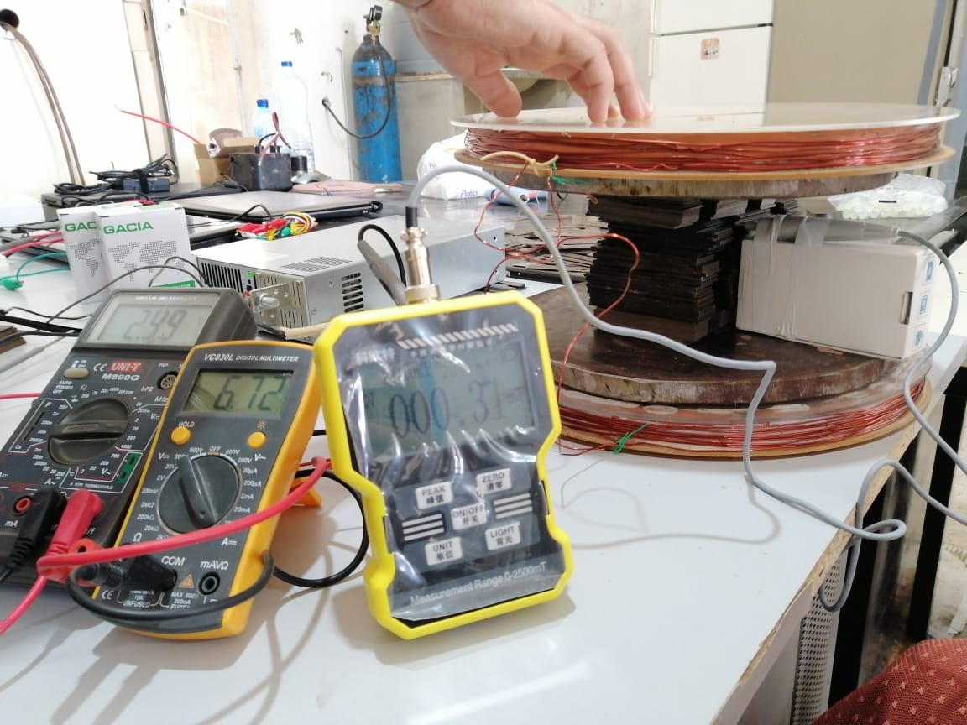
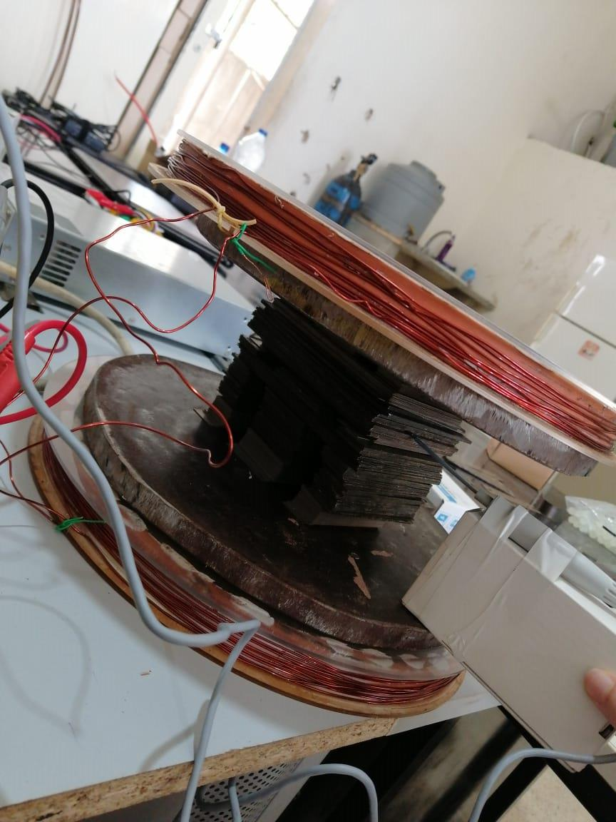

Figure III. 6 : Evaluation of the magnetic field when ordinary iron and transformer iron are simultaneously installed in the center of the Helmholtz coil

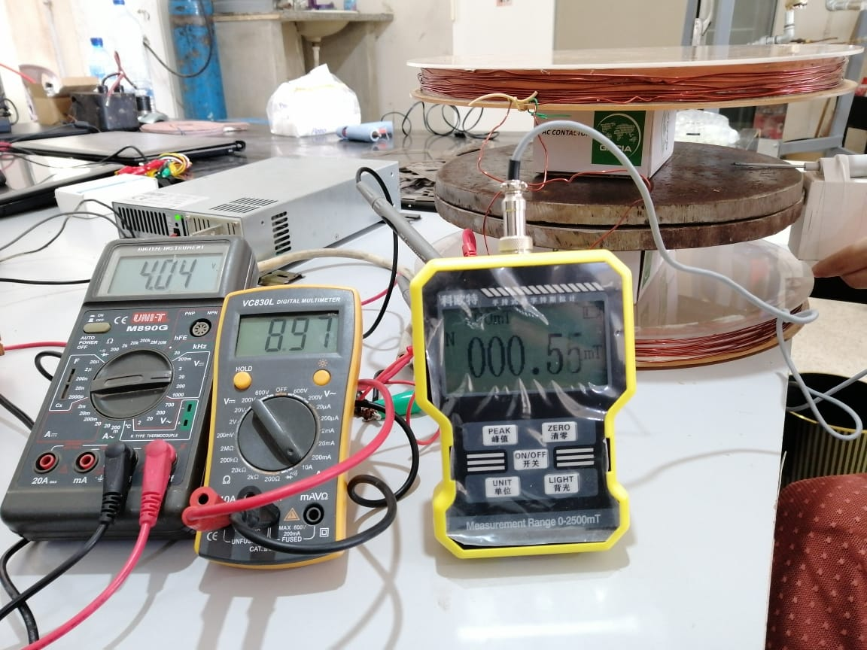

Figure III. 7 : Evaluation of the magnetic field when inserting two ordinary iron plates in the center of the Helmholtz coil
Conclusion :
From previous experiences we have drawn the following conclusions:
-The use of iron in the transformer did not bring any significant improvement. This can be attributed to the space between the pieces of iron and their uneven distribution inside the flat coil.
-Replacing the iron used in the transformer with another disc-shaped piece of iron placed inside the flat coil also did not bring any significant improvement. When we revisited this issue and researched the principle of using iron cores inside the coil to improve the magnetic field, we found that it was usually better to use iron where the radius << the width. Thus, the lack of increase in the magnetic field could be attributed to the fact that the thickness of the iron << the radius.
- Changing the position of the iron and placing it in the middle of the Helmholtz coil also did not bring any significant improvement.

- Test 20.10.23
The choice of iron volume in the Helmholtz coil design, where the radius is considerably larger than the thickness, presented an inefficiency in amplifying the magnetic field. This observation prompted consideration of an alternative iron configuration to optimize the magnetic field. Thus, we favored the use of an iron cylinder, where the thickness >> the radius, while wrapping the cylinder with copper coils. This approach was guided by maintaining the fundamental principles of the Helmholtz coil.
In our experiments, solenoids were positioned opposite each other, respecting a distance of 14 cm between them, as detailed in the experiments below.

- In the case where two solenoids have been arranged face to face:
For N=42 turns, I= 6.02 A, d= 14 cm; we have B= 0.23 mT.
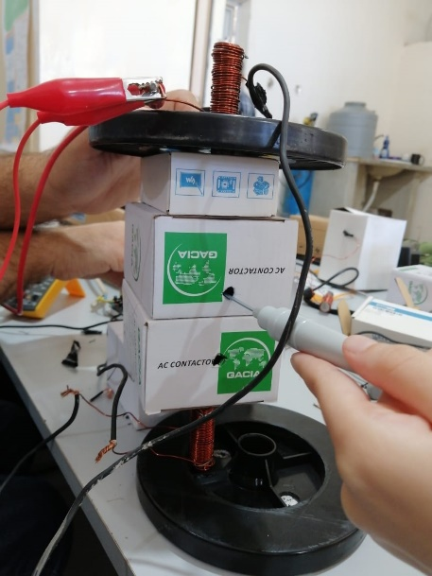

Figure III. 8: Évaluation du champ magnétique lors du positionnement de deux solénoïdes en face l'un de l'autre

- In the case where three solenoids, placed at equal distances from each other, were arranged face to face:
For N=42 turns, I= 3.5 A, d= 14 cm; we have B= 0.28 mT.
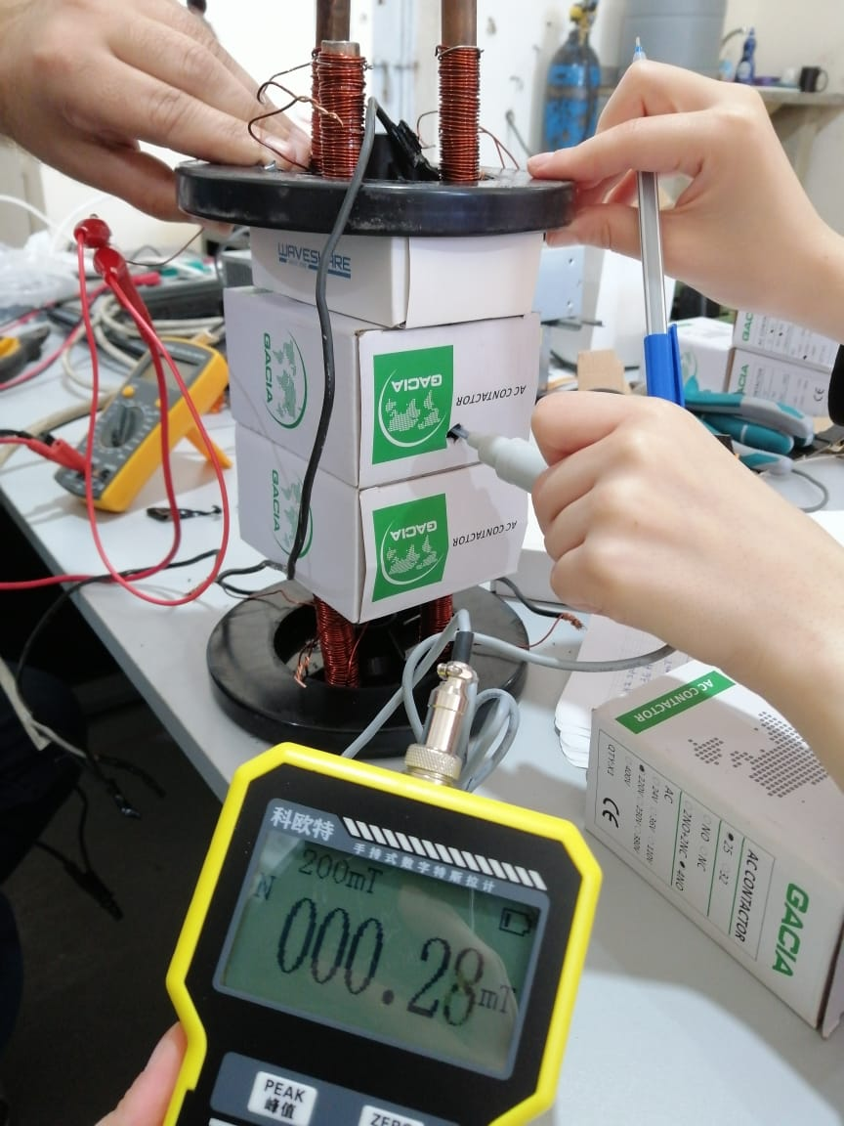

Figure III. 9: Évaluation du champ magnétique avec l'installation de trois solénoïdes, espacés de manière égale les uns des autres, en configuration face à face

- In the case where three solenoids, glued to each other, were arranged face to face:
For N=42 turns, I= 6 A, d= 14 cm; we have B= 0.5 mT.

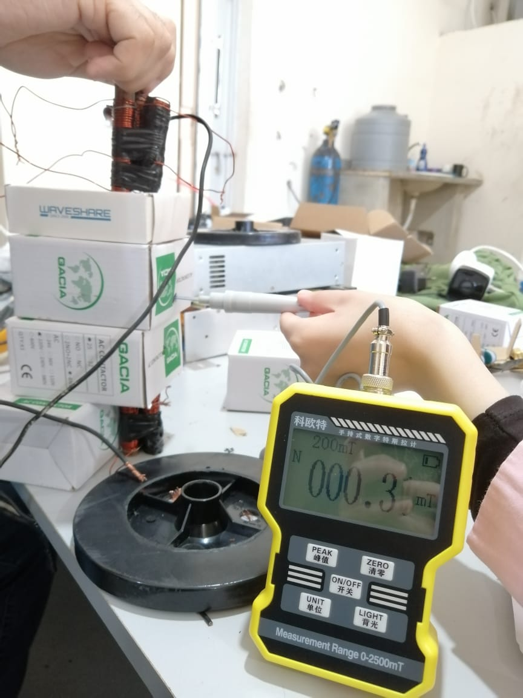
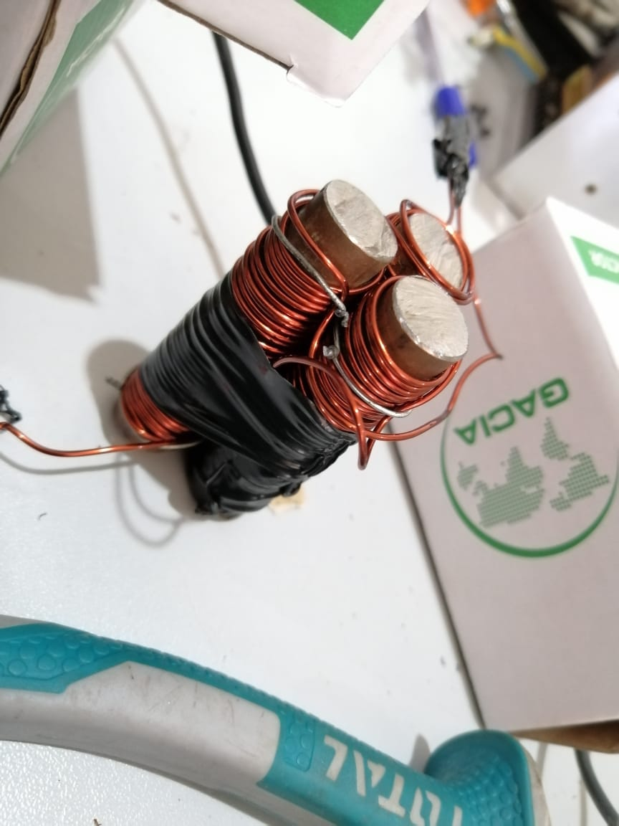

Figure III. 10 : Evaluation of the magnetic field when positioning three solenoids, back to back, in a face-to-face configuration

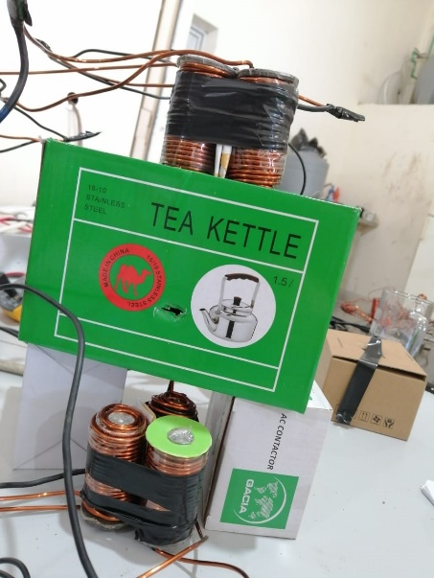
- In the case where three solenoids, glued to each other, were arranged face to face. However, in this situation we replaced the copper wires with wires with a higher thickness (2.25 mm).
For N=90 turns, I= 9.5 A, d= 14 cm; we have B= 2.54 mT.

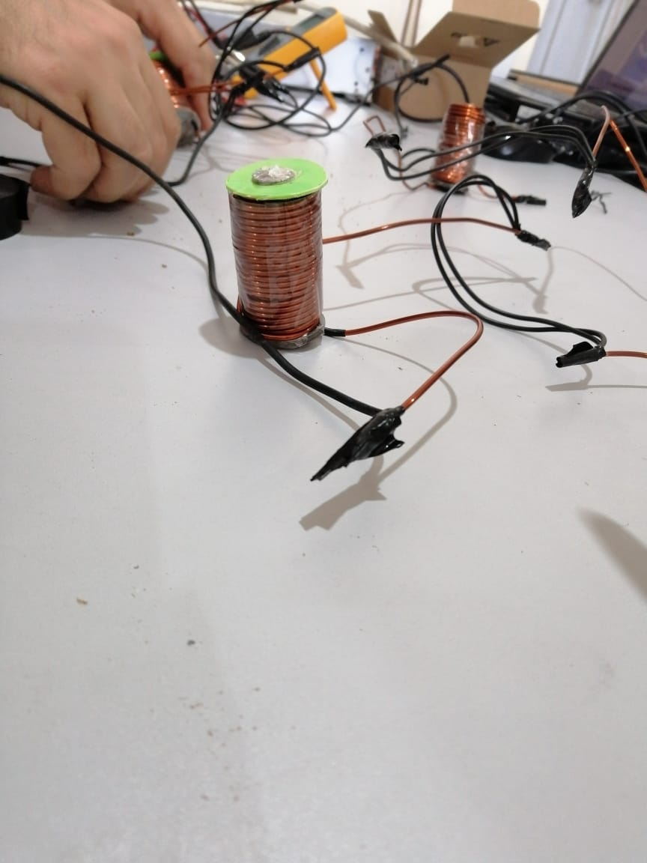

Figure III. 11 : Evaluation of the magnetic field when installing three juxtaposed solenoids, using 2.25 mm thick copper wires

Mass spectrometer test

3.1. Requirements

- System requirements:
The mass spectrometer must be able to provide electrons to collide with the atoms of the introduced gas, thus obtaining ions.
The mass spectrometer must be able to accelerate ions by exposing them to a high voltage.
The mass spectrometer must be able to separate the ions from each other and change their trajectory by exposing them to a magnetic field coming from the Helmholtz coil.
The detector must be able to capture ions based on their (mass/charge) after deflection.
- Mechanical requirements:
The cathode must be able to withstand thermal and electrical stress.
The cathode must be tungsten.
The anode must be made of stainless steel.
The tube must be made of stainless steel (ionization chamber + 2 horizontal tubes + 1 curved tube).
The vacuum pump must be able to create a vacuum in the stainless steel tube.
The plate that pushes the ions out of the ionization chamber should be made of stainless steel (slight positive charge).
The three plates that accelerate the ions must be made of stainless steel.
The Helmholtz coil should be made of two plastic pieces, with iron inside, and copper strips wrapped around it.
- Physical requirements:
A stainless steel plate (slightly positive charge) should be able to push the ions out of the ionization chamber.
Three stainless steel plates should be able to accelerate the ions.
The detector must be able to capture the ions and transmit a signal to the computer.
- Electrical requirements:
A power supply must be capable of supplying 17V to the tungsten.
A power supply must be capable of gradually supplying -300V, -150V and zero to the accelerator plates.
The anode and all stainless steel plates must be insulated from the tube to prevent voltage from propagating and passing through the tube.
- Magnetic requirements:
The Helmholtz coil must be able to generate the magnetic field on the bent tube.
The Helmholtz coil must be able to generate a magnetic field of 0.2 T.
- Safety requirements:
Electrical safety
All electrical connections must be coated with the correct insulation based on the current and voltage flowing through the connections.

3.2. System Test Specification

00001: Ensure complete air evacuation
Stage | Description of the stage | Expected result
Precondition | The system is off
Turn on the system | Turn on the pump | 95% empty
Presence of a leak | Risk of air leakage at the following locations: welds, flanges, anode, cathode, plates, tungsten windows, detector | Seal leak locations
Turn off the system | Turn off the pump | The pump stops extracting air
Use of silicon | Apply silicone to the areas where air is leaking. | Stop the leak and achieve 95% vacuum when we restart the pump
Postcondition | The system is off

00002: Tungsten power supply
Stage | Description of the stage | Expected result
Precondition | The system is off
Turn on the system | Turn on the power supply | Obtain a continuous power supply (8 V)
Turn off the system | Turn off the power supply | Continuous power supply stops
Postcondition | The system is off

00003: First positively charged plate (trap) electron)
Stage | Description of the stage | Expected result
Precondition | The system is off
Turn on the system | Turn on the power between the tungsten and the plate | Obtain a continuous power supply (17 V)
Turn off the system | Turn off the power supply | Continuous power supply stops
Postcondition | The system is off

00004: Second positively charged plate (ion repellent)
Stage | Description of the stage | Expected result
Precondition | The system is off
Turn on the system | Turn on the power supply | Obtain continuous power (determine experimentally)
Turn off the system | Turn off the power supply | Continuous power supply stops
Postcondition | The system is off

00005: Obtain electrons
Stage | Description of the stage | Expected result
Precondition | The system is off
Turn on the specific pump valve | Turn on the valve | The valve is open
Turn on the pump | Turn on the pump | 95% empty
Turn on the tungsten power supply | Turn on the power supply | Obtain a continuous power supply (8 V)
Turn on the power between the tungsten and the plate | Turn on the power supply | Obtain a continuous power supply (17 V)
Burning tungsten | Burn the tungsten by supplying it with 8V power | Get electrons around the tungsten (the lamp will light up).
Electron trap | The 17v power supply is connected to the first board | The first positively charged plate attracts electrons towards it (moving electrons)
Turn off the power to the electron trap | Turn off the power supply | Electrons are not in motion
Turn off the tungsten power supply | Turn off the power supply | The lamp will go out
Turn off the pump | Turn off the pump | The pump stops extracting air
Turn off the specific pump valve | Turn off the valve | The valve is closed
Postcondition | The system is off

00006: Detector
Stage | Description of the stage | Expected result
Precondition | The system is off
Turn on the system | Turn on the detector | The detector emits a signal when it receives ions
Turn off the system | Turn off the detector | The detector is not working
Postcondition | The system is off

00007: Ionization
Stage | Description of the stage | Expected result
Precondition | The system is off
Turn on the specific pump valve | Turn on the valve | The valve is open
Turn on the pump | Turn on the pump | 95% empty
Turn on the tungsten power supply | Turn on the power supply | Obtain a continuous power supply (8 V)
electron trap " plate | Turn on the power supply | Obtain a continuous power supply (17 V)
Burning tungsten | Burn the tungsten by supplying it with 8V power | Get electrons around the tungsten (the lamp will light up)
Electron trap | The 17V power supply is connected to the first board | The first positively charged plate attracts electrons towards it (moving electrons)
Turn off the pump | Turn off the pump | The pump stops extracting air
Turn off the specific pump valve | Turn off the valve | The valve is closed
Turn on the detector | Turn on the detector | The detector is working
Turn on the specific gas valve | Open the valve, introduce the steam, then, after a few minutes, turn off the valve | The electrons will collide with the atoms in the vapor sample (obtaining ions with a (+1) charge)
Turn on the power supply to the "ion repellent" plate | Turn on the power supply | Obtain continuous power (determine experimentally)
Ion repellent | The power supply is connected to the second plate | The detector emits a signal (indicating that the second positively charged plate has repelled the ions out of the ionization chamber, and the ions have entered the tube)
Turn off the detector | Turn off the detector | The detector is not working
Turn off the power to the ''ion repellent'' plate | Turn off the power supply | The second plate is no longer loaded
electron trap plate | Turn off the power supply | The first plate is no longer loaded
Turn off the tungsten power supply | Turn off the power supply | The lamp will go out
Postcondition | The system is off

00008: Power supply to the three plates (Acceleration zone)
Stage | Description of the stage | Expected result
Precondition | The system is off
Turn on the system | Turn on the power supply | Obtain a continuous power supply (-300 V, -150, 0)
Turn off the system | Turn off the power supply | Continuous power supply stops
Postcondition | The system is off.

00009: Helmholtz coil
Stage | Description of the stage | Expected result
Precondition | The system is off
Turn on the system | Turn on the Helmholtz coil by supplying it with power (determine experimentally) | Obtain a magnetic field (B = 0.2 T)
Turn off the system | Turn off the Helmholtz coil | The magnetic field stops
Postcondition | The system is off

000010: Acceleration and Deviation
Stage | Description of the stage | Expected result
Precondition | The system is off
Turn on the specific pump valve | Open the valve | The valve is open
Turn on the pump | Turn on the pump | 95% empty
Turn on the tungsten power supply | Turn on the power supply | Provide continuous power (8V)
electron trap " plate | Turn on the power supply | Provide 17V DC power
Burning tungsten | Burn the tungsten by supplying it with 8V power | Generate electrons around the tungsten (the lamp will light up)
Electron trap | The power supply is connected to the first plate | The first positively charged plate attracts electrons towards it (moving electrons)
Turn off the pump | Turn off the pump | The pump stops extracting air
Turn off the specific pump valve | Close the valve | The valve is closed
Turn on the detector | Turn on the detector | The detector is on
Turn on the specific gas valve | Turn on the valve, let the steam in, then after a few minutes turn the valve off | The electrons will collide with the atoms in the vapor sample (creating ions with a +1 charge)
Turn on the specific power supply for the "ion repellent" plate | Turn on the power supply | Obtain continuous power (determine experimentally)
Turn on the specific power supply for three plates | Turn on the power supply | Get a continuous power supply of (-300V, -150V, 0)
Turn on the Helmholtz coil | Turn on the Helmholtz coil on the bent tube | Obtain a magnetic field (B = 0.2 T)
Ion repellent | The power supply is connected to the second plate | The second positively charged plate repels the ions out of the ionization chamber, and the ions enter the tube
Acceleration of ions | Connect the power supply to the three plates at the beginning of the tube | Ions entering the tube will be accelerated
Ion deflection | The ions will be subjected to a magnetic field of B = 0.2 T as they pass through the curve | The detector emits a signal (indicating that the ions have left the ionization chamber, entered the tube, been accelerated by the plates, deflected by the magnetic field and have been detected)
Turn off the power to the three-plate stove | Turn off the power | Ion acceleration stops, no signal will appear
Turn off the detector | Turn off the detector | The detector is not working
Turn off the Helmholtz Coil | Turn off the Helmholtz coil | The magnetic field stops
Turn off the power supply (ion repellent) | Turn off the power | The second plate is no longer loaded
Turn off the power supply ( electron trap ) | Turn off the power | The first plate is no longer loaded
Turn off the tungsten power supply | Turn off the power | The lamp will go out
Postcondition | The system is off

2.3. System Test and Results

- Vacuum test 03.05.23
00001: Ensure complete air evacuation
Stage | Description of the stage | Expected result | Result
Precondition | The system is off
Turn on the system | Turn on the pump | 95% empty | Negative
Presence of a leak | Possibility of air leakage in certain places: welding-flanges-anode-cathode-tungsten-windows | Seal leaks | Positive
Turn off the system | Turn off the pump | The pump stops extracting air | Positive
Use of silicone | Apply silicone to the areas where there are air leaks | Stop leaks and achieve 95% vacuum when restarting the pump | Positive
Postcondition | The system is off

Analysis of test results:
To locate air leak locations, we applied soap and water to the surface of the device and then compressed the air inside;
When we spot bubbles appearing, this indicates an air leak at that location.
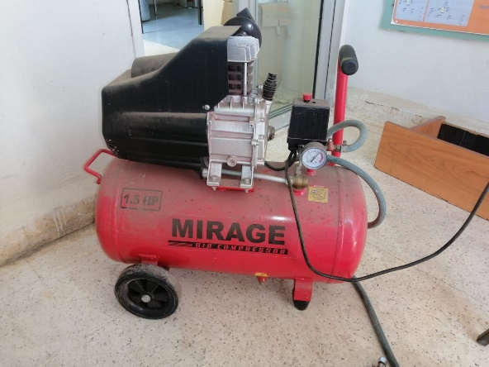
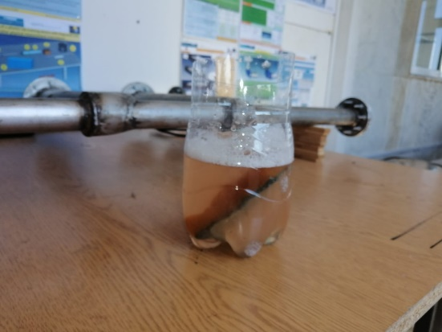
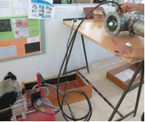

Figure III. 12 : Instruments used to locate air leaks
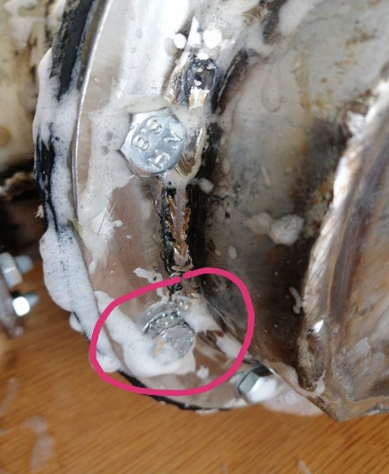
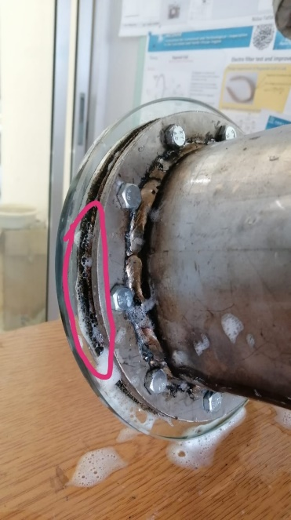
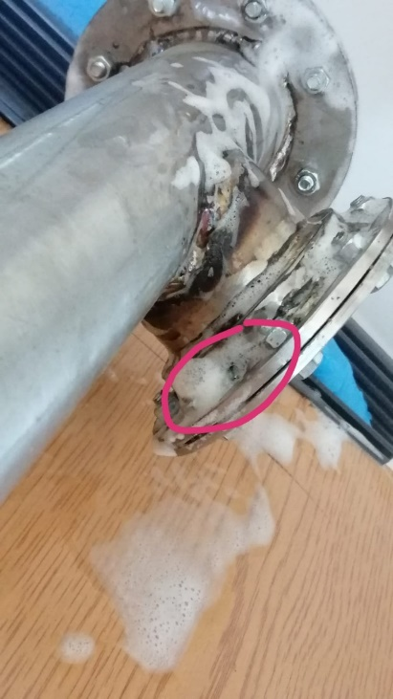

Figure III. 13 : Air leak points

What we need to do:
-We will redo the welding in the places where there were leaks during the previous welding.
-We will be replacing the gasket on the flanges due to leaks.

- Vacuum Test 09.06.23
00001: Ensure complete air evacuation
Stage | Description of the stage | Expected result | Result
Precondition | The system is off
Turn on the system | Turn on the pump | 95% empty | Negative
Presence of a leak | Possibility of air leakage in certain places: welding-flanges-anode-cathode-tungsten-windows | Seal leaks | Positive
Turn off the system | Turn off the pump | The pump stops extracting air | Positive
Use of silicone | Apply silicone to the areas where there are air leaks | Stop leaks and achieve 95% vacuum when restarting the pump | Positive
Postcondition | The system is off

Analysis of test results:
First, we cleaned the stainless steel tube with special and precise tools;
After cleaning, we noticed a small hole due to a soldering error.

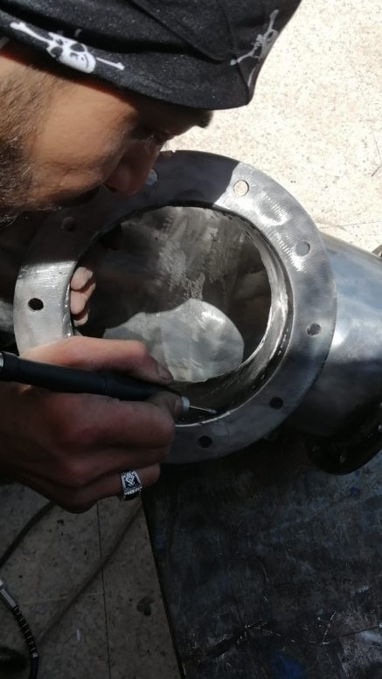
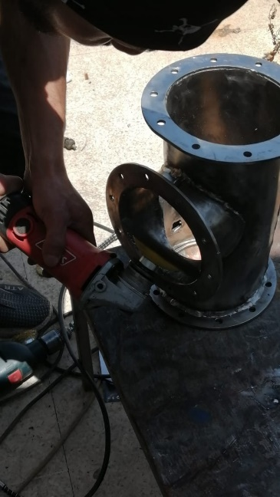
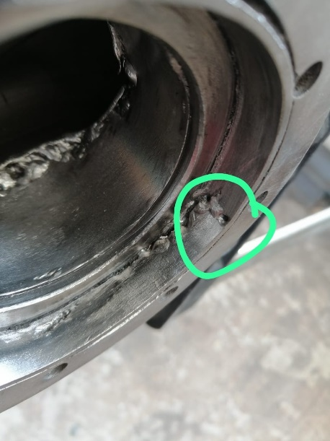

Figure III. 14 : During the stainless steel tube cleaning process

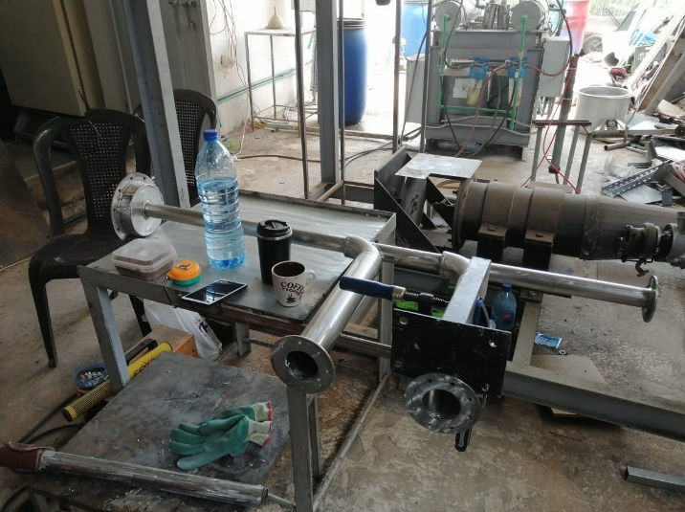

Figure III. 15: Préparation en cours du dispositif en vue d'améliorer le processus de soudure

To determine if there is still an air leak, we will retest the application of soapy water to the surface of the device and the air pressure inside the device.
When we spot bubbles appearing, this indicates an air leak at that location.

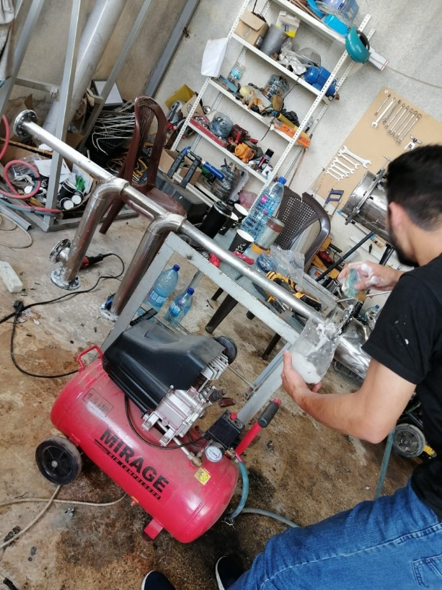

Figure III. 16: Exécution d'une nouvelle vérification de la présence de fuites d'air

These flanges were leaking:

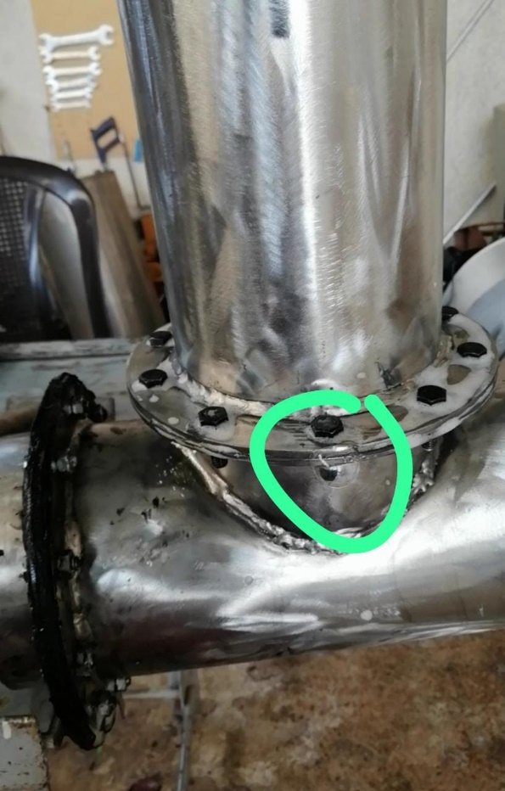
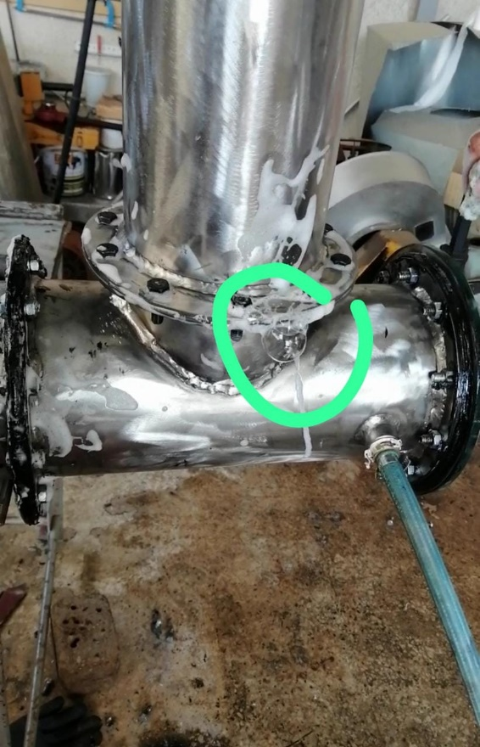

Figure III. 17 : Air leak locations

What we need to do:
We will add silicone around the flanges.

CHAPTER IV: CONCLUSION AND PERSPECTIVES

In conclusion, the project to manufacture a mass spectrometer to detect toxic gases from waste combustion presented several challenges, particularly in the design of the Helmholtz coil to ensure a magnetic field of 0.2 T in the deflection zone. Optimization attempts, whether using iron from the transformer or ordinary iron, faced limitations related to the material thickness. Adjustments, such as increasing the iron thickness and using thicker copper coils, improved the magnetic field, although the target value was not reached.
Looking ahead, promising solutions include exploring the use of soft iron cores, known for their high relativistic permeability, or fabricating iron cylinders by melting transformer material with a thickness greater than the radius. These approaches will need to adhere to the principles of the Helmholtz coil to ensure the spectrometer's efficiency.
Additionally, potential challenges in spectrometer operation have been identified, such as vacuum issues. Addressing this will require the adoption of a pump that can achieve high vacuum up to 10 ⁻⁷ torr, such as a turbomolecular pump in series with a rotary pump. Concerns regarding the insulation and fabrication of the Faraday cup detector are also raised, but further research could help address these potential issues.
In summary, these proposed improvements and solutions pave the way for future developments aimed at optimizing the mass spectrometer for more efficient detection of toxic gases.

Bibliography

[1] | E. Garg and M. Zubair, “Mass Spectrometer,” In StatPearls [Internet], 2023.
[2] | W. Barthelemy, "Thermionic Emission Isotope Mass Spectrometry," 2009.
[3] | G. Bouchoux and M. Sablier, "Mass spectrometry: principle and apparatus," Engineering Techniques, 2005.
[4] | “Mass Spectrometry Basics,” [Online]. Available: https://www.jeolusa.com/RESOURCES/Analytical-Instruments/Mass-Spectrometry-Basics.
[5] | P. Noriega, G. Gortaire and E. Osorio, “Mass Spectrometry and Its Importance for the Analysis and Discovery of Active Molecules in Natural Products,” Natural Drugs from Plants, 2021.
[6] | S. Harper, P. Calandra and S. Price, “Electron-impact ionization of hydrogen chloride,” Physical Chemistry Chemical Physics, vol. 3, no. 5, pp. 741-749, 2001.
[7] | J. Fletcher, M. Parkes and S. Price, "Electron ionization of sulfur dioxide," The Journal of Chemical Physics, vol. 138, no. 18, 2013.
[8] | J. Johns and R. Barrow, “Ionization Potentials of Hydrogen Fluoride and the Ground-State of the HF+ Ion,” Nature, vol. 179, no. 4571, p. 1186-1186, 1957.
[9] | M. Alagia and et al., "The double photoionization of hydrogen iodide molecules," The Journal of Chemical Physics, vol. 124, no. 20, 2006.
[10] | D. Lide, “Ionization potentials of atoms and atomic ions,” Handbook of Chemistry and Physics, vol. 10, p. 211, 1992.
[11] | P. Redhead and S. Feser, “Multiple ionization of mercury by successive electron impacts,” Canadian Journal of Physics, vol. 46, no. 17, pp. 1905-1913, 1968.
[12] | V. Bellosta, "Identification of organic compounds by mass spectrometry," 2005.
[13] | C. Cassignol, Y. Ortel and J. Taieb, "A mass spectrometer for the rapid analysis of gaseous mixtures; Mass spectrometer for the rapid analysis of gaseous mixtures," 1950.
[14] | J. Beynon and L. Brown, “Mass Spectrometry,” Encyclopedia Britannica, Nov 3, 2023.
[15] | J. Gross, Mass spectrometry: a textbook, Springer Science & Business Media, 2006.
[16] | V. Bhatt, R. Rautela, P. Sharma, D. Tiwari and S. Khushu, "Design & Development of Helmholtz Coil for Hyperpolarized MRI," In Proceedings of the COMSOL Conference, pp. 1-6, 2010.
[17] | M. Ashby, H. Shercliff and D. Cebon, “Materials: engineering, science, processing and design,” 2018.
[18] | “Faraday Cup,” [Online]. Available: https://www.electricity-magnetism.org/faraday-cup/.
[19] | E. Hoffmann and V. Stroobant, "Mass spectrometry: principles and applications," 2007.
[20] | K. Busch, “Detecting ions in mass spectrometers with the Faraday cup,” Spectroscopy, vol. 26, no. 11, pp. 12-18, 2011.
[21] | S. Sabbah, “A Solid-State Ion Detector for Use in Portable Mass Spectrometry,” Brigham Young University, 2014.

LIST OF ABBREVIATIONS

HCL | : Hydrogen Chloride
HF | : Hydrogen Fluoride
Hg | : Mercury
SO ₂ | : Sulfur Dioxide
CAD | : Computer Aided Design
FreeCAD | : a CAD software
PCB | Printed Circuit Board
Op-amps | : operational amplifier
Max | : maximum
Min | : minimum

LIST OF SYMBOLS

V | : Volume of the ionization chamber | m ³
IE1 | : First ionization energy | ev
IE2 | : Second ionization energy | ev
m | : Mass of an ion | Kg
Z | : Electric charge of an ion
R | : radius of curvature of an ion | m
E _{c} | : Kinetic energy of an ion | J or ev
q | : Charge | C
U | : Potential difference | V
v | : Speed of an ion | ms ⁻¹
F | : Magnetic force | N
B | : Magnetic field | T
Your | : Offset voltage offset | V
HAS | : Voltage gain
CMRR | : Common mode rejection ratio | dB
µ ₀ | : Vacuum permeability | H/m
µ _{r} | : Relative permeability of magnetic material
µ | : Magnetic permeability of the material | H/m
I | : Current intensity flowing through the two coils | HAS
D | : Diameter of each coil | m
N | : Number of turns
R ′ | : Radius of each coil | m
d ′ | : Distance between two coils | m
x | : Distance measured along the central axis of the coils | m

LIST OF FIGURES

Figure I. 1: Schematic representation of a mass spectrometer 9
Figure I. 2: Ionization chamber of the mass spectrometer 12
Figure I. 3: Ion acceleration zone of a mass spectrometer 14
Figure I. 4: Deflection zone of a mass spectrometer 15
Figure I. 5: Orientation of the magnetic force on a moving ion 16
Figure I. 6: Deflection of the trajectory of ions under the effect of the magnetic field 17
Figure I. 7: The detection process at the microscopic level 18
Figure I. 8: Arnocanali 20 type pump
Figure I. 9: Representative diagram of a Helmholtz coil 23
Figure I. 10: Schematic diagram of a Faraday cup 25

Figure II. 1: Typical schematic arrangement of an ion source 26
Figure II. 2: Sequence of steps in a mass spectrometer 26
Figure II. 3: Design of the mass spectrometer model 28
Figure II. 4: Specific measurements of mass spectrometer model 29
Figure II. 5: The components of the ionization chamber 30
Figure II. 6: Distribution of tension on the acceleration plates 30
Figure II. 7: The presence of the Helmholtz coil in the deflection zone 31
Figure II. 8: Position of the Faraday Cup type detector in the deflection zone 31
Figure II. 9: The curved tube where the magnetic field is applied′ 32
Figure II. 10: The trajectories of ions under the influence of the magnetic field 33
Figure II. 11: Length of the ionization chamber (~35 cm) 33
Figure II. 12: Cross-sectional diameter of the ionization chamber (~ 15 cm) 34
Figure II. 13: Cross-sectional diameter of two horizontal tubes (~ 14 cm) 34
Figure II. 14: Fabrication of flanges for the various components of the mass spectrometer 35
Figure II. 15: Manufacturing and assembly steps of mass spectrometer 35
Figure II. 16: Welding during the manufacture of the mass spectrometer 36
Figure II. 17: The assembled prototype also integrates the mass spectrometer 36
Figure II. 18: Principle of the Faraday cup 37
Figure II. 19: First design proposal [18] 38
Figure II. 20: Measurements of the first model 39
Figure II. 21: Cross section of module 1 39
Figure II. 22: The operating mode of the second model [21] 40
Figure II. 23: Measurements of the second model 40
Figure II. 24: The Operation of the Second Model [20] 41
Figure II. 25: Measurements of the third model 41
Figure II. 26: Measurements of the fourth model 42
Figure II. 27: Measurements of the fifth model 43
Figure II. 28: The operation of the fifth model 43
Figure II. 29: Miniaturized Design of the Second Model 44
Figure II. 30: Circuit diagram of the amplifier for the Faraday cup 45
Figure II. 31: The front-back image of the amplifier circuit (3D) 46
Figure II. 32: The front-back image of the amplifier circuit with the 46 copper layers
Figure II. 33: 48 operational amplifier
Figure II. 34: Some manufacturing conditions of the Helmholtz coil 49
Figure II. 35: Some measurements of the Helmholtz coil model with iron 50
Figure II. 36: Some characteristics of the Helmholtz coil model with iron 51
Figure II. 37: The location of ordinary iron in the Helmholtz coil 52
Figure II. 38: The location of the specific iron of the transformers in the Helmholtz coil 52

Figure III. 1: Arrangement of the transformer iron at a distance of 14 cm in each of the flat coils 55
Figure III. 2: Measurement of the magnetic field at the center of the Helmholtz coil using the iron of transformer 55
Figure III. 3: Measurement of the magnetic field using two ordinary iron plates 28 cm in diameter and 1.5 cm thick 56
Figure III. 4: Evaluation of the magnetic field in the absence of ferromagnetic material 57
Figure III. 5: Evaluation of the magnetic field when inserting two ordinary iron plates inside the space separating the flat coils of the Helmholtz coil 58
Figure III. 6: Evaluation of the magnetic field when ordinary iron and transformer iron are simultaneously installed in the center of the Helmholtz coil 58
Figure III. 7: Evaluation of the magnetic field when inserting two ordinary iron plates into the center of the Helmholtz coil 58
Figure III. 8: Evaluation of the magnetic field when positioning two solenoids opposite each other 60
Figure III. 9: Magnetic field evaluation with the installation of three solenoids, equally spaced from each other, in face-to-face configuration 60
Figure III. 10: Evaluation of the magnetic field when positioning three solenoids, back to back, in a face-to-face configuration 61
Figure III. 11: Evaluation of the magnetic field when installing three juxtaposed solenoids, using 2.25 mm thick copper wires 61
Figure III. 12: Instruments used to locate air leaks 73
Figure III. 13: Air leak points 74
Figure III. 14: During the cleaning process of the stainless steel tube 75
Figure III. 15: Preparation in progress of the device to improve the welding process 76
Figure III. 16: Performing a new air leak check 76
Figure III. 17: Air leak locations 77

LIST OF TABLES

Table I. 1: Ionization energy of certain types of gas 13
Table I. 2: Characteristics of some types of gases 17
Table I. 3: Pressure ranges in vacuum technology 19

INDEX

ipsum, 5, 6

[Don't forget to update the table.
Omit this page in case your memory doesn't include an index!
To insert an entry into the index table, position the cursor at the end of the desired word, then click REFERENCES, then MARK ENTRY, and then type MAIN ENTRY. ]

APPENDICES
[

Annex 1
Lorem ipsum dolor sit amet, consectetur adipiscing elit. Praesent a turpis tortor. Fusce sed turpis quis neque molestie ultricies vel vel ante. Aliquam luctus nunc in enim lobortis auctor. Ut egestas metus a nulla condimentum dictum. Phasellus bibendum sagittis leo et lacinia. Etiam lorem nulla, interdum non pellentesque et, scelerisk et purus. Quisque vel lectus ut quam sagittis feugiat ut eget ante. Donec interdum, felis at mattis euismod, sem lorem ullamcorper nisl, placerat tincidunt dui mi at massa. Pellentesque volutpat dapibus dolor id facilisis. Quisque gravida adipiscing diam vitae sodales. Sed faucibus pellentesque mauris, at hendrerit magna bibendum et.

Annex 2
Morbi venenatis, diam mattis fringilla mattis, elit metus ornare dui, quis ultrices dui massa quis nibh. Proin adipiscing orci est. Nullam blasted diam. Quisque ac ante leo. Vivamus eu leo a libero tempor aliquet ac at odio. Nam aliquet ullamcorper felis, eu imperdiet nunc iaculis ut. Praesent rhoncus ultrices ultrices. Morbi quis justo id tortor malesuada fermentum et nec velit. Phasellus egestas euismod lacinia. Morbi eu orci quam.
]

