Pilot plant penicillin production

Penicillin Production (totally about 29 days)
In the first, we put a half of bread in a fermentation conditions until will be able to see many fermented regions.
All used lab glassware are sterilized by adding some ml of water, covering with metallic paper and bowling until the water are totally evaporates (Or in the oven)
Microbial essays (culture and inoculation) are performed in a sterile area near a flame

Preparation of agarose gel(1days)
- We try to melt six tryptone tubes by using a heated water (bain marie)
- We weigh 3g of glucose powder
- In an erlenmeyer flask we mix the melted tryptone, the glucose and 60 ml of distilled water
- We keep heat until we get a homogeneous mixture
- We fill the mixture in six petri dishes
- We heat them in a pressure cooker after boiling for 15 min
- We let them cool down and we wait about 30 min until the gel are totally solidified
- We put them in the fridge until the time of microbial cultivation

Microbial culture (7 days)
- We cultivate the six petri dishes with the strains of penicillium
- We incubated them at room temperature for 7 days

Preparation of liquid medium(7 days)
- We weigh 400g of glucose powder, 400 g of lactose, 200g of peptone, 20g of MgCl₂, 20g of KCl, and 100g of KH₂PO₄ than we add them in the first container of the bioreactor
- We add 20 L of distilled water
- We heat them with mixing for 15min
- We let them cool down
- We inoculate them by the petri dishes already prepared (we need about 200 colony)
- We incubate them at room temperature for 7days with shaking

Filtration and the adding of ethyl acetate(7 days)
- After 7 days of incubation in liquid medium we filter the inoculated liquid medium by using of filter paper to the second container of the bioreactor containing 86g of charcoal and 100g of KH₂PO₄ and we leave them for 20 min
- We decant the liquid from the charcoal to the third container than we add ethyl acetate (proportion 50/50)
- (we may obtain about 12 L of bread penicillim filtrate so we need about 12 L of ethyl acetate)
- We incubate them at 4ºC some days (about 7 days).

Purification(7 days)
- Here the penicillin was dissolved in ethyl acetate
- The centrifugation method was applied to eliminate the pellet containing cells debris and all other contaminant (4000x for 15 min)
- The supernatant is moved to a forth other container (We may obtain about 12L of supernatant)
- We add about 1000g of sodium bicarbonate for the supernatant to obtain the penicillium in salt form.
- We cool them at 4ºC for about 7 days
- Then we remove the liquid and we dry the crystal

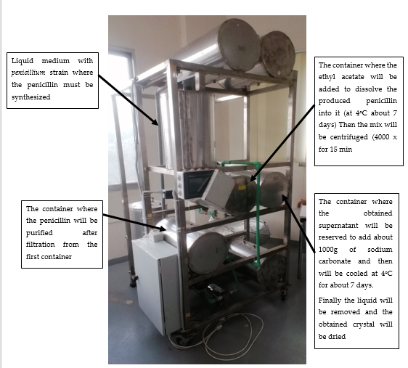

List of materials we need for this trial:
- 6 tubes of tryptone
- 40 g + 3 g glucose powder
- 20 L + 60 ml distilled water
- 400 g lactose
- 200g peptone
- 20 g MgCl₂
- 20 g KCL
- 100g + 100g KH₂PO₄
- 12 L ethyl acetate
- 86g Charcoal
- 1000g sodium bicarbonate

