|  |  |
| --- | --- |
| AECENAR_Kopf_withWebsiteAdress.jpg | MEGBI_logo  **MEGBI - Middle East Genetics and Biotechnology Institute**  **مركز أبحاث للجينات والتقنية البيولوجية**  <http://aecenar.com/index.php/institutes/megbi> |



**MEGBI-APP (Antibiotitics Pilot Plant) Report 2021**

**Ampicillin Production With Quantification of Penicillin and Ampicillin**

Authors:

Amin Etro Hind Abd El Hamid

Fatima El Hamadi Jana Hamzeh

Ihab Wahbe Alaa Bzal

Last Update: 03.01.2022 11:48

**Contents**

[1 Introduction 5](#_Toc92102852)

[1.1 Penicillin 5](#_Toc92102853)

[1.1.1 What is Penicillin? 5](#_Toc92102854)

[1.1.2 Characterization of purified penicillin: 6](#_Toc92102855)

[1.1.3 Penicillin production qualitative analysis: 6](#_Toc92102856)

[1.2 Ampicillin 8](#_Toc92102857)

[1.2.1 What is Ampicillin? 8](#_Toc92102858)

[1.2.2 Pharmacology 9](#_Toc92102859)

[1.2.3 Pharmacokinetics 9](#_Toc92102860)

[1.2.4 Side effects 9](#_Toc92102861)

[1.2.5 Overdose 10](#_Toc92102862)

[2 Devices, Materials and Methods 11](#_Toc92102863)

[2.1 Penicillin Production 11](#_Toc92102864)

[2.1.1 Preparation of agarose gel 11](#_Toc92102865)

[2.1.2 Microbial culture 11](#_Toc92102866)

[2.1.3 Preparation of liquid medium 12](#_Toc92102867)

[2.1.4 Filtration and the adding of ethyl acetate 12](#_Toc92102868)

[2.1.5 Purification 13](#_Toc92102869)

[2.2 Penicilin Quantification Proposed experimental protocol: 13](#_Toc92102870)

[2.2.1 Preparation of the turbidity calibration 0.5 McFarland(11): 13](#_Toc92102871)

[2.2.2 Quantification of the produced penicillin using the disk diffusion method (Kirby-Bauer Test)(12): 14](#_Toc92102872)

[2.3 Ampicillin production proposed protocol 16](#_Toc92102873)

[2.3.1 1P1S: 16](#_Toc92102874)

[2.3.2 1P2S: 16](#_Toc92102875)

[2.4 Proposed protocol for ampicillin quantification 17](#_Toc92102876)

[2.4.1 Preparation of the turbidity calibration 0.5 McFarland(11): 17](#_Toc92102877)

[2.4.2 The three bacterial strains which can be used: 17](#_Toc92102878)

[2.4.3 Quantification of the produced ampicillin using the disk diffusion method: 17](#_Toc92102879)

[2.5 Penicillin Production (Plant Scale) 19](#_Toc92102880)

[2.5.1 Quantification of produced penicillin G: 19](#_Toc92102881)

[2.5.2 Production of ampicillin from penicillin 20](#_Toc92102882)

[2.5.3 Ampicillin quantification 20](#_Toc92102883)

[2.5.4 Pilot plant Penicillin G Production 20](#_Toc92102884)

[3 Results 21](#_Toc92102885)

[3.1 Penicillin Production 21](#_Toc92102886)

[4 References 22](#_Toc92102887)

[5 Master thesis tasks: 23](#_Toc92102888)

# Introduction

Antibiotics, in one form or another, have been in use for centuries. The vast majority of novel antibiotics have been detected by screening of “wild isolates” obtained from soil and other natural habitats. With advances in organic chemistry many antibiotics are now also obtained by chemical synthesis. Drugs used in the chemotherapy of infectious diseases are classified into two groups. Drugs that have been synthesized by chemical procedures in the laboratory are called synthetic drugs while those produced by bacteria and fungi are called antibiotics. The antibiotics are widely distributed in the nature, where they play an important role in regulating the microbial population of soil, water, sewage, and compost. Of the several hundred naturally produced antibiotics that have been purified, only a few have been sufficiently non-toxic to be of use in medical practice. Penicillin was discovered accidentally in 1928 by Fleming, who showed its efficacy in laboratory cultures against many disease producing bacteria. This discovery marked the beginning of the development of antibacterial compounds produced by living organisms(1). Microbes develop resistance through various mechanisms such as altering the target, hydrolysis, efflux, glycosylation, phosphorylation, reprogramming peptidoglycan biosynthesis, ADP-ribosylation, nucleotidylation, monooxygenation and acetylation. Resistant infections are turning deadly(2).

Semi-synthetic penicillins antibiotics (SSPAs), one of the mostimportant families of anti-infection drugs in the world market, are mainly producedby a two-step fashion(3). Ampicillin is one of the most widely used -lactam antibiotics in therapy as it is suitable for a wide spectrum of bacterial infections and has a good level of activity and tolerability(4)

## Penicillin

### What is Penicillin?

Penicillins (P, PCN or PEN) are a group of antibiotics originally derived from Penicillium moulds (principally, P. chrysogenum, P. notatum and P. rubens). The discovery and manufacture of penicillins have changed the face of medicine. The several kinds of penicillin synthesized by various species of the mold *Penicillium* may be divided into two classes: the naturally occurring penicillins (those formed during the process of mold fermentation) and the semisynthetic penicillins (those in which the structure of a chemical substance—6-aminopenicillanic acid—found in all penicillins is altered in various ways). It is the first medications to be effective against many bacterial infections caused by staphylococci and streptococci , it still widely used today though many types of bacteria have developed resistance following extensive use. Because it is possible to change the characteristics of the antibiotic, different types of penicillin are produced for different therapeutic purposes(5).

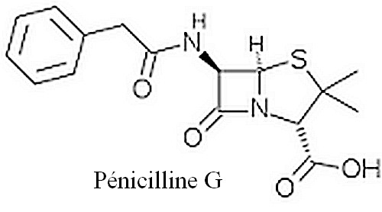

Figure 1: Penicillin G structure

### Characterization of purified penicillin:

Characterization of purified extract and crude extract of penicillin was finally analyzed for its activity on three different pathogenic organisms, *i.e*., *Klebsella* spp., wild strain of *Escherichia coli* (*E. coli*), and methycillin resistant *Staphylococcus aureus* (MRSA). A bacterial lawn of the foresaid bacterial species was spread on nutrient agar plate and a well was bored on the bacterial agar plates. And randomly selected samples which had a high rate of inhibition during routine assay were used for characterization. 100 µL of the samples from crude and purified extract were loaded in two different wells bored in a single plate. The plates were kept for inhibition at 37 °C for 16 to 24 h, and the results were noted(6).

### Penicillin production qualitative analysis:

#### Microbiological assay

The qualitative analysis was done through β-lactamase test using penicillin resistant *Staphylococcus aureus*. Briefly, filter paper was soaked in 0.2% bromophenol blue and 2% culture sample from different shake flask culture medium. The filter paper was dried and loopful culture of penicillin resistant *S. aureus* was placed on it. The change in color was noted to see the presence of β-lactamase enzyme and to confirm the penicillin production. Quantitative analysis was performed by measuring the diameter of zones of inhibition of all the culture samples and comparing them with the standard curve drawn by measuring the diameter of zones of inhibition of standard dilutions of commercially available penicillin G(7).

Antibiotic diffusion assays are based on the technique of allowing an antibiotic to diffuse through an agar gel which has been previously seeded with a sensitive test organism. This diffusion may be of two types: (a) linear diffusion, by bringing the antibiotic in contact with a column of seeded agar in a capillary or test tube; and (b) radial diffusion around a suitable reservoir on a seeded agar plate. Linear diffusion methods have been developed by both Japanese and American workers for penicillin and streptomycin; however, linear diffusion techniques require specialized equipment and are not in general use. The plate assay method for antibiotics is the most widely used and accepted method employing the diffusion technique. Its advantages lie in its simplicity as to labor and equipment. It has definite disadvantages in that the assay is affected by various salts, surface active agents, and solvents which tend to change diffusion characteristics of the antibiotics. With alterations in the diffusion characteristics the dose response curves of the sample and standard will no longer be parallel and the assay itself would be invalid. The distribution of an antibiotic in the agar around a reservoir can be expressed theoretically by an equation involving the initial quantity of antibiotic, the depth of the agar layer, the diffusion constant, the concentration at a given distance from the container, and the time of diffusion. Theory predicts that the square of the diameter of the inhibition zone will be proportional to the logarithm of the antibiotic concentration. This relationship has been found to hold for most antibiotics. Good assay plate methods are available for penicillin, streptomycin, bacitracin, and polymyxin; however, the newer broad spectrum antibiotics tend to give poorly defined zone edges on assay plates(8).

##### Factors influencing variability and error in microbiological assays:

Microbiological assay provides a valid measure of antibiotic activity with some   
problem of interference from biologically active compounds or degraded products.   
Several factors are investigated by scientists that normally cause variation in zone diameters in conventional agar diffusion bioassay. Among these factors the most considerable is the unequal exposure of the individual plates at the top or bottom of the stacks. Another major variable is the variable in the time interval between pouring seeded agar in the plates and the time of applying the solution of the antibiotic to the plates. Other factors that lead to variability and error in microbiological assay include agar thickness, inoculums concentration, incubation temperature, exposure-time duration and sample preparation. Factors affecting microbial growth rates include pH and chemical composition of media and pH of buffer solution used(9).

HPLC is a chromatographic technique used for the identification, quantification and purification of individual components of a mixture in analytical chemistry. HPLC is used extensively throughout the pharmaceutical industries for the quantification of antibiotics in pharmaceutical preparations. It is used to provide information on the composition of drug related samples.

The information obtained may be qualitative, indicating what compounds are present in the sample, or quantitative, providing the actual amounts of compounds in the sample. HPLC is used at all the different stages in the creation of a new drug, and is also used routinely during drug manufacturing. It is more attractive than the classical bioassay in terms of speed, accuracy and precision. Hence, it has largely replaced the microbiological assays to determine the antibiotic concentrations in body fluids and pharmaceutical preparations(9). HPLC analysis of penicillin was carried out with UV detector set at 254 nm. The column used for analysis is C-18. The mobile phase consisted of methanol: phosphate buffer (85:15, v/v) at flow rate 1 mL/min. Standard used for comparison is Pencom®13 (commercially available penicillin injection)(6).

The literature finding shows that both microbiological assay and HPLC method exhibit several advantages and inadequacies. Although HPLC method is fast, accurate and precise for quantification of potency of antibiotics, it cannot determine bioactivity. However, microbiological assay is simple, sensitive, accurate, precise and cost effective to estimate both potency and bioactivity. Besides this, microbiological assay become the most important method to quantify the concentration of active ingredient required for the inhibition of growth of antibiotic resistant microorganism(9).

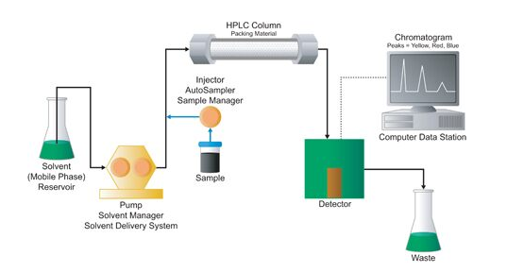

Figure 2: HPLC system

## Ampicillin

### What is Ampicillin?

**Ampicillin** is an [antibiotic](https://en.wikipedia.org/wiki/Antibiotic) used to prevent and treat a number of [bacterial infections](https://en.wikipedia.org/wiki/Bacterial_infection), such as [respiratory tract infections](https://en.wikipedia.org/wiki/Respiratory_tract_infection), [urinary tract infections](https://en.wikipedia.org/wiki/Urinary_tract_infections), [meningitis](https://en.wikipedia.org/wiki/Meningitis), [salmonellosis](https://en.wikipedia.org/wiki/Salmonellosis), and [endocarditis](https://en.wikipedia.org/wiki/Endocarditis). It may also be used to prevent [group B streptococcal infection](https://en.wikipedia.org/wiki/Group_B_streptococcal_infection) in newborns.

It is used by mouth, by [injection into a muscle](https://en.wikipedia.org/wiki/Intramuscular_injection), or intravenously. Common side effects include rash, nausea, and diarrhea. It should not be used in people who are [allergic to penicillin](https://en.wikipedia.org/wiki/Allergic_to_penicillin). Serious side effects may include [Clostridium difficile colitis](https://en.wikipedia.org/wiki/Clostridium_difficile_colitis) or [anaphylaxis](https://en.wikipedia.org/wiki/Anaphylaxis). While usable in those with [kidney problems](https://en.wikipedia.org/wiki/Kidney_problem), the dose may need to be decreased. Its use during  [pregnancy](https://en.wikipedia.org/wiki/Pregnancy) and [breast-feeding](https://en.wikipedia.org/wiki/Breastfeeding) appears to be generally safe. Ampicillin was discovered in 1958 and came into commercial use in 1961. It is on the [World Health Organization's List of Essential Medicines](https://en.wikipedia.org/wiki/WHO_Model_List_of_Essential_Medicines). The World Health Organization classifies ampicillin as critically important for human medicine. It is available as a [generic medication](https://en.wikipedia.org/wiki/Generic_medication)(10).

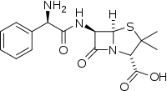

Figure 3: Ampicillin structure

### Pharmacology

**Mechanism of Action:**

Ampicillin is in the [penicillin](https://en.wikipedia.org/wiki/Penicillin" \o "Penicillin) group of [beta-lactam antibiotics](https://en.wikipedia.org/wiki/%CE%92-Lactam_antibiotic" \o "Β-Lactam antibiotic) and is part of the [amino-penicillin](https://en.wikipedia.org/wiki/Aminopenicillin" \o "Aminopenicillin) family. It is roughly equivalent to [amoxicillin](https://en.wikipedia.org/wiki/Amoxicillin" \o "Amoxicillin) in terms of activity. Ampicillin is able to penetrate Gram-positive and some Gram-negative bacteria. It differs from [penicillin G](https://en.wikipedia.org/wiki/Benzylpenicillin" \o "Benzylpenicillin), or benzylpenicillin, only by the presence of an [amino](https://en.wikipedia.org/wiki/Amino" \o "Amino) group. This amino group, present on both ampicillin and amoxicillin, helps these antibiotics pass through the pores of the outer membrane of Gram-negative bacteria, such as *E.coli*, [*Proteus mirabilis*](https://en.wikipedia.org/wiki/Proteus_mirabilis),  *[Salmonella enterica](https://en.wikipedia.org/wiki/Salmonella_enterica" \o "Salmonella enterica)*, and *[Shigella](https://en.wikipedia.org/wiki/Shigella" \o "Shigella)*.

Ampicillin acts as an irreversible inhibitor of the enzyme [trans-peptidase](https://en.wikipedia.org/wiki/DD-transpeptidase" \o "DD-transpeptidase), which is needed by bacteria to make the cell wall. It inhibits the third and final stage of bacterial cell wall synthesis in [binary fission](https://en.wikipedia.org/wiki/Binary_fission" \o "Binary fission), which ultimately leads to cell [lysis](https://en.wikipedia.org/wiki/Lysis" \o "Lysis); therefore, ampicillin is usually bacteriolytic(10).

### Pharmacokinetics

Ampicillin is well-absorbed from the [GI tract](https://en.wikipedia.org/wiki/GI_tract) (though food reduces its absorption), and reaches peak concentrations in one to two hours. The [bioavailability](https://en.wikipedia.org/wiki/Bioavailability) is around 62% for parenteral routes. Unlike other penicillins, which usually bind 60–90% to [plasma proteins](https://en.wikipedia.org/wiki/Plasma_proteins), ampicillin binds to only 15–20%.

Ampicillin is distributed through most tissues, though it is concentrated in the liver and kidneys. It can also be found in the [cerebrospinal fluid](https://en.wikipedia.org/wiki/Cerebrospinal_fluid) when the meninges become inflamed (such as, for example, meningitis). Some ampicillin is metabolized by hydrolyzing the beta-lactam ring to [penicilloic acid](https://en.wikipedia.org/wiki/Penicilloic_acid" \o "Penicilloic acid), though most of it is excreted unchanged. In the kidneys, it is filtered out mostly by [tubular secretion](https://en.wikipedia.org/wiki/Tubular_secretion); some also undergoes [glomerular filtration](https://en.wikipedia.org/wiki/Glomerular_filtration), and the rest is excreted in the [feces](https://en.wikipedia.org/wiki/Feces" \o "Feces) and [bile](https://en.wikipedia.org/wiki/Bile)(10).

### Side effects

Ampicillin is comparatively less toxic than other antibiotics, and side effects are more likely in those who are sensitive to penicillin and those with a history of [asthma](https://en.wikipedia.org/wiki/Asthma) or [allergies](https://en.wikipedia.org/wiki/Allergies). In very rare cases, it causes severe side effects such as [angioedema](https://en.wikipedia.org/wiki/Angioedema), anaphylaxis, and [*C. difficile*](https://en.wikipedia.org/wiki/C._difficile) infection (that can range from mild [diarrhea](https://en.wikipedia.org/wiki/Diarrhea) to serious [pseudomembranous colitis](https://en.wikipedia.org/wiki/Pseudomembranous_colitis)). Some develop [black "furry" tongue](https://en.wikipedia.org/wiki/Black_hairy_tongue). Serious adverse effects also include [seizures](https://en.wikipedia.org/wiki/Seizure) and [serum sickness](https://en.wikipedia.org/wiki/Serum_sickness). The most common side effects, experienced by about 10% of users are diarrhea and rash. Less common side effects can be [nausea](https://en.wikipedia.org/wiki/Nausea), [vomiting](https://en.wikipedia.org/wiki/Vomiting), [itching](https://en.wikipedia.org/wiki/Itching), and blood [dyscrasias](https://en.wikipedia.org/wiki/Dyscrasia" \l "Modern_use" \o "Dyscrasia). The gastrointestinal effects, such as hairy tongue, nausea, vomiting, diarrhea, and colitis, are more common with the oral form of penicillin. Other conditions may develop up several weeks after treatment(10).

### Overdose

Ampicillin overdose can cause behavioral changes, [confusion](https://en.wikipedia.org/wiki/Confusion), blackouts, and convulsions, as well as neuromuscular hypersensitivity, [electrolyte imbalance](https://en.wikipedia.org/wiki/Electrolyte_imbalance), and [kidney failure](https://en.wikipedia.org/wiki/Kidney_failure)(10).

# Devices, Materials and Methods

## Penicillin Production

**In the first**, we put an orange and a half of bread in a fermentation conditions until will be able to see many fermented regions.

**All used lab glassware** are sterilized by adding some ml of water, covering with metallic paper and bowling until the water are totally evaporates

**Microbial essays (culture and inoculation)** are performed in a sterile area near a flame

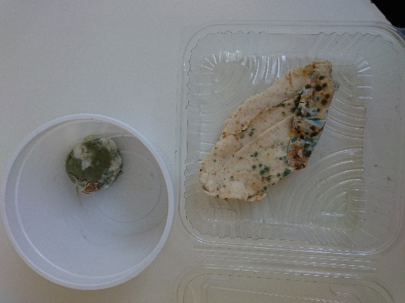

### Preparation of agarose gel

* We try to melt two tryptone tubes by using a heated water (bain marie)
* We weigh 1 g of glucose powder
* In an erlenmeyer flask we mix the melted tryptone, the glucose and 20 ml of distilled water
* We keep heating until we get a homogeneous mixture
* We fill the mixture in two petri dishes
* We heat them in a pressure cooker after boiling for 15 min
* We let them cool down and we wait about 30 min until the gel are totally solidified
* We put them in the fridge until the time of microbial cultivation

### Microbial culture

* We cultivate the two petri dishes differently with the two used strains of penicillium

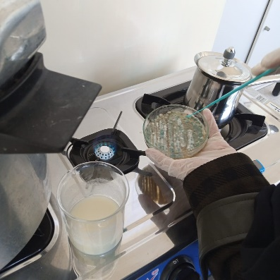 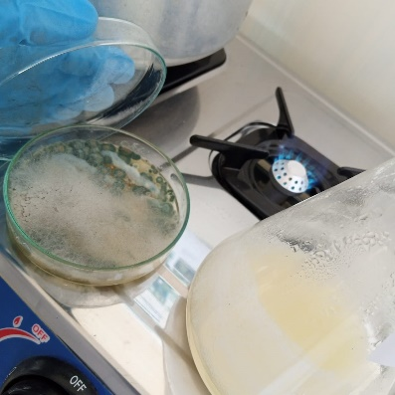

We incubatated them at room temperature for 7 days

### Preparation of liquid medium

* We weigh 4g of glucose powder, 4 g of lactose, 2g of peptone, 0.2g of MgCl2, 0.2g of KCl, and 1g of KH2PO4
* We add 200ml of distilled water
* We distribute the mixture in 2 erlenmeyer flasks (100 ml) with an equal proportion
* We heat them with mixing for 15min by using a magnetic hot plate stirrer
* We let them cool down for about 30 min
* We inoculate each of them with one of the two cultivated petri dishes already prepared (about two to three colony for each of them)
* We incubate them at room temperature for 7days (bread penicillium with shaking and the other lemon penicillium without shaking)

|  |  |
| --- | --- |
| IMG-20210421-WA0022 | IMG-20210421-WA0030 |

### Filtration and the adding of ethyl acetate

* After 7 days of incubation in liquid medium we filter the two inoculated liquid medium by using of filter paper
* Then in each of the obtaining filtrate we add 0.43g of charcoal and 0.5g of KH2PO4 and we leave them for 20 min
* We decant the liquid from the charcoal, then we add ethyl acetate(proportion 50/50)
* (we have used 60ml of lemon penicillim filtrate with 60 ml of ethyl acetate and 46 ml of bread penicillium filtrate with 46 ml of ethyl acetate)
* We incubate them in the fridge some days (about 7 days).

|  |  |
| --- | --- |
| IMG-20210421-WA0023 | IMG-20210421-WA0025 |

### Purification

1. Here the penicillin was dissolved in ethyl acetate
2. The centrifugation method was applied to eliminate the pellet containing cells debris and all other contaminant (4000x for 15 min)

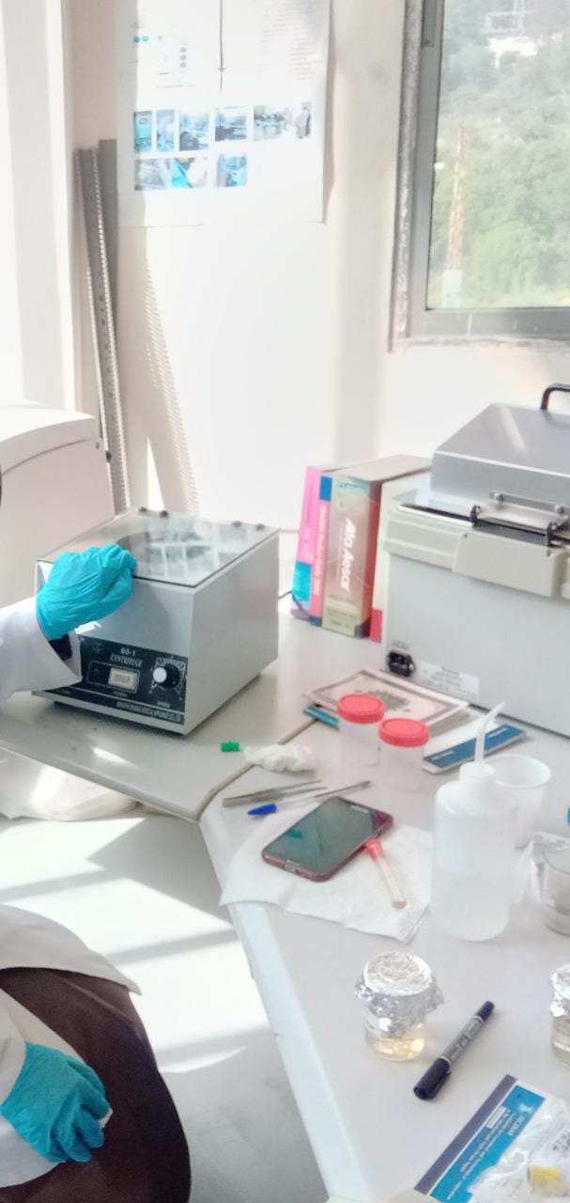

1. The supernatant is reserved (we got about 60 ml of supernatant for each species of penicillium)

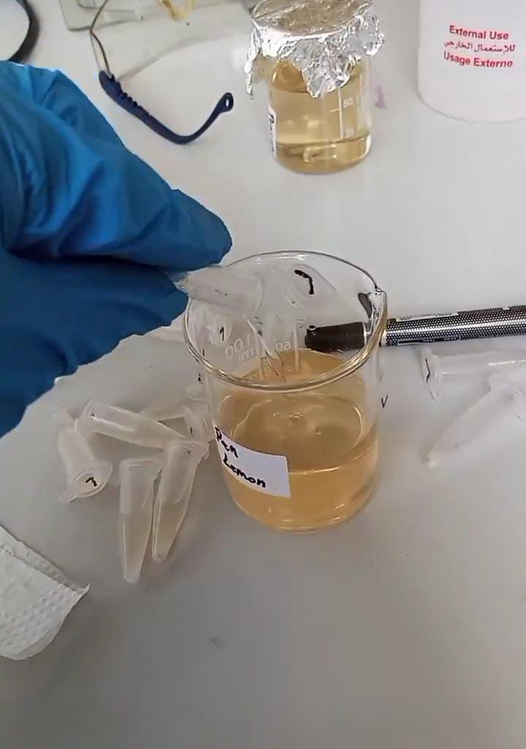

1. We add 5g of sodium bicarbonate for each supernatant to obtain the penicillium in salt form.

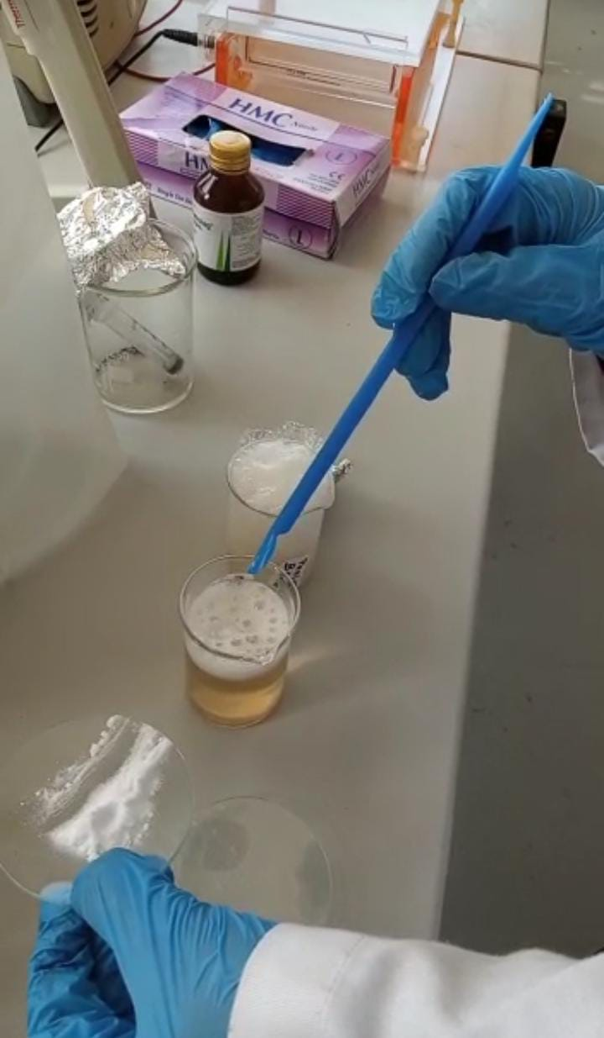

1. We left it in the fridge for a few days to precipitate the penicillium salt

## Penicilin Quantification Proposed experimental protocol:

### Preparation of the turbidity calibration 0.5 McFarland(11):

1. we added 0.5 mL of a 0.048 mol/L solution of BaCl2 (1.175% w/v BaCl2 2H2O) to 99.5 mL of a 0.18 mol/L solution (0.36 N) of H2SO4 (1% v/v) and we shook vigorously
2. We checked the density of the suspension using a spectrophotometer with a 1 cm beam and matching cuvettes. The absorbance at 625 nm should be between 0.08 and 0.13
3. We distributed the suspension in tubes of the same size as those used to adjust the inoculum and then we sealed the tubes
4. Once sealed, we stored these tubes at room temperature and protected from light. Before use, we mixed the tube vigorously using a Vortex (6 months’ storage)



### Quantification of the produced penicillin using the disk diffusion method (Kirby-Bauer Test)(12):

#### Preparation of the inoculum:

1. We took 3 to 5 colonies of the isolated colonies with a loop, and we added them in 2ml sterile saline (NaCl 0.9%)
2. We Vortex the saline tube to create a smooth suspension.
3. We adjust the turbidity of this suspension to a 0.5 McFarland standard

by adding more organism if the suspension is too light or diluting with

sterile saline if the suspension is too heavy.

1. Use this suspension within 15 minutes of preparation.
2. We inoculate the surface of Mueller Hinton agar plate by streaking the swab 3 times over the entire agar surface, we rotated the plate approximately 60֯ each time to ensure an even distribution of the inoculum
3. We allow the plate to sit at room temperature at least 3 to 5 minutes (but no more than 15 minutes) for the surface of the agar plate to dry before proceeding to the next step

#### Preparation of the disks:

1. We dilute the standard penicillin 10 times (Concentrations: 1.5; 1.4; 1.3; 1.2; 1.1; 1.0; 0.9; 0.8; 0.7; 0.6) to obtain different concentrations
2. We dip each of the 10 discs in one of the 10 concentrations of penicillin
3. We dip another one disk in the unknown produced penicillin
4. We distribute the 11 disks in plates at a distance of (26) mm apart
5. Once all disks are in place, we replaced the lid, inverted the plate and placed it at 37oC for 18 to 24 hours

**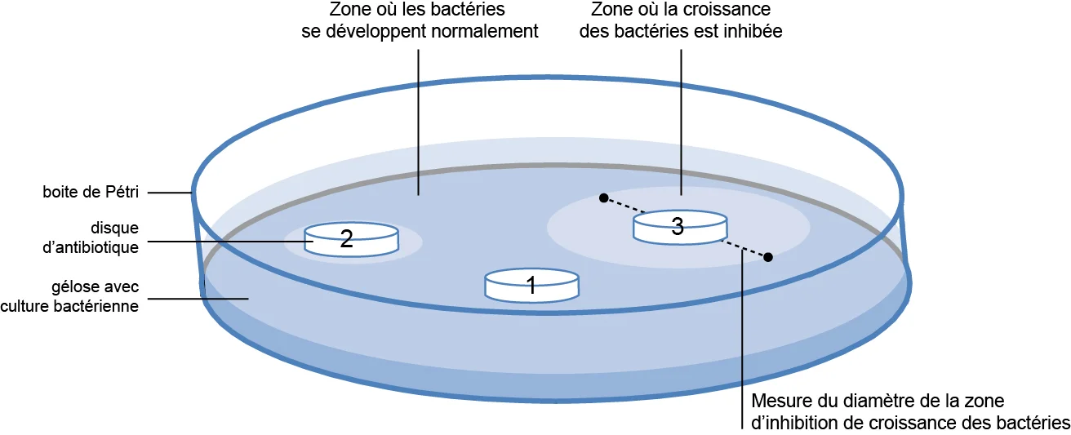**

#### Quantification of the produced penicillin:

1. After the growth time, we measured the zone of inhibition that had appeared using a ruler
2. We drew a graph showing the concentration of penicillin as a function of the diameter in order to be able to quantify the produced penicillin (Log C as a function of diameter)

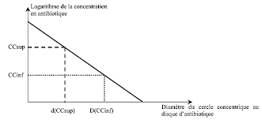

## Ampicillin production proposed protocol

To produce semi-synthetic β-lactam(Ampicillin), there are two proposed methods: One put-one step synthesis(1P1S) and one put two step synthesis while the second has showed a most overall yield then the first:

### 1P1S:

Pen G: 15 ml of 20 mM

D-PGME: 60 mM in 100 mM Phosphate buffer;PH7

iPGA(99.2 UPenG)

We add all the materials in round bottom flask on magnetic stir plate at To(22-25oC) about 160min

### 1P2S:

Pen G: 7.5ml of 40mM

Phosphate buffer: 100mM; PH7

iPGA:124UPenG/gram of carrier

We add all the materials in round bottom flask on magnetic stir plate at To(22-25oC). Then after about 60 min we add D-PGME(7.5 ml/120 mM).

Then after 160 min the PH was adjusted with NaOH from approximately 6.4-7.0

**!**

**The two-enzyme system with iPGA and AEH outperformed the systems that used only iPGA, thus demonstrating the clear advantage of using AEH**(1)**.**

**This result can be shown at the figure below :Figure 1**

**AEH:** Soluble amino ester hydrolase from *Xanthomonas campestris pv. Campestris*

**iPGA:** Eupergit-immobilized penicillin G acylase from *Escherichia coli*

**D-PGME:** (D)-phenylglycine methyl ester hydrochloride

## Proposed protocol for ampicillin quantification

### Preparation of the turbidity calibration 0.5 McFarland(11):

1. we add 0.5 mL of a 0.048 mol/L solution of BaCl2 (1.175% w/v BaCl2 2H2O) to 99.5 mL of a 0.18 mol/L solution (0.36 N) of H2SO4 (1% v/v) and we shook vigorously
2. We check the density of the suspension using a spectrophotometer with a 1 cm beam and matching cuvettes. The absorbance at 625 nm should be between 0.08 and 0.13
3. We distribute the suspension in tubes of the same size as those used to adjust the inoculum and then we seal the tubes
4. Once sealed, we store these tubes at room temperature and protect from light. Before use, we mix the tube vigorously using a Vortex (6 months’ storage)

### The three bacterial strains which can be used:

E.*coli* / S.*aureus* / S.*pneumonia*

### Quantification of the produced ampicillin using the disk diffusion method:

#### Preparation of the inoculum:

1. We took 3 to 5 colonies of the isolated colonies with a loop, and we added them in 2ml sterile saline (NaCl 0.9%)
2. We Vortex the saline tube to create a smooth suspension.
3. We adjust the turbidity of this suspension to a 0.5 McFarland standard

by adding more organism if the suspension is too light or diluting with

sterile saline if the suspension is too heavy.

1. Use this suspension within 15 minutes of preparation.
2. We inoculate the surface of Mueller Hinton agar plate by streaking the swab 3 times over the entire agar surface, we rotated the plate approximately 60֯ each time to ensure an even distribution of the inoculum
3. We allow the plate to sit at room temperature at least 3 to 5 minutes (but no more than 15 minutes) for the surface of the agar plate to dry before proceeding to the next step

#### Preparation of the disks:

1. We dilute the standard ampicillin 10 times (Concentrations: 1.5; 1.4; 1.3; 1.2; 1.1; 1.0; 0.9; 0.8; 0.7; 0.6) to obtain different concentrations
2. We dip each of the 10 discs in one of the 10 concentrations of ampicillin
3. We dip another one disk in the unknown produced ampicillin
4. We distribute the 11 disks in plates at a distance of (26) mm apart
5. Once all disks are in place, we replaced the lid, inverted the plate and placed it at 37oC for 18 to 24 hours

#### Quantification of the produced ampicillin:

1. After the growth time, we measured the zone of inhibition that had appeared using a ruler
2. We drew a graph showing the concentration of ampicillin as a function of the diameter in order to be able to quantify the produced ampicillin (Log C as a function of diameter)

## Penicillin Production (Plant Scale)

### Quantification of produced penicillin G:

High performance liquid chromatography(HPLC)

* We need a sensitive microbial organism such as: klebsiella, E.coli or MRSA
* We need different penicillin-ATB disk with different concentration
* Then we can determine the unknown concentration of the produced penicillin by comparing with the obtained standard curve

We can determine the concentration of produced penicillin by the reading of inhibition zones of different known concentration of standard penicillin

* on of produced penicillin by the reading of inhibition zones of different known concentration of standard penicillin

Liquid chromatography with tandem mass spectroscopy (LC-MS/MS)

3 principle methods to quantify the penicillin

Determination of penicillin concentration by biological assay

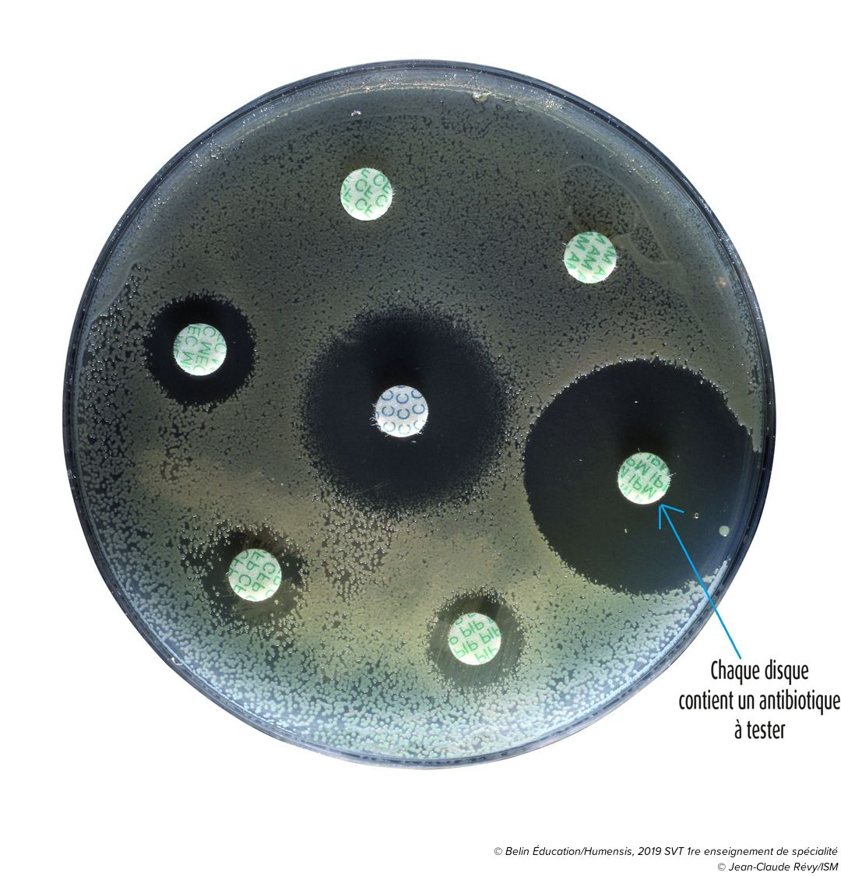



### Production of ampicillin from penicillin

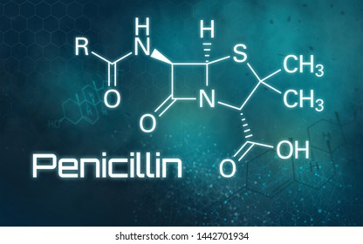 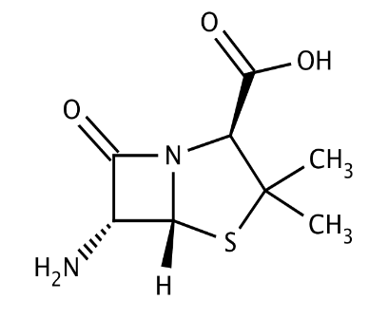

PAA

(byproduct)

6-APA

PGA

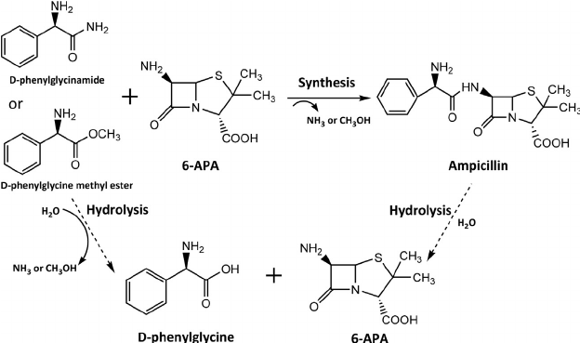

### Ampicillin quantification

Similar to penicillin quantification

### Pilot plant Penicillin G Production

Here we try to produce Penicillin G by using Bioreactor following the steps for Penicillin production mentioned above in (2.1)

# Results

## Penicillin Production

After cooling about 7 days we obtained penicillin crystals.

|  |  |
| --- | --- |
| WhatsApp Image 2021-05-05 at 11 | WhatsApp Image 2021-05-05 at 11 |

We poured the liquid throughly to remove it, then we kept the crystals in the fridge in order to dry them well.

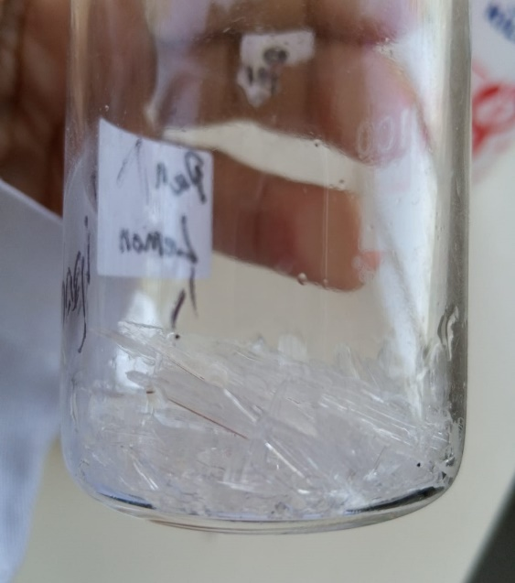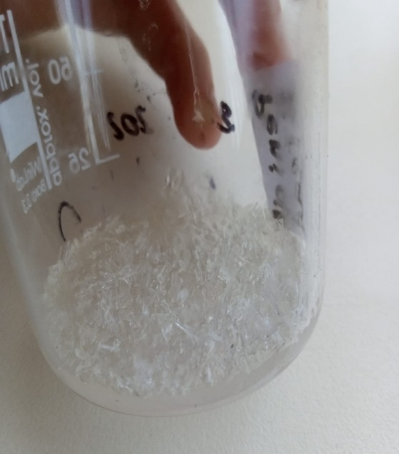

# References

1. ANTIBIOTIC PRODUCTION BY MICROBES ISOLATED FROM SOIL | INTERNATIONAL JOURNAL OF PHARMACEUTICAL SCIENCES AND RESEARCH [Internet]. 2013 [cited 2021 Dec 23]. Available from: https://ijpsr.com/bft-article/antibiotic-production-by-microbes-isolated-from-soil/

2. Manikindi PR. Extraction, Purification and Characterization of an Antibiotic-like Compound Produced by Rhodococcus sp. MTM3W5.2. :120.

3. Deng S, Ma X, Su E, Wei D. Efficient cascade synthesis of ampicillin from penicillin G potassium salt using wild and mutant penicillin G acylase from Alcaligenes faecalis. J Biotechnol. 2016 Feb 10;219:142–8.

4. Du L-L, Wu Q, Chen C-X, Liu B-K, Lin X-F. A two-step, one-pot enzymatic synthesis of ampicillin from penicillin G potassium salt. Journal of Molecular Catalysis B: Enzymatic. 2009 Jun 1;58(1):208–11.

5. MEGBI-APP (Antibiotics Production Pilot Plant) Final Report (Period 2016 - 2020). 2016.

6. Dayalan SAJ, Darwin P, Prakash S. Comparative study on production, purification of penicillin by Penicillium chrysogenum isolated from soil and citrus samples. Asian Pac J Trop Biomed. 2011 Jan;1(1):15–9.

7. Rahman S-U, Rasool MH, Rafi M. Penicillin production by wild isolates of Penicillium chrysogenum in Pakistan. Brazilian Journal of Microbiology. 2012 Jun;43(2):476–81.

8. DAVID GLICK. METHODS OF BIOCHEMICAL ANALYSIS. Vol. 1. 1954.

9. Dafale NA, Semwal UP, Rajput RK, Singh GN. Selection of appropriate analytical tools to determine the potency and bioactivity of antibiotics and antibiotic resistance. J Pharm Anal. 6 Aug;6(4):207–13.

10. Ampicillin. In: Wikipedia [Internet]. 2021 [cited 2021 Dec 29]. Available from: https://en.wikipedia.org/w/index.php?title=Ampicillin&oldid=1057194844

11. Antibiogramme | Protocole | Interprétation [Internet]. [cited 2021 Dec 2]. Available from: https://microbiologie-clinique.com/antibiogramme.html

12. Kirby-Bauer-Disk-Diffusion-Susceptibility-Test-Protocol-pdf.pdf [Internet]. [cited 2021 Dec 4]. Available from: https://asm.org/getattachment/2594ce26-bd44-47f6-8287-0657aa9185ad/Kirby-Bauer-Disk-Diffusion-Susceptibility-Test-Protocol-pdf.pdf

# Master thesis tasks:

1. **Quantification of produced penicillin G**:

Our laboratory had developed a machine to produce penicillin from P.*Chrysogenum.* After we succeeded in its manufacturing process, we try to quantify our product. We find there is three recurrent way to quantify penicillin: HPLC ; LC-MS/MS and biological assay. In this project we try to quantify the penicillin G, which was produce in last time, by using the biological assay which will enable us to determine the concentration of our produced penicillin referring on the measurement of inhibition zone resulting by different concentration of the standard penicillin G. You can find a detailed summary of the protocol below.

1. **Production of ampicillin from penicillin:**

Based on our produced penicillin we try to produce a semi-synthetic penicillin (Ampicillin). First we try to hydrolysis the penicillin with penicillin G acyclase (PGA), we obtain the β-lactam moiety for all penicillin: 6-aminopenicillanic acid (6-APA). Then a chemical coupling of 6-APA with an acyl side chain by using D-phenylglycine methyl ester(D-PGME) enable us to obtain finally the semi-synthetic penicillin (AMP).

1. **Ampicillin quantification:**

As we try to quantify the produced penicillin in the first project, here we try also to quantify the produced ampicillin and to determine the best way which can be used for this reason.

1. **Aspirin production, purification and quantification:**

Based on the advantage of aspirin as a pain, fever and inflammation reducing, we try to find a lab scale to produce Aspirin in our laboratory. For this chemical reaction we need: Phenol, Sodium hydroxide, Carbone dioxide, hydrogen and acetic anhydride. Then it is important to quantify our produced aspirin to know if we succeeded or not. You can find the detailed chemical reaction below

1. **Production of bioethanol from molasses using a special species of yeast**