Siting methodology:
A substantial disciplinary process with multiple sets of criteria is required to identify the best available location (s) for the UMSWI, the final goal of the present work is meeting the regulations requirements, minimizing the environmental, health and social costs,
To satisfy the mentioned final goal, the whole siting process is divided into several sequential steps:
-Identification of the evaluation criteria and sub-criteria associated with the problem and structuring them in a multi criteria decision hierarchy.
-Assignment of grading values to the sub-criteria within the GIS framework.
-Determination of the relative important weights of the sub-criteria by applying CSI.
-Aggregation of the criteria weight and attributes values.
-Ranking of the area according to their suitability score.
Due to the starting large area of analysis without any pre-defined set of candidate sites, a situation that can be quite common the use of two scale approach is proposed in this work.
Such approach allows first, for initial screening of the studied area mitting to identify suitable inter-union of municipal zone(s) satisfying the most (hereafter as global scale), technical and environmental requirements suitable siting place.
Then, the developed model to perform the multi criteria analysis is based on GIS.
All input data required for the analysis in the form of attribute map layers are extracted from several sources, the base map of the entire studied area being available in a digital geo-referenced form of the scale (…….).
Additional layers include spatial information on infrastructure (urban area, road, POI, Refugee Camp extract from CNRS 2017, OSM2021), slope (extract from DEM Aster 30m), Land use and Land cover, water resources (spring, river, affluent, well, extract from NLWE topographic map 1/20000 DEM Aster 30m), and soil type (extract from Bernard GEZE, soil map of Lebanon 1/200000).
The assignment of a suitability grade for every class in a certain attribute map is performed using ArcGIS software.
The resulting maps are then converted into raster cells representation of uniform grid sizes.
Finally, to synthesize and automate the multi criteria decision process in the GIS environment, the model uses Visual Basic programming language and suitability indexes for raster cells are assigned using GIS map Algebra, the spatial Modeller tool.
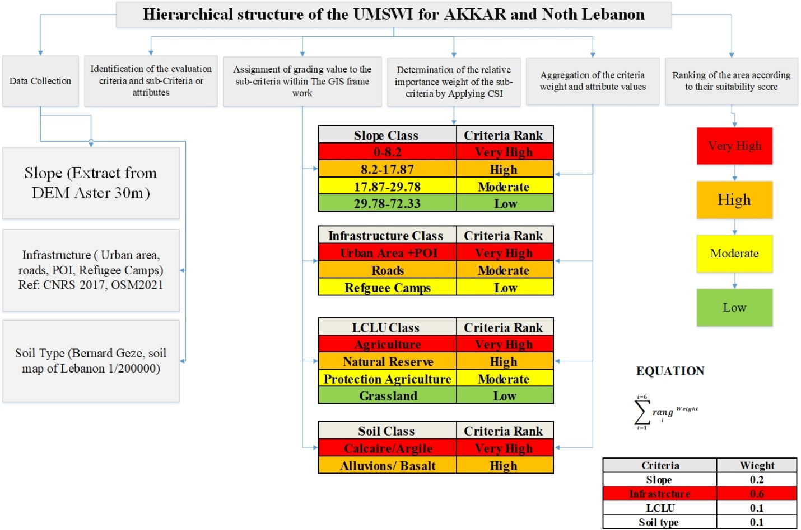
Table 1: The hierarchical structure of the UMSWI for the case study
The criteria used in the case and the description are presented in tables.
- Map Algebra method:
Map algebra is a simple and powerful algebra with which you can extracts all spatial analyst tools, operations and functions to performs geographic analysis.
Map algebra is available through the spatial analyst module, an extension of Arcpy Python site package. As map algebra has been integrated in python, all the functionality of Python and arcpy and its extensions (modules, classes, functions and proprieties) is available.
Spatial Analyst tools are accessed through and algebric format, that is an object whose name is identified to the left of the equal sign is created based on a tool operation stated to the right of the equal sign.
from arcpy.sa import *
outRas = Criteria("indem")
The above statement calculates the criteria for each cell in the indem dataset and creates a Raster object called OutRas to store the results.
Once the evaluation attributes are defined they must be combined into larger groups, the sub-criteria or criteria (see table1).
The relative weights by map algebra method are combined with GIS arrive to the area classification in terms of their overall suitability.
EQUATION:
$\sum_{i=1}^{i=6}{rang}$ weight

Assignment gradients values to the sub-criteria within GIS.
- Distance from roads network, the gradient was based on the premise.
- The terrain slope. Areas with sharp slope are not suitable. The gradient was based on the premise that the flatter area.
- Distance from urban area. An UMSWI should not be built up inside inhabited zones. The distance from urban centers and population settlements are grading elements for the attributes.

