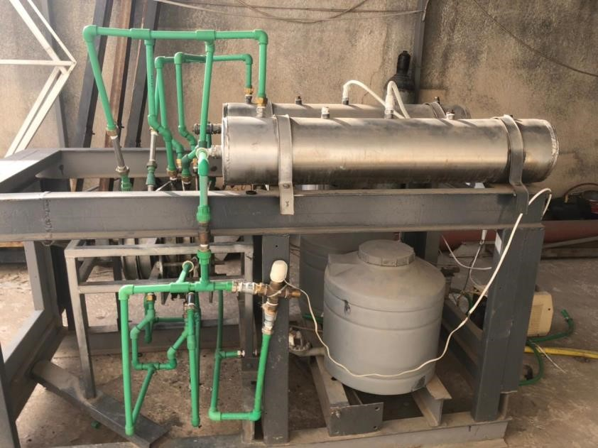
ICPT-Electrolyzer Operations Manual

Author:

Mounira Sayah

Nidaa Fatfat

Last Update:
01.11.2021

Table of Contents
1. Overview 3
2.Pre-Starting 4
2.1. Nitrogen purging 4
2.2. Tank 4
2.3. Safety precaution 4
3.Operating The Plant 5
3.1. Power control box 5
3.2. Usage steps 6
3.3. GUI 6
3.4. Turning off 7

Overview
Electrolysis is a method that uses water “H2O” as a raw material to produce hydrogen and oxygen gas (H2 & O2) through the electric current.
The electrolysis system consists of several cells attached to hydrogen and oxygen storage units. The hydrogen and oxygen are stored in containers after passing through the condenser to remove the excess water as a first step and then pressurized at 350-700 bar (compressor) and then stored in high pressure tanks to be used as a fuel cell.

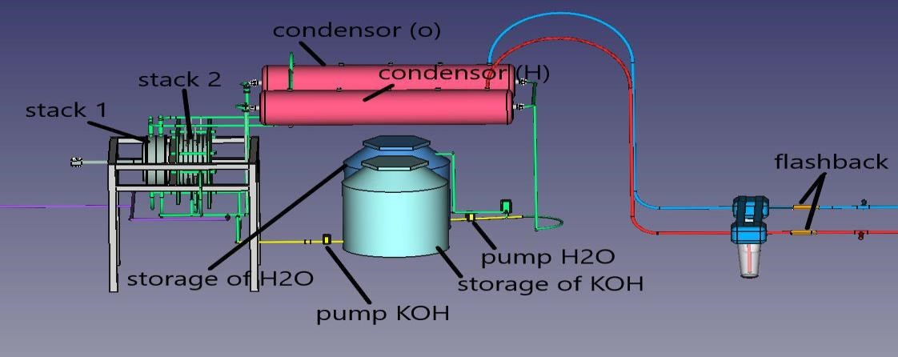
Figure ‎1-1. Electrolyser Diagram
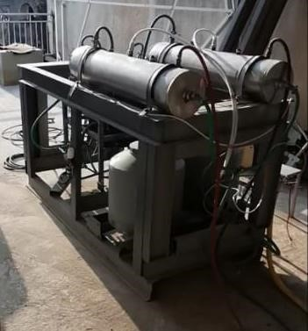
Figure ‎1-2. Electrolyser Plant

2.Pre-Starting
Please read these instructions thoroughly. This will make sure you obtain full safe use, Keep this instruction manual in a handy place for future reference.

2.1. Nitrogen purging
1. Make sure the circuit is closed (all valves are closed)
2. Make sure the power is turned off
3. Connect the Nitrogen tank to the system
4. Open Nitrogen tank valve
The amount of nitrogen needed for this process is based on how many times pressurized purges are needed to reduce the unwanted contaminant to the desired level.
5. Disconnect the nitrogen..

2.2. Tank
1. Make sure that the water tank has 60 liter of water
2. Make sure that the KOH tank has 60 liter of KOH

Safety precaution
Storage of H2 is dangerous, for this reason it should be burned using a fuel burner.

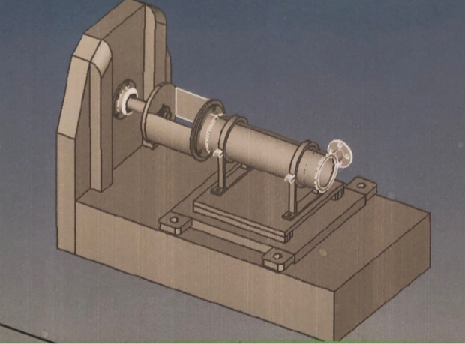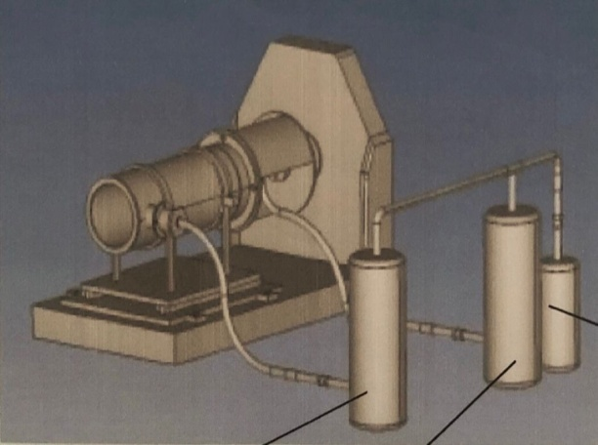

Figure 2-1. Fuel Burner

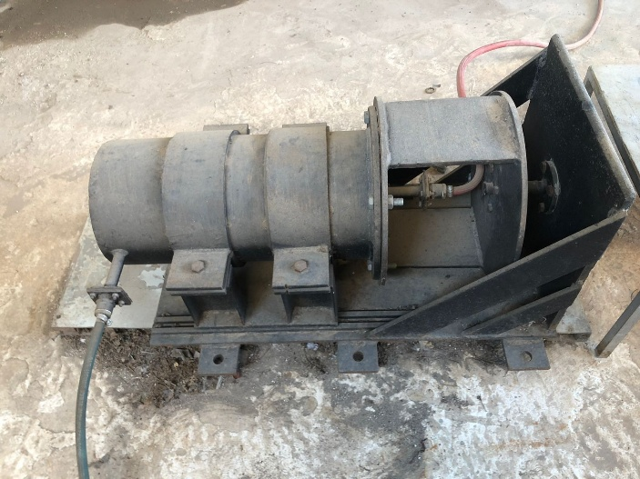

Figure 2-2. Fuel Burner Plant

3.Operating The Plant

3.1. Power control box
Fig.2. Power Control Box

1: cell power switch | a: cell power breaker
2: cell valves switch | b: valve pumps breaker
3: water pump switch | c: level detector
4: KOH pump switch | d: controller
5: water valve switch | e: relay box

3.2.Usage steps
- Turn on the main circuit breaker “cell power breaker “a” to connect power to cells.
- Turn on the valve pumps “b” to control the valves.
You have two optionsfor operating the Electrolyser:
  - Manual usage
Go to the switches “1,2,3,4 and 5”
At upper position, the switches will turn ON directly if the breaker is ON and the switch is up.
  - Automatic usage
Go to the switches “1,2,3,4 and 5”
At lower position, it will turn ON/OFF according to controller command.
- Control of the switches:
  - Turn on the KOH pump switch
  - Turn off the KOH pump switch when the liquid reach the permissible level in the cells
  - Turn on the cell power switch “voltage”
We must add h₂O when the liquid level in the cells decreases
  - Turn on the water pump switch
The water pump is always turned on, but there is a switch to change the flow from cells to itself
  - Turn on the valve of condensed water at (O₂ or H₂ side), when the amount of liquid found in the condenser reach ¾ of the max (then turn them off quickly when the level of liquid decreases slightly)

3.3. GUI
The graphic User Interface is a visual control method that receive data of the plant, and send control commands to it.
The GUI interface is shown in the image below. It is divided into 3 sections; The Power and connect, monitoring, and control.

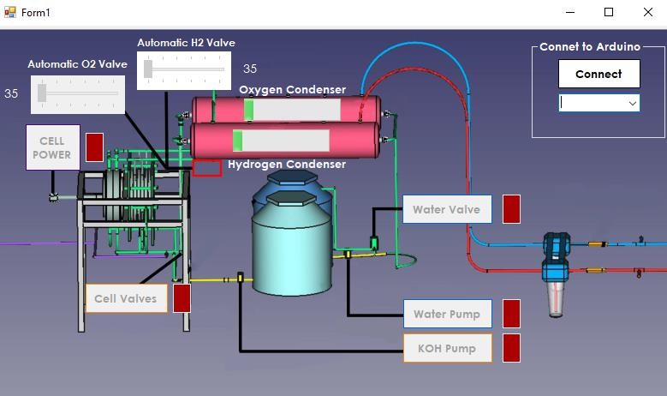
8

- Connect Button: This button is used to connect to the Arduino controller. It uses the COM port shown in the COM port box below it. All buttons will not work until the computer is connected to the station Arduino.
- Cell Power Button: if the electrolyzer is set to Auto mode and this button is pressed, the cell power (welding machine) is activated and its indicator (red box next to it) should turn green.
- The H₂ and O₂ Bars: Will indicate the current amount of liquid found in the condenser.
- Automatic valves (1 and 2): These sliders will control the servo valves at the indicated angle label (number to the left and right).
- Water Pump, KOH Pump, Water Return Valves, and Cell Valves: These buttons will control the respective appliances.

3.4. Turning off

1. Turn off the cell power
2. Turn off all the pumps and the valves
3. Turn on the cell valves to drain the liquid from the cells

