بسم الله الرحمن الرحيم
  - Air Liquefaction and Cryogenic

  - PROCESS CONTROL
  - SYSTEM

Produced by: Nour Karim
Raja Murad

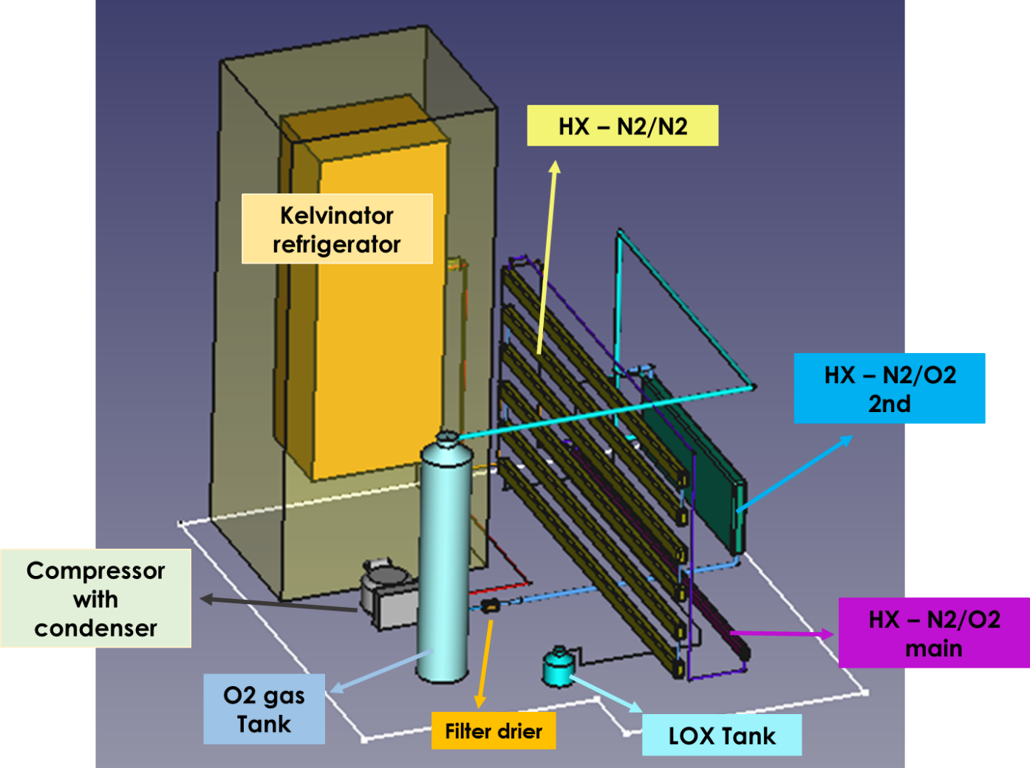
Table of Contents
1. Requirements and Overview 4
2. Plant-End 5
2.1. Description 5
2.2. Electrical Equipment 7
2.2.1. Compressor 7
2.2.2. Cooler 8
2.2.3. Evaporator 10
2.2.4. Sensors 10
2.2.5. Arduino 12
3. Process Control System 13
3.1. The System 16
3.2. Temperature Sensor (PT100) Measurement Circuit 16
3.2.1. R-V Control 18
3.2.2. Offset Control 20
3.2.3. Differential Amplifier 21
3.2.4. Calculating The Temperature 22
3.2.5. Circuit Design 23
3.3. GUI 25

Requirements and Overview
The liquification of oxygen (LOX) process control system to be implemented should have the following technical requirements:
- The user most be able to switch between manual and automatic modes.
- The user must be able to control the Liquification of Oxygen plant remotely, with a distance range that’s up to 1 km.
- The user must be able to monitor different sensor data on a well-organized GUI
- The system must have a 2-way communication channel.
Therefore, Figure 1 below, presents a brief graphical illustration of LOX system functionality.
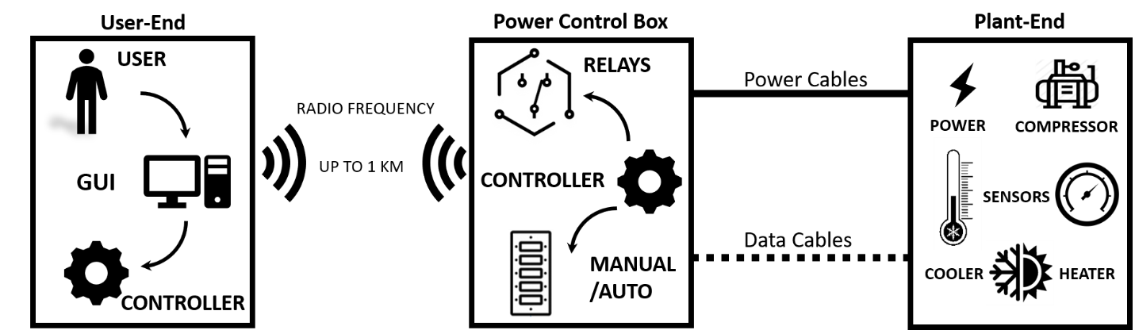
Figure 1. LOX System functionality
The system can be divided into 3 subcategories. First one is the plant where the liquification of oxygen setup is set, then, the power control unit that handles all the control procedure, and the user side where all the controls are set.
Note: photos about the three subcategories are needed.

Plant-End

Description
The following Figure 2 presents the real layout of prototype in AECENAR Facility. While Figure 3, illustrates the circuit design that Gaz must flow according to it. In addition, the places of temperature (mentioned by T1~6) and Pressure (mentioned by P) sensors are presented below.

Figure 2. Real Layout of LOX with Heat Exchanger
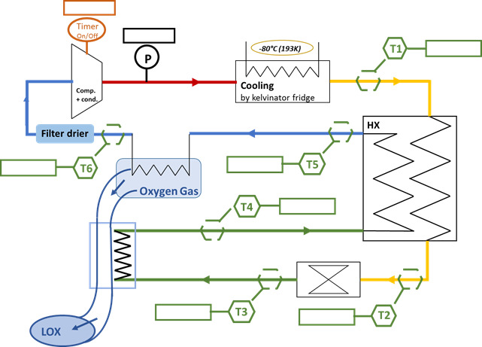
Figure 3. LOX Circuit with Heat Exchanger

Electrical Equipment
The following electrical devices had been chosen for LOX Prototype.

Compressor
LR25B Laboratory refrigerator compressor, shown in Figure 4., was selected.
Figure 4. LR25B Compressor

Cooler
The cooler is presented by a tunned refrigerator by adding seven cooling tubes inside it.
Figure 5. Cooling Tube Design
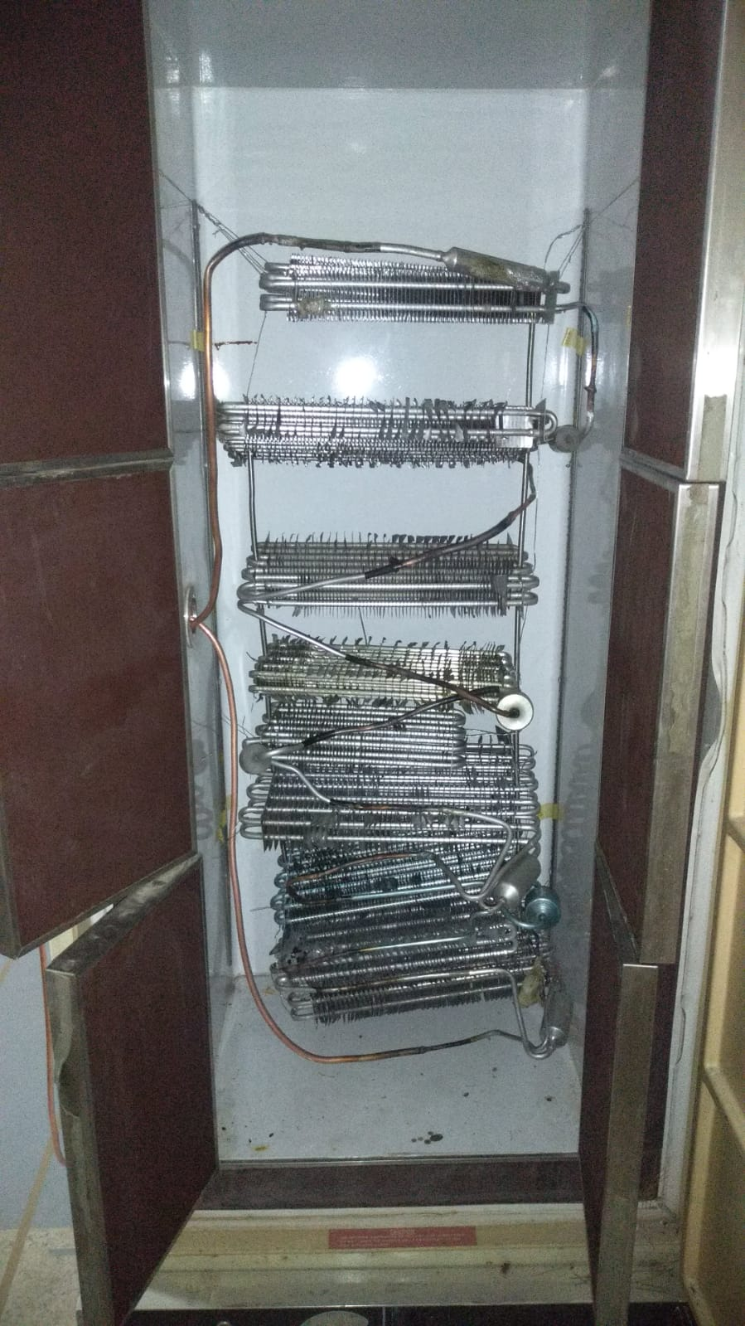
Figure 6. Cooler Tube Implementation

Evaporator
The evaporator or Heater, shown in Figure 7 below, is used to elevate temperature from -85 $℃$ to 7 $℃$.
Figure 7. Evaporator

Sensors

Cryometer
Cryometer is a temperature sensor specified for wide negative temperature range. There are 3 main types of cryometer: Thermocouples, vapor pressure thermometers, and resistance thermometers detector (RTD). In LOX system, a Platinum Resistance Thermometer (PRT) Pt100 Wire-Wound Detector Elements was used. Figure 8 presents Pt100 with its specification.
Figure 8. Cryometer (Model: Pt100)
Figure 9. Pt100 Class A

Pressure Sensor
Collect data and pic...
The pressure sensor is used to control the functionality of the compressor, and for pressure monitoring. The pressure sensor needed, should have the capability to measure pressure up to 16 BAR.

Arduino
Arduino is an open-source electronics platform based on easy-to-use hardware and software. Arduino Nano RF V3 is used in this project since it has a built-in RF24L01 radio frequency module.

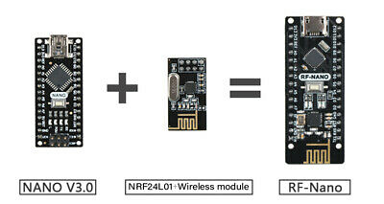
Process Control System
Figure 10. Arduino Nano RF
Note: the process control system is the same for LOX system with/without heat exchanger (HX)
LOX system will be controlled via Arduino
For better understanding, Figure 11 and Figure 12 presents LOX System with/without HX
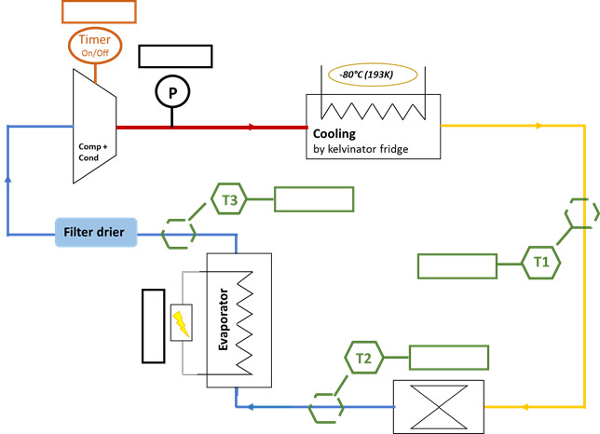
Figure 11. LOX without Heat Exchanger
Figure 12. LOX with Heat Exchanger
Referring to aforementioned circuit diagram, Table 1. Sensors ID with Role highlights sensors that’s have the same role with mentioning their IDs in each system.
Table 1. Sensors ID with Role
ID |  | ROLE
LOX With Heat Exchanger | LOX Without Heat Exchanger
T1 | T1 | Cooler control + Temperature monitoring
T2 |  | Temperature monitoring
T3 | T2 | Temperature monitoring
T4 |  | Temperature monitoring
T5 |  | Temperature monitoring
T6 | T3 | Evaporator control + Temperature monitoring
P | P | Compressor control + pressure monitoring

As can be seen, these two systems have the same basic components needed for fully system control. Therefore, all extra temperature sensors are for better temperature monitoring.
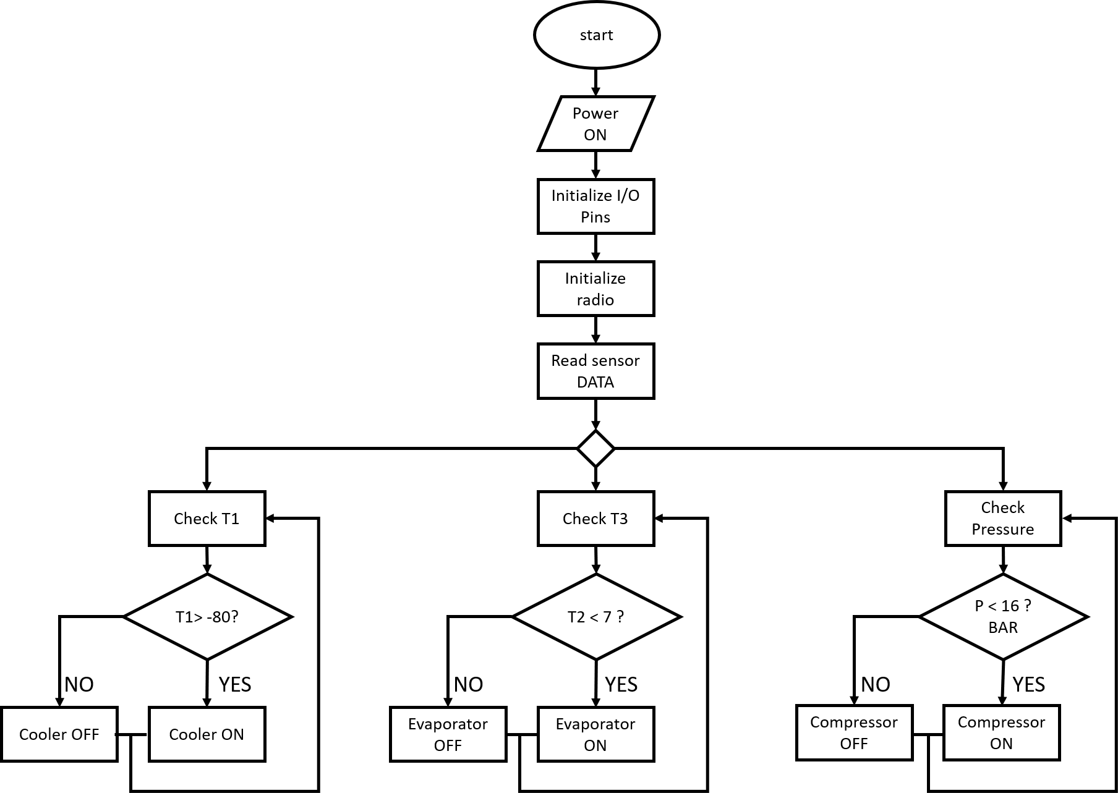
The flow chart below, gives more information about how sensors above will control its accountable device.
Figure 13. flow chart

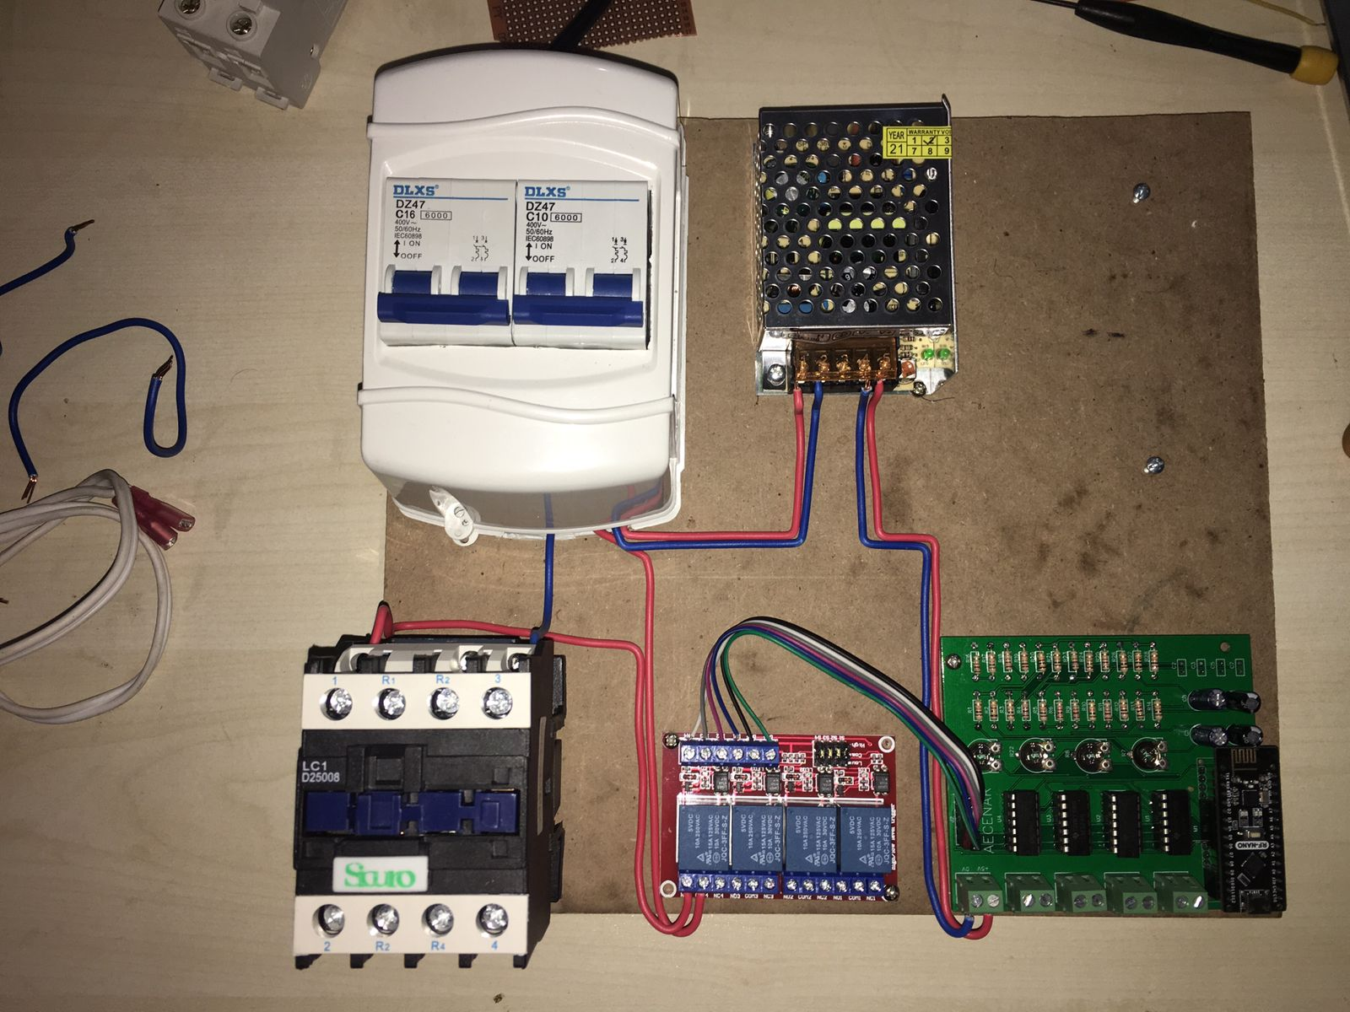
The System
DC Power Supply
Controller Circuit
Compressor Breaker
Controller Breaker

Compressor Contactor

Relay Box

Temperature Sensor (PT100) Measurement Circuit
The cryometer used, as mentioned before, measures a wide range of temperatures (-200 to 400 degrees C). In this project, the desired temperatures to be measured are between -200º to 100º C.
The Platinum cryometer (PT100) changes its resistance with the change of temperature in a known rhythm. To measure the change of the PT100, a Wheatstone bridge is used. The control circuit is composed of 3 parts as shown in Figure 14 below.
Figure 14. PT100 Control Circuit
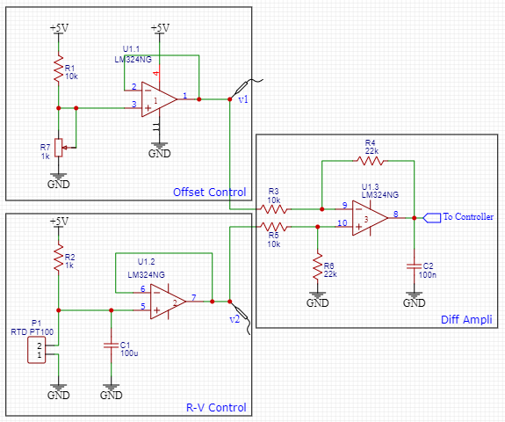
In the above circuit, when the resistance of the RTD (PT100) changes, the output voltage V_{out} (To controller) also changes. It is noteworthy that the PT100 RTD comes in different wiring connections: 2 wires, 3 wires, or 4 wires. All wiring connections have only single input and single output. For 4-wire wiring diagram, one can connect both connected terminals together (can be tested by continuity test via a multimeter).
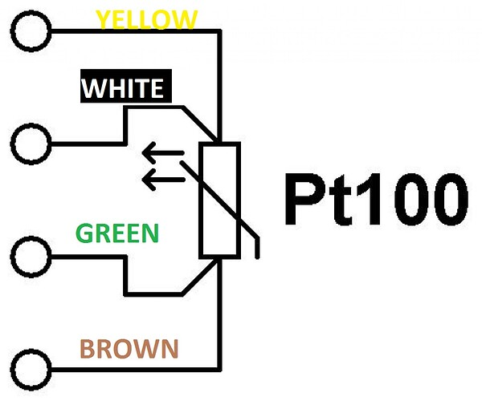

R-V Control
The first part of the circuit is the R-V Control shown in Figure 14 above which converts the resistance change of the RTD into voltage change at the voltage terminal v₂. The voltage across the PT100 can be expressed using voltage divider formula:
 | $$v_{RTD}=\frac{R_{RTD}}{R_{RTD}+R_{1}}×V_{cc}$$ | (1)
When choosing the value of R₁, one must respect the following restrictions:
- Value of resistor (R₁) must be great enough in order to avoid the self-heating problem. If we use low value resistance, more voltage drops across PT100 as a result more self-heating. This increase errors.
- Value of R₁ must be low enough in order to avoid the problem of lower signal to noise ratio. If we increase the value of R₁, change in magnitude per degree decreases as a result lower signal to noise ratio. Large value of R also increases noise which is also responsible for lower signal to noise ratio.
For selecting the best value of R₁, a trade-off between self-heating and better signal to noise ration should be taken. In this application, R₁ is chosen to be 1 K Ohms.
In order to design the proper amplifier, the range of temperature measurement (which is the desired temperatures to measure) should be known. In this application, it is desired to measure temperatures between -200º and +100º C. From the data table shown below in Figure 15 given by the manufacturers of the PT100, the voltage range between these 2 temperatures can be calculated:
The resistance at -200º C is 18.52 Ω which gives (from equation (1)):
 | $$v_{RTD}=\frac{18.52 Ω}{18.52 Ω+1000 Ω}×5V=0.0909 V$$ | (2)
And the resistance at +100º is 138.51 Ω which gives:
 | $$v_{RTD}=\frac{138.51 Ω}{138.51 Ω+1000 Ω}×5V=0.6082 V$$ | (3)
From equations (2) and (3), it is desired to measure voltages between 0.0909 V and 0.6082 V.
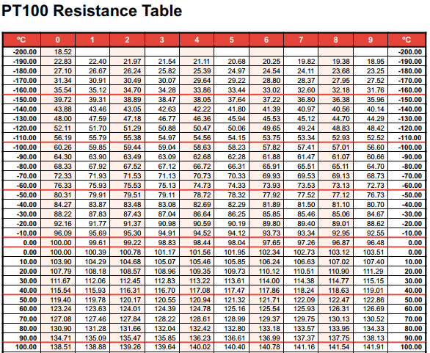
Figure 15. PT100 Resistance Table
The length of RTD leads may be long and might act as an antenna which starts to pick up noises from the surrounding environment. In order to avoid this problem, a high-value capacitor is used in parallel with the RTD which acts as a low-pass filter and removes all noises.
Finally, a voltage-follower circuit is used (using op amp LM324) which gives the advantages of avoiding the loading effect (voltage drop when a load is connected across the voltage divider network) and delivering a high input resistance. The output voltage measured across the PT100 is fed into the voltage-follower circuit which is basically a unity-gain non-inverting amplifier (gain = 1). It is called voltage-follower circuit since its output is equal and in phase with the input voltage. To proof this, assume an ideal operational amplifier is used, and refer to Figure 14 with $v_{2}$ being the output of the voltage-follower:
- $v_{n}=v_{p}$
- $i_{n}=i_{p}=0$
- $A_{v}→∞$
Doing node voltage method at negative node ($v_{n})$:
 | $$v_{n}=v_{2}$$ | (4)
Applying node voltage method at the positive node as well ($v_{p}$):
 | $$v_{p}=v_{RTD}=\frac{R_{RTD}}{R_{RTD}+R_{1}}×V_{cc}$$ | (5)
Since it is assumed as an ideal op amp, $v_{n}=v_{p}$:
 | $$v_{2}=v_{RTD}=\frac{R_{RTD}}{R_{RTD}+R_{1}}×V_{cc}$$ | (6)

Offset Control
The minimum temperature to be measured as stated before is -200º C which leads to 0.0909V and the maximum temperature is 100º C which gives 0.6082 V at $v_{2}$. In this case, we need to subtract the lower limit so that when the temperature is -200º C (0.0909 V), the voltage at $v_{2}$ becomes 0. So, an offset voltage divider circuit is designed so that it will output a constant 0.0909 V and is shown in Figure 14 (upper left circuit). The variable resistor (R₇) is used to adjust the voltage at ($v_{1}$) until it becomes exactly 0.0909V. The voltage-follower circuit is used with the same manner as before.

Differential Amplifier
To subtract the offset voltage from the voltage produced by the change of the PT100, a differential amplifier is used as shown in Figure 14 (right circuit). It has 2 input terminals isolated from the ground by some resistance. It amplifies the difference between the non-inverting input and the inverting input. Doing some math, and with $R_{3}=R_{5}=R_{A} and R_{4}=R_{6}=R_{B}$, the output of the diff. amplifier which will be fed to the Arduino ($v_{out})$ is given as:
 | $$v_{out}=\frac{R_{B}}{R_{A}}(v_{2}-v_{1})$$ | (7)
With, $v_{2}$ is the output from the PT100 voltage divider network and $v_{1}=0.0909 V$ is the offset voltage (voltage at -200º C). Equation (7) has 2 extremities:
- When the temperature is -200º C $→$ $v_{2}=0.0909 V→$ $v_{out}=\frac{R_{B}}{R_{A}}\left(0.0909-0.0909\right)=0$.
- When the temperature is 100º C $→v_{2}=0.6082 V→$ $v_{out}=\frac{R_{B}}{R_{A}}\left(0.6082-0.0909\right)=\frac{R_{B}}{R_{A}}\left(0.5173\right)$.
Here, the gain is expressed by the ratio $\frac{R_{B}}{R_{A}}$. The output of the amplifier will be used by Arduino’s analog input. Thus, a proper reference voltage should be selected.
The default internal Analog-to-Digital converter reference voltage in Arduino is 5V with 10-bit resolution (1024 divisions). Thus, the ADC resolution at 5V is $\frac{5}{1024}=4.88\frac{mV}{div}$.
So, for a temperature range between -200º and 100º C, lower voltage = 0.0909 V and higher voltage = 0.6082 V which results in voltage difference of (0.6082 – 0.0909) = 0.5173 V.
The total number of divisions for this temperature range is: $\frac{0.5173 V}{0.00488\frac{V}{div}}≈106 div$. Therefore, Arduino will show $\frac{{100}^{o}-(-{200}^{o})}{106 div}=\frac{{300}^{o}}{106 div}={2.83}^{o}\frac{C}{div}$. In this scenario, the lowest temperature change per division the Arduino can detect is 2.83º which is not good and an amplifier is a must.
In order to increase the resolution of the Arduino, it is beneficial to use the internal 1.1V reference voltage in Arduino (which can be accessed by code). Thus, the resolution will become: $\frac{1.1 V}{1024 div}=1.074\frac{mV}{div}$.
Finally, the gain of the amplifier ($\frac{R_{B}}{R_{A}}$) can be calculated from the equation (7) above. Here, the maximum voltage to be measured is 1.1V which represents the maximum voltage difference between the two extremities (0.5173 V). So:
 | $$v_{out}=1.1V$$  $$v_{2}-v_{1}=0.5173 V$$  $$v_{out}=\frac{R_{B}}{R_{A}}\left(v_{2}-v_{1}\right)→1.1V=\frac{R_{B}}{R_{A}}\left(0.5173\right)→\frac{R_{B}}{R_{A}}=2.126 ≈2.2$$ | (8)
The ratio of the feedback resistor should be 2.2 times greater than the resistor of the feedforward resistor. But it should be considered that:
- The ratio should be as close to 2.2 as possible.
- Higher value of resistance increases noise but reduces power consumption.
For this application, R_{A} = 10 K and R_{B} = 22 K.

Calculating The Temperature
The temperature can be calculate using the following equation found in the datasheet:
 | $$T=\frac{\left(\frac{R_{x}}{R_{0}}\right)-1}{0.00385}$$ | (9)
Where, $R_{x}$ is the current resistance of the PT100, $R_{0}$ is the PT100’s resistance at 0º C (which is 100 Ω). Here, $R_{x}$ will be calculated from the output voltage measured by the Arduino.
Figure 16 below shows the PT100’s resistance changes to temperature change and how the differential amplifier output is changing for different resistance values. It can be clearly seen from the figure below (right plot) that the resistance vs. voltage plot is not linear. So, a polynomial fitting tool is used (via Matlab) to estimate the 4th degree polynomial equation of this graph which will be used to calculate the exact resistance ($R_{x}$) value. The estimated polynomial equation of the resistance as a function of output voltage is shown below in equation (10).
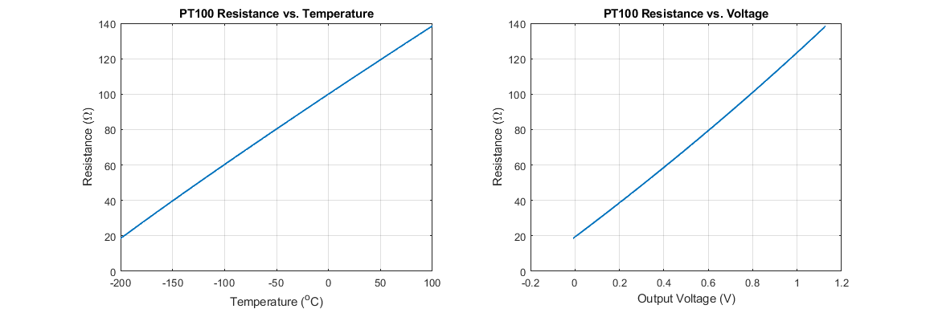
Figure 16. PT100 characteristics at the left (from datasheet) and PT100 resistnace with respect to differential amplifier output voltage at the right
 | $$R_{x}=0.0988 v_{out}^{4}+0.7862{ v}_{out}^{3}+8.7649 v_{out}^{2}+94.4629 v_{out}+19.368$$ | (10)
To sum things up, the Arduino’s role can be summarized as follow:
- Measure the voltage coming from the differential amplifier (between 0 and 1.1 V for -200º and 100º C respectively).
- $R_{x}$ is calculated from equation (10)
- Temperature is calculated from equation (9).

Circuit Design
In order to get better accuracy in measuring the temperature, a PCB has been designed. The fabrication files required to make the same boards and the simulated PCB design are attached below.
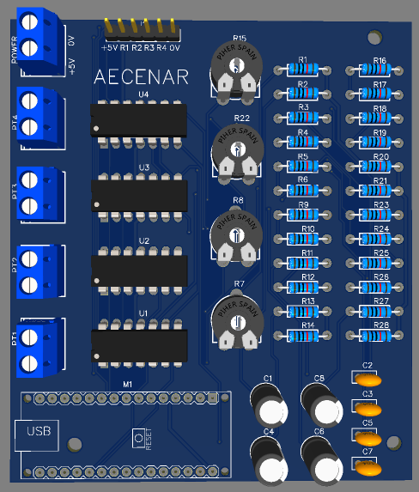
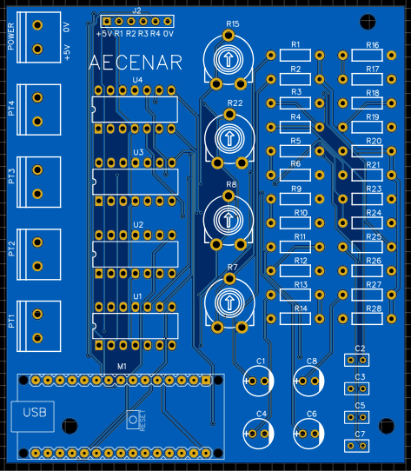

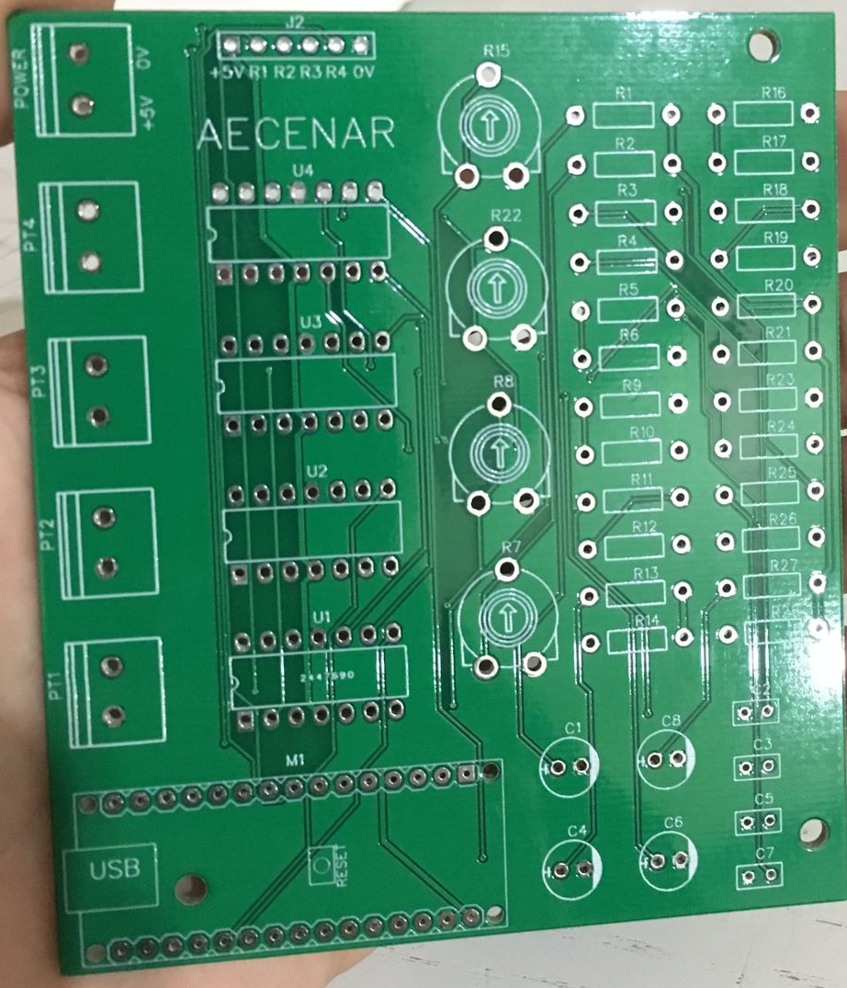
After fabrication:
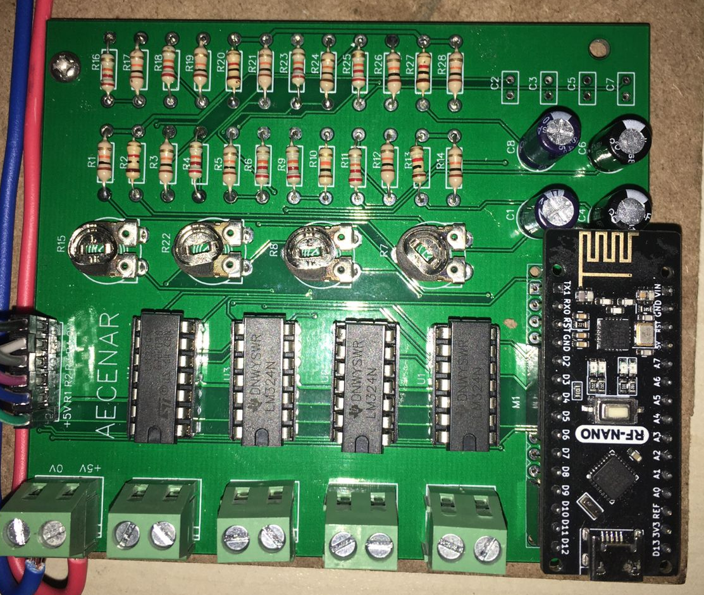

GUI
The GUI is used to send commands like turning ON the compressor and monitoring the temperature at different points of the system.
