Progress in the Electrochemical Synthesis of Ammonia

A b s t r a c t
Ammonia is one of the most important and widely produced chemicals worldwide with a key role in the growth of human population. Nowadays, the main route for ammonia synthesis is the Haber-Bosch process, developed a century ago. In this process, Fe-based catalysts are usually employed at temperatures between 400 and 500 ◦C and pressures between 130 and 170 bar. As opposed to the industrial process, in nature, plants and bacteria have been producing ammonia for millions of years at mild conditions. Atmospheric nitrogen is reduced by solvated protons on the FeMo cofactor of the metalloenzyme nitrogenase. The natural method of nitrogen fixation has motivated several research groups to explore the electrochemical synthesis of ammonia at ambient pressure. Since it was first demonstrated in 1998, the electrochemical synthesis has been studied in a variety of experimental configurations over a wide temperature range (25–800 ◦C). In the present review, the progress of this method in both solid and liquid electrolyte cells is reported.
The experimental studies are divided into:
- high (T > 500 ◦C)
- intermediate (500 ◦C > T > 100 ◦C)
- low (T < 100 ◦C) temperatures
The experimental observations are comparatively discussed with theoretical predictions based on DFT calculations. The techno-economic advantages and disadvantages of the electrochemical approach, as well as the requirements to be met in order to enable practical applications are also analyzed.

Introduction
Ammonia is one of the most important chemicals with an annual production exceeding 200 million tons [1]. Nearly 80% of the produced ammonia is used in the fertilizer industry and has played a key role in maintaining the growth of human population [2]. The dominant industrial route for its synthesis is the Haber-Bosch process, according to which ammonia is produced from the reaction of dinitrogen with dihydrogen:
The Haber-Bosch process was developed one hundred years ago [3] and employs Fe-based catalysts in the temperature range of 400–500 ◦C and at pressures of 130–170 bar [3–5]. The newer KAAP (Kellogg Advanced Ammonia Process) process uses a Ru-based catalyst at relatively lower pressures (<100 bar)[6]. The high operating pressures are dictated by the reaction stoichiometry and the Le Chatelier principle. The operating temperature is a trade-off solution. The need for fast reaction rates dictates operation at high temperatures. On the other hand, the need for high equilibrium conversion dictates operation at low temperatures [4]. Although the reaction is exothermic, a significant energy input is required. Today, the energy consumption for ammonia synthesis is about 1.4% of all energy consumed worldwide [7]. This high energy need is due to the production of hydrogen, the thorough purification of the reactant gases and the compression of the reacting mixture.
Because of its importance, the Haber-Bosch process is one of the most thoroughly studied catalytic reactions. Most of these theoretical and experimental studies suggest that the rate determining step is the dissociation of dinitrogen on the catalyst surface [2,8]. Since the first industrial application, numerous researchers have contributed to the discovery and development of more efficient ammonia synthesis catalysts, which would allow operation at lower temperatures and, consequently, at lower pressures [1–5].
As opposed to the industrial process, which requires elevated pressures and temperatures, plants and bacteria can convert gaseous nitrogen into ammonia at ambient conditions [2,7–10]. This is achieved with the use of metalloenzymes, called nitrogenases. These enzymes are formed by the combination of two proteins [11]. The first of these proteins mediates the electron transfer for the reduction of dinitrogen via an iron sulfur complex (Fe₄S₄). The other contains two iron-molybdenum cofactors (molybdenum may be substituted by vanadium or iron) on which the actual nitrogen fixation takes place according to the following overall reaction scheme [7,11]:
Despite the use of enzymes and the reaction’s exothermicity, a significant amount of energy equivalent to 8 ATP moles per mol of ammonia produced is consumed, i.e. 244 kJ/mol NH₃, which is still better than the industrial method [7]. Contrary to the Haber-Bosch synthesis, however, most of the studies of the enzyme-catalyzed synthesis propose an associative mechanism, wherein the N₂ bond breaks after partial hydrogenation ofthe N₂ molecule [2,7–9].
Concurrently with improvements in the Haber-Bosch process, several research groups studied the “natural” process and used transition metal complexes to develop an “abiological” process and thus, imitate nature [12,13]. Moreover, the need for protons and electrons for the completion of reaction (2) indicated that ammonia could be synthesized via an electrochemical process. To this end, various research groups tested the operation of aqueous electrochemical cells in which NH₃ was produced from H₂O and N₂ [1,4,5]. The problem, however, was that these cells had to operate at low temperatures at which the reaction kinetics were slow.
In 1981, Iwahara and coworkers [14] discovered solid state materials that exhibited substantially high proton (H⁺) conductivity at elevated temperatures (500–1000 ◦C). By using such a high-temperature solid electrolyte cell (Fig. 1), the electrochemical synthesis of ammonia from its elements was experimentally demonstrated in 1998 [15]. The process was simple. Gaseous hydrogen passed over the anodic electrode of the proton-conducting cell and was converted to H⁺. By imposition of the proper voltage, the produced protons were electrochemically transported to the cathode where they reacted with gaseous nitrogen to produce ammonia. The cell operated at an atmospheric pressure because the high pressure requirement was counterbalanced by the consumption of electrical energy. In fact, when the cell of Fig. 1 is used and the reactant hydrogen is supplied in the form of protons, one reactant volume produces two volumes of product. Thus, the high pressure requirement is essentially reversed [16].
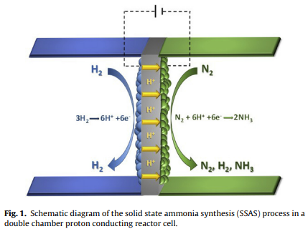
In the past two decades, several research groups have studied the Solid State Ammonia Synthesis (SSAS) in an effort to improve reaction rates and minimize the electric energy consumption. The main findings from studies published before 2013, have been reviewed recently by Amar et al. [5], Giddey et al. [1] and Garagounis et al. [4].
The present review reports on the progress in the electrochemical synthesis of ammonia in both solid electrolyte and liquid electrolyte cells. Depending on the operating temperature range, the experimental studies are divided into three groups:
- high temperature (T > 500 ◦C)
- intermediate temperature (500 ◦C > T > 100 ◦C)
- low temperature (T < 100 ◦C).
The presentation of the experimental findings is followed by a summary of the results obtained from theoretical studies, primarily DFT calculations. Theoretical predictions and experimental observations are then comparatively discussed, together with the similarities and differences between the catalytic and the electrochemical process. The techno-economic advantages and disadvantages of the electrochemical approach as well as the requirements to be met in order to enable promotion into industrial practice are also analyzed.

2. Experimental Studies

2.1. High Temperature SSAS
Table 1 summarizes the reported results on the electrochemical synthesis of ammonia at high temperatures (T > 500 ◦C) until the end of 2015.
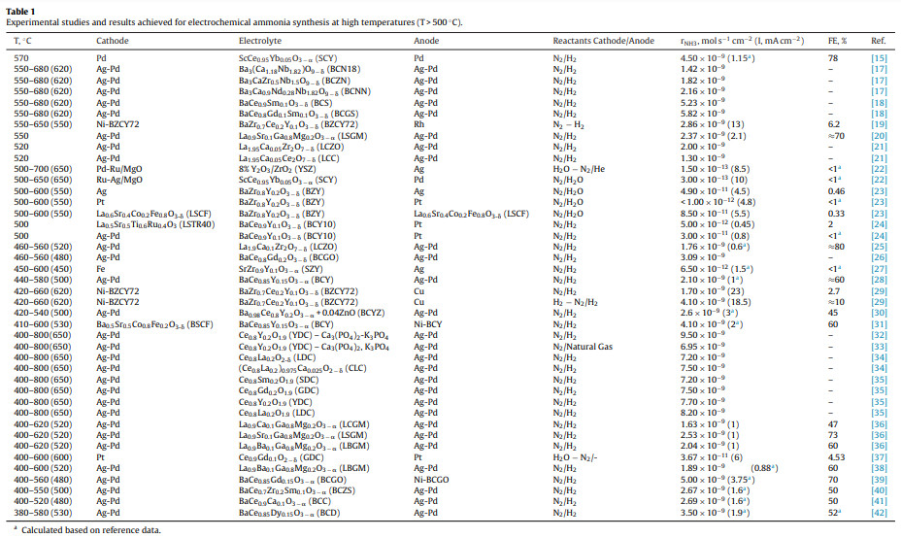
This table shows the electrolytes and electrodes used by various research groups, along with the maximum ammonia synthesis (and current density at which they were obtained) and Faradaic Efficiency (FE) values achieved when using these materials. Certain values of FE or current density are marked with an asterisk. These values were not reported in the cited reference, but have been calculated from data presented therein. Also, in a number of cases no specific value is given, because these works did not provide enough information to permit its calculation. Similar tables have been compiled for works conducted at intermediate and low temperatures (Tables 2 and 3, respectively)
Most of the studies presented in Table 1 employed solid electrolytes, in a reactor-cell design like that depicted in Fig. 1. In the majority of these cases, the electrolyte material was a perovskite. Materials with fluorite or pyrochlore structures have also been reported as possible electrolytes. One group [32,33] reported quite high ammonia rates with a composite electrolyte consisting of YDC combined with calcium-potassium phosphate. When, as in Fig. 1, the electrolyte is a proton conductor the electrochemical reactions at the two electrodes can be written as:
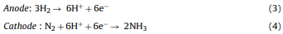
Reactions (3) and (4) combined give us an overall reaction which is the same as reaction (1). As can be seen in Table 1, the most common reactants at the anode and cathode were gaseous H₂ and N₂, respectively.
The highest rates have been observed over Pd-containing catalysts. In the earliest SSAS work, the cathodic electrode (catalyst) was Pd and the highest reaction rate was 4.5 × 10−9 mol s⁻¹ cm⁻², while the highest FE was 78% [15].
In the past decade, many researchers have tested the activity of Ag-Pd. Li et al. used barium cerates (BCS, BCGS) as electrolytes and reported reaction rates as high as 5.82 × 10−9 mol s⁻¹ cm⁻² [18].
Using a lanthanum-doped cerium oxide electrolyte (LDC), Liu et al. obtained a reaction rate of 8.2 × 10−9 mol s⁻¹ cm⁻² [35]. In addition to the high reaction rates, Ag-Pd electrodes have also given the highest Faradaic Efficiencies. The FEs attained by Zhang et al. [20], Chen et al. [36] and Xie et al. [25] were 70%, 73% and 80%, respectively, when using lanthanum gallate and lanthanum zirconate electrolytes.
The presence of water vapor (steam) has been reported to increase the protonic conductivity of perovskite electrolytes [5]. To this end, the introduction of humidified, rather than dry, hydrogen has also been examined on various materials [28,30,31,34,39–42]. It can be seen from Table 1 that, in the case of barium cerate-based electrolytes operating with wet hydrogen over the anode, higher reaction rates and FEs are obtained [31,39,42].
In the industrial process, a considerable fraction of the overall cost lies in the preparation of the hydrogen feed gas and specifically in its purification. Hydrogen is primarily produced from natural gas. The latter contains compounds which, even in trace amounts, can poison the industrial catalyst. Therefore, extensive purification of H₂ is required.
The electrochemical synthesis (Fig. 1) bypasses this requirement because, only protons (H+) are conducted through the solid electrolyte. Furthermore, it is not necessary to use gaseous H2. Apparently, any hydrogen-containing compound could be used.
Thus, using the solid electrolyte cell of Fig. 2 and an Ag-Ru/MgO catalyst(cathode), the feasibility of SSAS from steam and nitrogen was demonstrated in 2009 [22].
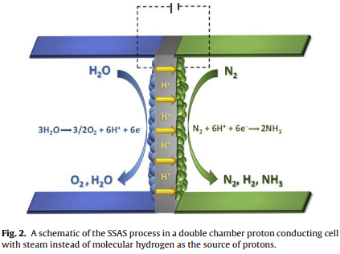
Similar studies followed on Pt and Ag electrodes [23]. Wang et al. [33] studied the reaction at 650◦C on a Ag-Pd cathode, with a YDC-Ca₃(PO₄)₂, K₃PO₄ composite electrolyte, but used natural gas (CH₄) as a hydrogen source. The maximum ammonia rate they observed was 6.95 × 10⁻⁹ mol s⁻¹ cm⁻², which is one of the highest at these temperatures.
Fig. 3 shows schematically how an oxygen-ion (O²⁻) conductor can be used for SSAS. Ammonia is synthesized from gaseous nitrogen and steam according to the following reactions:
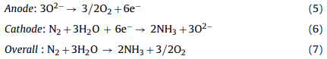
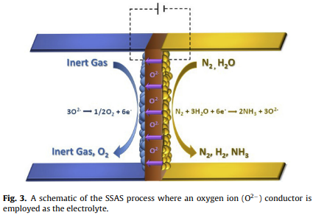
In this case both, steam electrolysis and ammonia synthesis take place at the cathode. Table 1 shows that the reaction rates obtained in these O²⁻ cells [22,37] were one to three orders of magnitude lower than those obtained in the cells of Fig. 1. This can be attributed to the presence of oxygen-containing compounds (H₂O) at the cathode. In such a configuration, a gaseous fuel could be supplied to the anode instead of an inert gas. The oxidation of this fuel by the oxygen pumped away from the cathode could reduce the energy requirements for the in situ production of hydrogen (steam electrolysis). Depending on the fuel and the operating temperature, the whole process could even become spontaneous, completely eliminating the need for electrical energy supply.

2.2. Electrochemical Synthesis at Intermediate Temperatures
Table 2 contains the results from studies conducted at intermediate temperatures, i.e. between 100 ◦C and 500 ◦C. Two categories of electrolytes were used in these studies, molten salts and composite materials.
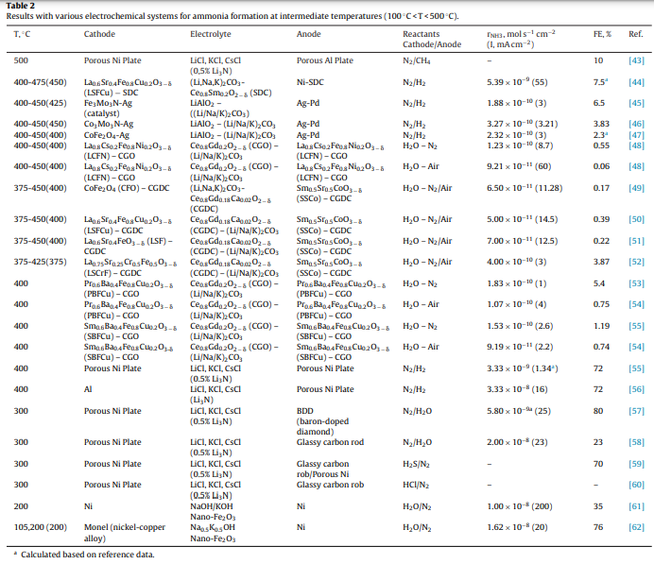
The cells with molten salt electrolytes have been operated at temperatures between 200 and 500 ◦C. Murakami et al. [55] first studied ammonia formation in the cell shown schematically in Fig. 4. The electrolyte was a eutectic mixture of LiCl, KCl and CsCl and the electrodes were porous nickel. 0.5 mol% Li₃N was dissolved in the electrolyte and was the source of nitride ions (N³⁻). Nitrogen supplied to the cathode was reduced to N³⁻ which traveled through the electrolyte and reacted with hydrogen at the anode to produce ammonia:
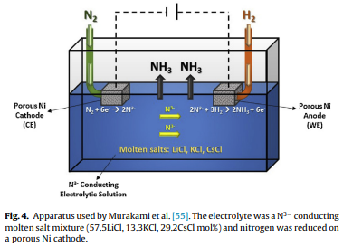
The eutectic mixture is the specific composition of at least two solid components that produces a change of phase to liquid at a certain temperature. This temperature receives the name of eutectic point temperature and corresponds to the minimum melting temperature of the different possible compositions.
The highest rate they observed was 3.33 × 10⁻⁹ mol s⁻¹ cm⁻² at 400 ◦C and 0.7V vs the Li⁺/Li electrode with a FE of 72%. The same cell also operated for short durations with different hydrogen sources such as methane [43], hydrogen sulfide [59] and hydrogen chloride [60]. In a similar study, the effect of replacing hydrogen with steam on the ammonia formation rate was investigated [57,58]. Steam was fed into the reactor over a glassy carbon rod which served as the anode [58]. The anode reaction in this case was:
When H₂O was used instead of H₂, a higher reaction rate was achieved (2 × 10⁻⁸ mol s⁻¹ cm⁻² at 2.9Vvs the Li⁺/Li electrode), but the FE was significantly lower (23%). The oxygen ions generated by reaction (9) reacted with the carbon electrode to produce carbon dioxide. To increase cell stability, the glassy carbon anode was replaced by boron-doped diamond [57]. Thus, O₂ instead of CO₂ was produced at the anode. The reaction yield, however, was much lower with the inert anode, possibly due to the reaction of NH₃ with O₂. Expanding on the above, Murphy et al. suggested that the system could be further improved [63]. Suggested improvements include, changing the electrolyte (e.g. with bromides in place of chlorides, or organic salts) or the electrodes and the use of multiple cathodes. Butthese suggestions have not been implemented by any researchers to date.
More recently Licht et al. introduced a similar set up but with the addition of a nano-particle catalyst to the molten electrolyte [61]. The electrolyte was a molten NaOH/KOH mixture (1:1 molar ratio) and the catalyst was a nano-powder of Fe₂O₃. The gas feeds were nitrogen and steam at cathode and anode respectively, and the maximum ammonia formation rate was 1 × 10⁻⁸ mol s⁻¹ cm⁻² at a 1.45% FE with the application of 2.4V vs the counter electrode (CE) [61]. The authors suggested that the performance of the cell could be improved by passing a high current for 15–30 min before applying the operating current, reporting FEs up to 76% [62]. The size of the catalyst particles was crucial; particles larger than 40 microns were completely inactive [62]
In the last decade, composite electrolytes have been tested in hydrogen fuel cells operating at intermediate temperatures (400–800 ◦C). These electrolytes consist of a mixture of a solid oxide with a second phase which changes the overall electrical, thermal or mechanical properties of the material. This extra phase is often an eutectic mixture of alkali metal salts such as carbonates, halides, sulphates or hydroxides [1]. The presence of the molten phase enhances the ionic conductivity and reduces the operating temperature of the electrolyte.
Amar et al. have tested such composite electrolytes for SSAS in cell configurations similar to those of Figs. 1 and 2. An eutectic salt mixture, (Li/Na/K)₂CO₃, was combined with LiAlO₂ at a mass ratio of 1:1. Three different catalysts/cathodes were examined, Fe₃Mo₃N [45], Co₃Mo₃N [46] and CoFe₂O₄ [47], under pure nitrogen, with wet hydrogen on the side of the anode (Table 2). The best of these materials was found to be Co₃Mo₃N, which achieved a maximum rate of 3.27 × 10⁻¹⁰ mol s⁻¹ cm⁻² at 450 ◦C with an applied voltage of 0.8V vs the CE. The highest faradaic efficiency (3.83%) was observed at 0.4V vs CE, but with a much lower production rate (0.75 × 10⁻¹⁰ mol s⁻¹ cm⁻²) [45]. The low efficiency in all cases was attributed to the rapid hydrogen evolution reaction at this temperature. The same research group reported a reaction rate 10 times higher than the above (5.39 × 10⁻⁹ mol s⁻¹ cm⁻² at 0.8V vs the CE) when the electrolyte was changed to (Li,Na,K)2CO3- SDC (30:70%wt), with a cathodic electrode consisting of a 70:30 mixture (by weight) of LSFCu and SDC [44].
Furthermore, Amar et al. have also tested ammonia synthesis in an oxygen-ion conducting composite electrolyte (see Fig. 3). Using (Li,Na,K)2CO3-CGdC (30:70 wt%) as the electrolyte they studied three different cathodes: CoFe2O4 [49], LSF [51] and LSCrF [52]. The most efficient of them was the LSCrF electrode mixed, with CGdC at a 70:30% wt ratio. The anode was SSCo-CGdC (30:70%wt) and was exposed to the atmosphere, while wet air was fed to the cathode. With this configuration, the researchers observed an ammonia rate equal to 4 × 10⁻¹⁰ mol s⁻¹ cm⁻² with a FE of 3.87% at 375 ◦C at an applied voltage of 1.4V vs CE. The higher voltage used in these studies compared to those of the same group with proton conductors, is dictated by the need to electrolyze steam which was the hydrogen source.
The same group have also studied the ammonia synthesis in a symmetrical single chamber reactor configuration, using (Li,Na,K)₂CO₃-(CGO) (70:30 wt%) as the electrolyte. This setup is similar to that shown in Fig. 3, but with both electrodes exposed to the same atmosphere. This means that, not only the ammonia synthesis electrode is exposed to steam which is a potential poison, but also the produced ammonia can react with gaseous oxygen generated by the electrolysis. Nevertheless, they tested three different perovskite type catalysts achieving a maximum ammonia rate of 1.83 × 10⁻¹⁰ mol s⁻¹ cm⁻² with a FE of 4.8% at 400 ◦C and 1.4V vs the CE with PBFCu [53].
An interesting approach, though not strictly electrochemical, was investigated by Itoh et al. [64]. The apparatus is shown in Fig. 5. An Ag-Pd membrane was used to separate hydrogen, generated in situ by water electrolysis.
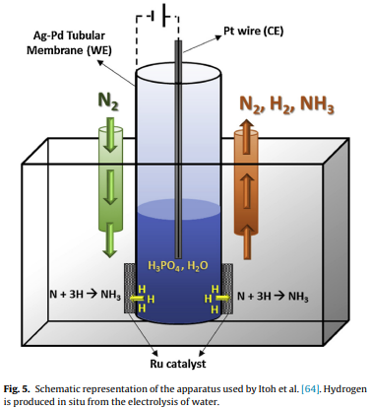
The membrane was shaped like a closed-ended tube and contained a phosphoric acid solution which served as electrolyte and water source. A Pt-wire was used as the anode, while the membrane also functioned as the cathode. The produced hydrogen, permeated through the membrane in atomic form, to react on a Ru catalyst deposited on its outer surface, over which gaseous nitrogen was flowing. Thus, hydrogen was produced electrochemically, while ammonia was produced catalytically. The highest ammonia synthesis rate measured in this study was 2.22 × 10⁻⁶ mol s⁻¹ cm⁻² at 150 ◦C but it was not stable. To improve stability, the authors introduced a porous Al₂O₃ layer on the ruthenium side of the membrane by a surface coating method. In this way they achieved much better stability but at the cost of catalytic activity (2.7 × 10⁻⁸ mol s⁻¹ g_{cat}⁻¹ at 100 ◦C).

2.3. Electrochemical Synthesis at Low Temperatures
Table 3 contains the results from studies conducted at low temperatures, i.e. T < 100 ◦C.
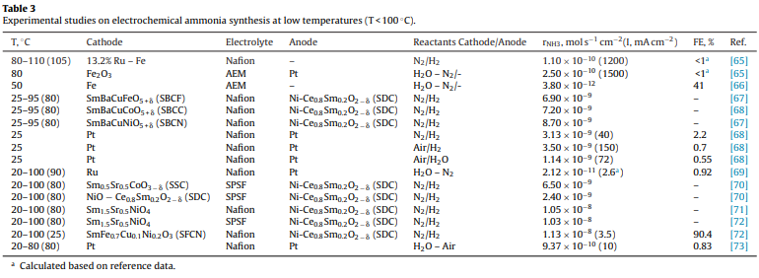
The proton conducting electrolytes used in these studies were Nafion and sulfonated polysulfone (SPSF). Operation at low temperatures provides two advantages.
- Firstly, reaction (1) is spontaneous
- secondly, the proton conductivity of low-temperature electrolytes, such as Nafion, is much higher than of those which operate at intermediate and high temperatures [4,5].
On the other hand, reaction kinetics are quite slow at low temperatures.
In 2000, the first low temperature ammonia synthesis was reported. Kordali et al. using a Nafion electrolyte combined with an alkaline solution and produced ammonia from water and nitrogen at temperatures up to 100 ◦C [69]. Fig. 6 is a schematic diagram of their cell.
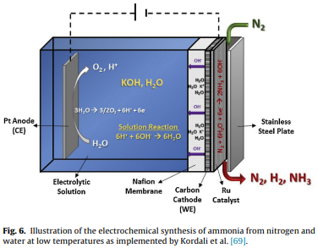
The anodic electrode was Pt, immersed in a KOH solution. The latter was in contact with a Nafion membrane. The cathode was a carbon cloth, on which the Ru catalyst was deposited. Gaseous N₂ was introduced at the cathode side. The reactions at the two electrodes and in the KOH solution can be written as:
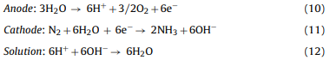
The above reactions combine to produce the overall reaction (7):
The hydrogen source for ammonia synthesis in the low temperature experiments was either gaseous H₂ [66–68,70–72] or H₂O [68,73]. The reactor cell configuration in these two cases were similar to those of Fig. 1 and Fig. 2, respectively. Using a SFCN electrode, Xu et al. reported the highest rate of 1.13 × 10⁻⁸ mol s⁻¹ cm⁻² and the highest FE of 90.4% [72]. In general, high reaction rates of the order of 10⁻⁸ mol s⁻¹ cm⁻² were observed on mixed oxide (e.g. SSN) and perovskite (e.g. SBCN) cathodes [67,71]. Lan et al. [68] used Pt electrodes and operated their cell at 25 ◦C. The reaction rate and FE achieved were not among the highest (1.14 × 10⁻⁹ mol s⁻¹ cm⁻² and 0.55, respectively) but this work is a significant contribution to the promotion of the electrochemical synthesis of ammonia because the most abundant substances were used as reactants (water and air) and the reaction was carried out at ambient conditions (25 ◦C and atmospheric pressure).

3. Theoretical Studies and Prediction of Promising catalytic systems
For many years, the research and development of the optimum ammonia synthesis catalysts was based on materials screening. During the discovery of the iron-based catalyst which is typically used in the Haber-Bosch process, around 3000 compounds were evaluated [3]. Such an evaluation required a lot of experiments with high cost and complexity. However, this method is effective and is still used by a lot of scientists nowadays.
In the past decade, the advances in computation and modelling fields helped substantially in the developing of new methods in several scientific fields, including catalysis [74]. Jacobsen et al. [75] designed a pioneering Co-Mo catalyst for ammonia synthesis, based on the energy of adsorption of N₂ on transition metal surfaces. The high activity of this material was confirmed through experiments with the Co₃Mo₃N nitride [75], thus showing that theory and experiment are equally needed in catalysis.
The significant results of theoretical studies in ammonia production systems have also been expanded to electrocatalytic systems at low temperature and pressure [2,9,76–82]. The scientific interest in the electrochemical synthesis increased considerably because ammonia production under mild conditions could reduce the overall cost of the process [1]. Density functional theory (DFT) calculations were used for the analysis of the energetics of possible pathways, mechanisms or electro-catalysts for nitrogen reduction [2,9,76–82]. The electrodes were usually assumed to be in contact with an acidic electrolyte in a liquid state.
Skúlason et al. [9] were the first to present a comprehensive DFT analysis for possible transition-metal electro-catalysts, where they predicted the applied voltage-bias needed for nitrogen reduction [9]. The theoretical analysis was carried out by considering both an associative and a dissociative Heyrovsky mechanism for flat and stepped surfaces. For the associative mechanism molecular nitrogen is reduced by solvated protons according to the following scheme (asterisk denotes a surface site):
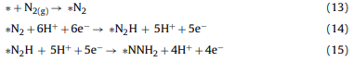
The mechanism continues with further hydrogenation of the NNH₂ species until the N-N bond breaks and NH₃ is formed [9].
In the dissociative mechanism, molecular nitrogen first dissociates on the catalyst surface and then the N-adatoms are hydrogenated to ammonia according to the following reaction pathway:
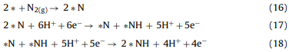
And then the *NH species are further hydrogenated until the formation and desorption of the NH₃ molecule.
The electrocatalytic activity of the various transition metal surfaces was measured by expressing each elementary reaction step’s free energy as a function of the applied overpotential and the binding energy of N-adatoms. Volcano plots were then prepared by assuming different limiting steps for each of the transition metal surfaces. At the top of the volcano diagrams, the most active surfaces were found.
The results showed that ammonia formation would be expected on Mo, Fe, Rh, and Ru via the associative mechanism, but with relatively low efficiencies due to the competing hydrogen evolution reaction (HER). Another important conclusion was that only early transition metal surfaces such as Sc, Y, Ti, and Zr, bind N-adatoms more strongly than H-adatoms under ambient conditions. Thus, ammonia formation was expected at applied biases between −1.0 and −1.5V vs the SHE (Standard Hydrogen Electrode) through a dissociative pathway [9].
In a recent review by van der Hamet al., the reductive adsorption of N₂ to *N₂H and the reductive desorption of *NH₂ to produce NH3 were reported as the steps with key energetics for the associative pathway [7]
In their work, data from Skúlason et al. [9] were used and it was pointed out that the difference in the adsorption energies of *N₂H and *NH₂ intermediates is far from the optimal difference required for electrocatalytic ammonia synthesis [7].
Recently, Montoya et al. [2] confirmed the latter by carrying out DFT calculations and cited this fundamental limitation of the single metal surfaces as the reason for the lack of experimental observations in electrochemical ammonia synthesis works [2]. Therefore, it was concluded that if an electrochemical ammonia synthesis process is to be realized, the electro-catalyst should have bi-functional surfaces, where both *N₂H and *NH₂ are adsorbed on different or on multiple active sites [2].
Howalt et al. [76] used a similar approach on pure metal nanoclusters of various transition metals [76] at low temperature and pressure. The analysis indicated that the reduction of nitrogen could occur through an associative Heyrovsky mechanism on Mo, Fe or Ru, but HER would be favored due to its lower onset potential [76]. A dissociative mechanism study was not included, because a thermally activated Langmuir-type step of N₂ cleavage would be necessary [76].
Several subsequent works focused on the nitride of the most promising Mo-electro-catalyst. [77–79]. Howalt et al. [77] showed that on molybdenum nano-clusters nitrogen would bind preferentially over hydrogen for specific nitrogen coverages at low overpotentials through an associative pathway. However, the presence of water in the reaction environment would reduce the efficiency of the electro-catalyst by blocking the active sites, due to preferential adsorption of oxygen over nitrogen [78].
Metanovic et al. [79] studied different δ-Mo₂N surfaces and they reported the (111) surface as the most promising since it has the highest activity for nitrogen reduction [79]. The latter was attributed to the existence of a side-on N₂ complex on the (111) surface, which activates the highly inert N₂, and to the high affinity of this surface to nitrogen atoms, which acts as a driving force for the dissociative adsorption of N₂. The competing HER would even be suppressed at low applied bias due to the high affinity of N-adatoms [79].
Abghoui et al. [80] used DFT calculations to identify which transition metal mononitrides could form ammonia via a Mars-van Krevelen mechanism [80,83]. A reaction mechanism which stipulates that a lattice nitrogen atom of the surface reacts towards ammonia and its vacancy is replenished by the dissociation of molecular nitrogen from the gaseous phase. The most promising electro-catalysts were ZrN, NbN, CrN and VN with a rocksalt structure [80]. The same group [81] took this study a step further by identifying the active facets of the most promising mononitrides for ammonia synthesis. The nitride surfaces were found stable to decomposition and water poisoning and at the same time ammonia formation with high faradaic efficiency was expected [81]. Specifically, the rocksalt (100) facets of VN and CrN exhibited the highest efficiencies (theoretically reaching even 100%) and were strongly suggested to experimentalists for future tests [81].

Discussion
Today, the Haber-Bosch process is a mature technology. Due to its tremendous industrial importance, the catalytic reaction of ammonia synthesis from its elements has been studied in detail in the past hundred years [4,8,9]. The reaction is equilibrium limited and the catalyst accelerates both the forward and the reverse reaction. The composition of the effluent mixture of NH₃, H₂ and N₂ is very close to that predicted by the equilibrium of reaction (1).
The yield to ammonia is a function of:
- the reactant feed flowrate
- the reactant composition
- the reaction temperature
- the pressure of operation
- and (primarily) the catalyst used.
The effect of the operating temperature on X_{NH3}, the equilibrium-predicted molar fraction of ammonia, for stoichiometric reactant mixture (PH₂/PN₂ = 3) and for various operating pressures, is depicted in Fig. 7a.
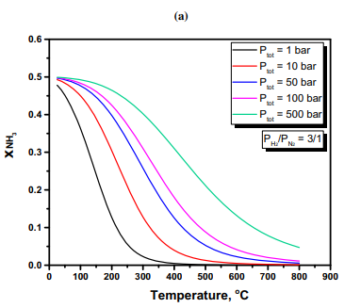
Fig. 7a. Equilibrium mole fraction of ammonia versus temperature (a) under various (total) pressures for the stoichiometric feed ratio
It can be seen that for temperatures between 400 ◦C and 500 ◦C, an industrially acceptable conversion (15-20%) is attainable at pressures between 50 and 100 bar.
In Fig. 7b, X_{NH3} is plotted vs temperature for atmospheric pressure and for various PH₂/PN₂ ratios.
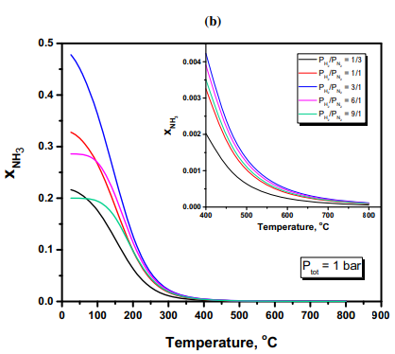
Fig. 7b. Equilibrium mole fraction of ammonia versus temperature (b) for various feed ratios under atmospheric pressure (inset showing temperature effect between 400 and 800 ◦C).
As expected, the stoichiometric PH₂/PN₂ ratio gives the highest conversion to ammonia. It should be pointed out that these are maximum theoretical concentrations and that reaction kinetics, as well as reactor design and operating conditions (e.g flow rate) play an important role in achieving them.
The electrochemical synthesis of ammonia has been studied only in the laboratory and for less than twenty years. Moreover, it is a more complicated system because there are additional factors that affect the reaction rate. The reactants are fed in separately and thus, the inlet flowrate of N₂ and H₂ can be controlled independently of each other. Furthermore, in addition to the effect of temperature and pressure, the rate of the electrochemical synthesis depends on the applied voltage and the generated current. Although the role of these electrochemical parameters has been addressed in previous reviews [1,4,5], a brief summary is presented below in order to include recent experimental findings.

Effect of applied potential
Ammonia is not produced unless the voltage becomes more negative (cathodic polarization) than a certain value. This onset value can be calculated from ΔG_{R}º, the free energy change of reaction (1):
- where F is Faraday’s constant.
- n is the number of electrons (or protons) per molecule of reacting N₂.
Similarly, if ammonia is produced from water and nitrogen, this onset value for E◦ can be calculated from the above equation using the free energy change of reaction (7).
Fig. 8 shows the dependence of the onset potential, V, on the operating temperature.
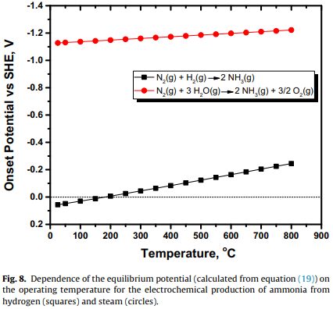
If ammonia is produced from reaction (1), the threshold values of E◦ are 0.057V and −0.123V vs SHE at 25 ◦C and 500 ◦C, respectively. When the hydrogen source is H₂O (equation (7)), the corresponding E◦ values are −1.13V vs SHE at 25 ◦C and −1.21V vs SHE at 500 ◦C.
According to most of the experimental studies [4,5,19,26,29], the effect of applied voltage on the rate of NH₃ synthesis follows the behavior shown schematically in Fig. 9.
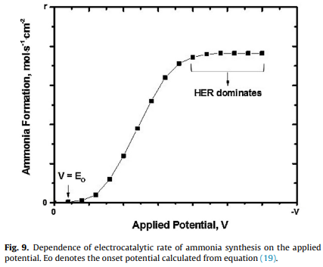

The production rate, rNH₃, increases with cell potential, −V, up to a certain value, above which the rate levels off. At higher applied potential values, HER is completely dominant.
The above reaction rate-voltage behavior stimulated the search for electrochemical promotion, a phenomenon observed in studies in which the catalyst is the working electrode of a solid electrolyte cell. For SSAS, this phenomenon could be studied in the H⁺ cell of Fig. 1. If, instead of pure N₂, a gaseous mixture of N₂ and H₂ is introduced over the cathode, ammonia will be formed under both, open- and closed-circuit conditions. If the reaction rate at open circuit is r_{o} and a constant current I is imposed, the reaction rate will increase from r_{o} to r. The rate increase can be correlated with I by means of the dimensionless parameter /\ [84,85]:
If /\ = 1, i.e. the rate increase is equal to the rate of H⁺ “pumping”, the effect is Faradaic. Since 1981, the phenomenon of Non-Faradaic (/\ > 1) Electrochemical Modification of Catalytic Activity (NEMCA), also called Electrochemical Promotion of Catalysis (EPOC) has been observed in numerous catalytic reaction systems [84,85].
Values of /\ as high as 3 × 105 have been reported [84].
In the case of SSAS, however the measured values were very low. On a Pd electrode, the values measured /\ by Marnellos et al. were as high as 2.0 [86].
Yiokari et al. used an industrial Fe catalyst and were able to increase the open-circuit rate by up to 13 times but only when operating under low conversions, i.e. far from equilibrium [87].
In a thermodynamic analysis for reactions with limited conversion, Garagounis et al. provided an explanation for the weak NEMCA effect observed in SSAS [88]. Specifically, the thermodynamic analysis indicated that for temperatures between 500 and 600 ◦C, /\ cannot exceed the value of 10. This is because the role of protons in equilibrium limited reaction is both, electrochemical and catalytic. The promotional effect of the H⁺ flux is weak because the pumped protons are used not only to modify the catalytic properties of the cathode, but also to carry the electrical power required for ammonia synthesis [88].
Nevertheless, introducing a H₂-N₂ mixture, rather than N₂ alone, over the cathode, was found to have a positive effect on the electrochemical synthesis rate. Recently, SSAS was studied over a Ni-BZCY72 cathodic electrode, with and without H₂ in the gas phase. Without H₂, the highest rate was 1.7 × 10⁻⁹ mol s⁻¹ cm⁻². When H₂ was present (PH₂/PN₂ = 1), an electrochemical reaction rate of 4.1 × 10⁻⁹ mol s⁻¹ cm⁻² was obtained, corresponding to a 140% enhancement of the open-circuit rate [29].

Effect of applied current
The effects of current and voltage are not independent of each other. At a given temperature and gas composition, the overall resistance of the cell remains constant. Therefore, the effect of applied current is expected to be similar to that of the potential (Fig. 9).
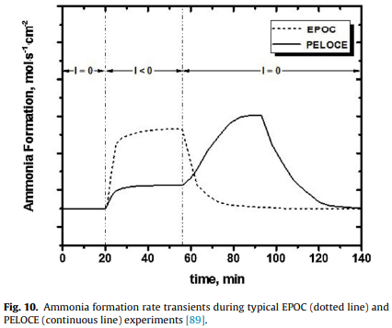
In general, the reaction rate will increase up to a certain level above which, it will become current independent. Wang et al. [31], however, observed a negative order dependence of the reaction rate on the imposed current. At low current density values, the rate increased with current. At I = 1 mA, the rate reached a maximum and attained lower values at higher currents [5,31]. A physical explanation of this behavior is that, at high currents, the catalyst surface is “poisoned” by protons, which combine with electrons and each other, thus forming H₂ rather than NH₃ [4,5].
Fig. 10 describes the characteristics of a peculiar phenomenon observed in a recent SSAS study [89]. The dotted line, is a typical plot of the electrochemical rate of NH3 synthesis vs. time in an EPOC experiment. The initial rate (I = 0) is enhanced upon closing the circuit. When the circuit is opened again, the rate quickly returns to its original value [84,85]. The continuous line shows the variation of the reaction rate with time when a BaZr_{0.7}Ce_{0.2}Y_{0.1} O_{2.9} (BZCY72) proton conducting ceramic was used as the electrolyte and a Ni-BZCY72 cermet was used as cathode. At T > 600 ◦C, after establishing a steady state open-circuit operation, the circuit was closed and a new steady state, which corresponded to a moderate increase in the reaction rate, was reached. Upon current interruption, instead of decreasing, the reaction rate increased and reached a maximum. After a period of time, during which it remained essentially unchanged, the rate decreases slowly to reach its open-circuit value. This phenomenon (Post-Electrochemical Open-Circuit Enhancement-PELOCE) was explained assuming that, under closed circuit, a fraction of protons transported to the cathode, is “stored” in the Ni-BZCY72 electrode in the form of a nickel hydride (Fig. 10). Upon current interruption, this hydride reacts with adsorbed N species to form ammonia [89].
One important difference between catalytic and electrocatalytic ammonia synthesis is that in the latter, one of the reactants (hydrogen) is supplied electrochemically. Hence, the electrolyte conductivity and specifically, the protonic conductivity, is crucial in determining the maximum reaction rate that can be achieved.
The protonic conductivity of low temperature electrolytes, such as Nafion and SPSF, is much higher than that of ceramic high temperature conductors [5]. Thus, there is no need to search for more effective low temperature conductors because the reaction rate is limited by the slow reaction kinetics rather than the supply of protons. This is not the case for high temperature SSAS. The conductivity of a solid electrolyte increases with temperature and is inversely proportional to the thickness of the membrane [4,5]. With a thin solid electrolyte, significantly higher proton fluxes will be obtained at a given temperature. Alternatively, the thin electrolyte can provide the same proton flux at a lower temperature. Recently, Coors et al. succeeded in fabricating anode supported tubular proton conducting cells with an electrolyte (BZCY72) thickness of only 30 micrometers [90,91]. This is a considerable step forward in scaling up SSAS at elevated temperatures.

4.3 The appropriate electro-catalyst
An ideal electro-catalyst should exhibit high catalytic activity and electronic conductivity and at the same time it should suppress HER. Unfortunately, the best Haber-Bosch catalysts often contain large proportions of oxides, which significantly decreases their conductivity. This has led many researchers to explore materials used in typical hydrogenation reactions.
Tables 1–3 show that many materials have been tested as working electrodes (catalysts) in the past fifteen years, including Ru, Fe, Pt, Pd, Ag-Pd, Ni, Ni-Cu as well as conductive oxides and composite materials such as SSN, SBCN, BSCF, SSCO, Ni-BZCY72, etc. The Ag-Pd cathode was used in almost half of the studies and it was the electrode on which the most promising results were obtained.
This is an unexpected result. The Haber-Bosch catalysts are Fe- and Ru-based materials. Ag and Pd are among the worst catalysts for nitrogen dissociative adsorption [2,9]. Furthermore, under cathodic polarization conditions the surfaces of these two metals are expected to be “flooded” with protons making the side-on nitrogen adsorption difficult [2,9].
Table 1, however, shows that on Ag-Pd electrodes, both high reaction rates (> 10⁻⁹ mol s⁻¹ cm⁻²) and FE (up to 80%), were observed. The work of Skúlason et al. [9], may provide an indirect explanation for the high catalytic activity of the Ag-Pd electrode. This study suggested that early transition metals such as Sc, Y, Ti and Zr could effectively catalyze ammonia synthesis upon imposing a negative voltage, i.e., when used as electrodes [9]. In the studies presented in Table 1, the solid electrolytes contained early transition metals such as Y and Zr. Hence, it is possible that the observed activity of Ag-Pd is due to the presence of these early transition metals at the electrode-electrolyte interphase [4].
Unfortunately, the experimental studies to date show that cathodic electrodes based on the best known catalysts (Ru and Fe) facilitate HER at the expense of nitrogen hydrogenation. Another important category of ammonia synthesis catalysts which have recently attracted much interest is the transition metal nitrides [92]. Interestingly, only Amar and co-workers tested nitrides in an electrochemical configuration [45,46]. In particular, Fe₃Mo₃N-Ag [45] and Co₃Mo₃N-Ag [46] were studied at operation temperatures of 400–450 ◦C. The formation rate and FE observed were rather low and reached 3.27 × 10⁻¹⁰ mol s⁻¹ cm⁻² and 6.5%, respectively. This could possibly be attributed to the lack of adequate electronic conductivity of these particular nitrides [45,46]. On the other hand, theoretical studies based on DFT calculations identified certain nitrides as promising electro-catalysts at ambient conditions [79–81]. The theoretical analysis of Abghoui et al. predicted stable operation and FEs higher than 75% for V, Cr, Nb and Zr mononitrides at applied bias between 0.5 and 0.76V vs SHE [81]. These results are very promising and further research in this direction could move the electrochemical approach one step forward.

Techno-economic considerations
The electrochemical synthesis of ammonia exhibits several advantageous characteristics compared to the catalytic (Haber Bosch) process. The first is that the solid electrolyte is a selective ionic membrane, i.e. protons (H+) are the only species that can be transported to the cathode. Today, a significant fraction of the overall cost for NH₃ production is due to the extensive purification of hydrogen. This is necessary because hydrogen, which is produced from steam reforming of natural gas, contains carbon monoxide, water vapor, oxygen and sulfur compounds, which, even in trace amounts, may cause poisoning of the catalyst [3,4]. In SSAS, hydrogen is supplied in the form of protons and therefore the cost of purification is completely eliminated.
Another advantage of the electrochemical method is that the use of gaseous hydrogen can be bypassed. In the Haber-Bosch process, NH₃ is produced exclusively via reaction (1). In the electrochemical synthesis, depending on the temperature of operation, either steam or an aqueous solution can be the hydrogen source. Ammonia can be thus produced via either reaction (1) or (7). In the latter case, the electrical energy consumption will be higher because of the more negative voltage required for water electrolysis. Consequently, the economic feasibility of the electrochemical process will depend strongly on the electrical energy cost. If solar or wind energy is the electricity source, the economics may be favourable, especially when taking into account the environmental effect (use of renewable energy, no CO₂ emissions).
Regardless of the electricity source, scaling up of an electrochemical process requires high FE’s to be achieved. Giddey at al. suggested that the industrial promotion of SSAS will require the combination of reaction rates of the order of 10⁻⁷ mol s⁻¹ cm⁻² with FE’s exceeding 50% [1]. Table 3 shows that, with the exception of ref. [72], the FEs at low temperatures are very low (typically <1%) because of the slow reaction kinetics. At high temperatures (Table 1), the FE’s are acceptably high, but a large fraction of the produced ammonia is inevitably lost because of the reverse reaction (ammonia decomposition), the rate of which increases with temperature. It is unfortunate that there are no solid state materials exhibiting both, mechanical and chemical strength and high protonic conductivity at temperatures between 250 ◦C and 450 ◦C.

Conclusions
Over the past two decades, a large number of studies worldwide have contributed to the promotion of the electrochemical synthesis of ammonia. New proton conducting materials have been employed and numerous materials have been used as working electrodes. The search for efficient electro-catalysts has been supported by theoretical studies, primarily based on DFT calculations. Reaction rates and Faradaic Efficiencies as high as a 3.3 × 10⁻⁸ mol s⁻¹ cm⁻² [56] and 90.4% [72], respectively, have been reported. Also, ceramic proton conductors with a 30 µm thickness, capable of producing NH₃ at rates of the order of 10⁻⁶ molH₂ s⁻¹ cm⁻², have been fabricated and tested [89,90]. Hence, considerable progress has been achieved. Intense collaboration, however, among researchers in the fields of materials science, solid state ionics and heterogeneous catalysis, will be required in order to promote the electrochemical synthesis to the industrial level.

