Nitrogen Generator
Nitrogen generators and stations are stationary or mobile air-to-nitrogen production complexes.
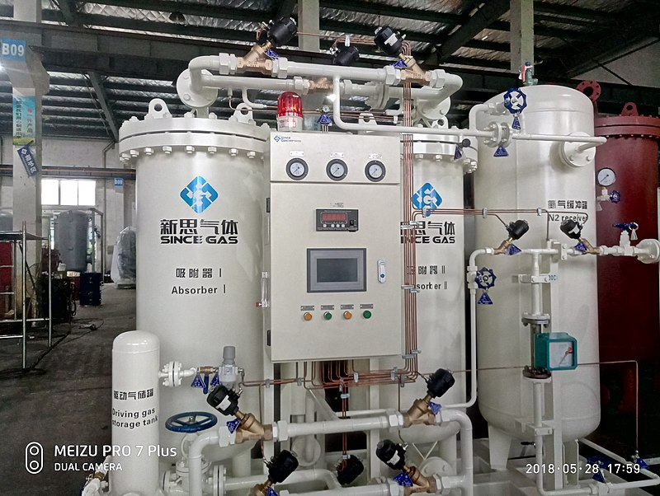
Figure 1 A PSA nitrogen generator

Adsorption technology

Adsorption concept
The adsorption gas separation process in nitrogen generators is based on the phenomenon of fixing various gas mixture components by a solid substance called an adsorbent. This phenomenon is brought about by the gas and adsorbent molecules' interaction.^{[1]}
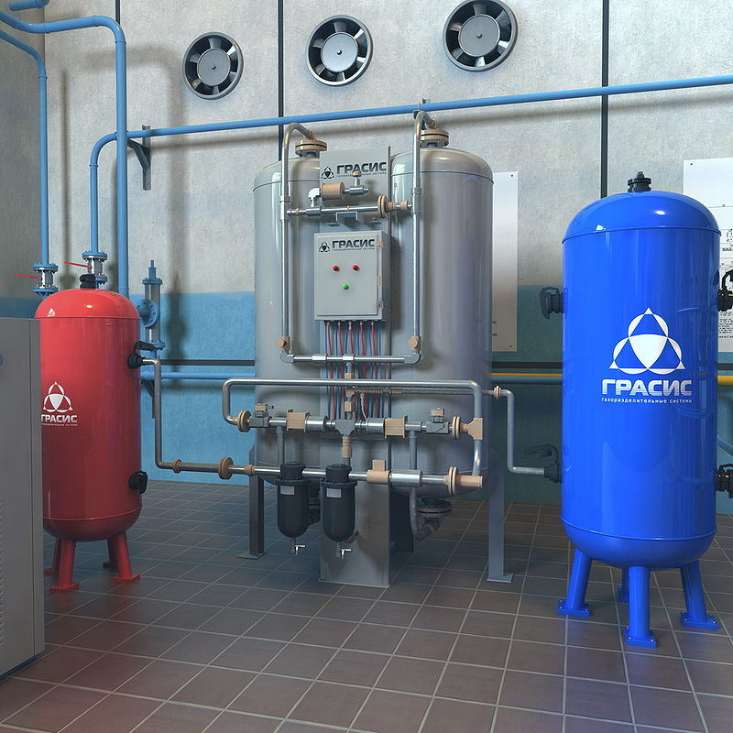
Figure 2 Adsorption nitrogen generator

Pressure swing adsorption technology
The technology of air-to-nitrogen production with the use of adsorption processes in nitrogen generators is well studied and widely applied at industrial facilities for the recovery of high-purity nitrogen.^{[2][3]}
The operating principle of a nitrogen generator utilizing the adsorption technology is based upon the dependence of the adsorption rates featured by various gas mixture components upon pressure and temperature factors. Among nitrogen adsorption plants of various types, pressure swing adsorption (PSA) plants have found the broadest application world-wide.
The system's design is based on the regulation of gas adsorption and adsorbent regeneration by means of changing pressures in two adsorber–adsorbent-containing vessels. This process requires constant temperature, close to ambient. With this process, nitrogen is produced by the plant at the above-atmospheric pressure, while the adsorbent regeneration is accomplished at below-atmospheric pressure.
The swing adsorption process in each of the two adsorbers consists of two stages running for a few minutes. At the adsorption stage oxygen, H₂O and CO₂ molecules diffuse into the pore structure of the adsorbent whilst the nitrogen molecules are allowed to travel through the adsorber–adsorbent-containing vessel. At the regeneration stage the adsorbed components are released from the adsorbent vented into the atmosphere. The process is then multiplely repeated.^{[4]}

Advantages
- High nitrogen purity: PSA nitrogen generator plants allow production of high-purity nitrogen from air, which membrane systems are unable to provide – up to 99.9995% nitrogen. But in most cases they do not produce more than 98.8% nitrogen with the remainder being argon that is not separated from the nitrogen by the usual PSA process. The argon is not normally a problem, as argon is more inert than nitrogen. This nitrogen purity may also be ensured by cryogenic systems, but they are considerably more complex and justified only by large consumption volumes. The nitrogen generators use CMS (carbon molecular sieve) technology to produce a continuous supply of ultra high purity nitrogen and are available with internal compressors or without.
- Low operating costs: By substitution of out-of-date air separation plants nitrogen production savings largely exceed 50%.^{[citation needed]} The net cost of nitrogen produced by nitrogen generators is significantly less than the cost of bottled or liquefied nitrogen.^{[5]}
- Environmental impact: Generating nitrogen gas is a sustainable, environmentally friendly and energy efficient approach to providing pure, clean, dry nitrogen gas. Compared to the energy needed for a cryogenic air separation plant and the energy needed to transport the liquid nitrogen from the plant to the facility, generated nitrogen consumes less energy and creates far fewer greenhouse gases.^{[6]}

Applications of nitrogen generators
- Food and beverage industries: The moment food or beverages are produced, or fruits and vegetables harvested, an aging process kicks in until the complete decay of the products. This is caused by chemical reactions with oxygen, bacteria and other organisms. Generators are used to flood the products with N₂ that displaces the oxygen and prolongs the product lifetime significantly because these organisms cannot develop. Furthermore, chemical degradation of food caused by oxidation can be eliminated or stopped.
- Analytical chemistry: Nitrogen generators are required for various forms of analytical chemistry such as liquid chromatography–mass spectrometry and gas chromatography where a stable and continuous supply of nitrogen is necessary.
- Aircraft & motor vehicle tires: Although air is 78% nitrogen, most aircraft tires are filled with pure nitrogen. There are many tire and automotive shops with nitrogen generators to fill tires. The advantage of using nitrogen is that the tank is dry. Often a compressed air tank will have water in it that comes from atmospheric water vapor condensing in the tank after leaving the air compressor. Nitrogen maintains a more stable pressure when heated and cooled as a result of being dry and doesn't permeate the tire as easily due to being a slightly larger molecule (155 pm) than O₂ (152 pm).
- Chemical and petrochemical industries: The primary and very important application of nitrogen in chemical and petrochemical industries is the provision of inert environment aimed at ensuring general industrial safety during cleaning and protection of process vessels. In addition, nitrogen is used for pipelines pressure testing, chemical agents transportation, and regeneration of used catalysts in technological processes.
Aircraft tires use nitrogen fill to delay tire rupture on rejected take off events, allowing evacuation time before brake system heat causes an internal tire fire. Fusible plugs in the tire are the primary protection against heat induced pressure excursion. Internal tire fires can kindle at initial stop due to local hot sections of the wheels.
- Electronics: In electronics, nitrogen serves to displace oxygen in the manufacture of semi-conductors and electric circuits, heat treatment of finished products, as well as in blowing and cleaning. The most common uses in electronics are in the soldering process. Specifically Selective, Reflow, and Wave Soldering equipment.
- Fire Protection: The fire protection industry uses nitrogen gas for two different applications - fire suppression and corrosion prevention. Nitrogen generators are used in hypoxic air fire prevention systems to produce air with a low oxygen content which will suppress a fire. To prevent corrosion, nitrogen generators are used in place of or in conjunction with a compressed air system to provide supervisory nitrogen gas in place of air for dry pipe and pre-action fire sprinkler systems.^{[9]}
- Glass industry: In glass production, nitrogen proves efficient as a cooling agent for electric arc furnace electrodes as well as to displace oxygen during process procedures.
- Metallurgy: The metal industry generally utilizes nitrogen as a means of protecting ferrous and non-ferrous metals during annealing. Also, nitrogen is helpful in such standard industry processes as neutral tempering, cementing, hard brazing, stress relieving, cyanide hardening, metal-powder sintering and extrusion die cooling.
- Paint-and-varnish industry: Paint and varnish production uses nitrogen for the creation of an inert environment in process vessels to ensure safety, as well as for oxygen displacement during packing in order to prevent polymerization of drying oils.
- Petroleum industry: In the petroleum industry, nitrogen is an indispensable component in a number of processes. Most commonly, nitrogen is used to create an inert environment for preventing explosions and for fire safety and to support transportation and transfer of hydrocarbons. Additionally, nitrogen is used for pipeline testing and purging, cleaning technological vessels and cleaning liquefied gas carriers and hydrocarbon storage facilities.
- Pharmaceutical industry: In the pharmaceutical industry, nitrogen finds application in pharmaceuticals packaging, and ensuring against explosion and fire safety in activities where fine dispersed substances are used.

Pressure swing adsorption
Pressure swing adsorption (PSA) is a technique used to separate some gas species from a mixture of gases (typically air) under pressure according to the species' molecular characteristics and affinity for an adsorbent material. It operates at near-ambient temperature and significantly differs from the cryogenic distillation commonly used to separate gases. Selective adsorbent materials (e.g., zeolites, (aka molecular sieves), activated carbon, etc.) are used as trapping material, preferentially adsorbing the target gas species at high pressure. The process then swings to low pressure to desorb the adsorbed gas.
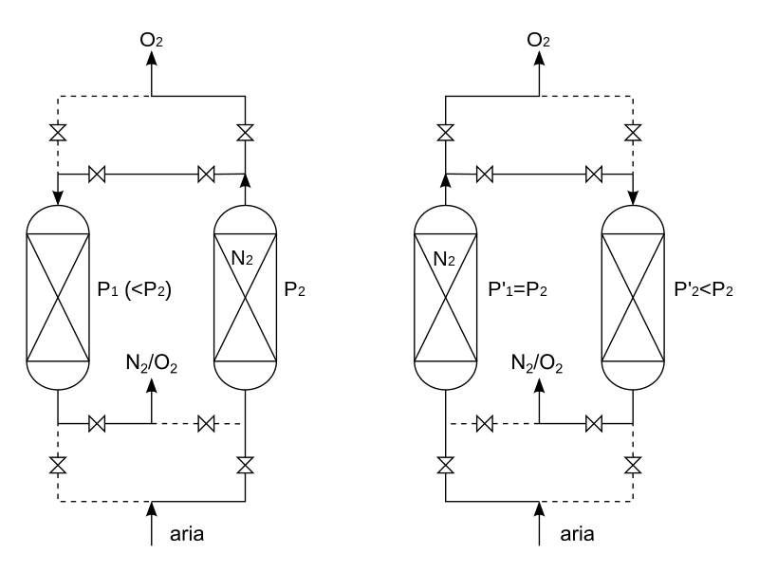
Figure 3 Schematic drawing of the PSA process ("aria" = air input). Note the symmetry in a vertical plane between the left and the right sketches.

Process
Pressure swing adsorption process (PSA) is based on the phenomenon that under high pressure, gases tend to be trapped onto solid surfaces, i.e., to be "adsorbed". The higher the pressure, the more gas is adsorbed. When the pressure is dropped, the gas is released, or desorbed. PSA can be used to separate gases in a mixture because different gases are adsorbed onto a given solid surface more or less strongly. For example, if a gas mixture such as air is passed under pressure through a vessel containing an adsorbent bed of zeolite that attracts nitrogen more strongly than oxygen, a fraction of nitrogen will stay in the bed, and the gas exiting the vessel will be richer in oxygen than the mixture entering. When the bed reaches the limit of its capacity to adsorb nitrogen, it can be regenerated by decreasing the pressure, thus releasing the adsorbed nitrogen. It is then ready for another cycle of producing oxygen-enriched air.
Using two adsorbent vessels allows near-continuous production of the target gas. It also allows a pressure equalisation, where the gas leaving the vessel being depressurised is used to partially pressurise the second vessel. This results in significant energy savings, and is a common industrial practice.

Adsorbents
Aside from their ability to discriminate between different gases, adsorbents for PSA systems are usually very porous materials chosen because of their large specific surface areas. Typical adsorbents are zeolite, activated carbon, silica gel, alumina, or synthetic resins. Though the gas adsorbed on these surfaces may consist of a layer only one or at most a few molecules thickness, surface areas of several hundred square meters per gram enable the adsorption of a large portion of the adsorbent's weight in gas. In addition to their affinity for different gases, zeolites and some types of activated carbon may utilize their molecular sieve characteristics to exclude some gas molecules from their structure based on the size and shape of the molecules, thereby restricting the ability of the larger molecules to be adsorbed.
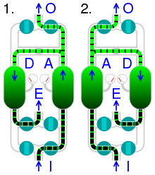
Animation of pressure swing adsorption, (1) and (2) showing alternating adsorption and desorption.
I | compressed air input |  | A | adsorption
O | oxygen output |  | D | desorption
E | exhaust

Variations of PSA technology

Double Stage PSA
(DS-PSA, sometimes also referred to as Dual Step PSA).
With this variant of PSA developed for being use in laboratory nitrogen generators, nitrogen gas is produced into two steps: in the first step, the compressed air is forced to pass through a carbon molecular sieve to produce nitrogen at a purity of approximately 98%; in the second step this nitrogen is forced to pass into a second carbon molecular sieve and the nitrogen gas reaches a final purity up to 99.999%. The purge gas from the second step is recycled and partially used as feed gas in the first step.
In addition, the purge process is supported by active evacuation for better performance in the next cycle. The goals of both of these changes is to improve efficiency over a conventional PSA process.
DS-PSA can also be applied to increase the oxygen concentration. In this case, an aluminum silica based zeolite adsorbs nitrogen in the first stage reaching 95% oxygen in the outlet, and in the second stage a carbon-based molecular sieve adsorbs the residual nitrogen in a reverse cycle, concentrating oxygen up to 99%.

Rapid PSA
Rapid pressure swing adsorption, or RPSA, is frequently used in portable oxygen concentrators. It allows a large reduction in the size of the adsorbent bed when high purity is not essential and when the feed gas (air) can be discarded.^{[7]} It works by quickly cycling the pressure while alternately venting opposite ends of the column at the same rate. This means that non-adsorbed gases progress along the column much faster and are vented at the distal end, while adsorbed gases do not get the chance to progress and are vented at the proximal extremity.^{[8]}

Vacuum swing adsorption
Vacuum swing adsorption (VSA) segregates certain gases from a gaseous mixture at near ambient pressure; the process then swings to a vacuum to regenerate the adsorbent material. VSA differs from other PSA techniques because it operates at near-ambient temperatures and pressures. VSA typically draws the gas through the separation process with a vacuum. For oxygen and nitrogen VSA systems, the vacuum is typically generated by a blower. Hybrid Vacuum Pressure swing adsorption (VPSA) systems also exist. VPSA systems apply pressurized gas to the separation process and also apply a vacuum to the purge gas. VPSA systems, like one of the portable oxygen concentrators, are among the most efficient systems measured on customary industry indices, such as recovery (product gas out/product gas in) and productivity (product gas out/mass of sieve material). Generally, higher recovery leads to a smaller compressor, blower, or other compressed gas or vacuum source and lower power consumption. Higher productivity leads to smaller sieve beds. The consumer will most likely consider indices which have a more directly measurable difference in the overall system, like the amount of product gas divided by the system weight and size, the system initial and maintenance costs, the system power consumption or other operational costs, and reliability.
How Does A PSA Nitrogen Generator Work? - Pressure Swing Adsorption
The gas separation process in (Pressure Swing Adsorption) PSA nitrogen generators is based on the ability to fix various gas mixture components and particles by a physical solid substance. These are called adsorbents.

Adsorption in PSA nitrogen generators
The gas separation process in PSA N₂ generators is based on the ability to fix various gas mixture components and particles by a physical solid substance. These are called adsorbents.
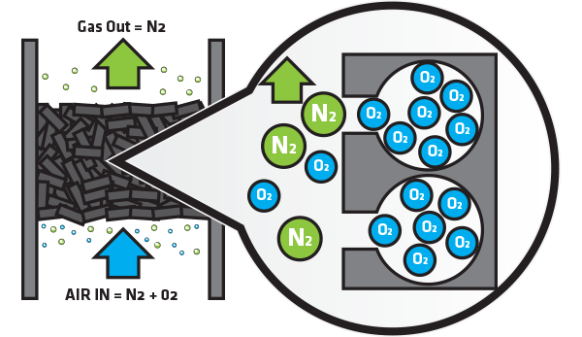
Figure 4 PSA process illustration

PSA nitrogen generators
The technology of air-to-nitrogen generation with the use of adsorption processes in PSA nitrogen generators is well studied and widely applied at industrial facilities for the recovery of high-purity nitrogen. This is then used in many industries from food packaging to supporting laboratory instrumentation such as Liquid Chromatography Mass Spectrometry (LC-MS) and Gas Chromatography (GC).
https://youtu.be/oe6OFvfzoyY

Producing Nitrogen via Pressure Swing Adsorption
Nitrogen gas is a staple of the chemical industry. Because it is an inert gas, nitrogen is suitable for a wide range of applications covering various aspects of chemical manufacturing, processing, handling, and shipping. Due to its low reactivity, nitrogen is an excellent blanketing and purging gas that can be used to protect valuable products from harmful contaminants. It also enables the safe storage and use of flammable compounds, and can help prevent combustible dust explosions. Nitrogen gas can be used to remove contaminants from process streams through methods such as stripping and sparging.
Because of the widespread and growing use of nitrogen in the chemical process industries (CPI), industrial gas companies have been continually improving methods of nitrogen production and supply to make them more efficient, cost-effective, and convenient for chemical processors. Multiple nitrogen technologies and supply modes now exist to meet a range of specifications, including purity, usage pattern, portability, footprint, and power consumption. Choosing among supply options can be a challenge. Onsite nitrogen generators, such as pressure swing adsorption (PSA) or membrane systems, can be more cost-effective than traditional cryogenic distillation or stored liquid nitrogen, particularly if an extremely high purity (e.g., 99.9999%) is not required.
Generating nitrogen gas
Industrial nitrogen gas can be produced by either cryogenic fractional distillation of liquefied air, or separation of gaseous air using adsorption or permeation. German engineer Carl von Linde developed cryogenic distillation of air, the oldest method of nitrogen production, in 1895 (1). Cryogenic distillation is still used today in large commercial air separation plants, and accounts for nearly 65–70% of the total nitrogen production (2).
Leonard Pool (the founder of Air Products) introduced the concept of generating industrial gases onsite in the early 1940s. Onsite cryogenic plants were built on or near the user’s site, and the product was delivered by pipeline. This method provided a low-cost, reliable supply for large-volume users of industrial gases. However, due to the relatively high capital and power costs associated with onsite cryogenic plants, smaller-volume users were typically limited to liquid nitrogen supply delivered by vacuum-insulated trucks. The stored liquid nitrogen was vaporized and piped as needed.
In the 1980s, alternative methods of onsite gaseous nitrogen generation, such as PSA and membrane separation, came into practice. Initially, these techniques were suitable only for small-volume, low-purity applications. Today, however, PSA and membrane systems are an efficient supply mode for a variety of volumes, purity requirements, and usage patterns.
PSA systems operate on the principle of adsorption, whereas membrane systems separate based on selective permeation.
The two most important factors to consider when choosing among nitrogen supply options are the required nitrogen purity and the required nitrogen flowrate.
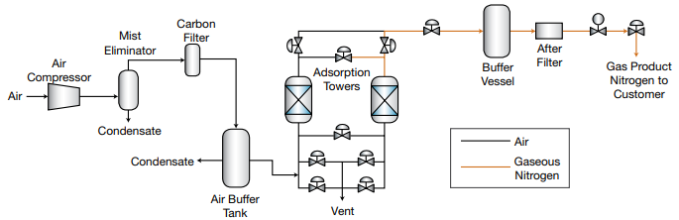
Figure 5 . PSA systems can provide a reliable, low-cost nitrogen supply to meet a wide variety of process requirements.
Pressure swing adsorption. In the PSA process (Figure 5), compressed air first passes through a combination of filters to remove entrained oil and water. The purified air is then directed to one of two adsorption vessels that are packed with carbon molecular sieves (CMS). The remaining impurities, such as carbon dioxide and residual moisture, are adsorbed by the CMS at the entrance of the adsorbent bed. At high pressures, the CMS selectively adsorbs oxygen, allowing nitrogen to pass through at the desired purity level. While one vessel is producing nitrogen, the second vessel is depressurized to remove the adsorbed oxygen, which is then vented to the atmosphere. The automatic cycling of adsorption and desorption between the two beds enables the continuous production of nitrogen.
A large range of flow and purity combinations can be met by adjusting the size of the air compressor and adsorption vessels containing the CMS. PSAs can economically produce nitrogen gas at flowrates from less than 5,000 scfh to greater than 60,000 scfh, and at purities ranging from 95% to 99.9995%.
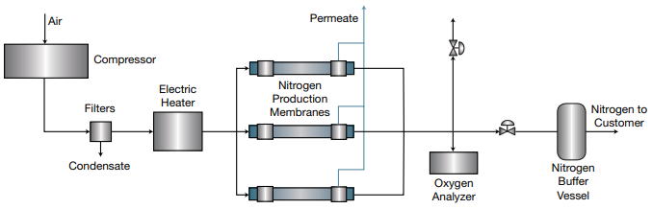
Figure 6 Membrane systems use selective gas permeation to generate nearly pure nitrogen.
Membrane separation. Membrane systems operate on the principle of selective gas permeation. A typical membrane process (Figure 2) uses several membrane modules, each containing thousands of hollow fibers. Every molecule passing through the fibers has a characteristic permeation rate that is a function of its ability to dissolve in, diffuse through, and dissolve out of the hollow-fiber membrane. The permeation rate is the product of the solubility and diffusivity rates of the gas in the membrane. When compressed air passes through the fibers, oxygen, water vapor, and carbon dioxide are selectively removed, creating a nitrogenrich product stream.
Membrane systems typically produce nitrogen with a purity of 95–99.5%, and, in some cases, greater than 99.9% nitrogen purity. Product purity depends on the feed purity, available differential partial pressure, and desired recovery level.

